Supplementary Information for The Polygenic Risk Score Knowledge Base:
A centralized online repository for calculating and contextualizing polygenic risk scores

Madeline L. Page^{1,*}, Elizabeth L. Vance^{1,*}, Matthew E. Cloward^{2,*}, Ed Ringger², Louisa Dayton², for the Alzheimer's Disease Neuroimaging Initiative³, Justin B. Miller^{1,+}, John S.K. Kauwe^{1,+}

¹Department of Biomedical Informatics, University of Kentucky Sanders-Brown Center on Aging, Lexington, KY 40539, USA
²Department of Biology, Brigham Young University, Provo, UT 84602, USA
³The Alzheimer's Disease Neuroimaging Initiative affiliations are listed in the Acknowledgments section.

Correspondence should be addressed to JSKK. Tel: 8011-422-2993; Fax: 801-422-0900; Email: kauwe@byu.edu
*The authors wish it to be known that, in their opinion, the first three authors should be regarded as co-first authors
⁺The authors wish it to be known that, in their opinion, the last two authors should be regarded as co-last authors

Table of Contents
Figures 3
Figure S1: PRSKB data compilation pipeline 3
Figure S2: PRSKB calculator interface 4
Figure S3: Sample JSON output 5
Figure S4: Sample TSV condensed output 6
Figure S5: Sample TSV verbose output 6
Figure S6: GWA study browser interface 6
Figure S7: PRSKB command-line interface usage instructions 7
Figure S8: PRSKB command-line interface menu 7
Figure S9: Covid-19 polygenic risk score distribution for UK Biobank individuals 8
Supplementary Files 9
File S1: Linkage disequilibrium clumping 9
Supplementary References: 10

Figures

Figure S1: PRSKB data compilation pipeline
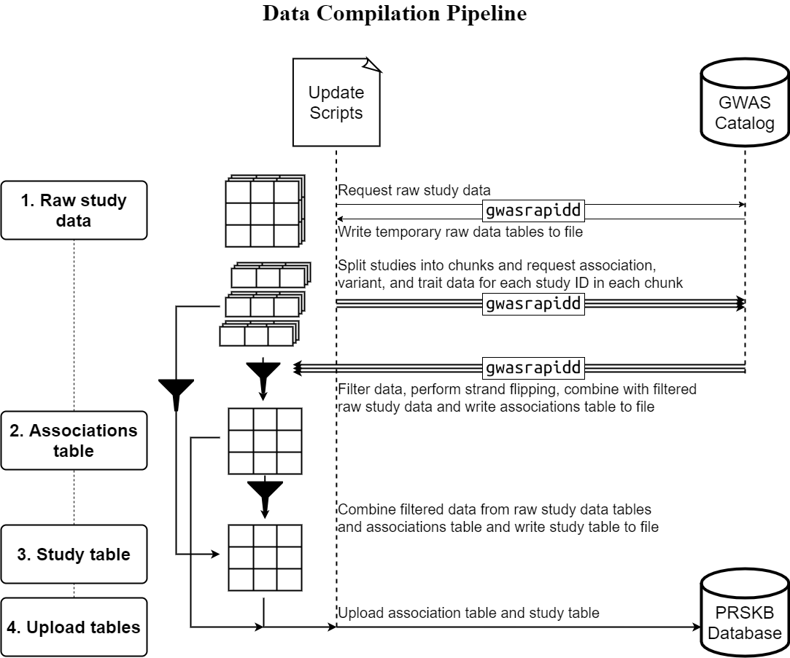
Figure S1:PRSKB data compilation pipeline. Every month, the PRSKB database is automatically synced with the NHGRI-EBI GWAS Catalog using a collection of shell, R, and Python scripts. Data from the GWAS Catalog is downloaded via the gwasrapidd R library, which uses the GWAS Catalog's API to connect to the database. All filtering and sorting of data downloaded
is done by PRSKB's scripts. Arrows in this diagram represent the flow of data.
1. The scripts first download raw GWA study data from the GWAS Catalog using the gwasrapidd R library. The data are then written out to temporary TSV tables.
2. Association data are downloaded for each study ID in the temporary raw data tables. The study IDs are split into groups to speed up association data download time.
The association data are filtered so that only non-haplotype autosomal associations that have risk alleles and odds ratios are preserved. The filtered data
undergoes strand flipping, in which alleles reported on the opposite strand are corrected. The data is formatted and written to the associations_table.tsv 3. Data from the associations table and the temporary TSV tables are filtered, formatted, and sorted and written to the study_table.tsv.
4. Finally, the associations_table.tsv and the study_table.tsv are uploaded to the PRSKB database.
.

Figure S2: PRSKB calculator interface
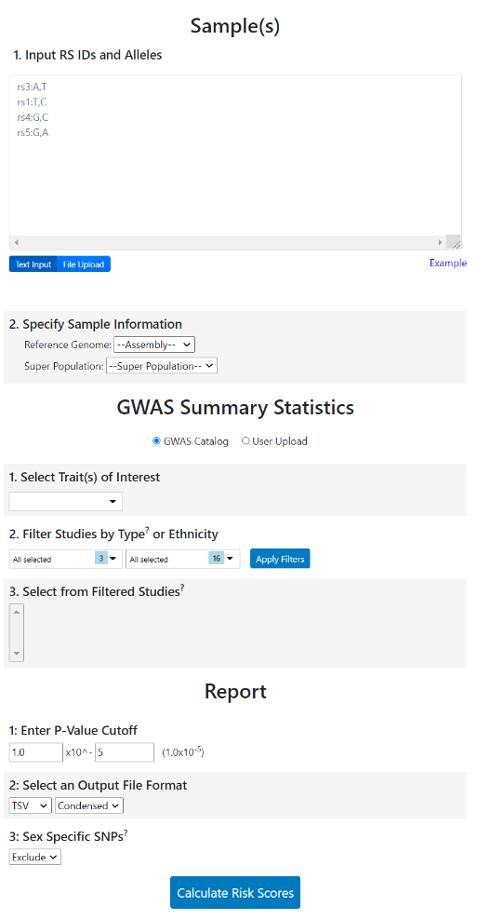
Figure S2: PRSKB calculator interface. The PRSKB calculator is accessed under the “Calculate” tab at prs.byu.edu. Users upload a text or VCF file with genotype information, select the studies used for risk score calculations, indicate the p-value threshold for variants to include in the risk score calculations, and select the output file format (condensed TSV, verbose TSV, or JSON).

Figure S3: Sample JSON output
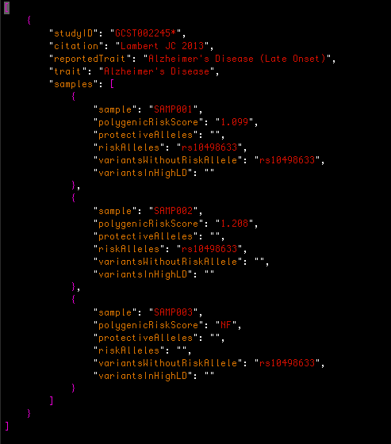
Figure S3: Sample JSON output. For each study, the JSON output includes the study ID, study citation, trait information, and sample information. The sample information includes the sample name, polygenic risk score, a list of variants that decreased risk for the trait, a list of variants that increased risk for the trait, a list of variants that were carried by the individual with an allele other than the risk allele, and a list of variants that were not included in the calculation because they were in LD with other utilized variants. Studies marked by an asterisk indicate that not every variant from the GWA study was present in the input file. Studies marked by a ‘†’ indicate studies that had duplicate variants with varying p-values and only one of those variants was used in the PRS calculation.

Figure S4: Sample TSV condensed output
Figure S4: Sample TSV condensed output. The condensed TSV output includes one line per study. Each line contains the study ID, study citation, trait information, and a polygenic risk score for each sample in the input file. Studies marked by an asterisk indicate that not every variant from the GWA study was present in the input file. Studies marked by a ‘†’ indicate studies that had duplicate variants with varying p-values, and only one of those variants was used in the PRS calculation.

Figure S5: Sample TSV verbose output
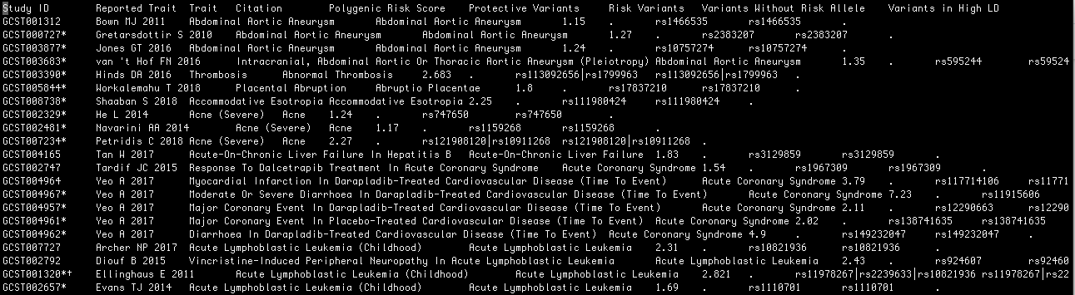
Figure S5: Sample TSV verbose output. The verbose TSV output includes a line for each study and sample. Each line includes the study ID, sample ID, trait information, study citation, polygenic risk score for the sample, a list of variants that decreased risk for the trait, a list of variants that increased risk for the trait, a list of variants that were carried by the individual with an allele other than the risk allele, and a list of variants that were not included in the calculation because they were in LD with other utilized variants. Studies marked by an asterisk indicate that not every variant from the GWA study was present in the input file. Studies marked by a ‘†’ indicate studies that had duplicate variants with varying p-values, and only one of those variants was used in the PRS calculation.

Figure S6: GWA study browser interface
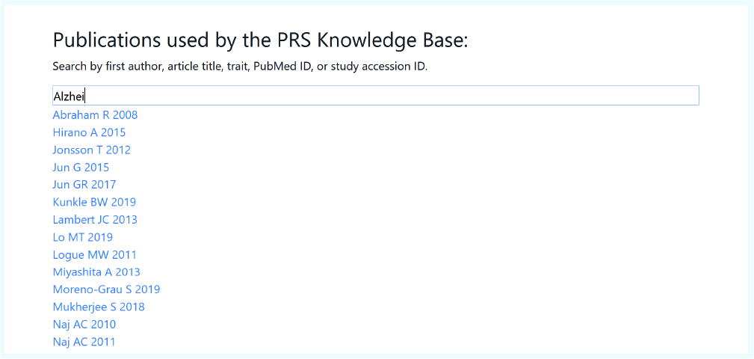
Figure S6: GWA study browser. The GWA study browser can be found under the “Studies” tab at prs.byu.edu or at “Option 2: Search for a specific study or trait” on the command-line interface menu.

Figure S7: PRSKB command-line interface usage instructions
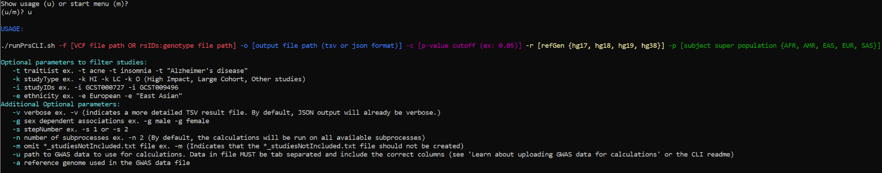
Figure S7: PRSKB command-line interface usage instructions. The usage instructions are accessed by running the runPrsCli.sh bash script without any of the parameters.

Figure S8: PRSKB command-line interface menu
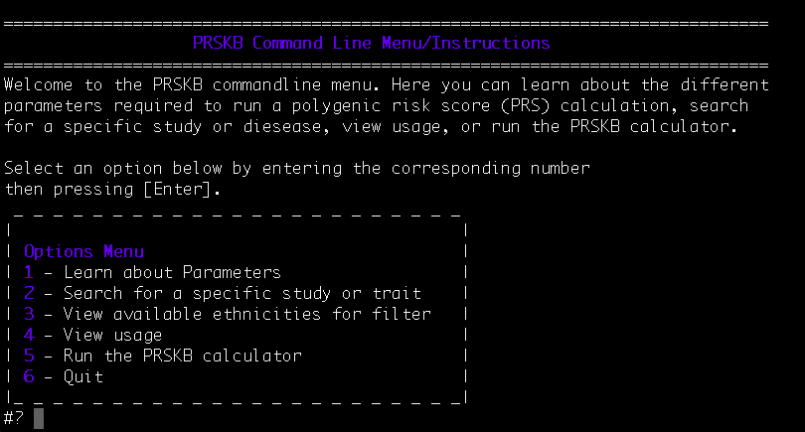
Figure S8: PRSKB command-line interface menu. The CLI menu can be accessed through running the runPrsCLI.sh bash script without any of the parameters.

Figure S9: Covid-19 polygenic risk score distribution for UK Biobank individuals
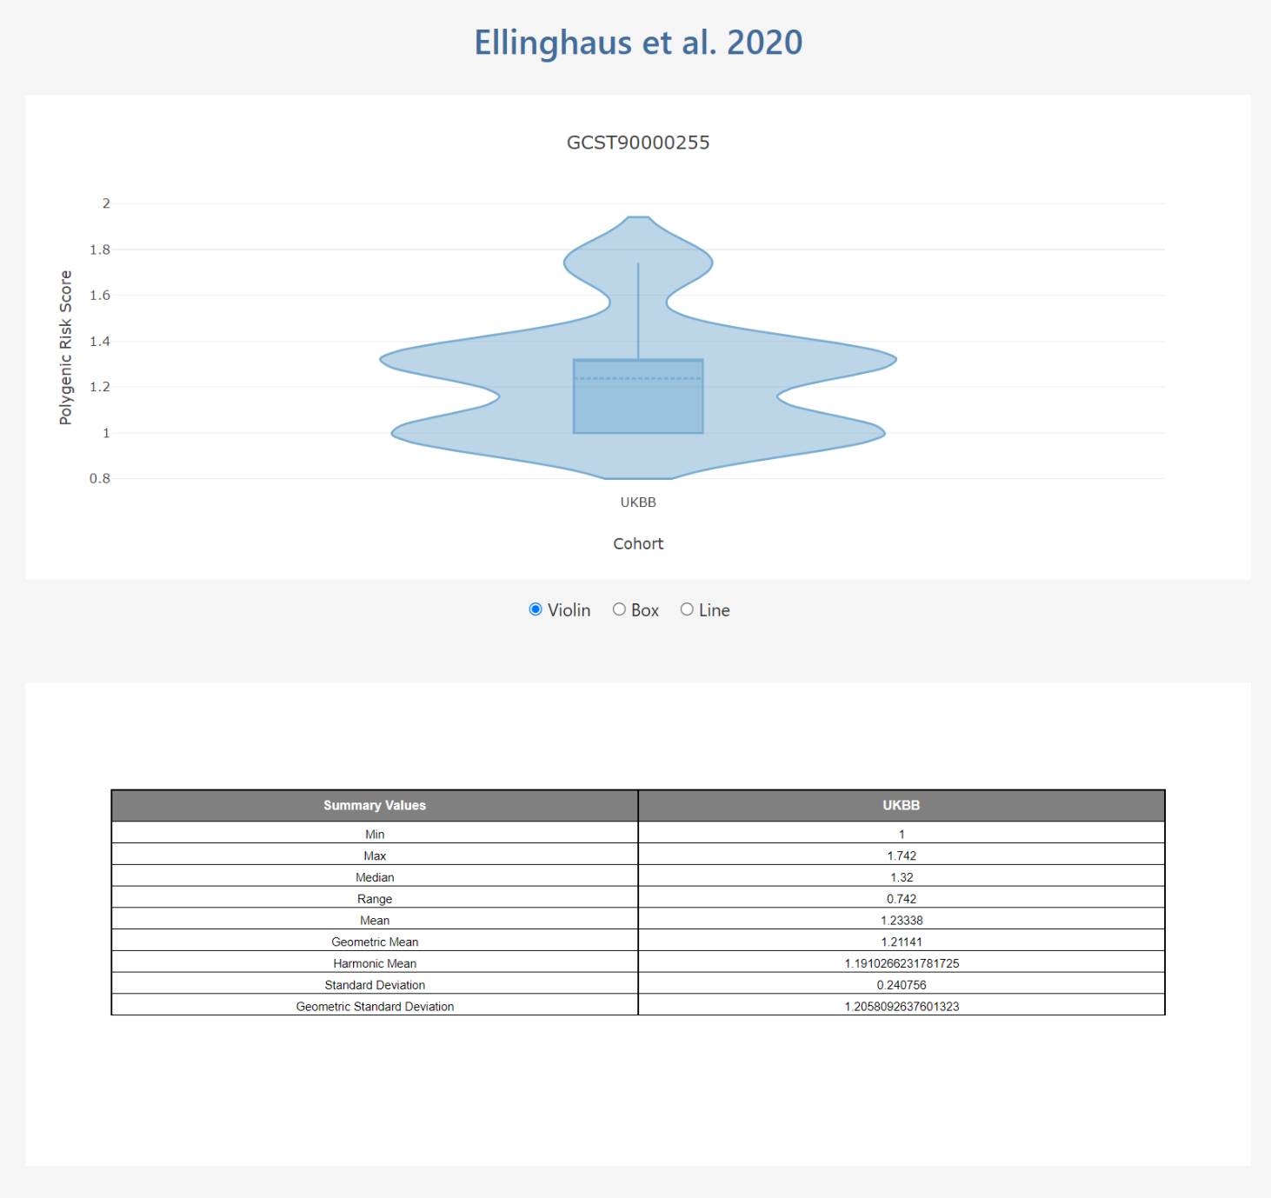
Figure S9: Covid-19 polygenic risk score distribution for UK Biobank individuals, based on GWA summary statistics reported by Ellinghaus, et al.¹. This is an example of the type of graphics and data that are available under the “Visualize” tab at prs.byu.edu. Users can look at the distributions of risk scores for any study using the UK Biobank, 1000 Genomes, or ADNI datasets.

Supplementary Files

File S1: Linkage disequilibrium clumping

Linkage disequilibrium (LD) clumping files are stored on our server and are available online by using the population and reference genome. The URL for the European population (EUR) using reference genome hg38 would be written as follows:

https://prs.byu.edu/get_clumps_download_file?refGen=hg38&superPop=EUR

In order to account for LD in the PRS calculations, we pre-computed the LD regions for each variant in the 1000 Genomes database. We used the PLINK² LD Clumping command, which requires reference genotype data in order to calculate LD between the variants present in a target input file.

We use 1000 Genomes data for both the reference and target files. To create the reference files, we downloaded 1000 Genomes variant call format (VCF) files and separated each file by super population (African, American, East Asian, European, and South Asian). Next, we used PLINK to convert each VCF file into a binary file set by running the following command, where ${population} is one of the population specific VCF files.

PLINK --vcf ${population} --make-bed

The variants intended to be grouped into LD regions are found in the ${variant_file}. The PLINK --clump operation scans the ${variant_file} and extracts fields with the headers ‘SNP’ (reference SNP ID number) and ‘P’ (p-value). For each population, we created a variant file, where the ‘SNP’ column contained the variants listed in the corresponding population-filtered VCF file. The ‘P’ column typically contains p-values for the association that each SNP has with a designated trait. This value is used to arrange the variants within each clump based on their association with the given trait. Since our intent was to identify LD regions for all variants from 1000 Genomes, regardless of their association with a certain trait, we filled every value in this column with ‘0’. As a result, the final LD clumps are unordered.

For each super population (African, American, East Asian, European, and South Asian), we executed the LD clumping command as follows, where ${reference_data} refers to the population-specific binary file set and ${variant_file} indicates the file with the list of rsIDs.

PLINK --bfile ${reference_data} --clump ${variant_file} --clump-p1 1 --clump-p2 1 --clump—r2 0.25 --clump-kb 500

The following four parameters determined the level of clumping that was performed:
--clump-p1: The significance threshold for the variant with the lowest p-value in a clump
--clump-p2: The significance threshold for all other variants in a clump
--clump-r2: The r-squared value that signifies the linkage disequilibrium threshold for clumping
--clump-kb The physical distance (kb) threshold for clumping

In order to maintain as many variants as possible in our final regions, we used a p-value threshold of 1 for both p1 and p2. Based on previous polygenic risk score analyses that use the clumping method, we assigned an r-squared threshold of 0.25 and a kb threshold of 500^{3,4}.

After applying this process for both the hg19 and hg38 available reference genome data, we converted the variant coordinates in each LD clump to the hg17 and hg18 reference genomes.

Supplementary References:

1 Ellinghaus, D. et al. Genomewide Association Study of Severe Covid-19 with Respiratory Failure. The New England journal of medicine 383, 1522-1534, doi:10.1056/NEJMoa2020283 (2020).
2 Purcell, S. et al. PLINK: a tool set for whole-genome association and population-based linkage analyses. Am J Hum Genet 81, 559-575, doi:10.1086/519795 (2007).
3 Privé, F., Vilhjálmsson, B. J., Aschard, H. & Blum, M. G. B. Making the Most of Clumping and Thresholding for Polygenic Scores. The American Journal of Human Genetics 105, 1213-1221, doi:https://doi.org/10.1016/j.ajhg.2019.11.001 (2019).
4 Wray, N. R. et al. Research review: Polygenic methods and their application to psychiatric traits. Journal of child psychology and psychiatry, and allied disciplines 55, 1068-1087, doi:10.1111/jcpp.12295 (2014).

