Supplementary Information

Sustained CO₂-photoreduction activity and high selectivity over C, Mn-codoped ZnO core-triple shell hollow spheres

Sayed et al.

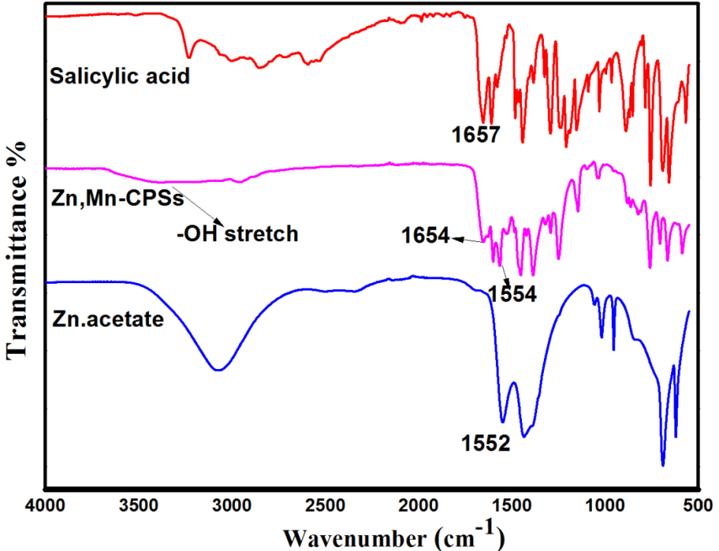
Supplementary Figure S1 FTIR spectra of salicylic acid, Zn acetate and Zn, Mn-CPSs.

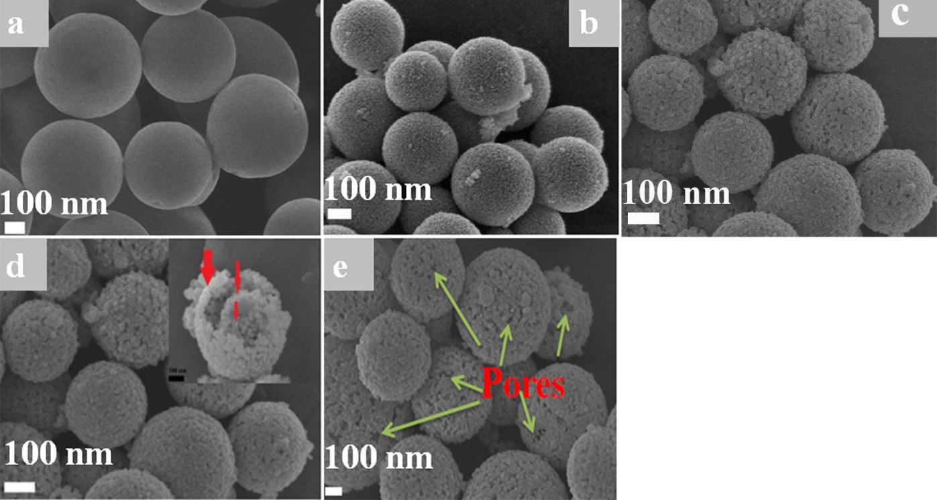

Supplementary Figure S2 Morphology of the prepared samples. FESEM of Mn, Zn CPSs precursors a before calcination, after calcination for b 1 h, c 2 h and d 3 h, the inset in d shows the core-triple shell morphology. e FESEM image shows the porosity of C, Mn-ZnO CTSHSs sample.

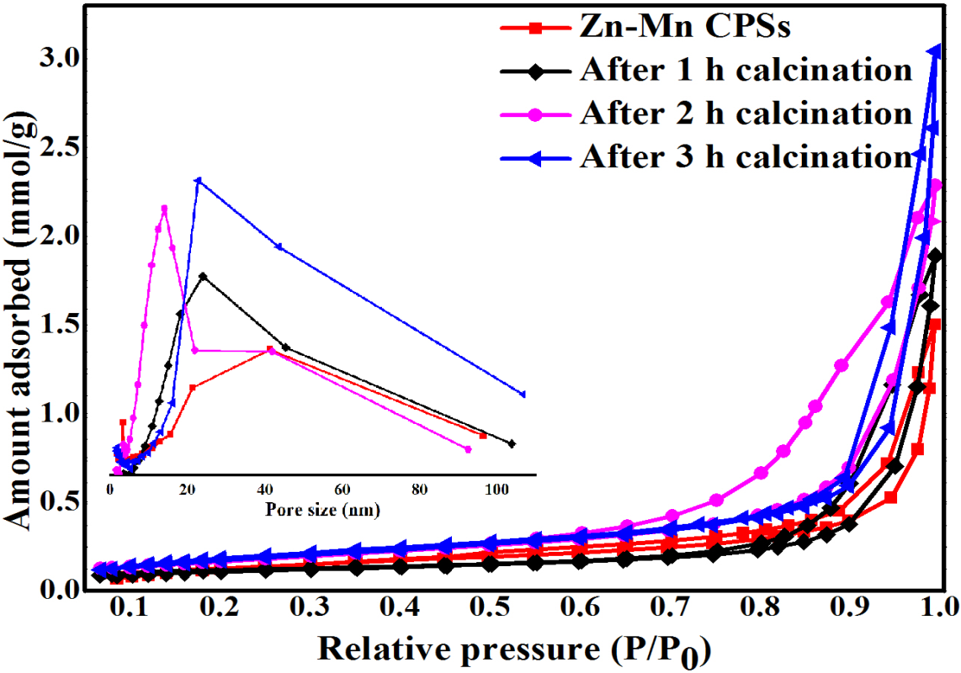
Supplementary Figure S3 N₂ adsorption-desorption isotherms of Mn, Zn-CPSs precursors, and the precursor after calcination for 1, 2 and 3 h. The inset represents the pore size distribution of the samples.

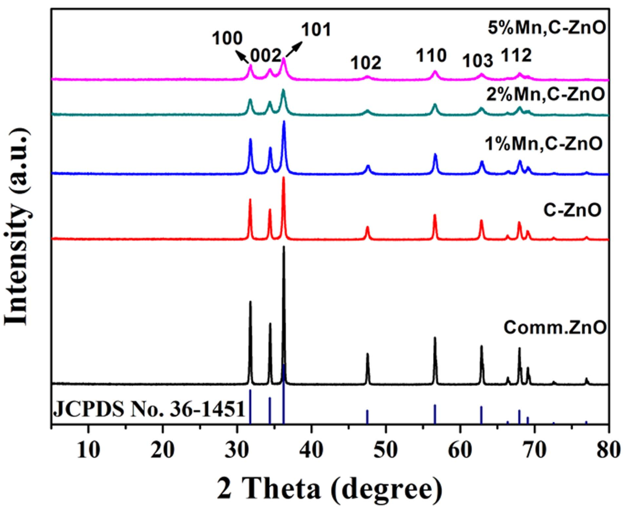
Supplementary Figure S4 XRD patterns of the prepared samples together with commercial ZnO.

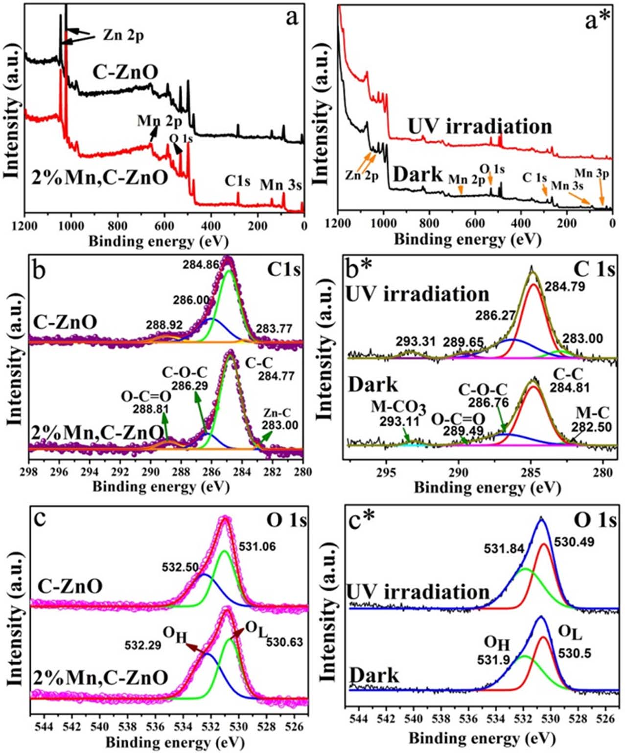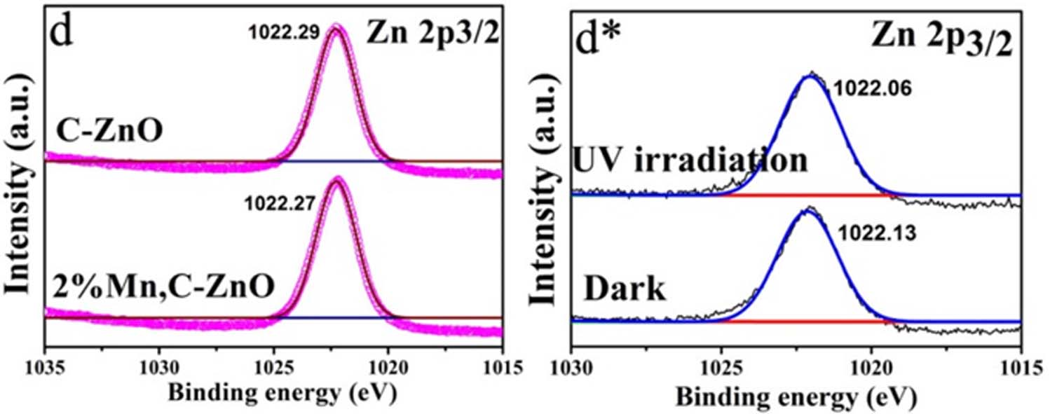
Supplementary Figure S5 Chemical analysis of samples. XPS spectra of C-ZnO and 2%Mn,C-ZnO CTSHSs samples (left panel) and 2%Mn, C-ZnO sample loaded with CO₂ under both dark and irradiation conditions (right panel). a, a* The survey spectra of samples and high resolution XPS of b, b* C 1s, c, c* O 1s and d, d* Zn 2p.
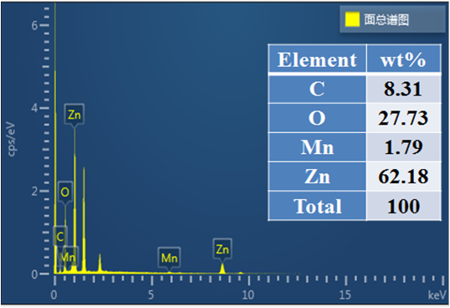
Supplementary Figure S6 EDS elemental signals, the inset table represents the weight percentage of each element in the sample.

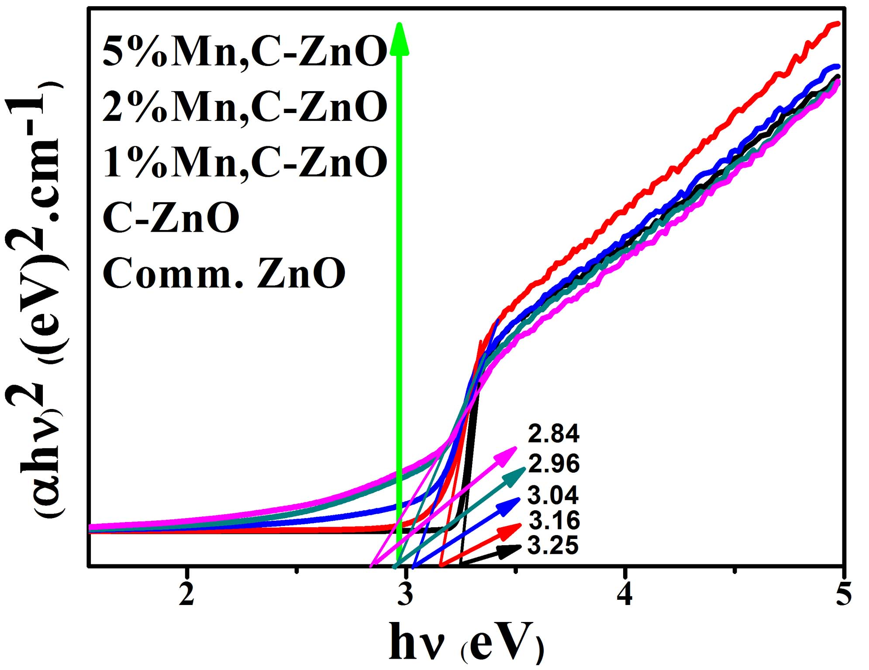
Supplementary Figure S7 Bandgap estimation of the prepared samples. Tauc plots of prepared C-ZnO and C, Mn-ZnO samples together with comm. ZnO. The results indicate a progressive narrowing of the ZnO-band gap after C and Mn doping.

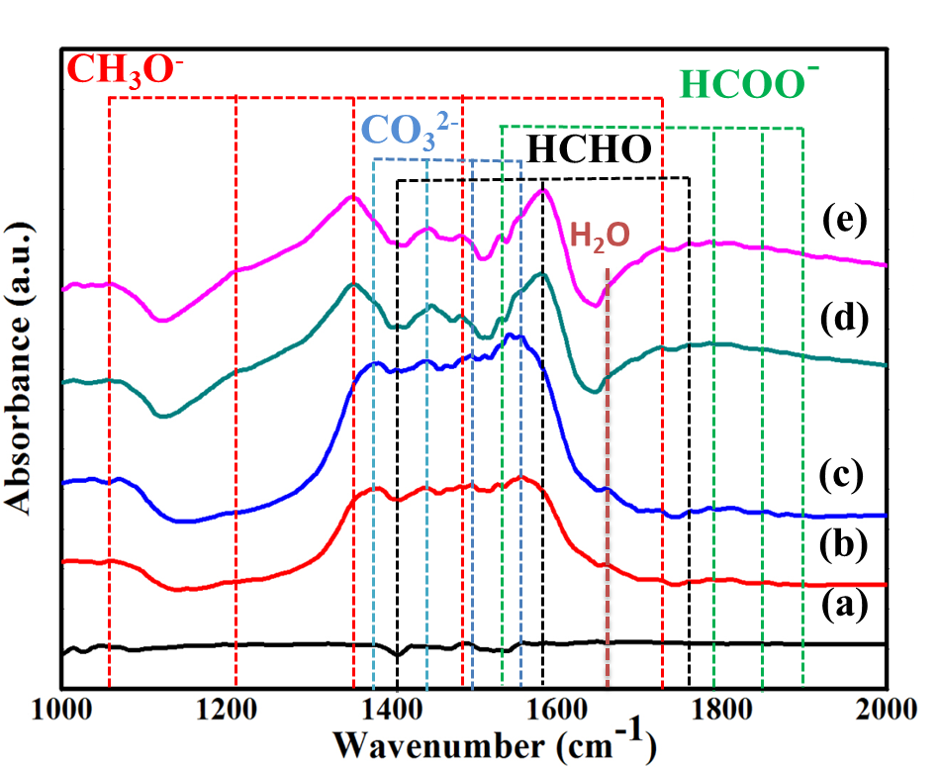
Supplementary Figure S8 CO₂ PR pathway over Mn, C-codoped ZnO photocatalyst. In-situ DRIFTS spectra of photocatalytic CO₂ reduction using 2%Mn, C-ZnO CTSHSs sample under dark condition after a 0 min , b 30 min and c 60 min. And under 365 nm LED light irradiation after d 30 min and e 60 min.

Supplementart Table S1 BET surface area (S _{BET}), pore volume (V_{pore}) and average pore size (V_{pore}) of the starting Mn, Zn-CPSs and the calcined intermediate products.
Sample | S _{BET} (m² g⁻¹⁾ | V_{pore} (cm³ g⁻¹) | Average pore size (nm)
Zn-Mn-CPSs | 5.4 | 0.03 | 28
After calcination for 1 h | 9.2 | 0.05 | 29
After calcination for 2 h | 11 | 0.07 | 19
After calcination for 3 h (2% Mn,C-ZnO CTSHSs) | 14 | 0.11 | 28
C-ZnO CTSHSs | 14 | 0.08 | 23
Comm. ZnO | 14 | 0.02 | 7.5

Supplementary Table S2 XRD parameters of C, Mn-ZnO CTSHSs with different content of Mn together with Comm. ZnO.

Sample | Calculated* “a” ( ^{ᵒ}A) | Calculated “c” ( ^{ᵒ}A) | Diffraction from “100” plane |  | Diffraction from “101” plane
Sample | Calculated* “a” ( ^{ᵒ}A) | Calculated “c” ( ^{ᵒ}A) | 2 Theta | d ( ^{ᵒ}A) | 2 Theta | d ( ^{ᵒ}A)
Comm. ZnO | 3.2588 | 5.2518 | 31.6480 | 2.8222 | 36.0992 | 2.4862
C-ZnO | 3.2529 | 5.1024 | 31.7633 | 2.8152 | 36.3545 | 2.4692
1% Mn,C-ZnO | 3.2502 | 5.0932 | 31.7802 | 2.8130 | 36.1134 | 2.4852
2% Mn,C-ZnO | 3.2526 | 5.2360 | 31.7407 | 2.8171 | 36.1991 | 2.4794
5% Mn,C-ZnO | 3.2466 | 5.2703 | 31.8209 | 2.8099 | 36.2408 | 2.4768

Supplementary Table S3 Comparison of CO₂ photocatalytic reduction activity of Mn,C-codoped ZnO CTSHSs with some reported systems.
Catalyst | Irradiation source | Main product | Evolution rate (μmol g⁻¹h⁻¹) | Reference
TiO₂/MXene Ti₃C₂ composite | 300 W Xe arc lamp | CH₄ | 0.22 | ¹
g-C₃N₄/Bi₂WO₆  composite | 300 W Xe arc lamp | CO | 5.19 | ²
Cu₂O/TiO₂ composite | 1 kW high-pressure Hg (Xe) arc lamp | CO | 2.11 | ³
MOF-derived ZnO/NiO  porous hollow spheres | 300 W Xe arc lamp | CH₃OH | 1.57 | ⁴
Reduced graphene oxide-CdS nanorod composite | 300 W Xe lamp | CH₄ | 2.51 | ⁵
C, Mn-ZnO core-triple shell hollow spheres | 300 W Xe lamp | CH₃OH | 11.64 | This work

Supplementary Table S4 TRPL fitting parameters for the analyzed samples; comm. ZnO, C-ZnO and Mn, C-ZnO CTSHSs.
Sample | τ₁ (ns) (percentage) | τ₂ (ns) (percentage) | B₁ | B₂ | τ(ns) (average)*
Comm. ZnO | 0.25 (75%) | 2.64 (25 %) | 9113 | 282 | 0.8
C-ZnO | 0.170 (73%) | 2.75 (27 %) | 7251 | 164 | 0.9
2%Mn,C-ZnO | 0.24 (68%) | 2.83 (32 %) | 8372 | 328 | 1.1

Supplementary Note 1
XRD analysis. in Supplementary Figure S4, we can notice (i) the absence of secondary phases arising from the doping process even with 5% Mn loading, (ii) dramatic change of the characteristic diffraction peaks and the apparent contraction on the cell parameters (Supplementary Table S2) of the prepared samples compared to those of typical hexagonal ZnO sample manifests that C and Mn were successfully doped to the ZnO lattice structure rather than attached to the surface. Mn could replace some Zn²⁺ within the ZnO lattice and may be introduced as Mn (II) or higher oxidation states. After the doping process, prepared ZnO CTSHSs samples exhibit almost lattice contraction ((Supplementary Table S2, as indicated from the lattice constants) which could be attributed to the extremely small ionic radius of C ions replaced the O ions within the lattice (ionic radii= 0.66, 0.58, 0.53, 0.46, 0.6, 0.29 and 1.24 ᵒA for Mn²⁺, Mn³⁺ , Mn⁴⁺, Mn⁷⁺, Zn²⁺, C⁴⁻ and O²⁻, respectively).⁶ Based on this fact, it is reasonable to notice such a change in the lattice constants. Furthermore, crystal distortion and surface defects generated within the prepared samples upon C and Mn doping (further confirmed from XPS and DRS results) is very crucial for altering the surface energy of the photocatalysts and providing more active sites for targeted application thus enhance the photocatalytic activity.⁷
The calculation of the lattice constants “a” and “c” is based on the following equation: ⁸
$$\frac{1}{d^{2}}=\frac{4}{3}\left(\frac{h^{2}+hk+k^{2}}{a^{2}}\right)+\frac{l^{2}}{c^{2}}$$
where h, k, and l are Miller’s indices. The values of “a” and “c” were derived from this equation by applying the values of the d-spacing of the (100) and (101) planes, respectively, (see Supplementary Table S2).

Supplementary Note 2
XPS interpretation. The XPS survey spectra of C-ZnO and 2%Mn, C-ZnO CTSHSs (untreated and CO₂-treated one under both dark and illumination conditions) samples are presented in Supplementary Figure S5a, a*, which show the characteristic peaks for Zn, O, C and Mn. The high resolution XPS of Zn 2p_{3/2} at ~ 1022 eV assuming Zn²⁺ state of ZnO in all samples (Supplementary Figure5d).⁹ The slight chemical shift of this peak to lower binding energies (BEs) after Mn insertion and CO₂ loading ascertain the finite Mn substitution of Zn²⁺ in the lattice of ZnO and an added Zn-Mn binding energy and possible emergence of new Zn-CO₂ bond, respectively, which also confirmed from C 1s peak fitting.^{10,11}
The XPS for the O 1s in all samples shows two different oxygen states. That (i) at higher BE is typically associated with loosely bound oxygen (O_{H}) on the surface such as OH groups and O²⁻ ions in oxygen-deficient regions. That (ii) at lower BE is due to lattice oxygen (O_{L}) from ZnO.^{12–16} Obviously, the intensity of O_{H} peak increases upon Mn incorporation, indicating more surface oxygen-containing groups. Oxygen-containing groups are believed to not only facilitate the adsorption and activation of reactant molecules at the photocatalyst surface but also suppress the charge carrier recombination.¹⁷ Therefore, it is reasonable to predict a higher photocatalytic activity of Mn,C-ZnO TSHSs samples over C-ZnO one. Additionally, the O_{L} peak has been shifted to higher BE after Mn doping revealing Mn-O-Zn bond.¹²
The core level C 1s XPS for all samples are fitted into four peaks and presented in Fig.S5c. The peaks around 288.9, 286.0, 284.8 and 283.0 eV are ascribed to C=C, C-O-C, C-C and M-C, respectively. Those were originated from hydrocarbon residues of the decomposed carbon skeleton and successful carbon doping.^{1,18} After CO₂ treatment, a new tiny peak at ~ 293 eV is evolved, which could be ascribed to M-CO₂ binding upon the interaction between metallic centers and loaded CO₂ molecules.

Supplementary Note 3
CO₂ reduction mechanism. Once activated at the preferential Mn active sites on the surface of the catalyst, the obtained CO₂˙ˉ radical anions are highly reactive. They underwent several proton-coupled multiple-electron-transfer reactions, almost instantaneously, culminated in a variety of valuable products.^{7,19,20} To elucidate the photoreduction (PR) mechanism of CO₂ and explore the intermediate products of such process over 2%Mn,C-ZnO CTSHSs sample, in-situ DRIFTS spectrum of the sample was analyzed during the reaction under dark and light conditions (Supplementary Figure S8).
Markedly, CO₂ molecules underwent recognizable adsorption and activation over the photocatalyst as indicated by the distinctive carbonate peaks (at 1380, 1445,1495 and 1541 cm⁻¹) arising from CO₂ adsorption onto surface-active Mn-species of the Mn, C-ZnO CTSHSs sample under dark conditions.²¹ No detectable products were observed without light irradiation (Supplementary Figure S8b,c) suggesting that CO₂ is indeed photocatalytically reduced to valuable product. Upon light illumination, distinctive formaldehyde (HCHO) and formate (HCOO⁻) peaks (at 1403, 1583, 1784 and 1530, 1808, 1858, 1934 cm⁻¹, respectively)^{1,4} emerged on the DRIFTS spectra as intermediate products. Moreover, a time-enhanced peak for the predominant product (i.e. methanol, CH₃OH) appeared at 1060, 1211, 1350, 1481 and 1725 cm⁻¹.^{4,21} Based on these findings, the photocatalytic CO₂ reduction paradigm can be drawn. Firstly, reliable adsorption of CO₂ molecules onto Mn⁵⁺ species (with AOS~5), is attained, followed by successful activation steps will culminate in the active radical anion intermediates i.e. CO₂˙ˉ formation (see original manuscript, Fig.7). Furthermore, this active intermediate will take a proton from water to yield HCOO˙ or ˙COOH, according to its binding mode to the photocatalyst, which could experience subsequent reduction steps by the photoexcited electrons from the photocatalyst resulting in HCOO⁻, CO and CH₃OH, respectively (Supplementary Equations 1-7):²²
${{CO}_{2}\left(ads\right)+{Mn}^{5+}\left(S\right) CO}_{2}^{˙ˉ}\left(ads\right)+{Mn}^{6+}(S) (1)$ ${ CO}_{2}^{˙-}\left(ads\right)+H^{+}\left(ads\right)→{HCOO}^{∙}\left(ads\right) \left(2\right)$
$${ HCOO}^{∙}\left(ads\right)+e^{-}→{HCOO}^{-}\left(ads\right) (3)$$
$${CO}_{2}^{˙-}\left(ads\right)+H^{+}\left(ads\right)→˙COOH\left(ads\right) \left(4\right)$$
$$˙COOH\left(ads\right)+e^{-}→CO\left(ads\right)+{OH}^{-} (5)$$
$$CO\left(ads\right)+4H^{+}\left(ads\right)+4e^{-}→{CH}_{3}OH (6)$$
$${Mn}^{6+}\left(S\right)+e^{-}→ {Mn}^{5+}\left(S\right) (7)$$

The regeneration of the Mn⁵⁺ species is very critical to maintain sustainable and stable activity observed for the Mn-doped ZnO photocatalyst. Moreover, the charge trapping action manifested to restore the active Mn⁵⁺ species is of great essence for charge carrier’s separation.

Supplementary Note 4
Fitting of TRPL. *: τ(average) represents the average lifetime for charge carriers generated on the photocatalyst upon light illumination, and such value is calculated based on the following equation²³ via substitution with the fitting parameters deduced from the TRPL results:
$$τ\left(average\right)=\frac{B_{1}τ_{1}^{2}+B_{2}τ_{2}^{2}}{B_{1}τ_{1}+B_{2}τ_{1}}$$
where τ_{1 and} τ₂ are the lifetimes of radiative and non-radiative actions that occurred after the excitation process, respectively, and B₁ and B₂ are the pre-exponential factors.

Supplementary References
1. Low, J., Zhang, L., Tong, T., Shen, B. & Yu, J. TiO₂/MXene Ti₃C₂composite with excellent photocatalytic CO₂ reduction activity. J. Catal. 361, 255–266 (2018).
2. Li, M. et al. Highly selective CO₂ photoreduction to CO over g-C₃N₄/Bi ₂WO₆ composites under visible light. J. Mater. Chem. A 3, 5189–5196 (2015).
3. Aguirre, M. E., Zhou, R., Eugene, A. J., Guzman, M. I. & Grela, M. A. Cu₂O/TiO₂ heterostructures for CO₂ reduction through a direct Z-scheme: Protecting Cu₂O from photocorrosion. Appl. Catal. B Environ. 217, 485–493 (2017).
4. Chen, S., Yu, J. & Zhang, J. Enhanced photocatalytic CO₂ reduction activity of MOF-derived ZnO/NiO porous hollow spheres. J. CO₂ Util. 24, 548–554 (2018).
5. Yu, J., Jin, J., Cheng, B. & Jaroniec, M. A noble metal-free reduced graphene oxide-cds nanorod composite for the enhanced visible-light photocatalytic reduction of CO₂ to solar fuel. J. Mater. Chem. A 2, 3407–3416 (2014).
6. Shannon, R. D. & Prewitt, C. T. Effective ionic radii in oxides and fluorides. Acta Crystallogr. Sect. B 25, 925–946 (1969).
7. Li, W. Advances in CO₂ Conversion and Utilization. in Advances in CO₂ Conversion and Utilization 5–55 (American Chemical Society, 2010). doi:10.1021/bk-2010-1056.ch005
8. Sharma, D. & Jha, R. Analysis of structural, optical and magnetic properties of Fe/Co co-doped ZnO nanocrystals. Ceram. Int. 43, 8488–8496 (2017).
9. Wang, T. et al. A Co₃O₄ -embedded porous ZnO rhombic dodecahedron prepared using zeolitic imidazolate frameworks as precursors for CO₂ photoreduction. Nanoscale 8, 6712–6720 (2016).
10. Etacheri, V., Roshan, R. & Kumar, V. Mg-doped ZnO nanoparticles for efficient sunlight-driven photocatalysis. ACS Appl. Mater. Interfaces 4, 2717–2725 (2012).
11. Guo, Y. et al. Solution-based doping of manganese into colloidal ZnO nanorods. J. Phys. Chem. C 112, 8832–8838 (2008).
12. Ajrina, N. et al. Mn-doping-induced photocatalytic activity enhancement of ZnO nanorods prepared on glass substrates. Appl. Surf. Sci. 439, 285–297 (2018).
13. Sambandam, B., Michael, R. J. V. & Manoharan, P. T. Oxygen vacancies and intense luminescence in manganese loaded Zno microflowers for visible light water splitting. Nanoscale 7, 13935–13942 (2015).
14. Wang, Y. et al. Synergistic effect of N-decorated and Mn²⁺ doped ZnO nanofibers with enhanced photocatalytic activity. Sci. Rep. 6, 32711 (2016).
15. Gallegos, M. V., Peluso, M. A., Thomas, H., Damonte, L. C. & Sambeth, J. E. Structural and optical properties of ZnO and manganese-doped ZnO. J. Alloys Compd. 689, 416–424 (2016).
16. Santos, V. P. et al. Structural and chemical disorder of cryptomelane promoted by alkali doping: Influence on catalytic properties. J. Catal. 293, 165–174 (2012).
17. Liu, D. et al. Defect-related photoluminescence and photocatalytic properties of porous ZnO nanosheets. J. Mater. Chem. A 2, 15377 (2014).
18. Wang, S. et al. C-doped ZnO ball-in-ball hollow microspheres for efficient photocatalytic and photoelectrochemical applications. J. Hazard. Mater. 331, 235–245 (2017).
19. Aylmer-Kelly, A. W. B., Bewick, A., Cantrill, P. R. & Tuxford, A. M. Studies of electrochemically generated reaction intermediates using modulated specular reflectance spectroscopy. Faraday Discuss. Chem. Soc. 56, 96–107 (1973).
20. Zhu, D. D., Liu, J. L. & Qiao, S. Z. Recent Advances in Inorganic Heterogeneous Electrocatalysts for Reduction of Carbon Dioxide. Adv. Mater. 28, 3423–3452 (2016).
21. Xia, P., Zhu, B., Yu, J., Cao, S. & Jaroniec, M. Ultra-thin nanosheet assemblies of graphitic carbon nitride for enhanced photocatalytic CO₂ reduction. J. Mater. Chem. A 5, 3230–3238 (2017).
22. Yu, J., Xiang, Q. & Zhou, M. Preparation, characterization and visible-light-driven photocatalytic activity of Fe-doped titania nanorods and first-principles study for electronic structures. Appl. Catal. B Environ. 90, 595–602 (2009).
23. Xia, P., Liu, M., Cheng, B., Yu, J. & Zhang, L. Dopamine Modified g-C₃N₄ and Its Enhanced Visible-Light Photocatalytic H₂-Production Activity. ACS Sustain. Chem. Eng. 6, 8945–8953 (2018).

