Supplemental Figures

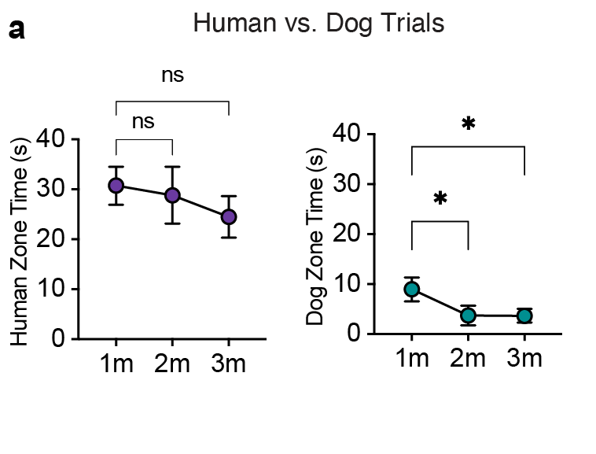
Supplemental Fig. 1. Time-Binned Zone Time
Comparison of engagement time (time (s) in zone) for each stimulus type (i.e. human vs. dog) within each time bin (1st, 2nd, and 3rd minute of trial time) (mean + SEM; Tukey’s post hoc test).

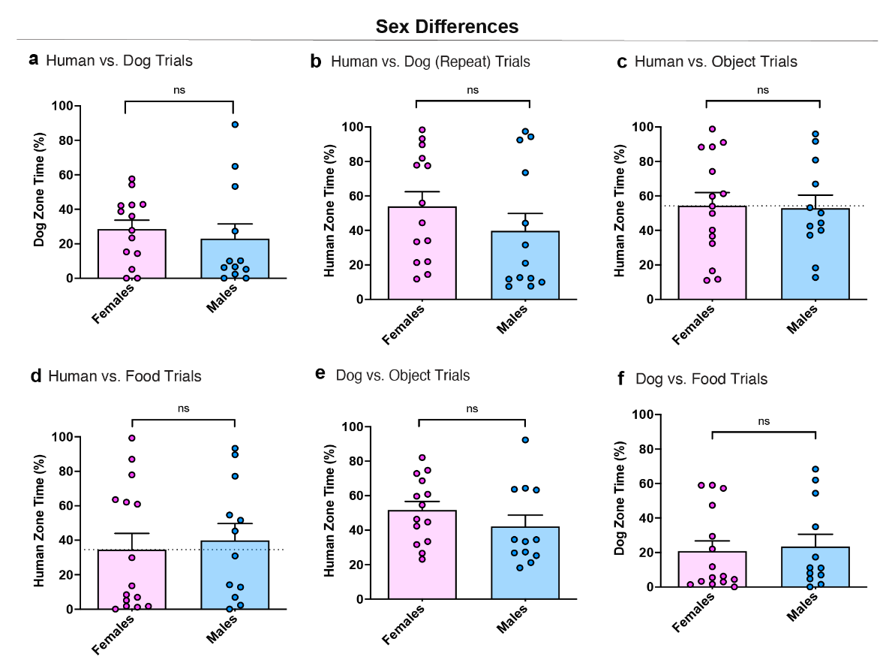
Supplemental Fig. 2. Sex Differences
Comparison of human (a,b,c,d,) or dog (e,f) engagement time (% time in zone) for adult subjects in males versus female subjects (mean + SEM; paired t-test).

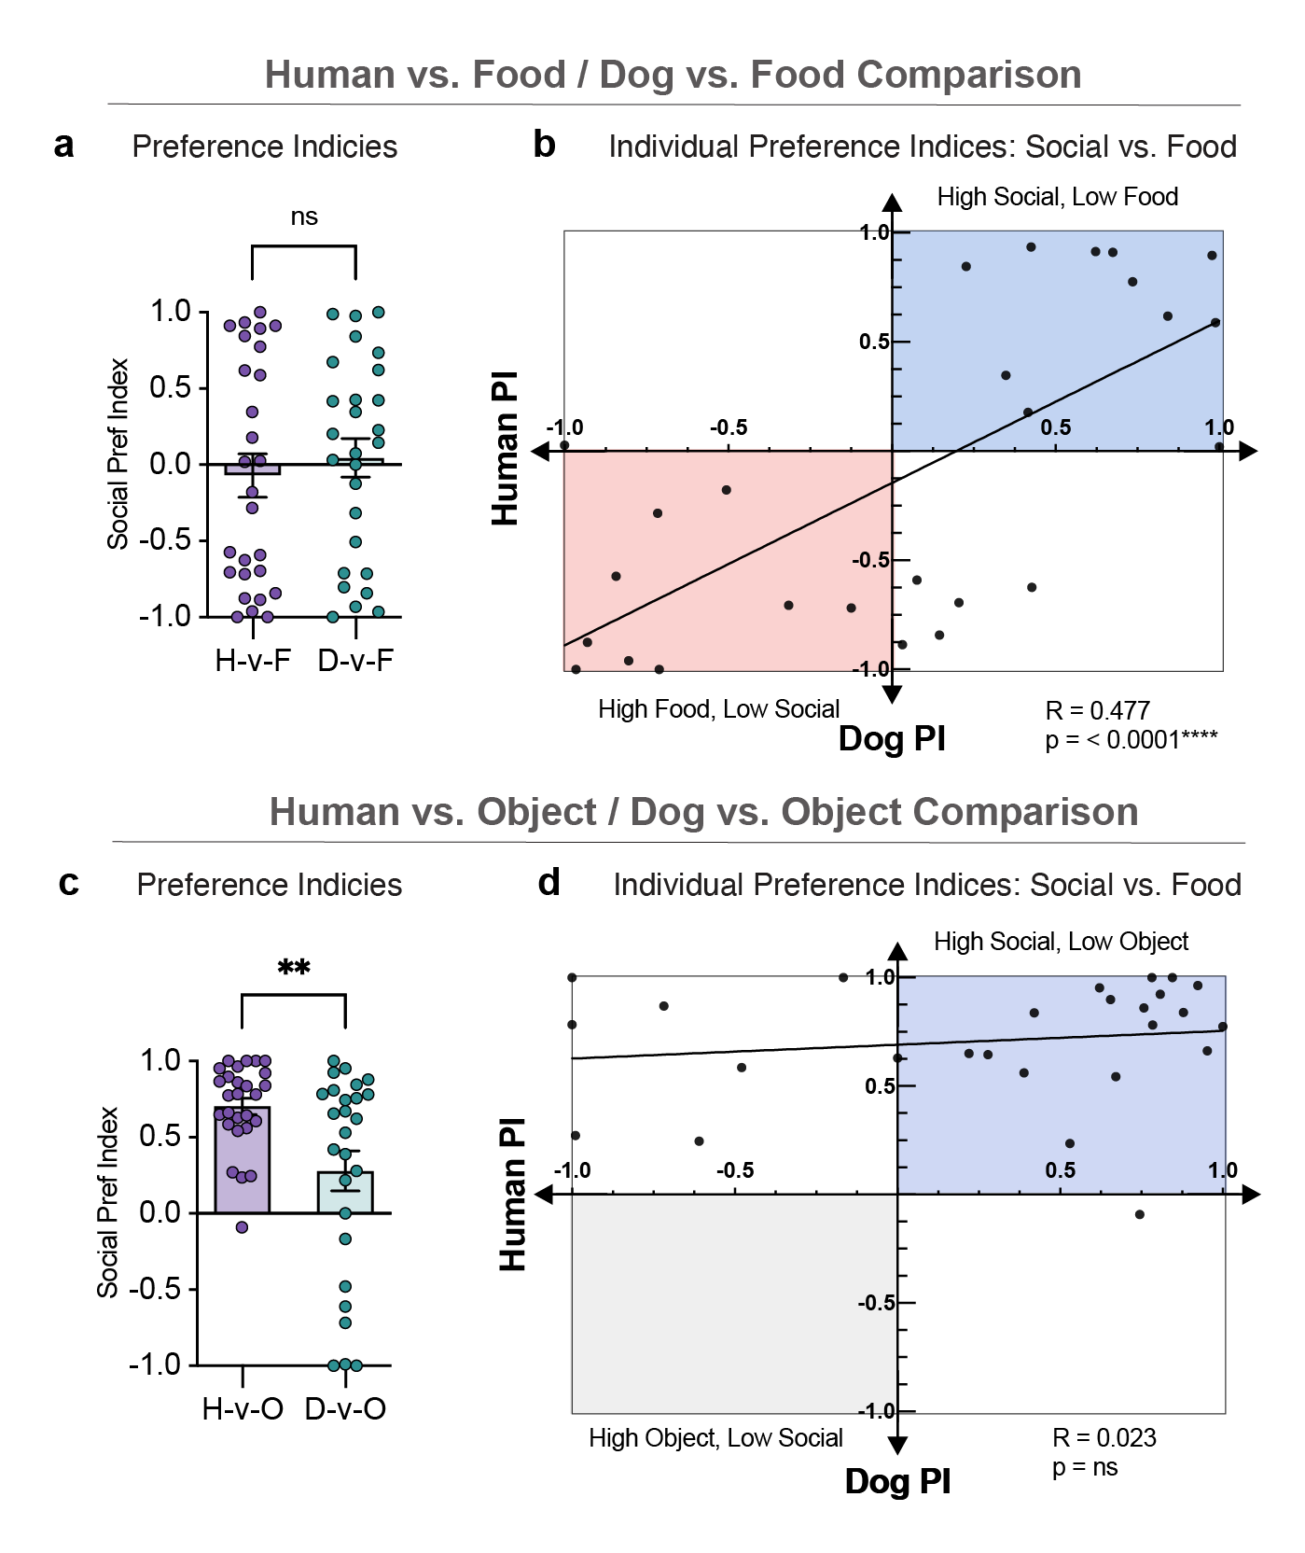
Supplemental Fig. 3. Comparison of Preferences Across Trial Types
Comparison of human preference indices across food trials (a) and object trials (c) (mean + SEM; paired t-test). (h) Relationship between preference indices (PI) in the food trials (b) and object trials (d) (linear regression). ***P < 0.0001

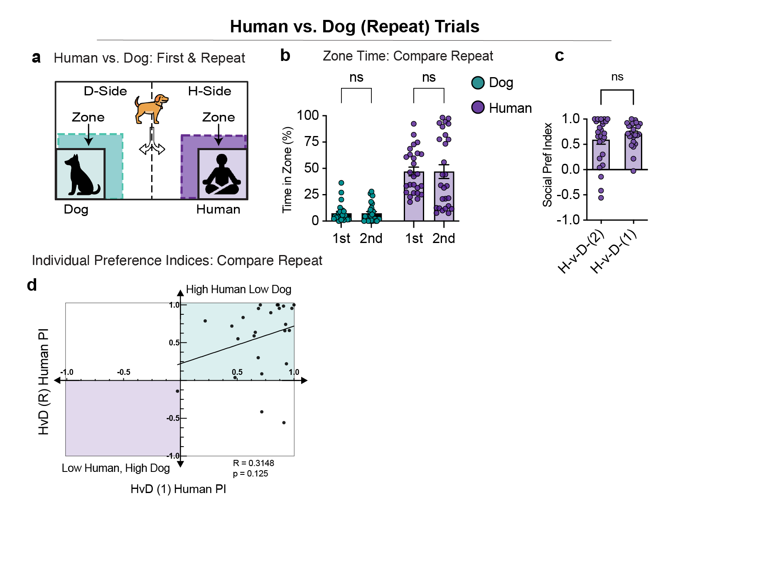
Supplemental Fig. 4. Human vs. Dog (Repeat Trial)
Diagram of experimental setup (a) for human vs. dog repeat (R) trial from an individual dog. b) Comparison of engagement time (% time in zone) for adult subjects in human vs. dog (1st) trials vs repeat (2nd) (mean + SEM; paired t-test). c) Comparison of human preference indices across repeated human vs. dog trials (mean + SEM; paired t-test). (d) Relationship between human preference index in the first and repeated human vs. dog trials (linear regression).

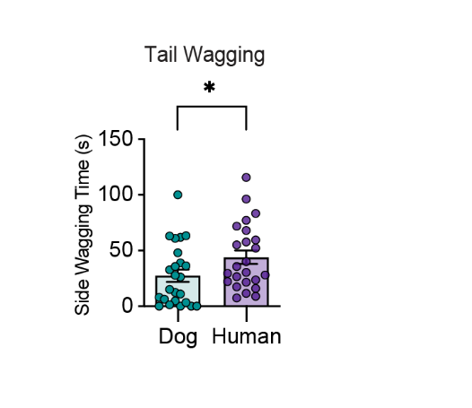

Supplemental Fig. 5. Percent of Side Time Wagging
Comparison of Human vs. Dog (1) trial wag time (% time spent wagging) in human side versus dog side of the arena (mean + SEM; paired t-test).

Supplementary Table 1a. Subject Demographics Summary
Characteristic | n | % | Mean (SD) | Range
Total dogs tested | 32
Sex
Male | 16 | 50
Female | 16 | 50
Age (years) |  |  | 5.45 (3.8) | 1-15
Size
Small/Medium | 9 | 28.1
Large | 23 | 71.9

Supplementary Table 2b. Individual Subject Demographics
ID |  | Breed |  | Sex |  | Age (Years)
1 | Norwegian Elkhound |  | M |  | 9
2 | Norwegian Elkhound |  | F |  | 4
3 | Dachshund |  | F |  | 2
4 | Dachshund |  | F |  | 2
5 | Collie |  | F |  | 1.5
6 | Collie |  | M |  | 9
7 | Labrador |  | M |  | 2
8 | Shepherd Mix |  | F |  | 4
9 | Bassett Hound |  | F |  | 4
10 | Poodle |  | M |  | 4
11 | Havanese |  | F |  | 7
12 | Mini Poodle mix |  | M |  | 15
13 | Pitbull / German Shepherd / Husky |  | M |  | 2
14 | Great Pyrenees / German Shepherd / Rottweiler |  | F |  | 5
15 | Dalmatian |  | M |  | 4
16 | Labradoodle |  | M |  | 12
17 | Labradoodle |  | M |  | 12
18 | Labrador |  | F |  | 5
19 | Australian Shepherd / Mudi mix |  | M |  | 2
20 | English setter |  | F |  | 3
21 | Japanese Chin |  | F |  | 8
22 | Pitbull |  | F |  | 8
23 | German Shepherd / Labrador |  | M |  | 8
24 | Golden Retriever |  | F |  | 9
25 | Dachshund |  | F |  | 3
26 | Labrador |  | M |  | 7
27 | Beagle Rat terrier / Labrador mix |  | F |  | 12
28 | Great Pyrenees / Maremma |  | F |  | 2
29 | Beagle/Coonhound mix |  | M |  | 2
30 | Beagle/Coonhound mix |  | M |  | 2
31 | Pitbull |  | M |  | 1
32 | German Shepherd / Great Pyrenees |  | M |  | 4

Supplementary Video 1.
Video of Noldus Ethovision automated tracking for an individual trial.

