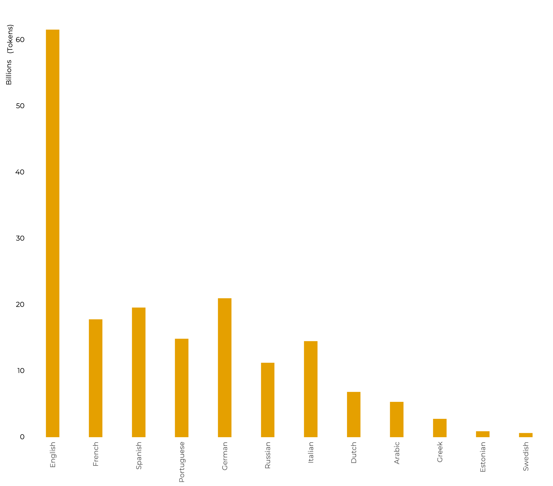
Figure A: Corpus size on SketchEngine (in billions of tokens)

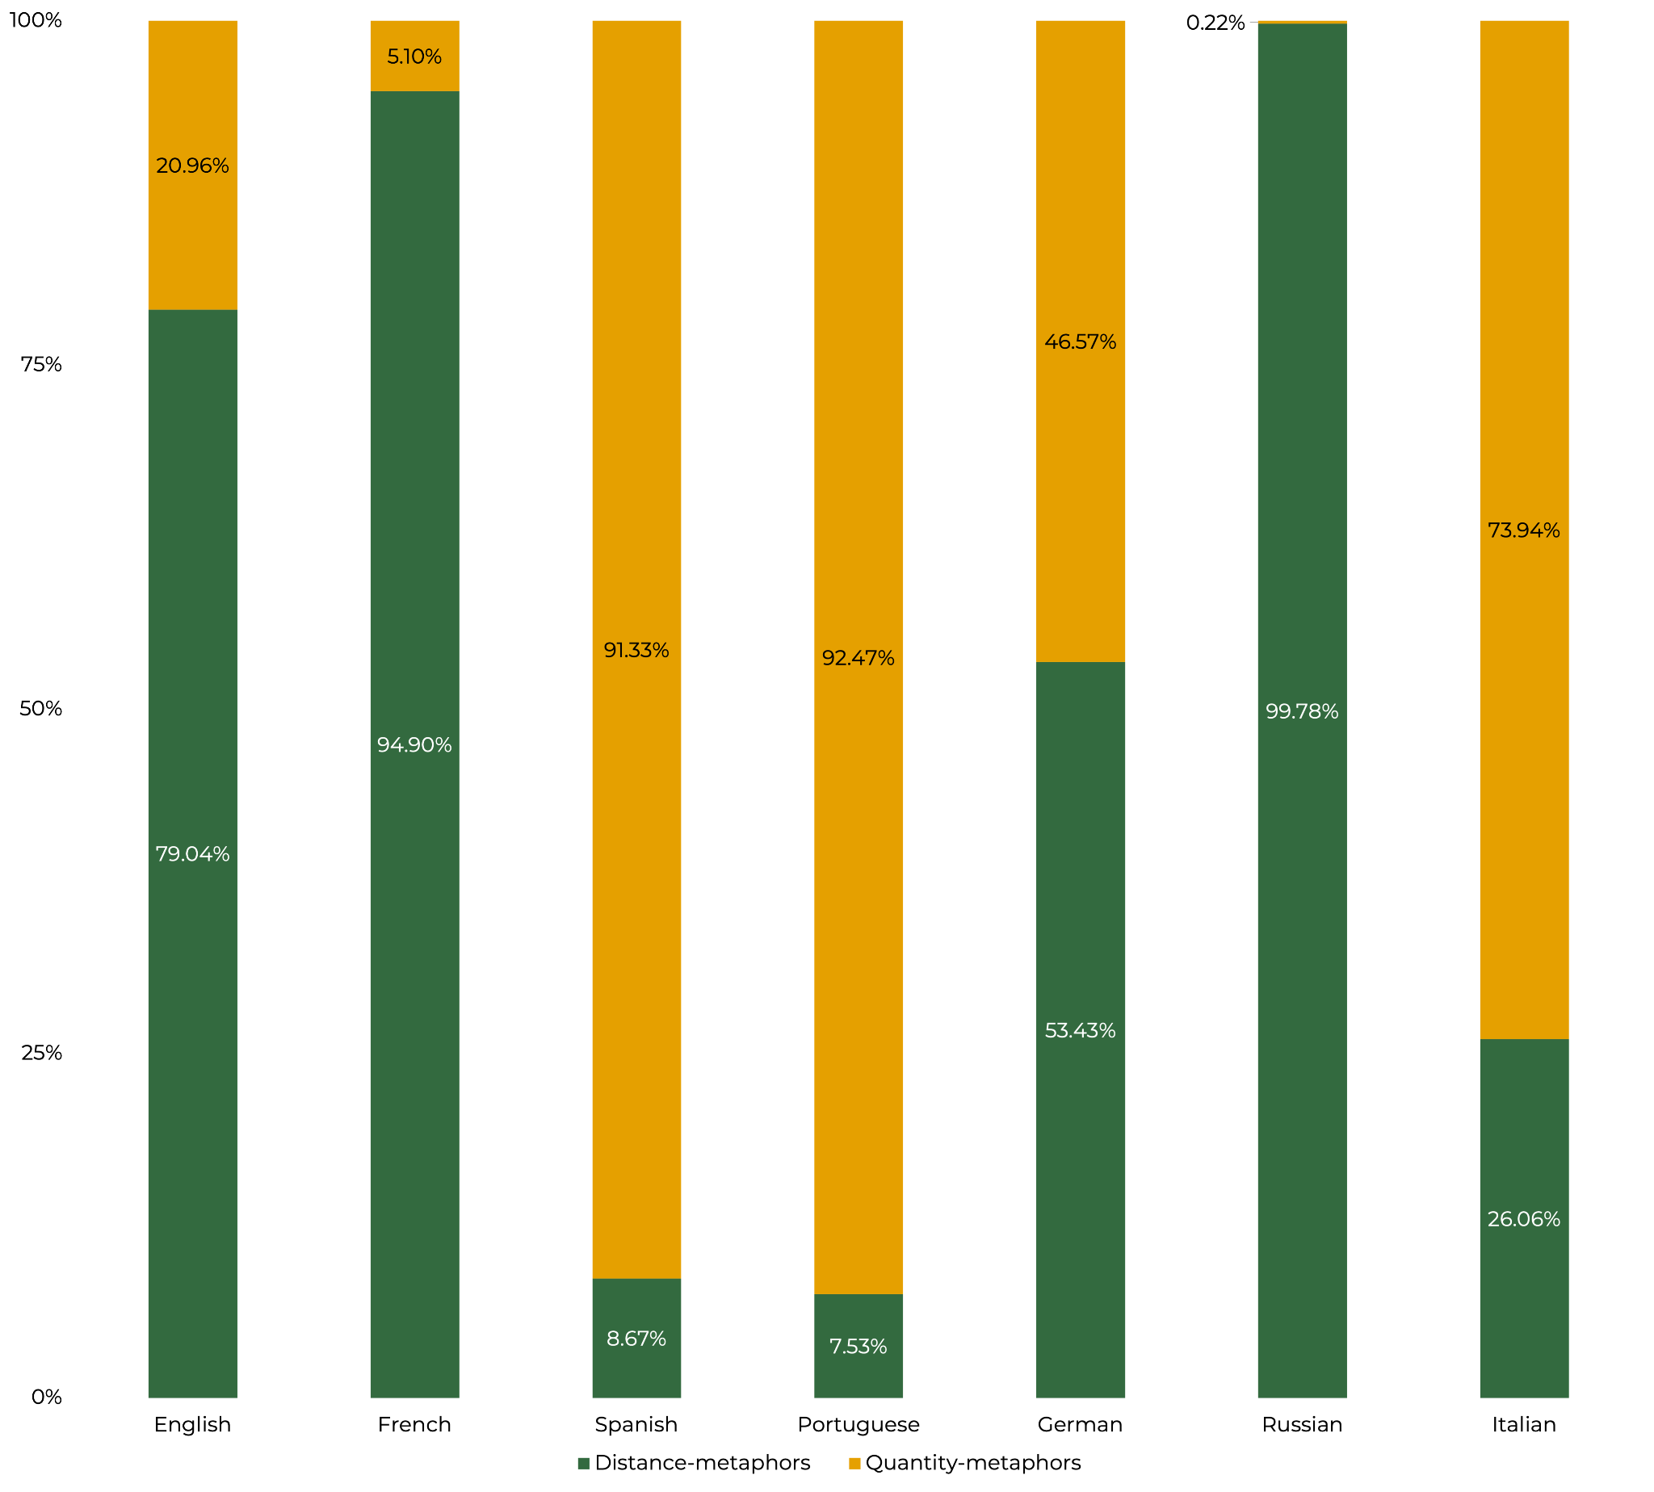

Figure B: Corpus Analysis on SketchEngine. Relative frequencies of metaphor usage across languages.

