Supporting information for

Modular RNA-based PROTACs for selective degradation of multidomain RNA-binding proteins
Florian Malard^{1,2,+,*}, Léa Bouton^{1,2,+}, Giulia Chiarazzo^{1,2,+}, Corinne Burre², Brune Vialet¹, Samuel Amintas^{3,4} and Sébastien Campagne^{1,2,*}
¹Univ. Bordeaux, CNRS, INSERM, ARNA, UMR 5320, U1212, F-33000 Bordeaux, France
²Univ. Bordeaux, CNRS, INSERM, IECB, US1, UAR 3033, F-33600 Pessac, France
³Univ. Bordeaux, INSERM, BRIC, UMR1312, F-33000 Bordeaux, France
⁴Tumor Biology Department and Biobank, Bordeaux University Hospital, F-33000 Bordeaux, France
*Correspondence should be addressed to florian.malard@inserm.fr or sebastien.campagne@inserm.fr
⁺These authors contributed equally.
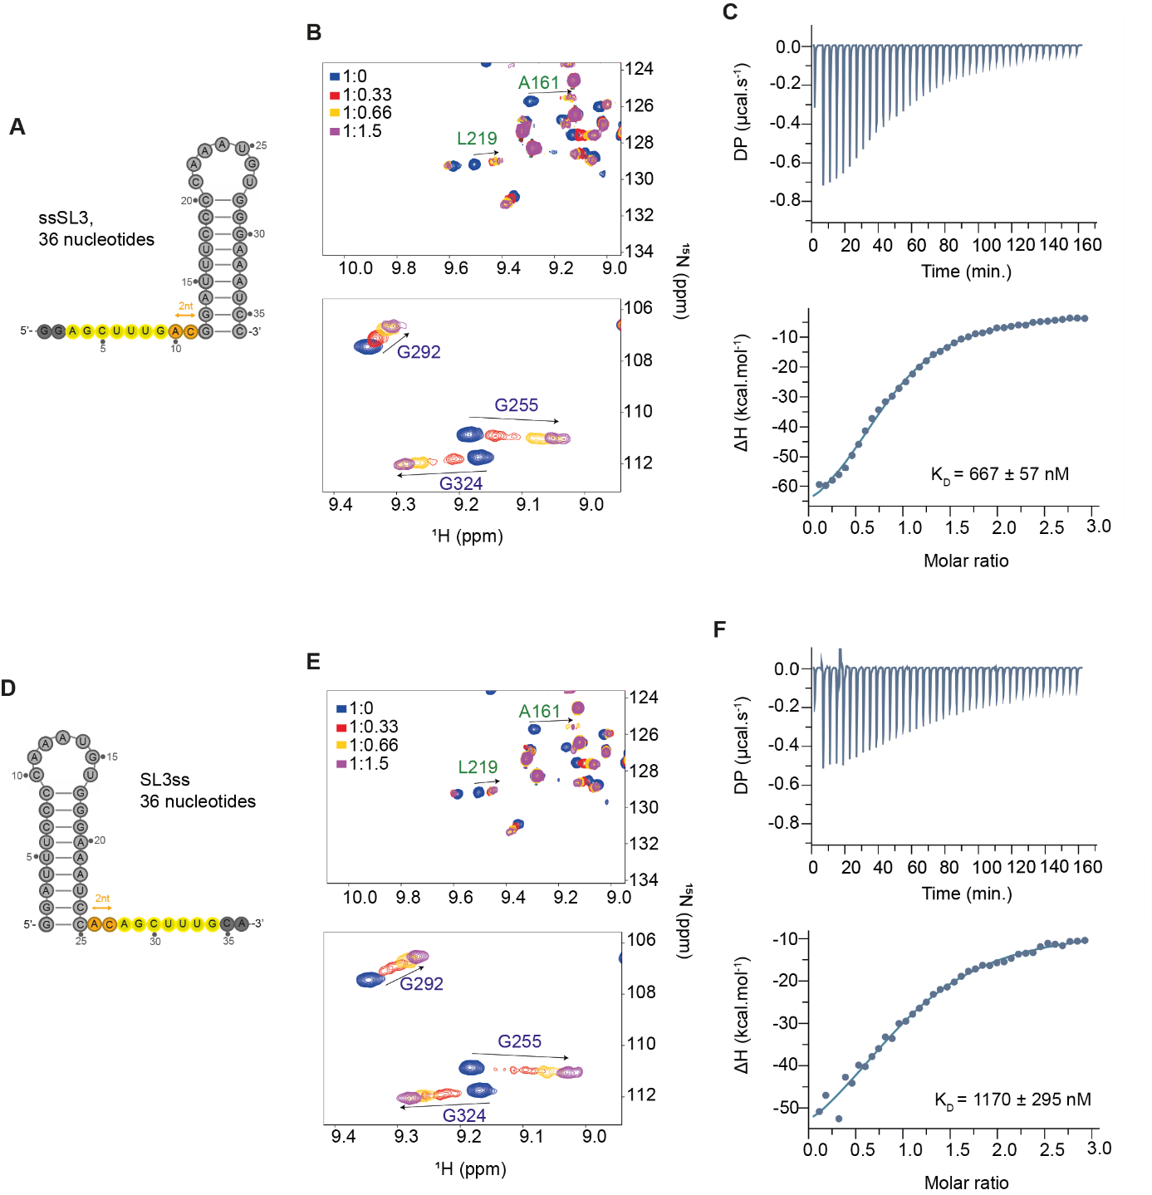
Figure S1. The RNA1 series, influence of the position of single stranded motif with respect to the stem loop. A. Schematic representation of the ssSL3 RNA in which the single stranded motif is placed upstream of SL3. B. Portions of the overlay of 2D ¹H-¹⁵N HSQC spectra of RBM39 RRM12 recorded in presence of increasing amount of ssSL3. The spectra are colored according to the protein:RNA ratios indicated on the spectra. C. ITC titration of RBM39 RRM12 by ssSL3. The determined dissociation constant is indicated on the panel. D. Schematic representation of the SL3ss RNA in which the single stranded motif is placed downstream of SL3. E. Portions of the overlay of 2D ¹H-¹⁵N HSQC spectra of RBM39 RRM12 recorded in presence of increasing amount of SL3ss. The spectra are colored according to the protein:RNA ratios indicated on the spectra. F. ITC titration of RBM39 RRM12 by SL3ss. The determined dissociation constant is indicated on the panel.

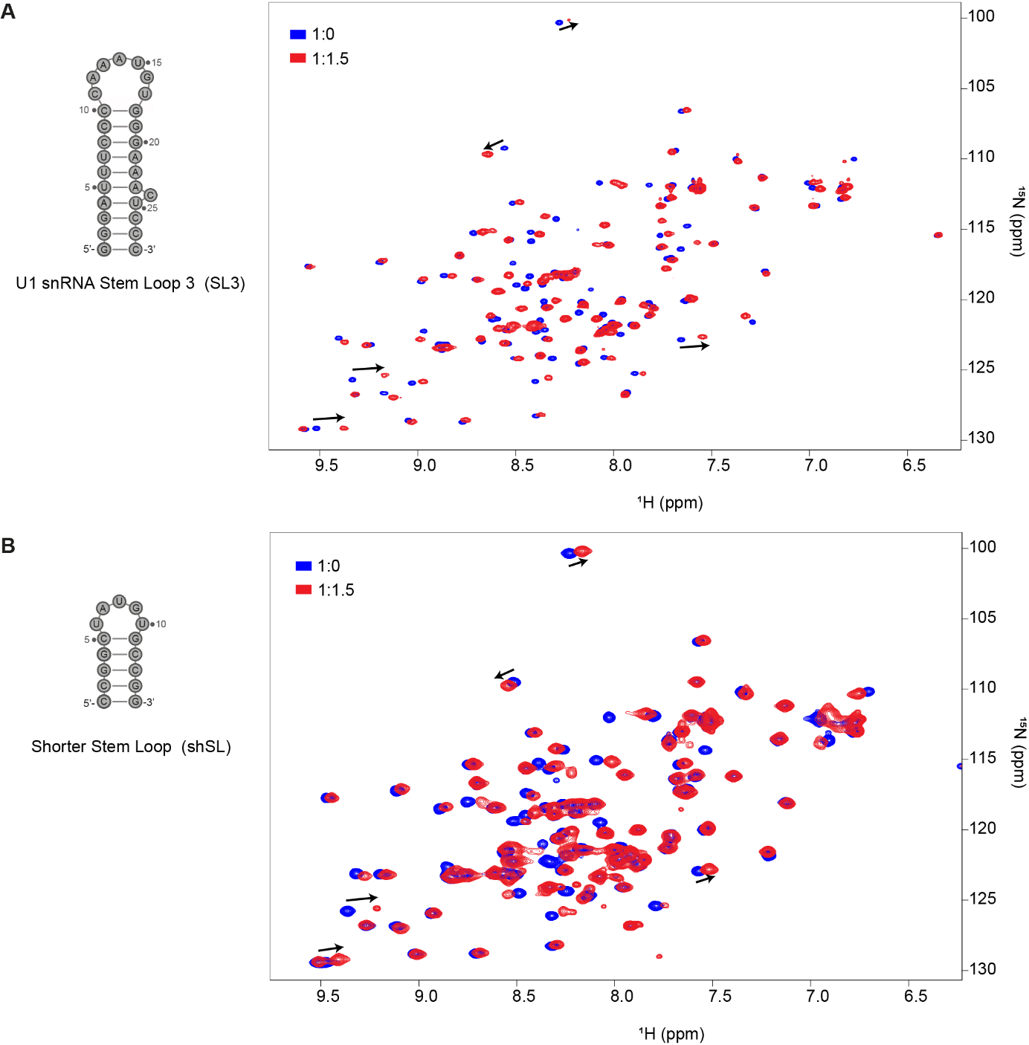
Figure S2. RBM39 RRM1 interacts with U1 snRNA SL3 and with the shorter stem loop shSL. A. Schematic representation of U1 snRNA SL3 and overlay of the 2D ¹H-¹⁵N HSQC spectra of RBM39 RRM1 before (blue) and after the addition of 1,5 equivalents of SL3 (red). B. Schematic representation of the shorter stem loop shSL and overlay of the 2D ¹H-¹⁵N HSQC spectra of RBM39 RRM1 before (blue) and after the addition of 1,5 equivalents of shSL (red). Spectra are colored according to the protein:RNA ratios.

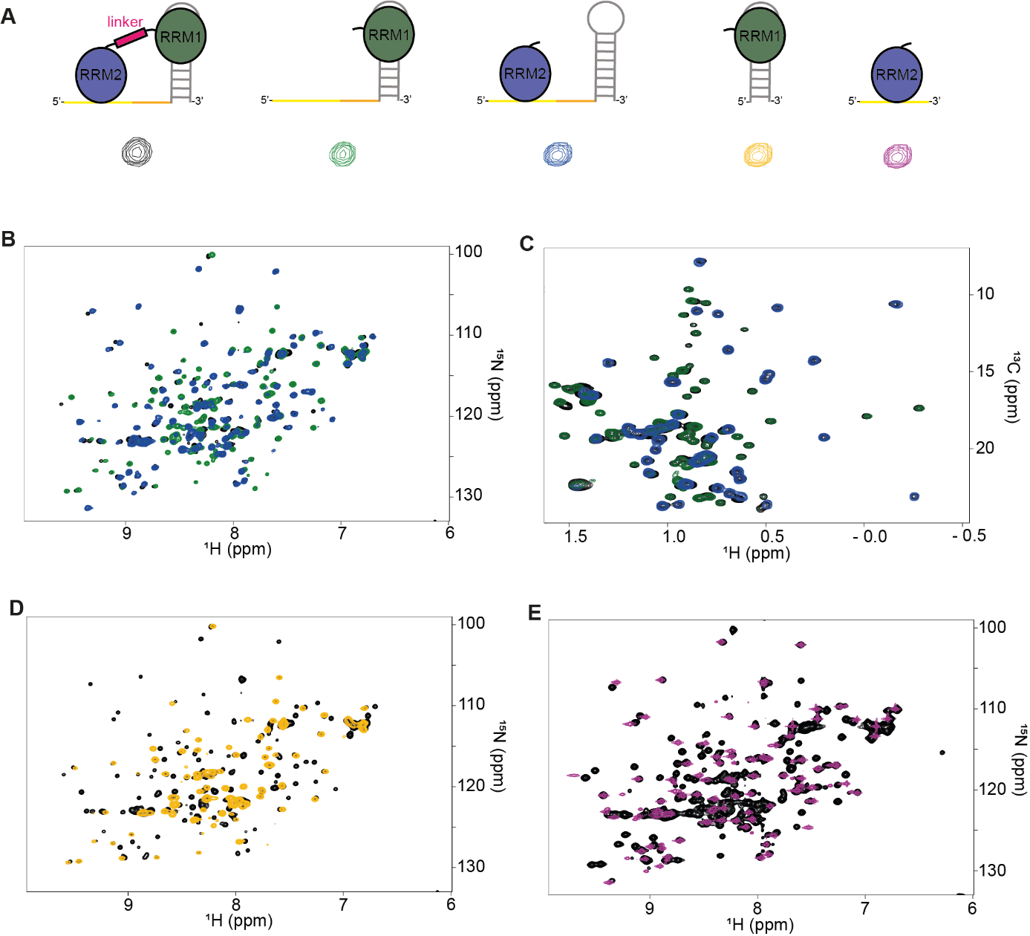
Figure S3. NMR spectra comparison. A. Schematic representations of the different RBM39:RNA complexes, the color code is indicated between each complex. B. Overlay of the 2D ¹H-¹⁵N HSQC spectra of RBM39 RRM12 bound to RNA2_4nt (black), RBM39 RRM1 bound to RNA2-4nt (green) and RBM39 RRM2 bound to RNA2-4nt (blue). C. Overlay of the 2D ¹H-¹³C HSQC spectra (methyl region) of RBM39 RRM12 bound to RNA2_4nt (black), RBM39 RRM1 bound to RNA2-4nt (green) and RBM39 RRM2 bound to RNA2-4nt (blue). D. Overlay of the 2D ¹H-¹⁵N HSQC spectra of RBM39 RRM12 bound to RNA2_4nt (black) and of RBM39 RRM1 bound to shSL3 (orange). E. Overlay of the 2D ¹H-¹⁵N HSQC spectra of RBM39 RRM12 bound to RNA2_4nt (black) and of RBM39 RRM2 bound to 5’-AGCUUUG-3’ (violet).

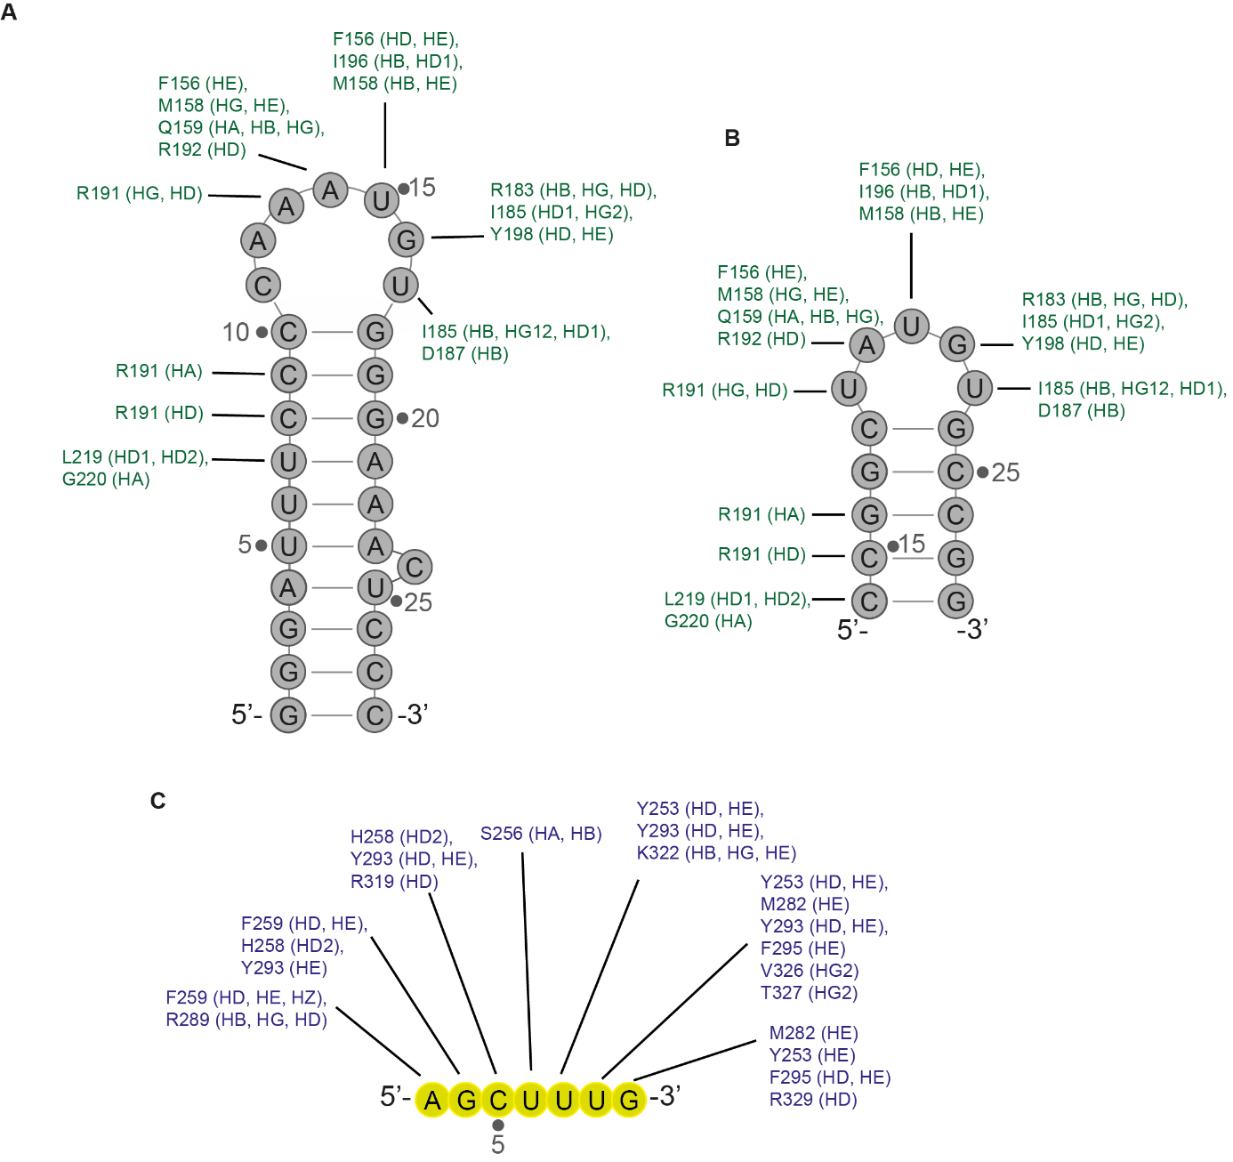
Figure S4. Intermolecular restraints used to constraint the protein:RNA interfaces. A. Schematic illustration of the intermolecular NOE restraints that were used to compute the solution structure of RBM39 RRM1 bound to U1 snRNA SL3 (PDB ID 7ZAP). B. Schematic representation of the intermolecular restraints used to constraint the position of RBM39 RRM1 on the shorter stem loop. These restraints were not observed on the NMR data due to line broadening and deduced from the experimental restraints used to compute the solution structure of RBM39 RRM1 bound to U1 snRNA SL3 (PDB ID 7ZAP). C. Schematic representation of the intermolecular NOE restraints used to compute the solution structure of RBM39 RRM2 bound to AGCUUUG (PDB ID 7Q33). Similar restraints were used to constraint the RBM39 RRM2 – RNA2-4nt interface.

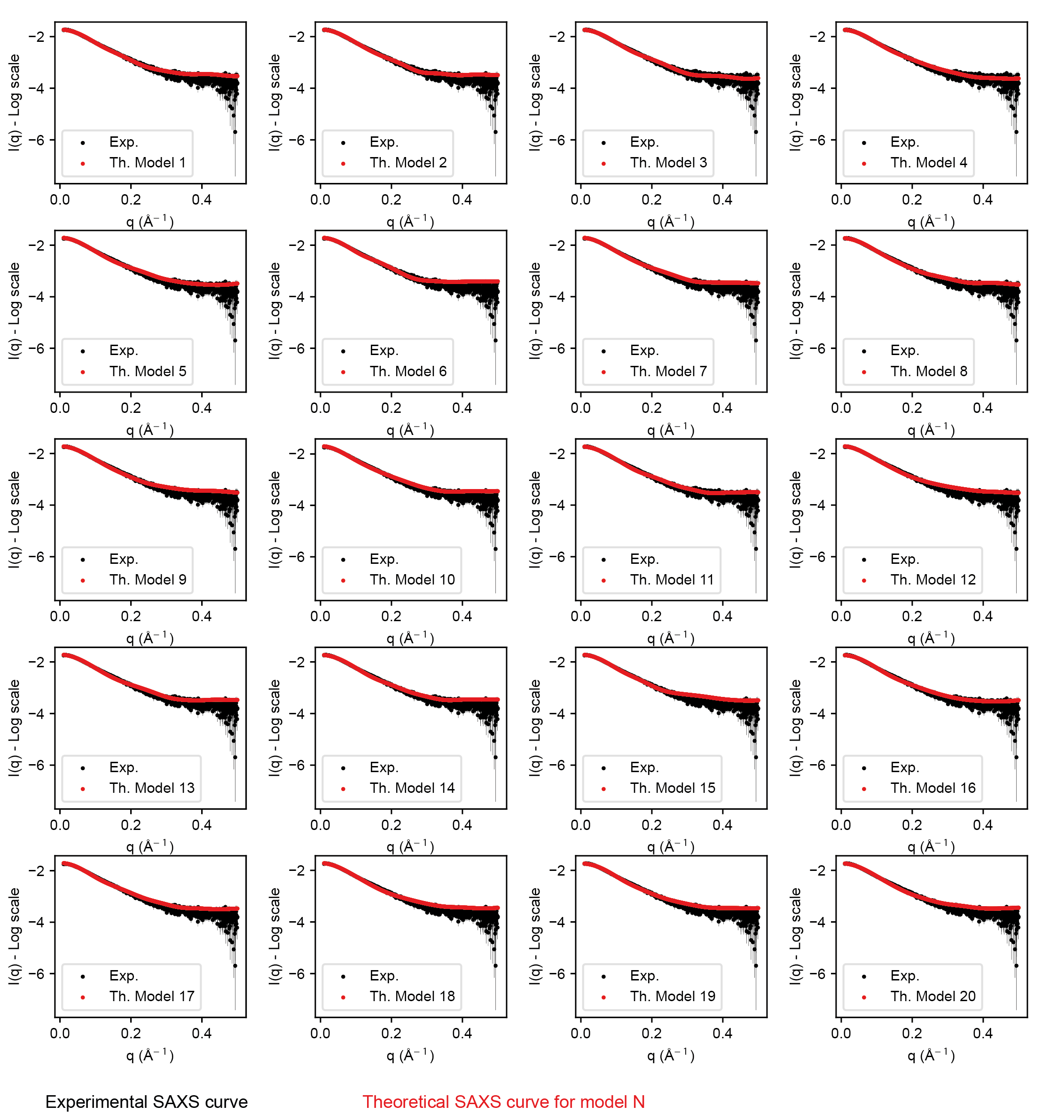
Figure S5. Experimental versus back calculated SAXS curves. Plots showing the measured and back calculated Small-angle X-ray scattering (SAXS) intensity I (q) as a function of the wave vector q for each model of the structural ensemble.

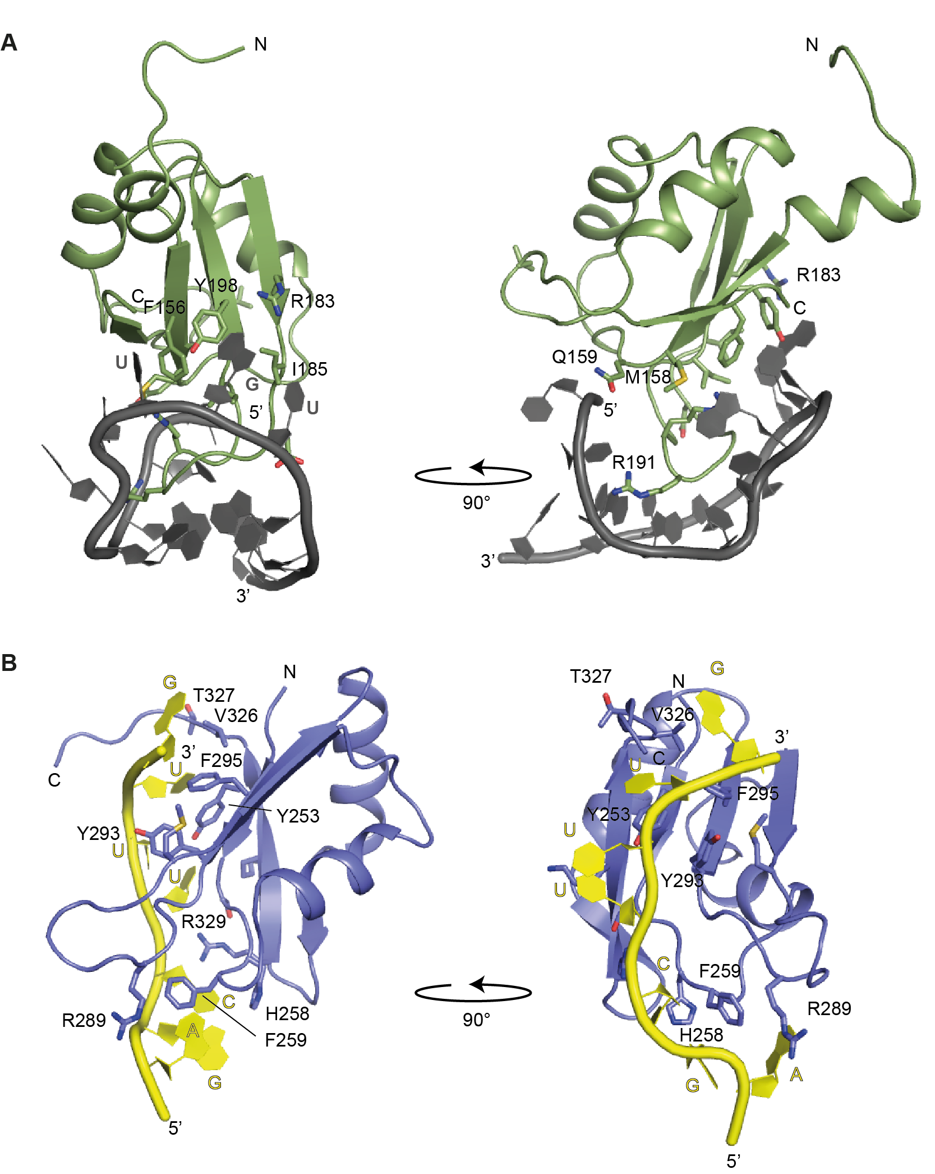
Figure S6. Details of the protein-RNA interfaces observed in the structural model for RBM39 RRM12 bound to RNA2-4nt. A. Cartoon representation of the RBM39 RRM1 – shSL protein-RNA interface. B. Cartoon representation of the RBM39 RRM2 – AGCUUUG protein-RNA interface.

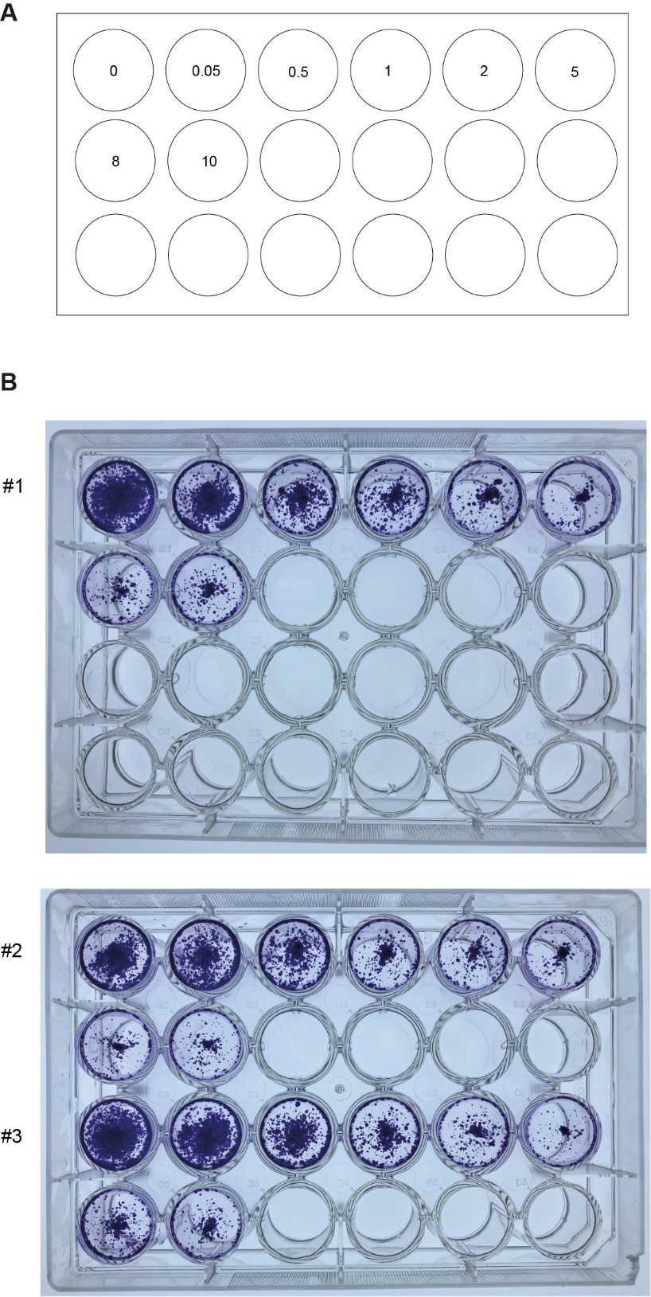
Figure S7. Colony formation assays to determine the proliferation capacity of HCT116 colorectal cancer cells upon transfection of RNA2-4nt aptamer. A. Schematic representation of the experiments performed in triplicates in 24 well plates. The concentrations of the RNA2-4nt aptamer are given in μM. B. Pictures of the plates after staining with crystal violet.

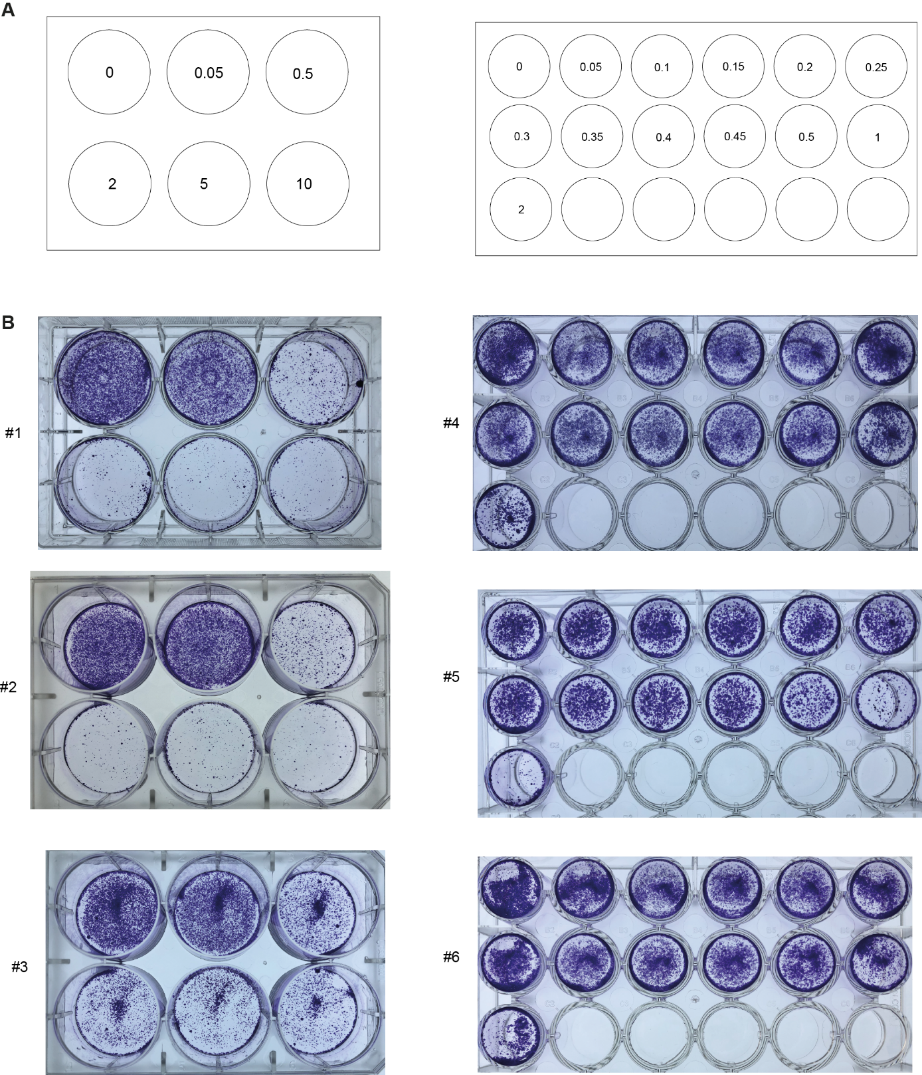

Figure S8. Colony formation assays to determine the proliferation capacity of HCT116 colorectal cancer cells upon transfection of RNA2-4nt PROTAC. A. Schematic representation of the experiments performed in triplicates in 6 or 24 well plates. The concentrations of the RNA PROTAC are given in μM. B. Pictures of the plates after staining with crystal violet.

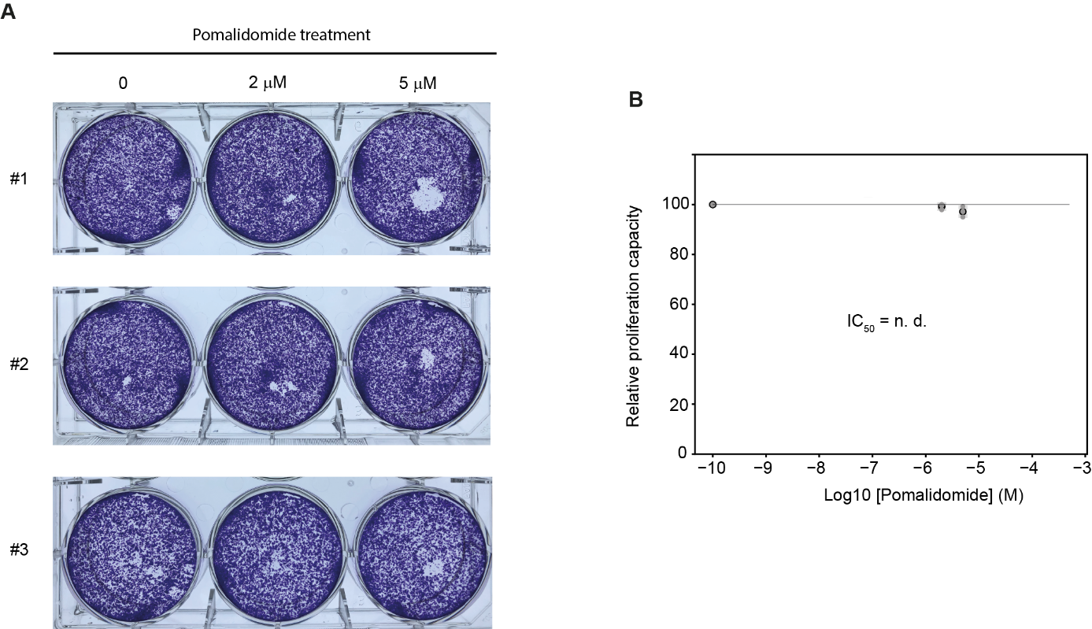

Figure S9. Effect of pomalidomide on the proliferation capacity of HCT116 cells. A. Pictures of the plates after crystal violet staining of the cells which grow in presence of pomalidomide. B. Plot showing the relative proliferation capacity of HCT116 as a function of the logarithm of pomalidomide concentration.
Supplementary table 1. Structural statistics of the RBM39 RRM12/RNA2-4nt models.
 | RBM39_RRM1-2 | RNA2-4nt
NMR distance and dihedral constraints
Distance restrains
Total NOE | 4519 | 199
Intra-residue | 883 | 118
Inter-residue | 3488 | 81
Sequential (|i – j| = 1) | 1086 | 54
Nonsequential (|i – j| > 1 ) | 2402 | 27
Hydrogen bonds | 100 | 21
Protein–nucleic acid intermolecular | 165
Total dihedral angle restraints
Protein
Φ | 74
Ψ | 74
Nucleic acid
Base pair
Sugar pucker |  | 12
Backbone |  | 62
Model statistics
Violations (mean and s.d.)
Distance constraints (Å) > 0.4 Å | 9.0 ± 3.5
Dihedral angle constraints (º) > 5° | 2.8 ± 1.8
Max. dihedral angle violation (º) | 113.87 ± 31.87
Max. distance constraint violation (Å) | 1.02 ± 0.45
Deviations from idealized geometry
Bond lengths (Å) | 0.0 ± 0.0
Bond angles (º) | 0.0 ± 0.0
Agreement with SAXS data (Crysol fit)
χ² (Chi²) | 4.82 ± 0.73

Supplementary table 2 – Oligonucleotides used in this study.
 | Sequences
DNA templates for in vitro transcription
ssSL3-fw | ATTCTAATACGACTCACTATAGGAGCTTTGACGGATTTCCCCAAATGTGGGAAATCC
ssSL3-bw | GGATTTCCCACATTTGGGGAAATCCGTCAAAGCTCCTATAGTGAGTCGTATTAGAAT
SL3-ss-fw | ATTCTAATACGACTCACTATAGGATTTCCCCAAATGTGGGAAATCCACAGCTTTGCA
SL3-ss-bw | TGCAAAGCTGTGGATTTCCCACATTTGGGGAAATCCTATAGTGAGTCGTATTAGAAT
SL3-fw | GGCCAGTGAATTCTAATACGACTCACTATAGGGATTTCCCCAAATGTGGGAAACTCCC
SL3-bw | GGGAGTTTCCCACATTTGGGGAAATCCCTATAGTGAGTCGTATTAGAATTCACTGGCC
RNA
ssSL3 | GGAGCUUUGACGGAUUUCCCCAAAUGUGGGAAAUCC
SL3ss | GGAUUUCCCCAAAUGUGGGAAAUCCACAGCUUUGCA
SL3 | GGGAUUUCCCCAAAUGUGGGAAACUCCC
shSL3 | CCGGCUAUGUGCCGG
RNA2-0nt | AGCUUUGCCGGCUAUGUGCCGG
RNA2-2nt | AGCUUUGAACCGGCUAUGUGCCGG
RNA2-4nt | AGCUUUGAACCGGCUAUGUGCCGG
siRNA
siRNA-ctrl | AGGUAGUGUAAUCGCCUUGdTdT
siRNA-CDS2 | GAGAAUUCAUCUUGAGUUAdTdT
siRNA-3’UTR | GGAAAGAGAUGCAAGGACAdTdT
qPCR primers
RBM39 fw | GCAGCAATCTCTTCCCGAAC
RBM39 rev | CTCATCCTTCTTGTAAGGAGC
RBM39 rev poison exon | TCGTTAGGCAAGTCTTCTTGTA

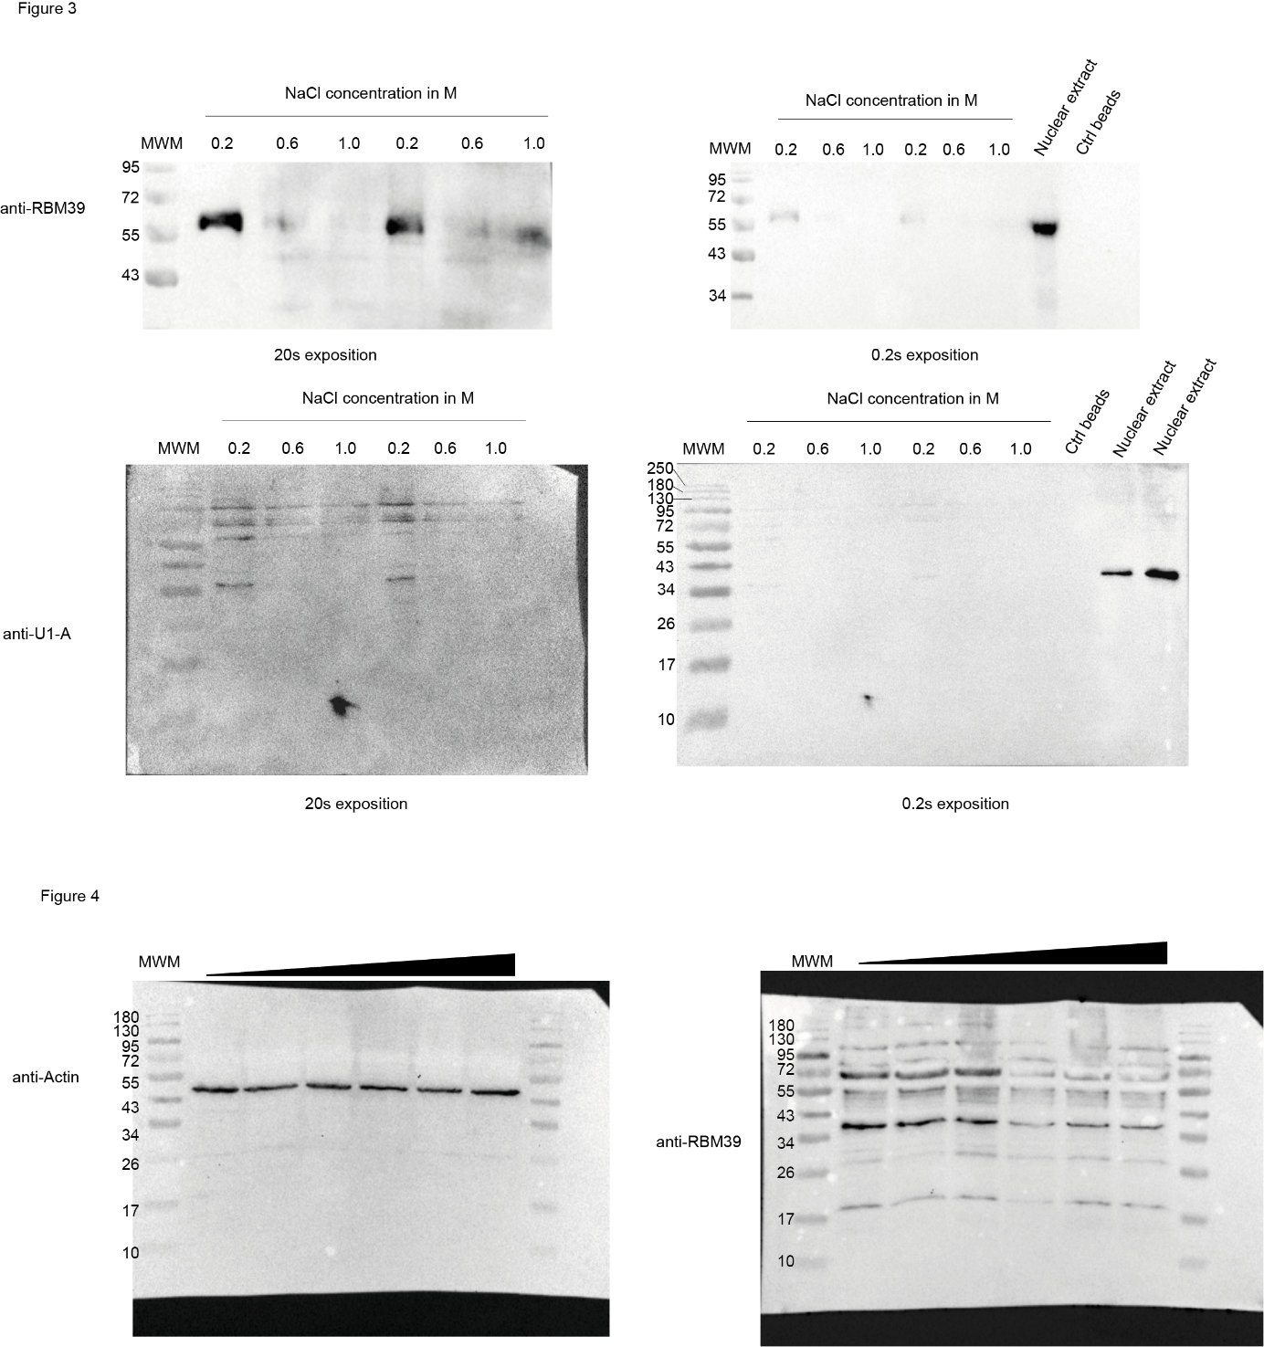

Uncropped blots presented in main figures.

