DOI:
Article type:

Deep Learning-based Noise Robust Flexible Piezoelectric Acoustic Sensors for Speech Processing

Young Hoon Jung¹, Trung Xuan Pham², Dias Issa², Hee Seung Wang¹, Jae Hee Lee¹, Mingi Chung¹, Bo-Yeon Lee³, Gwangsu Kim², Chang D. Yoo^{2*} and Keon Jae Lee^{1*}

¹Y. H. Jung, ^{[+]} H. S. Wang, J. H. Lee, M. Chung, Prof. K. J. Lee
Department of Materials Science and Engineering, Korea Advanced Institute of Science and Technology (KAIST)
291 Daehak-ro, Yuseong-gu, Daejeon
34141, Republic of Korea
E-mail: keonlee@kaist.ac.kr

²T. X. Pham, ^{[+]} D. Issa, Prof. G. Kim, Prof. C. D. Yoo
Department of Electrical Engineering, Korea Advanced Institute of Science and Technology (KAIST)
291 Daehak-ro, Yuseong-gu, Daejeon
34141, Republic of Korea
E-mail: cd_yoo@kaist.ac.kr

³Dr. B.-Y Lee
Department of Nature-Inspired System and Application, Korea Institute of Machinery and Materials (KIMM)
156 Gajeongbuk-Ro, Yuseong-gu, Daejeon
34103, Republic of Korea

^{[+]} These authors contributed equally to this work.

Keywords: Flexible piezoelectric, Acoustic sensor, Deep learning algorithm, Noise-robust, Speaker Recognition, Speech Enhancement

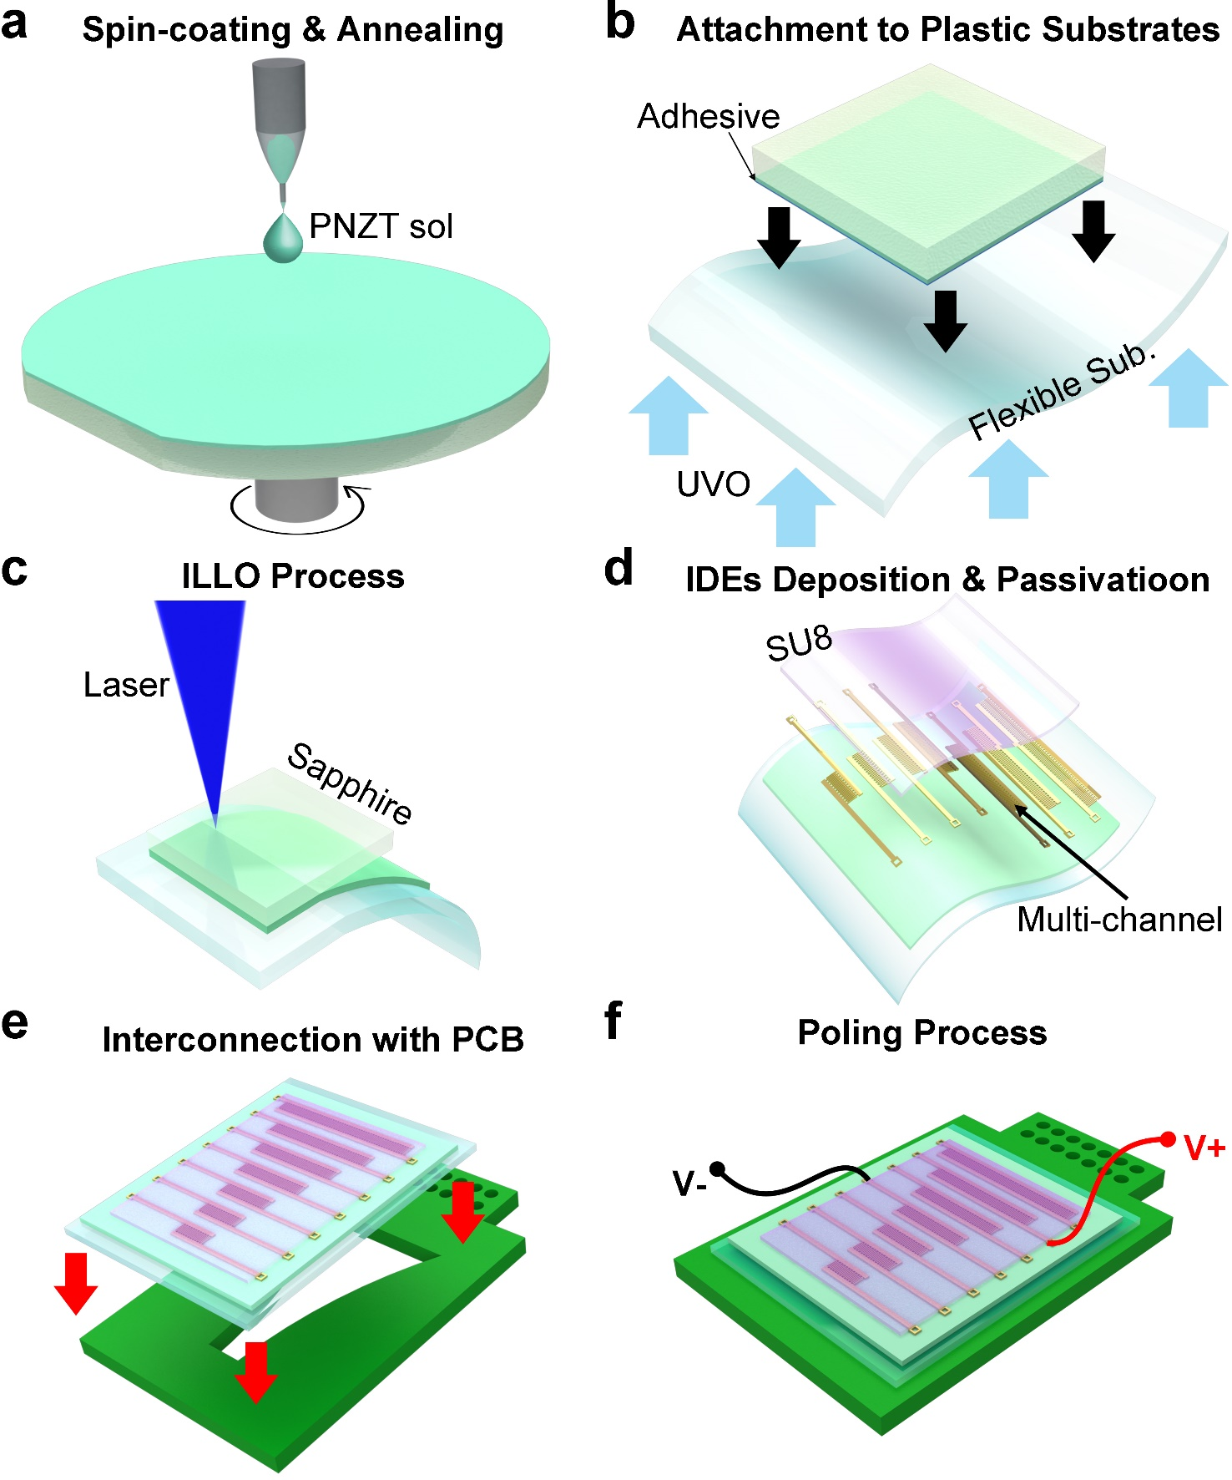
Supplementary Figure 1. Fabrication process of NPAS. a Spin coating of PNZT and crystallization. b Attachment of PNZT on a PET substrate. c Piezoelectric membrane transfer via ILLO method d Photolithography for IDEs and SU8. e Interconnection with PCB. f Alignment of piezoelectric dipoles by poling process.

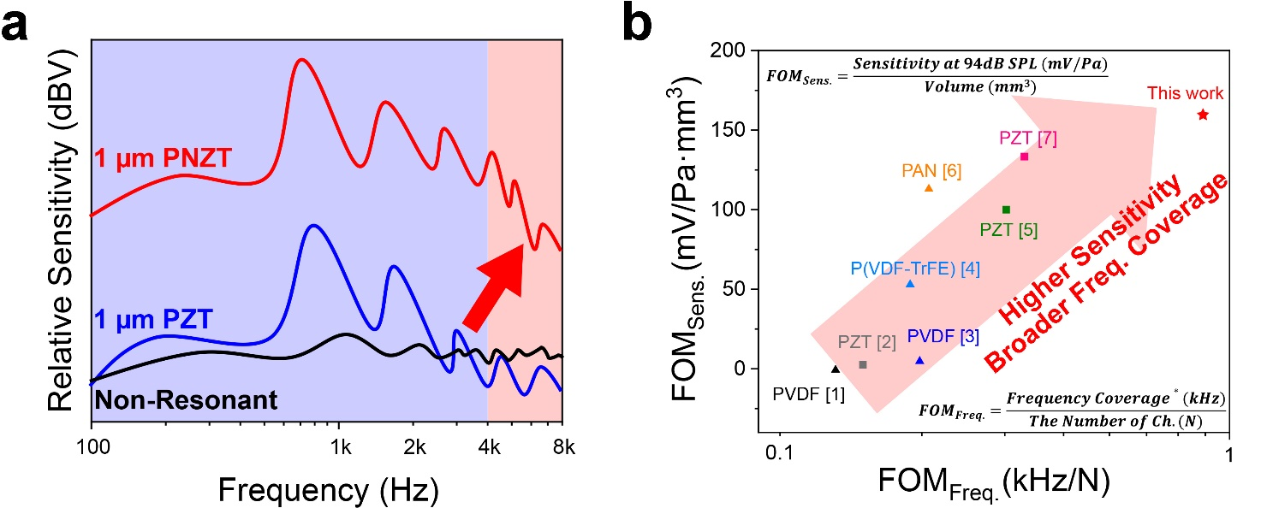
Supplementary Figure 2. Comparison of sensor properties between PNZT and other piezoelectric films. a Frequency response of 1µm thick PNZT and PZT membrane. b Comparison of sensitivity and frequency coverage figure of merits (FOMs) between the NPAS and previous resonant piezoelectric acoustic sensors ^{1–7}. Sensitivity FOM was defined as sensitivity per volume because the piezoelectric sensitivity is proportional to active area and thickness of piezoelectric film ^{8–10}. (Sensitivity$= V/P= V/(P^{0} ×{10}^{L_{p}/20})$, where $V$ is the peak voltage at$L_{p}$, $P^{0}$ is the reference sound pressure of 0.00002 Pa, and $L_{p}$ is the SPL in dB unit.) ³. Frequency coverage FOM was expressed as frequency coverage per the number of channels since the resonance bandwidth of each channel is important in the resonant acoustic sensors.

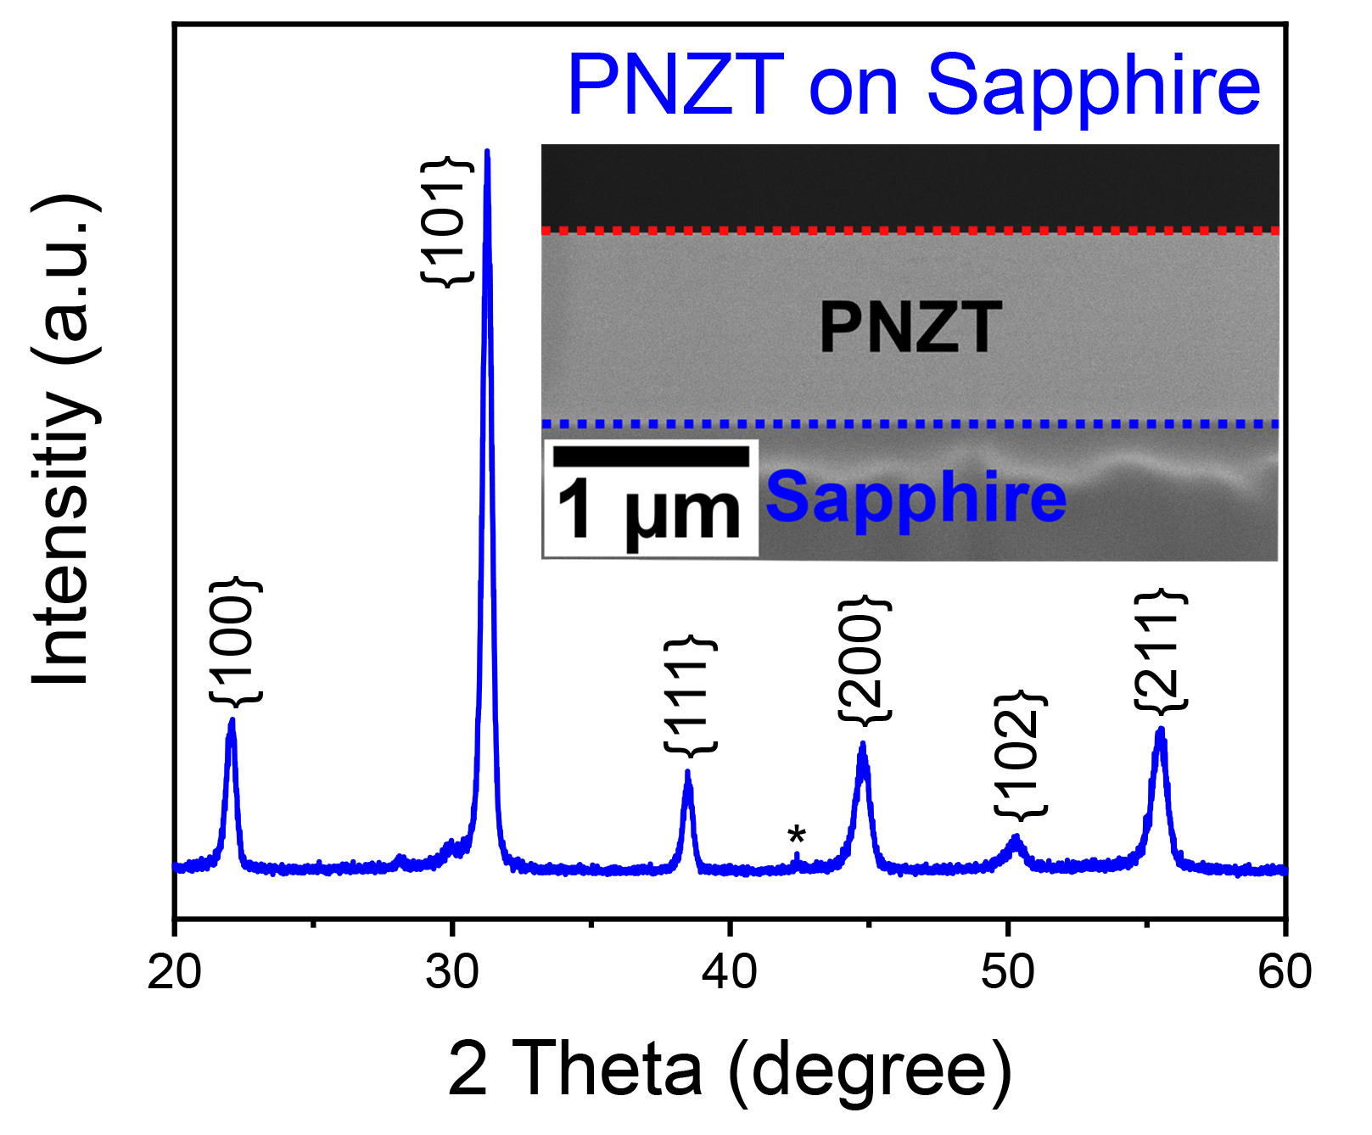
Supplementary Figure 3. XRD analysis results of PNZT membrane on sapphire substrates. θ-2θ scan mode XRD of PNZT thin film on a rigid mother substrate. Inset shows the cross-sectional SEM image of PNZT membrane on sapphire substrates.

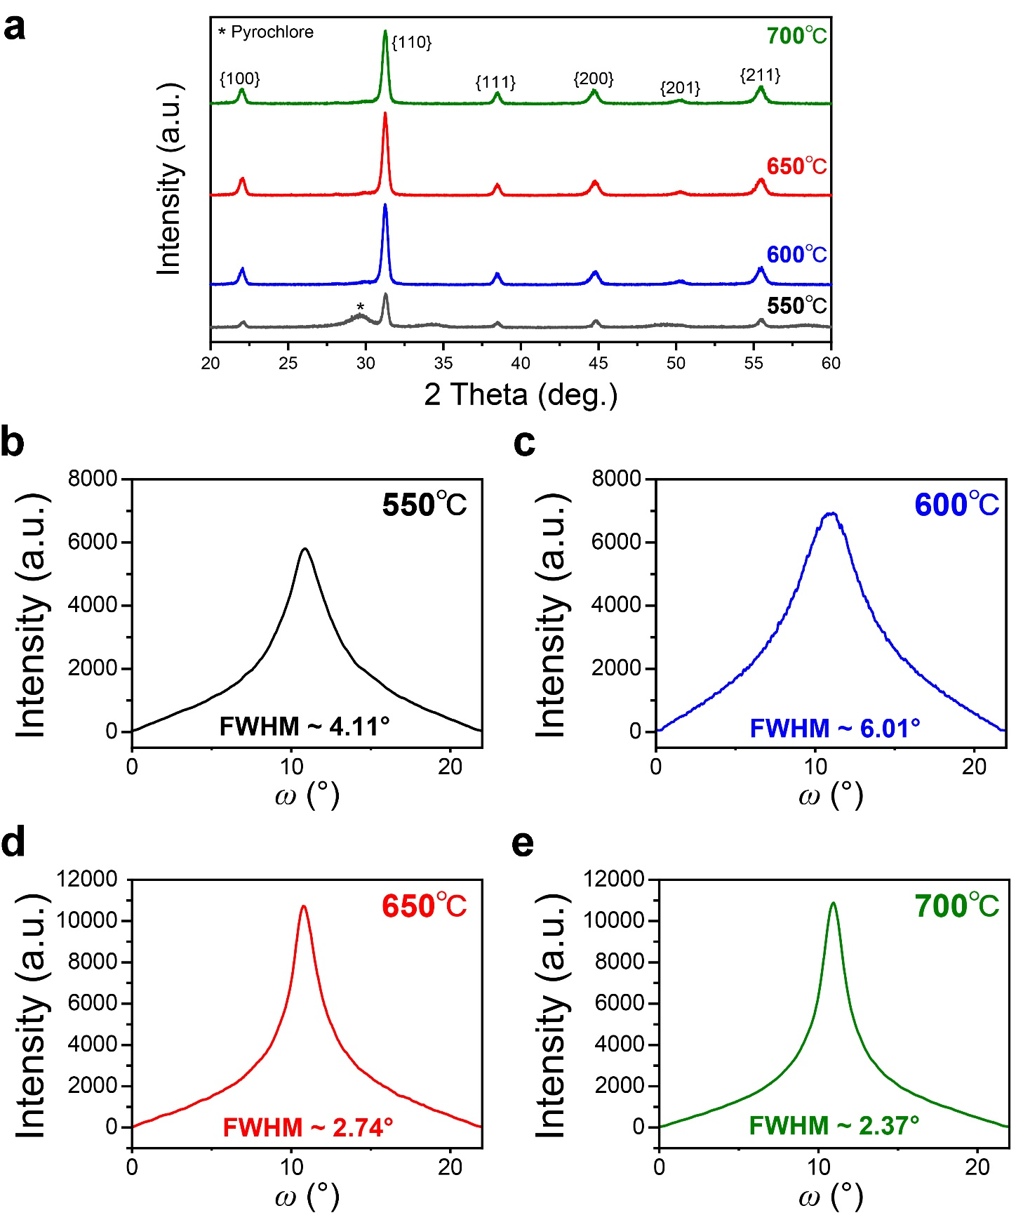
Supplementary Figure 4. XRD patterns as a function of heat-treatment temperature. a θ-2θ mode XRD of PNZT film as a function of annealing temperature. b-e Rocking curve 100 peaks of PNZT membrane annealed at 550℃ (b), 600℃ (c), 650℃ (d), and 700℃ (e).

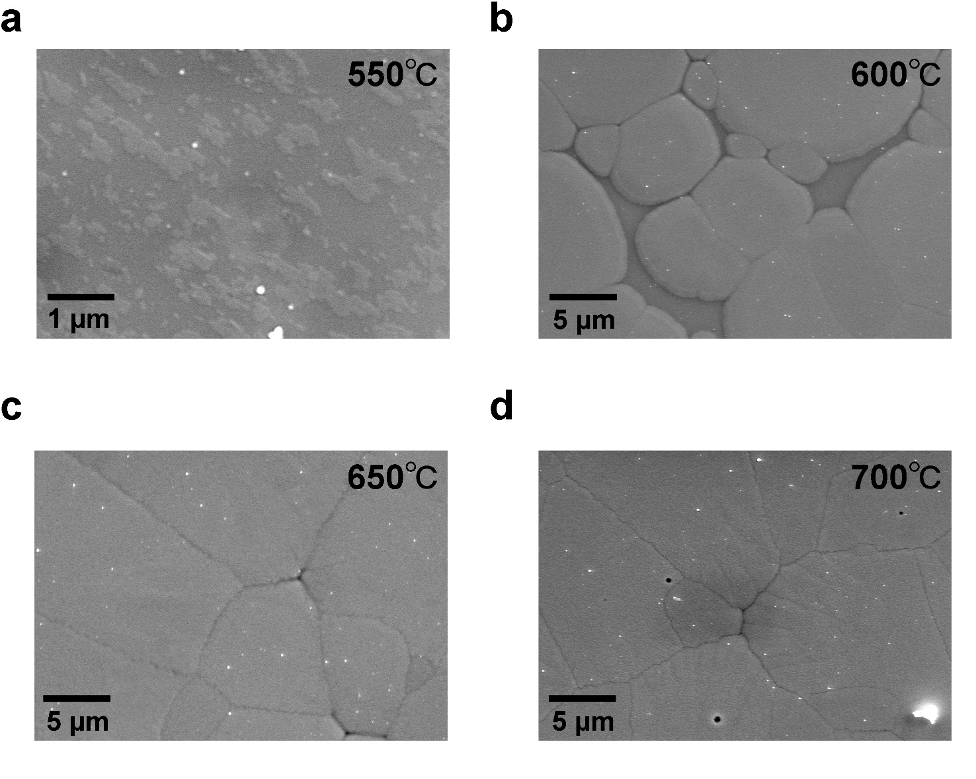
Supplementary Figure 5. Surficial analysis as a function of annealing temperature. SEM images of PNZT membrane annealed at 550℃ (a), 600℃ (b), 650℃ (c), and 700℃ (d).

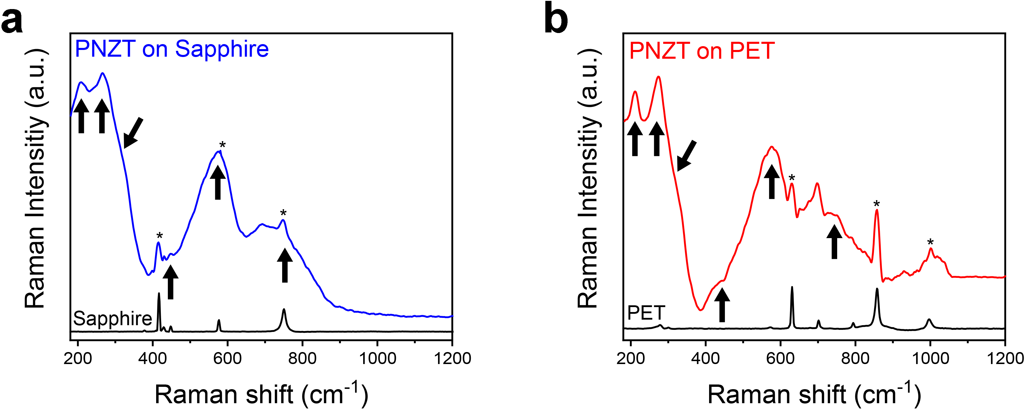
Supplementary Figure 6. Raman spectra of PNZT thin film before and after ILLO process. Analysis of perovskite PNZT phases on sapphire (a), and plastic substrates (b). The asterisks indicate the peaks from Al₂O₃ and PET. The arrows denote the typical perovskite phases.

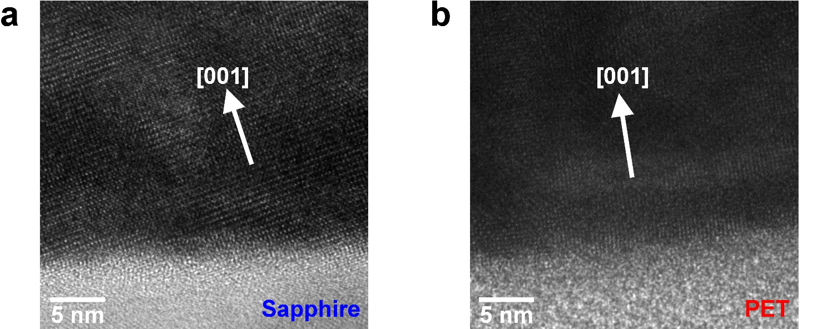
Supplementary Figure 7. Crystallographic analysis of the PNZT membrane. HRTEM images of PNZT thin film on plastic (a) and sapphire substrates (b).

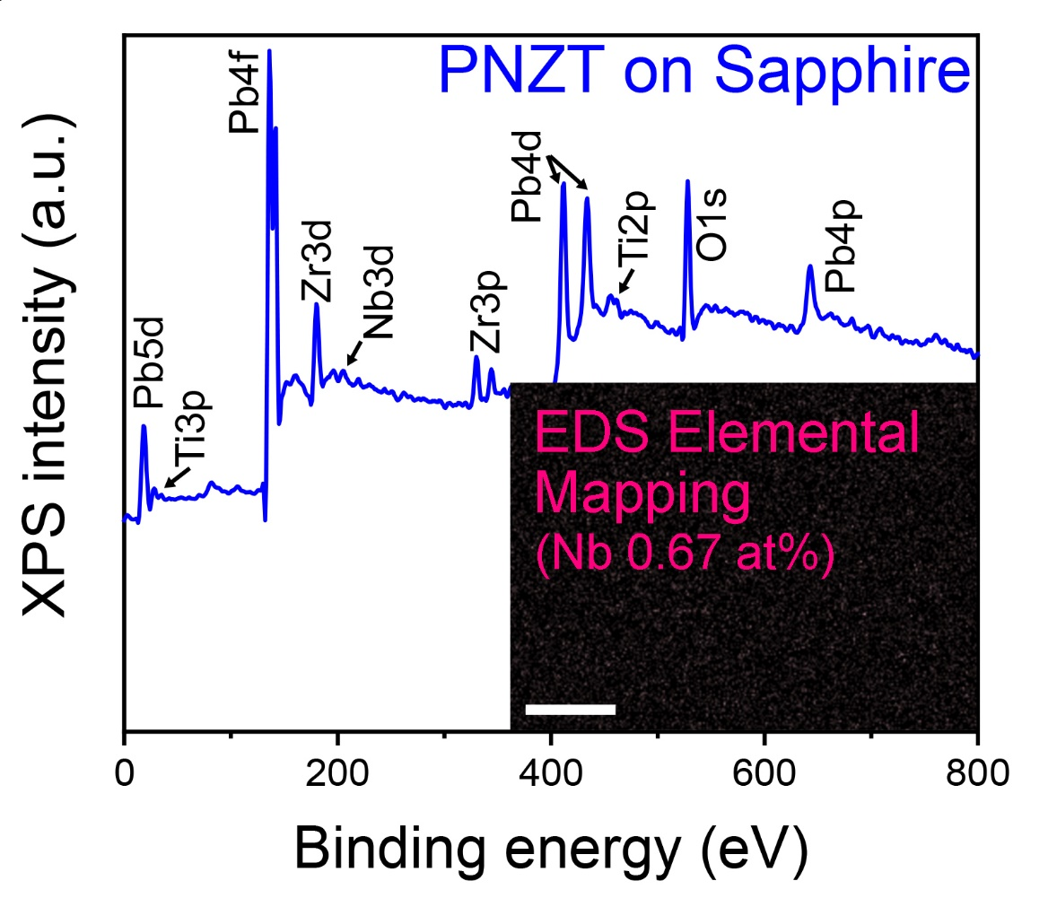
Supplementary Figure 8. Surface analysis results of PNZT membrane on sapphire substrates. XPS analysis of PNZT film before ILLO transfer. Inset shows the EDS elemental mapping results (scale bar: 3µm).

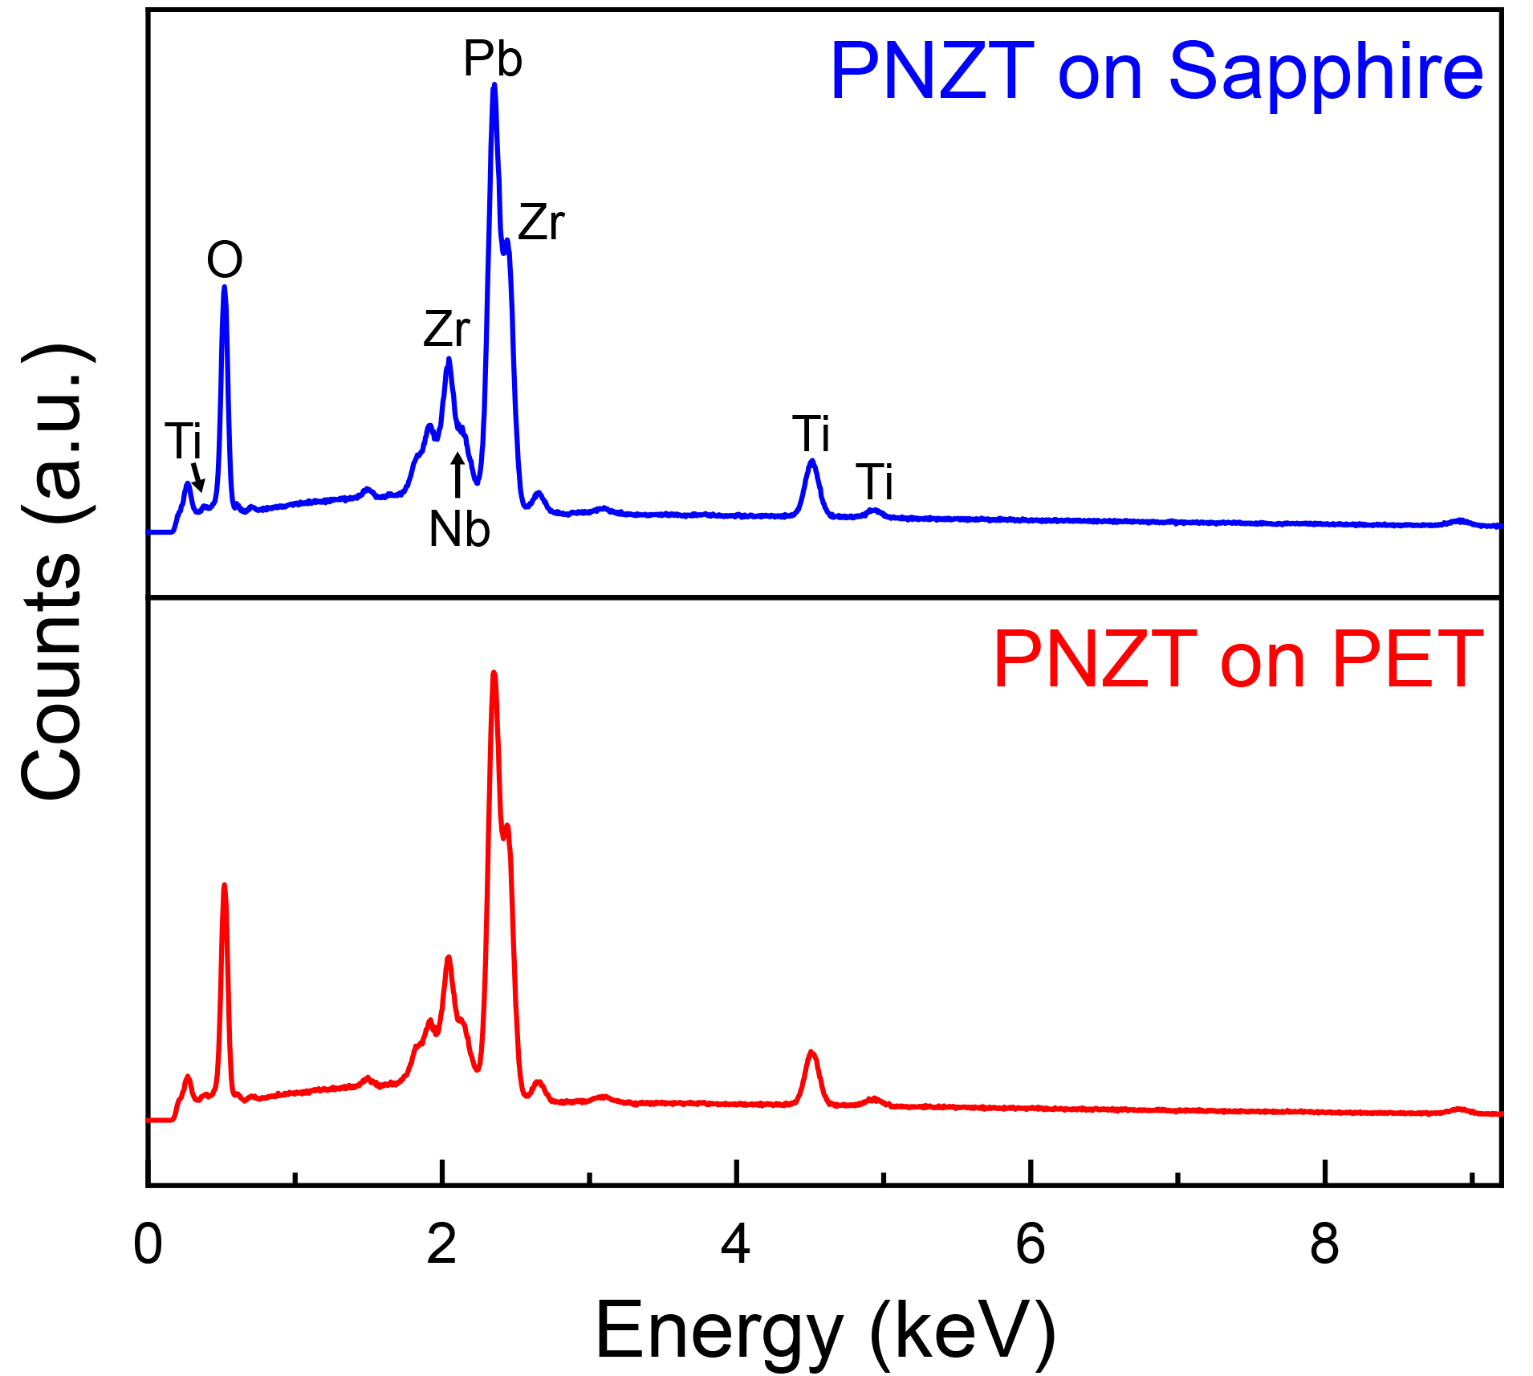
Supplementary Figure 9. Compositional analysis result before and after LLO process. EDS curves obtained from the surface of PNZT membrane.

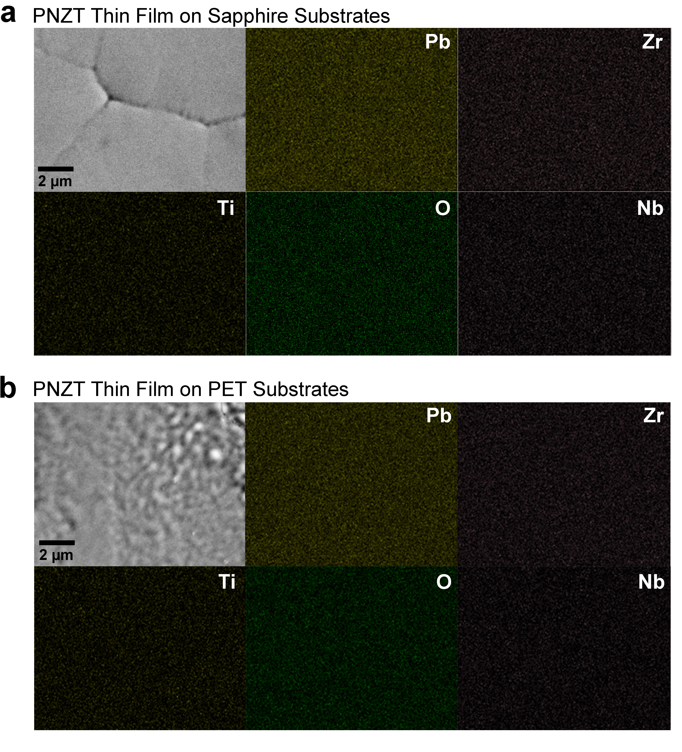
Supplementary Figure 10. EDS elemental mapping results of PNZT thin film on PET and sapphire substrates. EDS elemental mapping obtained from plastic (a) and sapphire substrates (b).

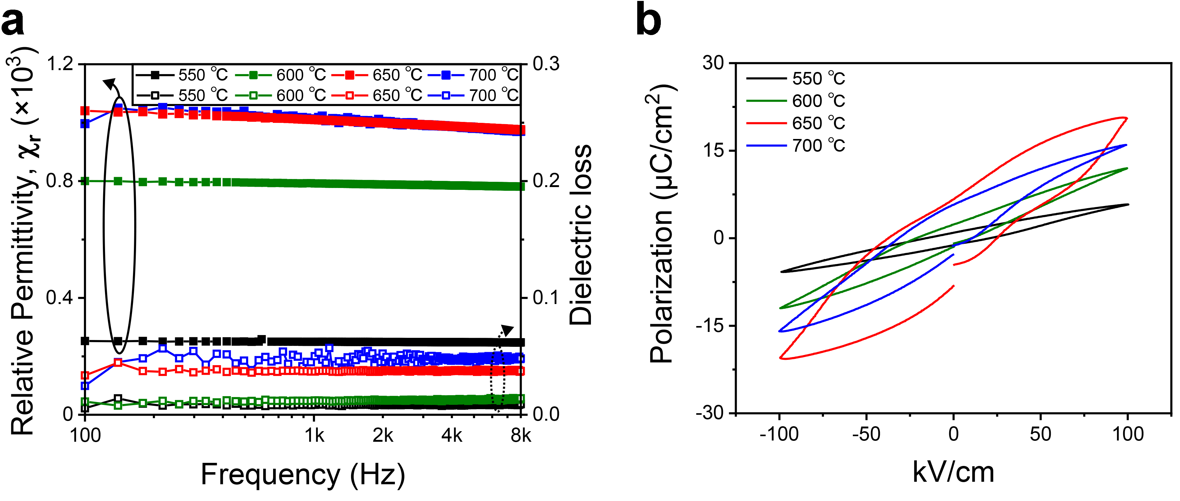
Supplementary Figure 11. Ferroelectric and piezoelectric characteristics as a function of annealing temperature. Dielectric properties (a) and P-E hysteresis loop (b) of PNZT membrane as a function of heat-treatment temperature.

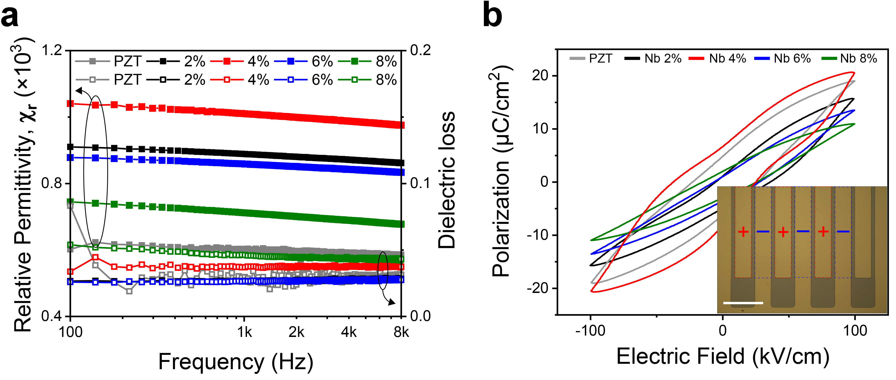
Supplementary Figure 12. Dielectric and piezoelectric properties as a function of Nb concentration. Ferroelectric properties (a) and P-E hysteresis loop (b) of PNZT thin film as a function of heat-treatment temperature (scale bar: 50 µm).

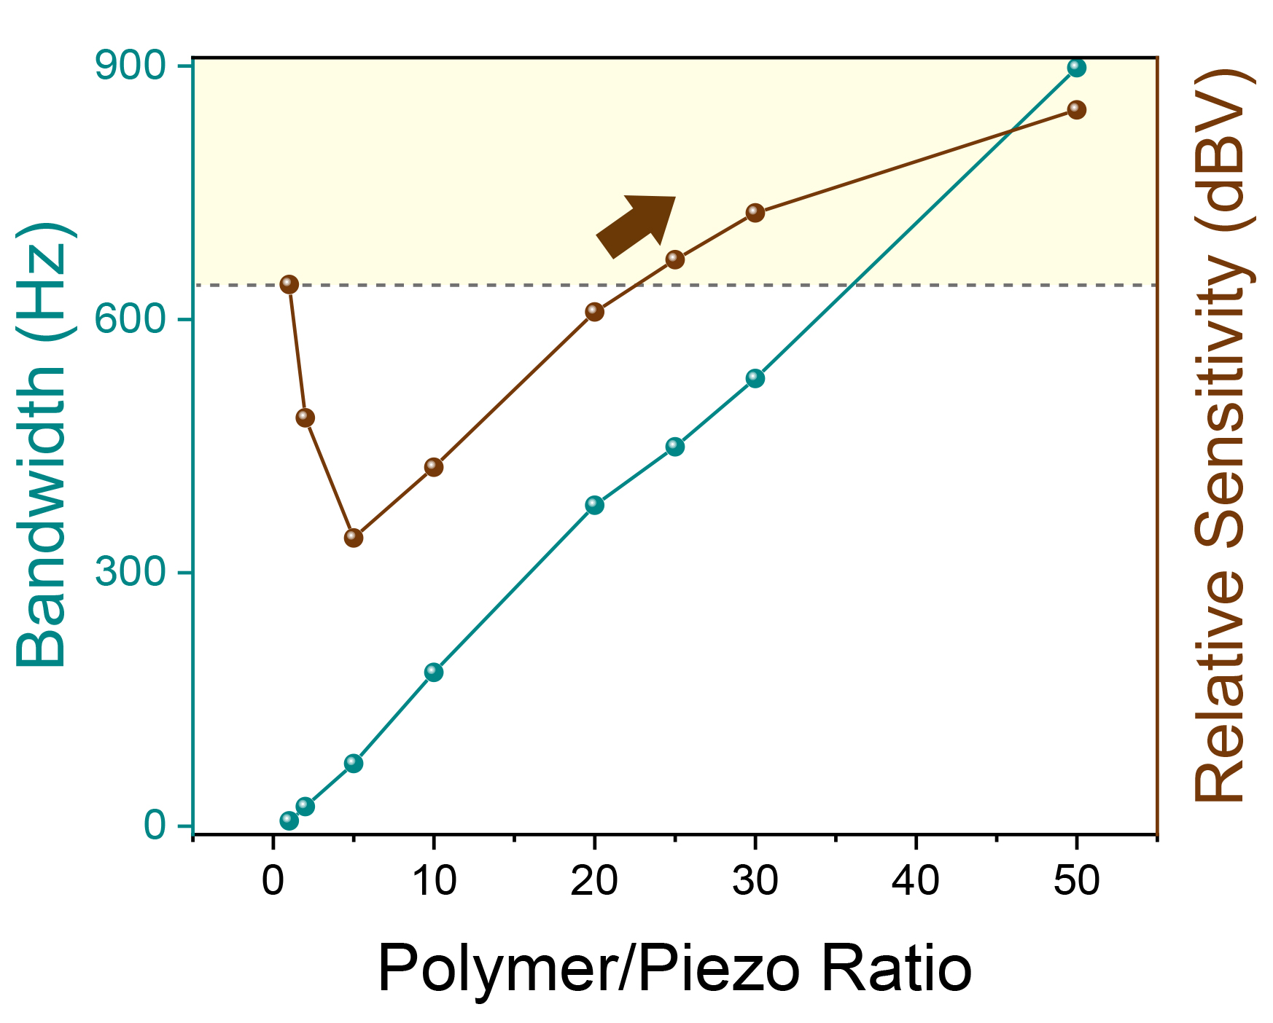
Supplementary Figure 13. Optimization of polymer to piezoelectric film ratio. The frequency bandwidth and relative sensitivity as a function of the ratio of polymer to 1 µm thick piezoelectric membrane.

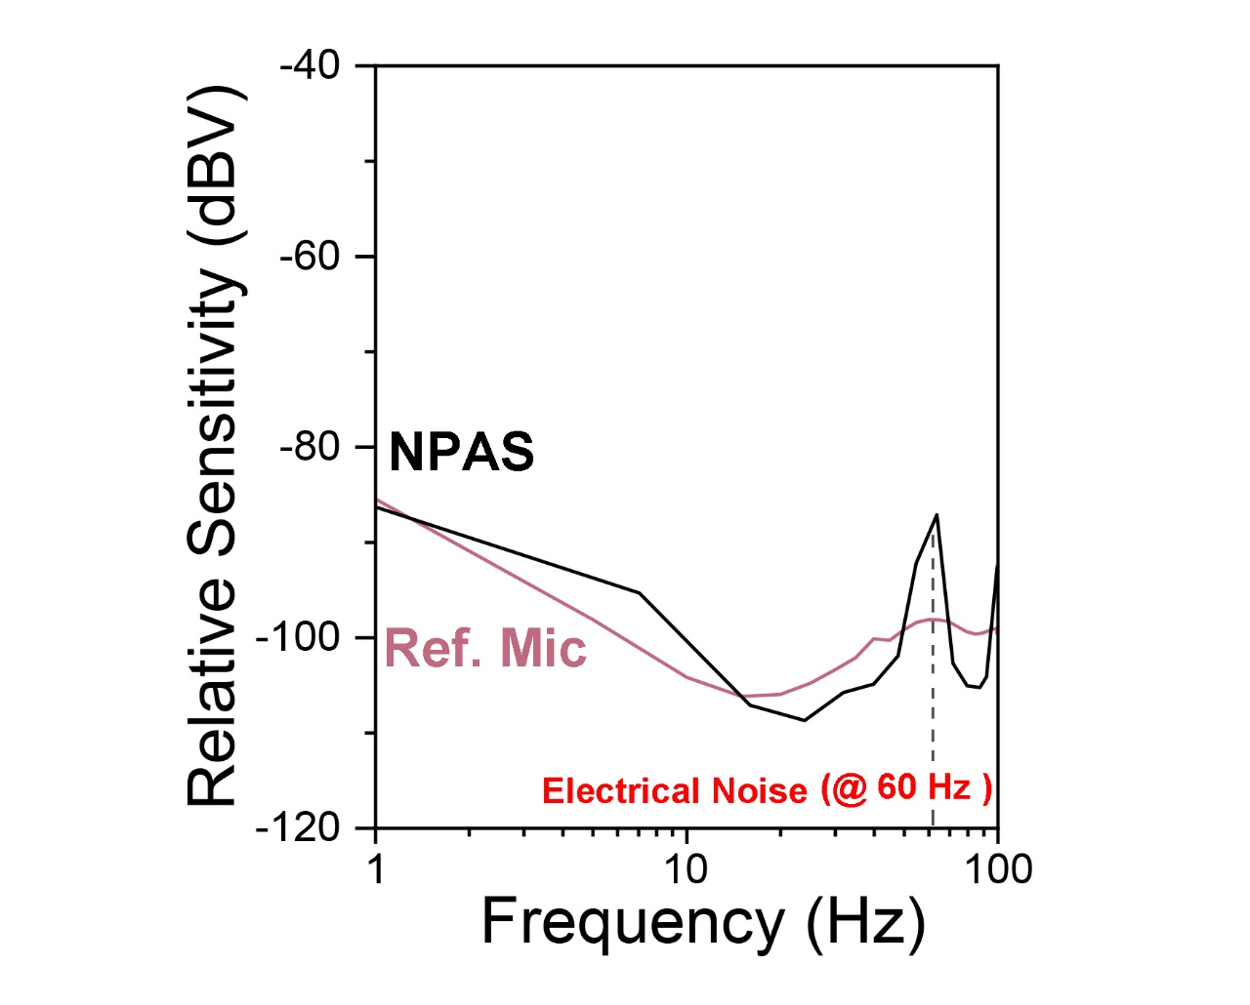
Supplementary Figure 14. Frequency response of NPAS over noise dominant range. Comparison of frequency response between NPAS and reference microphone in the range of 1 – 100 Hz under white noise input.

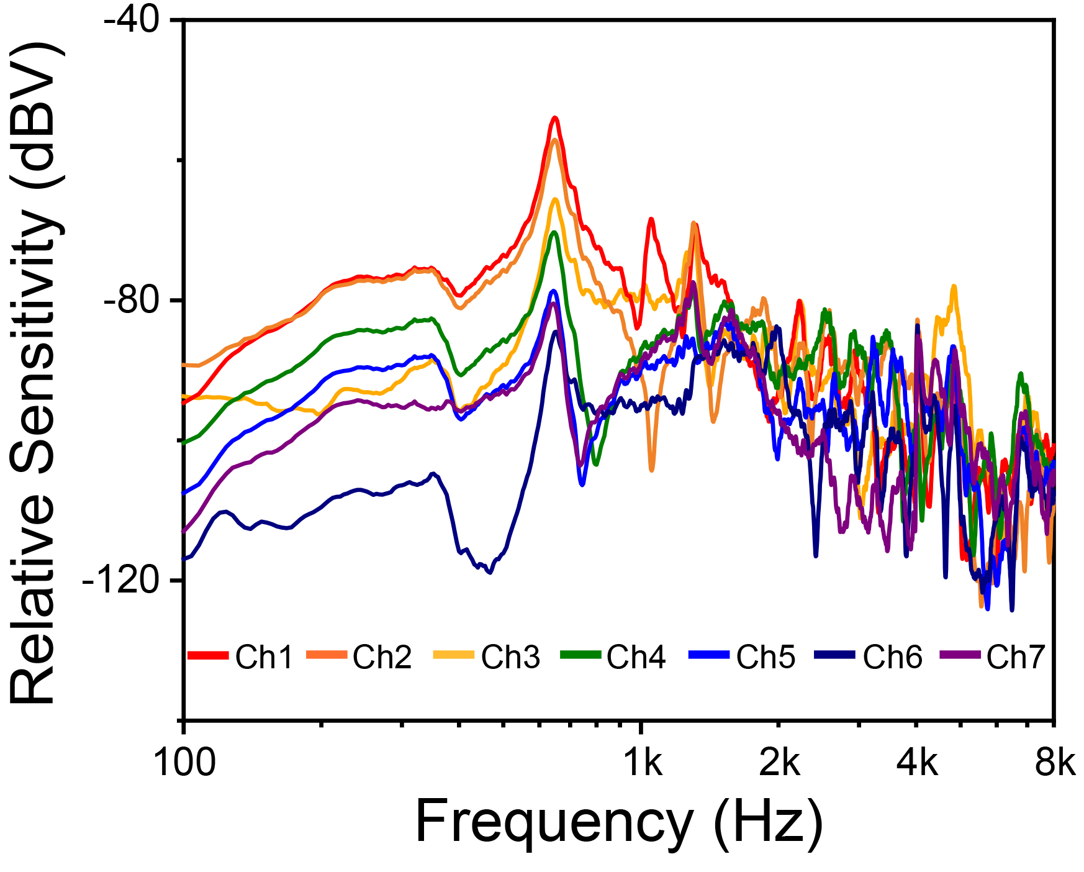
Supplementary Figure 15. Relative sensitivity signals depending on channels. Frequency response of entire NPAS channels under white noise of 94 dB SPL.

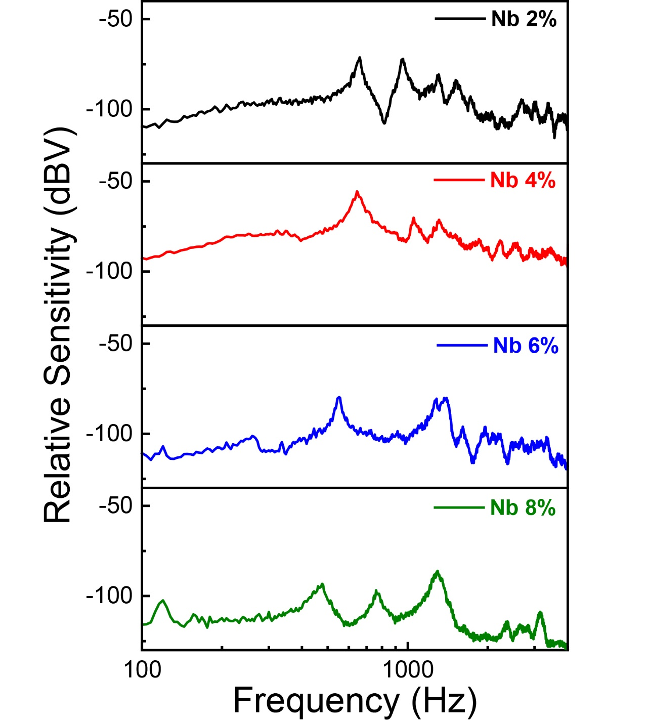
Supplementary Figure 16. Optimization of NPAS as a function of Nb concentration. Frequency response of NPAS from Nb 2% to Nb 8%.

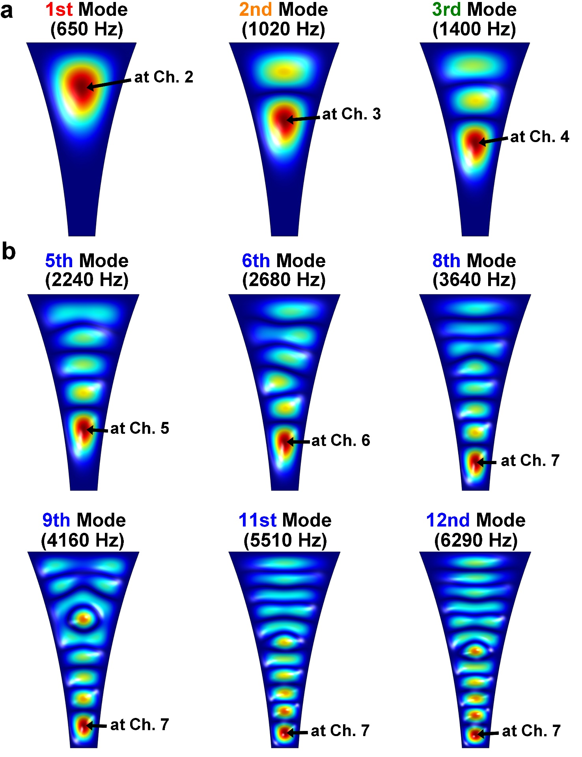
Supplementary Figure 17. Theoretical analysis of flexible NPAS membrane. FEM simulation results of NPAS thin film at 1st – 3rd resonant frequencies (a), and 5th – 12th resonances (b).

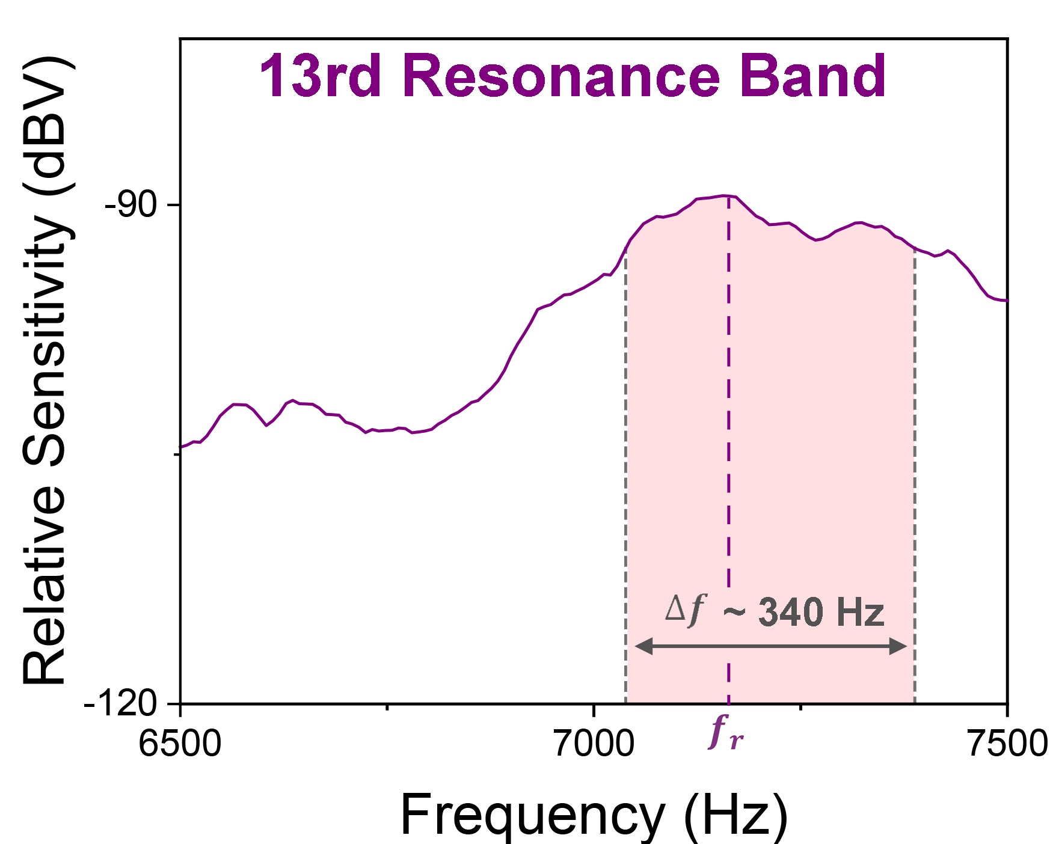
Supplementary Figure 18. The electrical signals of 13rd resonance band. Magnified signals of frequency response under white noise at 94 dB SPL.

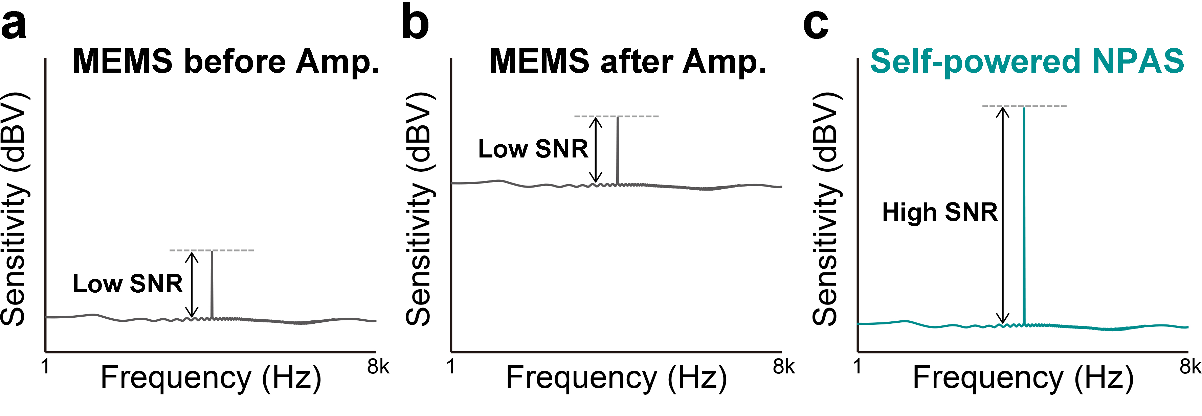
Supplementary Figure 19. Comparison of the SNR of commercial MEMS microphone and self-powered NPAS. a The low SNR of MEMS device before the amplification. b The insignificant increase in SNR of commercial microphone after the amplification. c The high SNR of self-powered NPAS. The MEMS microphone requires the unstable amplifying circuit due to low sensitivity, which results in the high power consumption with high noise baseline.

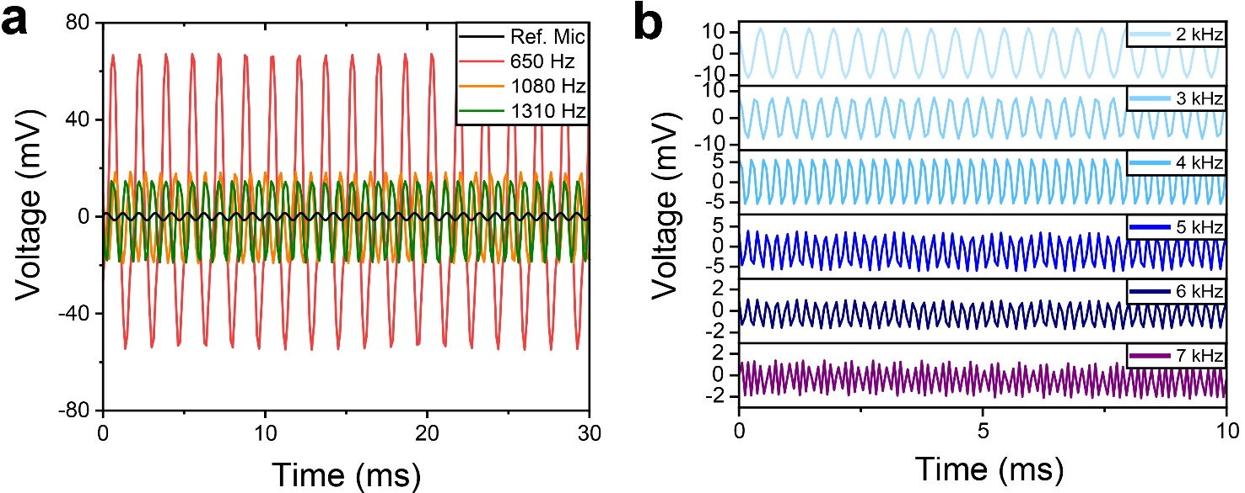
Supplementary Figure 20. Detailed electrical signals as a function of time. The magnified peak to peak voltage signal under monochromatic soundwaves of 1st – 3rd resonances (a), and 2 – 7 kHz frequencies (b), showing superior sensitivity compared to a reference microphone.

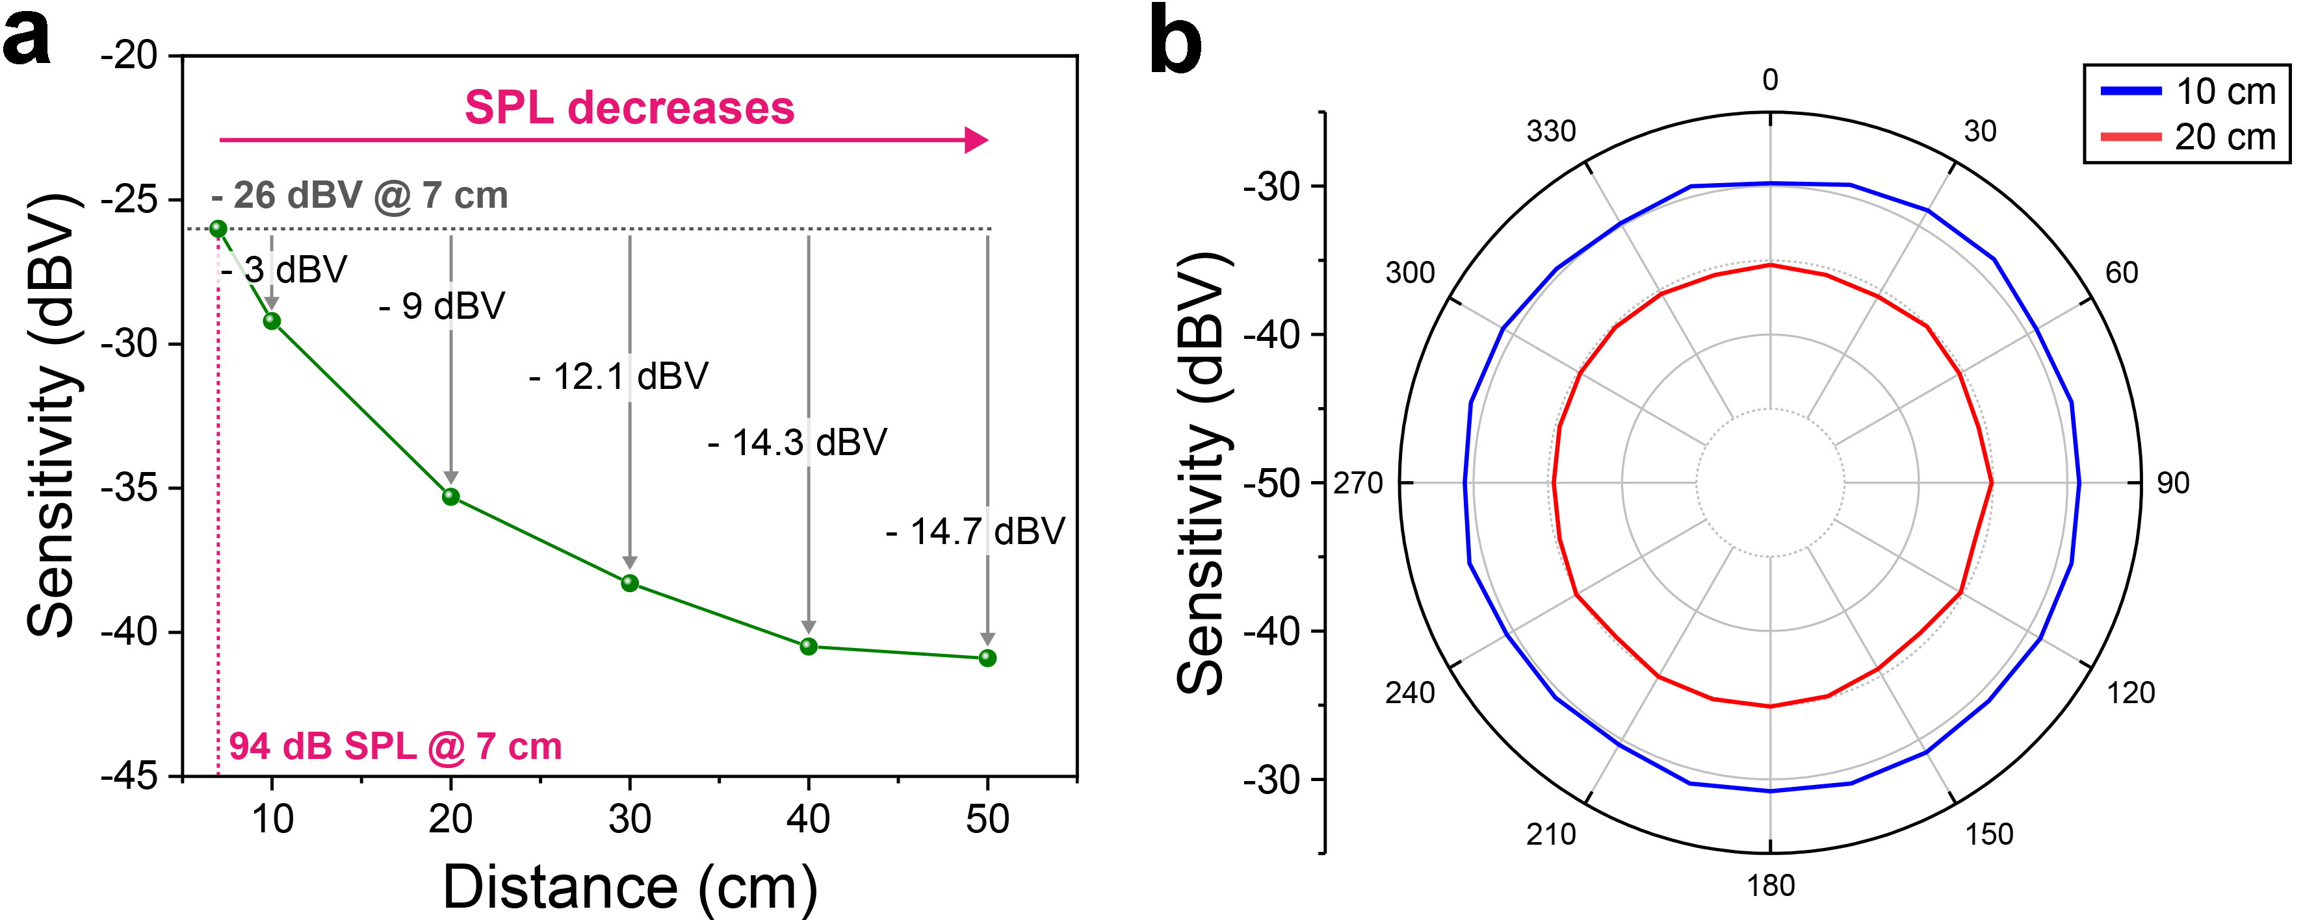
Supplementary Figure 21. Directional characteristics of NPAS. a Experimentally calculated decreases in sensitivity depending on the distance. b The sensitivities of NPAS as a functions of distance and incident angle.

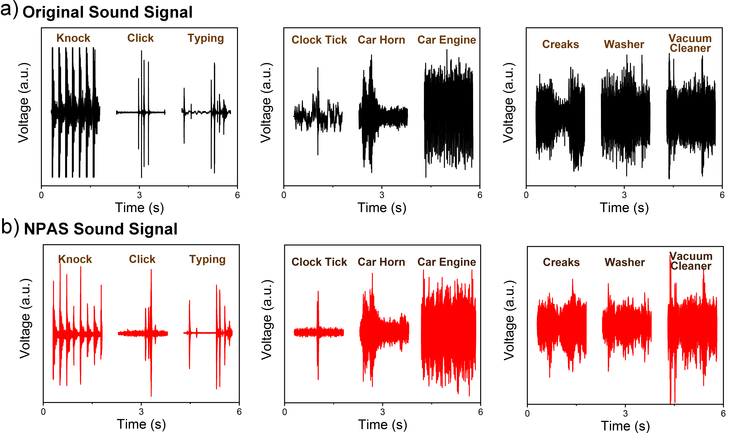
Supplementary Figure 22. Comparison of noise signals between original and NPAS. Original sound signal (a) and NPAS signal (b) of indoor/outdoor noise.

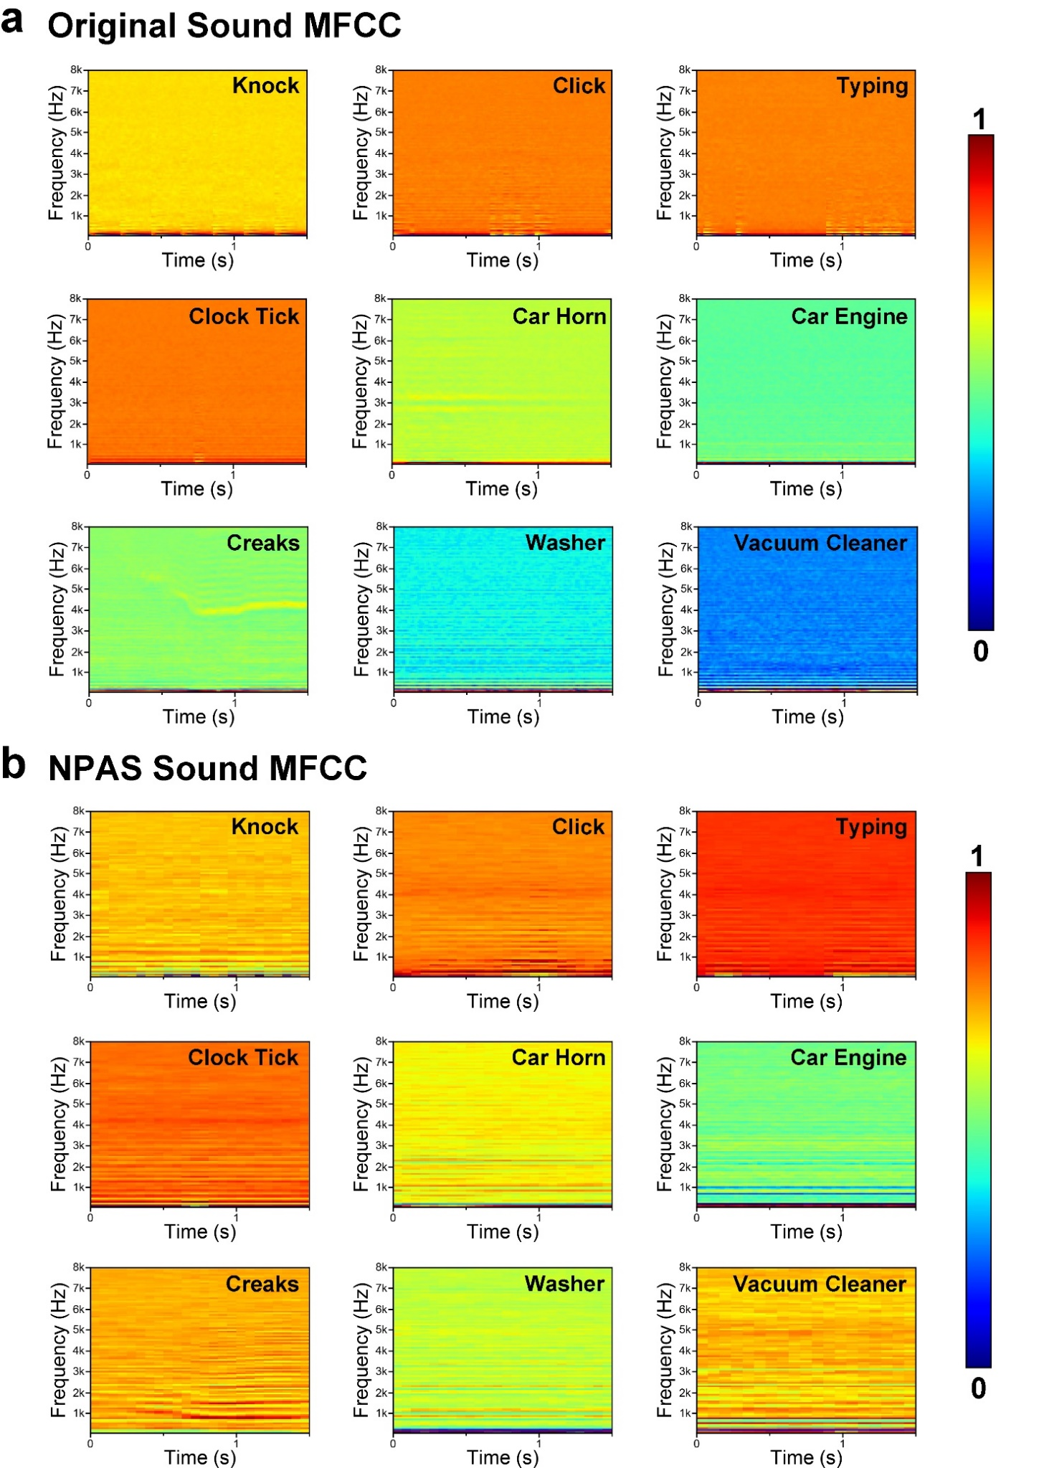
Supplementary Figure 23. Comparison of noise MFCC features between original and NPAS. Original sound MFCC (a) and NPAS MFCC (b) of indoor/outdoor noise.
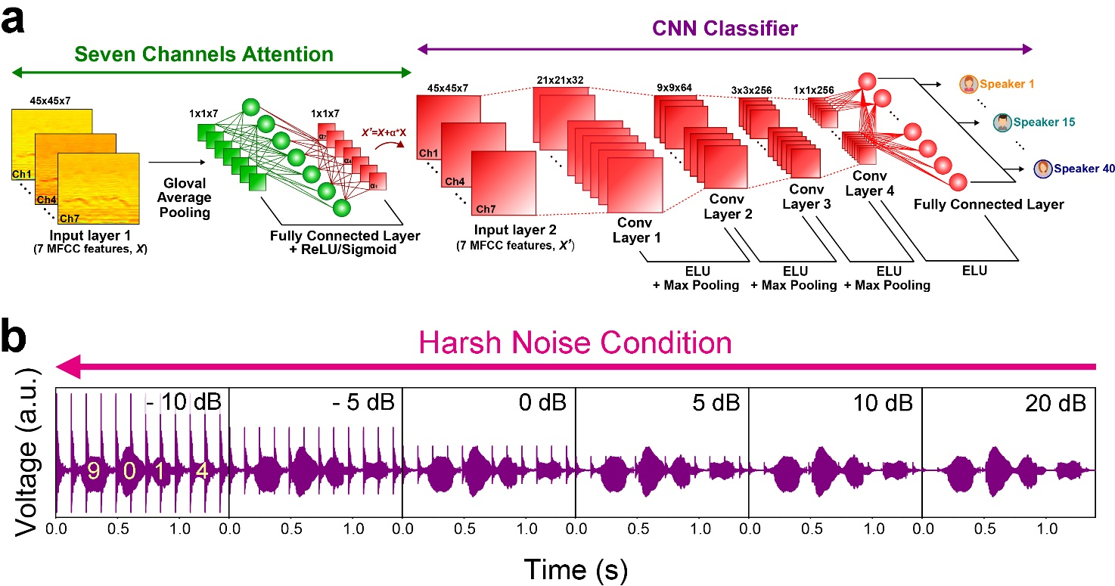
Supplementary Figure 24. Detailed CNN process and SNR-dependent waveforms of NPAS. a Overall process of CNN from learning seven-channel inputs to classifying the speaker. b The waveform of NPAS signals under different SNR conditions.

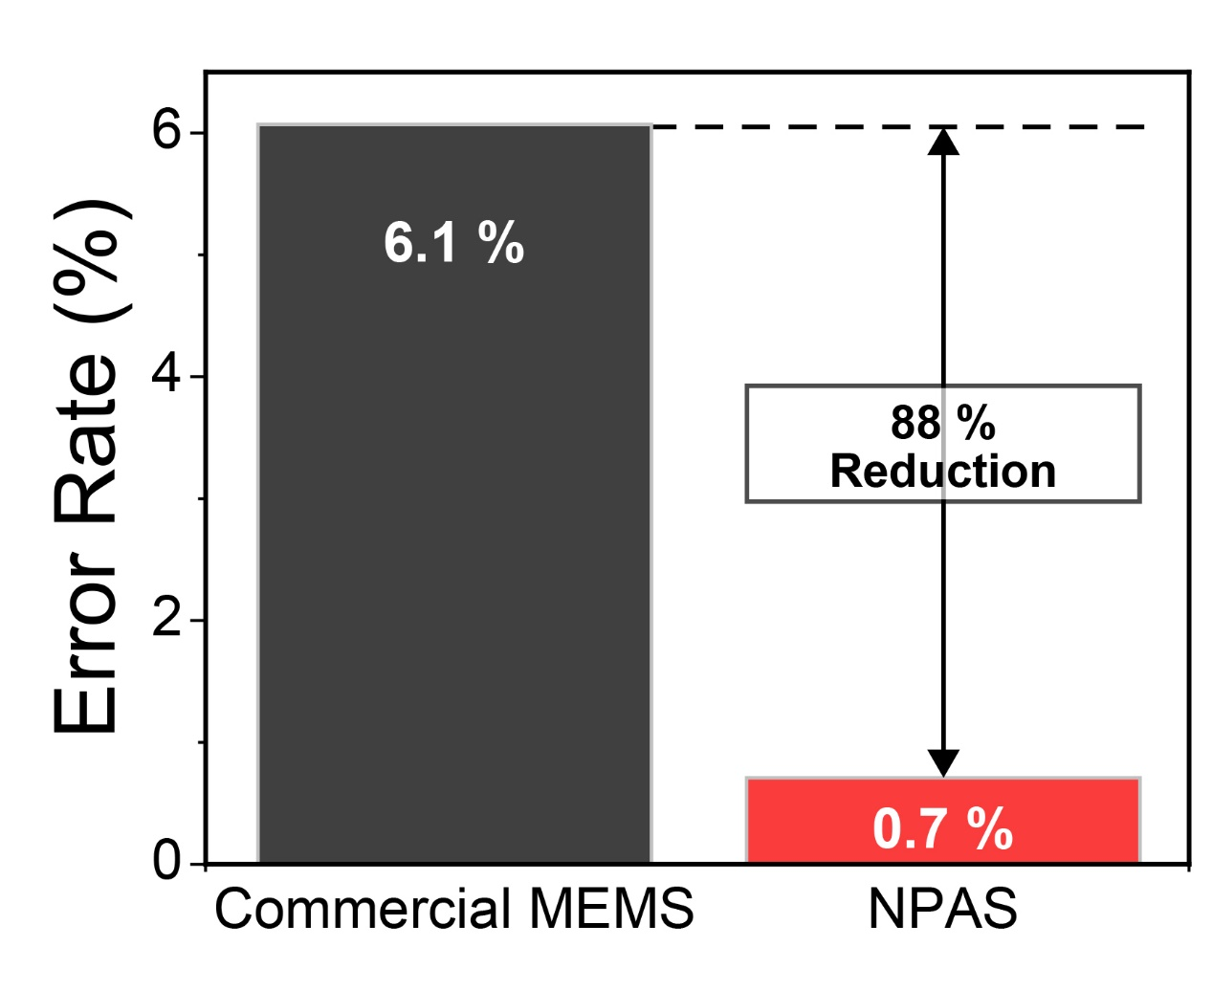
Supplementary Figure 25. Comparison of speaker recognition error rate between MEMS microphone and NPAS without noise signal. Speaker recognition error rate of NPAS outperforming commercialized microphone in the condition of anechoic room.

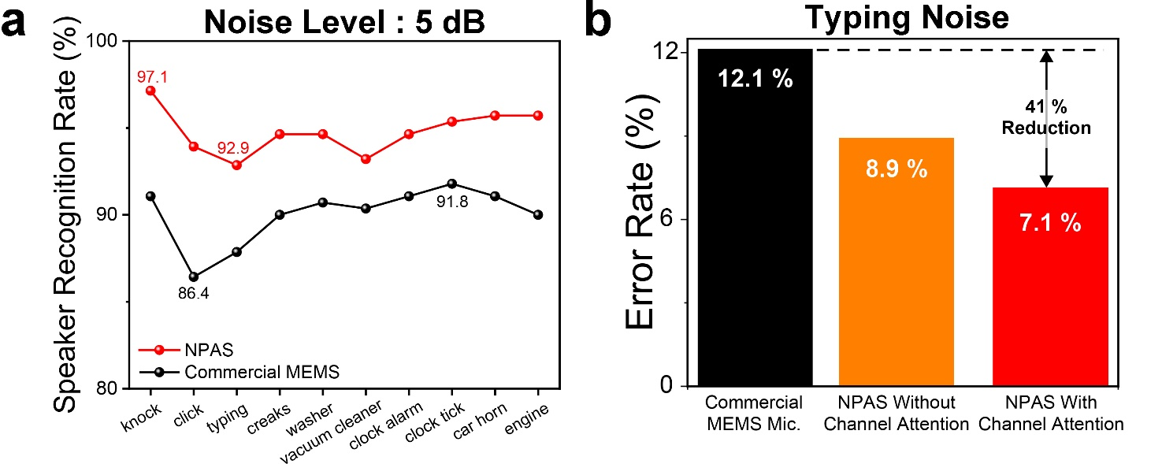
Supplementary Figure 26. Speaker recognition of MEMS microphone and NPAS under single noise condition. a Speaker recognition rate of NPAS outperforming commercialized microphone in each noisy environment . b Comparison of error rate among commercial MEMS microphone, NPAS without channel attention, and NPAS with channel attention in typing noise condition.

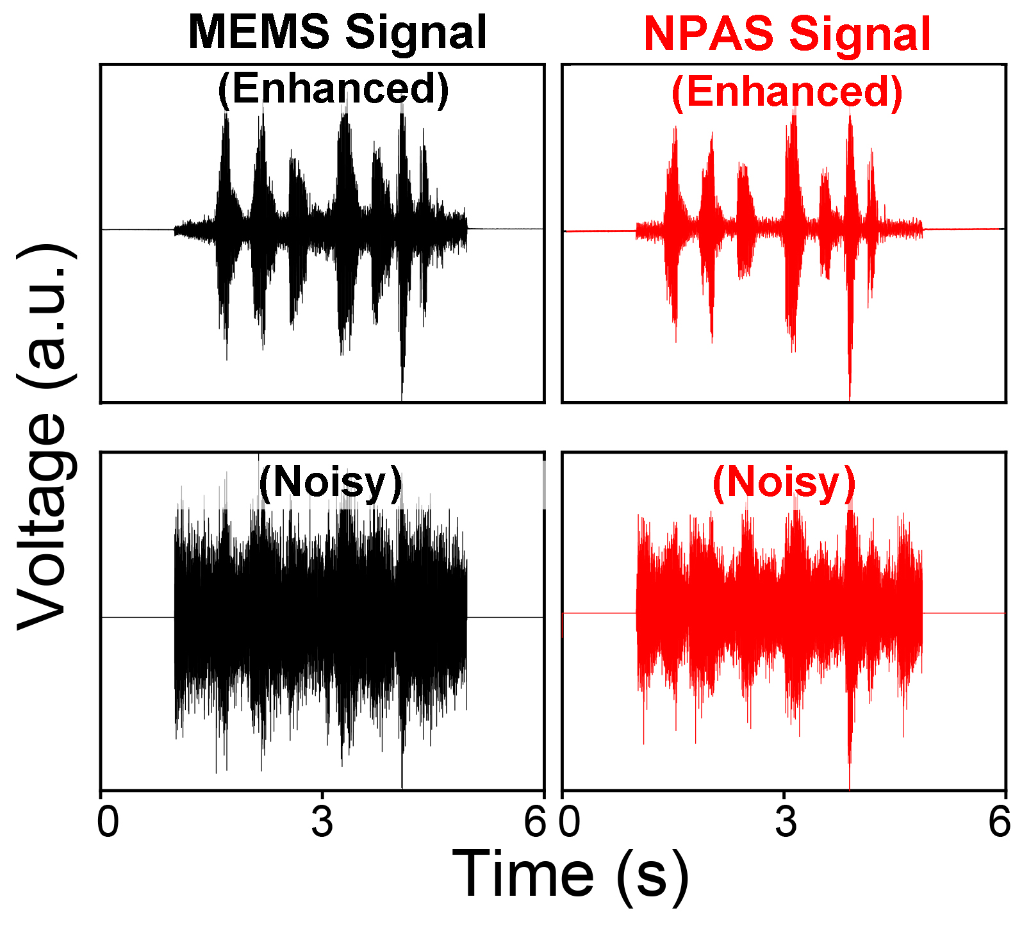
Supplementary Figure 27. Comparison of speech enhancement between MEMS microphone and NPAS. The analyzed waveform of commercial microphone and NPAS.

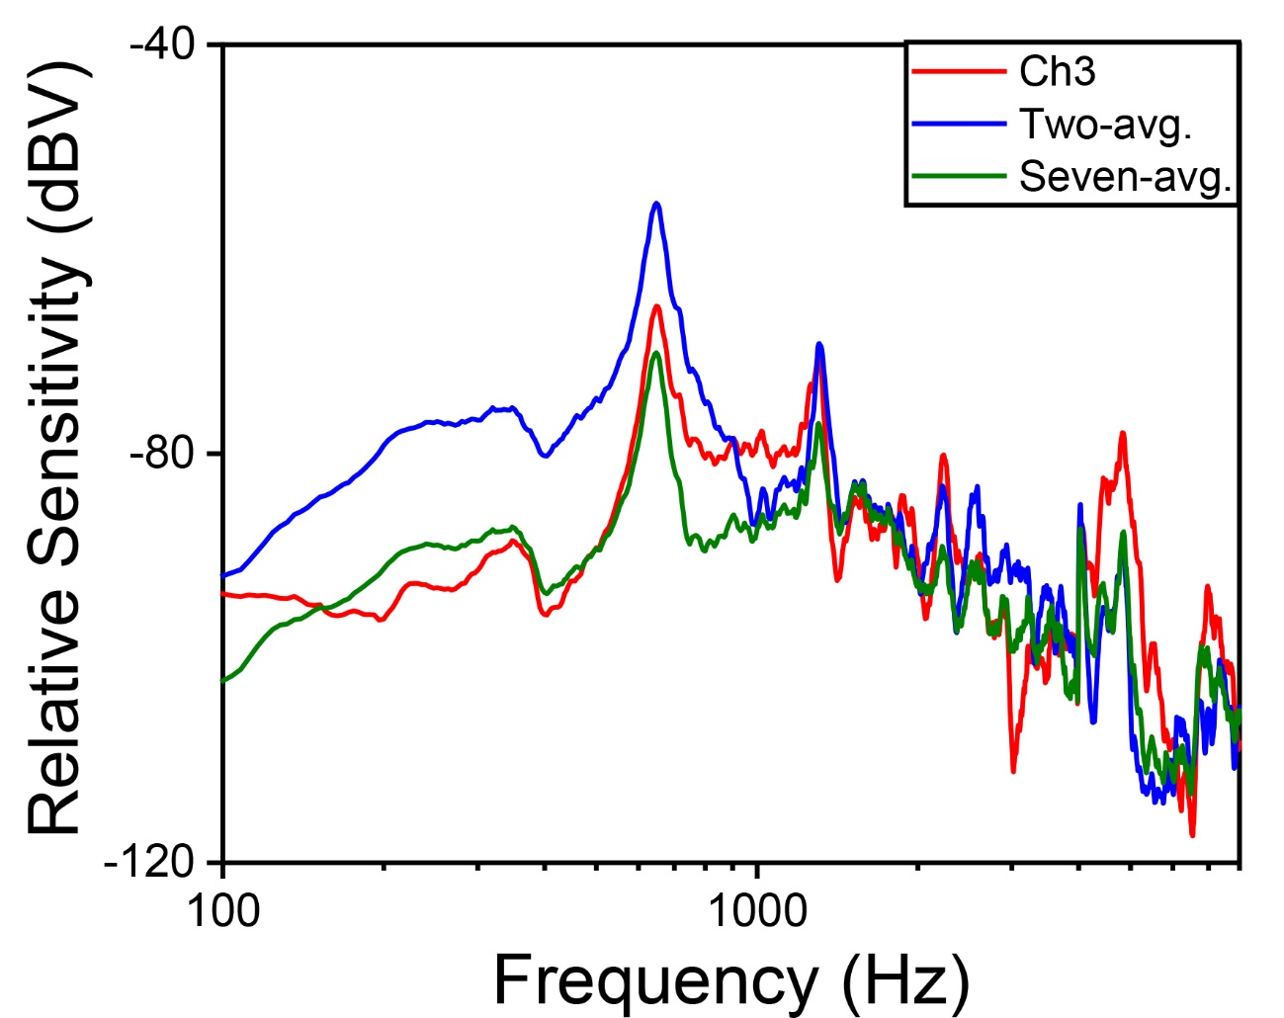
Supplementary Figure 28. Frequency response of channel 3, two-averaging, and seven-averaging. Comparison of NPAS sensitivity signals among single channel 3 (red), two-averaging (blue), and seven-averaging (green).

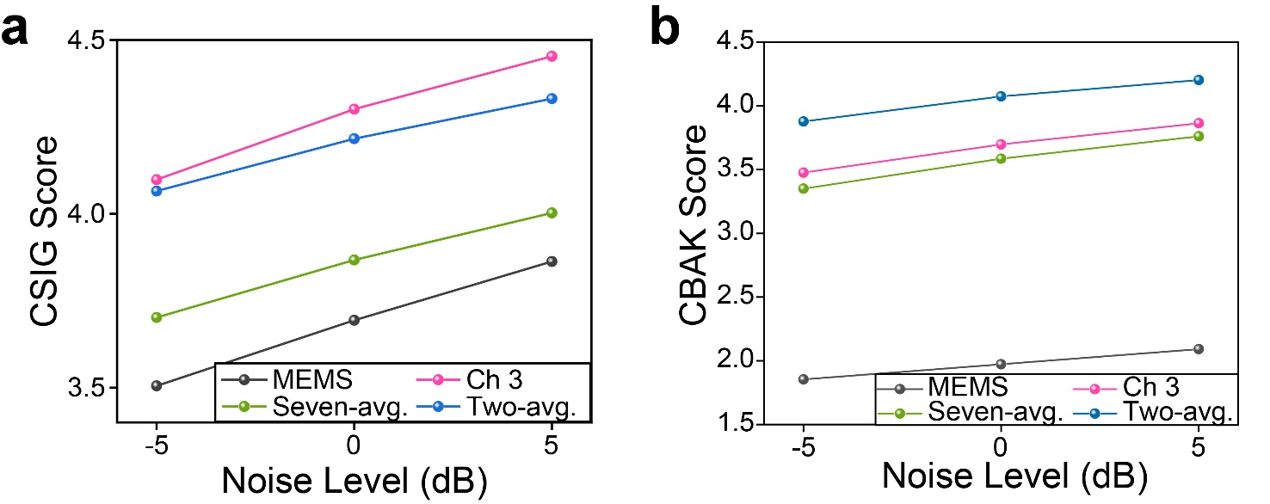
Supplementary Figure 29. CSIG and CBAK score of channel 3, two-averaging, and seven-averaging. a The comparison of NPAS CSIG score depending on the channel-selection. b The NPAS CBAK score of channel 3, two-averaging, and seven-averaging compared to commercial MEMS microphone.

Elements  Samples | Pb (at. %) | Zr (at. %) | Ti (at. %) | O (at. %) | Nb (at. %)
PNZT thin film on PET | 23. 65 | 9.03 | 7.02 | 59.55 | 0.75
PNZT thin film on Sapphire | 23.54 | 9.47 | 7.52 | 58.79 | 0.67
Supplementary Table 1. Chemical composition of PNZT membrane obtained by EDS elemental mapping. Comparison of composition of piezoelectric film on PET and sapphire substrates.

 | [Ref.] | [Ref. ] | [Ref. ] | [Ref. ] | [Ref. ] | [Ref. ] | [Ref. ] | [Ref. ]
Material | PVDF Film | PZT Film | PVDF Nanoweb | P(VDF-TrFE) Nanoweb | PZT Film | PAN | PZT Film | PNZT Film
Material Thickness ($μm$) | 40 | 2 | 40 | 20 | 1 | 30 | 3 | 1
Size⁽²⁾ (mm²) | 799 | 300 | 1200 | 1200 | 450 | 1200 | 130 | 375
Sensitivity⁽³⁾ (mV/Pa) | 0.0253⁽⁴⁾ | 1.5 | 266  (@ 0.22 kHz) | 1289.3  (@ 0.21 kHz) | 4096.3  (@ 0.23 kHz) | > 45⁽⁹⁾  (@ 0.65 kHz) | 52  (@ 0.83 kHz) | 62  (@ 0.65 kHz)
FOM_{Sens.}  (mV/Pa$∙$mm³) | 7.92 $×$ 10⁻ ⁴ | 2.5 | 5.54 | 53.7 | 100 | 113.9 | 133 | 165.3
The Number of Channels (N) | 24 | 3 | 1 | 1 | 7 | 1 | 7 | 7
Frequency Coverage* (kHz) | 3.5 | 0.5 | 0.22 | 0.21 | 2.35 | 0.23 | 2.57 | 6.15
FOM_{Freq.} (kHz/N) | 0.146 | 0.167 | 0.22 | 0.21 | 0.336 | 0.23 | 0.367 | 0.879
Supplementary Table 2. Benchmarks between NPAS and previous reports. Comparison of this work with previous resonant piezoelectric acoustic sensors.

References
1. Shintaku, H. et al. Development of piezoelectric acoustic sensor with frequency selectivity for artificial cochlea. Sensors Actuators, A Phys. 158, 183–192 (2010).
2. Lee, H. S. et al. Flexible inorganic piezoelectric acoustic nanosensors for biomimetic artificial hair cells. Adv. Funct. Mater. 24, 6914–6921 (2014).
3. Lang, C., Fang, J., Shao, H., Ding, X. & Lin, T. High-sensitivity acoustic sensors from nanofibre webs. Nat. Commun. 7, 11108 (2016).
4. Lang, C. et al. High-output acoustoelectric power generators from poly(vinylidenefluoride-co-trifluoroethylene) electrospun nano-nonwovens. Nano Energy 35, 146–153 (2017).
5. Han, J. H. et al. Basilar membrane-inspired self-powered acoustic sensor enabled by highly sensitive multi tunable frequency band. Nano Energy 53, 198–205 (2018).
6. Shao, H. et al. Efficient conversion of sound noise into electric energy using electrospun polyacrylonitrile membranes. Nano Energy 75, 104956 (2020).
7. Wang, H. S. et al. Biomimetic and flexible piezoelectric mobile acoustic sensors with multiresonant ultrathin structures for machine learning biometrics. Sci. Adv. 7, eabe5683 (2021).
8. Lee, W. S. & Lee, S. S. Piezoelectric microphone built on circular diaphragm. Sensors Actuators, A Phys. 144, 367–373 (2008).
9. Lee, J. W., Choi, J. J., Park, G. T., Park, C. S. & Kim, H. E. Thick Pb(Zr,Ti)O3 films fabricated by inducing residual compressive stress during the annealing process. J. Mater. Res. 20, 2898–2901 (2005).
10. Han, G. et al. Effect of film thickness on the piezoelectric properties of lead zirconate titanate thick films fabricated by aerosol deposition. J. Am. Ceram. Soc. 94, 1509–1513 (2011).

