Supplementary Method S1

Appendix A: Abbreviated Math Anxiety Index – AMAS [18]
1. Having to use the tables in the back of a math book.
2. Thinking about an upcoming math test 1 day before.
3. Watching a teacher work an algebraic equation on the blackboard.
4. Taking an examination in a math course.
5. Being given a homework assignment of many difficult problems that is due the next class meeting.
6. Listening to a lecture in math class.
7. Listening to another student explain a math formula.
8. Being given a “pop” quiz in math class.
9. Starting a new chapter in a math book

Appendix B: Edingburgh Handedness Inventory – EHI (Oldfield, 1971)
Which hand do you prefer to use when:
- Writing
- Drawing
- Throwing
- Using scissors
- Using a toothbrush
- Using a knife (without a fork)
- Using a spoon
- Using a broom (upper hand)
- Striking a match
- Opening a box (holding the lid)
- Holding a computer mouse
- Using a key to unlock a door
- Holding a hammer
- Holding a brush or comb
- Holding a cup while drinking

Supplementary Table S2: Description of all 6 administered tasks
Domain | Task | Description
Numerical | Single-digit magnitude comparison  (64 trials) | Participants chose the larger of two digits (1–9) shown on top of each other; digit distance and presentation frequency were controlled.
Numerical | Two-digit magnitude comparison  (272 trials) | Participants chose the larger of two numbers (23–98), presented on top of each other; round decades and ties were excluded.
Numerical | Dot comparison  (64 trials) | Participants chose the larger of two dot sets shown on top of each other. Six dot sizes were used; stimuli controlled for surface area and dot size distribution (adapted from Tricoche et al., 2023).
Language | Phonological  (64 trials) | Participants judged whether two simultaneously presented words rhymed. Words were presented in four conditions: similar orthography/similar phonology (e.g., dime–lime; similar orthography/different phonology (e.g. pint–mint), different orthography/similar phonology (e.g., jazz–has), and different orthography/different phonology (e.g,. press–list).
Language | Morpho-lexical  (64 trials) | Participants judged whether two word fragments formed an existing word. Items included morphologically correct words (e.g., depress) morphological violations (e.g., inpress) , real words, and pseudowords (adapted from Lochy et al., 2024).
Language | Syntax  (64 trials) | Participants judged whether two words formed a correct phrase. Items included verb inflection (e.g., correct: I have, incorrect: I has) and both syntactic number agreement (e.g., two tables) and violations (e.g., two womans).

Supplementary Figure S3
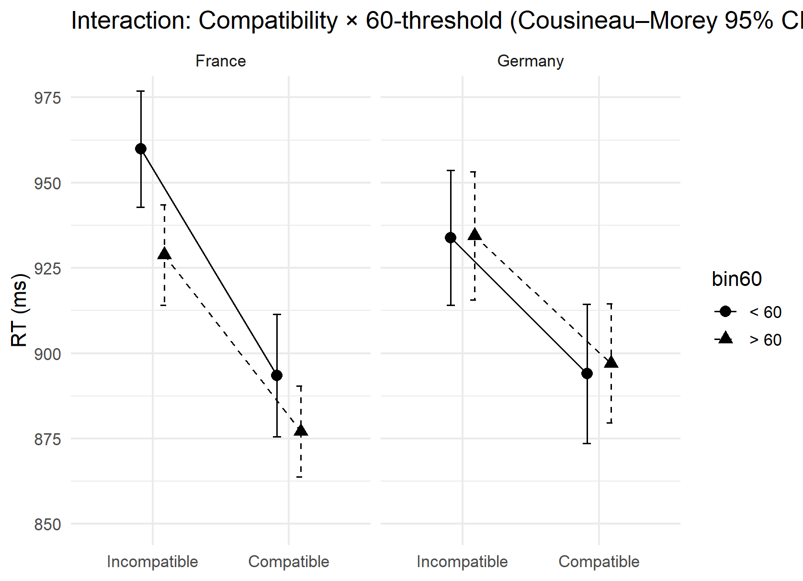
Figure 2: Mean reaction times (in ms) for compatible and incompatible trials above and below 60 for both French and Germans speakers. Mean reaction times are drawn as distinct lines and plotted separately for France (left) and Germany (right) with within-subject 95% confidence intervals (CIs, Cousineau–Morey [11,12]). The UDCE is visible as a clear compatibility benefit in both countries. Unlike Germans, French participants are slower in the <60 trials at both compatibility levels. Overlapping Cousineau–Morey-corrected CIs suggest that any threshold differences are small/uncertain, while the compatibility effect is pronounced in both panels.

