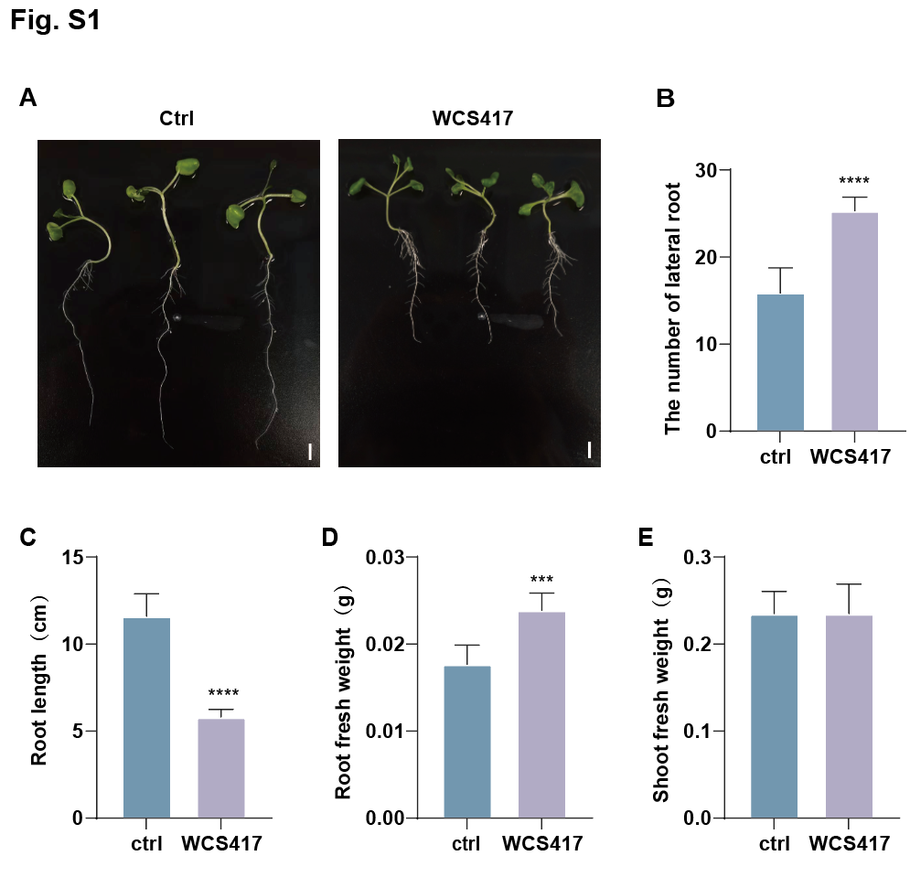Fig S1. The developmental responses of B. napus seedlings to WCS417 were assessed in a ½ MS liquid medium.
A. WCS417 induces changes in root architecture. B-E. Quantification of growth parameters in seedlings with or without WCS417 inoculation. (B) Lateral root number. (C) Primary root length. (D) Root fresh weight. (E) Shoot fresh weight. Significance analysis was calculated using GraphPad Prism 8 with an unpaired two-tailed Student's t-test. Error bars represent the standard deviation of six biological replicates. n = 6; Asterisks indicate significant differences between the two sets of data. ** P < 0.01，*** P <0.001, ****P < 0.0001. Scale bar, 1 cm.
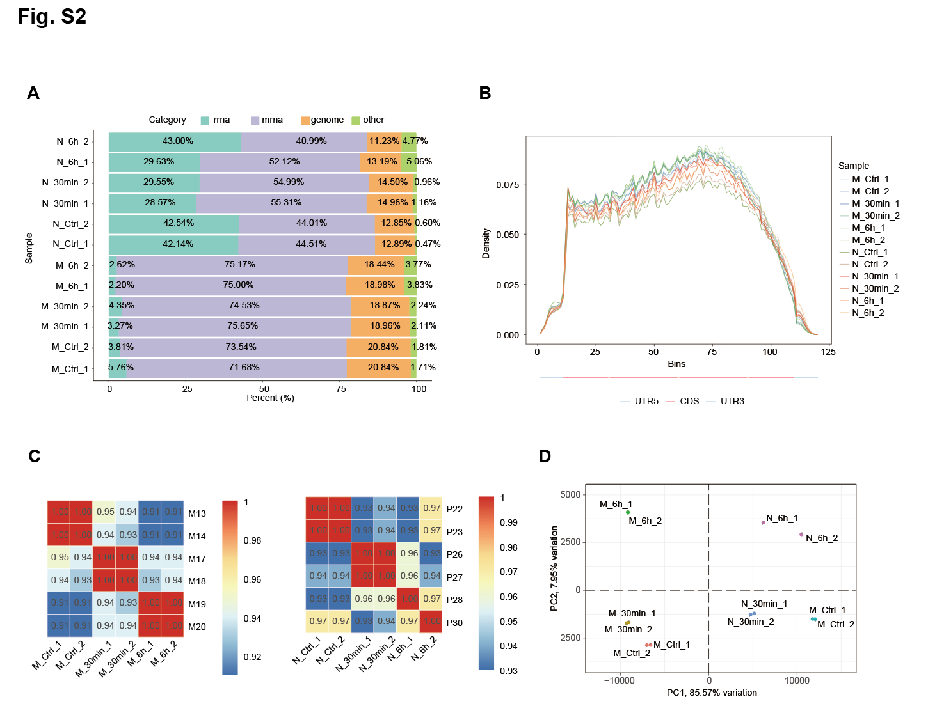
Fig S2. Quality control analysis of transcriptome and translatome sequencing data. A. Proportion of reads mapped to different types of reference sequences in RNA-seq and RNC-seq. B. Read density profile of RNC-seq reads across gene bodies. C. Correlation analysis among different time points and treatment groups in RNA-seq and RNC-seq. D. Principal component analysis of RNA-seq and RNC-seq data across different time points and treatment groups. 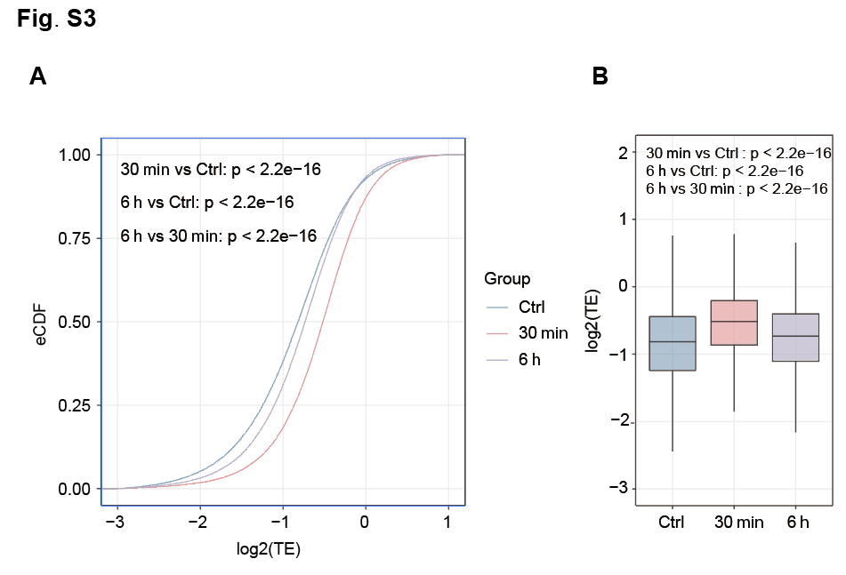
Figure S3. Changes in global translation ratios of plant genes following bacterial colonization. A. Cumulative distribution plot. B. Box plot.
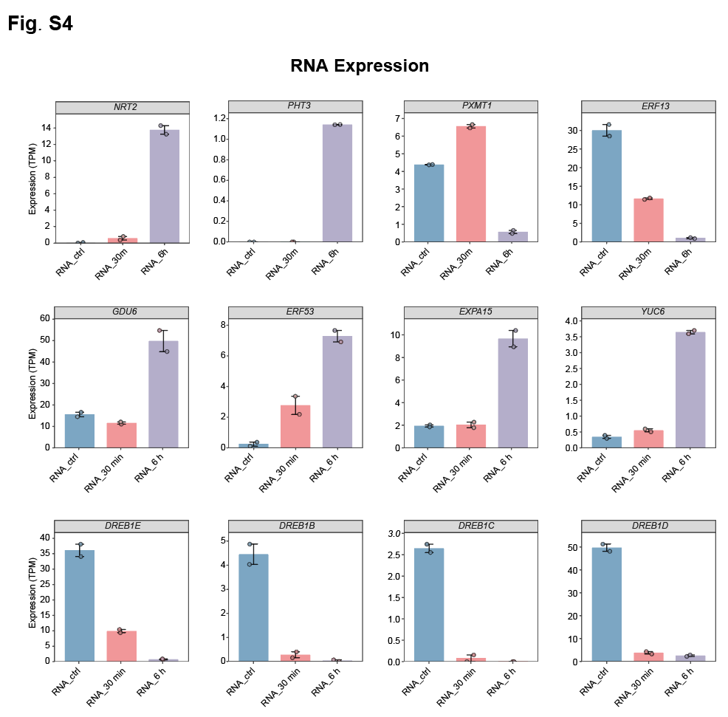
Figure S4. Genes with altered mRNA expression levels at 30 minutes and 6 hours post-WCS417 infection.

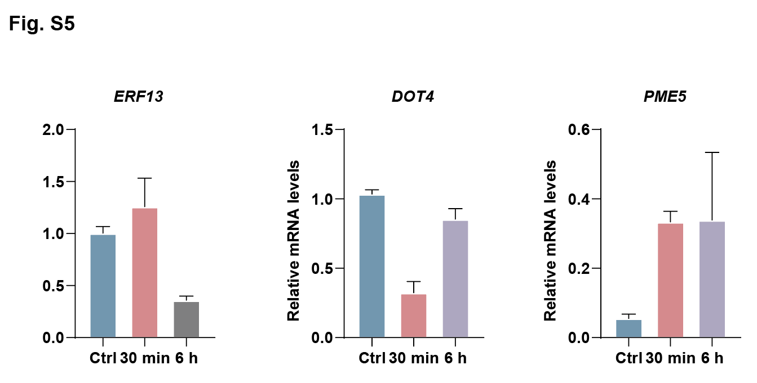
Figure S5. Genes with altered mRNA expression levels at 30 minutes and 6 hours post-WCS417 infection.

