SUPPLEMENTARY MATERIAL
1. Supplementary Material A — Distribution-based MID Estimation Methods
Abbr. | Full Name | Formula/ Definition | Notes | Ref.
ES | Effect size | $$ES=\frac{X_{1}-X_{0}}{\sqrt{{∑{\left(X_{0}-\overline{X_{0}}\right)}^{2}}/{\left(n-1\right)}}}$$ | Mean change between baseline and follow-up, divided by the baseline SD, representing the “signal-to-noise ratio.” An ES of 0.5 was used as the threshold for a “small” effect. | Cohen, 1988^{[1]}
SD | Standard deviation | $$SD=\sqrt{\frac{1}{n-1}\sum_{i=1}^{n}{{\left(X_{0}-\overline{X_{0}}\right)}^{2}}}$$ | Baseline SD. | Normanet al., 2003^{[2]}
SEM | Standard error of measurement | $${SEM=SD}_{Baseline}\sqrt{1-r}$$ | Calculated at baseline and follow-up, reflecting the extent of variation attributable to instrument unreliability. r represents the test-retest reliability coefficient. | Wyrich et al., 1999^{[3]}
MDC | Minimal detectable change | $${MDC}_{ind}=SEM*z_{score}*\sqrt{2}$$  ${MDC}_{group}={MDC}_{ind}÷\sqrt{n}$  $$Ratio=MID÷MDC$$ | A z-score of 1.64 corresponds to a 90% confidence level, and a z-score of 1.96 corresponds to a 95% confidence level. | Schmitt et al., 2007^{[4]} and de Boer et al., 2005 ^{[5]}
x₀ = pre-test score; x₁ = post-test score; n = sample size.
REFERENCES
[1] Kazis LE, Anderson JJ, Meenan RF. Effect sizes for interpreting changes in health status. Med Care 1989;27(3 Suppl):S178-89. doi: 10.1097/00005650-198903001-00015.
[2] Norman GR, Sloan JA, Wyrwich KW. Interpretation of changes in health-related quality of life: the remarkable universality of half a standard deviation. Med Care 2003;41(5):582-92. doi: 10.1097/01.Mlr.0000062554.74615.4c.
[3] Wyrwich KW, Tierney WM, Wolinsky FD. Further evidence supporting an SEM-based criterion for identifying meaningful intra-individual changes in health-related quality of life. J Clin Epidemiol 1999;52(9):861-73. doi: 10.1016/s0895-4356(99)00071-2.
[4] Schmitt JS, Di Fabio RP. Reliable change and minimum important difference (MID) proportions facilitated group responsiveness comparisons using individual threshold criteria. J Clin Epidemiol 2004;57(10):1008-18. doi: 10.1016/j.jclinepi.2004.02.007.
[5] de Boer MR, de Vet HC, Terwee CB, et al. Changes to the subscales of two vision-related quality of life questionnaires are proposed. J Clin Epidemiol 2005;58(12):1260-8. doi: 10.1016/j.jclinepi.2005.04.007.

2. Supplementary Material B — Supplementary Tables and Figures

eTable 1. Distribution of EQ-5D-3L utility index and modified Rankin scale (mRS) scores.
Distribution of EQ-5D Measurement Results
 | Scale | N |  | Mean (SD) | Median |  | Max |  | Min
V 1 | EQ-5D-3L | 9998 |  | 0.546 (0.327) | 0.597 |  | 1.00 |  | -0.149
V 1 | EQ-VAS |  |  | 64.9 (19.8) | 70 |  | 100 |  | 0
V 2 | EQ-5D-3L | 9980 |  | 0.709 (0.306) | 0.783 |  | 1.00 |  | -0.149
V 2 | EQ-VAS |  |  | 78.1 (17.4) | 80 |  | 100 |  | 0
V 3 | EQ-5D-3L | 9264 |  | 0.801 (0.259) | 0.875 |  | 1.00 |  | -0.149
V 3 | EQ-VAS |  |  | 83.1 (15.1) | 90 |  | 100 |  | 0
V 4 | EQ-5D-3L | 8576 |  | 0.846 (0.237) | 1.00 |  | 1.00 |  | -0.149
V 4 | EQ-VAS |  |  | 85.8 (14.2) | 90 |  | 100 |  | 0
Distribution of Modified Rankin Scale Scores Results, No. (%)
 | V 1 |  | V 2 |  |  | V 3 |  | V 4
0 | 453 (4.53) |  | 1501 (15.04) |  |  | 2108 (22.75) |  | 2547 (29.70)
1 | 3166 (31.67) |  | 3821 (38.29) |  |  | 3801 (41.03) |  | 3497 (40.78)
2 | 2073 (20.73) |  | 1682 (16.85) |  |  | 1507 (16.27) |  | 1257 (14.66)
3 | 1333 (13.33) |  | 1122 (11.24) |  |  | 939 (10.14) |  | 648 (7.56)
4 | 1890 (18.90) |  | 1256 (12.59) |  |  | 639 (6.90) |  | 415 (4.84)
5 | 1083 (10.83) |  | 597 (5.98) |  |  | 264 (2.85) |  | 209 (2.44)
6 | 0 (0.00) |  | 1 (0.01) |  |  | 6 (0.06) |  | 3 (0.03)

eTable 2. MIDs for EQ-5D-5L from the anchor-, distribution-, and instrument-based methods.
 | EQ-5D-3L Utility Index
Direction of Change | Method | V2 | 95%CIª | V3 | 95%CI | V4 | 95%CI
All | Anchor-based
All | AC | 0.180 | 0.174, 0.187 | 0.104 | 0.096, 0.111 | 0.065 | 0.058, 0.073
All | CD | 0.100 | 0.092, 0.107 | 0.068 | 0.061, 0.076 | 0.044 | 0.037, 0.052
All | Regression | 0.217 | 0.212, 0.222 | 0.157 | 0.152, 0.162 | 0.129 | 0.124, 0.133
All | Pooled_{group} | 0.166 | 0.147, 0.185 | 0.110 | 0.092, 0.127 | 0.079 | 0.062, 0.096
All | ROC | NA | NA | NA | NA | NA | NA
All | Distribution-based
All | 0.2SD | 0.065 | NA | 0.061 | NA | 0.052 | NA
All | 0.5SD | 0.163 | NA | 0.153 | NA | 0.129 | NA
All | SEM | 0.180 | NA | 0.163 | NA | 0.139 | NA
All | 0.5ES | 0.249 | NA | 0.15 | NA | 0.087 | NA
All | Pooled | 0.164 | NA | 0.132 | NA | 0.102 | NA
All | Instrument-defined^{b}
All | idMID | 0.120 | NA | 0.108 | NA | 0.108 | NA
Improve | Anchor-based
Improve | AC | 0.216 | 0.209, 0.222 | 0.153 | 0.145, 0.160 | 0.119 | 0.111, 0.126
Improve | CD | 0.135 | 0.128, 0.143 | 0.117 | 0.109, 0.125 | 0.098 | 0.090, 0.106
Improve | Regression | 0.216 | 0.210, 0.221 | 0.153 | 0.147, 0.158 | 0.119 | 0.113, 0.125
Improve | Pooled_{group} | 0.189 | 0.172, 0.206 | 0.141 | 0.125, 0.157 | 0.112 | 0.096, 0.128
Improve | ROC | 0.104 | 0.093, 0.168 | 0.007 | 0.006, 0.096 | NA
Improve | Distribution-based
Improve | 0.2SD | 0.066 | NA | 0.059 | NA | 0.050 | NA
Improve | 0.5SD | 0.165 | NA | 0.147 | NA | 0.126 | NA
Improve | SEM | 0.169 | NA | 0.146 | NA | 0.124 | NA
Improve | 0.5ES | 0.286 | NA | 0.139 | NA | 0.102 | NA
Improve | Pooled | 0.172 | NA | 0.123 | NA | 0.101 | NA
Improve | Instrument-defined
Improve | idMID | 0.091 | NA | 0.093 | NA | 0.093 | NA
Deteriorate | Anchor-based
Deteriorate | AC | 0.086 | 0.063, 0.109 | 0.084 | 0.071, 0.098 | 0.087 | 0.073, 0.100
Deteriorate | CD | 0.166 | 0.144, 0.189 | 0.12 | 0.106, 0.134 | 0.108 | 0.095, 0.121
Deteriorate | Regression | 0.086 | 0.071, 0.101 | 0.084 | 0.073, 0.095 | 0.087 | 0.078, 0.096
Deteriorate | Pooled_{group} | 0.113 | 0.087, 0.138 | 0.096 | 0.083, 0.109 | 0.094 | 0.081, 0.107
Deteriorate | ROC | NA | NA | NA | NA | NA | NA
Deteriorate | Distribution-based
Deteriorate | 0.2SD | 0.066 | NA | 0.069 | NA | 0.055 | NA
Deteriorate | 0.5SD | 0.164 | NA | 0.172 | NA | 0.137 | NA
Deteriorate | SEM | 0.168 | NA | 0.164 | NA | 0.132 | 0.168
Deteriorate | 0.5ES | 0.071 | NA | 0.215 | NA | 0.079 | NA
Deteriorate | Pooled | 0.117 | NA | 0.155 | NA | 0.101 | NA
Deteriorate | Instrument-defined
Deteriorate | idMID | 0.148 | NA | 0.123 | NA | 0.123 | NA
Abbreviations: EQ-5D-3L, three-level EuroQol five-dimensional questionnaire; CI, confidence interval (based on 1000 bootstrap replicates); AC, average change; CD, change difference; ROC, receiver operating characteristic; ES, effect size; NA, not applicable; SD, standard deviation; SEM, standard error of measurement; idMID, instrument-defined minimally important difference.
ª Interval estimation was derived by using bootstrapping with 5000 replicates. Pooled CI estimates combine individual SE² and observed MlD variance under-distribution, Values for direction of change deteriorate have been multiplied by -1.
^{b} The method of Instrument-defined was used to calculate the baseline, which V2 is the same as V3.

eTable 3. Sample sizes used for calculating anchor- and distribution-based methods.
Method | Direction of Change | Sample size
Method | Direction of Change | V2 |V1 | V3 |V2 | V4 |V3
Anchor-based | Minor change
Anchor-based | All | 3650 | 2909 | 2374
Anchor-based | Improve | 3220 | 2312 | 1756
Anchor-based | Deteriorate | 430 | 597 | 618
Anchor-based | No change | 4570 | 5254 | 5453
Anchor-based | Sum | 8220 | 8163 | 7827
Distribution-based | Major change
Distribution-based | All | 5374 | 3908 | 2943
Distribution-based | Improve | 4677 | 3138 | 2131
Distribution-based | Deteriorate | 697 | 770 | 812
Distribution-based | No change | 4570 | 5254 | 5453
Distribution-based | Sum | 9944 | 9162 | 8396

eTable 4. Performance of different minimal detectable change (MDC) and minimal important difference (MID) by ROC at the individual level.
Direction | Phase | Measure | Cut-point | Sensitivity, % | Specificity, % | PPV, % | NPV, %
Improve | Acute phase | MDC 95 | 0.468 | 23 | 98 | 92 | 45
Improve | Acute phase | MDC 90 | 0.392 | 29 | 97 | 90 | 43
Improve | Acute phase | MID individual | 0.104 | 78 | 64 | 69 | 26
Improve | Subacute phase | MDC 95 | 0.405 | 18 | 98 | 87 | 33
Improve | Subacute phase | MDC 90 | 0.339 | 25 | 98 | 86 | 31
Improve | Subacute phase | MID individual | 0.007 | 73 | 69 | 59 | 19
Improve | Chronic phase | MDC 95 | 0.344 | 13 | 99 | 84 | 25
Improve | Chronic phase | MDC 90 | 0.288 | 24 | 97 | 78 | 23
Improve | Chronic phase | MID individual | NA
Deteriorate | Acute phase | MDC 95 | 0.466 | 17 | 100 | 94 | 11
Deteriorate | Acute phase | MDC 90 | 0.390 | 27 | 100 | 94 | 10
Deteriorate | Acute phase | MID individual | NA
Deteriorate | Subacute phase | MDC 95 | 0.455 | 11 | 100 | 79 | 12
Deteriorate | Subacute phase | MDC 90 | 0.380 | 15 | 99 | 74 | 11
Deteriorate | Subacute phase | MID individual | NA
Deteriorate | Chronic phase | MDC 95 | 0.366 | 17 | 99 | 82 | 11
Deteriorate | Chronic phase | MDC 90 | 0.306 | 23 | 99 | 78 | 10
Deteriorate | Chronic phase | MID individual | NA
Abbreviations: MDC, meaningful detectable change.
Note. The receiver operator characteristic curve (ROC) with an area under the curve (AUC) below 0.7 was not reliable and was excluded from the analysis.

eTable 5. Credibility Assessment Results.
CREDIBILITY ASSESSMENT - CORE CRITERIA
Is the patient or necessary proxy responding directly to both the PROM and the anchor?
If a clinician or anyone else is responding to the anchor directly and the patients are capable of providing this information, the answer should be "no." Any other necessary proxy (e.g. caregiver, parent, wife, relative) responding to the anchor, the answer is "yes".
[ X ] Yes [ ] No [ ] Impossible to tell
Rationale: The data collection methods for PROMs and anchor measures in this study were as follows: admission and discharge follow-ups were conducted via face-to-face patient interviews, while all subsequent follow-ups were performed through telephone interviews with patients.
Is the anchor easily understandable and relevant for patients or necessary proxy?
With "easily understandable and relevant" we mean that, when presented with the anchor (either actually presented or hypothetically) as an outcome, and without too much education, the patients are able to understand the data provided for the outcome (anchor) and use it easily for decision-making. For example, when addressing a multi-item PROM addressing the potential therapeutic effects of an intervention for iron-deficiency anemia, an anchor of patient’s global rating of improvement in fatigue may be easier to understand and more relevant for decision- making than serum iron levels. If you were a patient, how would you answer this question?
[ X ] Definitely yes [ ] To a great extent [ ] Not so much [ ] Definitely no [ ] Impossible to tell
Rationale: The anchor mRS ratings selected for this study demonstrate high clinical relevance, simplicity of use, and robust reliability and validity.
Has the anchor shown good correlation with the PROM?
This assessment is made using the correlation coefficients reported by the authors. If the anchor is a transition question then this is correlation between the transition item and the PROM change score. For any other anchor, this is the correlation between the change in the anchor and the change in the PROM. If the study is cross-sectional, this is the correlation between the anchor and the PROM score. Only consider the absolute value of the correlation coefficient.
[ ] Definitely yes [ X ] To a great extent [ ] Not so much [ ] Definitely no [ ] Impossible to tell
≥0.7 ≥0.5 to <0.7 ≥0.3 to <0.5 <0.3
Rationale: The anchors selected in this study demonstrated strong correlations with the outcome measures. Specifically, the absolute values of correlation coefficients were: ≥0.606 for all changes, ≥0.561 for improve changes, and ≥0.355 for deteriorate changes.
Is the MID precise?
Precision around the MID estimate is quantified by the width of the 95% CI and expressed as a percentage. For example, if the MID estimate is 23.5 and the 95% CI ranges from 23.1 to 23.8, then precision may be calculated as: 23.8 一 23.1 / 23.5 * 100 = 3%. According to our guide provided for our responses to this credibility question, a result of 3% would warrant a rating of definitely yes. In many cases, the authors may not report any measure of variability (e.g. SD, SE, 95% CI). In these situations, we ask that you consider the sample size used to estimate the MID. We provide ranges for both situations (i.e. percentage of the confidence interval width in relation to the MID, and sample sizes) to help inform your judgment. If the judgments according to the two criteria differ, we suggest using the higher (more permissive) of the two ratings.
[ X ] Definitely yes [ ] To a great extent [ ] Not so much [ ] Definitely no [ ] Impossible to tell
≤10% or ≥200 patients 11-25% or 150-199 patients 26-49% or 100-149 patients ≥50% or <100 patients

Rationale: The study calculated both the percentage of the confidence interval width relative to the MID and the sample size, ultimately selecting the more lenient criterion. The results showed that the study included a sample size of 9,978 participants, which far exceeds the threshold of 200 patients.
Does the threshold or difference between groups on the anchor used to estimate the MID reflect a small but important difference?
Establishing the degree of change on a PROM that constitutes the MID requires some knowledge about the degree of change on the anchor that is small but important to patients. In addition to inspecting the threshold on the anchor, it is necessary to judge whether the method of analysis indeed calculates a small but important difference. Below, we present examples and provide associated guidance.
For transition rating anchors, consider the wording and number of responses. For instance, the mean change in PROM score in patients with a transition rating anchor scale designation of (a little better’ on a seven-point scale including the categories (much worse, somewhat worse, a little worse, no change, a little better, somewhat better, much better, ’ as reflecting an MlD would warrant a definitely yes, whereas a choice of "much better" would warrant a definitely no.
In some cases, authors may use a threshold for their analysis and include only patients who achieved this threshold; other times, they may include patients who achieved this threshold or greater. For instance, the investigators may define the MID as the mean change in the PROM score in patients who achieved a ≥5% change in weight loss. This approach includes even those patients who had a 10%, 30% or 50% reduction in weight loss and thus would warrant a definitely no.
[ X ] Definitely yes [ ] To a great extent [ ] Not so much [ ] Definitely no [ ] Impossible to tell

Rationale: In this large-scale prospective study, the threshold adopted a one-grade change in mRS ratings, which has demonstrated sensitivity in detecting clinically meaningful changes, as established through both the prospective study design and Delphi method validation.

eTable 6. Kruskal-Wallis test results.
TOAST Classification | V 1 (N=4475) |  | V 2 (N=4461) |  | V 3 (N=4143) |  | V 4 (N=3746)
TOAST Classification | Utility | N | Utility | N | Utility | N | Utility | N
SA | 0.678 | 1131 | 0.797 | 1129 | 0.864 | 1082 | 0.905 | 993
SOE | 0.610 | 159 | 0.782 | 105 | 0.846 | 96 | 0.888 | 86
SUE | 0.591 | 2890 | 0.763 | 158 | 0.849 | 147 | 0.883 | 127
LAA | 0.585 | 105 | 0.693 | 2880 | 0.787 | 2658 | 0.845 | 2401
CE | 0.218 | 190 | 0.505 | 189 | 0.656 | 160 | 0.734 | 139
statistic | 124.20 |  | 124.20 |  | 104.25 |  | 104.25
P | <.001 |  | <.001 |  | <.001 |  | <.001
Abbreviations: SA, small-artery occlusion; SOE, stroke of other explicit etiology; SUE, stroke of undetermined etiology; LAA, large-artery atherosclerosis; CE, cardioembolic infarction.

Table S7. Post-hoc Dunn-Bonferroni analysis.
V | group1 | group2 | statistic | Adjusted P | Adjusted P sig.
1 | LAA | CE | -6.814 | 0.000 | ****
1 | LAA | SA | 9.265 | 0.000 | ****
1 | LAA | SOE | 2.652 | 0.000 | ****
1 | LAA | SUE | 3.430 | 0.000 | ****
1 | CE | SA | 10.650 | 0.000 | ****
1 | CE | SOE | 6.369 | 0.058 | ns
1 | CE | SUE | 7.346 | 0.437 | ns
1 | SA | SOE | -0.606 | 0.761 | ns
1 | SA | SUE | -0.531 | 0.761 | ns
1 | SOE | SUE | 0.133 | 0.773 | ns
2 | LAA | CE | -6.814 | 0.000 | ****
2 | LAA | SA | 9.265 | 0.000 | ****
2 | LAA | SOE | 2.652 | 0.080 | ns
2 | LAA | SUE | 3.430 | 0.006 | **
2 | CE | SA | 10.650 | 0.000 | ****
2 | CE | SOE | 6.369 | 0.000 | ****
2 | CE | SUE | 7.346 | 0.000 | ****
2 | SA | SOE | -0.606 | 1.000 | ns
2 | SA | SUE | -0.531 | 1.000 | ns
2 | SOE | SUE | 0.133 | 1.000 | ns
3 | LAA | CE | -4.756 | 0.000 | ****
3 | LAA | SA | 7.938 | 0.000 | ****
3 | LAA | SOE | 2.606 | 0.092 | ns
3 | LAA | SUE | 2.563 | 0.104 | ns
3 | CE | SA | 7.998 | 0.000 | ****
3 | CE | SOE | 5.090 | 0.000 | ****
3 | CE | SUE | 5.274 | 0.000 | ****
3 | SA | SOE | -0.176 | 1.000 | ns
3 | SA | SUE | -0.784 | 1.000 | ns
3 | SOE | SUE | -0.387 | 1.000 | ns
4 | LAA | CE | -4.300 | 0.000 | ***
4 | LAA | SA | 7.734 | 0.000 | ****
4 | LAA | SOE | 2.169 | 0.301 | ns
4 | LAA | SUE | 1.315 | 1.000 | ns
4 | CE | SA | 7.377 | 0.000 | ****
4 | CE | SOE | 4.471 | 0.000 | ****
4 | CE | SUE | 4.027 | 0.001 | ***
4 | SA | SOE | -0.497 | 1.000 | ns
4 | SA | SUE | -1.833 | 0.669 | ns
4 | SOE | SUE | -0.842 | 1.000 | ns
Asterisks (*) indicate statistical significance: *P<.05, ** P<.01, *** P<.001, **** P<.0001; non-significant results denoted as “ns”. Note. SA > LAA > CE across Vs 2-4; SUE and SOE comparisons not significant.

eTable 8. Results of mixed-effects model regression.
Effect | Variable | Coefficient | 95% CIs | SE | P value
Fixed | Age | -0.0002 | (-0.001, 0.000) | 0.0002 | .181
Fixed | Gender
Fixed | Male | Reference
Fixed | female | 0.004 | (-0.002, 0.010) | 0.003 | .157
Fixed | Delta mRS | -0.148 | (-0.151, -0.145) | 0.002 | < .001
Fixed | Visit
Fixed | V2 | Reference
Fixed | V3 | -0.056 | (-0.063, -0.050) | 0.003 | < .001
Fixed | V4 | -0.071 | (-0.078, -0.064) | 0.004 | < .001
Fixed | TOAST
Fixed | CE | Reference
Fixed | LAA | -0.016 | (-0.031, 0.002) | 0.007 | .029
Fixed | SA | -0.021 | (-0.036, -0.006) | 0.008 | .006
Fixed | SOE | -0.012 | (-0.035, 0.012) | 0.012 | .326
Fixed | SUE | -0.014 | (-0.034, 0.007) | 0.011 | .187
Fixed | Intercept | 0.111 | 0.011 |  | < .001
Random | ID (Intercept) | 0.000
Random | Residual | 0.161

eTable 9. EQ-5D-3L utility index MID estimates from linear mixed effect model.
Visit | TOAST | MID estimate for improvement |  | MID estimate for deterioration
Visit | TOAST | Estimate (95% CI) | P value | Estimate (95% CI) | P value
V2 | LAA | 0.238 [0.232, 0.244] | <.0001 | -0.067 [-0.074, -0.060] | <.0001
V3 |  | 0.177 [0.172, 0.183] | <.0001 | -0.119 [-0.126, -0.113] | <.0001
V4 |  | 0.162 [0.157, 0.168] | .0001 | -0.134 [-0.141, -0.128] | .0001
V2 | CE | 0.261 [0.243, 0.280] | <.0001 | -0.060 [-0.079, -0.041] | <.0001
V3 |  | 0.193 [0.179, 0.208] | <.0001 | -0.104 [-0.119, -0.089] | <.0001
V4 |  | 0.178 [0.163, 0.193] | .0001 | -0.119 [-0.134, -0.104] | .0001
V2 | SA | 0.232 [0.224, 0.241] | <.0001 | -0.089 [-0.098, -0.080] | <.0001
V3 |  | 0.173 [0.165, 0.180] | <.0001 | -0.124 [-0.132, -0.117] | <.0001
V4 |  | 0.158 [0.150, 0.165] | .0001 | -0.139 [-0.147, -0.132] | .0001
V2 | SOE | 0.264 [0.239, 0.289] | <.0001 | -0.057 [-0.082, -0.032] | <.0001
V3 |  | 0.182 [0.163, 0.201] | <.0001 | -0.115 [-0.134, -0.096] | <.0001
V4 |  | 0.167 [0.148, 0.186] | .0001 | -0.130 [-0.149, 0.111] | .0001
V2 | SUE | 0.247 [0.227, 0.267] | <.0001 | -0.074 [-0.094, -0.054] | <.0001
V3 |  | 0.180 [0.164, 0.196] | <.0001 | -0.117 [-0.133, -0.101] | <.0001
V4 |  | 0.165 [0.149, 0.181] | .0001 | -.132 [-0.148, -0.116] | .0001

eFigure 1. Distribution of changes in modified Rankin scale (mRS) scores from V 1 (upper) and the previous adjacent visit (lower).
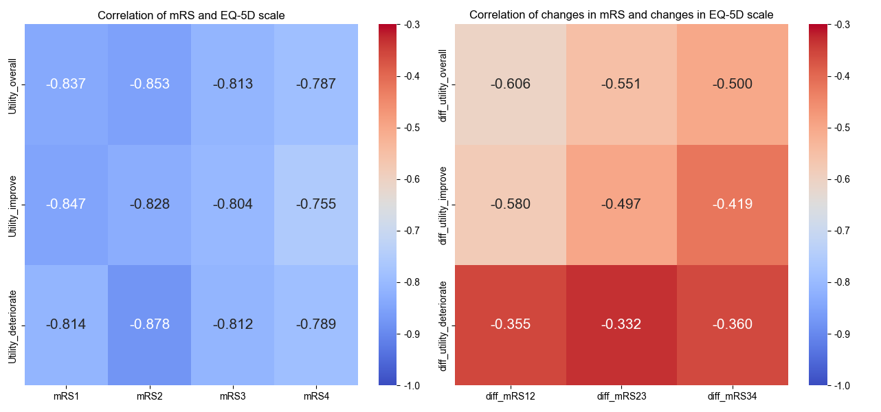

eFigure 2. Correlation between EQ-5D scale with mRS (left) and change in EQ-5D scale with change in mRS (right).
Note. The suffixes 2-4 of mRS represent V 2-4 respectively; 23 indicates the difference between V 3 and V 2, and 34 follow the same logic.

eFigure 3. Normal Q-Q plots assessing normality of Δutility.

eFigure 4. Scatter plot of EQ-5D utility change vs. mRS score change.

eFigure 5. Residuals versus fitted values and normal Q–Q plots for linear regression assumptions.
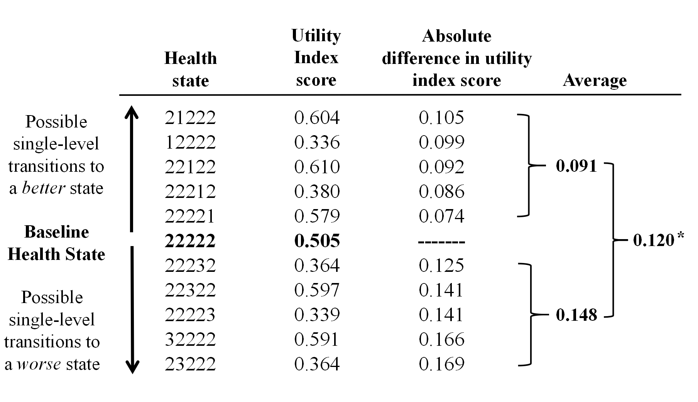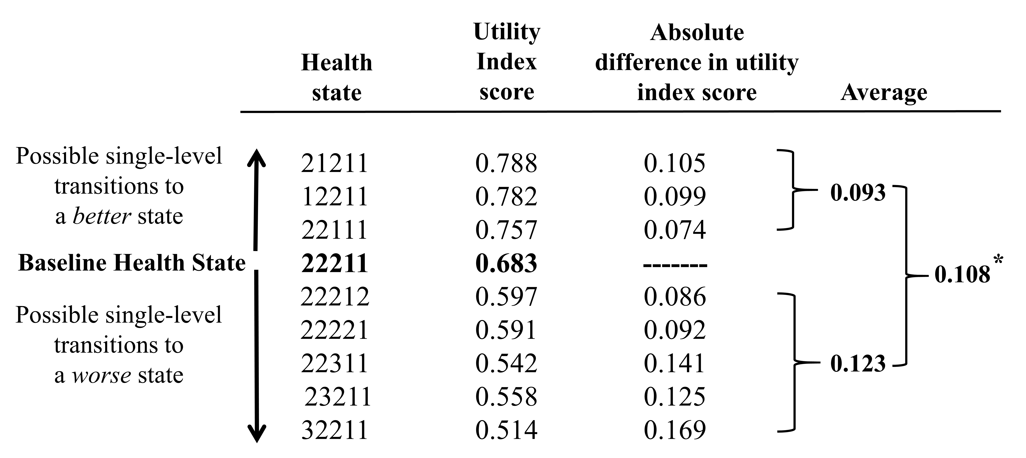

eFigure 6. Calculation of the instrument-defined MID estimate for the EQ-5D-3L index score on the basis of the Chinese scoring algorithm.
Note. Top: V1; Under: V2
The asterisk (*) denotes the average value of all changes, including both deterioration and improvement. Values have been rounded to three decimal places for display purposes, and thus the MlD estimate differs as a result of rounding error.

eFigure 7. The ratio of minimal importance differences (MID) to (minimal detectable change) MDC at the group level.
The blue box indicates that the group‑level MID exceeded measurement error

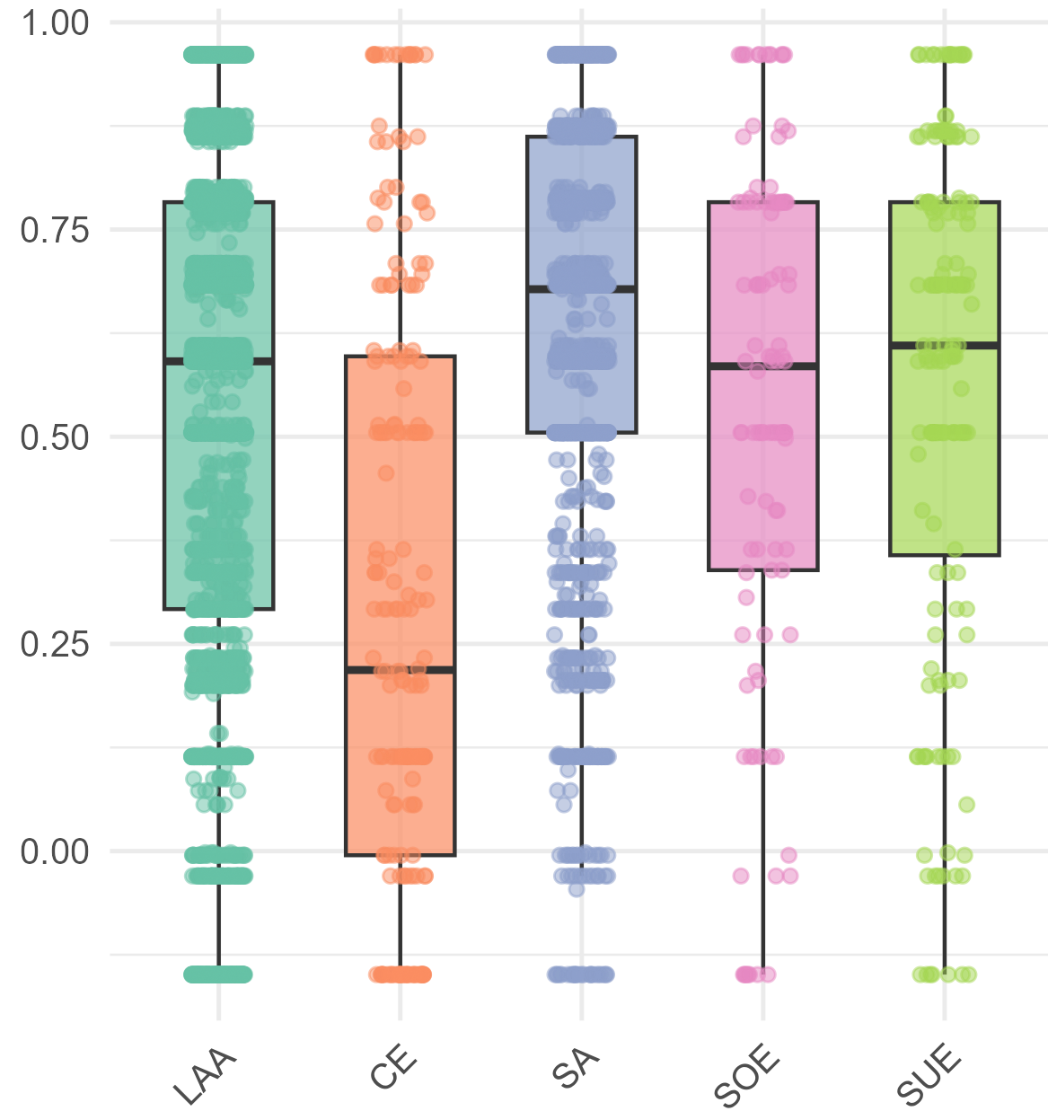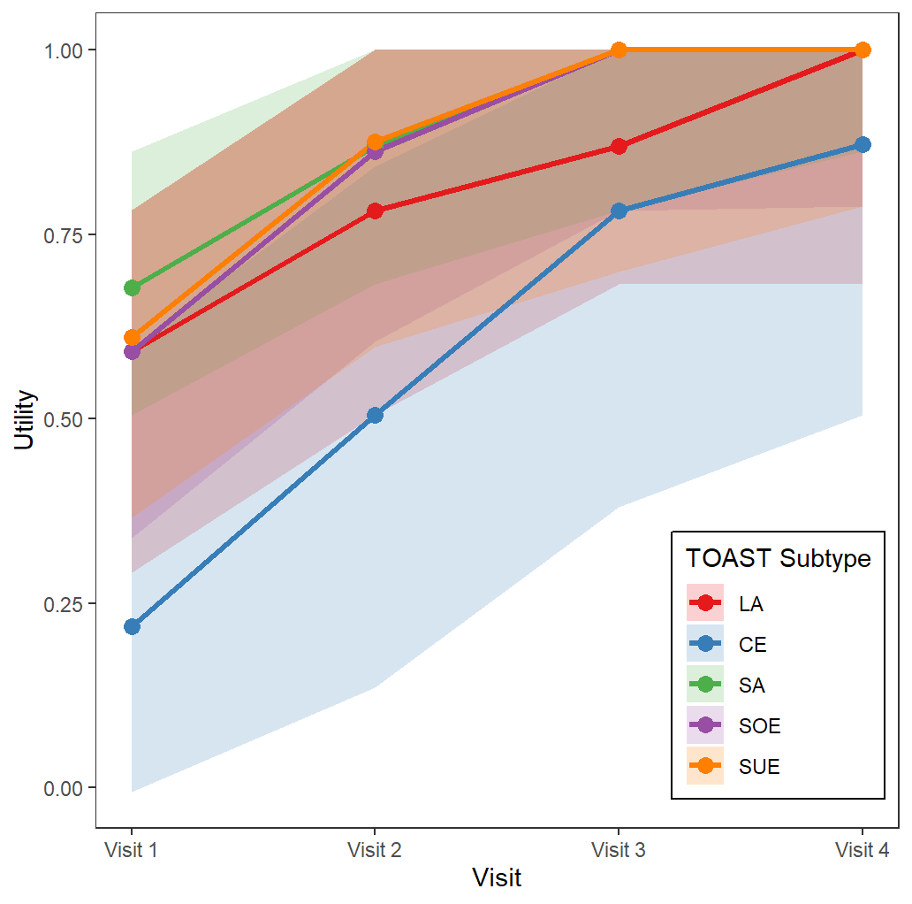

eFigure 8. Baseline utility distribution (left) and utility change (right) by TOAST subtype.
Note. Left: Boxplot (center=median, box=IQR); Right: Trend lines (line=median, ribbon=IQR)

eFigure 9. Overall minimal importance differences (MIDs) across three TOAST subtypes.
Abbreviations: CE, cardioembolic infarction; LAA, large-artery atherosclerosis; SA, small-artery occlusion.
Note Overall MIDs were derived by pooling minimal improvement and minimal deterioration, with Δ utility for deterioration multiplied by –1

eFigure 10. Distribution of Δ utility (Δ mRS=1, -1, 0) across three phases.

