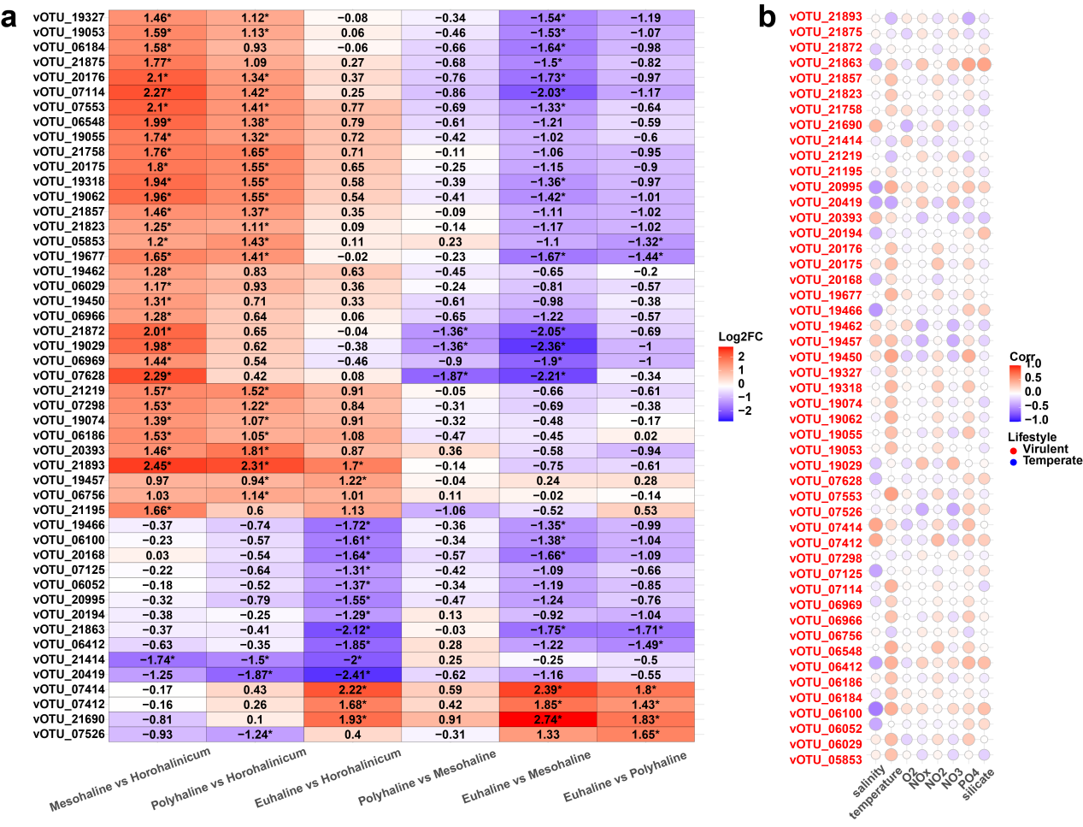
Fig.S1 Differential Viral Populations and Their Environmental Correlates. a. Heatmap of differential vOTUs identified using the ANCOM-BC2 trend test (p < 0.05). The log2 fold change values represent the relative abundance changes of vOTUs compared to each other and p-values are from ANCOM-BC2 pairwise directional test. Significant differences are indicated by asterisks (*p < 0.05, **p < 0.01, ***p < 0.001, ****p < 0.0001). b. Spearman correlation analysis of differential vOTUs with various environmental parameters (salinity (5.1-34.3PSU), temperature (9.8-29.5°C), dissolved oxygen (3.60-19mg L⁻¹), and nutrient concentrations (NO³⁻: 0.320-20.956 μM; NO²⁻: 0.000-2.023 μM; silicate: 0.259-40.879 μM; PO₄³⁻:0.026-4.876 μM).), with color-coded font indicating the strength and direction of the correlations: red for positive correlations and blue for negative correlations. The color represents the correlation coefficient, which ranges from -1 to 1 with a gradient from blue to red. Deeper colors indicate stronger correlations. The size of the circle represents the p-value, with smaller p-values corresponding to larger circles.

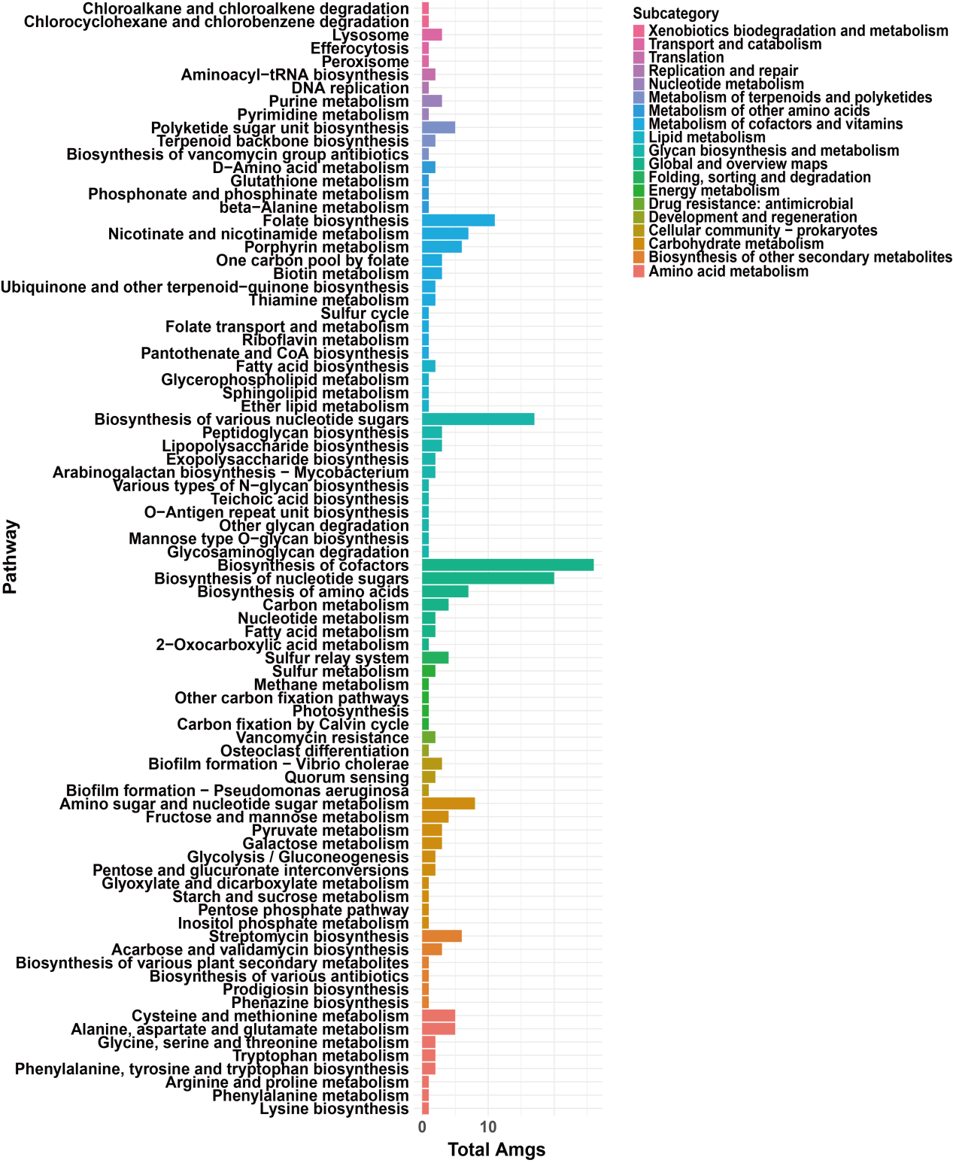
Fig.S2 Functional distribution of Ulva-associated bacterial phage AMGs based on KEGG Orthologs (KO).

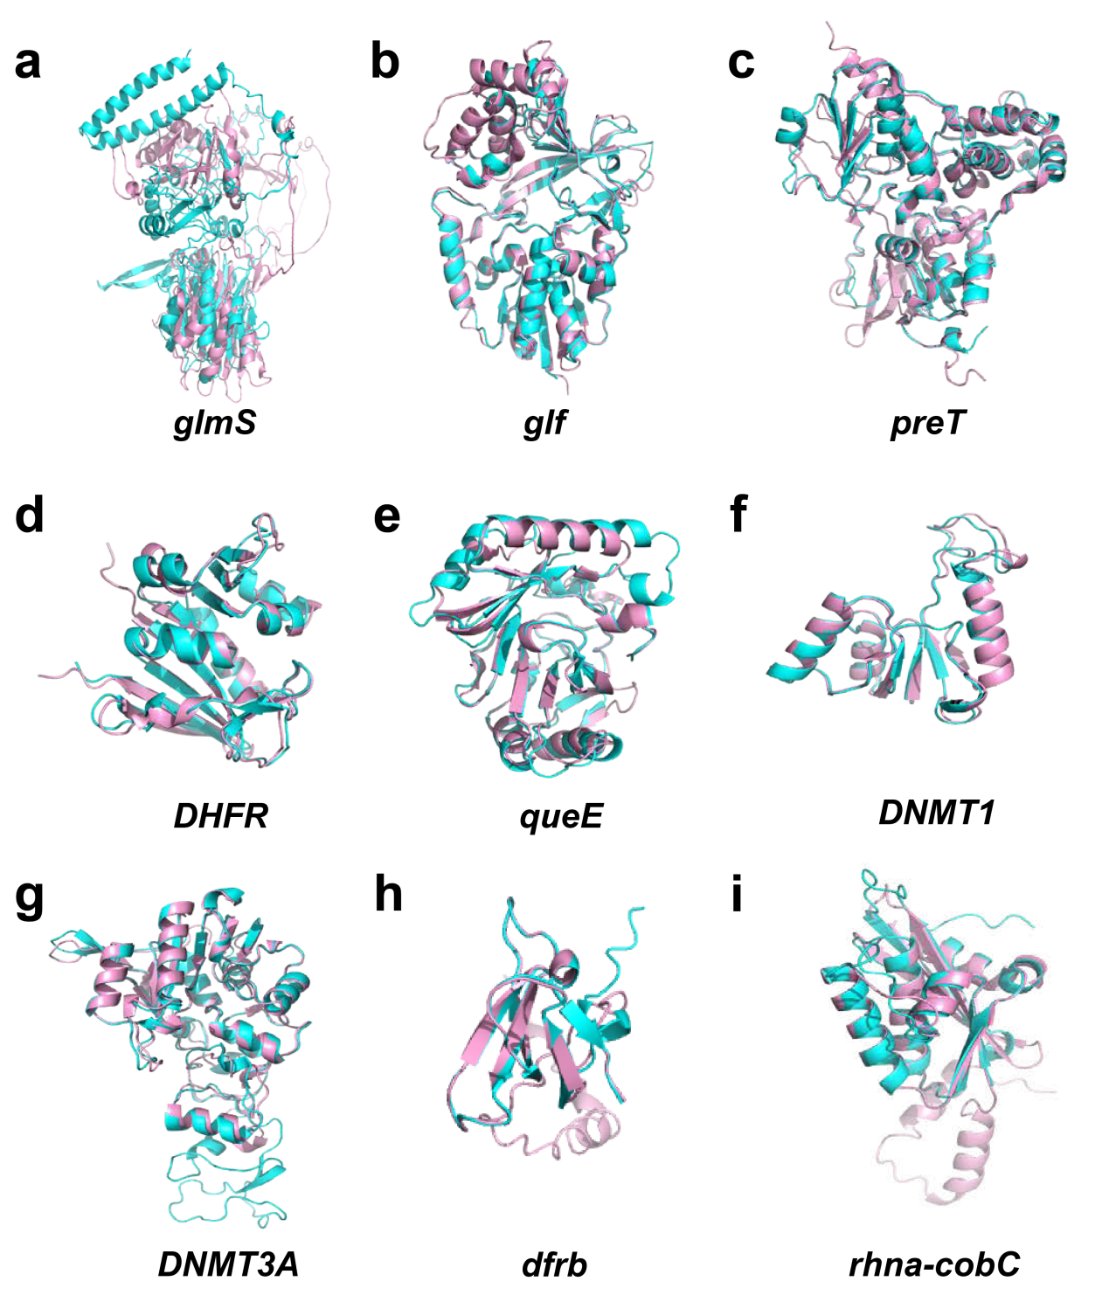
Fig.S3 Structural models of phage-encoded AMGs. Three-dimensional ribbon representations of nine AMGs (glmS, glf, preT, DHFR, queE, DNMT1, DNMT3A, dfrB, rhnA-cobC) are shown. Blue indicates the protein structures derived from the phage genomes, while pink denotes the highly similar homologous proteins from bacterial sources.

