Supplemental figures and legends
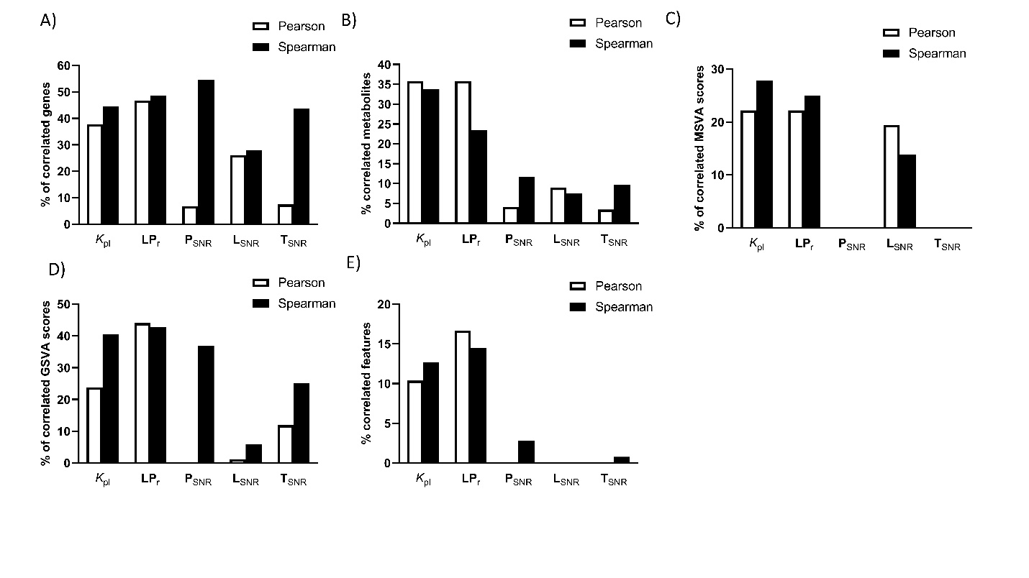
Supplemental Figure 1.
Metabolic imaging parameters correlate with many individual metabolic features.
Percentage of metabolic features that correlate with each individual ¹³C-HP-MRI imaging parameters, as determined by Pearson or Spearman correlation with A) 2522 metabolic transcript counts as determined by RNAseq, B) 84 individual metabolic pathways scores, determined by ssGSEA C) 145 different metabolite concentrations and D) 12319 different untargeted metabolomic features, determined by LC-MS analysis.
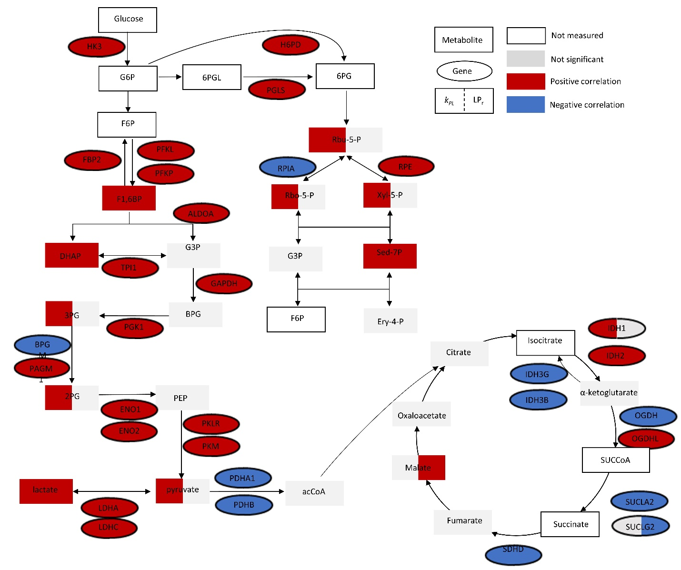
Supplemental Figure 2.
Diagram of glycolysis, pentose phosphate pathway and tricarboxylic acid cycle, highlighting the correlations between selected metabolites and genes with the ¹³C HP imaging parameters k_{PL} and LP_{r}.
Abbreviations for metabolite names are as follows, in alphabetical order: 2-PG (2-Phosphoglycerate), 3-PG (3-Phosphoglycerate), 6-PG (6-phosphogluconate), 6-PGL (6-phosphoglucono-δ-lactone), acCoA (Acetyl-Coenzyme), AKG (α-Ketoglutarate), BPG (Bisphosphoglycerate), DHAP (Dehydroxyacetonephosphate), Ery-4-P (Erythrose-4-phosphate), F1,6BP (Fructose-1,6-bisphosphate), F6P (Fructose-6-phosphate), FUM (Fumarate), G3P (Glyceraldehyde-3-phosphate), G6P (Glucose-6-phosphate), ISO (Isocitrate), Mal (Malate), OAA (Oxaloacetate), PEP (Phosphoenolpyruvate), Rbo-5-P (ribose-5-phosphate), Rbu-5-P (ribulose 5-phosphate), Sed-7-P (Sedeptulose-7-phosphate), SUC (Succinate), SuCCoa (Succinyl-CoenzymeA), Xyl-5-P (xylulose-5-phosphate).
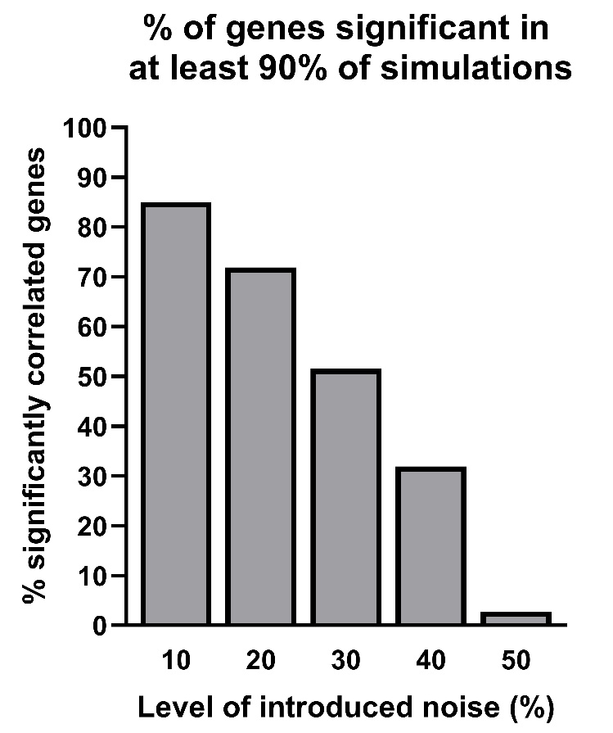
Supplemental Figure 3.
Introduction of small amounts of noise in k_{PL} does not significantly affect the number of correlations with gene expression data.
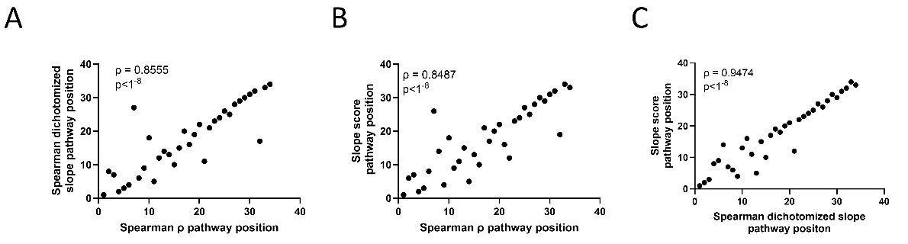
Supplemental Figure 4.
Different pathway consensus scoring algorithms show a high intercorrelation value.
(A-B) Correlation plots between different consensus scoring algorithms. (A) Dichotomized Pearson slope vs Spearman ρ, (B) Pearson slope vs Spearman ρ and (C) Pearson slope vs Dichotomized Pearson slope.
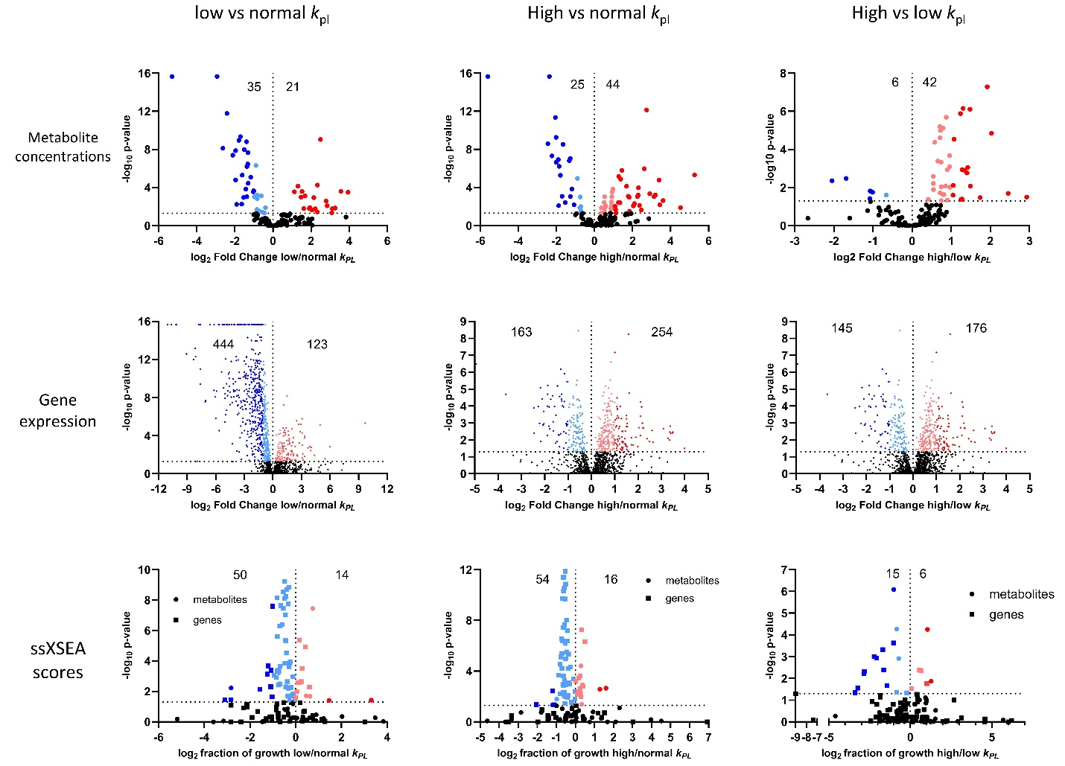
Supplemental Figure 5.
Highlighting differences between low k_{PL}, high k_{PL} and normal adjacent tissue.
A-I) Volcano plots of the ratios of (A,B,C) metabolite concentrations, (D,E,F) gene expression levels and (G,H,I) combined single sample metabolite set variation analysis score and single sample gene set variation analysis score (ssMSEA and ssGSEA, respectively), between (A,D,G) low k_{PL} regions and healthy tissue, (B,E,H) high k_{PL} regions and healthy tissue and adjacent healthy tissue and (C,F,I) high k_{PL} vs low k_{PL} regions. Light coloring indicates features increased by less than 2-fold and dark coloring indicate features increased by more than two-fold.

Supplemental Table 1.
Imaging parameters in individual biopsies
Supplemental Table 2.
RNAseq normalized gene counts.

Supplemental Table 3.
Metabolite concentrations in individual biopsies.

Supplemental Table 4.
Spearman and pearson correlation of metabolic genes and metabolic imaging parameters.

Supplemental Table 5.
Metabolic genes correlation parameters sorted by pathway.

Supplemental Table 6.
Spearman and pearson correlation of metabolites and metabolic imaging parameters.

Supplemental Table 7.
Metabolite correlation parameters sorted by pathway.

