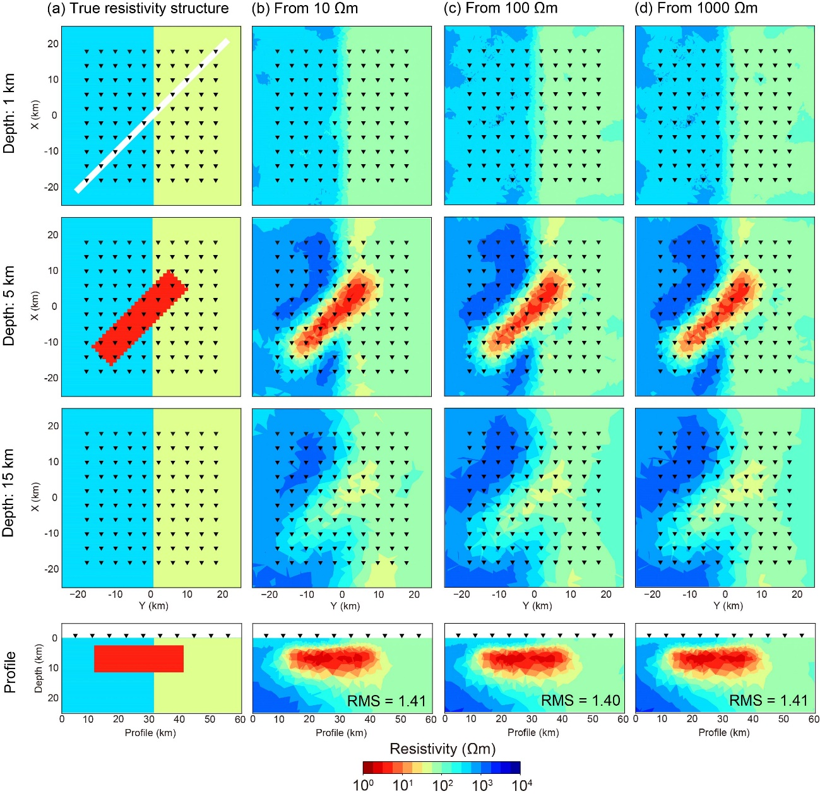
Figure S1. Electrical resistivity structures obtained by the combined inversion using the phase tensor and the vertical magnetic transfer function. (a) True resistivity structure (OC model). (b)-(c) Resultant resistivity structures obtained by the combined inversion with three different initial models. The lowermost panels are the vertical cross-sections of the profile along the major axis of the oblique conductor, which is shown as a white line in the upper-left panel. The inverted triangles indicate the locations of observation stations.

