Appendix

Templates for tables and figures
Table 1: Subject disposition by treatment group
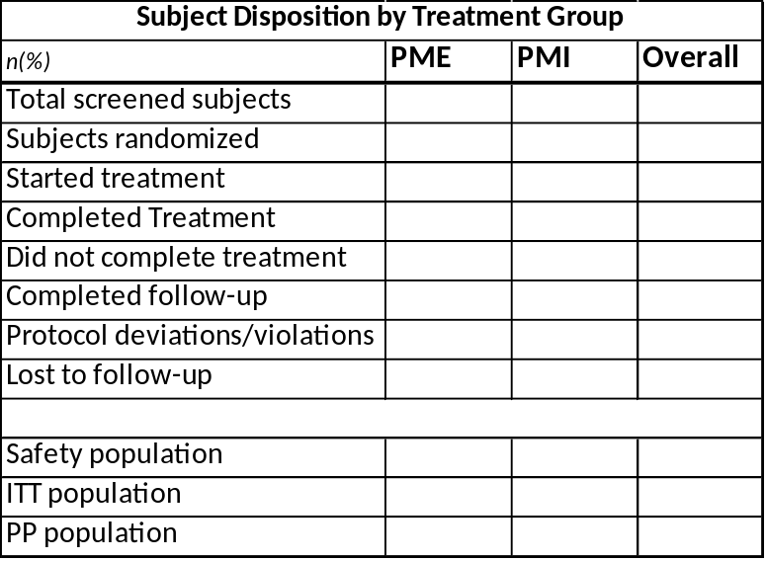
Abbreviations: Intention To Treat (ITT), Per Protocol (PP), Phantom Motor Execution (PME), Phantom Motor Imagery (PMI).

Table 2: Protocol Deviations Leading to Exclusion from PP Population (ITT Population)
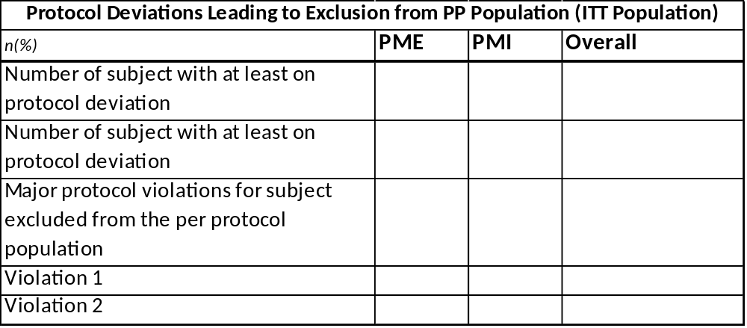
Abbreviations: Phantom Motor Execution (PME), Phantom Motor Imagery (PMI).

Table 3: Demographic and baseline characteristics for ITT population
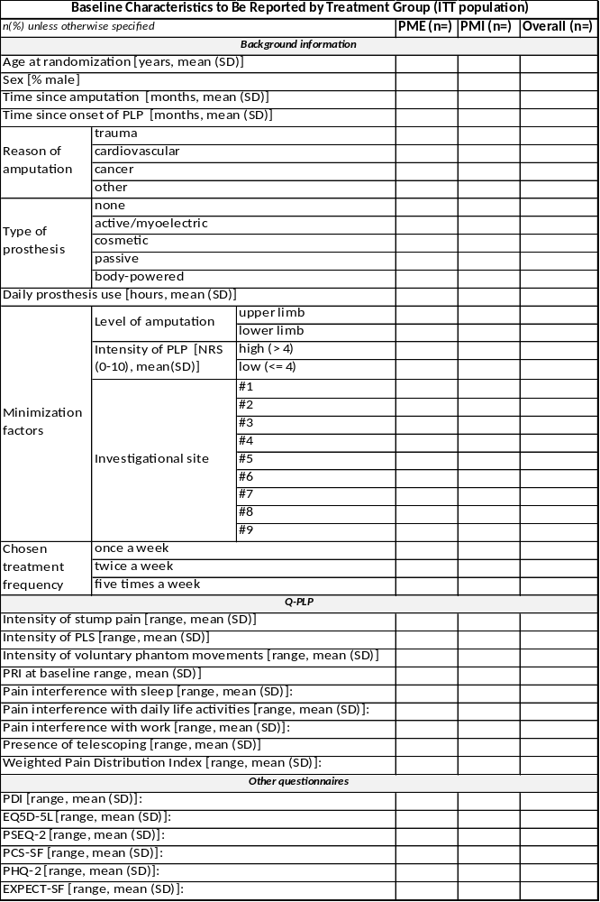
Abbreviations: Phantom Motor Execution (PME), Phantom Motor Imagery (PMI), Phantom Limb Pain (PLP), Numeric Rate Scale (NRS), Questionnaire for Phantom Limb Pain (Q-PLP), Pain Disability Index (PDI), 2-item Pain Self-Efficacy Questionnaire (PSEQ-2), Euroqol-5D-5L (EQ-5D-5L), Pain Catastrophizing Scale Short Form (PCS-SF), 2-item Patient Health Questionnaire (PHQ-2), Patients' Global Impression of Change (PGIC), Opinion About Treatment (OAT), Health Care Climate Questionnaire (HCCQ) and Expectations for Complementary and Alternative Medicine Treatments Short Form (EXPECT-SF).

Table 5: Prior medications
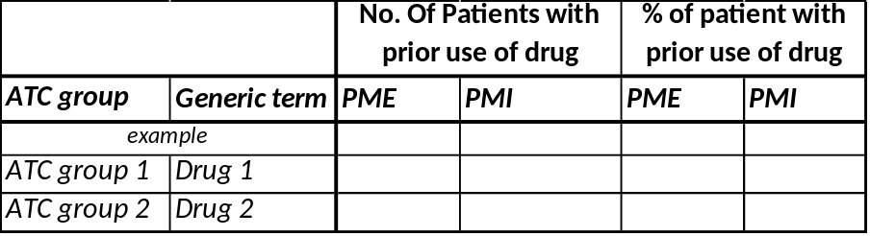
Abbreviations: Phantom Motor Execution (PME), Phantom Motor Imagery (PMI).

Table 7: Prior Treatment
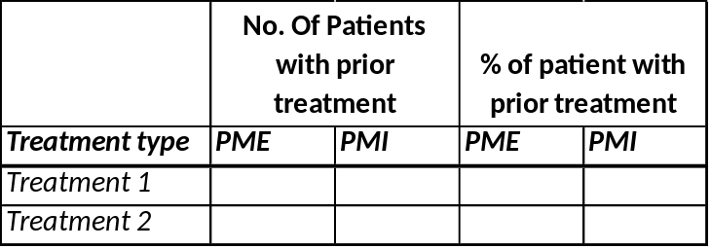
Abbreviations: Phantom Motor Execution (PME), Phantom Motor Imagery (PMI).

Table 6: Concomitant medications
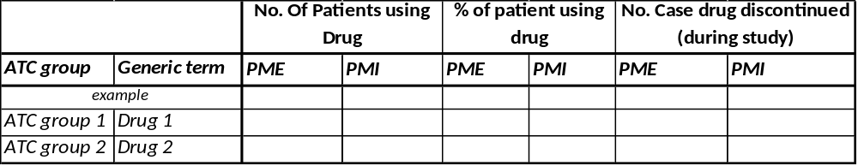
Abbreviations: Anatomical Therapeutic Chemical (ATC) group, Phantom Motor Execution (PME), Phantom Motor Imagery (PMI).

Table 8: Summary of outcome assessment schedule
Session | Summary of content
Visit 0 | - Patient Information (T/E)  - Study Consent (T/E)  - Pre-Assessment (T/E)  - Background Information (T/E)  - Q-PLP (T/E)  - PDI (T/E)  - EQ5D-5L (T/E)  - PSEQ-2 (T/E)  - PCS-SF (T/E)  - PHQ-2 (T/E)  - EXPECT-SF (T/E)
Randomization
Visit 1 | - Treatment session (T)  - Q-PLP (E)  - OAT (E)  - EXPECT-SF (E)  - HCCQ-SF (E)
Visit 2-14 | - Treatment session (T)  - Q-PLP (E)
Visit 15 | - Treatment session (T)  - Q-PLP (E)  - PDI (E)  - EQ5D-5L (E)  - PSEQ-2 (E)  - PCS-SF (E)  - PHQ-2 (E)  - PGIC (E)  - HCCQ-SF (E)
1-month follow-up | - Q-PLP (E)  - PDI (E)  - EQ5D-5L (E)  - PSEQ-2 (E)  - PCS-SF (E)  - PHQ-2 (E)
3-month follow-up
6-month follow-up

Abbreviations: Questionnaire for Phantom Limb Pain (Q-PLP), Pain Disability Index (PDI), 2-item Pain Self-Efficacy Questionnaire (PSEQ-2), Euroqol-5D-5L (EQ-5D-5L), Pain Catastrophizing Scale Short Form (PCS-SF), 2-item Patient Health Questionnaire (PHQ-2), Patients' Global Impression of Change (PGIC), Opinion About Treatment (OAT), Health Care Climate Questionnaire (HCCQ) and Expectations for Complementary and Alternative Medicine Treatments Short Form (EXPECT-SF).

Table 11: Summary of Adverse Events (ITT Population)
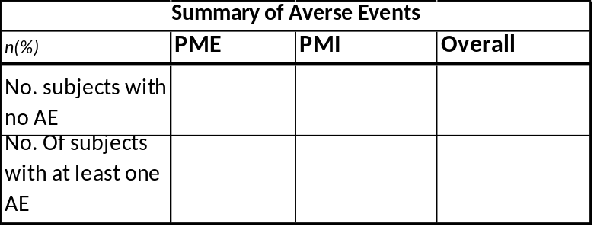
Abbreviations: Phantom Motor Execution (PME), Phantom Motor Imagery (PMI).
Table 9: Primary Efficacy Analysis (ITT Population)
Mean Changes in Primary efficacy outcome and group difference (p-value)
Analysis |  | Mean change from baseline |  |  |  | Between group differences
Analysis |  | PME | PMI |  |  | PME vs PMI | Effect size | p-value
Main unadjusted comparison
Adjusted comparison

Abbreviations: Phantom Motor Execution (PME), Phantom Motor Imagery (PMI).

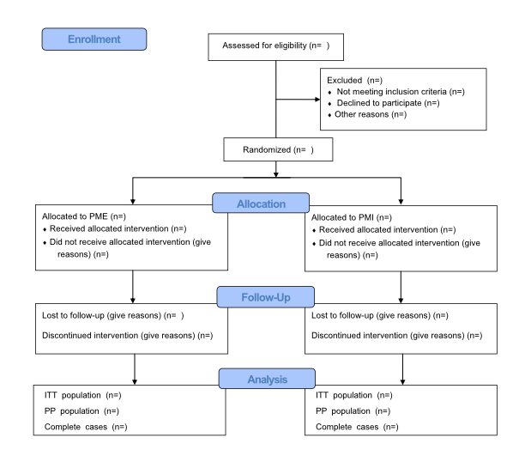
Figure 1: CONSORT flowchart. Abbreviations: Phantom Motor Execution (PME), Phantom Motor Imagery (PMI).

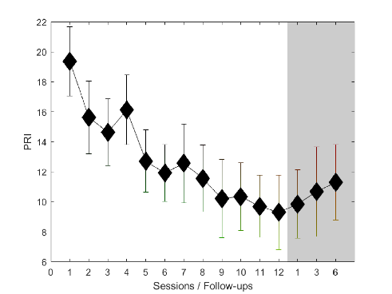
Figure 2: Example of Subjects Profile of Pain rating Index (PRI) over time by Treatment Group

