Supplementary files
Within-season flexibility in migration strategies in a migratory songbird
This supplementary file includes:
Supplementary file 1
Supplementary file 2
Supplementary file 3

Supplementary file 1
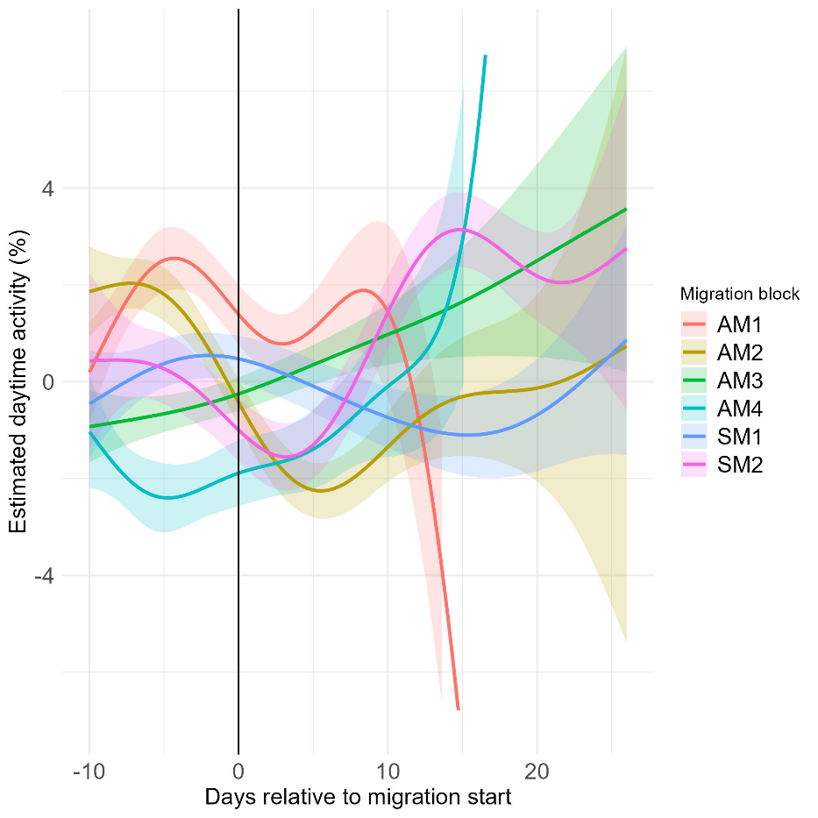
Supplementary figure 1. Estimated changes in diurnal activity (%) in relation to the onset of migratory flight periods, derived from a generalized additive mixed model (GAMs). Each coloured line represents a different migratory block (AM1–AM4 = autumn migration periods; SM1–SM2 = spring migration periods, corresponding to Figure 2), with shaded areas indicating 95% confidence intervals. Day 0 (vertical line) marks the first day of each migratory period. The curves illustrate how diurnal activity tends to fluctuate before, during, and after the onset of migration, with distinct dynamics across different migratory periods.
Supplementary table 1. Estimated marginal means (± SE) of daytime activity percentage by migration period. Periods sharing the same letter are not significantly different (α = 0.05).
Period | EMM (± SE) | Lower CL | Upper CL | Group
AM1 | 6.74 ± 0.33 | 5.81 | 7.68 | de
AS1 | 8.50 ± 0.23 | 7.82 | 9.18 | f
AM2 | 3.13 ± 0.28 | 2.32 | 3.93 | a
AS2 | 5.57 ± 0.19 | 4.94 | 6.19 | c
AM3 | 4.16 ± 0.34 | 3.20 | 5.12 | ab
AS3 | 4.99 ± 0.23 | 4.30 | 5.67 | bc
AM4 | 3.75 ± 0.33 | 2.80 | 4.70 | a
SM1 | 5.80 ± 0.31 | 4.92 | 6.68 | cd
SS1 | 7.91 ± 0.38 | 6.84 | 8.99 | ef
SM2 | 6.72 ± 0.28 | 5.91 | 7.53 | de

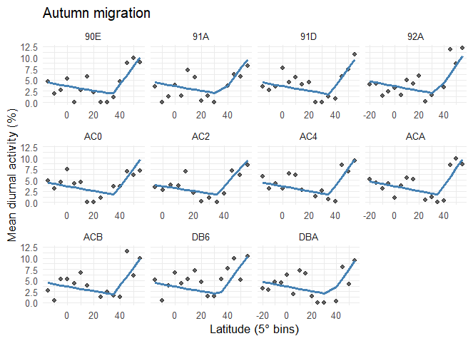
Supplementary figure 2. Individual relationships between latitude (5° bins) and mean diurnal activity (%) during autumn migration. Each panel shows one bird (ID given above each plot). Black points represent observed mean diurnal activity within each latitude bin, and blue lines show fitted segmented mixed-effects model. Across individuals, diurnal activity generally declined with decreasing latitude until around 30–35°N, after which activity increased again toward lower latitudes.
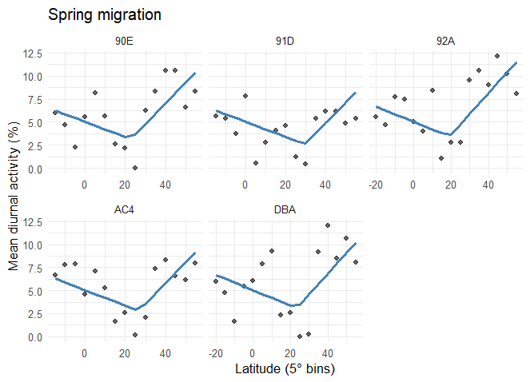
Supplementary figure 3. Individual relationships between latitude (5° bins) and mean diurnal activity (%) during spring migration. Each panel shows one bird (ID given above each plot). Black points represent observed mean diurnal activity within each latitude bin, and blue lines show fitted segmented mixed-effects model. Across individuals, diurnal activity generally declined with decreasing latitude until around 20–25°N, after which activity increased again toward the higher latitudes as the approached the breeding grounds.

Supplementary file 2
Includes pressure derived positions for each individual thrush nightingale in this study. Bown line connects autumn migration stopovers, black lines connect spring migration stopovers. Dates are given for stopovers lasting more than 5 days in duration. Maps have an orthographic projection.

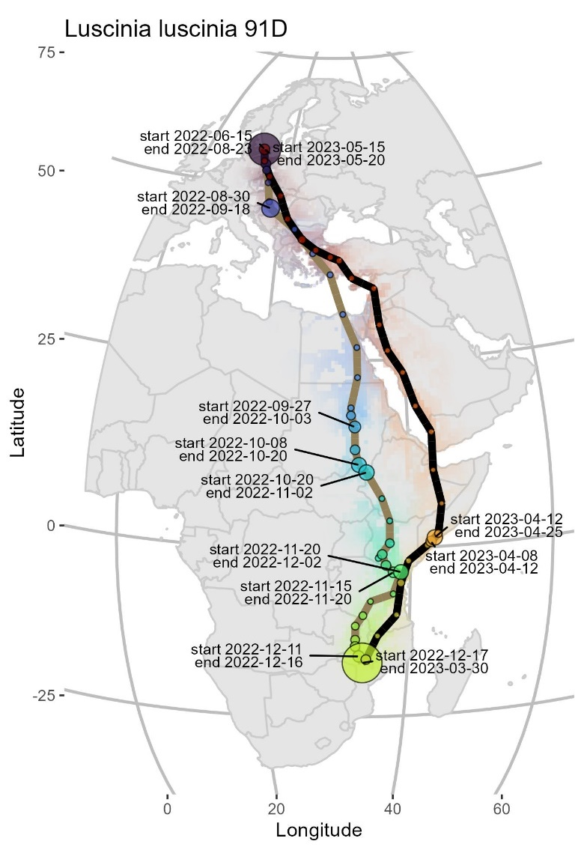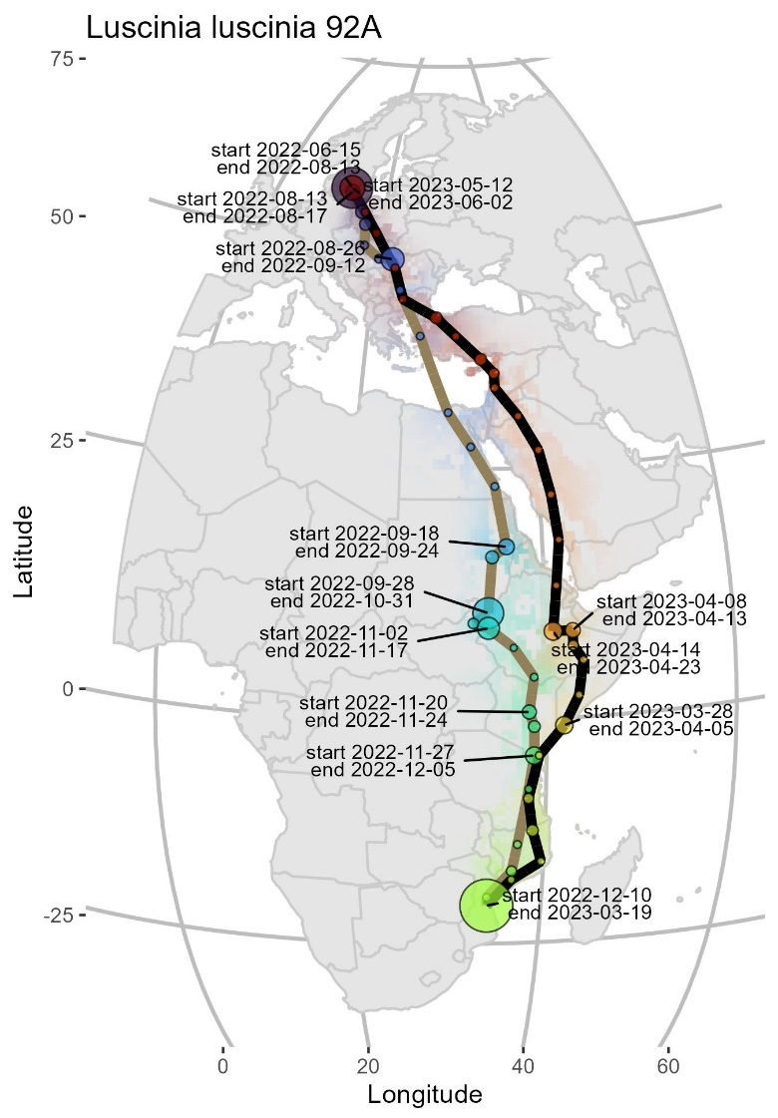
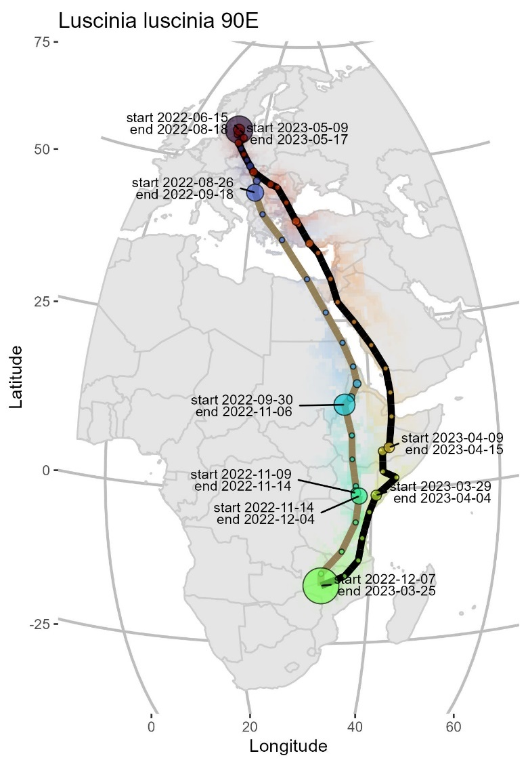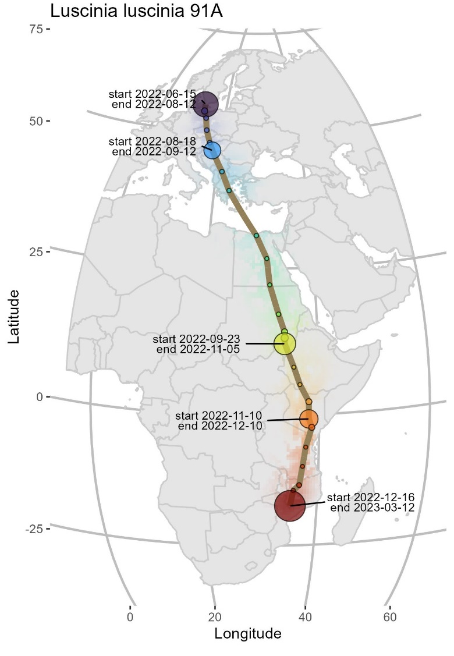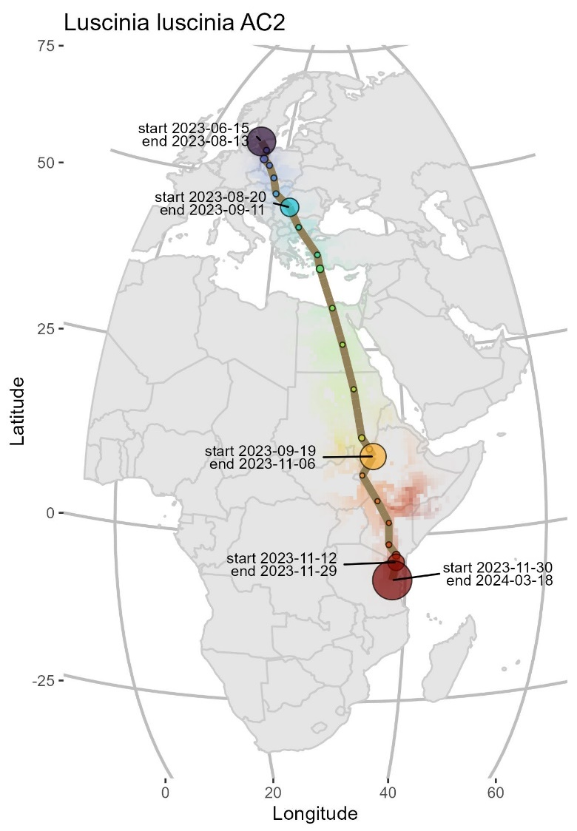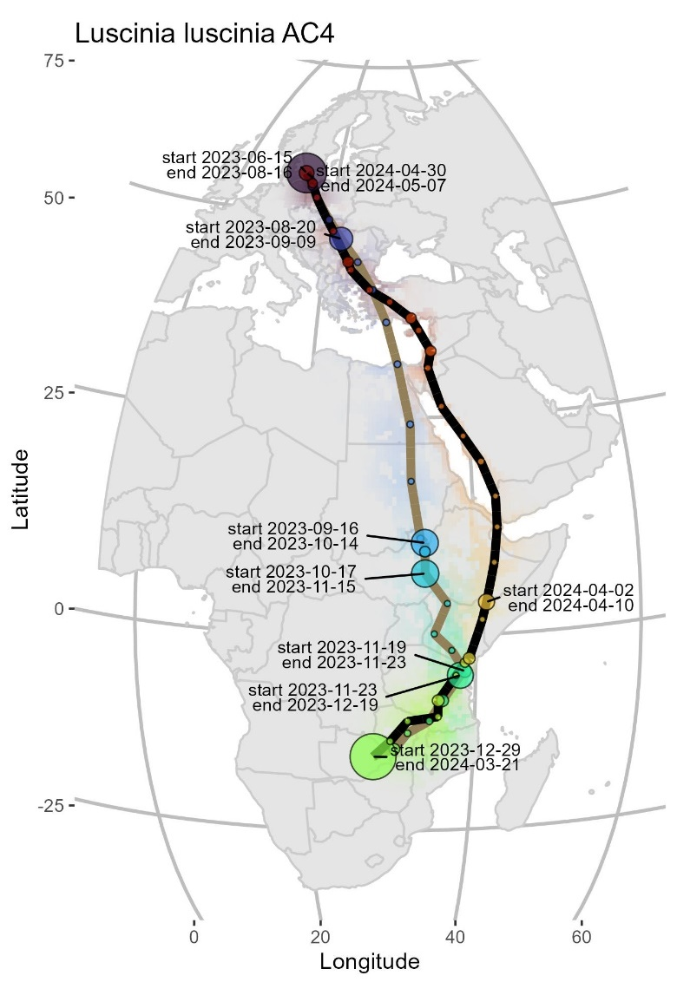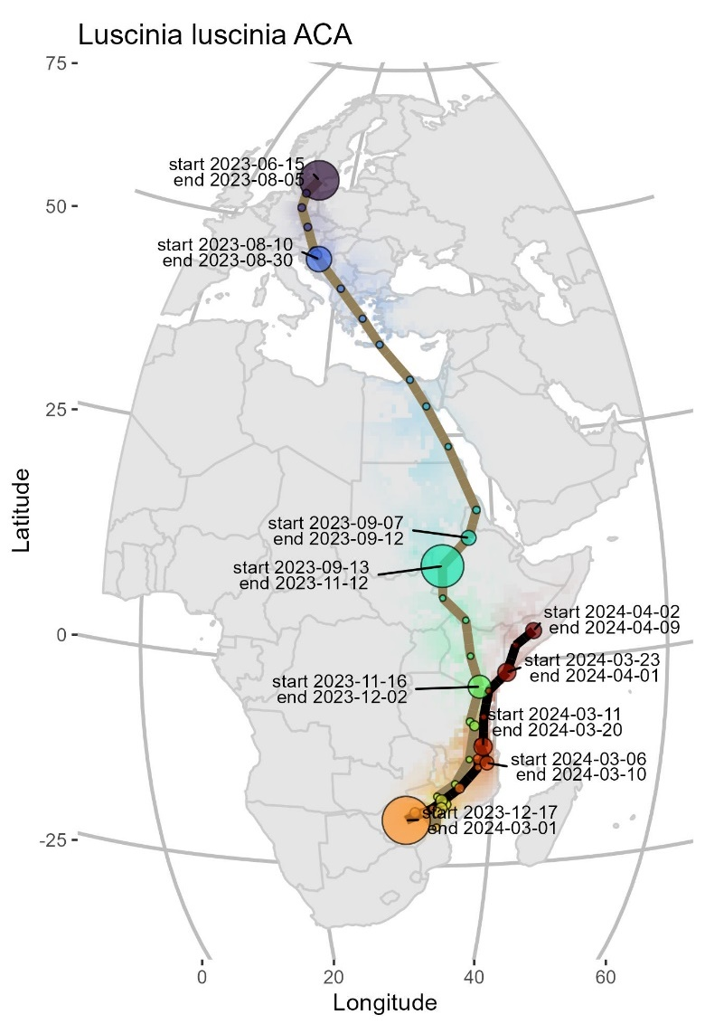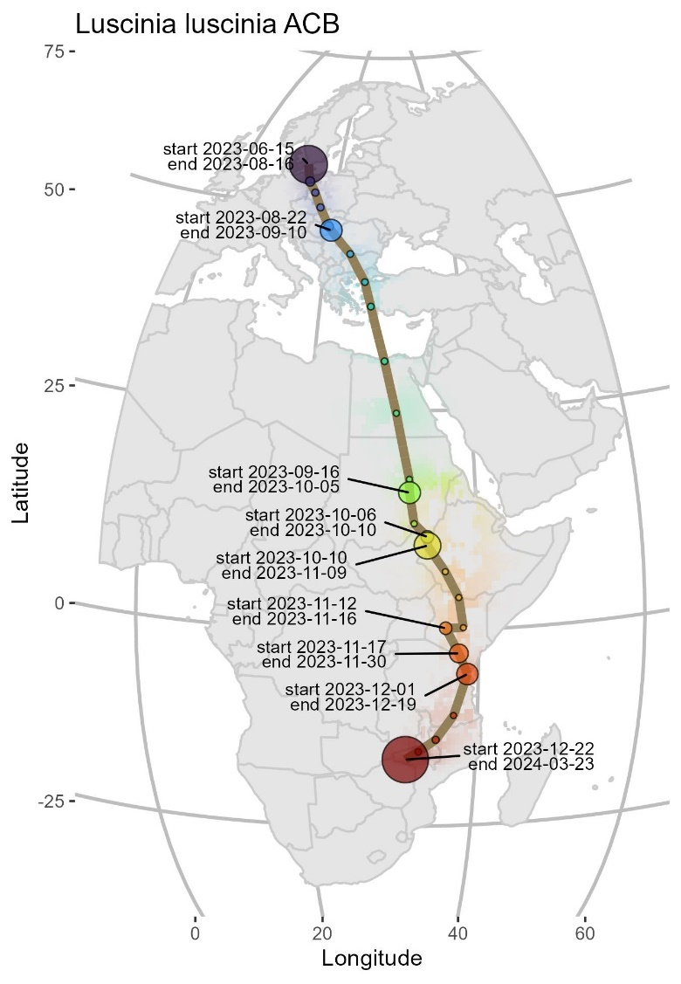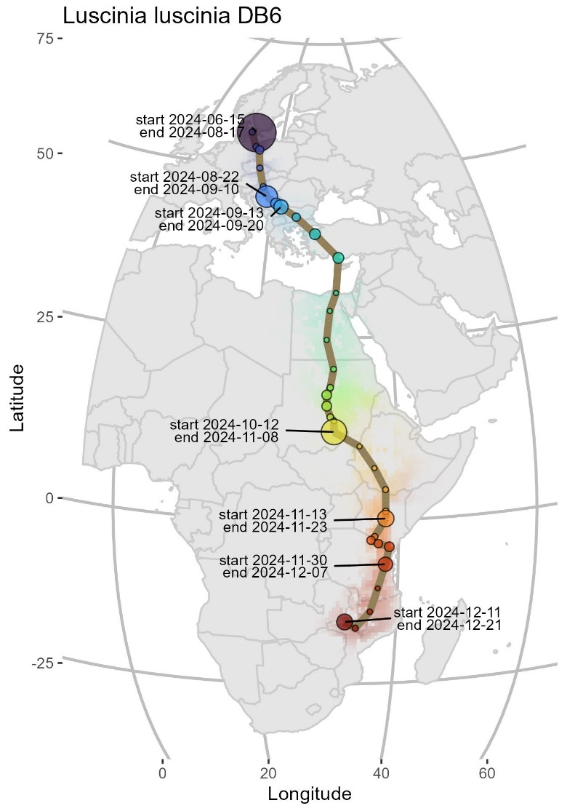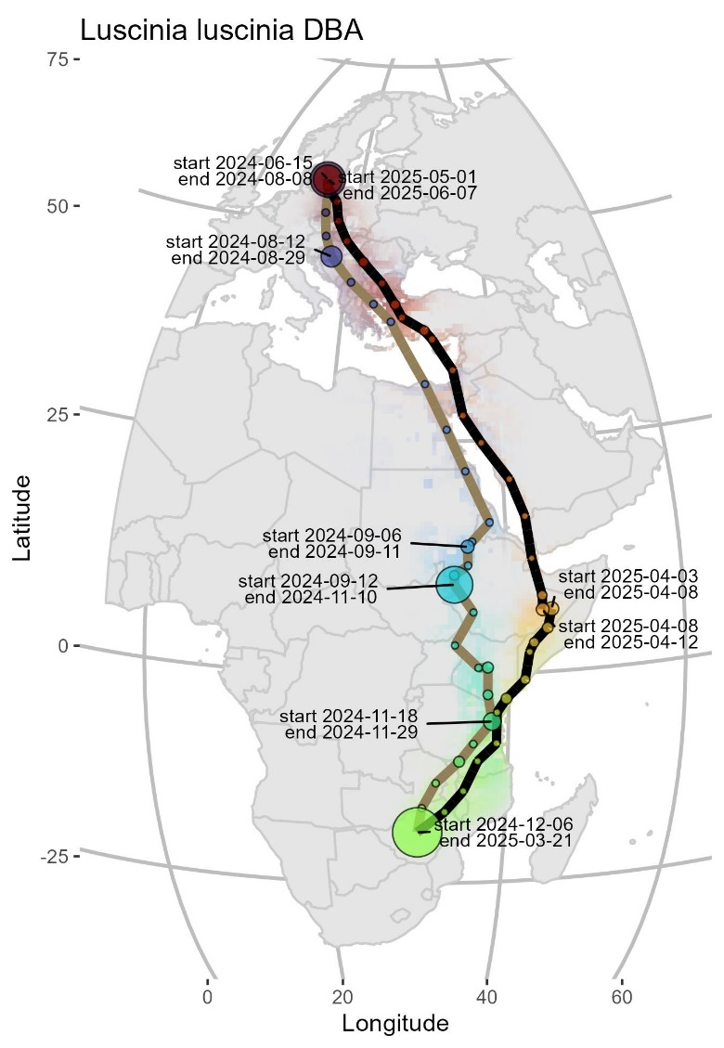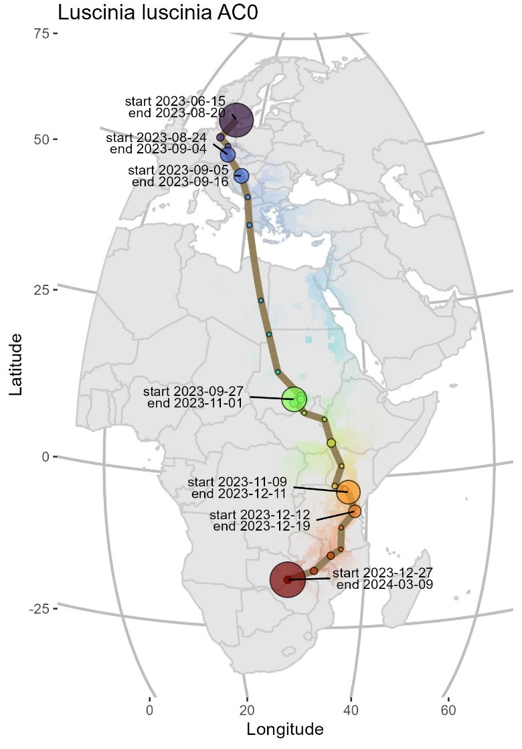

Supplementary file 3

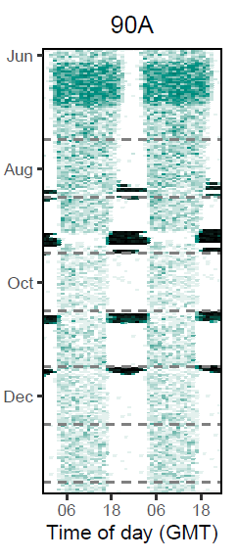
Individual actograms for each thrush nightingale included in this study
