Table S1. Validity statistics of the YOLOv11 Algorithm-based system compared to G-walk system to determine spatio-temporal gait parameters in older adults
Parameter | G-walk  Mean±SD | YOLOv11 Algorithm  Mean±SD | r | p | Consistency | LoA% | Agreement
Cadance, steps/min | 105.28±16.00 | 102.97±14 | 0.95 | <0.001* | Excellent | 19.57 | Moderate
Gait speed, m/s | 1.06±0.27 | 0.94±0.21 | 0.90 | <0.001* | Excellent | 47.04 | Moderate
Swing phase L, % GCT | 39.01±3.69 | 40.46±3.98 | 0.46 | 0.009* | Moderate | 39.36 | Moderate
Stance phase L, % GCT | 60.89±3.83 | 59.53±3.98 | 0.45 | 0.012* | Moderate | 26.82 | Moderate
First double support L, % GCT | 11.28±3.55 | 9.88±3.38 | 0.65 | <0.001* | Strong | 108.18 | Poor
Single support L, % GCT | 39.53±3.79 | 39.96±3.30 | 0.61 | <0.001* | Strong | 31.07 | Moderate
Gait cycle duration L, s | 1.18±0.17 | 1.19±0.17 | 0.92 | <0.001* | Excellent | 23.25 | Moderate
Stride length L, m | 1.21±0.21 | 1.26±0.19 | 0.61 | <0.001* | Strong | 56.90 | Poor
Swing phase R, % GCT | 39.75±3.97 | 40.01±3.38 | 0.49 | 0.005* | Moderate | 36.86 | Moderate
Stance phase R, % GCT | 60.57±4.31 | 59.98±3.38 | 0.44 | 0.013* | Moderate | 26.92 | Moderate
First double support R, % GCT | 9.44±2.79 | 10.25±3.83 | 0.48 | 0.006* | Moderate | 138.49 | Poor
Single support R, % GCT | 39.56±3.85 | 40±3.84 | 0.24 | 0.188 | Poor | 46.61 | Moderate
Gait cycle duration R, s | 1.15±0.17 | 1.18±0.16 | 0.95 | <0.001* | Excellent | 16.75 | Moderate
Stride length R, m | 1.19±0.19 | 1.21±0.17 | 0.72 | <0.001* | Strong | 42.46 | Moderate
Abbreviations: SD, standard deviation; LoA, Limit of agreement; GCT, Gait cycle time; r, Pearson correlation coefficient; *p<0.05 in Pearson correlation analysis.

Table S2. The reliability analysis of YOLOv11 algorithm-based system determining spatio-temporal characteristics of gait in older adults
Parameter | YOLOv11 Test Mean±SD | YOLOv11 Retest  Mean±SD | 95% CI |  | ICC | Interpretation | p
Parameter | YOLOv11 Test Mean±SD | YOLOv11 Retest  Mean±SD | Lower | Upper | ICC | Interpretation | p
Cadance, steps/min | 102.97±14 | 105.12±13.64 | 0.84 | 0.96 | 0.92 | Excellent | <0.001*
Gait speed, m/s | 0.94±0.21 | 0.98±0.21 | 0.82 | 0.96 | 0.91 | Excellent | <0.001*
Swing phase L, % GCT | 40.46±3.98 | 40.48±3.41 | 0.01 | 0.77 | 0.53 | Moderate | 0.024*
Stance phase L, % GCT | 59.53±3.98 | 59.51±3.41 | 0.01 | 0.77 | 0.53 | Moderate | 0.024*
First double support L, % GCT | 9.88±3.38 | 8.87±3.57 | 0.34 | 0.84 | 0.68 | Moderate | 0.001*
Single support L, % GCT | 39.96±3.30 | 41.01±3.55 | 0.37 | 0.85 | 0.69 | Moderate | 0.001*
Gait cycle duration L, s | 1.19±0.17 | 1.15±0.14 | 0.76 | 0.95 | 0.89 | Good | <0.001*
Stride length L, m | 1.26±0.19 | 1.27±0.19 | 0.76 | 0.95 | 0.89 | Good | <0.001*
Swing phase R, % GCT | 40.01±3.38 | 41.01±3.56 | 0.20 | 0.81 | 0.60 | Moderate | 0.006*
Stance phase R, % GCT | 59.98±3.38 | 58.98±3.56 | 0.04 | 0.77 | 0.54 | Moderate | 0.020*
First double support R, % GCT | 10.25±3.83 | 10.27±2.90 | -0.21 | 0.72 | 0.43 | Poor | 0.071
Single support R, % GCT | 40±3.84 | 39.78±3.17 | -0.32 | 0.70 | 0.37 | Poor | 0.108
Gait cycle duration R, s | 1.18±0.16 | 1.16±0.14 | 0.75 | 0.94 | 0.88 | Good | <0.001*
Stride length R, m | 1.21±0.17 | 1.26±0.15 | 0.67 | 0.93 | 0.86 | Good | <0.001*
Abbreviations: SD, standard deviation; CI, confidence interval; ICC, Intra-class correlation coefficient; GCT, Gait cycle time; * p<0.05 in reliability analysis.

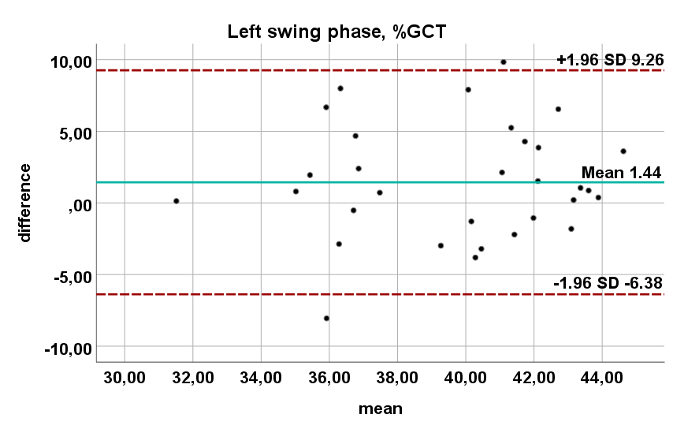 | 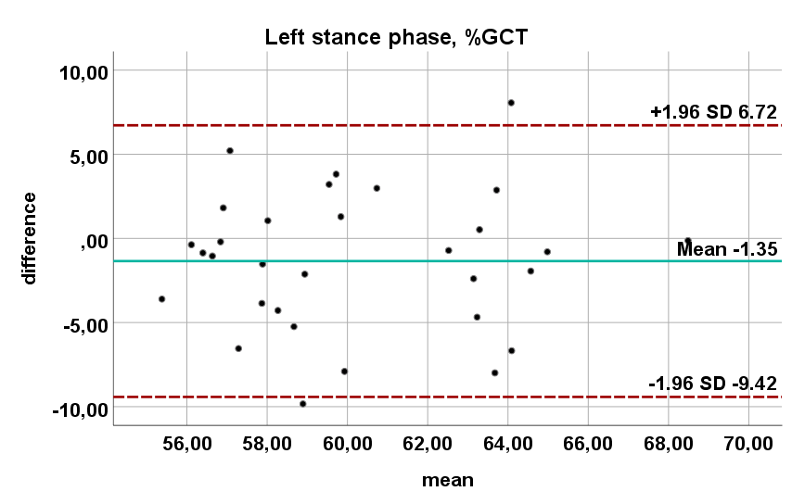 | 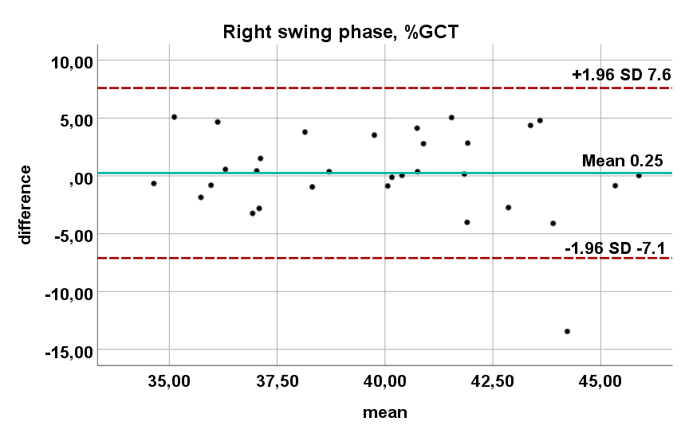 | 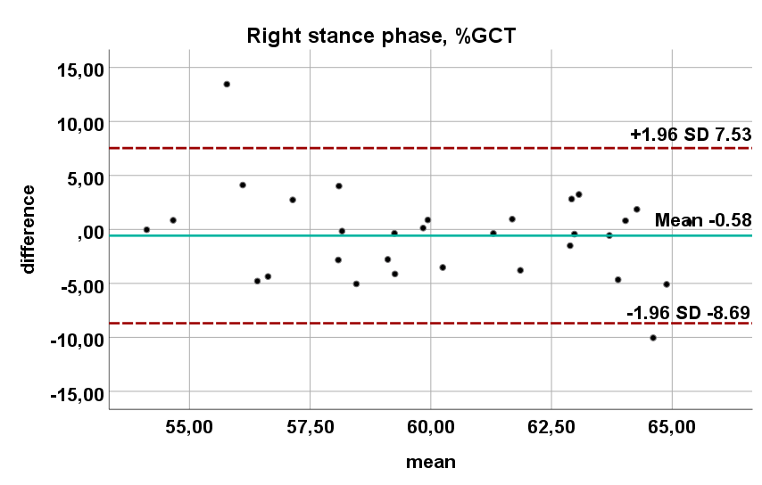
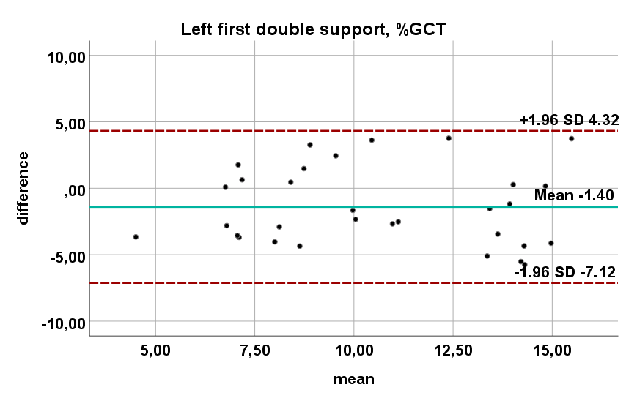 | 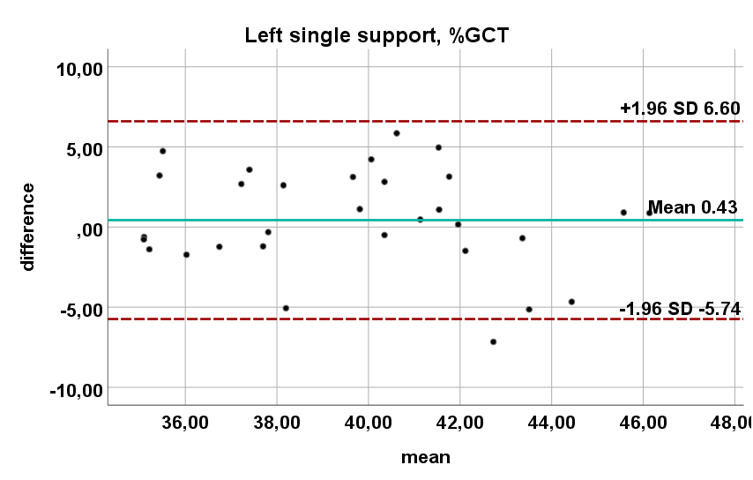 | 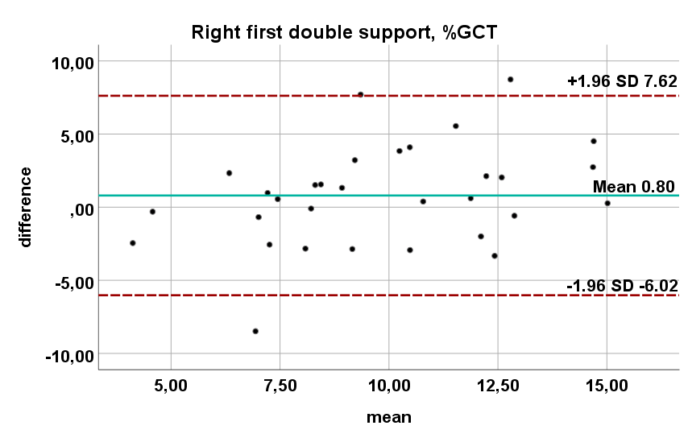 | 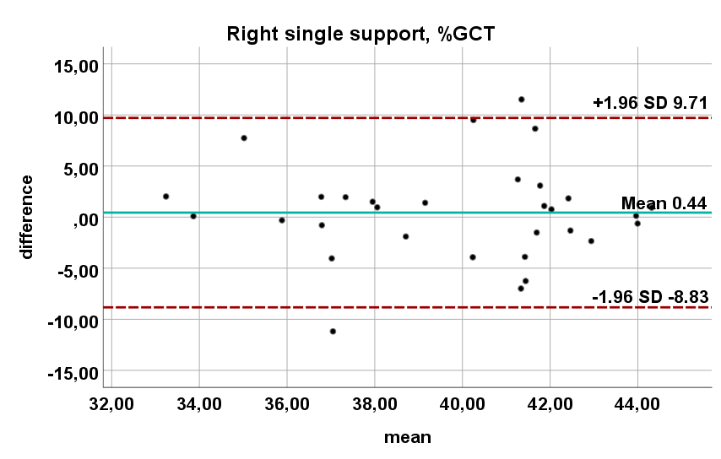
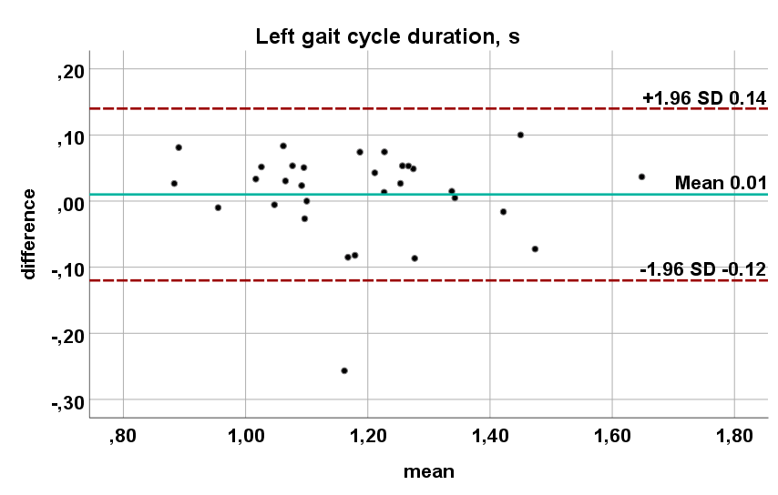 | 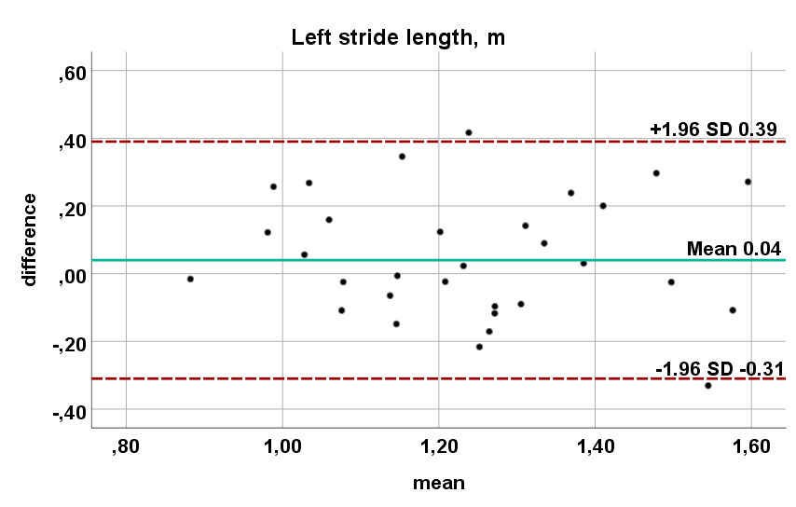 | 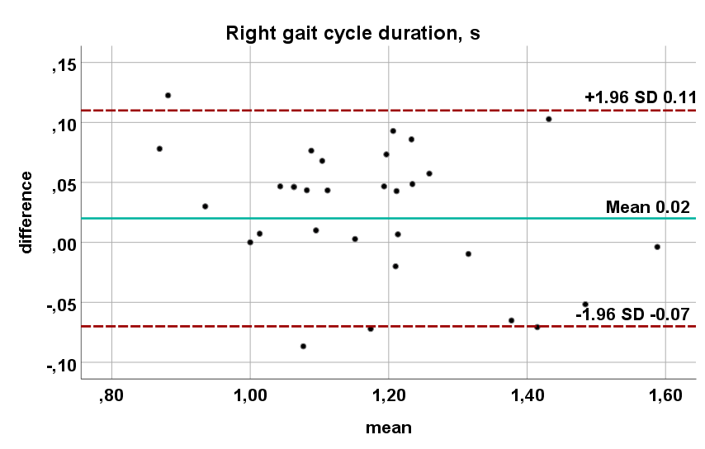 | 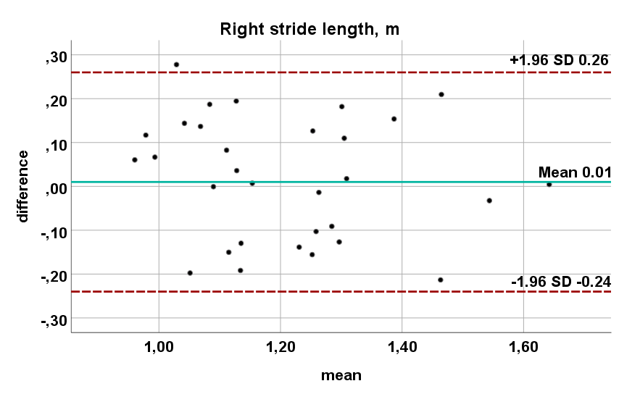
Figure S1. The agreement analysis between the YOLOv11 algorithm-based system and the G-walk system

