Supplementary Materials for
“The Clinical Value of Alpha-diversity metrics to establish Dysbiosis in Microbiome Studies”
Nataša Mortvanski*^{1,2}, Anna Sayol-Altarriba*^{1,3,4}, Andrea Aira^{1,4}, Elisa Rubio^{1,3,4}, Gregori Casals⁵, Alex Soriano⁶, José Luis Villanueva-Cañas†⁷, and Climent Casals-Pascual†^{1,3,4}
¹ISGlobal, Barcelona, Spain.
²Pompeu Fabra University (UPF), Barcelona, Spain.
³Faculty of Medicine and Health Sciences, University of Barcelona (UB), Barcelona, Spain.
⁴Department of Clinical Microbiology, CDB, Hospital Clinic of Barcelona, Barcelona, Spain.
⁵Department of Biochemistry and Molecular Genetics, Centre for Biomedical Diagnosis, Hospital Clínic de Barcelona, IDIBAPS, Barcelona, Spain
⁶Department of Infectious Diseases, Hospital Clinic of Barcelona, IDIBAPS, Barcelona, Spain
⁷Molecular Biology CORE (CDB), Hospital Clínic of Barcelona, Barcelona, Spain.

† Corresponding authors. Emails: ccasals@clinic.cat, jlvillanueva@clinic.cat
* These authors contributed equally.

1 Supplementary Notes 2
1.1 Data processing in QIIME2 2
1.2 Overview of different alpha diversity metrics 3
1.2.1 Richness metrics 3
1.2.2 Evenness metrics 4
1.2.3 Both richness and evenness 5
1.3 Study design 7
1.4 Overview of the Shiny application 8
1.5 SCFAs quantification 12
2 Supplementary Tables 12
3 Supplementary Figures 21
References 31

1 Supplementary Notes

1.1 Data processing in QIIME2
All QIIME2 artefacts analysed on Qiita platform went through the same standardised preprocessing procedure. Trimmed to a length of 100bp, quality control was done by Deblur 2021.09, Greengenes database was used as reference phylogeny. In order to avoid doing data preparation for all these studies from scratch, we decided to keep working with these artefacts.

However, Deblur is not the most compatible with analysing paired-end sequencing data, such as data obtained from Hospital Clínic de Barcelona (paired reads need to be joined before denoising). In this case it was easier to use the DADA2 pipeline for quality control. CDI data from BioProject database (Khanna et al. 2016) on the other hand is produced by single-end sequencing technology. Since it was being compared with American Gut Project data (McDonald et al. 2018 ) and other CDI datasets (Weingarden et al. 2015, Khanna et al. 2017) obtained from Qiita, we wanted to analyse these datasets in the same way. That is why we processed it using Deblur.

Pre-fitted sklearn-based taxonomy classifier scikit-learn_0.24.1 was used for taxonomy assignment on Qiita platform (the most recent update of QIIME2 - qiime2 2022.2.1), while scikit-learn_0.23.1 was used for Khanna et al. (2016) CDI dataset and Hospital Clínic’s data (analysed on local machine with QIIME2 version 2020.8.0).

1.2 Overview of different alpha diversity metrics
We conducted a literature search to obtain the definitions of different alpha metrics that were used in the analysis. There are two main aspects on which those indices are based, namely richness and evenness. Some of the indices are based on a combination of both. Below are the results sorted accordingly.

1.2.1 Richness metrics
Richness indices estimate the number of different species in a sample. The simplest measure for richness is the number of species or Operational Taxonomic Units (OTU). However, simply counting the number of present species is strongly affected by the bias introduced by undersampling and sequencing. This bias is even worse when the species evenness is low. There are numerous different metrics that are trying to capture or estimate richness. Here are some of the metrics that can be calculated using QIIME2 that we selected to use in our analysis:

Chao1 index is a nonparametric estimator of species richness that is correcting the observed richness for the number of lost species, estimated considering the distribution of the rarest species (Bent 2008, Finotello 2018). Chao's index for estimation of species richness is given by the equation (Thukral 2017, Website: CD Genomics):

$$S_{\left(max\right)Chao}=S_{obs}+\left(a^{2}+b^{2}\right)$$

, where Smax = maximum no. of species, Sobs = number of species observed in different samples, a = singletons (number of species represented by one individual each), b = doubletons (number of species represented by two individuals each).

Margalef’s index measures the species richness in a given area or community. It is defined as:
$$R_{MAR}=\frac{S-1}{lnN}$$

, where, S is the total number of species and N is the total number of individuals in the sample (Thukral 2017).

Menhinick’s index is defined as the ratio of the total number of species (S) to square root of number of individuals in the sample (N) (Thukral 2017):

$$R_{MEN}=\frac{S}{\sqrt{N}}$$

Fisher alpha is measuring the relationship between the number of species and the relative abundance of each species (Finotello 2018). This index is based upon the logarithmic distribution of number of individuals of different species:

$$S=αln\left(1+\frac{N}{α}\right)$$

where, S is the total number of species and N is the total number of individuals in the sample. The value of Fisher’s alpha is computed by iteration (Thukral 2017).

Faith’s phylogenetic diversity is the sum of OTU branch lengths. It takes into account phylogenetic distance between OTUs. The greater the number of unique, phylogenetically more distant OTUs, the higher this index will be (Finotello 2018).

1.2.2 Evenness metrics
Evenness indices measure how evenly the relative abundances are distributed across the different species. Besides being a valuable indicator of biodiversity, evenness also determines the stability and resilience of an ecosystem. Some indices estimate unevenness or dominance, which is complementary to evenness.

Gini index (Bendel 1989, Zheng 2008) is also defined in reference to the Lorenz curve which results from a plot of the cumulative proportion of the population to the cumulative proportion of the variable. The Gini coefficient can be, as in the figure, deﬁned geometrically as the ratio of two geometrical areas in the unit box: (a) the area between the line of perfect equality (45 degree line in the unit box) and the Lorenz curve, which is called area A and (b) the area under the 45 degree line, or areas A + B. Because areas A + B represents the half of the unit box, that is, A+B = 1/2 , the Gini Coefficient, G, can be written as:
$G=\frac{A}{A+B}=2A=1-2B$
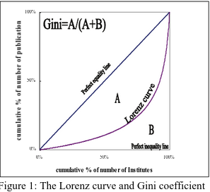

Therefore a Gini coefficient is a number between 0 and 1 that measures the degree of inequality with 0 being maximum equality and 1 being maximum inequality.
Strong’s index (Strong 2002) assesses species relative dominance concentration. It was, in part, based on the Gini index and Lorenz curve or partial order approach, but without the need to calculate area. It is defined as:

$$D_{W}=\max_{i}\left[\left({b_{i}}/Q\right)-i/R\right]$$

, where R = the number of species in the sample, i = the i-th species in the data set (i = 1 through R), b = the sequential cumulative totaling of i-th species abundance values ($a_{k}$) ranked largest to smallest (i.e., b = largest $a_{k}$, b = b + second largest $a_{k}$, b = b + third largest $a_{k}$ . . . ), Q = sum of species abundance values ($Σa_{k}$), where k = 1 through R;
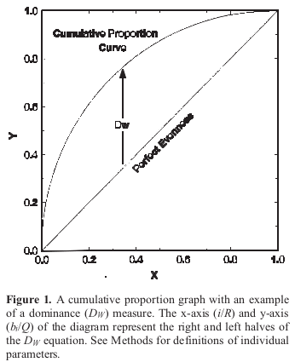

Pielou evenness is calculated as the ratio of the observed diversity to the maximum possible diversity having the same number of species (Pielou 1966). The formula is:

$$J’=H’/H’max$$

It has Shannon’s formula in both numerator and denominator. $H’max=logS$, where S is the number of species.

1.2.3 Both richness and evenness
Shannon’s index (Shannon–Weaver index, Shannon entropy) (Thukral 2017) was originally developed for communication systems and is based on information theory, however, it can also be used to define the biological diversity of the communities. The information content, H, therefore can be written as a function of probability:
$$H'=-\sum{}\frac{n_{i}}{N}ln\frac{n_{i}}{N}=-\sum{}p_{i}lnp_{i}$$

, where a message consists of N number of alphabets (number of species), pi is the probability of each letter in a message consisting of m alphabets (species), ni is the number of individuals of the i th letter (specie).

The minimum value of H’ is 0 when all the individuals in the sample belong to the same species. This community has minimal redundancy and therefore maximum entropy (Bent 2008). This index is reaching the maximum if all the species in the sample are represented by equal number of individuals:
$$H’max=logS$$

Simpson’s index reflects the probability that any two organisms sampled will be the same phylotype by capturing both richness and relative abundance (Finotello 2018). If there are k species consisting of n individuals, distributed among different species as n1, n2, n3, …nk, then the probability (p1) of the first individual belonging to a species will be:

$$p_{i}={\frac{n_{i}}{n}}_{}$$

Probability (p1,2) that the second individual drawn from the sample without replacement also belongs to the same species will be:
$$p_{1,2}={\left(\frac{\frac{n_{1}}{n}*n_{1}-1}{n-1}\right)}_{}$$

The sum of the probabilities for all the species is a measure of the concentration (or abundance) (C) of the species:
$$C_{Simpson}={\left(\frac{\sum{}n_{1}\left(n_{i}^{}-1\right)}{n\left(n-1\right)}\right)}_{}$$

If the sample size is large, then the probability (p1,2) that the second individual drawn from the sample with replacement also belongs to the same species (C’) will be:
$$C_{Simpson}={\sum{}p_{i}^{2}=\frac{\sum{}n_{i}^{2}}{n^{2}}}_{}$$
The maximum value of Simpson’s concentration is 1 when all the individuals in the sample belong to the same species. It follows logarithmic distribution which means that similar increments on the assessment scale do not represent equal changes in dominance concentration.

1.3 Study design
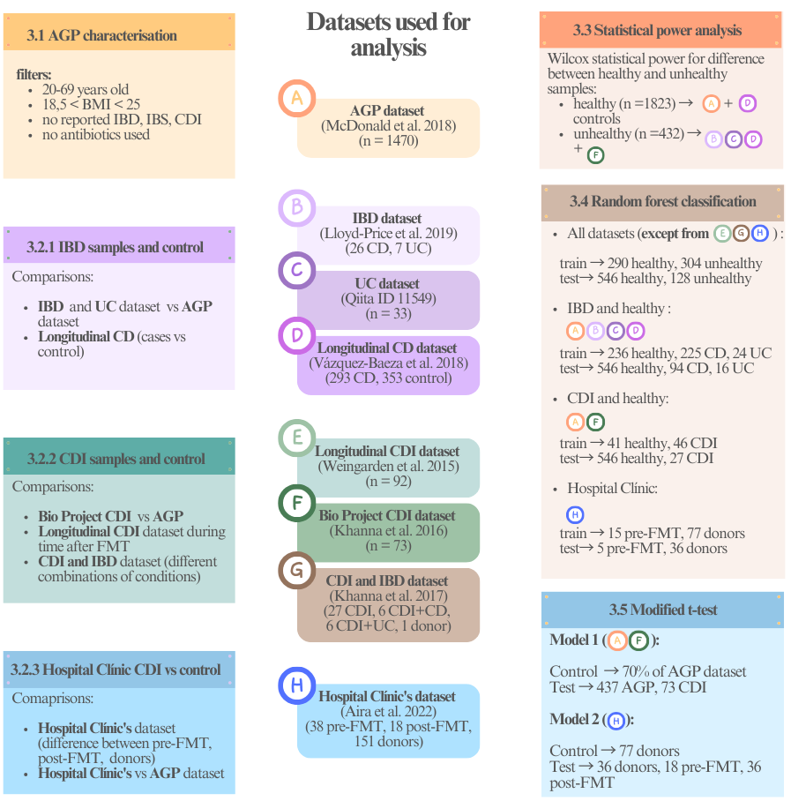

2 Supplementary Tables

Reference | Qiita ID | Study title | 16S reg. | Raref. depth | N  (used in analysis) | Metadata | Country | Techn.
McDonald et al. 2018 | 10317 | American Gut: an Open Platform for Citizen Science Microbiome Research | V4 | 5000 | 1470 (healthy) | Yes | America/ Europe | Illumina MiSeq
Lloyd-Price et al. 2019 | 11484 | Multi-omics of the gut microbial ecosystem in inflammatory bowel diseases | V4 | 1000 | 33  (26 CD,  7 UC) | Yes | America | Illumina MiSeq  HiSeq2000 or 2500 2x101
No publication (PI: Robert Knight)  (Website: Qiita) | 11549 | Metaomics Reveals Microbiome Based Proteolysis as a Driver of Ulcerative Colitis Severity | V4 | 4500 | 33  (UC) | Yes | America (UCSD) | Illumina MiSeq
Vázquez-Baeza et al. 2018 | 2538 | Guiding longitudinal sampling in IBD cohorts | V4 | 7000 | 646  (293 CD, 353 control) | Yes | America (UNC) | Illumina HiSeq 2000
Weingarden et al. 2015 | 1924 | Dynamic changes in short- and long-term bacterial composition following fecal microbiota transplantation for recurrent Clostridium difficile infection | V4 | 15000 | 92  (CDI) | Yes | America (UMN) | Illumina MiSeq  2 × 150 bp
Khanna et al. 2017 | 10057 | Changes in microbial ecology after fecal microbiota transplantation for recurrent C. difficile infection affected by underlying inflammatory bowel disease | V4 | 30000 | 40  (27 CDI,  6 CDI+CD, 6 CDI+UC, 1 donor) | Yes | America | Illumina MiSeq
Supplementary Table S1. Properties of selected studies from Qiita repository. All artefacts from Qiita had the same preprocessing steps (Deblur 2021.09 (Reference phylogeny for SEPP: Greengenes_13.8, BIOM: all.biom) | Trimming (length: 100))

Study | Study Accession | 16S reg. | N  (used in analysis) | Rarefact. depth | Metadata | Country | Techn.
Khanna et al. 2016 | PRJNA342347 | V4 | 73  (CDI) | 6260 | Yes | America | Illumina MiSeq (Single-Read)
Supplementary Table S2. Properties of selected study from BioProject repository.

Dataset* | 16S region | n (Pre-FMT) | n (Post-FMT) | n (donors) | Rarefaction depth | Technology
CDI samples | V3-V4 | 38 | 18 | 38 | 5500 | Illumina MiSeq
Catalan biobank | V3-V4 | / | / | 113 | 15000 | Illumina MiSeq
*BioProject accession PRJNA1337461.
Supplementary Table S3. Properties of data from Hospital Clínic.

metric | statistic | p.value | skewness | kurtosis
Faith PD | 0.9937 | 4.46e-12 | 0.2673 | 2.7841
Margalef | 0.9915 | 1.83e-07 | 0.3456 | 2.9911
Menhinick | 0.9915 | 1.83e-07 | 0.3456 | 2.9911
Chao1 | 0.9831 | 1.51e-15 | 0.5375 | 3.3656
Fisher alpha | 0.9742 | 7.79e-06 | 0.6494 | 3.4489
Gini index | 0.9604 | 1.38e-19 | -0.7684 | 3.6214
Strong | 0.9559 | 1.21e-20 | 0.8152 | 3.4930
Shannon entropy | 0.9454 | 1.14e-30 | -0.8837 | 3.4804
Pielou evenness | 0.8938 | 6.89e-23 | -1.2674 | 4.4065
Simpson | 0.7173 | 2.53e-44 | -2.2548 | 8.2933
Supplementary Table S4. American Gut Project data alpha metrics’ distribution statistics. Normality test (Shapiro-Wilk), skewness and kurtosis of different metrics

parameter | group1 | group2 | p.value | p.adjusted
Chao1 | CD | healthy | 2.10e-18 | 3.16e-17
Margalef | CD | healthy | 3.15e-09 | 1.57e-08
Faith PD | CD | healthy | 4.41e-08 | 1.70e-07
Gini index | CD | healthy | 9.39e-08 | 2.82e-07
Strong | CD | healthy | 4.32e-06 | 1.08e-05
Fisher alpha | CD | healthy | 0.00007 | 0.00015
Pielou evenness | CD | healthy | 0.00831 | 0.01558
Menhinick | CD | healthy | 0.07199 | 0.10798
Shannon entropy | CD | healthy | 0.14985 | 0.20434
Simpson | CD | healthy | 0.75357 | 0.76939
Supplementary Table S5. Results of the Mann-Whitney-Wilcoxon test for difference in means of healthy population and Crohn’s disease samples from Lloyd-Price et al. 2019

parameter | group1 | group2 | p.value | p.adjusted
Chao1 | UC | healthy | 3.27e-27 | 9.82e-26
Margalef | UC | healthy | 1.40e-14 | 1.40e-13
Menhinick | UC | healthy | 1.41e-12 | 1.06e-11
Fisher alpha | UC | healthy | 9.57e-12 | 5.74e-11
Faith PD | UC | healthy | 4.52e-08 | 1.70e-07
Gini index | UC | healthy | 8.05e-08 | 2.68e-07
Strong | UC | healthy | 0.00072 | 0.00144
Shannon entropy | UC | healthy | 0.01894 | 0.03157
Pielou evenness | UC | healthy | 0.20476 | 0.26708
Simpson | UC | healthy | 0.48789 | 0.56295
Supplementary Table S6. Results of the Mann-Whitney-Wilcoxon test for difference in means of healthy population and Ulcerative colitis samples (Lloyd-Price et al. 2019 and Qiita ID: 11549)

parameter | group1 | group2 | p.value | p.adjusted
Fisher alpha | Control (AGP) | Control_2 | 1.93e-187 | 1.93e-185
Gini index | Control (AGP) | Control_2 | 2.40e-30 | 2.66e-29
Margalef | Control (AGP) | Control_2 | 4.85e-13 | 1.87e-12
Menhinick | Control (AGP) | Control_2 | 5.61e-10 | 1.44e-09
Chao1 | Control (AGP) | Control_2 | 7.50e-06 | 1.32e-05
Faith PD | Control (AGP) | Control_2 | 0.00045 | 0.00066
Simpson | Control (AGP) | Control_2 | 0.20806 | 0.22615
Pielou evenness | Control (AGP) | Control_2 | 0.4135 | 0.43526
Shannon entropy | Control (AGP) | Control_2 | 0.52903 | 0.54539
Strong | Control (AGP) | Control_2 | 0.77432 | 0.77432
Supplementary Table S7. Results of the Mann-Whitney-Wilcoxon test for difference in means of controls from longitudinal CD study (Vázquez-Baeza et al. 2018) and AGP controls

parameter | group1 | group2 | p.value | p.adjusted
Faith PD | CD_2 | CD_1 | 2.01e-14 | 3.01e-13
Gini index | CD_2 | CD_1 | 2.14e-09 | 5.35e-09
Menhinick | CD_2 | CD_1 | 6.30e-08 | 1.35e-07
Strong | CD_2 | CD_1 | 9.74e-07 | 1.83e-06
Pielou evenness | CD_2 | CD_1 | 0.00015 | 0.00024
Chao1 | CD_2 | CD_1 | 0.00586 | 0.00732
Margalef | CD_2 | CD_1 | 0.01065 | 0.01278
Simpson | CD_2 | CD_1 | 0.22596 | 0.2421
Fisher alpha | CD_2 | CD_1 | 0.42371 | 0.43832
Shannon entropy | CD_2 | CD_1 | 0.68844 | 0.68844
Supplementary Table S8. Results of the Mann-Whitney-Wilcoxon test for difference in means of CD samples from longitudinal study (Vázquez-Baeza et al. 2018) and CD samples from first data set (Lloyd-Price et al. 2019)

parameter | group1 | group2 | p.value | p.adjusted
Simpson | crohns | control | 0.00007 | 0.00010
Pielou evenness | crohns | control | 0.00010 | 0.00014
Shannon entropy | crohns | control | 0.00067 | 0.00091
Chao1 | crohns | control | 0.00074 | 0.00097
Strong | crohns | control | 0.00087 | 0.00109
Gini index | crohns | control | 0.00926 | 0.01068
Faith PD | crohns | control | 0.04426 | 0.04918
Margalef | crohns | control | 0.06702 | 0.06702
Menhinick | crohns | control | 0.06702 | 0.06702
Fisher alpha | crohns | control | 0.06702 | 0.06702
Supplementary Table S9. Results of the Mann-Whitney-Wilcoxon test for difference in means of controls and Crohn’s samples in Vázquez-Baeza et al. 2018

parameter | group1 | group2 | p.value | p.adjusted
Chao1 | crohns (surgery) | control | 1.39e-24 | 4.17e-23
Margalef | crohns (surgery) | control | 2.14e-23 | 3.22e-22
Menhinick | crohns (surgery) | control | 4.20e-23 | 4.20e-22
Fisher alpha | crohns (surgery) | control | 1.23e-21 | 6.15e-21
Faith PD | crohns (surgery) | control | 1.23e-21 | 6.15e-21
Gini index | crohns (surgery) | control | 1.23e-21 | 6.15e-21
Strong | crohns (surgery) | control | 1.04e-19 | 4.47e-19
Pielou evenness | crohns (surgery) | control | 1.27e-19 | 4.77e-19
Shannon entropy | crohns (surgery) | control | 1.65e-17 | 5.50e-17
Simpson | crohns (surgery) | control | 9.04e-11 | 2.26e-10
Supplementary Table S10. Results of the Mann-Whitney-Wilcoxon test for difference in means of controls and Crohn’s samples that undergone surgery in Vázquez-Baeza et al. 2018

parameter | group1 | group2 | p.value | p.adjusted
Chao1 | healthy | CDI | 2.92e-47 | 2.92e-46
Faith PD | healthy | CDI | 9.10e-47 | 4.55e-46
Fisher alpha | healthy | CDI | 2.69e-45 | 8.97e-45
Gini index | healthy | CDI | 1.41e-44 | 3.52e-44
Margalef | healthy | CDI | 8.07e-44 | 1.61e-43
Menhinick | healthy | CDI | 1.06e-43 | 1.77e-43
Shannon entropy | healthy | CDI | 9.76e-21 | 1.39e-20
Simpson | healthy | CDI | 7.75e-12 | 9.69e-12
Pielou evenness | healthy | CDI | 0.00004 | 0.00004
Strong | healthy | CDI | 0.99646 | 0.99646
Supplementary Table S11. Results of the Mann-Whitney-Wilcoxon test for difference between controls and CDI samples in Khanna et al. 2016

parameter | group1 | group2 | p.value | p.adjusted
Chao1 | donor | CDIpost | 2.84e-20 | 8.52e-19
Chao1 | donor | CDIpre | 1.46e-15 | 2.18e-14
Faith PD | donor | CDIpost | 6.45e-15 | 6.45e-14
Faith PD | donor | CDIpre | 1.34e-14 | 1.00e-13
Fisher alpha | donor | CDIpost | 7.26e-13 | 4.36e-12
Fisher alpha | donor | CDIpre | 1.18e-12 | 5.88e-12
Gini index | donor | CDIpost | 5.29e-12 | 2.27e-11
Gini index | donor | CDIpre | 1.04e-11 | 3.90e-11
Margalef | donor | CDIpost | 3.19e-11 | 1.06e-10
Margalef | donor | CDIpre | 6.77e-11 | 1.85e-10
Pielou evenness | donor | CDIpost | 6.77e-11 | 1.85e-10
Pielou evenness | donor | CDIpre | 9.17e-11 | 2.29e-10
Shannon entropy | donor | CDIpost | 2.67e-10 | 6.16e-10
Shannon entropy | donor | CDIpre | 9.59e-10 | 2.05e-09
Simpson | donor | CDIpost | 2.05e-09 | 4.11e-09
Simpson | donor | CDIpre | 7.63e-09 | 1.43e-08
Strong | donor | CDIpost | 8.33e-08 | 1.47e-07
Strong | donor | CDIpre | 2.16e-07 | 3.59e-07
Menhinick | donor | CDIpre | 0.00001 | 0.00002
Gini index | CDIpre | CDIpost | 0.00876 | 0.01314
Shannon entropy | CDIpre | CDIpost | 0.00925 | 0.01321
Chao1 | CDIpre | CDIpost | 0.01016 | 0.01385
Fisher alpha | CDIpre | CDIpost | 0.01271 | 0.01469
Margalef | CDIpre | CDIpost | 0.01271 | 0.01469
Menhinick | CDIpre | CDIpost | 0.01271 | 0.01469
Simpson | CDIpre | CDIpost | 0.01273 | 0.01469
Menhinick | donor | CDIpost | 0.09159 | 0.10177
Pielou evenness | CDIpre | CDIpost | 0.09762 | 0.10459
Faith PD | CDIpre | CDIpost | 0.14901 | 0.15415
Strong | CDIpre | CDIpost | 0.31623 | 0.31623
Supplementary Table S12. Results of the Mann-Whitney-Wilcoxon test for difference in means of different conditions (healthy donors, CDi pre-FMT, CDI post-FMT) in Hospital Clínic’s dataset (Aira et al. 2022)

model | accuracy_condition | accuracy_healthy_or_not
all alpha metrics | 0.88 | 0.89
Faith + Gini | 0.85 | 0.86
Menhinick + Gini | 0.84 | 0.85
Chao1 + Gini | 0.84 | 0.87
Fisher + Gini | 0.83 | 0.85
Margalef + Gini | 0.82 | 0.85
Chao1 + Pielou | 0.72 | 0.74
Chao1 + Simpson | 0.72 | 0.74
Menhinick + Strong | 0.72 | 0.74
Menhinick + Pielou | 0.71 | 0.73
Menhinick + Shannon | 0.71 | 0.72
Fisher + Pielou | 0.71 | 0.74
Fisher + Shannon | 0.71 | 0.73
Margalef + Shannon | 0.70 | 0.74
Margalef + Pielou | 0.70 | 0.73
Margalef + Simpson | 0.70 | 0.73
Faith + Pielou | 0.69 | 0.70
Chao1 + Shannon | 0.69 | 0.73
Fisher + Simpson | 0.69 | 0.71
Menhinick + Simpson | 0.68 | 0.71
Chao1 + Strong | 0.68 | 0.72
Margalef + Strong | 0.68 | 0.71
Faith + Shannon | 0.68 | 0.68
Faith + Simpson | 0.68 | 0.70
Fisher + Strong | 0.67 | 0.71
Faith + Strong | 0.64 | 0.66
Supplementary Table S13. Accuracy of prediction of different models of random forest classifier trained on a dataset consisting of IBD (CD and UC), CDI and healthy samples

model | accuracy_condition | accuracy_healthy_or_not
all alpha metrics | 0.87 | 0.88
Faith + Gini | 0.86 | 0.86
Menhinick + Gini | 0.85 | 0.86
Fisher + Gini | 0.84 | 0.86
Margalef + Gini | 0.83 | 0.85
Chao1 + Gini | 0.82 | 0.84
Fisher + Simpson | 0.70 | 0.70
Menhinick + Pielou | 0.70 | 0.69
Chao1 + Pielou | 0.69 | 0.70
Margalef + Pielou | 0.69 | 0.70
Fisher + Pielou | 0.69 | 0.69
chao1 + shannon_entropy | 0.69 | 0.70
margalef + simpson | 0.68 | 0.70
chao1 + simpson | 0.68 | 0.69
Menhinick + Simpson | 0.68 | 0.68
Fisher + Shannon | 0.67 | 0.67
Menhinick + Strong | 0.67 | 0.66
Menhinick + Shannon | 0.67 | 0.66
Margalef + Shannon | 0.66 | 0.66
Chao1 + Strong | 0.65 | 0.67
Margalef + Strong | 0.64 | 0.65
Fisher + Strong | 0.64 | 0.65
Faith + Simpson | 0.63 | 0.63
Faith + Pielou | 0.62 | 0.61
Faith + Shannon | 0.61 | 0.62
Faith + Strong | 0.59 | 0.62
Supplementary Table S14. Accuracy of prediction of different models of random forest classifier trained on dataset consisting of IBD (CD and UC) and healthy samples

model | accuracy
Chao1 + Gini | 1.00
Margalef + Gini | 1.00
Menhinick + Gini | 1.00
Fisher + Gini | 1.00
Faith + Gini | 0.99
Faith + Strong | 0.98
Faith + Pielou | 0.98
Faith + Shannon | 0.98
Faith + Simpson | 0.98
All alpha metrics | 0.98
Chao1 + Simpson | 0.97
Menhinick + Pielou | 0.97
Menhinick + Simpson | 0.97
Chao1 + Strong | 0.97
Chao1 + Pielou | 0.97
Chao1 + Shannon | 0.97
Menhinick + Shannon | 0.97
Menhinick + Strong | 0.96
Margalef + Strong | 0.96
Margalef + Pielou | 0.95
Fisher + Strong | 0.95
Fisher + Pielou | 0.95
Fisher + Shannon | 0.95
Fisher + Simpson | 0.95
Margalef + Shannon | 0.95
Margalef + Simpson | 0.95
Supplementary Table S15. Accuracy of prediction of different models of random forest classifier trained on dataset consisting of CDI and healthy samples

model | accuracy
Chao1 + Gini | 1.00
Margalef + Gini | 1.00
Menhinick + Gini | 1.00
Menhinick + Strong | 1.00
Menhinick + Shannon | 1.00
Fisher + Gini | 1.00
Faith + Gini | 1.00
All alpha metrics | 1.00
Chao1 + Strong | 0.97
Menhinick + Pielou | 0.97
Menhinick + Simpson | 0.97
Fisher + Shannon | 0.97
Fisher + Simpson | 0.97
Faith + Strong | 0.97
Faith + Pielou | 0.97
Faith + Shannon | 0.97
Faith + Simpson | 0.97
Chao1 + Pielou | 0.95
Chao1 + Simpson | 0.95
Margalef + Strong | 0.95
Margalef + Pielou | 0.95
Fisher + Pielou | 0.95
Chao1 + Shannon | 0.92
Margalef + Shannon | 0.92
Margalef + Simpson | 0.92
Fisher + Strong | 0.92
Supplementary Table S16. Accuracy of prediction of different models of random forest classifier trained on dataset consisting of Hospital Clínic’s CDI samples before FMT and healthy donor samples

3 Supplementary Figures

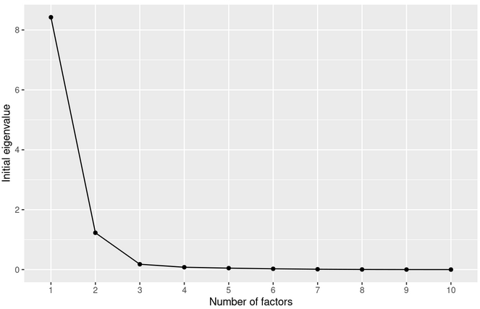
Supplementary Figure S1. Scree plot based on exploratory factor analysis of 10 alpha diversity indices computed on AGP dataset

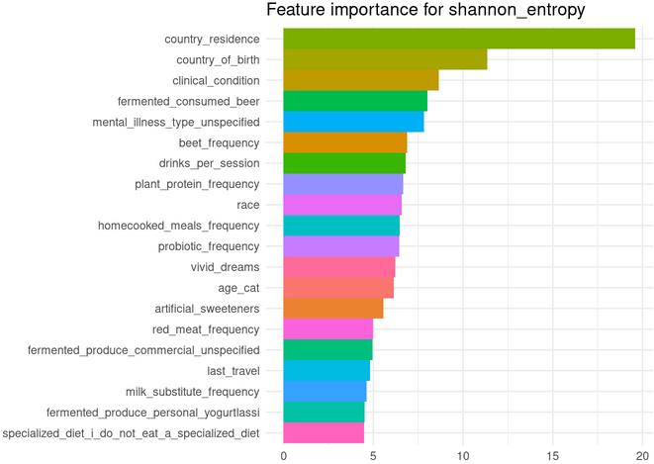
Supplementary Figure S2. Feature importance of AGP metadata categories for estimating alpha diversity metrics (in this case Shannon entropy) obtained by Random Forest classifier

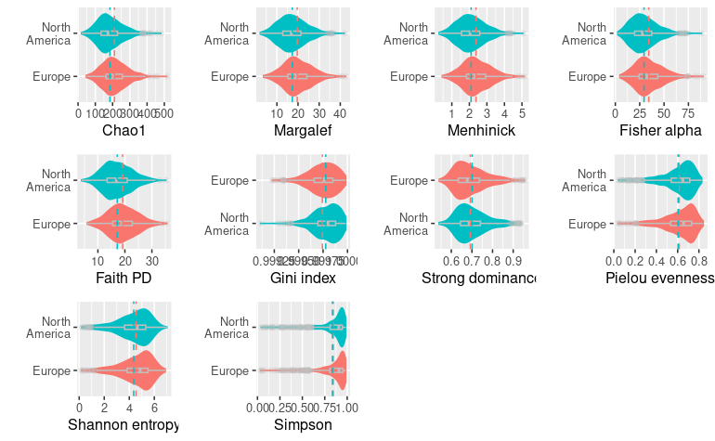
Supplementary Figure S3. Difference in distributions and means of alpha metrics in groups of AGP samples with different countries of residence (grouped by continents)

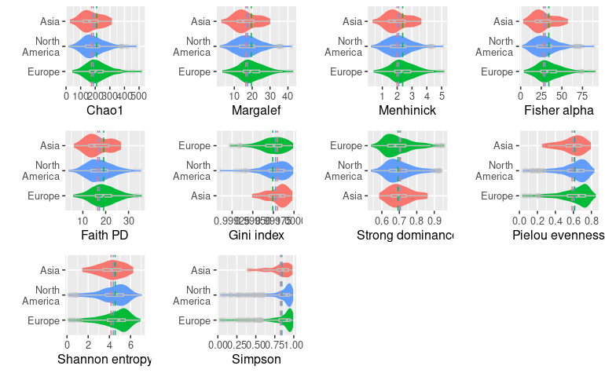
Supplementary Figure S4. Difference in distributions and means of alpha metrics in groups of AGP samples with different countries of birth (grouped by continents)

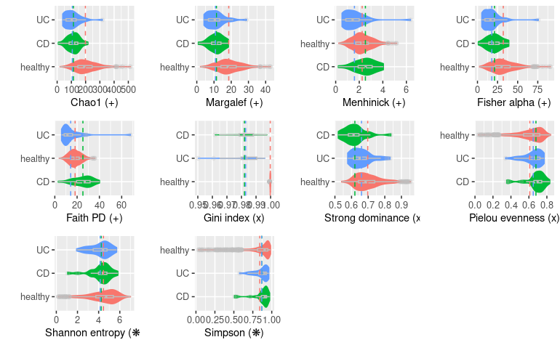Supplementary Figure S5. Difference in distributions and means of different alpha metrics between healthy and IBD dataset (Lloyd-Price et al. 2019 and Qiita ID: 11549)

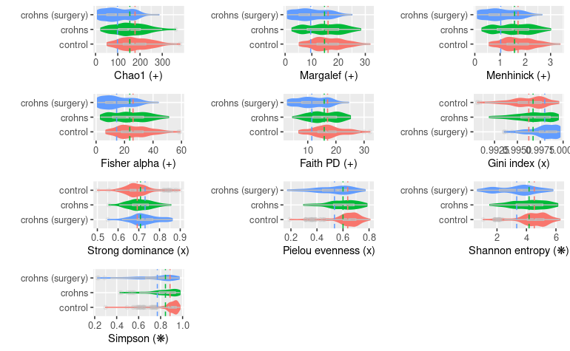
Supplementary Figure S6. Difference in distributions and means of different alpha metrics between controls and Crohn’s samples (Vázquez-Baeza et al. 2018)

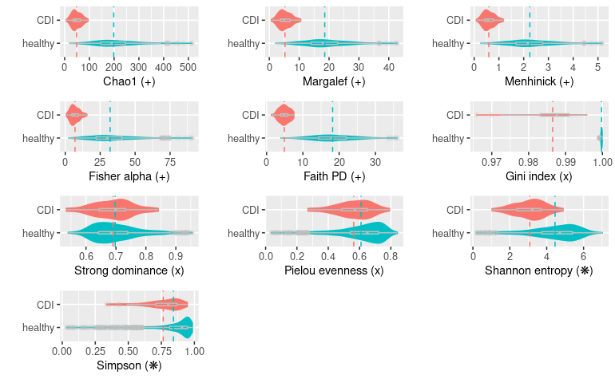
Supplementary Figure S7. Difference in distributions and means of different alpha metrics between controls and CDI samples (Khanna et al. 2016)
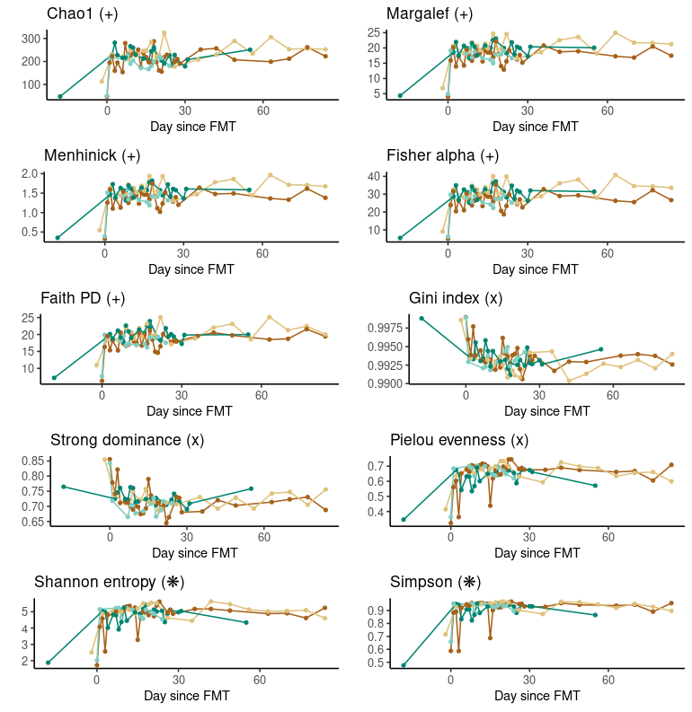
Supplementary Figure S8. Progression of alpha diversity metrics’ value in time of CDI samples after FMT (Weingarden et al. 2015)

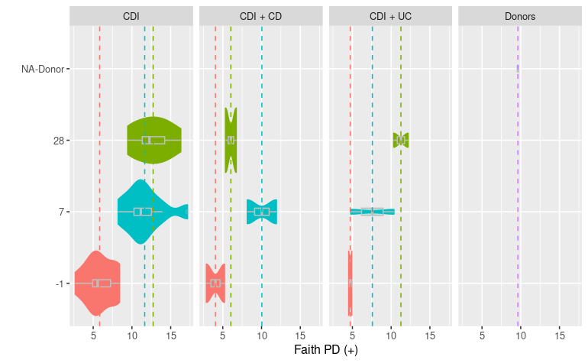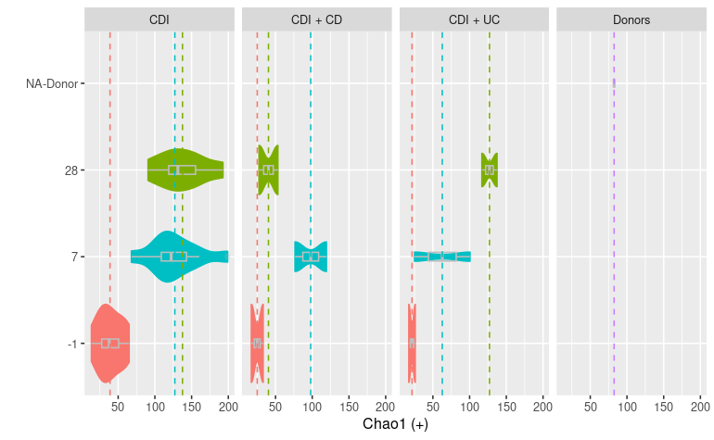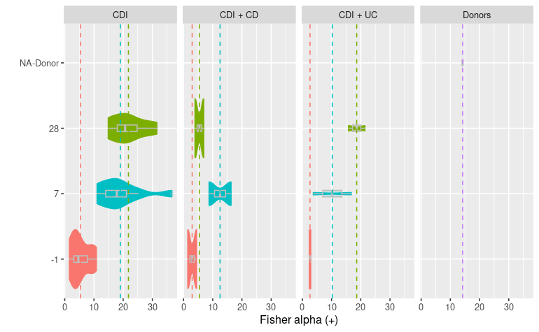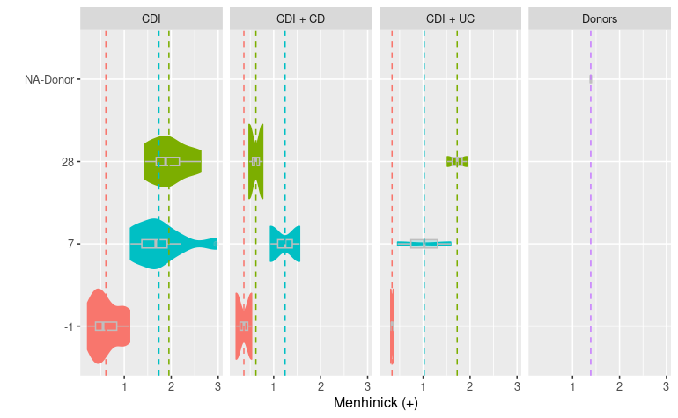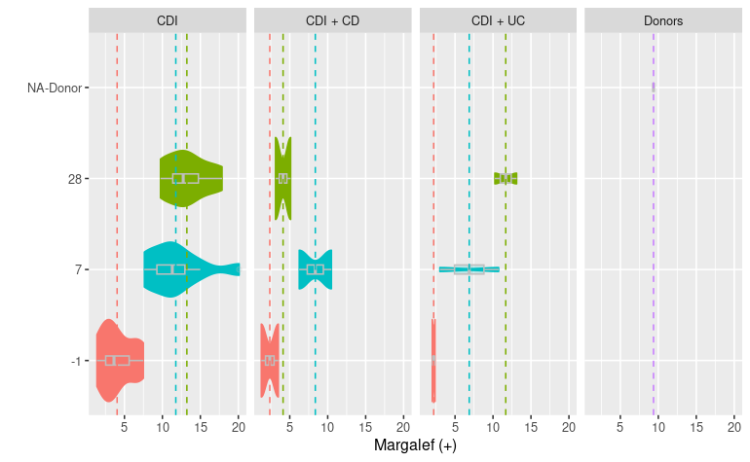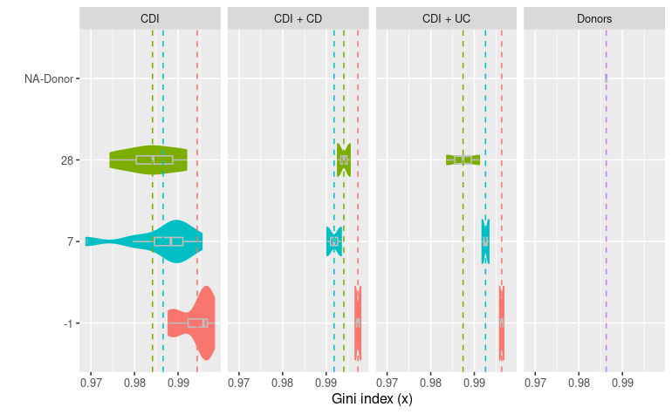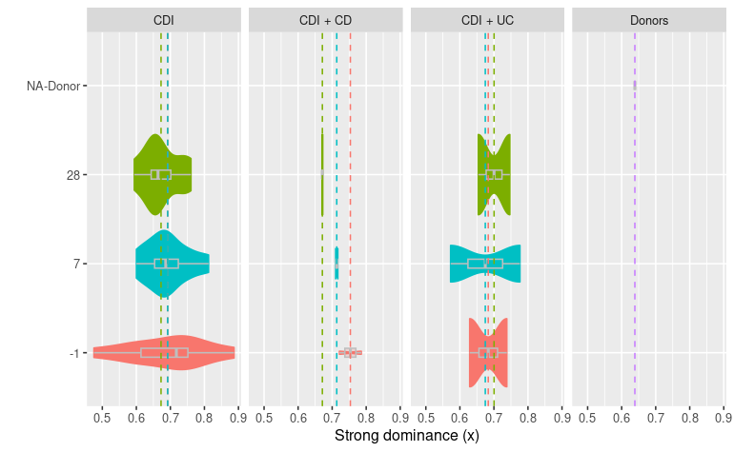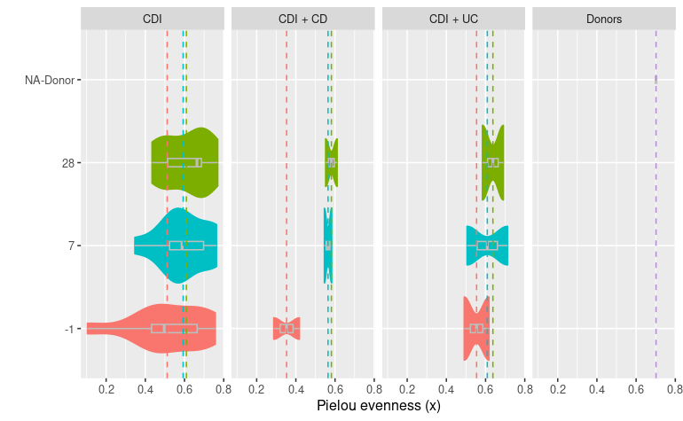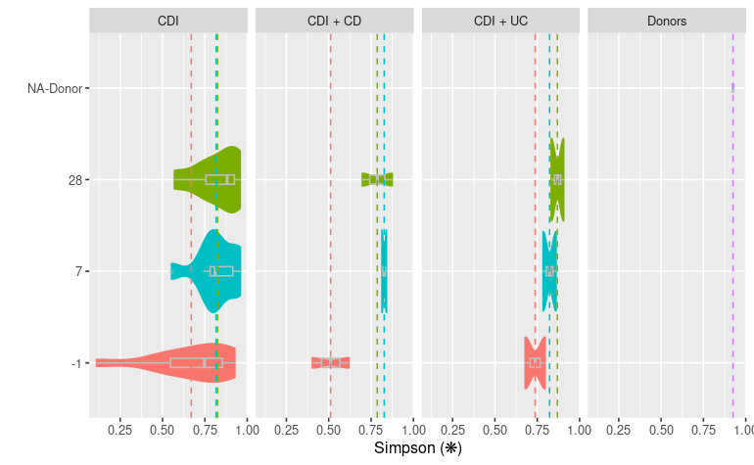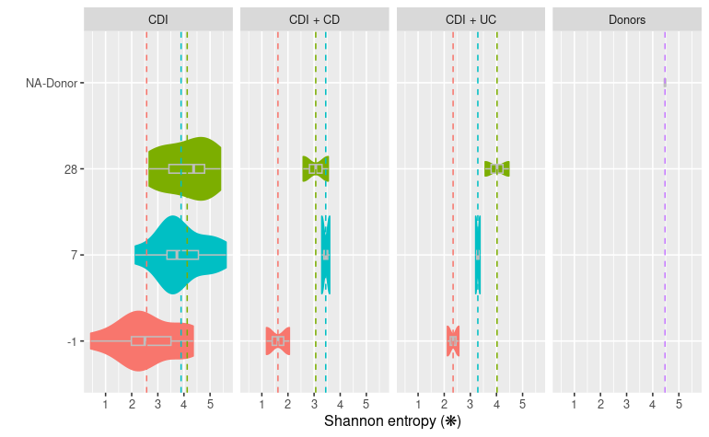
Supplementary Figure S9. Difference of different alpha diversity value depending on day since FMT in CDI patients with different underlying conditions (none, CD or UC) from Khanna et al. 2017

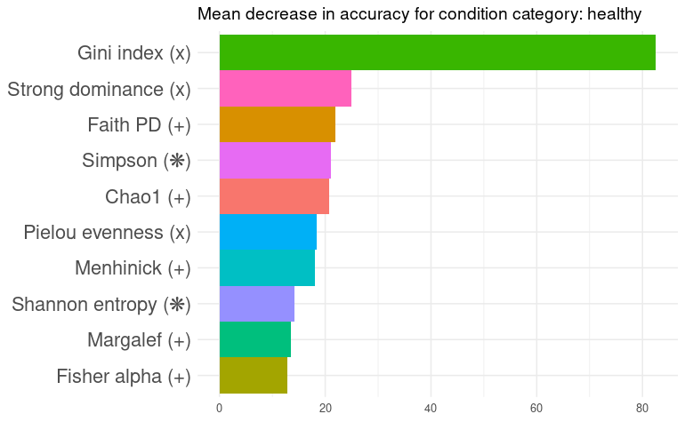
Supplementary Figure S10. Feature importance for predicting health status obtained by Random Forest classifier. Classifier trained on all datasets: IBD, CDI and healthy AGP controls. (+) richness metrics, (x) evenness metrics, (❋) both richness and evenness

References
Aira A et al. New Procedure to Maintain Fecal Microbiota in a Dry Matrix Ready to Encapsulate. Front Cell Infect Microbiol. 2022. 12:899257. Published 2022 Jun 10. doi:10.3389/fcimb.2022.899257
Bendel RB et al. Comparison of skewness coefficient. coefficient of variation, and Gini coefficient as inequality measures within populations. Oecologia. 1989;78(3):394-400. doi:10.1007/BF00379115
Bent SJ, Forney LJ. The tragedy of the uncommon: understanding limitations in the analysis of microbial diversity. ISME J. 2008 Jul;2(7):689-95. doi: 10.1038/ismej.2008.44. Epub 2008 May 8. PMID: 18463690.
Finotello F, Mastrorilli E, Di Camillo B. Measuring the diversity of the human microbiota with targeted next-generation sequencing. Brief Bioinform. 2018;19(4):679-692. doi:10.1093/bib/bbw119
Khanna S et al. Changes in microbial ecology after fecal microbiota transplantation for recurrent C. difficile infection affected by underlying inflammatory bowel disease. Microbiome. 2017;5(1):55. Published 2017 May 15. doi:10.1186/s40168-017-0269-3
Khanna S et al. Gut microbiome predictors of treatment response and recurrence in primary Clostridium difficile infection. Aliment Pharmacol Ther. 2016;44(7):715-727. doi:10.1111/apt.13750
Lloyd-Price J et al. Multi-omics of the gut microbial ecosystem in inflammatory bowel diseases. Nature. 2019;569(7758):655-662. doi:10.1038/s41586-019-1237-9
McDonald D et al. American Gut: an Open Platform for Citizen Science Microbiome Research. mSystems. 2018;3(3):e00031-18. Published 2018 May 15. doi:10.1128/mSystems.00031-18
Pielou EC. The measurement of diversity in different types of biological collections. Journal of Theoretical Biology. 1966;13:131–144.doi:10.1016/0022-5193(66)90013-0
Strong WL. Assessing species abundance unevenness within and between plant communities. Community Ecology.2002;3(2):237–246.doi:10.1556/comec.3.2002.2.9
Thukral A. A review on measurement of Alpha diversity in biology. Agricultural Research Journal. 2017; 54:1. doi:10.5958/2395-146X.2017.00001.1
Vázquez-Baeza Y et al. Guiding longitudinal sampling in IBD cohorts. Gut. 2018;67(9):1743-1745. doi:10.1136/gutjnl-2017-315352
Website: CD Genomics. The Use and Types of Alpha-Diversity Metrics in Microbial NGS.https://www.cd-genomics.com/microbioseq/the-use-and-types-of-alpha-diversity-metrics-in-microbial-ngs.html (17 April 2023, date last accessed)
Website: Qiita. Metaomics Reveals Microbiome Based Proteolysis as a Driver of Ulcerative Colitis Severity. https://qiita.ucsd.edu/study/description/11549 (16 January 2023, date last accessed)
Weingarden A et al. Dynamic changes in short- and long-term bacterial composition following fecal microbiota transplantation for recurrent Clostridium difficile infection. Microbiome. 2015;3:10. Published 2015 Mar 30. doi:10.1186/s40168-015-0070-0
Zheng M et al. Using Lorenz Curve and Gini Coefficient to Reflect the Inequality Degree of S&T Publications: An Examination of the Institutional Distribution of Publications in China and other Countries. Economics. 2008.

