Supporting Information

Efficient Glycerol Carbonylation over Multimetallic ZIF Catalysts: Synergy of Structure Regulation and Charge Optimization
Liyao Zhao^{al}, Zhihao Lv^{a1}, Shuqi Qiª, Pingbo Zhang*ª, Jiawen Zhangª, Mingming Fan*ª

Key Laboratory of Synthetic and Biological Colloids, Ministry of Education, School of Chemical and Material Engineering, Jiangnan University, Wuxi, China

* Corresponding authors.
E-mail addresses: pingbozhang@126.com, fanmm2000@126.com
^{l}Liyao Zhao and Zhihao Lv have contributed equally to this work
and should be considered co-first authors.

1. Experimental Procedures
1.1 Carrier Preparation

Preparation of ZIF-67:
3.20 g of Co(NO₃)₂·6H₂O was dissolved in 200 mL of methanol. Then, 4.4 g of 2-methylimidazole was dissolved in 200 mL of methanol. The two solutions were mixed and stirred at room temperature for 24 hours. The resulting solution was filtered under vacuum, washed three times with methanol, and dried at 80°C for 12-24 hours.
Preparation of ZIF-8:
3.20 g of Zn(NO₃)₂·6H₂O was dissolved in 70 mL of methanol. Then, 3.3 g of 2-methylimidazole was dissolved in 70 mL of methanol. The two solutions were mixed and stirred at room temperature for 24 hours. The resulting solution was filtered under vacuum, washed three times with methanol, and dried at 80°C for 12-24 hours.
Preparation of Cu-MOF:
0.483 g of Cu(NO₃)₂·3H₂O and 0.4024 g of 2-methylimidazole were dissolved in 100 mL of DMF. The reaction solution was placed in a hydrothermal reactor and heated at a rate of 5°C/min in a programmable oven to 140°C. The solution was then maintained at 140°C for 24 hours. After the reaction, the solution was cooled to room temperature at a rate of 2°C/min. The resulting cloudy solution was washed with DMF and chloroform, filtered, and dried at 80°C for 24 hours to obtain Cu-MOF.
Preparation of Cu-ZIF-8:
3.972 g (0.013 mol) of hexahydrate zinc nitrate and 1.08 g of trihydrate copper nitrate were placed into a beaker, and 45 mL of methanol was added. 9.72 g (0.118 mol) of 2-methylimidazole was dissolved in 45 mL of methanol to form the ligand solution. This ligand solution was rapidly added to the metal solution, causing the color to change quickly from light blue to deep blue. The resulting solution was placed in a hydrothermal reactor and heated at a rate of 5°C/min to 140°C using a programmable oven. The reaction was maintained at 140°C for 24 hours. After the reaction, the solution was cooled to room temperature at 2°C/min. The resulting cloudy solution was filtered using an organic microporous membrane and a circulating water pump to obtain the target product, Cu-ZIF-8.
Preparation of Co-ZIF-8:
3.20 g of Zn (NO₃)₂·6H₂O and 0.18 g of Cu(NO₃)₂·3H₂O were dissolved in 75 mL of methanol. Then, 3.3 g of 2-methylimidazole was dissolved in 75 mL of methanol. The two solutions were mixed and stirred at room temperature for 24 hours. The resulting solution was filtered under vacuum, washed three times with methanol, and dried at 80°C for 12-24 hours.
Preparation of Cu-ZIF-67:
4.01 g of hexahydrate cobalt nitrate and 1.08 g of trihydrate copper nitrate were placed into a beaker, and 45 mL of methanol was added. 9.72 g (0.118 mol) of 2-methylimidazole was dissolved in 45 mL of methanol to form the ligand solution. This ligand solution was rapidly added to the metal solution, causing the color to change quickly from pale purple to bluish-purple. The resulting solution was placed in a hydrothermal reactor and heated at a rate of 5°C/min to 140°C using a programmable oven. The reaction was maintained at 140°C for 24 hours. After the reaction, the solution was cooled to room temperature at 2°C/min. The resulting cloudy solution was filtered using an organic microporous membrane and a circulating water pump to obtain the target product, Cu-ZIF-67.
1.2 Catalyst Preparation:
The preparation method for the catalysts from the above-mentioned supports was identical. 0.4 g of the support was dispersed in 50 mL of methanol, and 4 mL of a 1 g/L palladium acetate methanol solution was added. After stirring for 4 hours, the solution was filtered, and the solid was dried at 80°C for 8 hours. The resulting catalyst was then calcined under nitrogen at 600°C for 2 hours in a tube furnace to obtain the final catalyst. The catalyst was named Pd/support-N.

1.3. Characterization
Scanning electron microscope (SEM) images were taken on a Hitachi S-4800 Scanning electron microscope. optical emission spectroscopy (ICP-OES) was measured by Thermo Fisher iCAP PRO. N₂ adsorption and desorption isotherms were obtained at 298K using a Quantachrome Autosorb-IQ instrument. Powder X-ray diffraction patterns were measured with a Bruker D8 with Cu Kα radiation (λ =1.5406 Å). FT-IR spectroscopy was performed on a Nicolet iS50 FT-IR infrared spectrometer. The chemical valence states and elements present in the catalyst surface were analyzed through X-ray photoelectron spectrometry (XPS) equipped with Al/Κα radiation (Thermo, ESCALAB250XI). The obtained binding energies were referenced to the C 1s peak at 284.8 eV. Chemisorption test uses Mike Autochem2930. The 100mg sample was weighed and placed in the reaction tube, and was heated at 10℃/min from room temperature to 300℃ for drying pre-treatment. He air flow (30-50 mL /min) was purged for 1h and cooled to 50 ℃. 10% carbon dioxide /He mixture (30-50 mL /min) was injected for 1h to saturation, then He air flow (30-50 mL /min) was switched to purge for 1h to remove the weak physical adsorption of carbon dioxide on the surface, and finally it was desorbed at 800℃ at a heating rate of 10 ℃ /min in He atmosphere. Exhaled gas is detected with TCD.
2. Catalytic performance test
To obtain reproducible and distinguishable peaks, this experiment was carried out using gas chromatography for performance testing by the method of silanization. A certain amount of reaction solution was weighed with an excess of silanization reagent. The reaction solution: hexamethyldisilazane: trimethylchlorosilane 1:9:3 by weight ratio was processed into a 10 mL centrifuge tube. The tube was closed, stirred for 5 min, and the NH₄Cl was allowed to precipitate as a white solid after 30 min at room temperature. Then, 0.5 ml (251.08 g/L) of tritiated tetra ethylene glycol internal standard solution was added to the mixture. centrifugation was performed at 2500 rpm for 5 min, and the supernatant was taken for gas chromatographic analysis. The reaction products were analyzed by gas chromatography using a Nexis GC-2030. The chromatographic conditions were as follows: the column was a KB-Wax capillary column (30 m*0.32 mm*0.50 μm), with N₂ as carrier gas and a separation ratio of 1/20; the column temperature was programmed to 80 °C for 2 min, and then the temperature was increased to 260 °C at a rate of 30 °C/min; the temperature of the vaporization chamber was 280 °C, and the temperature of the detector was 300 °C. The internal standard of tetraethyleneglycol tris(3-acetonitriloethylene) was chosen as the internal standard, and the internal standard of tetraethyleneglycol tris(3-acetonitriloethylene) was chosen as the internal standard. Tetraethylene glycol was used as the internal standard, and the quantitative analysis was carried out by the internal standard method. The yield and selectivity were evaluated based on the peak areas of the silylated derivatives of unreacted glycerol and generated carbonates. The standard curve of the internal standard method is shown in Figure S1 (a-b).[3]

a
b
Fig. S1. (a-b) Internal standard curve.

Y₁=0.20535x+0.00549
Y₂=1.30251x+0.20779
$\begin{aligned}Yield\%=\frac{Y_{2}⋅m_{Internal standard}}{m_{Theoretical yield}}\#\left(1\right)\end{aligned}$
$$\begin{aligned}Selectivity\%=\frac{Y_{2}∙m_{Internal standard}∙m_{glycerol}}{m_{Theoretical yield}\left(m_{glycerol}-Y_{1}·m_{Internal standard}\right)}\#\left(2\right)\end{aligned}$$
Fig.S2 Reusability activity test chart.
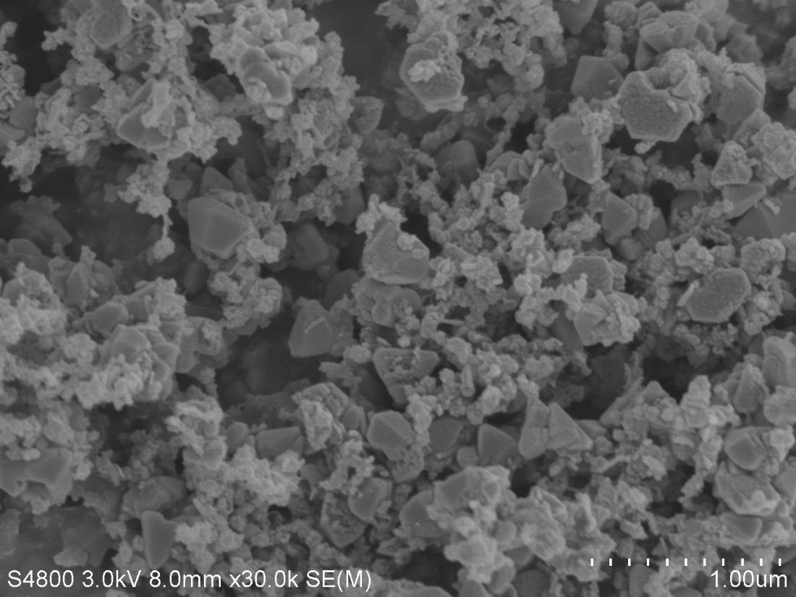
Fig.S3 SEM figure of Cu-MOF.

3. Computational methods

All quantum chemical calculations were performed by using the Gaussian 16 program and use the way of DFT(B3LYP). For geometry optimization and frequency calculations, genecp basis set was used. 6-31g(d) was used for C H O N elements, and LANL2DZ was used for Pd I Cu elements. The optimal geometry for each compound was determined. The singlet point energy calculations were performed with a larger basis set 6-311G (d, p) and LANL2DZ basis set. For TS optimization and frequency calculations, the way of B3LYP and genecp basis set were used. 6-311G (d, p) was used for C H O N elements, and LanL2DZ was used for Pd I and Cu elements. The IRC analysis calculations were performed with basis set 6-311G (d, p) and LANL2DZ basis set(N=50). The DFT-D3 with BJ-damping was applied to correct the weak interaction to improve the calculation accuracy. The visualization of the ESP images were achieved using GaussView 6.0 software.[4,5]
Reference
- Awadallah-F A, Hillman F, Al-Muhtaseb SA, Jeong H-K (2019) Adsorption Equilibrium and Kinetics of Nitrogen, Methane and Carbon Dioxide Gases onto ZIF-8, Cu_{10%} /ZIF-8, and Cu_{30%} /ZIF-8. Ind Eng Chem Res 58:6653–6661. https://doi.org/10.1021/acs.iecr.8b05892.
- Shuai C, Yuan X, Shuai Y, et al (2022) Nitrogen-doped carbon-ZnO heterojunction derived from ZIF-8: a photocatalytic antibacterial strategy for scaffold. Materials Today Nano 18:100210. https://doi.org/10.1016/j.mtnano.2022.100210
- Lee JG, Yoon S, Yang E, et al (2020) Structural evolution of ZIF-67-derived catalysts for furfural hydrogenation. Journal of Catalysis 392:302–312. https://doi.org/10.1016/j.jcat.2020.10.014
- Gaussian 16, Revision C.01, Frisch, M. J.; Trucks, G. W.; Schlegel, H. B.; Scuseria, G. E.; Robb, M. A.; Cheeseman, J. R.; Scalmani, G.; Barone, V.; Petersson, G. A.; Nakatsuji, H.; Li, X.; Caricato, M.; Marenich, A. V.; Bloino, J.; Janesko, B. G.; Gomperts, R.; Mennucci, B.; Hratchian, H. P.; Ortiz, J. V.; Izmaylov, A. F.; Sonnenberg, J. L.; Williams-Young, D.; Ding, F.; Lipparini, F.; Egidi, F.; Goings, J.; Peng, B.; Petrone, A.; Henderson, T.; Ranasinghe, D.; Zakrzewski, V. G.; Gao, J.; Rega, N.; Zheng, G.; Liang, W.; Hada, M.; Ehara, M.; Toyota, K.; Fukuda, R.; Hasegawa, J.; Ishida, M.; Nakajima, T.; Honda, Y.; Kitao, O.; Nakai, H.; Vreven, T.; Throssell, K.; Montgomery, J. A., Jr.; Peralta, J. E.; Ogliaro, F.; Bearpark, M. J.; Heyd, J. J.; Brothers, E. N.; Kudin, K. N.; Staroverov, V. N.; Keith, T. A.; Kobayashi, R.; Normand, J.; Raghavachari, K.; Rendell, A. P.; Burant, J. C.; Iyengar, S. S.; Tomasi, J.; Cossi, M.; Millam, J. M.; Klene, M.; Adamo, C.; Cammi, R.; Ochterski, J. W.; Martin, R. L.; Morokuma, K.; Farkas, O.; Foresman, J. B.; Fox, D. J. Gaussian, Inc.Wallingford CT, 2016.
- GaussView, Version 6, Dennington, Roy; Keith, Todd A.; Millam, John M. SemichemInc., Shawnee Mission, KS, 2016.

