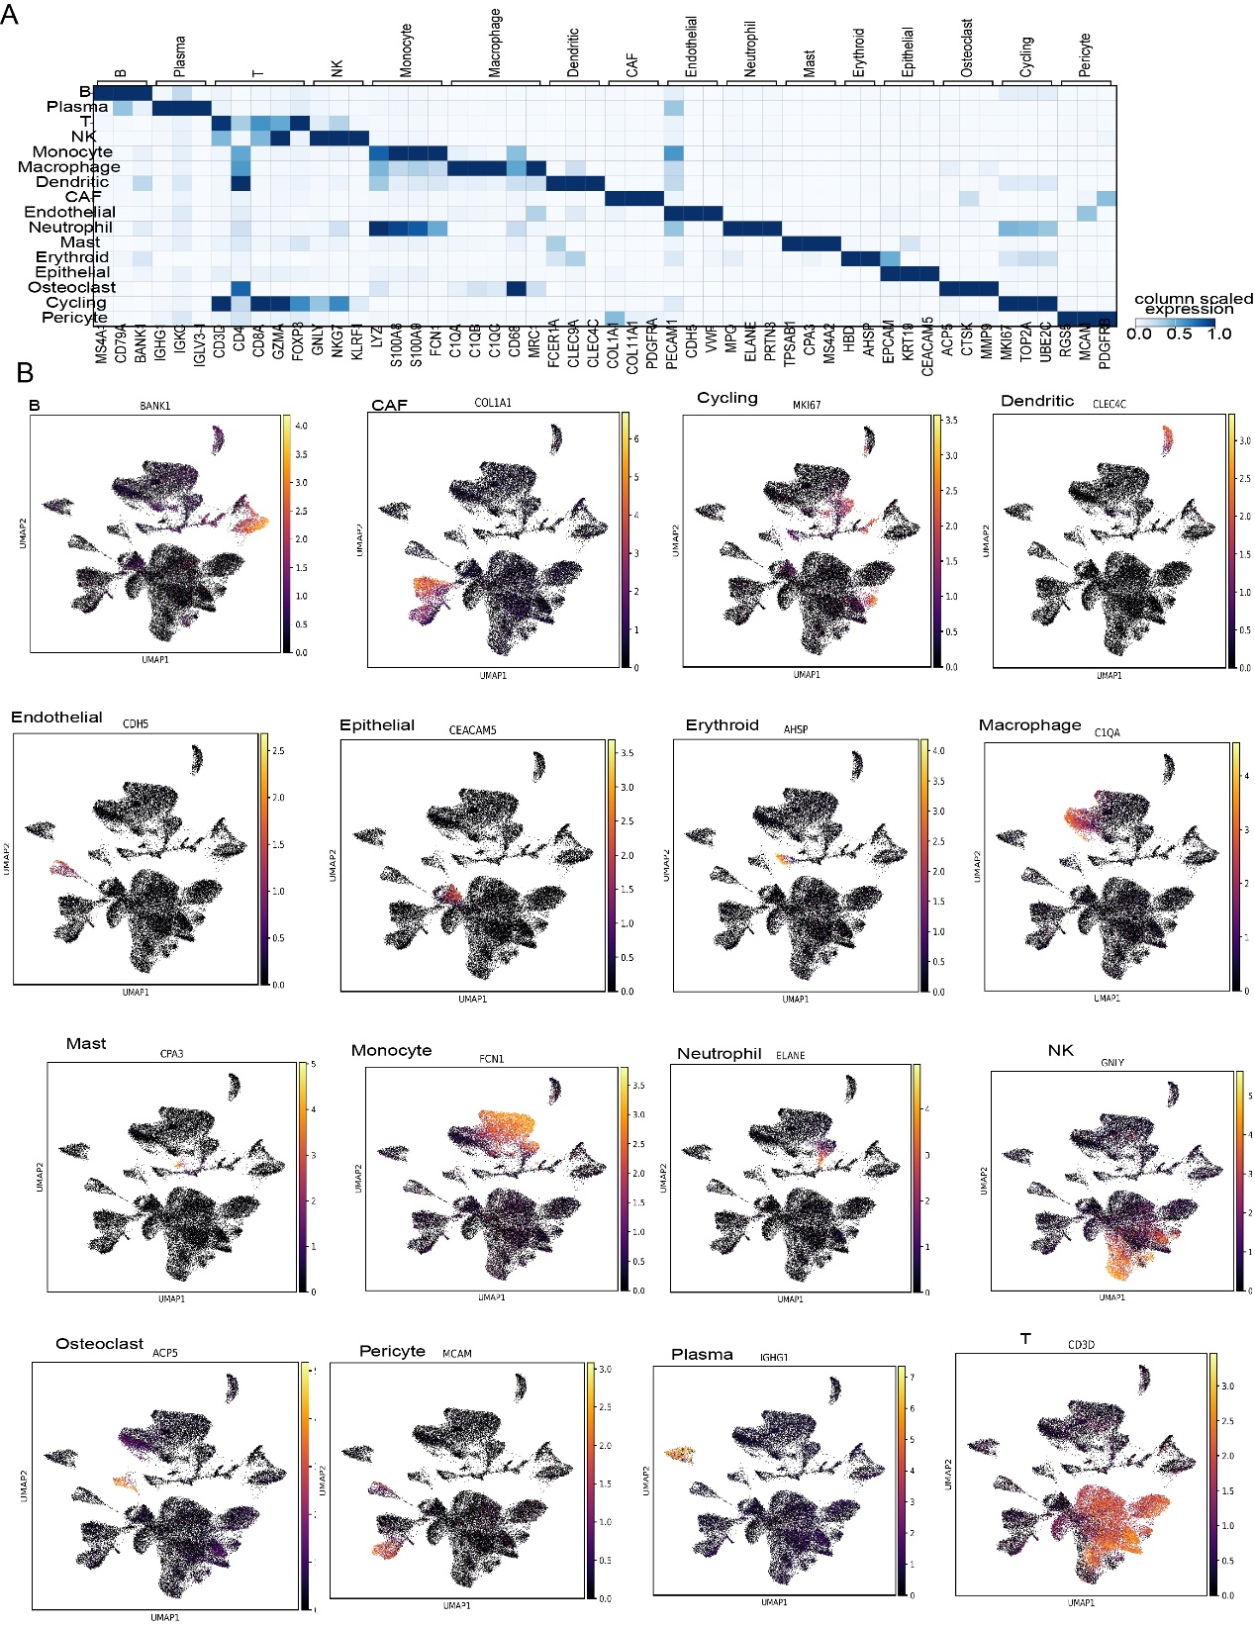
Supplementary 1. Single-cell sequencing analysis of multiple bone metastasis tissues. A. Marker gene expression distribution in different cell populations. B. Gene expression characteristics of different cell populations.
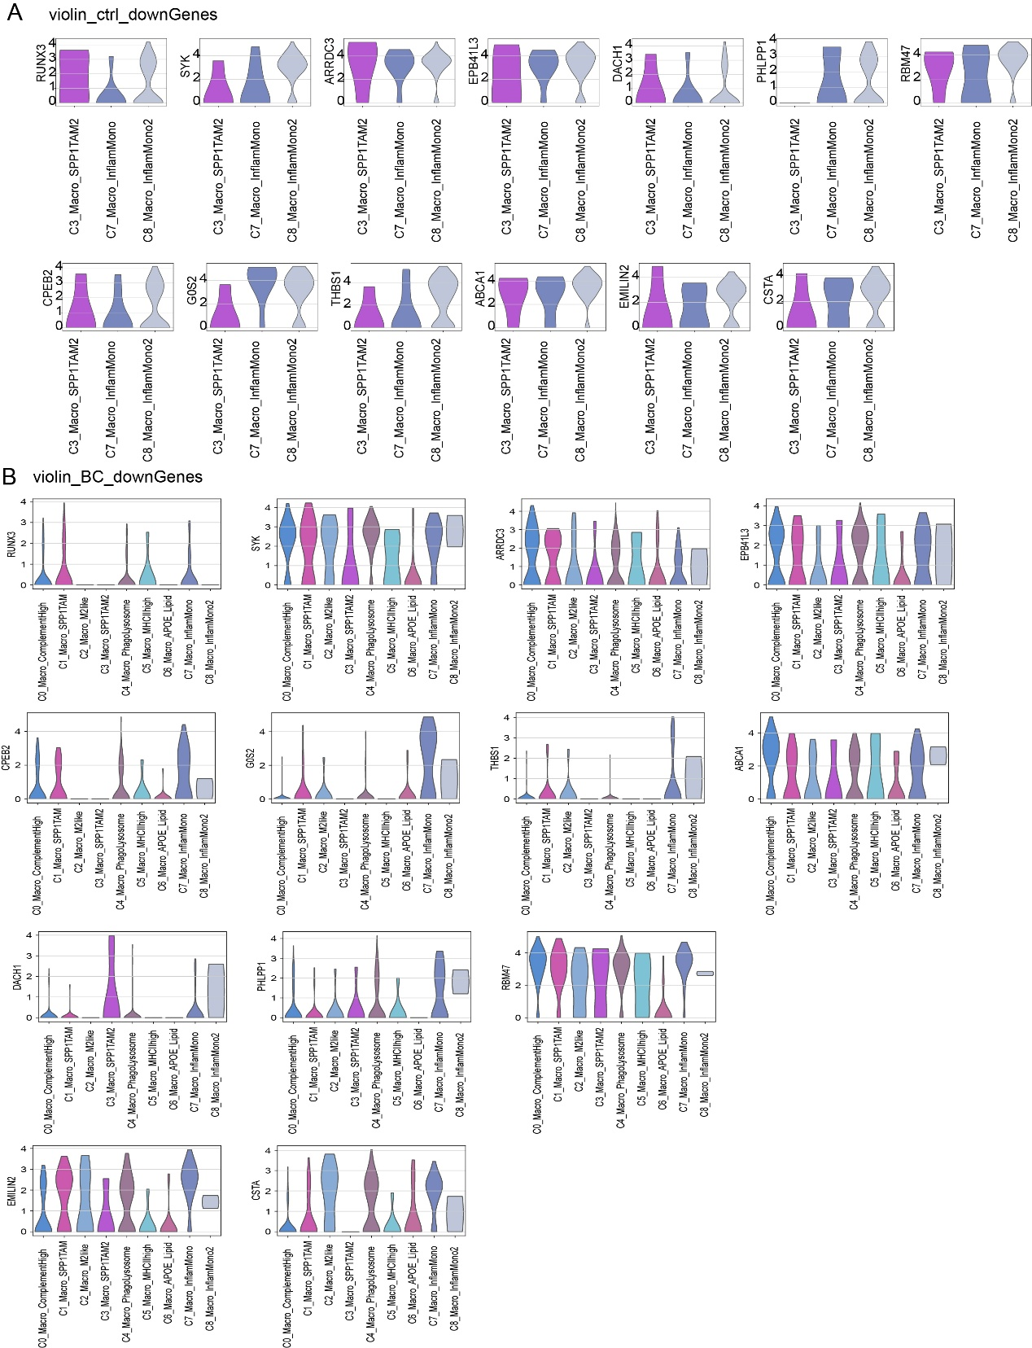
Supplementary 2. Gene expression changes in macrophage populations in multiple bone metastatic tumor tissues.
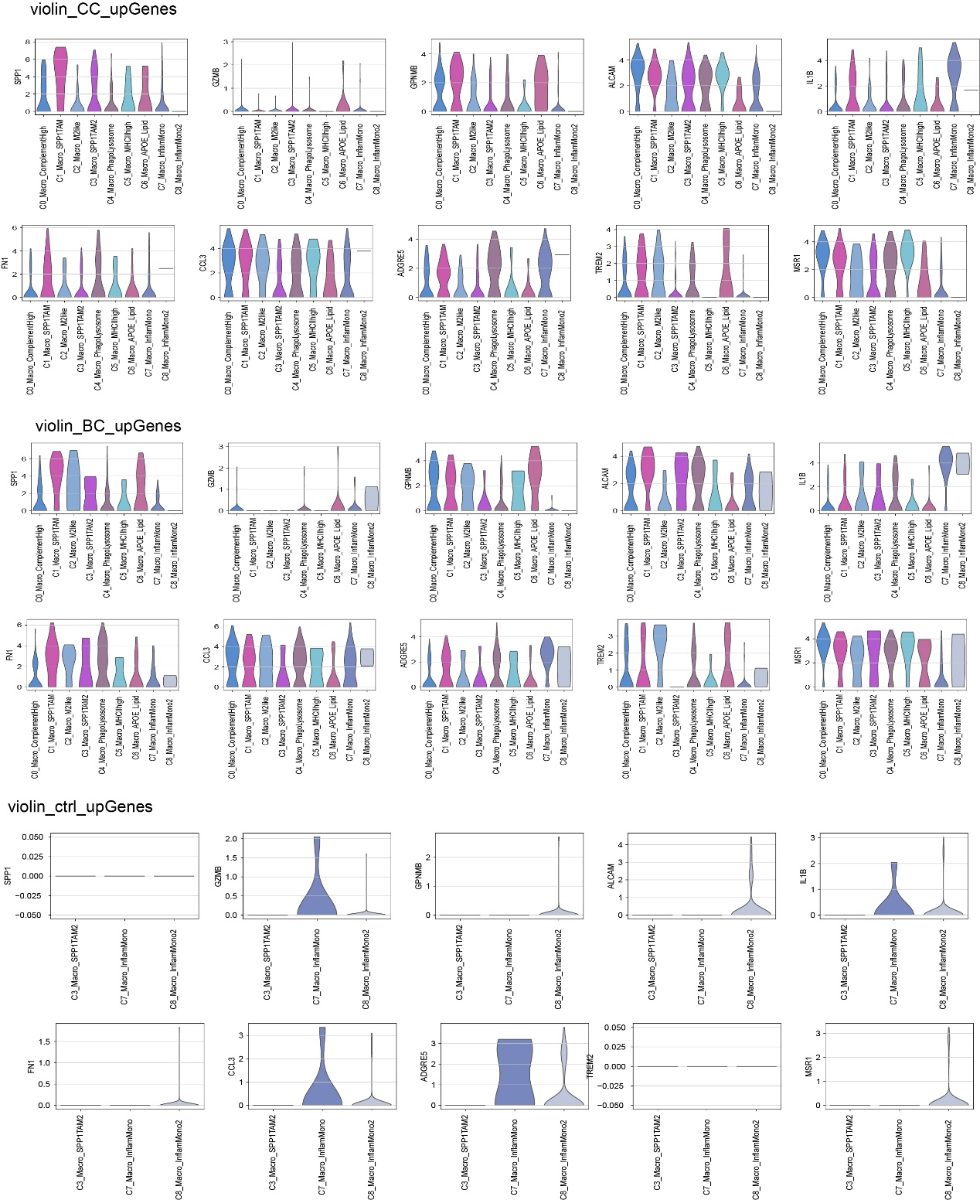
Supplementary 3. Gene expression changes in macrophage populations in multiple bone metastatic tumor tissues.
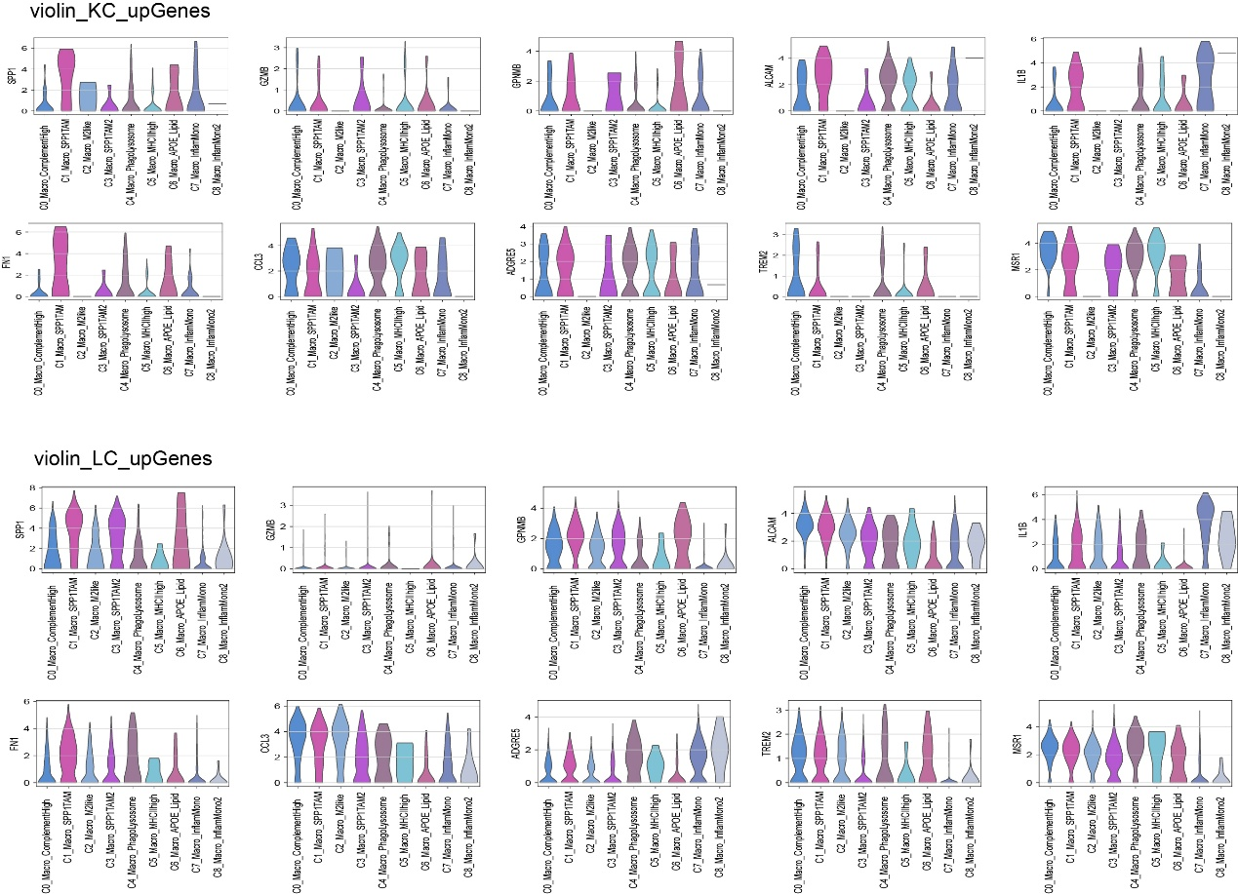
Supplementary 4. Gene expression changes in macrophage populations in multiple bone metastatic tumor tissues.
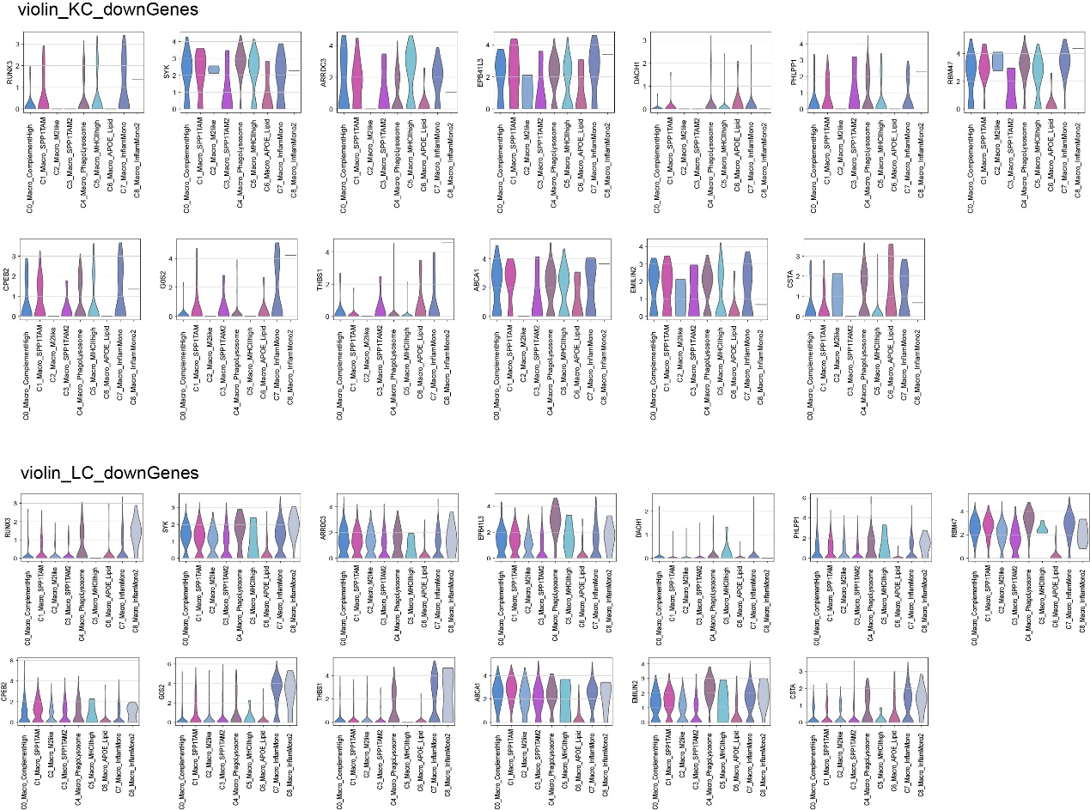
Supplementary 5. Gene expression changes in macrophage populations in multiple bone metastatic tumor tissues.
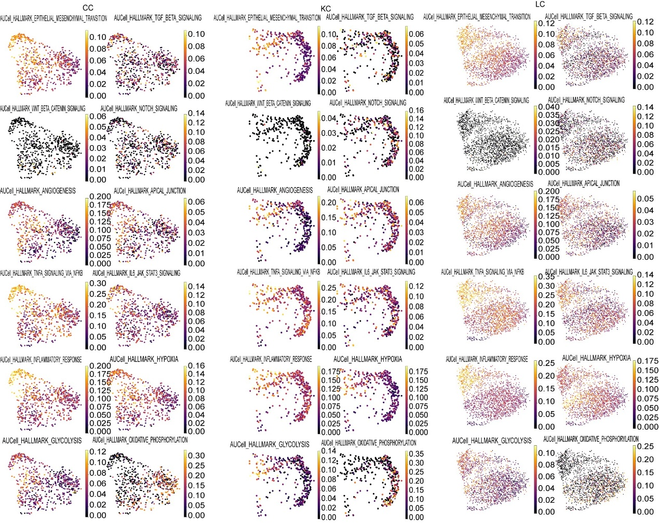
Supplementary 6. Cell distribution of key signaling pathways in macrophages of different bone metastatic tumor tissues.
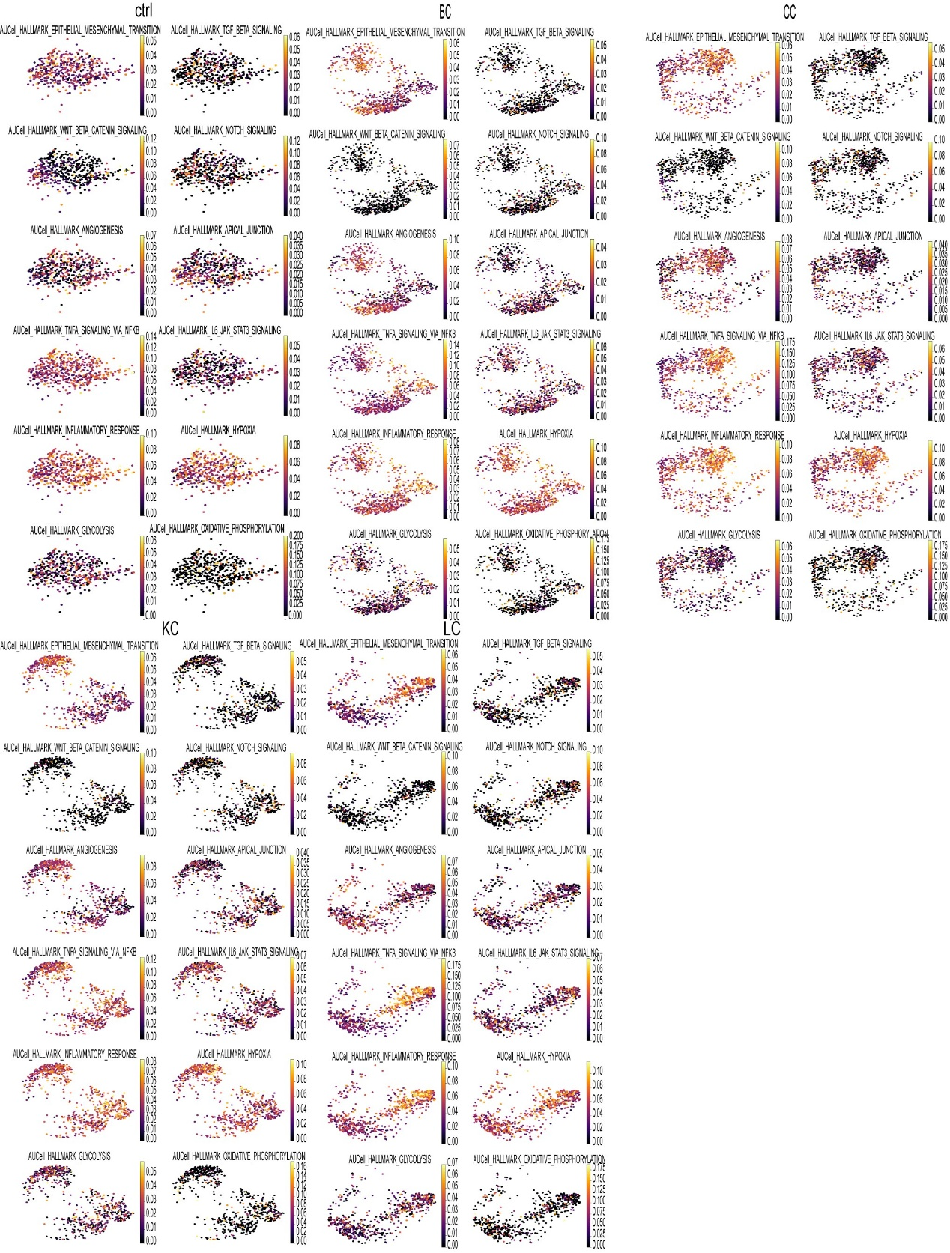
Supplementary 7. Changes in signaling pathways of NK cell populations in multiple bone metastatic tumor tissues.

