Supplementary Figure 1. Elevated free amino acids and mTORC1 activity in gcgr^{DKO} zebrafish.

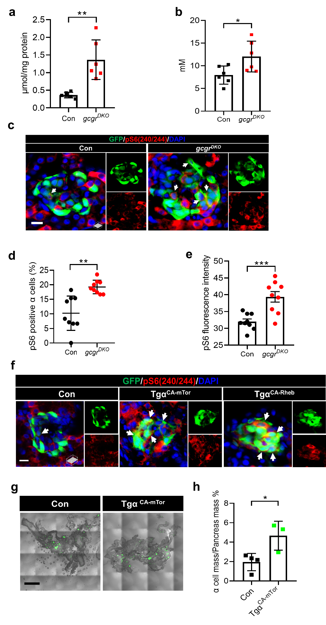
S Fig 1. Elevated free amino acids and mTORC1 activity in gcgr^{DKO} zebrafish. a. Free amino acids levels of control and gcgr^{DKO} larvae (5 dpf), normalized by total protein concentration (Data represent means ± SEM, n = 6, 40 fish/replicate, for each group). b. Serum free amino acids levels of control and gcgr^{DKO} zebrafish adults (Data represent means ± SEM, n = 6 for each group). c. Representative images of pS6(240/244) and GFP immunofluorescence in 5 dpf islet sections of control and gcgr^{DKO} larvae. pS6(240/244) signal in α cells is indicated by arrows. Scale bar, 8 μm. d. Quantification of the percentage of pS6(240/244) positive α cells in control and gcgr^{DKO} larvae at 5 dpf (Data represent means ± SEM, n = 9 for each group). e. Quantification of average pS6(240/244) fluorescence intensity in α cells of control and gcgr^{DKO} larvae at 5 dpf (Data represent means ± SEM, n = 9 for each group). f. Representative images of pS6(240/244) and GFP immunofluorescence in islet sections (5 dpf) of control, Tgα^{CA-MTOR} and Tgα^{CA-Rheb} larvae. pS6(240/244) signal in α cells is indicated by arrows. Scale bar, 8 μm. g. Representative images of a whole-mount adult pancreas of control and Tgα^{CA-MTOR} fish showing α cell mass. Scale bar, 1000 μm. h. Quantification of the percentage of area occupied by α cells in pancreata of adult control and Tgα^{CA-MTOR} fish (Data represent means ± SEM, n = 4 or 3 for each group). *P < 0.05, **P < 0.01, ***P < 0.001 (Two-tailed unpaired t-test).

Supplementary Figure 2. Loss of casr results in hypercalcemia, skeletal dysplasia and growth retardation.

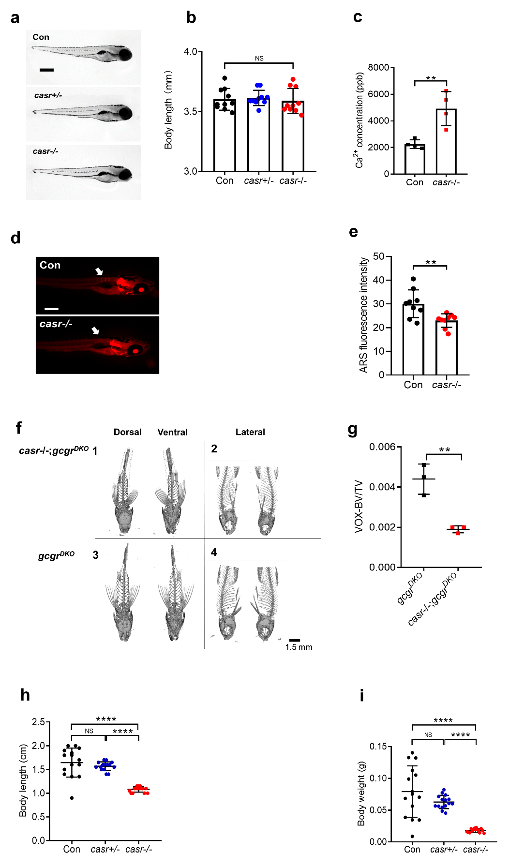
S Fig 2. Loss of casr results in hypercalcemia, skeletal dysplasia and growth retardation. a. Gross appearance of control, casr +/- and casr-/- larvae at 5 dpf. b. Body length of casr +/- and casr-/- larvae at 5 dpf (Data represent means ± SEM, n = 10 for each group). c. Body Ca²⁺ concentration of control and casr-/- larvae at 7 dpf (Data represent means ± SEM, n = 4, 20 fish/replicate, for each group). d. Representative images of alizarin red S (ARS) staining in control and casr-/- larvae at 10 dpf. Calcium deposition in notochord is indicated by arrows (scale bar, 300 μm). e. Quantification of average ARS fluorescence intensity in control and casr-/- larvae notochord at 10 dpf (Data represent means ± SEM, n = 9 for each group). f. Representative images of micro-CT scan in gcgr^{DKO} and casr-/-;gcgr^{DKO} zebrafish at 60 dpf. g. Quantification of bone volume fraction (Bone volume/Body volume) in micro-CT graph (Data represent means ± SEM, n = 3 for each group). h. Body length of zebrafish at 2 months (Data represent means ± SEM, n = 15 for each group) i. Body weight of zebrafish at 2 months (Data represent means ± SEM, n = 15 for each group). **P < 0.01, ****P < 0.0001, NS means no significant difference (One-way ANOVA, Tukey’s multiple comparisons test or two-tailed unpaired t test).

Supplementary Figure 3. CaSR is essential for α cell proliferation.

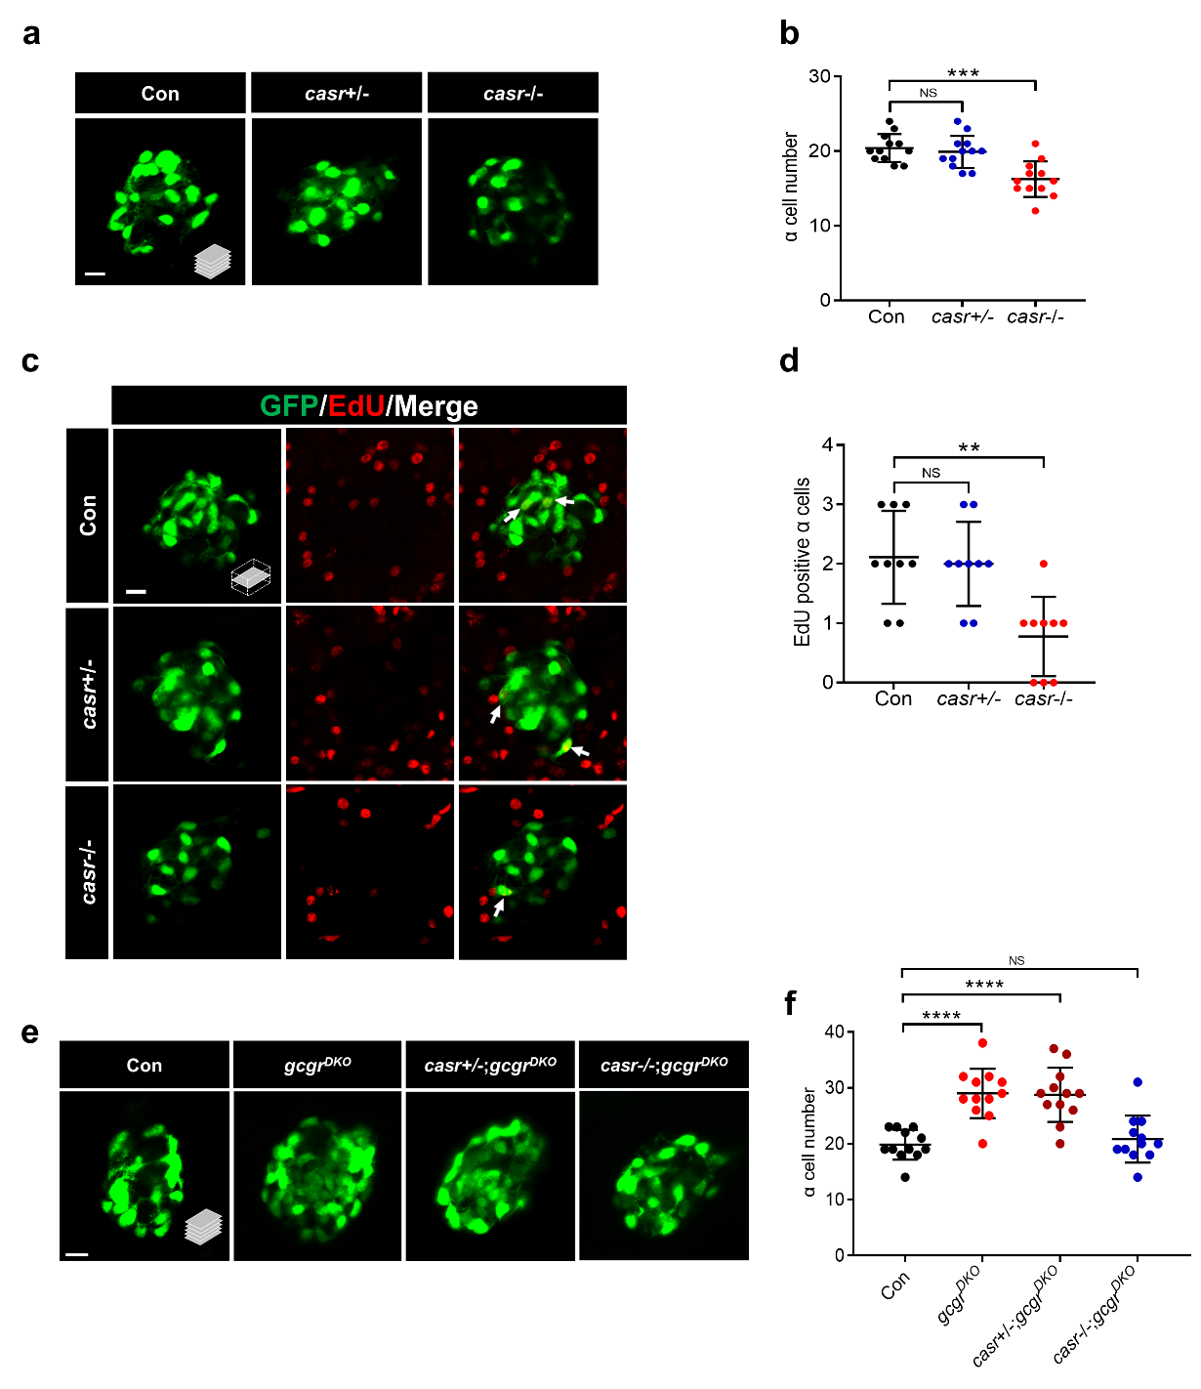
S Fig 3. CaSR is essential for α cell proliferation. a. Representative images of α cells in control, casr +/- and casr-/- larvae at 5 dpf (scale bar, 10 μm). b. Quantification of α cell number in control, casr +/- and casr-/- larvae at 5 dpf (Data represent means ± SEM, n = 12 for each group). c. Representative images of EdU staining in control, casr +/- and casr-/- larvae at 5 dpf. EdU (Red) positive α cells is indicated by arrows (scale bar, 10 μm). d. Quantification of EdU positive α cell number in control, casr +/- and casr-/- larvae at 5 dpf (Data represent means ± SEM, n = 9 for each group). e. Representative images of α cells in control, gcgr^{DKO}, casr +/-;gcgr^{DKO} and casr-/-;gcgr^{DKO} larvae at 5 dpf (scale bar, 10 μm). f. Quantification of α cell number in control, gcgr^{DKO}, casr +/-;gcgr^{DKO} and casr-/-;gcgr^{DKO} larvae at 5 dpf (Data represent means ± SEM, n = 12 for each group). **P < 0.01, ***P < 0.001, ****P < 0.0001, NS means no significant difference (One-way ANOVA, Tukey’s multiple comparisons test).

Supplementary Figure 4. Activation of a Gi-DREADD in α cells fails to restore proliferation in casr-/-;gcgr^{DKO} zebrafish.

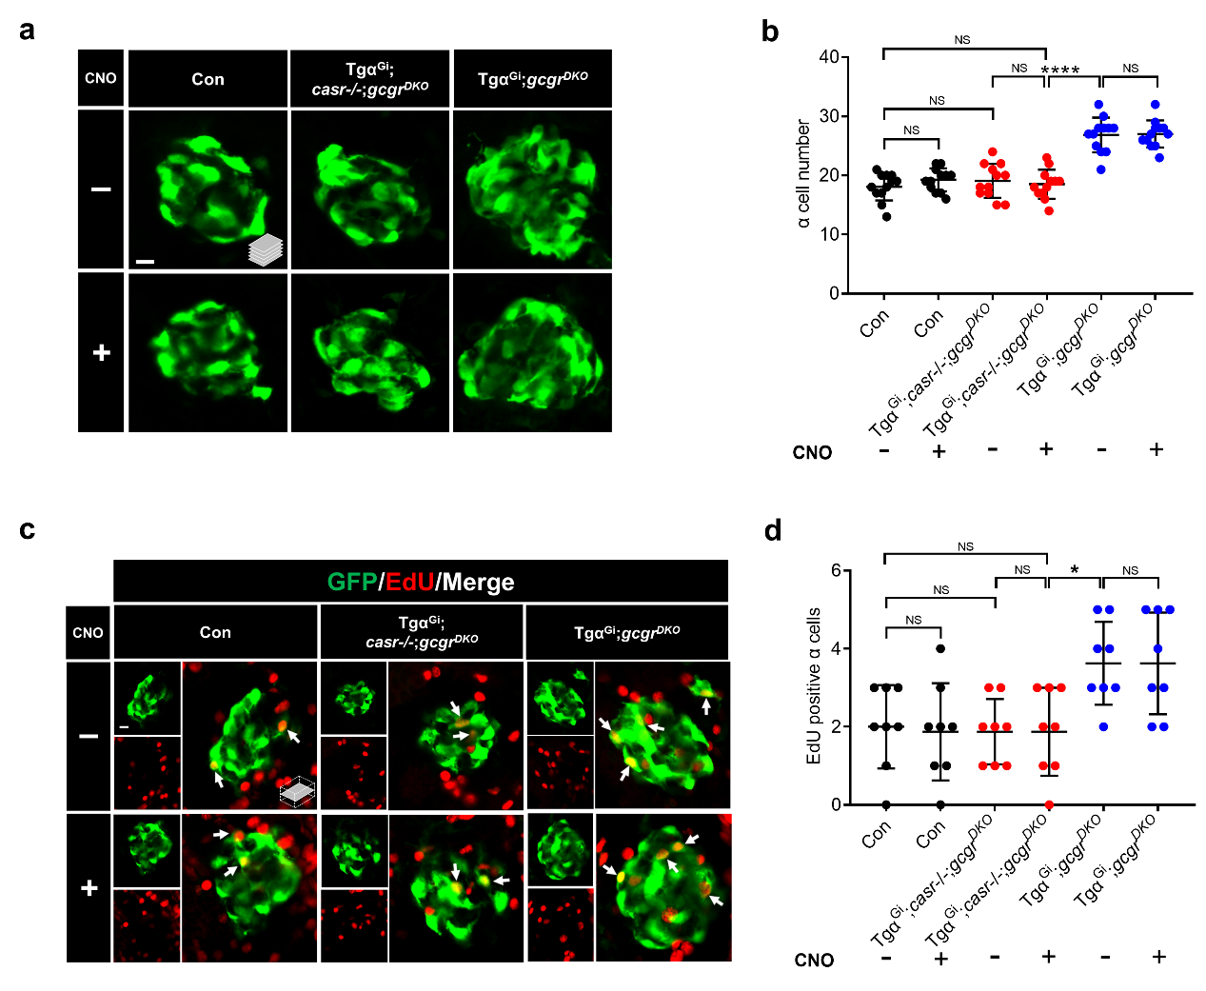

S Fig 4. Activation of a Gi-DREADD (hM4Di) in α cells fails to restore proliferation in casr-/-;gcgr^{DKO} zebrafish. a. Representative images of α cells in 5 dpf control, Tgα^{Gi} (Tg(gcga:hM4Di,cryaa:tagRFP));casr-/-;gcgr^{DKO} and Tgα^{Gi};gcgr^{DKO} larvae treated with 20 μM CNO or vehicle for 48 hours (scale bar, 10 μm). b. Quantification of α cell number in 5 dpf control, Tgα^{Gi};gcgr^{DKO} and Tgα^{Gi} casr-/-;gcgr^{DKO} larvae treated with 20 μM CNO or vehicle (Data represent means ± SEM, n = 12 for each group). c. Representative images EdU labeling in 5 dpf control, Tgα^{Gi};casr-/-;gcgr^{DKO} and Tgα^{Gi};gcgr^{DKO} larvae treated with 20 μM CNO or vehicle for 48 hours. EdU (Red) positive α cells are indicated by arrows (scale bar, 10 μm). d. Quantification of EdU positive α cell number in 5 dpf control, Tgα^{Gi};casr-/-;gcgr^{DKO} and Tgα^{Gi};gcgr^{DKO} larvae treated with 20 μM CNO or vehicle for 4 hours (Data represent means ± SEM, n = 8 for each group). *P < 0.05, ****P < 0.0001, NS means no significant difference (One-way ANOVA, Tukey’s multiple comparisons test).

Supplementary Figure 5. Mek1/2 activation is necessary for α cell proliferation.

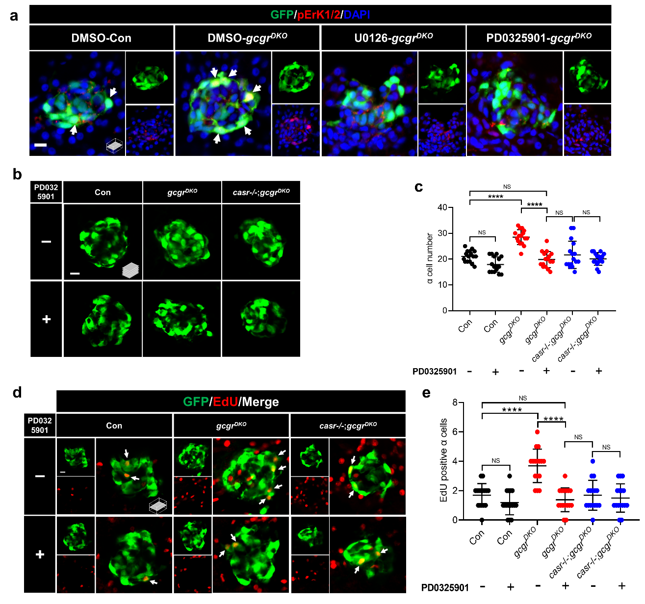

S Fig 5. Mek1/2 activation is necessary for α cell proliferation. a. Representative images of pERK1/2 and GFP immunofluorescence in islet sections of control and gcgr^{DKO} larvae (5 dpf) treated with vehicle, 10 μM U0126 or 10 μM PD0325901 for 48 hours. pERK1/2 signal in α cells is indicated by arrows (scale bar, 7 μm). b. Representative images of α cells in 5 dpf control, gcgr^{DKO} and casr-/-;gcgr^{DKO} larvae treated with 10 μM PD0325901 or vehicle for 48 hours (scale bar, 10 μm). c. Quantification of α cell number in 5 dpf control, gcgr^{DKO} and casr-/-;gcgr^{DKO} larvae treated with 10 μM PD0325901 or vehicle for 48 hours (Data represent means ± SEM, n = 16 for each group). d. Representative images of EdU labeling in 5 dpf control, gcgr^{DKO} and casr-/-;gcgr^{DKO} larvae treated with 10 μM PD0325901 or vehicle for 48 hours. EdU (Red) positive α cells are indicated by arrows (scale bar, 10 μm). e. Quantification of EdU positive α cell number in 5 dpf control, gcgr^{DKO} and casr-/-;gcgr^{DKO} larvae treated with 10 μM PD0325901 or vehicle for 48 hours (Data represent means ± SEM, n = 16 for each group). ****P < 0.0001, NS means no significant difference (One-way ANOVA, Tukey’s multiple comparisons test).

Supplementary Table 1. Transgenic and mutant strains

Abbreviation | Mutant lines¹
Con | Wild Type
gcgr^{DKO} | gcgra-/-; gcgrb-/-
Tgα^{CASR} | Tg(gcga:CASR, cryaa:tagRFP)
Tgα^{Gq} | Tg(gcga:hM3Dq, cryaa:tagRFP)
Tgα^{Gi} | Tg(gcga:hM4Di, cryaa:tagRFP)
Tgα^{CA-MTOR} | Tg(gcga:MTOR^{L1460P}, cryaa:tagRFP)
Tgα^{CA-Rheb} | Tg(gcga:Rheb^{S16H}, cryaa:YFP)

¹ All the mutant lines are in the Tg(gcga:EGFP) background.

