Figure 1. UV–Vis Spectrum of Neem-mediated V₂O₅ Nanoparticles.

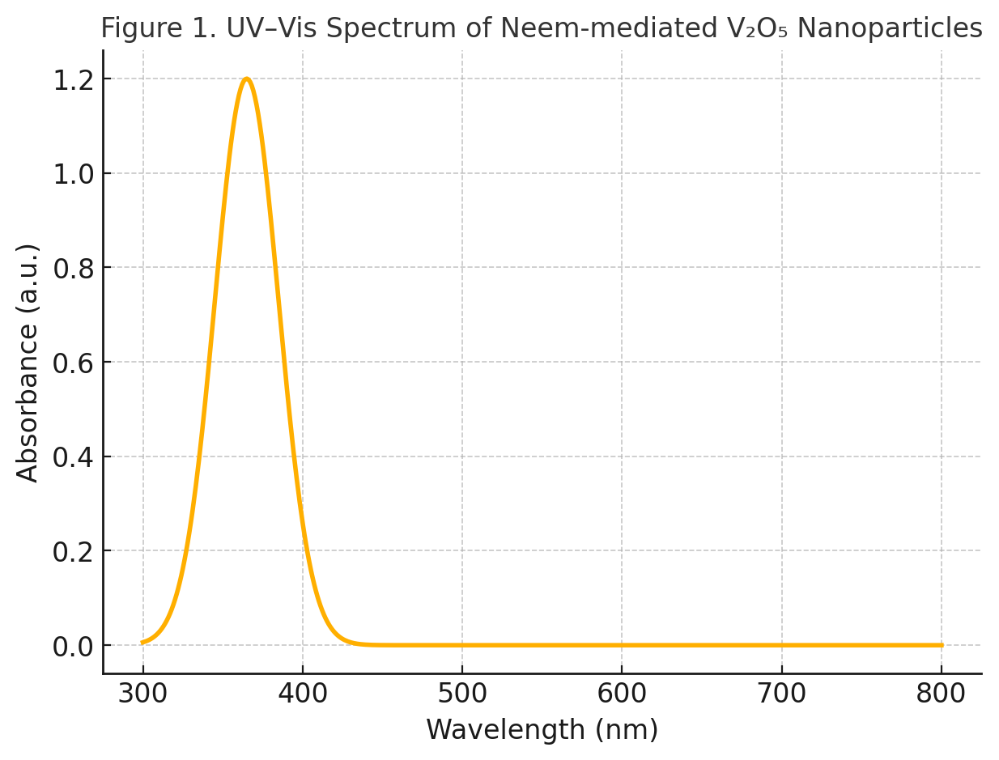

Figure 2. FTIR Spectrum of V₂O₅ Nanoparticles
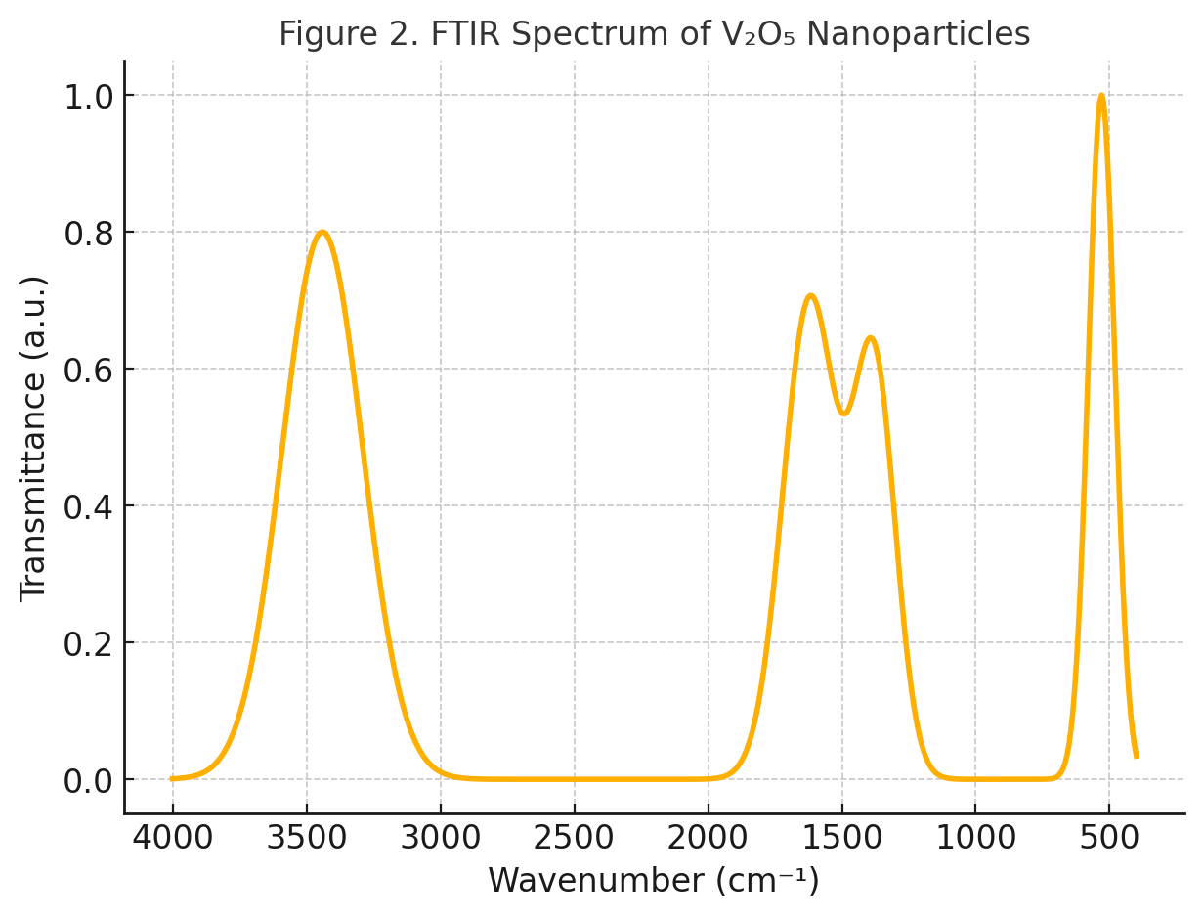

Figure 3. XRD Pattern of Orthorhombic V₂O₅ Nanoparticles

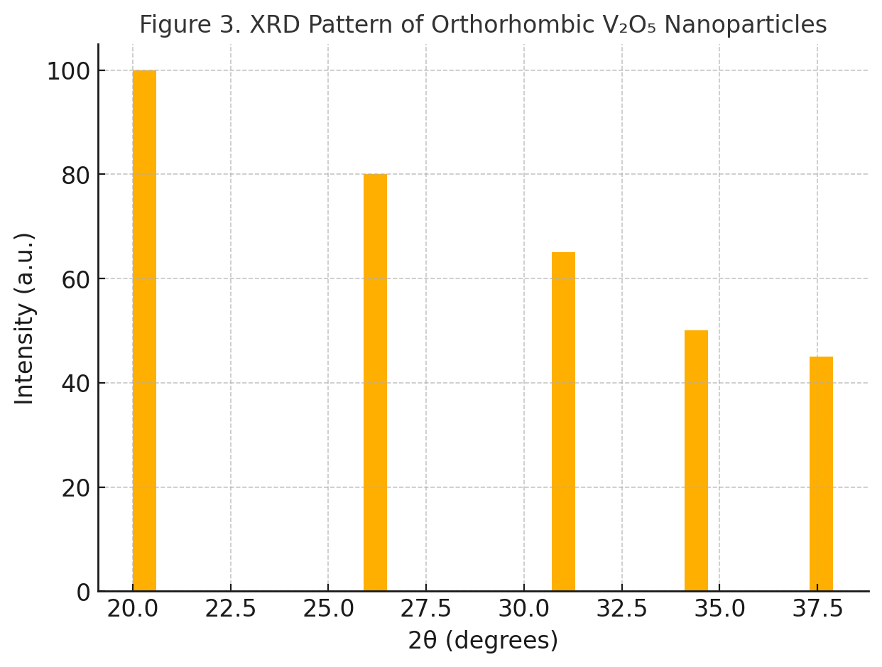

Figure 4. Morphological and Colloidal Characterization of Neem-mediated V₂O₅ Nanoparticles
(a) Scanning Electron Micrograph (SEM) showing quasi-spherical V₂O₅ nanoparticles with slight agglomeration, indicating uniform morphology and effective stabilization by neem phytochemicals. Average particle size observed: 20–80 nm.
(b) Transmission Electron Micrograph (TEM) displaying well-dispersed nanoparticles with clear lattice fringes, confirming crystalline nature. The inset Selected Area Electron Diffraction (SAED) pattern exhibits concentric rings corresponding to orthorhombic V₂O₅ planes, validating high crystallinity.
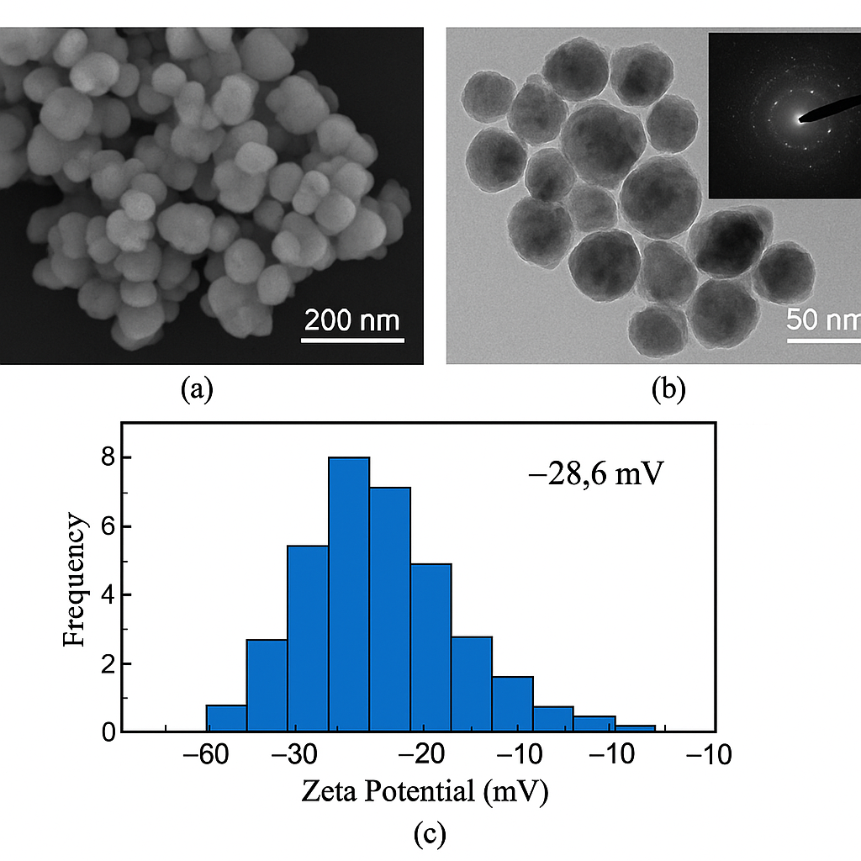
Figure5: Zeta Potential Distribution of neem-derived V₂O₅ nanoparticles showing a prominent peak at –28.6 mV, indicating strong negative surface charge and excellent colloidal stability due to phytochemical capping.

Figure 6a. α-Amylase Inhibition Activity of V₂O₅ NPs

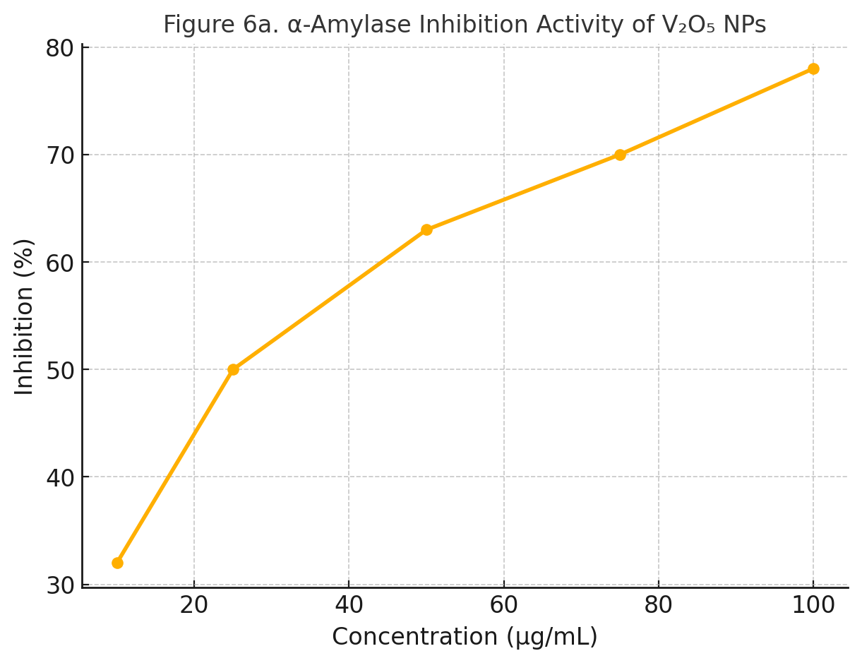

Figure 6b. Cytotoxicity of V₂O₅ NPs against Cancer Cell Lines

