Gel Permeation Chromatography Process for Highly Oriented Cs₃Cu₂I₅ Nanocrystal Film
Yu-Hong Cheng¹, Rikuo Suzuki¹, Narumi Shinotsuka¹, Hinako Ebe¹, Naoaki Oshita², Ryohei Yamakado¹, Takayuki Chiba¹ *, Akito Masuhara², and Junji Kido¹ *
1 Graduate School of Organic Materials Science, Yamagata University, 4-3-16 Jonan, Yonezawa, Yamagata 992-8510, Japan
2 Graduate School of Science and Engineering, Yamagata University, 4-3-16 Jonan, Yonezawa, Yamagata 992-8510, Japan
*Corresponding authors
Takayuki Chiba: T-chiba@yz.yamagata-u.ac.jp and Junji Kido: kid@yz.yamagata-u.ac.jp

DFT calculation:
The crystal structure of Cs₃Cu₂I₅ was obtained from SXRD spectra by Rietveld refinement. For slab systems, surface reconstruction and single-point calculations were performed, whereas for the bulk systems, single point calculations were performed at the ZORA-GGA-PBE/DZP theoretical level using the ADF BAND package. In the slab and bulk system, the cif files listed in a separate file were used. For the slab system, two layers of the bulk system were used in the (020) direction, where the surfaces are (020) and (040).
The surface energy was calculated from the following equation:
$σ=\frac{1}{A}(E_{slab}-nE_{bulk})$ (1)
where σ is the surface energy, A is the surface area of the slab on both sides, E_{slab} is the model of the slab system, n is a factor to match the number of atoms in the bulk system with the number of atoms in the slab system, and E_{bulk} is the energy of the bulk system. The calculation was based on the exact crystal model with infinite boundary of a-axis and c-axis shown in Figure S4 ¹.
Figure S1 (a) Schematic of hot-injection and typical purification process by adding anti-solvent to the Cs₃Cu₂I₅ dispersion. (b) the SEM of the precipitate of anti-solvent treated dispersion
Figure S2 (a) the TEM image of Cs₃Cu₂I₅ NCs before processing GPC and its (b) size distribution
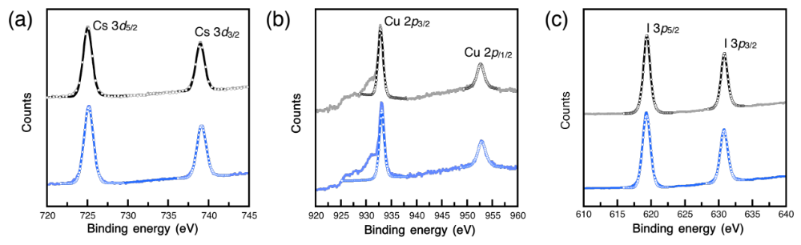
Figure S3 The XPS spectra of Cs₃Cu₂I₅ film prepared by the dispersion with or without GPC process: (a)Cs 3d, (b) Cu 3p, and (c) I 3p
Figure S4 the calculation is based on the model on a slab of (a) (020) phase and (b) (040) phase
Figure S5 the PL decay of Cs₃Cu₂I₅ film

Figure S6 (a) the photo of dispersion, dried cell, and re-dispersed solution in toluene, (b) the PL spectra, and the (c) PL decay spectra
Table S1 The XPS composition from before and after GPC NCs prepared by spin coating
 | Cs | Cu | I
Before GPC | 24.49 | 17.88 | 57.63
 | 26.30 | 20.05 | 53.64
 | 23.82 | 17.59 | 58.57
average | 24.87 | 18.51 | 56.61
After GPC | 26.38 | 17.32 | 56.29
 | 27.99 | 17.04 | 54.98
 | 26.61 | 18.24 | 55.15
average | 26.99 | 17.53 | 55.47
Table S2 Single crystal X-ray diffraction data for Cs₃Cu₂I₅ NCs
Empirical formula | Cs₃Cu₂I₅
Temperature | 292(2) K
Source | Mo-Ka
Crystal system | Orthorhombic
Space group | Pnma
Unit cell dimensions | a = 10.1824(8) Å, alpha = 90 deg.
 | b = 11.6655(11) Å, beta = 90 deg.
 | c = 14.3687(12) Å, gamma = 90 deg.
Volume | 1706.8(3) Å³
Crystal size | 0.500 × 0.460 × 0.310 mm
Z | 4
R₁ | 0.0434
wR₂ | 0.1120
GOF | 1.126

Table S3 The thin film XRD peak information and the comparison of calculated data
No. | Miller index | Calculated data 2θ (deg.) | Thin film  2θ (deg.) | d (Å) | FWHM (deg.)
1 | (020) | 15.178 | 15.320 | 5.779 | 0.396
2 | (040) | 30.630 | 30.799 | 2.9008 | 0.401
3 | (060) | 46.681 | 46.896 | 1.9358 | 0.454

Table S4 The optical properties of each Cs₃Cu₂I₅ in different forms.
Samples | PL (nm) | FWHM (nm) | PLQY (%) | 𝛕_{avg} (µs)
NCs colloid (Before GPC) | 444 | 73.1 | ~100 | 1.237
NCs colloid (After GPC) | 443 | 73.5 | ~100 | 1.236
NCs  re-dispersion | 442 | 72.4 | 98.3 | 1.175
NCs film  (GPC purified) | 443 | 74.3 | 79.7 | 1.284
NCs + PMMA | 443 | 74.9 | nd^{(a)} | 1.141
a) no data

1. K. Momma, F. Izumi, "VESTA 3 for three-dimensional visualization of crystal, volumetric and morphology data" J. Appl. Crystallogr. 44, 1272 (2011).

