A Practical Approach for Continuous In Situ Characterization of
Radiation Quality Factors in Space

Igor Shuryak^{1*}, Tony C. Slaba², Ianik Plante³, Floriane Poignant⁴, Steven R. Blattnig², David J. Brenner¹

1. Center for Radiological Research, Columbia University Irving Medical Center, New York, NY10032
2. NASA Langley Research Center, Hampton, VA 23681
3. KBR, Houston, TX 77058
4. National Institute of Aerospace, Hampton, VA 23666

* Corresponding author: Igor Shuryak, M.D., Ph.D.
Center for Radiological Research, Columbia University,
630 West 168th St., New York, NY 10032
Phone: 212-305-2405; Fax: 212-305-3229
E-mail: is144@cumc.columbia.edu

Supplementary Figure 1. Comparison of model fits (Eq. A2 in Supplementary Data online, red curves) with the data (black points, blue circles) for mouse tumorigenesis induced by H, He, C, O, Si, or Fe ions, or γ rays. Black points represent the number of tumors in individual mice. Blue circles and bars represent mean values and standard errors, and red curves represent model fits. Two of the Si irradiated mice had >40 tumors (50 and 53), but these points are not shown in the Si panel below to improve visualization at lower y-axis values.
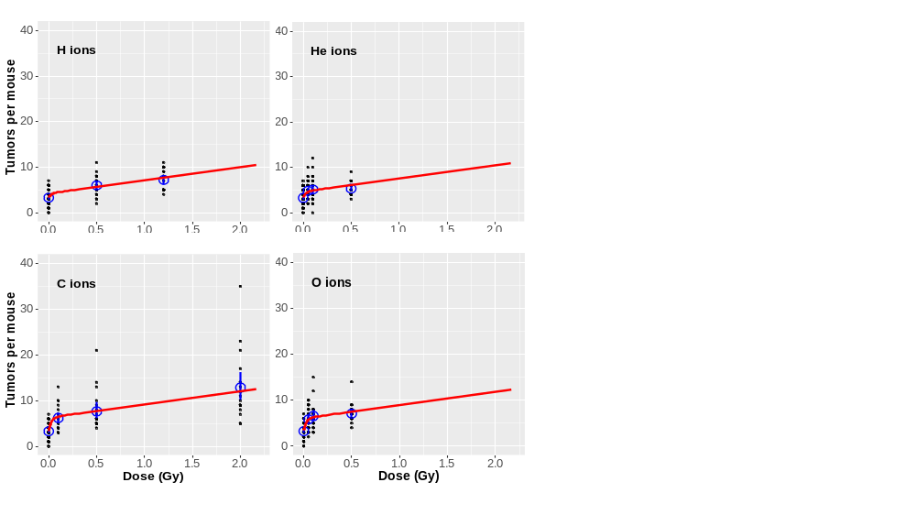

Supplementary Figure 1 (continued)
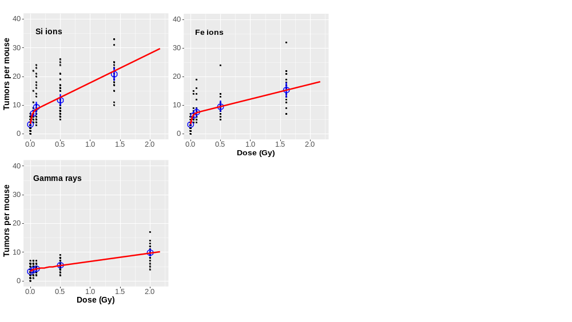

Supplementary Figure 2. Calculated dose-normalized microdosimetric energy deposition distributions d(y) as function of lineal energy (y) for different ion types (energies given in the text) and spherical target diameters (d = 2, 4, 8, or 16 µm).

