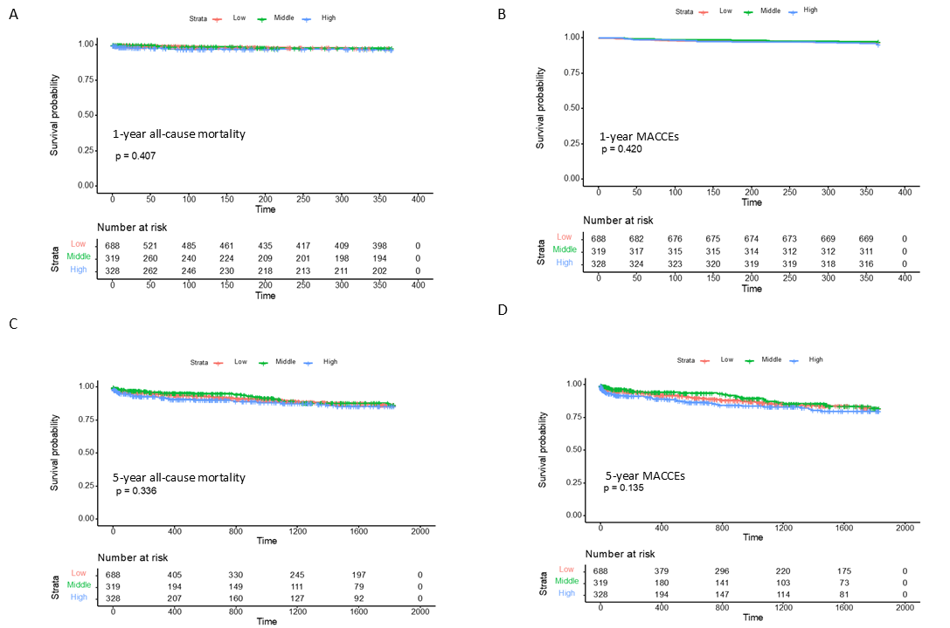
Fig. S1 The relationship between AIP and 1-year and 5-year outcomes. A. The relationship between AIP and the incidence of 1-year all-cause death. B. The relationship between AIP and the incidence of 1-year MACCEs. C. The relationship between AIP and the incidence of 5-year all-cause death. D. The relationship between AIP and the incidence of 5-year MACCEs. AIP, atherogenic index of plasma; MACCEs, major adverse cardiovascular and cerebrovascular events.

