Table 1: Combine Gini Coefficients compared to average Gini coefficients and domestic surface area Gini coefficients.

Site | Combined Gini Coefficient (CGC) | Arithmetic mean of Gini coefficients | Geometric mean of Gini coefficients (CAI) | Domestic surface area Gini coefficient | n variables | n cases
Chunchucmil | 0.357 | 0.556 | 0.550 | 0.465 | 6 | 113
Uxul | 0.238 | 0.496 | 0.496 | 0.424 | 9 | 10
Mayapan | 0.155 | 0.491 | 0.472 | 0.435 | 9 | 8
Tikal | 0.481 | 0.598 | 0.587 | 0.442 | 4 | 34
Copan | 0.249 | 0.422 | 0.401 | 0.172 | 9 | 9
Çatalhöyük | 0.447 | 0.591 | 0.563 | 0.251 | 8 | 13

Table 2: Uxul Gini coefficients for individual variables

Variables | Gini coefficients
Volume of architecture | 0.548
Surface area of architecture | 0.424
Greenstone artifacts per 1000 sherds | 0.581
Obsidian per 1000 sherds | 0.366
Shell per 1000 sherds | 0.692
Polychrome sherds per 1000 sherds | 0.315
Musical instruments per 1000 sherds | 0.430
Figurines per 1000 sherds | 0.473
Incense burners per 1000 sherds | 0.639

Table 3: Uxul Correlation Matrix
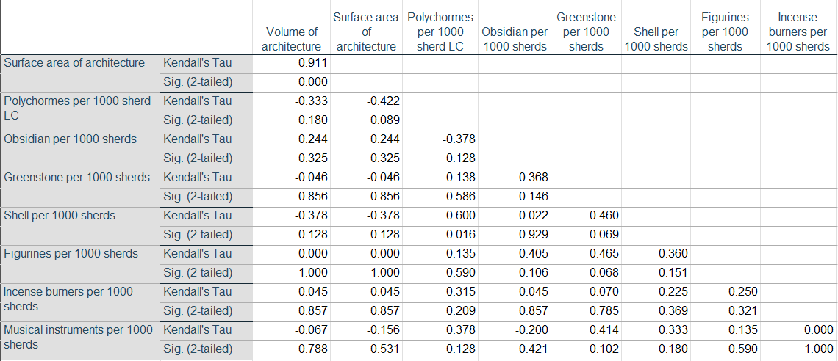

Table 4: Mayapan Gini coefficients for individual variables

Variable | Gini coefficient
Obsidian artifacts per 1000 sherds | 0.440
Shell artifacts per 1000 sherds | 0.382
Ritual sherds per 1000 sherds | 0.537
Fancy sherds per 1000 sherds | 0.304
Imported sherds per 1000 sherds | 0.351
Chert points per 1000 sherds | 0.605
Metal artifacts per 1000 sherds | 0.763
Surface area of architecture | 0.435
Chert per 100 sherds | 0.605

Table 5: Mayapan Correlation Matrix

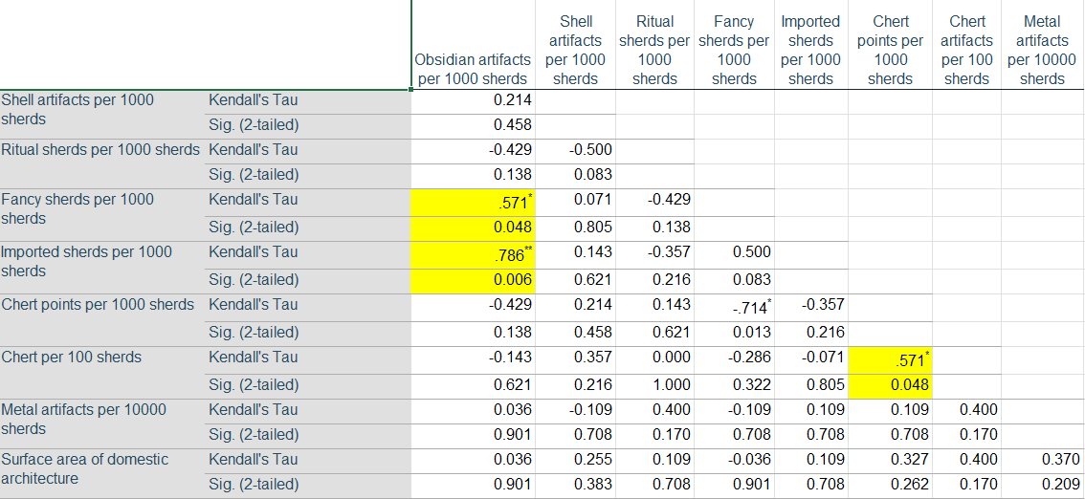

Table 6 Çatalhöyük Gini coefficients for individual variables

Variable | Gini coefficients
Grinding tools | 0.86
Paintings | 0.544
Faunal installations | 0.656
Burial MNI | 0.494
Grave goods | 0.472
Exotic shell | 0.785
# exotic shell sources | 0.28
Exotic stone beads | 0.646
House surface area | 0.251

Table 7 Çatalhöyük correlation matrix
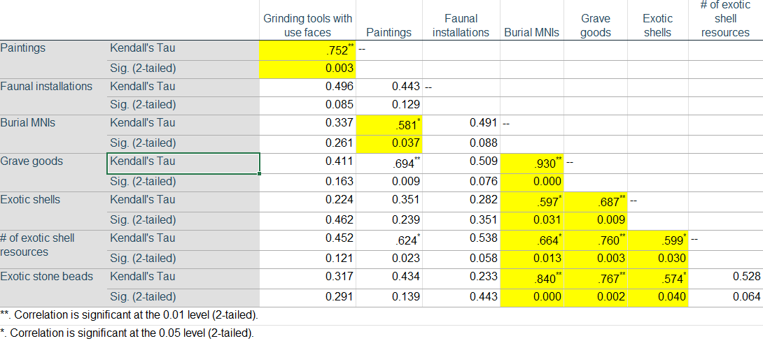

Table 8: Copan Gini coefficients
Variable | Gini coefficient
Architectural labor investment | 0.407
surface area of structures | 0.172
Extent of sculpture | 0.617
Imported fancy pottery | 0.363
Quantity of portable ornaments | 0.509
Figurines | 0.434
Chert and obsidian bifaces | 0.378
Proporiton of basalt grinding stones | 0.391
Worked bone | 0.529

Table 9 Copan correlation matrix
