Supplementary Materials
AI-Driven Discovery Reveals Critical Thresholds and Persistent Inequities in Urban Sustainability
* The supplementary materials contain variable selection rationale, the detailed input variables, domain features, the detailed formula for methodological development, and supporting results.

Supplementary Text 1. Variable Selection Rationale
Our 26 base variables operationalize the triple-bottom-line framework for urban sustainability—evaluating environmental quality, social equity, and economic vitality^{1,2}. Variables were organized into domain-specific feature sets recognizing that certain factors such as transit access and housing characteristics influence multiple sustainability dimensions simultaneously.
Environmental features capture ecosystem services and climate aspects: vegetation characteristics (tree canopy coverage, plant diversity) affect air quality, with research demonstrating varied PM2.5 capture efficiency across species³ and significant associations between urban greenspace and environmental outcomes⁴; air pollution and emissions (PM2.5, CO₂ per household) reflect health impacts⁵; physical resilience (flood risk) addresses climate adaptation⁶; net primary productivity (NPP) quantifies ecosystem functioning⁷; and transit access reduces car dependency⁸. Research demonstrates tree canopy's air quality benefits and relationships between greenspace patterns and urban environmental quality^{3,4,5}.
Social features emphasize opportunity access and well-being: economic opportunity (employment index, college education rate) reflects human capital development, with employment and access to services are essential to social health²; housing affordability (housing+transportation affordability, inverted housing cost burden) reflect true cost of living, with empirical research in both developed and developing contexts showing that suburban households spend significantly more on combined housing and transportation costs⁹; safety reflects quality of life, with research demonstrating associations between built environment characteristics, socio-economic conditions, and crime rates across multiple cities^{4,10,11,12}; housing tenure and household stability (renter rate, married households) indicate community characteristics; and transit access enables mobility and job accessibility, with research showing job access significantly affects housing prices and spatial distribution of populations¹³.
Economic features measure vitality and market dynamics: income and wealth (median household income, home values) serve as measures of economic capacity; economic activity (employment rate, retail density) captures local market vitality¹⁴; housing market dynamics (renter rate, housing cost burden) indicate economic pressure, with housing affordability research demonstrating relationships between price-to-income ratios and economic sustainability¹⁵; and transit access affects economic activity through improved accessibility¹³.
Land use variables quantify development intensity gradients (open space, low/medium/high intensity development, natural areas) that structure environmental quality and urban form, with empirical research demonstrating associations between development patterns and environmental quality as well as social health^{3,11}.
This variable set follows four criteria: (1) alignment with aspects appearing consistently across established sustainability frameworks, (2) empirical validation through prior research, (3) public data availability ensuring reproducibility, and (4) recognition that certain factors (transit, housing) span multiple sustainability dimensions, reflecting urban planning theory that sustainable development emerges from mutually reinforcing co-benefits.

Supplementary Table 1. Variables for Multi-Objective Optimization
Variable Name | Description
Environmental Indicators
treeCCov17 | Tree canopy coverage (2017)
plantDivrs | Plant species diversity index
NPP_avg | Average net primary productivity
co2_per_hh_local | Household CO₂ emissions (local)
urbanFlood | Urban flood risk index
eclipsPM25 | PM2.5 air pollution
Social Indicators
emp_ovrll_ndx | Employment opportunity index
college18 | College education rate (2018)
ht_ami | Housing + Transportation Affordability
crime_rate_per_1000 | Crime incidents per 1000 residents
Economic Indicators
median_household_income | Median household income
mdHome18 | Median home value
employment_rate | Employment rate
retail_density | Retail establishments density
Enhanced Socioeconomic Features (shared)
RenterRate | Renter-occupied housing units
MarriedHouseholds | Married household rate
HCB | Housing cost burden
bus_rail_stop_count_800m | Transit stops within 800m buffer
Demographic Control Control Variables
GEOID | Census tract identifier
pop_total | Total population
pop_density | Population density
Land Use Control Variables
Developed_Open_Space | Open space in developed areas
Developed_Low_Intensity | Low-intensity development
Developed_Medium_Intensity | Medium-intensity development
Developed_High_Intensity | High-intensity development
Natural_Area | Natural/undeveloped area

Supplementary Table 2. Feature Summary
Domain | Base Variables | Engineered Features | Total Predictors | Key Composite Indices
Environmental | 6 | 3 | 9 | Development diversity, sustainable mobility, green space efficiency
Social | 4 | 4 | 8 | Housing diversity/stability, social equity, transit leverage
Economic | 4 | 3 | 7 | Economic vulnerability, TOD potential, gentrification pressure

Supplementary Text 2. Environmental Domain Features
Three engineered features enhance environmental prediction by capturing land use mixing, green space efficiency, and low-carbon mobility potential.
2.1 Environmental Domain Features
Development Diversity Index quantifies land use heterogeneity using Shannon entropy:
$$H=-\sum_{i}{p_{i}}×\ln\left(p_{i}\right)/\ln\left(4\right)$$
where $p_{i}$= proportion of development type $i∈\{\text{open, low, medium, high}\}$. Values range from 0 (single land use type) to 1 (equal mix of all types); higher values indicate more diverse, mixed-use development patterns associated with reduced travel distances and lower emissions.
Green Space Per Capita normalizes open space by population density using a logarithmic adjustment:
$$\text{Green}\text{_}\text{Space}\text{_}\text{PC}=\frac{\text{Open}\text{_}\text{Space}}{\log\left(\text{Density}\right)+0.1}$$
This ratio reflects that dense neighborhoods share green spaces more efficiently—a downtown tract with 10% parks serving 30,000 people provides better per-capita access than a sparse area with 15% parks serving 5,000 people. Higher values indicate better green space provision relative to local population needs.
Sustainable Mobility Index synthesizes transportation-related sustainability factors:
$$\text{Sustainable}\text{_}\text{Mobility}=f\left(\text{Transit},\text{Open}\text{_}\text{Space},1-{\text{CO}}_{2}\right)$$
This composite synthesizes transit infrastructure (reducing car dependence), walkable open space (enabling active transportation), and actual emissions outcomes. Higher values indicate neighborhoods with robust sustainable transportation options and correspondingly lower carbon footprints.
2.2 Social Domain Features
Four engineered features emphasize community stability, housing tenure diversity, and equitable access to opportunities.
Housing Diversity Index penalizes extreme tenure compositions:
$$\text{Housing}\text{_}\text{Diversity}=1-\left|\text{Renter}\text{_}\text{Rate}-0.50\right|$$
The index operationalizes the urban planning concept of "balanced communities" and "tenure mix" policies that aim to enhance social diversity in residential environments by avoiding mono-tenure neighborhoods^{16,17}. Values range from 0 (100% renters or 100% owners) to 1 (perfect 50-50 split). Higher values indicate mixed-tenure neighborhoods associated with greater social stability.
Housing Stability Score combines household structure and affordability:
$$\text{Housing}\text{_}\text{Stability}=f\left(\text{Married}\text{_}\text{Households},1-\text{HCB}\right)$$
This composite captures two dimensions of residential longevity—family structure (married households tend to stay longer) and economic capacity to remain (lower housing cost burdens). Higher values indicate neighborhoods where residents are both inclined and able to stay long-term.
Social Equity Index integrates multiple dimensions of opportunity access:
$$\text{Social}\text{_}\text{Equity}=f\left(1-\text{HCB},\text{Transit},\text{Income},\text{Safety}\right)$$
This comprehensive metric integrates housing affordability (lower cost burden = better), transit accessibility (more stops = better), median income (higher = more resources), and safety (lower crime = better). Higher values indicate neighborhoods where residents have equitable access to economic opportunities, mobility, and safe environments.
Transit Accessibility Leverage captures the multiplicative interaction between infrastructure and user base:
$$\text{Transit}\text{_}\text{Leverage}=\text{Transit}\text{_}\text{Stops}×\text{Population}\text{_}\text{Density}$$
This interaction term reflects that transit's social impact scales with ridership potential—10 transit stops in a dense neighborhood serves far more residents than the same 10 stops in a sparse area, amplifying accessibility benefits through network effects. Higher values indicate locations where transit infrastructure reaches larger populations.
2.3 Economic Domain Features
Three engineered features quantify economic vulnerability, development potential, and transformation pressure.
Economic Vulnerability Index identifies at-risk areas requiring policy intervention:
$$\text{Economic}\text{_}\text{Vulnerability}=f\left(1-\text{Income},\text{HCB},\text{Unemployment}\right)$$
This composite identifies at-risk areas by combining income deficits (lower income = higher vulnerability), housing cost stress (higher burden = higher vulnerability), and joblessness. Higher values signal neighborhoods requiring economic intervention and support services.
Transit-Oriented Development (TOD) Potential evaluates suitability for densification:
$$\text{TOD}\text{_}\text{Potential}=f\left(\text{Transit},\text{Medium}\text{_}\text{Intensity},\text{High}\text{_}\text{Intensity}\right)$$
This metric evaluates where densification makes economic sense—areas with strong transit access and existing medium-to-high intensity development can absorb additional density without major infrastructure investment. Higher values indicate prime locations for transit-oriented development policies and upzoning.
Gentrification Pressure signals areas experiencing rapid economic transformation:
$$\text{Gentrification}\text{_}\text{Pressure}=f\left(\text{Income},\text{Ownership}\text{_}\text{Rate},\text{Transit}\right)$$
This composite captures rapid economic change through rising incomes (attracting higher-earning residents), increasing homeownership (shifting from rental to owned units), and improving transit access (increasing location desirability). Higher values signal neighborhoods at risk of displacement pressures requiring anti-gentrification policies.

Supplemental Table 3. Land Use Average Percentage Share of Top Performers
Objective | Open Space | Low Intensity | Med Intensity | High Intensity | Population Density
Balanced | 25.283 | 10.871 | 8.741 | 55.105 | 19103.880
Economic | 0.047 | 1.677 | 30.129 | 68.147 | 22931.206
Environmental | 38.802 | 24.761 | 9.867 | 26.570 | 13045.141
Social | 0.643 | 6.587 | 35.702 | 57.069 | 26847.597

Supplementary Figure 1. Chicago’s Green Infrastructure Corridor as Today
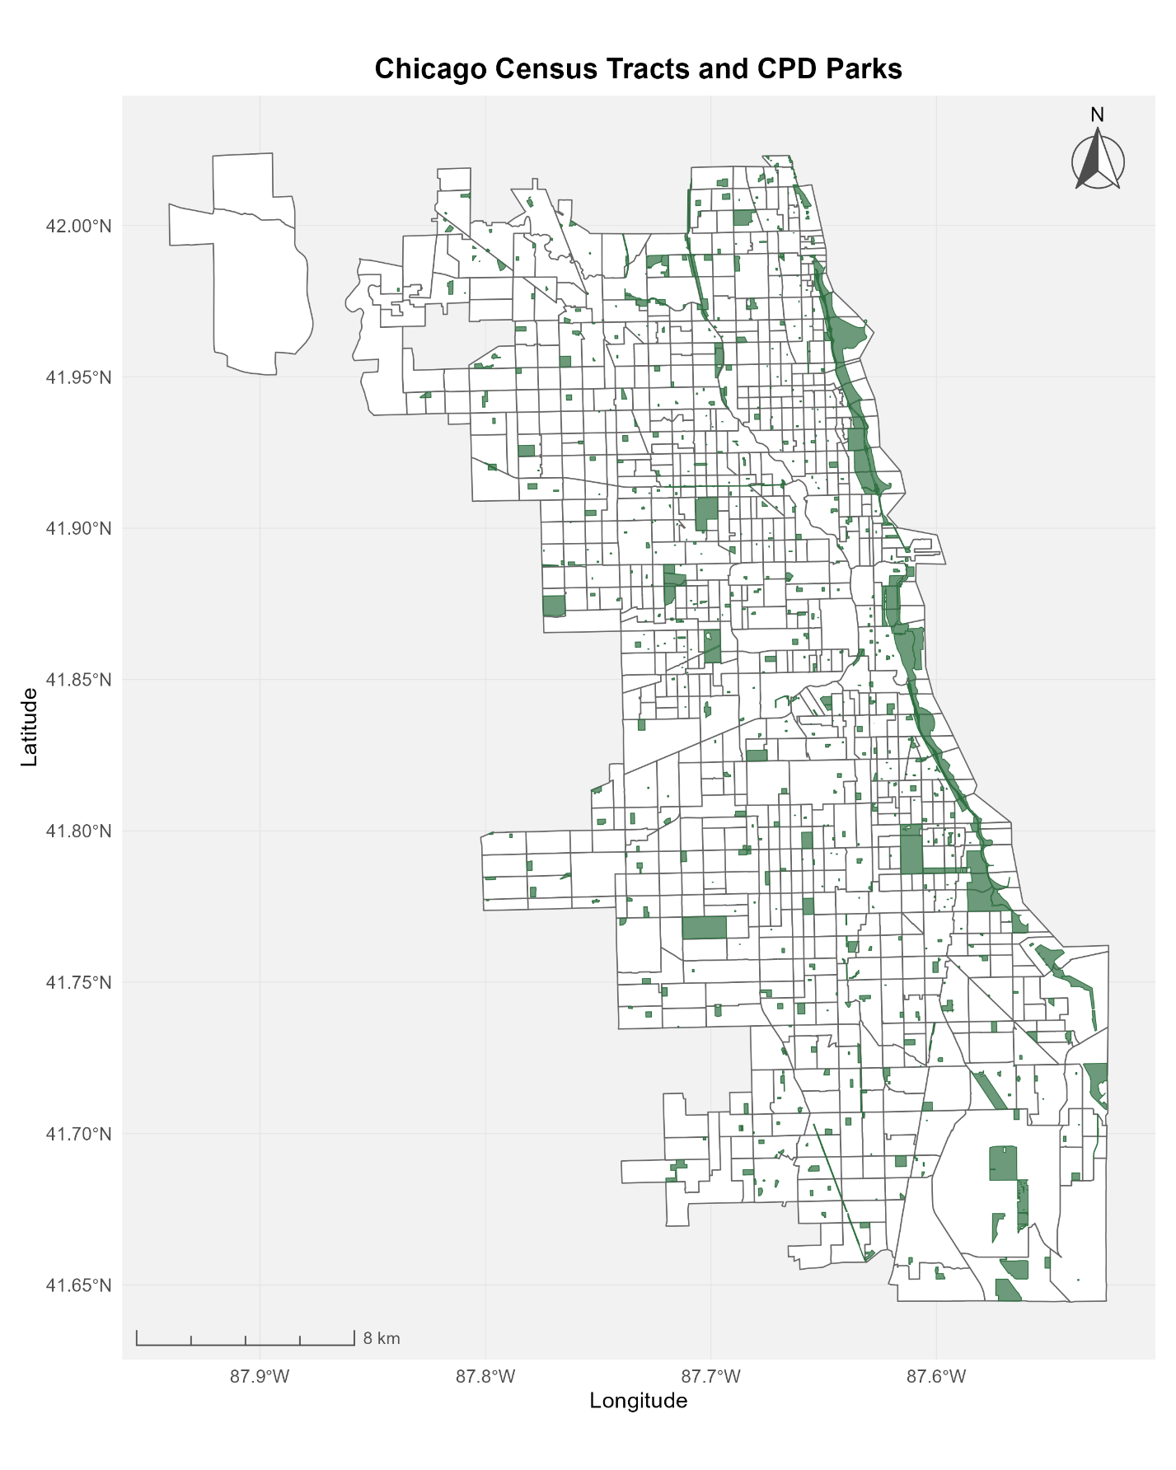

Supplementary References
- United Nations. (2015). Transforming our world: The 2030 agenda for sustainable development. https://sdgs.un.org/goals/goal11
- Scipioni, A., Mazzi, A., Zuliani, F. & Mason, M. Indicators for urban sustainability: Key lessons from a systematic analysis of 67 measurement initiatives. Ecol. Indic. 119, 106853 (2019).
- Chen, L., Liu, C., Zhang, L., Zou, R. & Zhang, Z. Variation in tree species ability to capture and retain airborne fine particulate matter (PM2.5). Sci. Rep. 7, 3206 (2017).
- Wo, J. C., Kim, J. & Hipp, J. R. Urban greenspace and neighborhood crime. Criminology 62, 440-472 (2024).
- Nowak, D. J., Hirabayashi, S., Bodine, A. & Greenfield, E. Modeled PM2.5 removal by trees in ten U.S. cities and associated health effects. Environ. Pollut. 178, 395-402 (2013).
- Gao, M., Wang, Z. & Yang, H. Review of urban flood resilience: Insights from scientometric and systematic analysis. Int. J. Environ. Res. Public Health 19, 8837 (2022).
- Liu, X. et al. Global urban expansion offsets climate-driven increases in terrestrial net primary productivity. Nat. Commun. 10, 5558 (2019).
- Chen, E., Liu, Y., Yang, M., Ye, Z. & Nie, Y. The sustainability appeal of urban rail transit. Transp. Res. Part A Policy Pract. 186, 104152 (2024).
- Yousefi, M. & Dadashpoor, H. Testing the housing and transportation affordability index in a developing world context: A sustainability comparison of central and suburban districts in Qom, Iran. Cities 38, 40-46 (2014).
- Graif, C., Lungeanu, A. & Yetter, A. M. Urban poverty and neighborhood effects on crime: Incorporating spatial and network perspectives. Soc. Networks 51, 40-59 (2017).
- He, Q. & Li, J. The roles of built environment and social disadvantage on the geography of property crime. Cities 121, 103472 (2022).
- Sanciangco, J. C., Bautista, D. & Kim, J. H. Socio-economic, built environment, and mobility conditions associated with crime: A study of multiple cities. Sci. Rep. 10, 13871 (2020).
- Liu, Y., Liu, Y. & Chen, Y. Revisiting urban sustainability from access to jobs: Assessment of economic gain versus loss of social equity. J. Transp. Geogr. 88, 102861 (2020).
- Esteban-Bravo, M., Mugica, J. M. & Vidal-Sanz, J. M. Do business density and variety determine retail performance? IDEAS Work. Pap. Ser. RePEc (2006).
- Alshubiri, F. & Al Ani, M. K. Housing affordability indicators and the sustainability paradigm in OECD countries. Cities 148, 104904 (2024).
- Acolin, A. Owning vs. Renting: the benefits of residential stability? Hous. Stud. 37, 644–667 (2020).
- Levin, I., Santiago, A. M. & Arthurson, K. Creating mixed communities through housing policies: Global perspectives. J. Urban Aff. 44, 291–304 (2021).

