Supplementary Information
Mapping global cropland potential to deliver iron and zinc where they are most needed

Table of Contents
Supplementary Data
Supplementary Data 1a: Nutrient Composition, Contribution, and Weighted Contribution of Crops for Iron and Zinc
Supplementary Data 1b: Global and Regional Combined Nutrient Scores (CNS) for Selected Crops
Supplementary Data 2 – 5: Average yield potential (tonnes per hectare) and corresponding nutrient yield (milligrams per hectare) of cowpea, soybean, pearl millet, and Phaseolus beans across global regions as well as estimated number of population iron and zinc requirements met by regions.
Supplementary Data 6. Regional prevalence data for iron and zinc deficiencies. Supplementary Data 7. Regional food supply data from and Standardized Yield Potential by Region and Crop.

Supplementary Tables and Figures
Table S1a: Summary Statistics for Variables Across Six Clusters: Minimum, Mean, and Maximum Values.
Table S1b: Descriptive Statistics and Variable Contribution in Multivariate Clustering
Figure S2b – e. Global Attainable Yield and Suitability of Current Cropland for Soybeans, Cowpeas, Phaseolus Beans, and Pearl Millet (Maps)
Figure S3c: Standardized Average Crop Yield Potential and Micronutrient Deficiencies Across Six Clusters: Comparative Distribution of Yield Potential and Nutrient Deficiencies.
Figure S3d: Optimal Number of Clusters Determined by Pseudo-F Statistic.
References

Table S1a. Summary Statistics for Variables Across Six Clusters: Minimum, Mean, and Maximum Values.
Clusters | 1 |  |  | 2 |  |  | 3 |  |  | 4 |  |  | 5 |  |  | 6
Variables | Min | Mean | Max | Min | Mean | Max | Min | Mean | Max | Min | Mean | Max | Min | Mean | Max | Min | Mean | Max
Cowpea | 0 | 0.24 | 0.38 | 1.76 | 2.06 | 2.37 | 1.04 | 1.26 | 1.42 | 0 | 0.08 | 0.26 | 0.01 | 0.16 | 0.31 | 0.73 | 1.09 | 1.65
Phaseolus Beans | 0.75 | 1.17 | 2.2 | 2.51 | 2.89 | 3.26 | 1.88 | 2.09 | 2.3 | 0 | 0.28 | 0.51 | 3.25 | 3.36 | 3.48 | 0.82 | 1.44 | 2.21
Soybean | 0.21 | 0.62 | 0.92 | 1.95 | 2.31 | 2.64 | 1.02 | 1.26 | 1.71 | 0 | 0.15 | 0.33 | 2.28 | 2.53 | 2.78 | 0.7 | 1.29 | 2.19
Pearl Millet | 0 | 0.13 | 0.65 | 1.38 | 1.64 | 1.91 | 0.03 | 0.39 | 0.84 | 0 | 0.1 | 0.39 | 0 | 0 | 0 | 0.7 | 0.98 | 1.34
Zinc Deficiency | 4.1 | 8.28 | 14.48 | 12.5 | 18.8 | 25.1 | 10.8 | 15.1 | 21.98 | 8.76 | 14.12 | 17.91 | 5.59 | 8.96 | 12.33 | 24.99 | 28.6 | 32.13
Iron Deficiency | 9.45 | 13.95 | 19.35 | 20.8 | 26.64 | 32.48 | 15.3 | 25.1 | 33.79 | 24.27 | 28.06 | 31.58 | 10.91 | 16 | 21.08 | 31.46 | 41.8 | 48.01
Standardized average crop yield potential and micronutrient deficiencies across six clusters. Each plot shows the distribution of standardized values within clusters, enabling comparison of average yield potential for the four crops and prevalence of iron and zinc deficiencies.

Table S1b. Descriptive Statistics and Variable Contribution in Multivariate Clustering
Variable | Mean (tonne/ha) | Std. Dev. | Min | Max | R²
Cowpea | 0.76 | 0.67 | 0 | 2.37 | 0.9
Phaseolus Beans | 1.62 | 0.99 | 0 | 3.48 | 0.86
Soybean | 1.13 | 0.81 | 0 | 2.78 | 0.84
Pearl Millet | 0.46 | 0.55 | 0 | 1.91 | 0.82
Zinc Deficiency (%) | 15.6 | 7.96 | 4.1 | 32.13 | 0.76
Iron Deficiency (%) | 25.5 | 10.83 | 9.45 | 48.02 | 0.75
Summary statistics of average yield potential for Phaseolus beans, soybean, cowpea, and pearl millet, and prevalence of iron and zinc deficiencies. R² values indicate the degree to which each variable differentiates between clusters: higher values, such as for Phaseolus beans (R² = 0.9), denote stronger discriminative power, whereas lower values for iron and zinc deficiencies indicate weaker separation among clusters.
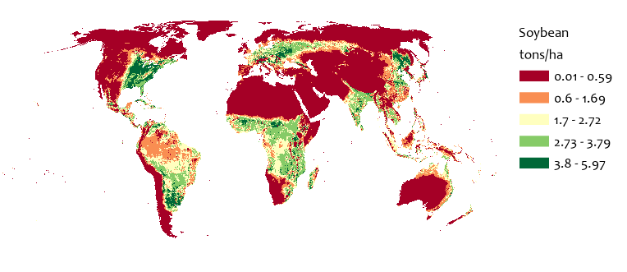b | 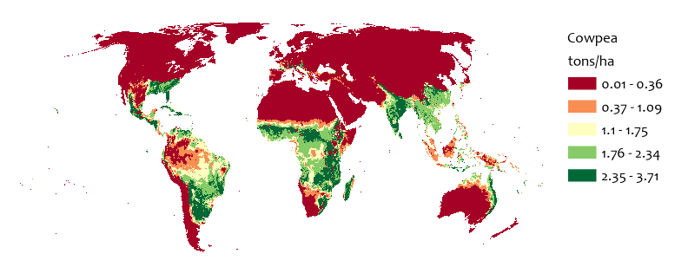  c
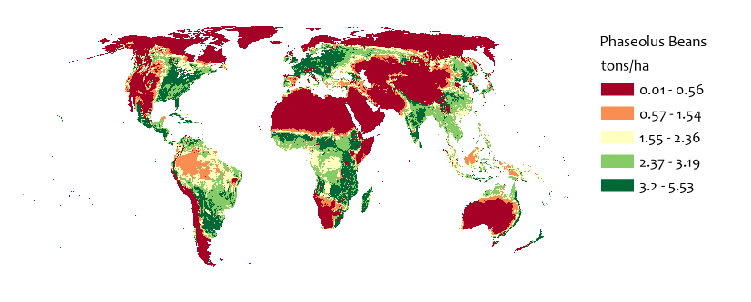  d | 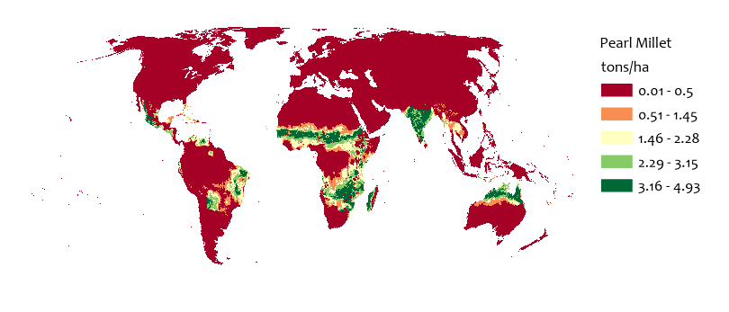  e
Fig. S2b – e. Global suitability and attainable yield (tonnes ha⁻¹) of current rain-fed, high-input cropland for soybean, cowpea, Phaseolus bean, and pearl millet. Estimates are shown at 5-arc-minute resolution (~9 × 9 km at the equator) ¹.

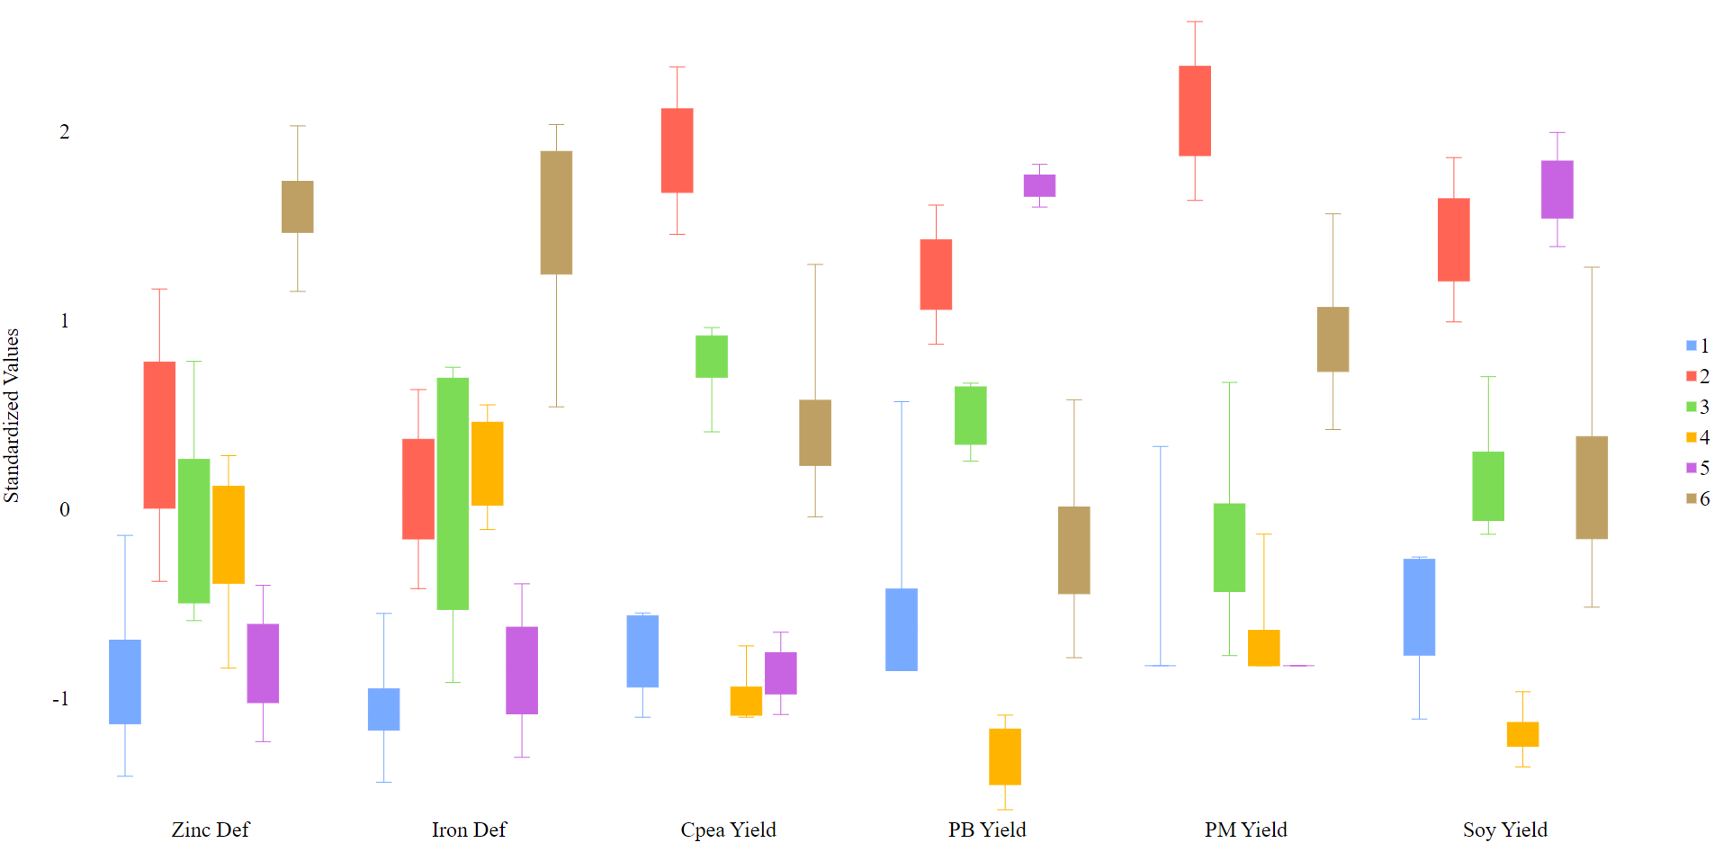
Fig S3d. Fig. S3d. Standardized average crop yield potential and micronutrient deficiencies across six clusters. Each plot shows the distribution of standardized values within clusters, enabling comparison of average yield potential for the four crops and deficiency prevalence for iron and zinc.

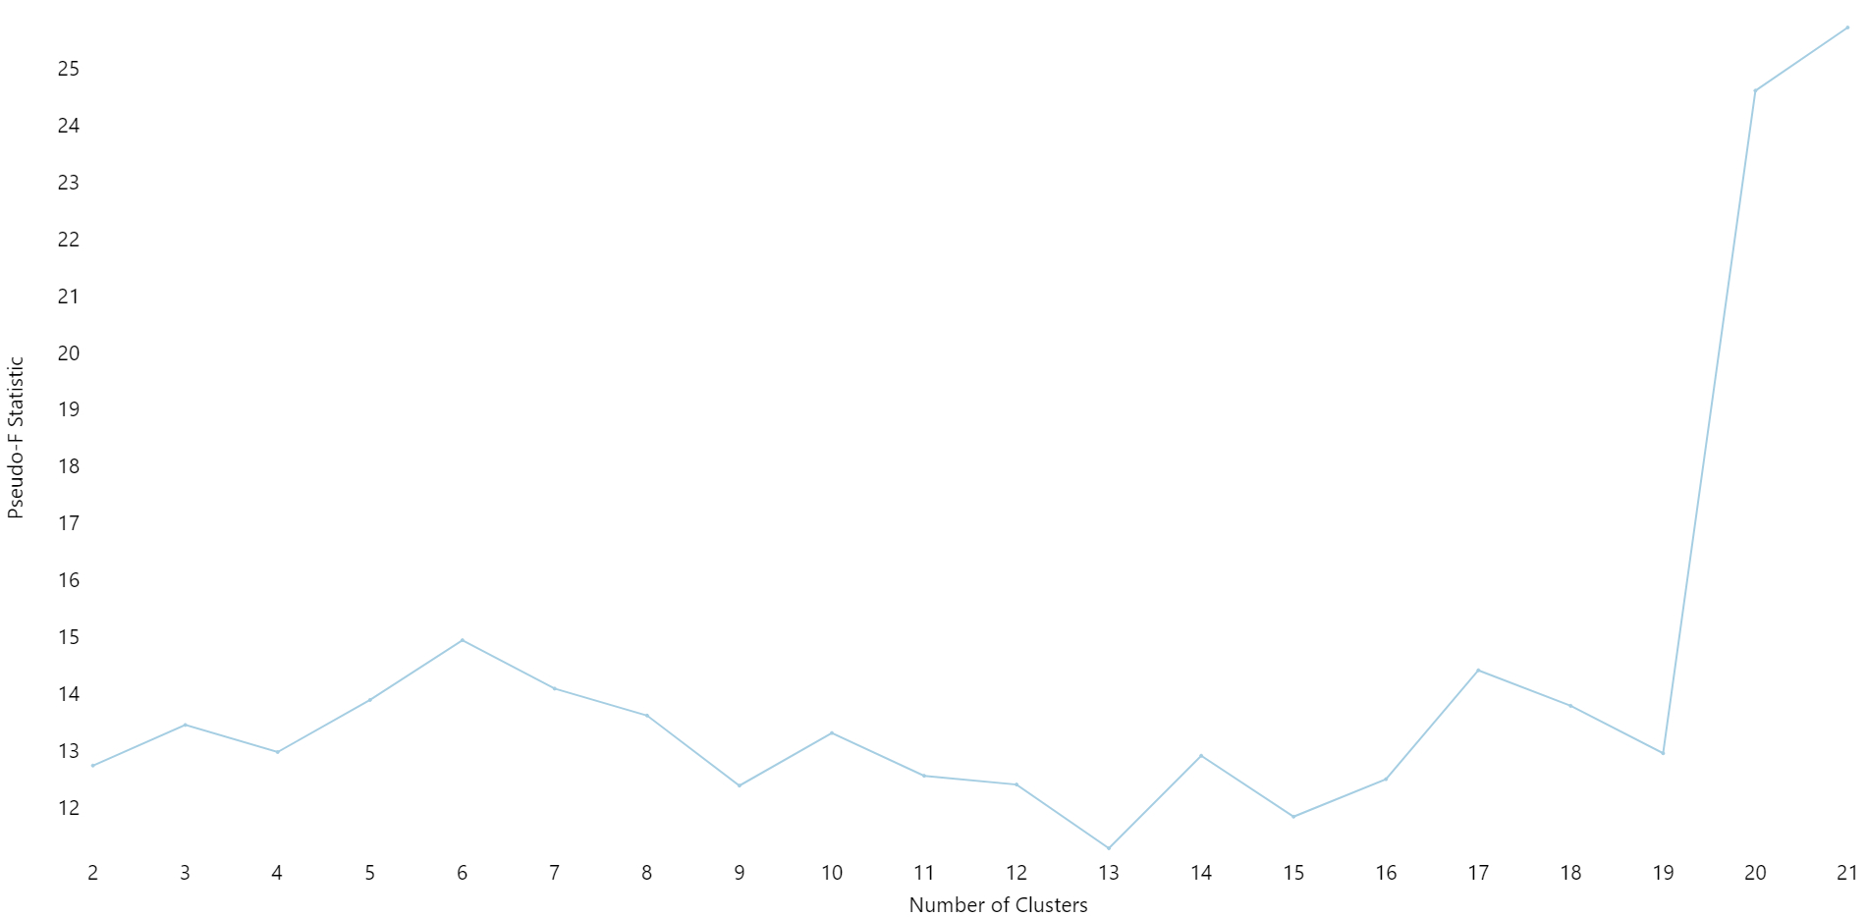
Fig. S3e. Determination of the optimal number of clusters using the Pseudo-F statistic. Pseudo-F values are plotted against the number of clusters (2–21), with a distinct peak at six clusters, indicating the best balance between within-cluster compactness and between-cluster separation.
References
1. FAO & IIASA. Global Agro-Ecological Zones (GAEZ v4) - Data Portal User’s Guide. (FAO and IIASA, 2021). doi:10.4060/cb5167en.

