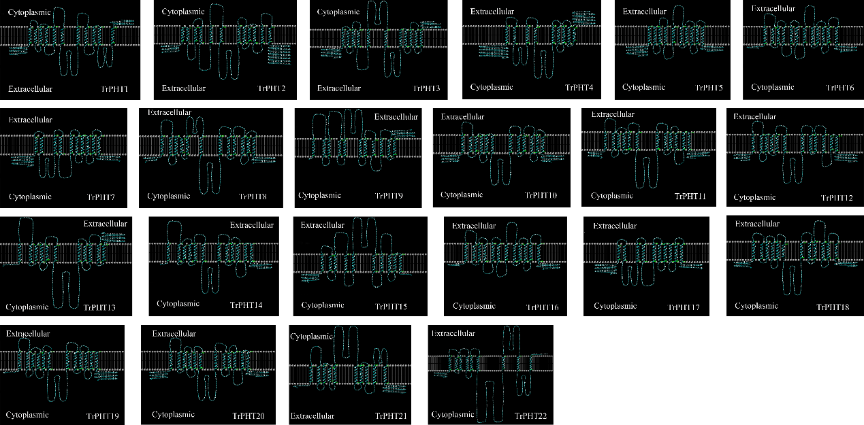
Figure S1. Predicted topology profile of TrPHTs proteins (made and displayed using the TMHMM and Topo2 software).

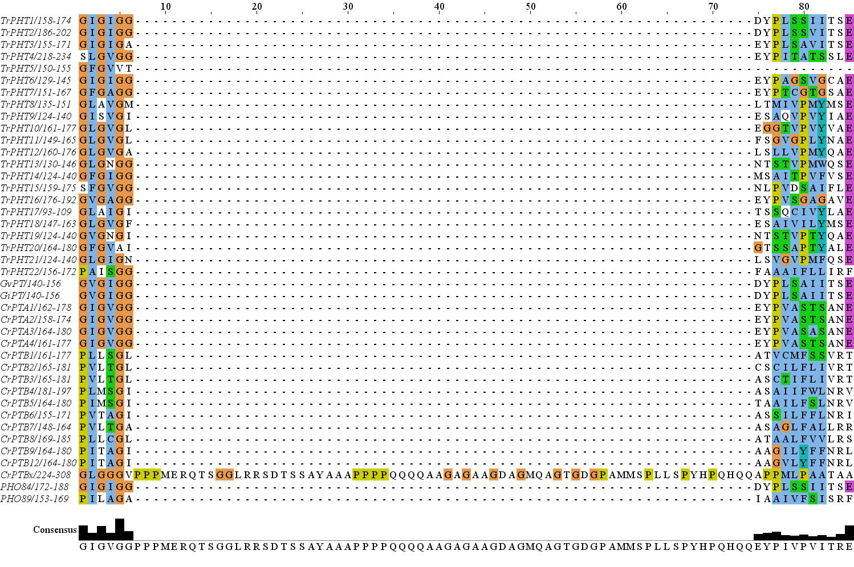
Figure S2. Multiple sequence alignment of signature motif in TrPHTs.

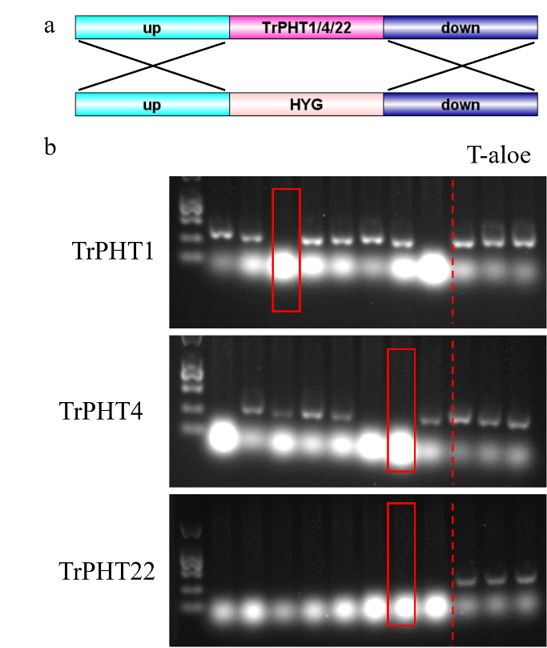
Figure S2. Schematic diagram of TrPHT1/4/22 gene knockout fragment construction (a) and PCR validation of TrPHT1/4/22 knockout mutant strains (b).

