Supplementary Data
Digital Simulation Assessments of the Sensitivity of Quantitative MRI for Detection of an Iron Oxide Nanoparticle Brain MRI Contrast Agent.
Joong H. Kim^{1,2}, Wen-Tung Wang¹, Andrew K. Knutsen¹, David L. Brody^{1,2,3*}
¹Center for Neuroscience and Regenerative Medicine, Henry M. Jackson Foundation, Bethesda, MD, USA.
²Laboratory of Functional and Molecular Imaging, National Institute of Neurological Disorders and Stroke, National Institutes of Health, Bethesda, MD, USA.
³Department of Neurology, Uniformed Services University of the Health Sciences, Bethesda, MD, USA.

Supplementary Figure 1: R1 values of in vivo mouse brain and 3 nm IONP at low (4.7T) and high (9.4 T) field. a - e. Coronal R1 maps of in vivo mouse brains at 4.7T, mouse 01 - 05. f - j. Coronal R1 maps of in vivo mice brains at 9.4T, mouse 06 - 10. The longitudinal relaxation rate constant (R1 (s⁻¹)) of in vivo mouse brain was assessed at both 4.7T and 9.4T using MP2RAGE. Note that the mouse 01 – 05 are different from mouse 06 – 10. The quantification of R1 was done at cortex, shown in panel a, resulting in R1 values (s⁻¹) 0.62 ± 0.01 at 4.7T and 0.53 ± 0.01 at 9.4T. k. The r1 relaxivity of 3 nm IONP was assessed at both 4.7T and 9.4T using modified fast inversion recovery (MFIR) with IONPs suspended in 1xPBS at 0.0, 0.02, 0.04, 0.06, 0.08, 0.1 mM [Fe]. The relaxivity (r1) is the slope obtained from the linear regression fit. The derived r1, 1.87 mM⁻¹s⁻¹ at 4.7T and 0.79 mM⁻¹s⁻¹ at 9.4T, were used for digital simulations.

Supplementary Figure 2: Signal to noise ratio (SNR) and reproducibility of MP2RAGE on in vivo mouse brain. a - e. the absolute ΔR1 (|ΔR1|) maps at 4.7T, mouse 01- 05. f - j. the absolute ΔR1 (|ΔR1|) maps at 9.4 T, mouse 06- 10. The |ΔR1| maps were produced following the procedures described in Figure 1. aa - ee. Signal to noise (SNR) map of 2nd inversion recovery T1 weighted image of MP2RAGE at 4.7T, mouse 01 - 05. ff - jj. SNR map of 2nd inversion recovery T1 weighted image of MP2RAGE at 9.4T, mouse 06 - 10. Region of interest analysis was done on cortex shown in panel aa. k. quantified SNR and |ΔR1| at 4.7T. l. quantified SNR and |ΔR1| at 9.4 T. The mean and standard deviation is from the voxel-by-voxel histogram of cortex ROI analysis. Images at 9.4T had about two times the SNR and one third of the average absolute R1 difference than images at 4.7T.

Supplementary Figure 3: Quantitative Analysis of ESIONPs detectability. The supplementary figure 3 is reproduced from reference 41. |ΔR1| in a 6 by 6 voxel region of interest around the injection site (shown in Figure 7k in reference 41) plotted as a function of injected iron concentration. Dashed line shows the 95% confidence interval around the |ΔR1| for saline injection (0.0 mM [Fe]), and indicates the theoretical detection limit. Solid line indicates the linear regression between |ΔR1| and [Fe]. Linear regression intersects the theoretical detection limit at about 0.03 mM [Fe]. The Supplementary Figure 3 is reproduced from the previous report of Kim et al. 2021, reference 41 in this study.

Supplementary Figure 4: R2 map of in vivo mouse brain at 9.4T. a - c. Coronal R2 map of in vivo mouse brain using long repetition time (TR), 8.0 s. d - f. Coronal R2 map of in vivo mouse brain using short TR, 1.0 s. In vivo mouse brain R2 maps were obtained using both 2D (long TR) and 3D (short TR) multi echo train MR sequence. Both 2D and 3D sequences utilized 8ms echo spacing, 20 echo trains and 160 μm x 160 μm x 240 μm (zero-filled to 80 μm cubic) voxel sizes. In the 2D long TR scans, 5.0 mm image gap was used to avoid imaging artifacts like imperfect RF profile- induced R2 change. There was no gap used for the 3D short TR scans. The R2 of in vivo mouse brain from 2D long TR scans was largely preserved in R2 maps from 3D short TR scans. The 3D multi echo sequence provided whole mouse brain R2 maps having 160 μm x 160 μm x 240 μm spatial resolution with 10 min scan time, whereas the 2D long TR sequence needed about one hour to get the same brain coverage with same spatial resolution as 3D. Thus, 3D multi echo train MR sequence with 1.0 s TR was used to get R2 maps of in vivo mouse brains.

Supplementary Figure 5: R1 and R2 value of 3 nm IONP at 3.0T. a. R1 of 3 nm IONP at 3.0T. b. R2 of 3 nm IONP at 3.0T. The 3 nm IONPs suspended in 1xPBS at 0.0, 0.02, 0.04, 0.06, 0.08, 0.1 mM [Fe]. The r1 and r2 relaxivity of 3 nm IONP was assessed using modified fast inversion recovery (MFIR) and multi echo T2 respectively. The relaxivities are the slope obtained from the linear regression fit. The derived r1, 3.94 mM⁻¹s⁻¹, and r2, 12.9 mM⁻¹s⁻¹, were used for digital simulation.

Supplemental Figure 6: Digital simulation of scattered IONP R1 contrast in human brain. a-i, b-i. two independent R1 maps from the same normal human volunteer, obtained one week apart. The second scan (2nd R1 map, panel b-i) was co-registered to the first scan (1st R1 map, panel a-i) using ANTs. a-ii, b-ii. Close up views of panel a-i (scan 1) and b-i (scan 2). c. the absolute ΔR1 (|ΔR1|) map between the first scan R1 map (panel a-ii, baseline scan) and the second scan R1 map (panel b-ii). d. The simulated effects on R1 of IONP contrast agent were digitally added to panel b-ii to produce panel d. The simulated additional R1 values were placed in 3x3 voxel locations indicated with solid arrows. The digitally added R1 values were 0.16 (, equivalent to 0.04 mM [Fe]), 0.24 (, equivalent to 0.06 mM [Fe]), 0.32 (∗, equivalent to 0.08 mM [Fe]), and 0.39 s⁻¹(#, equivalent to 0.10 mM [Fe]). Areas with relatively high R1 in the original scans are pointed out by arrowheads, which were difficult to clearly distinguish from simulated contrast agent effects in the R1 maps. e. the absolute ΔR1 (|ΔR1|) map between the first scan (panel a-ii) and the second scan with digitally simulated R1 effects of IONPs (panel d). The locations with digitally simulated additional R1 are clearly visible for R1 equivalent to 0.06, 0.08, and 0.1 mM [Fe] whereas the effect of R1 equivalent to 0.04 mM [Fe] was less conspicuous. The conspicuity of R1 equivalent to 0.06 mM [Fe] is higher in the subtraction image (panel e) than in the original digitally seeded map (panel d) because of the suppression of areas with relatively high R1 in the original scans.

Supplementary Figure 7: R2 map of human brain at 3.0 T. a. average R2 map from echo time (TE) = 10 and 110 ms. b. average R2 map from echo time (TE) = 30 and 110 ms. c. test-retest signal to noise ratio (TrTSNR) map of R2 map from echo time (TE) = 10 and 110 ms. d. TrTSNR map of R2 map from echo time (TE) = 30 and 110 ms. The value of TrTSNR 20 represents 95 % reproducibility. R2 map from echo time (TE) = 30 and 110 ms show better reproducibility.

Supplementary Figure 1
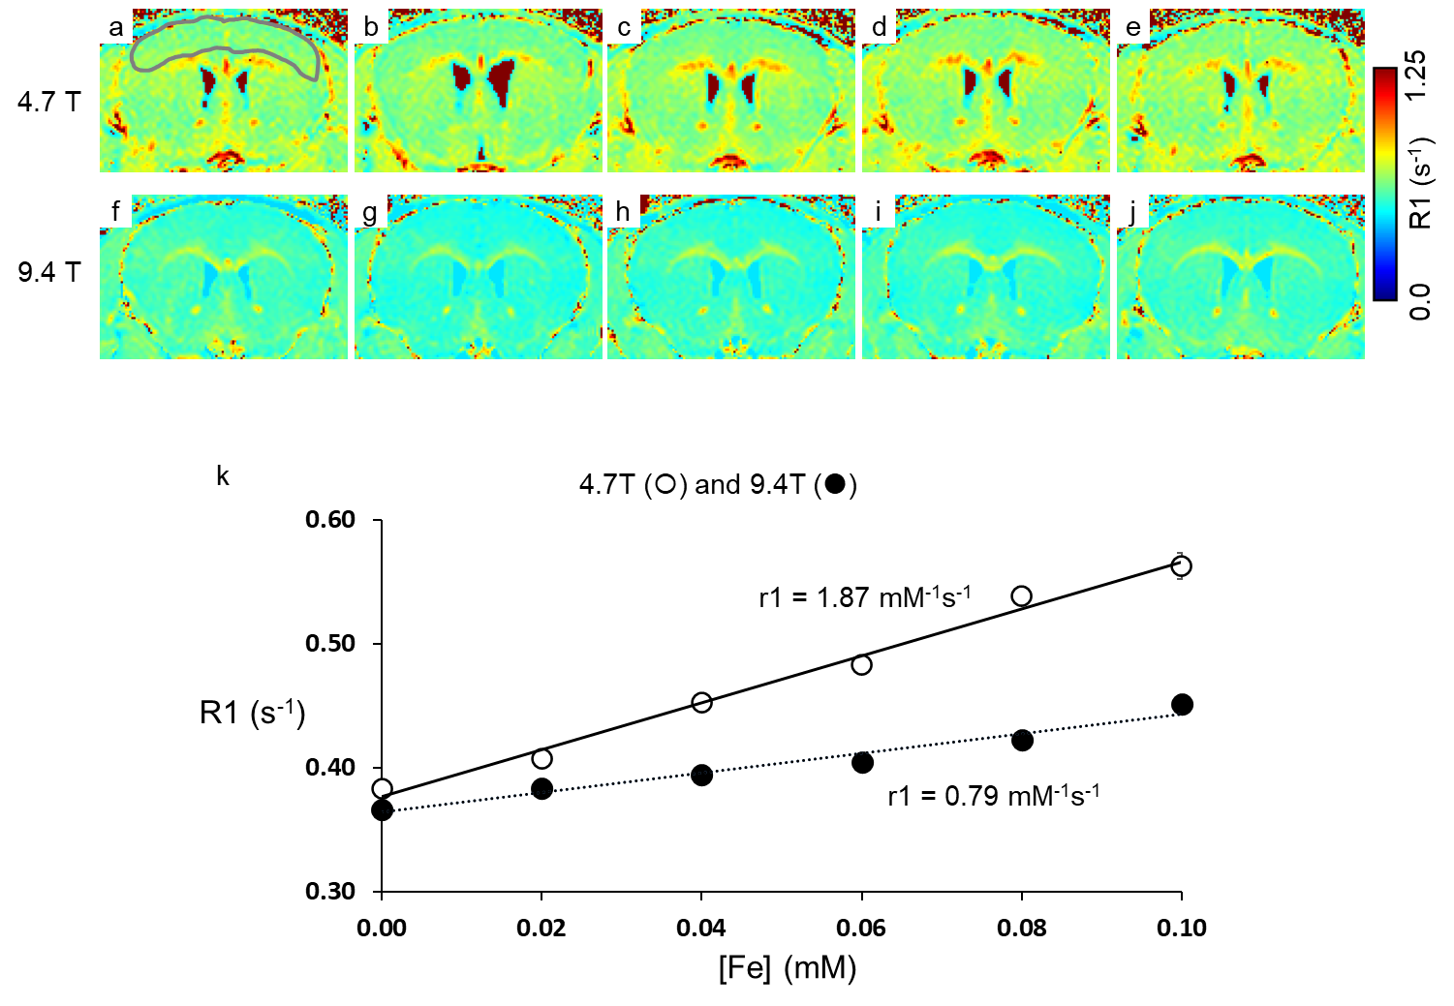
Supplementary Figure 1: R1 values of in vivo mouse brain and 3 nm IONP at low (4.7T) and high (9.4 T) field. a - e. Coronal R1 maps of in vivo mouse brains at 4.7T, mouse 01 - 05. f - j. Coronal R1 maps of in vivo mice brains at 9.4T, mouse 06 - 10. The longitudinal relaxation rate constant (R1 (s⁻¹)) of in vivo mouse brain was assessed at both 4.7T and 9.4T using MP2RAGE. Note that the mouse 01 – 05 are different from mouse 06 – 10. The quantification of R1 was done at cortex, shown in panel a, resulting in R1 values (s⁻¹) 0.62 ± 0.01 at 4.7T and 0.53 ± 0.01 at 9.4T. k. The r1 relaxivity of 3 nm IONP was assessed at both 4.7T and 9.4T using modified fast inversion recovery (MFIR) with IONPs suspended in 1xPBS at 0.0, 0.02, 0.04, 0.06, 0.08, 0.1 mM [Fe]. The relaxivity (r1) is the slope obtained from the linear regression fit. The derived r1, 1.87 mM⁻¹s⁻¹ at 4.7T and 0.79 mM⁻¹s⁻¹ at 9.4T, were used for digital simulations.

Supplementary Figure 2
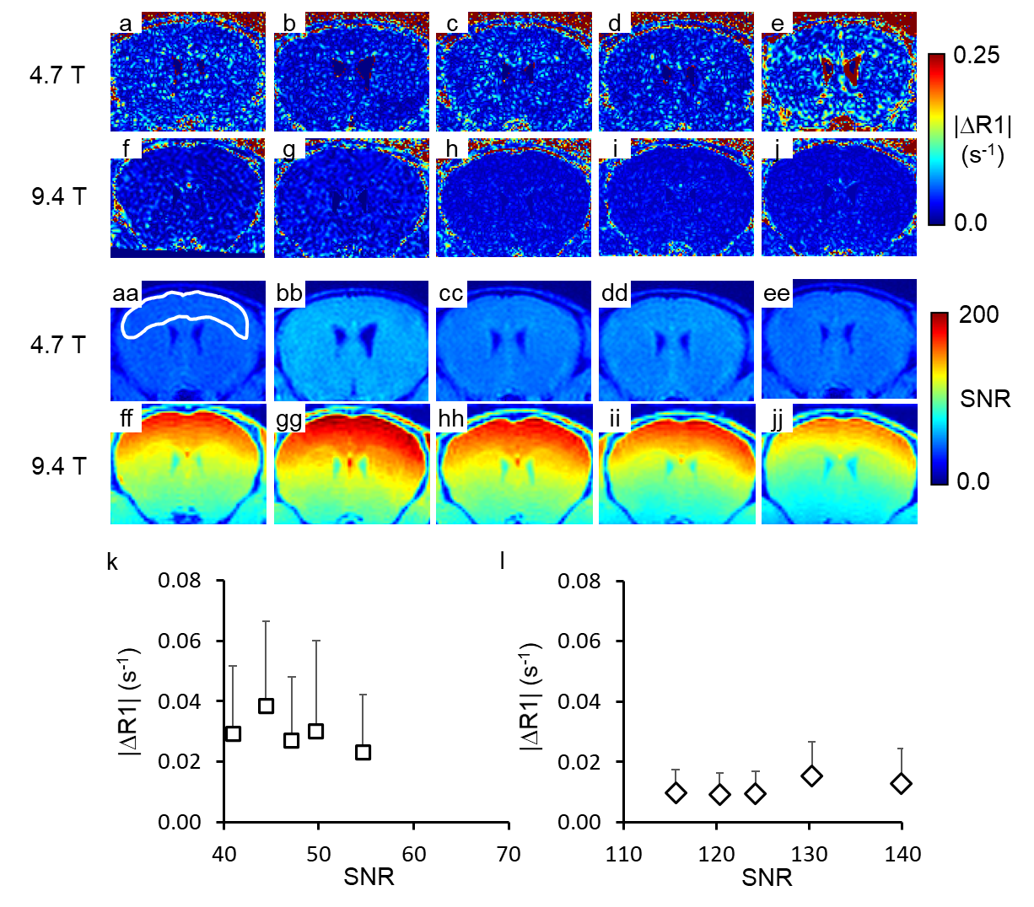
Supplementary Figure 2: Signal to noise ratio (SNR) and reproducibility of MP2RAGE on in vivo mouse brain. a - e. the absolute ΔR1 (|ΔR1|) maps at 4.7T, mouse 01- 05. f - j. the absolute ΔR1 (|ΔR1|) maps at 9.4 T, mouse 06- 10. The |ΔR1| maps were produced following the procedures described in Figure 1. aa - ee. Signal to noise (SNR) map of 2nd inversion recovery T1 weighted image of MP2RAGE at 4.7T, mouse 01 - 05. ff - jj. SNR map of 2nd inversion recovery T1 weighted image of MP2RAGE at 9.4T, mouse 06 - 10. Region of interest analysis was done on cortex shown in panel aa. k. quantified SNR and |ΔR1| at 4.7T. l. quantified SNR and |ΔR1| at 9.4 T. The mean and standard deviation is from the voxel-by-voxel histogram of cortex ROI analysis. Images at 9.4T had about two times the SNR and one third of the average absolute R1 difference than images at 4.7T.

Supplementary Figure 3
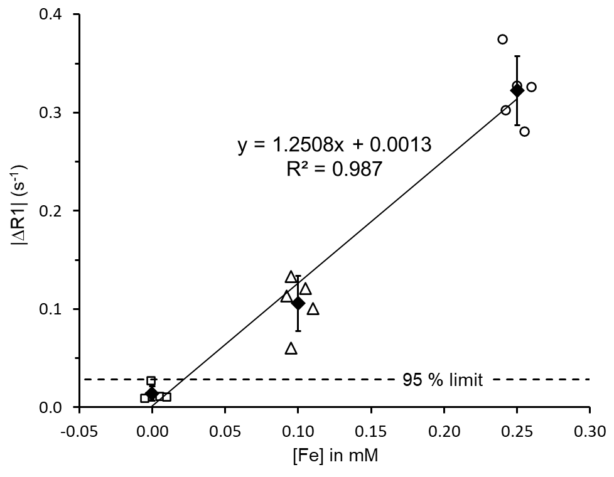
Supplementary Figure 3: Quantitative Analysis of ESIONPs detectability. The supplementary figure 3 is reproduced from reference 41. |ΔR1| in a 6 by 6 voxel region of interest around the injection site (shown in Figure 7k in reference 41) plotted as a function of injected iron concentration. Dashed line shows the 95% confidence interval around the |ΔR1| for saline injection (0.0 mM [Fe]), and indicates the theoretical detection limit. Solid line indicates the linear regression between |ΔR1| and [Fe]. Linear regression intersects the theoretical detection limit at about 0.03 mM [Fe]. The Supplementary Figure 3 is reproduced from the previous report of Kim et al. 2021, reference 41 in this study.

Supplementary Figure 4
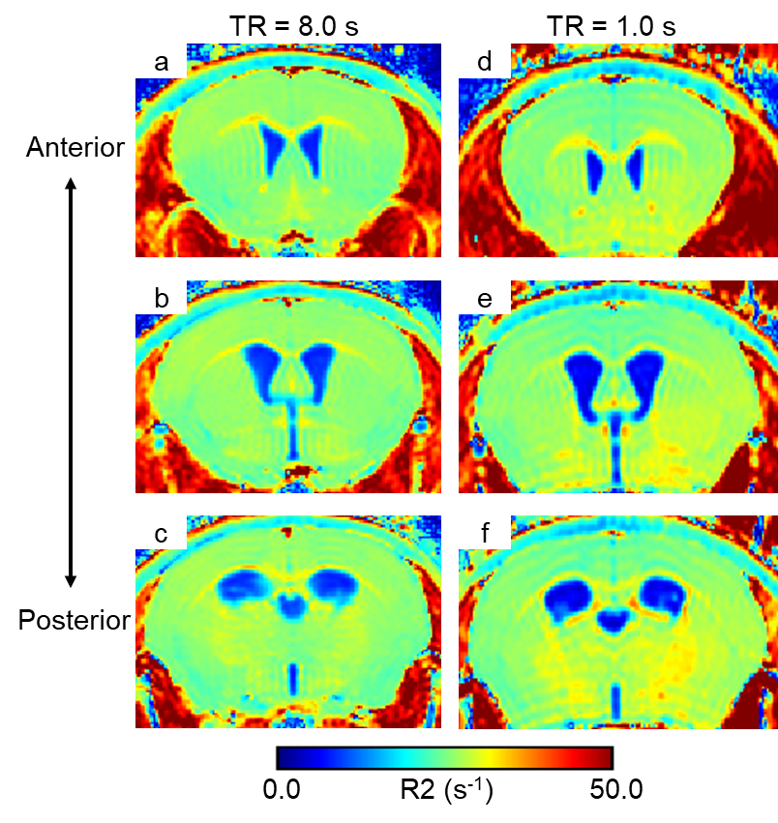
Supplementary Figure 4: R2 map of in vivo mouse brain at 9.4T. a - c. Coronal R2 map of in vivo mouse brain using long repetition time (TR), 8.0 s. d - f. Coronal R2 map of in vivo mouse brain using short TR, 1.0 s. In vivo mouse brain R2 maps were obtained using both 2D (long TR) and 3D (short TR) multi echo train MR sequence. Both 2D and 3D sequences utilized 8ms echo spacing, 20 echo trains and 160 μm x 160 μm x 240 μm (zero-filled to 80 μm cubic) voxel sizes. In the 2D long TR scans, 5.0 mm image gap was used to avoid imaging artifacts like imperfect RF profile- induced R2 change. There was no gap used for the 3D short TR scans. The R2 of in vivo mouse brain from 2D long TR scans was largely preserved in R2 maps from 3D short TR scans. The 3D multi echo sequence provided whole mouse brain R2 maps having 160 μm x 160 μm x 240 μm spatial resolution with 10 min scan time, whereas the 2D long TR sequence needed about one hour to get the same brain coverage with same spatial resolution as 3D. Thus, 3D multi echo train MR sequence with 1.0 s TR was used to get R2 maps of in vivo mouse brains.

Supplementary Figure 5
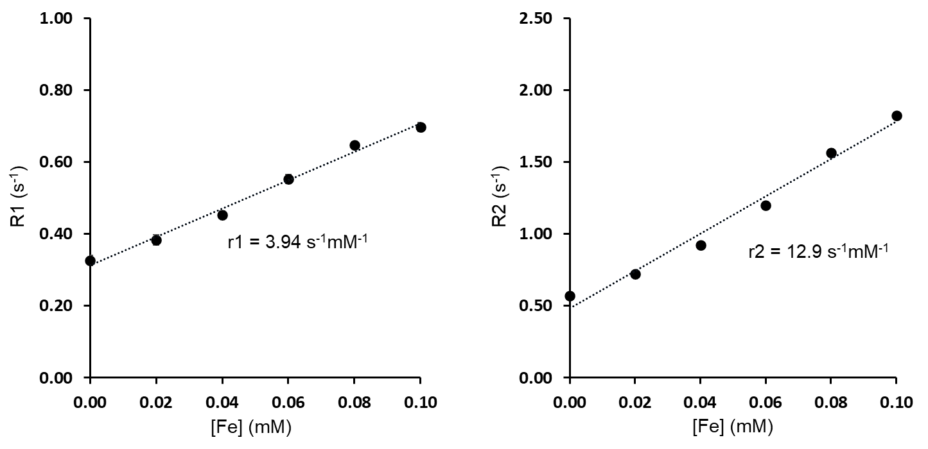
Supplementary Figure 5: R1 and R2 value of 3 nm IONP at 3.0T. a. R1 of 3 nm IONP at 3.0T. b. R2 of 3 nm IONP at 3.0T. The 3 nm IONPs suspended in 1xPBS at 0.0, 0.02, 0.04, 0.06, 0.08, 0.1 mM [Fe]. The r1 and r2 relaxivity of 3 nm IONP was assessed using modified fast inversion recovery (MFIR) and multi echo T2 respectively. The relaxivities are the slope obtained from the linear regression fit. The derived r1, 3.94 mM⁻¹s⁻¹, and r2, 12.9 mM⁻¹s⁻¹, were used for digital simulation.

Supplementary Figure 6
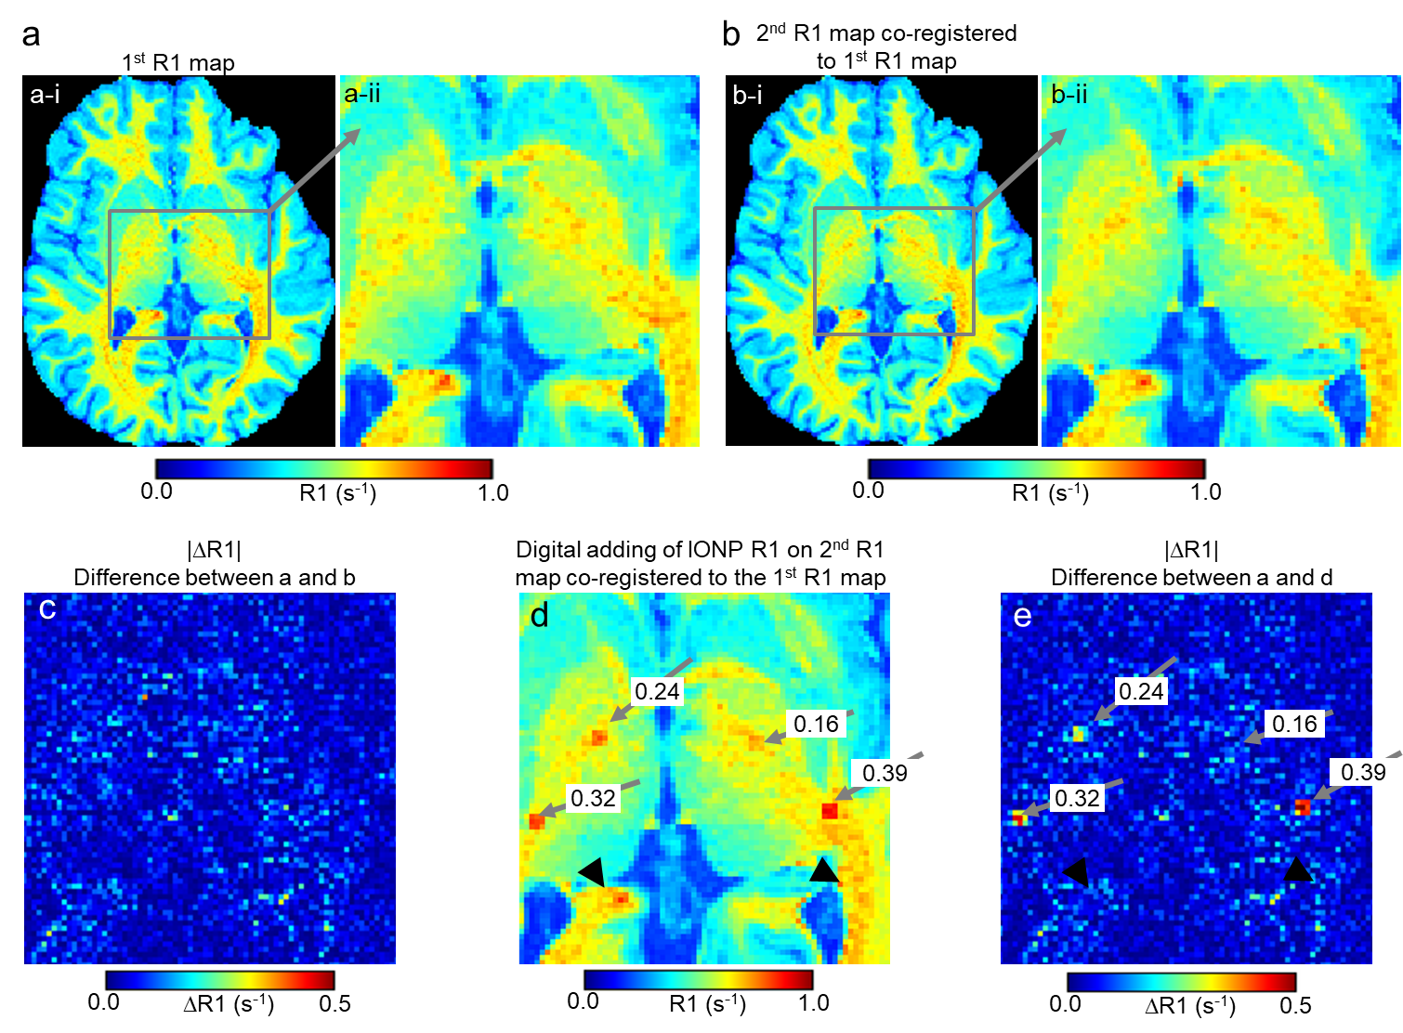
Supplemental Figure 6: Digital simulation of scattered IONP R1 contrast in human brain. a-i, b-i. two independent R1 maps from the same normal human volunteer, obtained one week apart. The second scan (2nd R1 map, panel b-i) was co-registered to the first scan (1st R1 map, panel a-i) using ANTs. a-ii, b-ii. Close up views of panel a-i (scan 1) and b-i (scan 2). c. the absolute ΔR1 (|ΔR1|) map between the first scan R1 map (panel a-ii, baseline scan) and the second scan R1 map (panel b-ii). d. The simulated effects on R1 of IONP contrast agent were digitally added to panel b-ii to produce panel d. The simulated additional R1 values were placed in 3x3 voxel locations indicated with solid arrows. The digitally added R1 values were 0.16 (, equivalent to 0.04 mM [Fe]), 0.24 (, equivalent to 0.06 mM [Fe]), 0.32 (∗, equivalent to 0.08 mM [Fe]), and 0.39 s⁻¹(#, equivalent to 0.10 mM [Fe]). Areas with relatively high R1 in the original scans are pointed out by arrowheads, which were difficult to clearly distinguish from simulated contrast agent effects in the R1 maps. e. the absolute ΔR1 (|ΔR1|) map between the first scan (panel a-ii) and the second scan with digitally simulated R1 effects of IONPs (panel d). The locations with digitally simulated additional R1 are clearly visible for R1 equivalent to 0.06, 0.08, and 0.1 mM [Fe] whereas the effect of R1 equivalent to 0.04 mM [Fe] was less conspicuous. The conspicuity of R1 equivalent to 0.06 mM [Fe] is higher in the subtraction image (panel e) than in the original digitally seeded map (panel d) because of the suppression of areas with relatively high R1 in the original scans.

Supplementary Figure 7

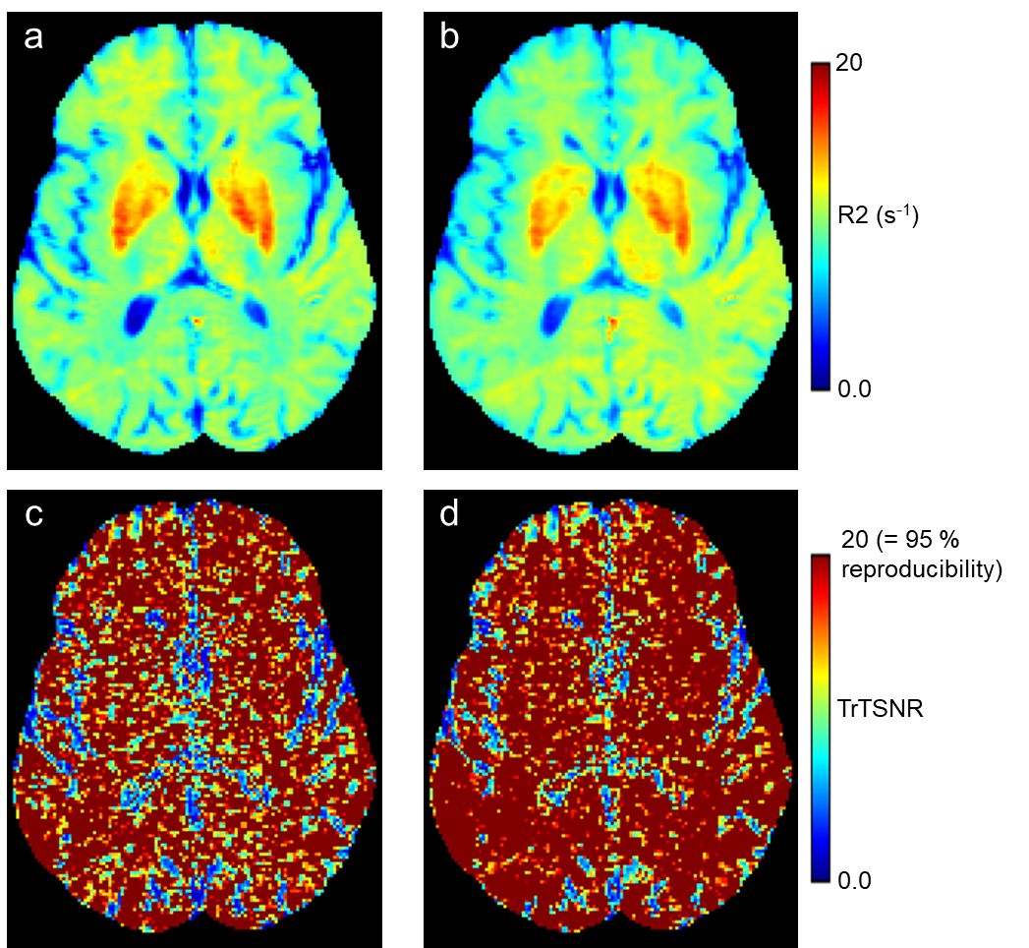
Supplementary Figure 7: R2 map of human brain at 3.0 T. a. average R2 map from echo time (TE) = 10 and 110 ms. b. average R2 map from echo time (TE) = 30 and 110 ms. c. test-retest signal to noise ratio (TrTSNR) map of R2 map from echo time (TE) = 10 and 110 ms. d. TrTSNR map of R2 map from echo time (TE) = 30 and 110 ms. The value of TrTSNR 20 represents 95 % reproducibility. R2 map from echo time (TE) = 30 and 110 ms show better reproducibility.

