SUPPLEMENTARY FIGURES
Supplementary Table 1. Global proteomic profiling of undifferentiated KOLF2.1 iPSCs. Proteins associated with the undifferentiated state are highlighted in blue and shown in the second tab of the excel sheet.
Supplementary Table 2-7. Proteomic analysis of each experimental group is shown, along with proteins identified as differentially expressed.
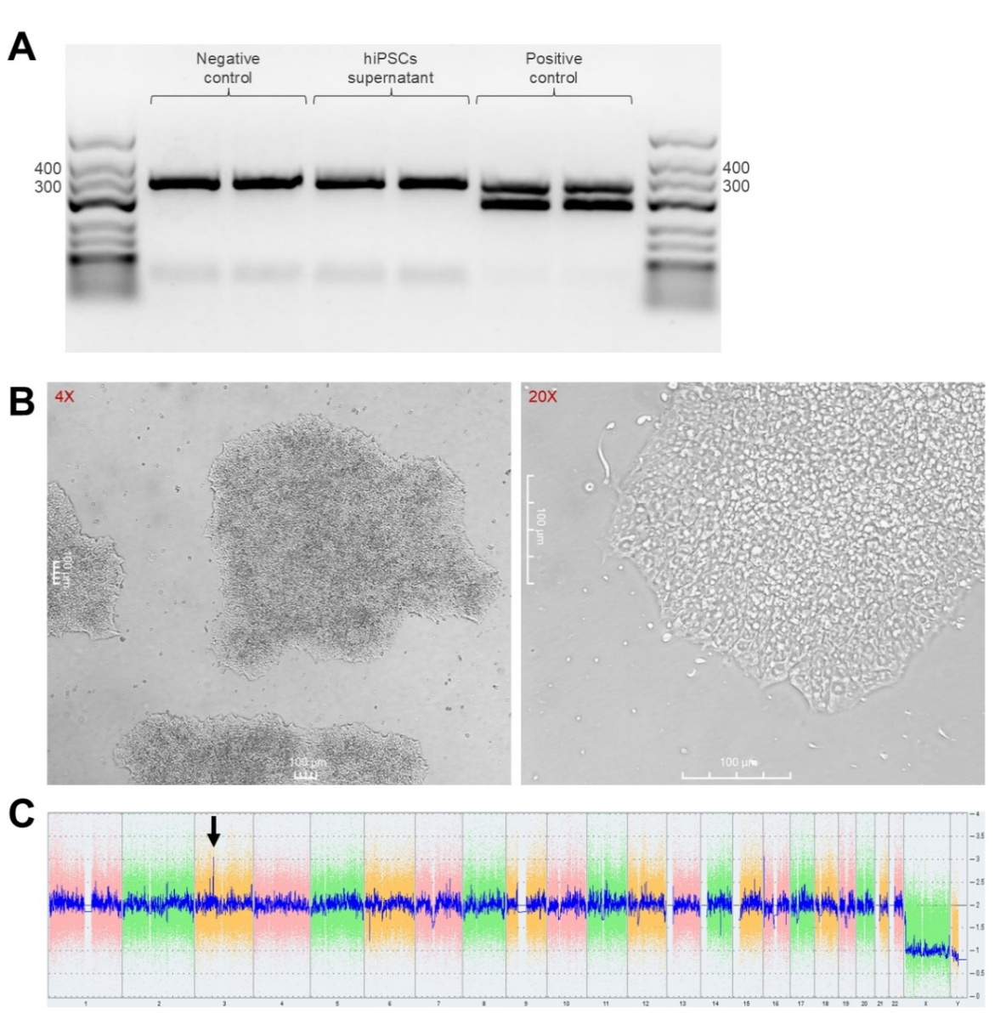
Supplementary Figure 1. hiPSC Master Bank characterization. (A) PCR amplification of mycoplasma was conducted using the PCR Mycoplasma Test kit (Mdbioproducts). PCR products were visualized by gel electrophoresis in 2% agarose with 0.5 μg/mL ethidium bromide and run at 125V for 60 mins. Samples were loaded in duplicate in order from left to right: DPBS control, hiPSC supernatant, and positive control, with GeneRuler Low Range DNA Ladder (Thermo) loaded on either side. Internal control bands appear at 357 bp and positive results appear at 270 bp. (B) Representative images of hiPSC morphology were taken at 4X and 20X. Scale bar represents 100 μm. (C) Karyotype analysis, conducted via the KaryoStat+ assay (ThermoFisher), displays copy number variations across the genome. A gain mutation can be seen on chromosome 3.
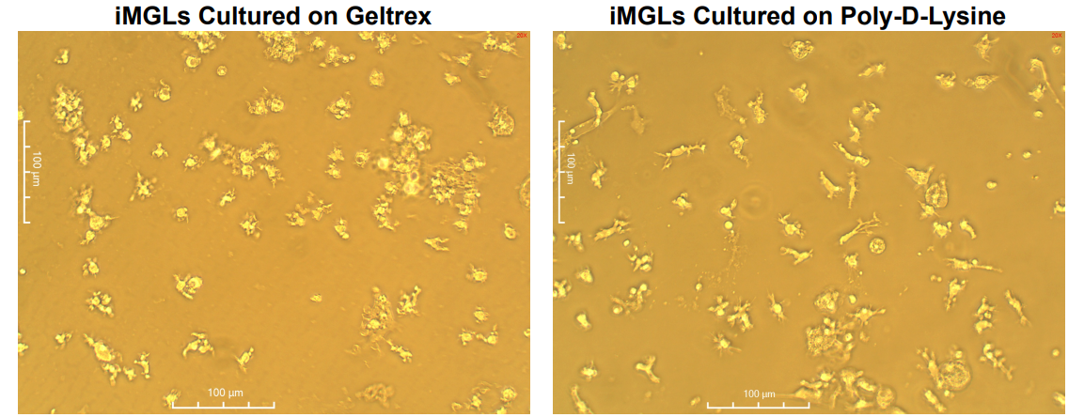
Supplementary Figure 2. iMGL morphology on Geltrex and Poly-D-Lysine matrices. Representative photos of iMGLs cultured on Geltrex and Poly-D-Lysine within a 6-well plate. Morphology of the cells appear altered depending on the chosen matrix. Cells cultured on Geltrex were loosely adherent and appeared round with short cellular processes, while cells on Poly-D-Lysine were strongly adherent and appeared more ramified. Photos were taken at 20X on a Moticam Microscope camera. Scale bars represent 100 μm.

