Blue LED mediated synthesis of quinazolinone and degradation of organic pollutants using CuWO₄ nanoparticles; A Green Approach
Murugan Arunachalapandi*, Rajakumar Utchimahali
Department of Chemistry and Research center, Sri Paramakalyani College, Alwarkurichi, 627 412, Tamil Nadu, India.
*corresponding author email ID: arunachalapandi13@gmail.com ; co-author email ID: rutchimahali29073@gmail.com

Graphical Abstract

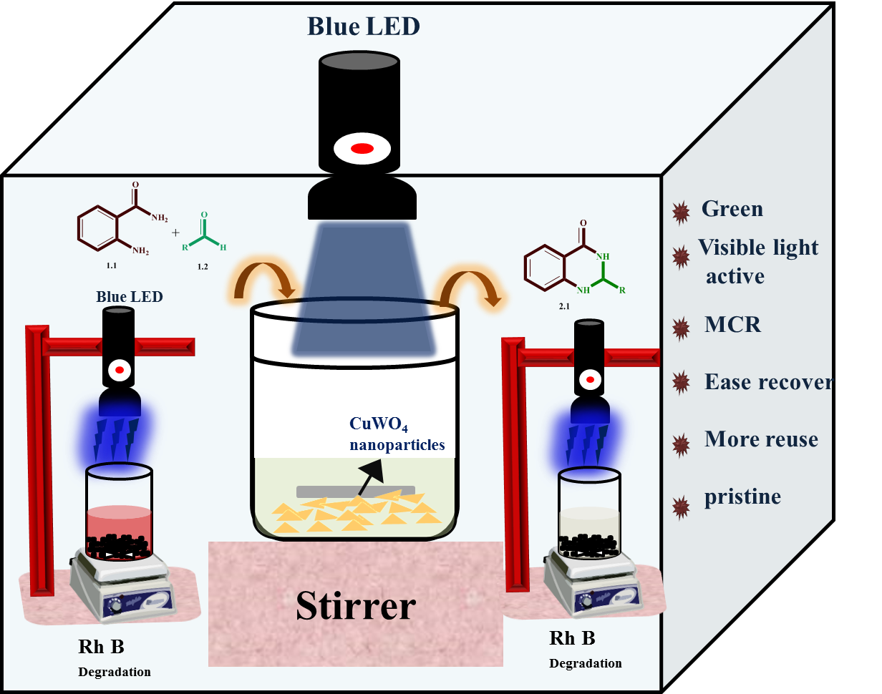

Abstract
Nanotechnology is a versatile tool to apply all chemistry research performed in this decade. Here in the present work, we successfully synthesize CuWO₄ nanoparticles using a simple co-precipitation method. The synthesized CuWO₄ nanoparticles were analyzed to know their properties by using various characterization tools such as XRD, UV-DRS, HR-SEM, and FT-IR analysis. From Tauc’s plot calculation we find the prepared nanoparticles having maximum activity in the visible light medium. The band edge distance between VB and CB ranged at 2.53 eV, confirming the capability of electrons in the valence band to absorb visible light to excite the conduction band. From this we successfully conduct the organic formation reaction in the synthesis of quinazolinone derivatives using CuWO₄ nanoparticles in a blue LED medium. In addition, CuWO₄ nanoparticles also performed for the degradation of rhodamine B dye from wastewater to get 95% of the dye removed in the presence of a visible light medium.

Keywords; CuWO₄ nanoparticles, quinazolinone, Rhodamine B, Visible light
SUPPLEMENTARY DATA
Derivatives of quinazolinones
2.1a. 2-phenyl-2,3-dihydroquinazolin-4(1H)-one
Light brown solid; M.F-C₁₄H₁₂N₂O; ¹H NMR (400 MHz, DMSO-d₆) (δ ppm); 5.755 (s, 1H), 6.658- 7.758 (m, 2H), 7.117 (s, 1H), 7.227-7.264 (t, 1H), 7.350-7.621 (m, 6H), 8.294 (s, 1H); ¹³C-NMR (100 MHz, DMSO-d₆) (δ ppm); 67, 114, 115, 117, 126, 127, 128, 128, 133, 142, 146, 167.
2.1b. 2-(4-bromophenyl)-2,3-dihydroquinazolin-4(1H)-one
Pale yellow solid; M.F-C₁₄H₁₁BrN₂O; ¹H NMR (400 MHz, DMSO-d₆) (δ ppm); 5.777 (s, 1H), 6.670- 7.769 (m, 2H), 7.219 (s, 1H), 7.242-7.280 (t, 1H), 7.341-7.672 (m, 5H), 8.399 (s, 1H); ¹³C-NMR (100 MHz, DMSO-d₆) (δ ppm); 65, 114, 115, 117, 122, 126, 127, 130, 131, 131, 133, 145, 147, 163.
2.1c. 2-(4-cyanophenyl)-2,3-dihydroquinazolin-4(1H)-one
Pale yellow solid; M.F-C₁₅H₁₁N₃O; ¹H NMR (400 MHz, DMSO-d₆) (δ ppm); 7.119 (s, 1H), 7.291- 7.312 (d, 2H), 7.642-7.649 (m, 2H), 7.661 (s, 1H), 7.794-8.210 (m, 4H), 8.761 (s, 1H); ¹³C-NMR (100 MHz, DMSO-d₆) (δ ppm); 65, 113, 116, 119, 123, 128, 129, 130, 131, 132, 133, 136, 140, 150, 160, 195.
2.1d. 2-(4-nitrophenyl)-2,3-dihydroquinazolin-4(1H)-one
White solid; M.F-C₁₄H₁₁N₃O₃; ¹H NMR (400 MHz, DMSO-d₆) (δ ppm); 5.913 (s, 1H), 6.674- 6.778 (m, 2H), 7.248-7.337 (m, 2H), 7.598-7.751 (m, 2H), 7.341-7.672 (m, 2H), 8.251-7.257 (s, 1H), 8.528 (s, 1H); ¹³C-NMR (100 MHz, DMSO-d₆) (δ ppm); 65, 115, 115, 117, 124, 127, 128, 134, 147, 147, 149, 163.

2.1e. 2-(4-carboxyphenyl)-2,3-dihydroquinazolin-4(1H)-one
Dirty white solid; M.F-C₁₅H₁₂N₂O₃; ¹H NMR (400 MHz, DMSO-d₆) (δ ppm); 6.528-6,57 (d, 1H), 6.681- 6.782 (m, 1H), 7.230-7.748 (m, 5H), 8.002-9.430 (m, 3H), 13.321 (s, 1H); ¹³C-NMR (100 MHz, DMSO-d₆) (δ ppm); 87, 116, 121, 124, 125, 126, 128, 129, 130, 130, 131, 132, 132, 163.
2.1f. 2-(4-methylphenyl)-2,3-dihydroquinazolin-4(1H)-one
Yellow solid; M.F-C₁₅H₁₄N₂O; ¹H NMR (400 MHz, DMSO-d₆) (δ ppm); 2.331 (s, 3H), 5.776 (s, 1H), 6.671- 6.770 (m, 2H), 7.226-7.62 (m, 6H), 7.676 (s, 1H), 8.399 (s, 1H); ¹³C-NMR (100 MHz, DMSO-d₆) (δ ppm); 26, 65, 114, 115, 117, 124, 127, 128, 134, 146, 147, 149, 163.

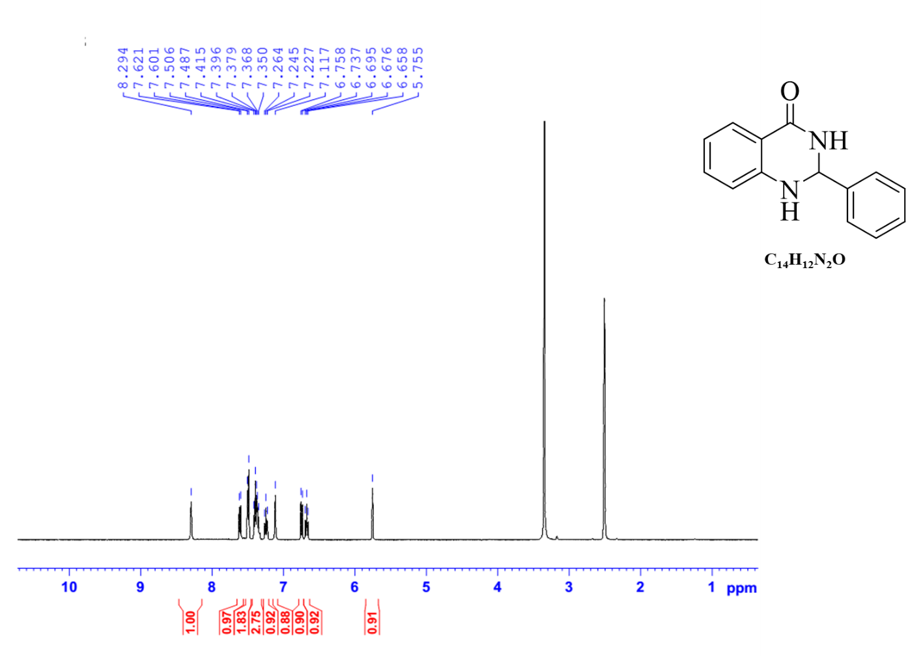
Fig. S1; ¹H-NMR of 2.1a
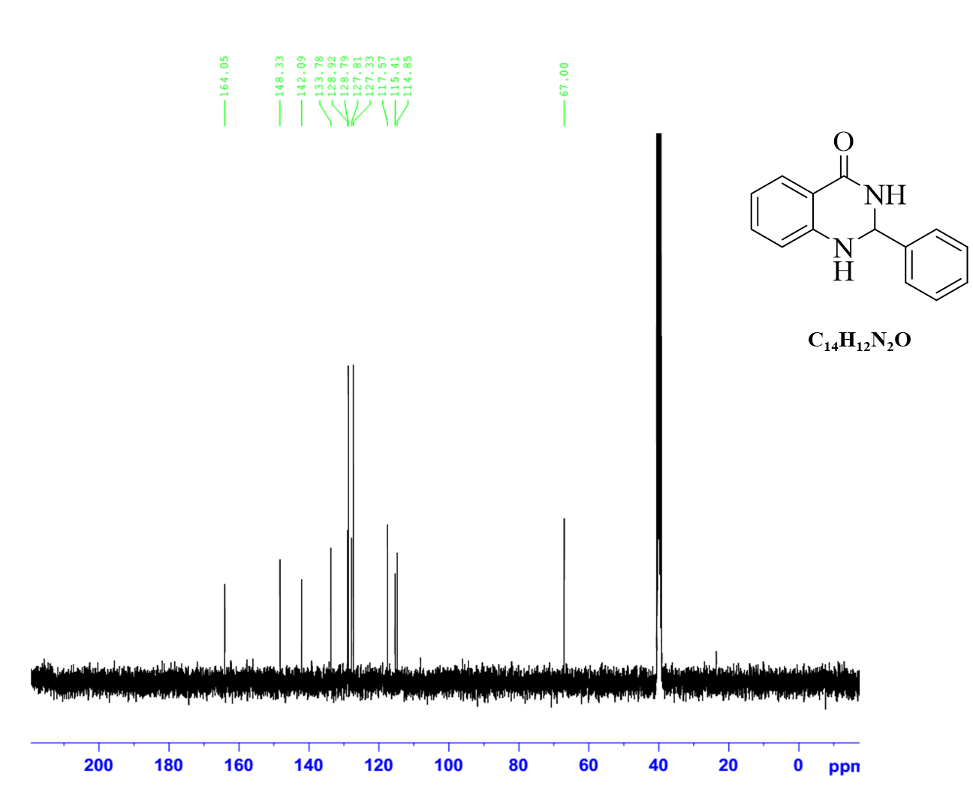
Fig. S2; ¹³C-NMR of 2.1a

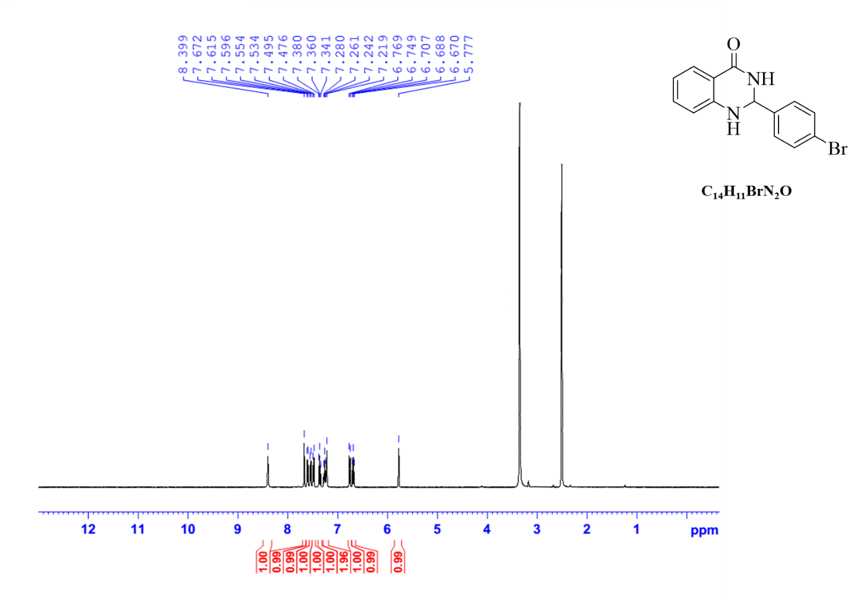
Fig. S3; ¹H-NMR of 2.1b
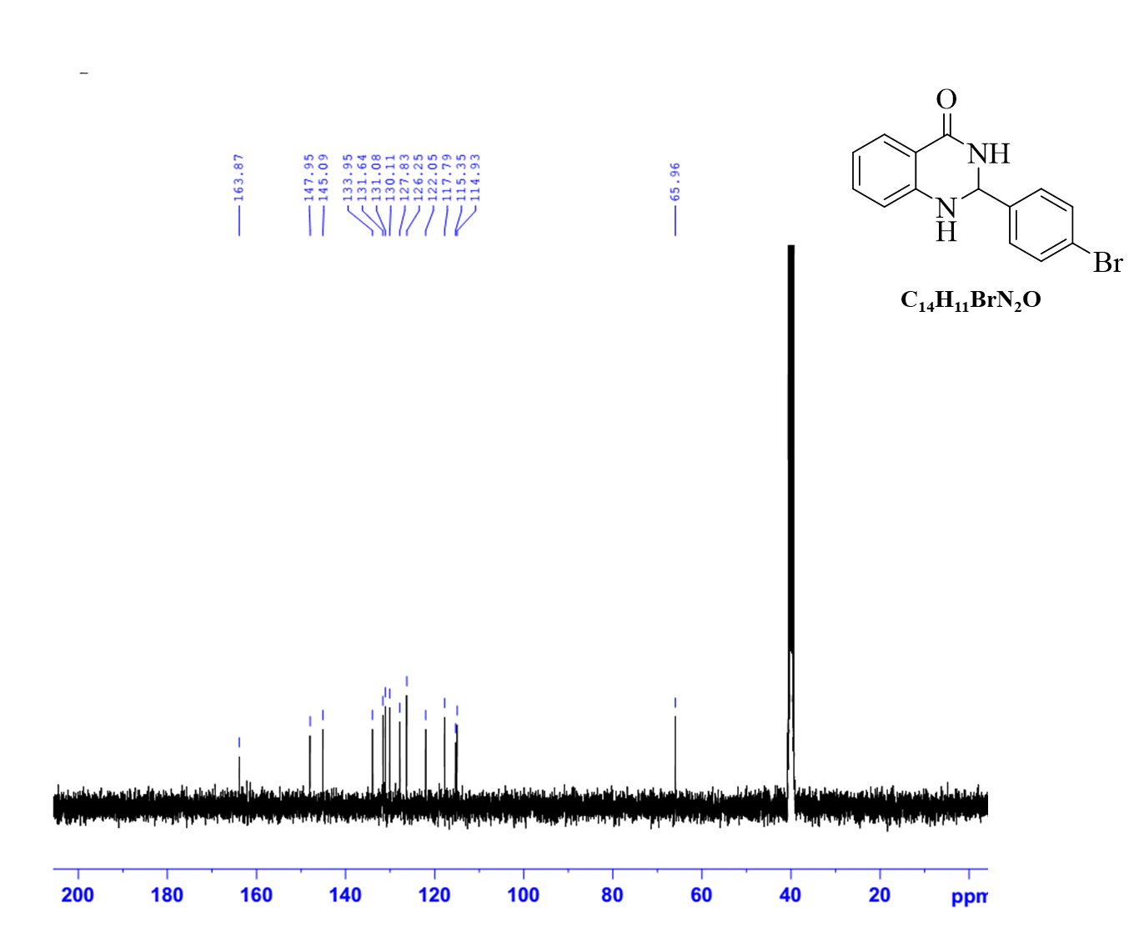
Fig. S4; ¹³C-NMR of 2.1b

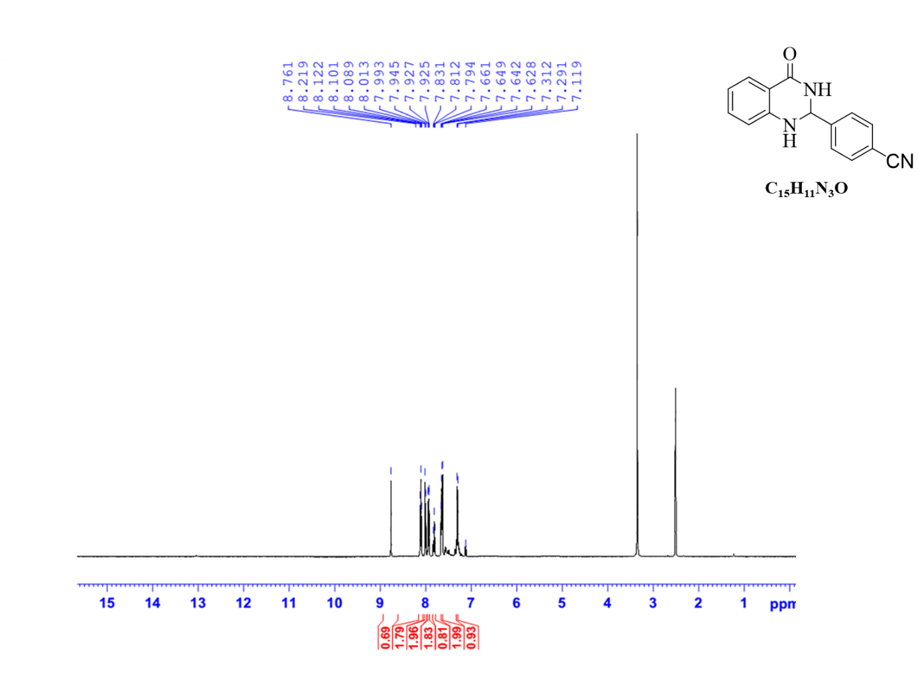
Fig. S5; ¹H-NMR of 2.1c

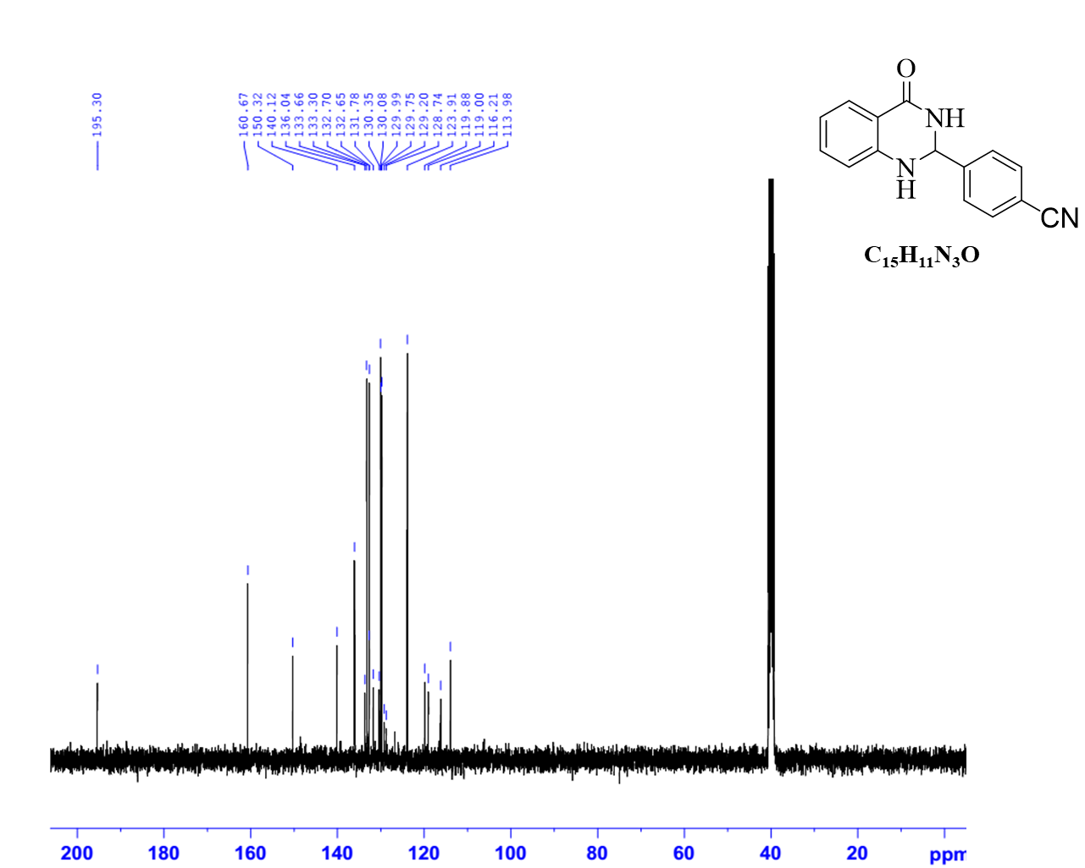
Fig. S6; ¹³C-NMR of 2.1c

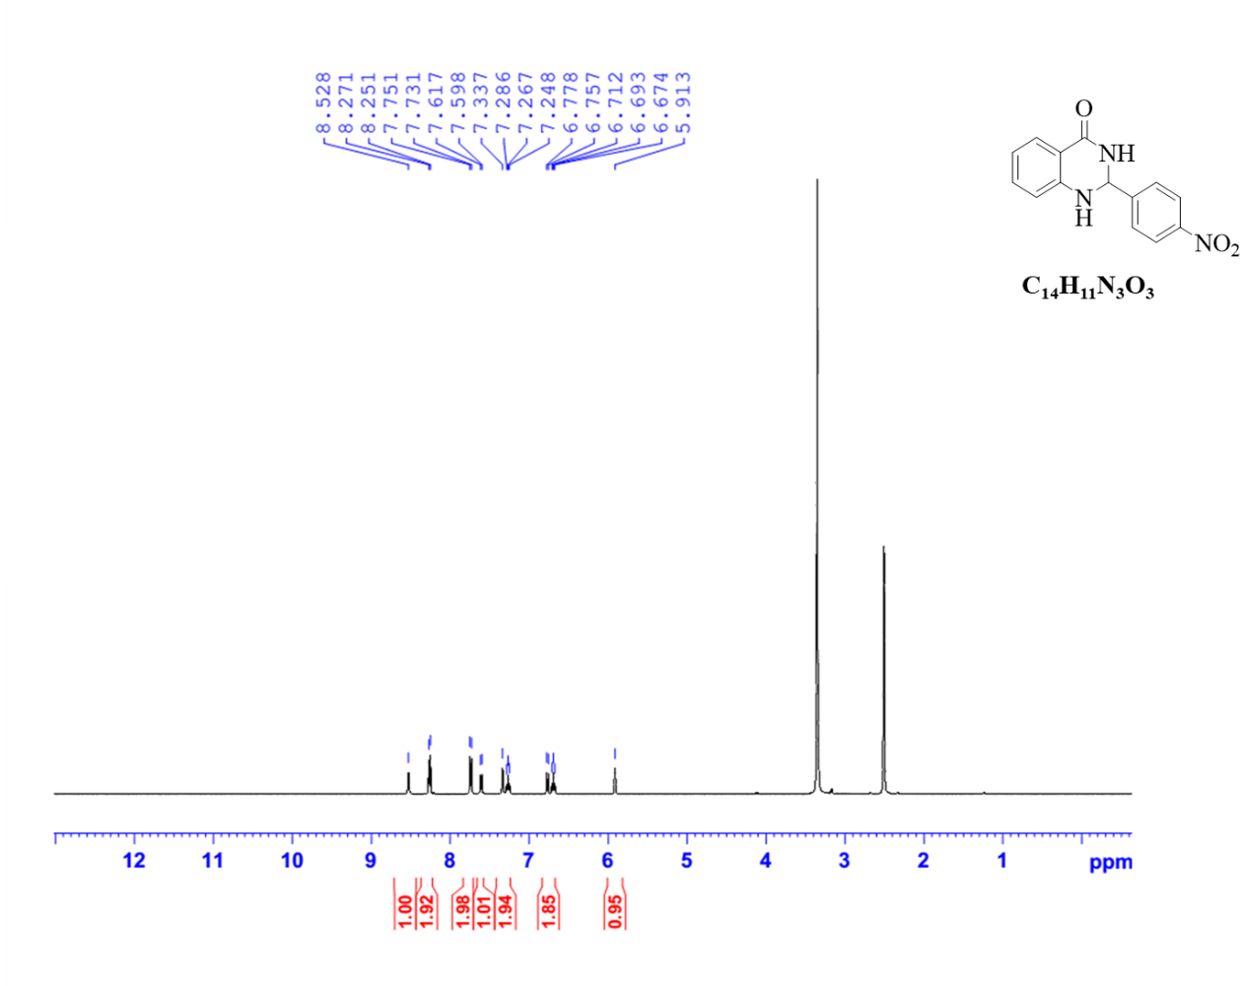
Fig. S7; ¹H-NMR of 2.1d

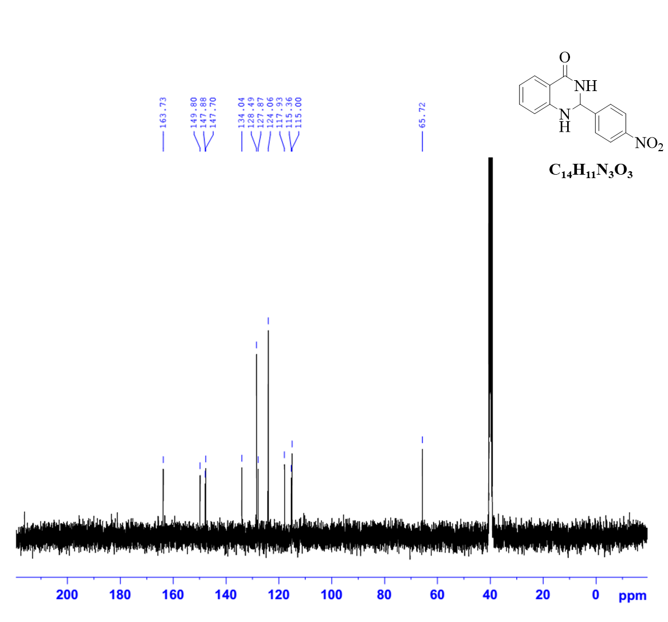
Fig. S8; ¹³C-NMR of 2.1d

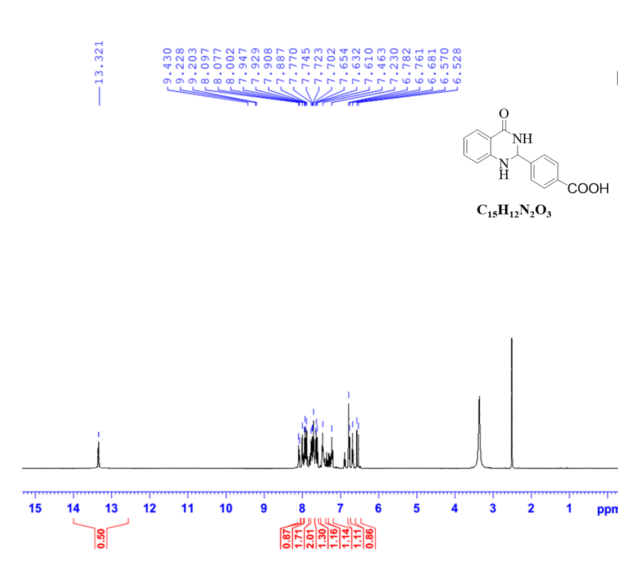
Fig. S9; ¹H-NMR of 2.1e

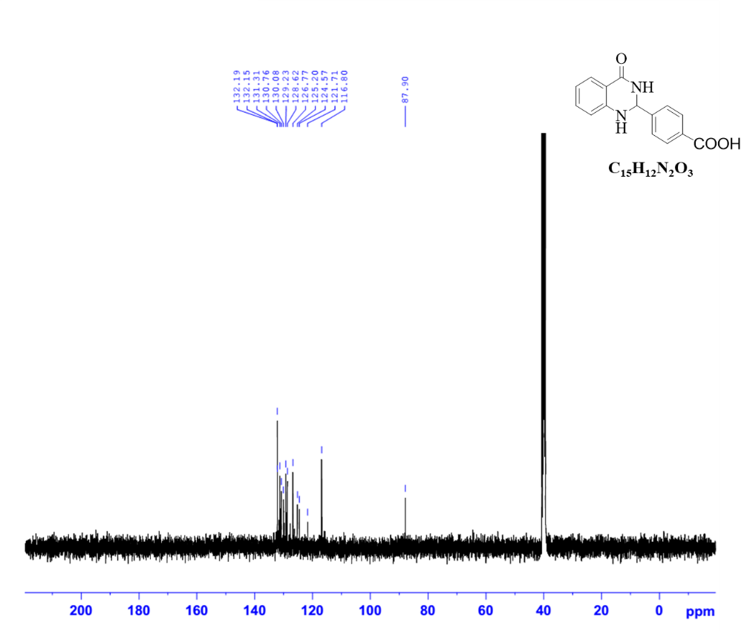
Fig. S10; ¹³C-NMR of 2.1e

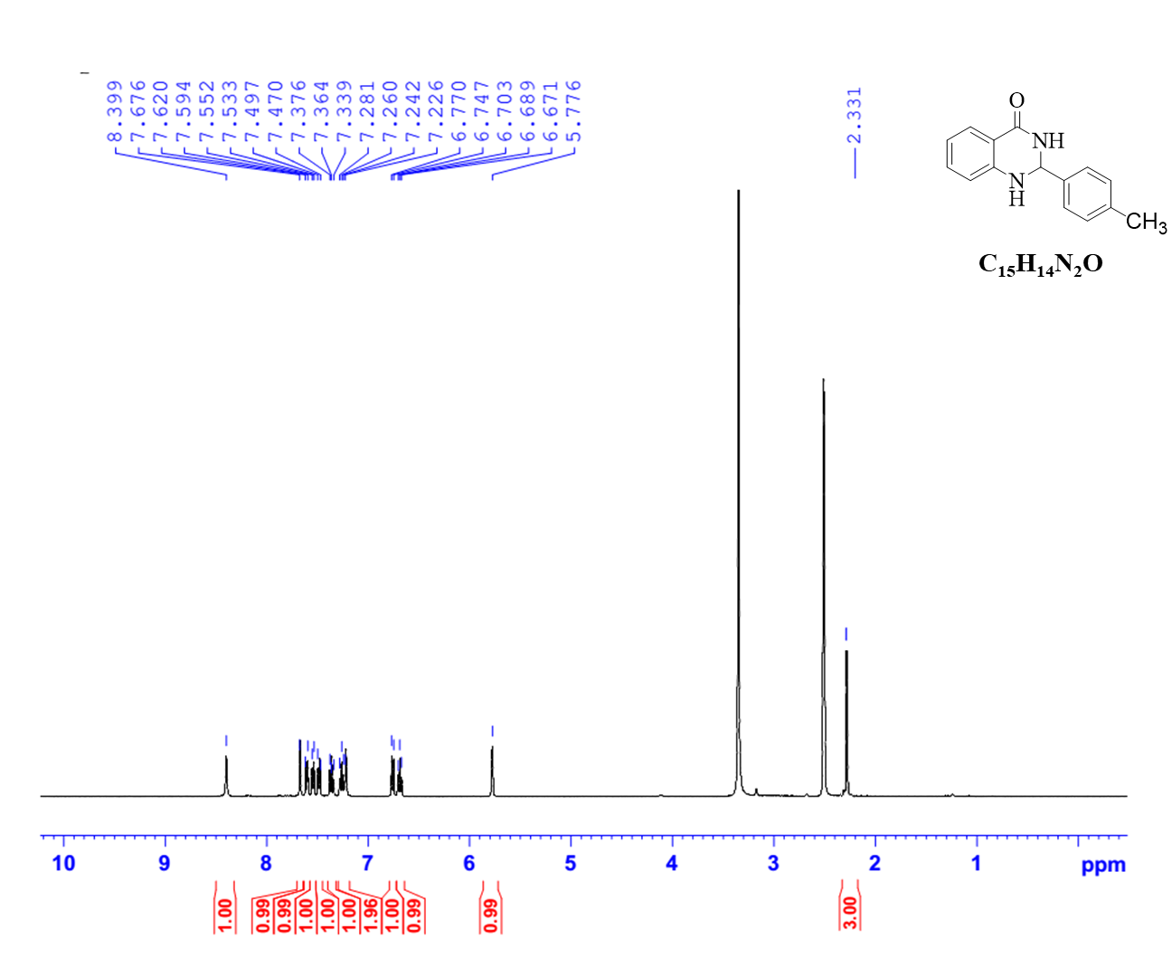
Fig. S11; ¹H-NMR of 2.1f

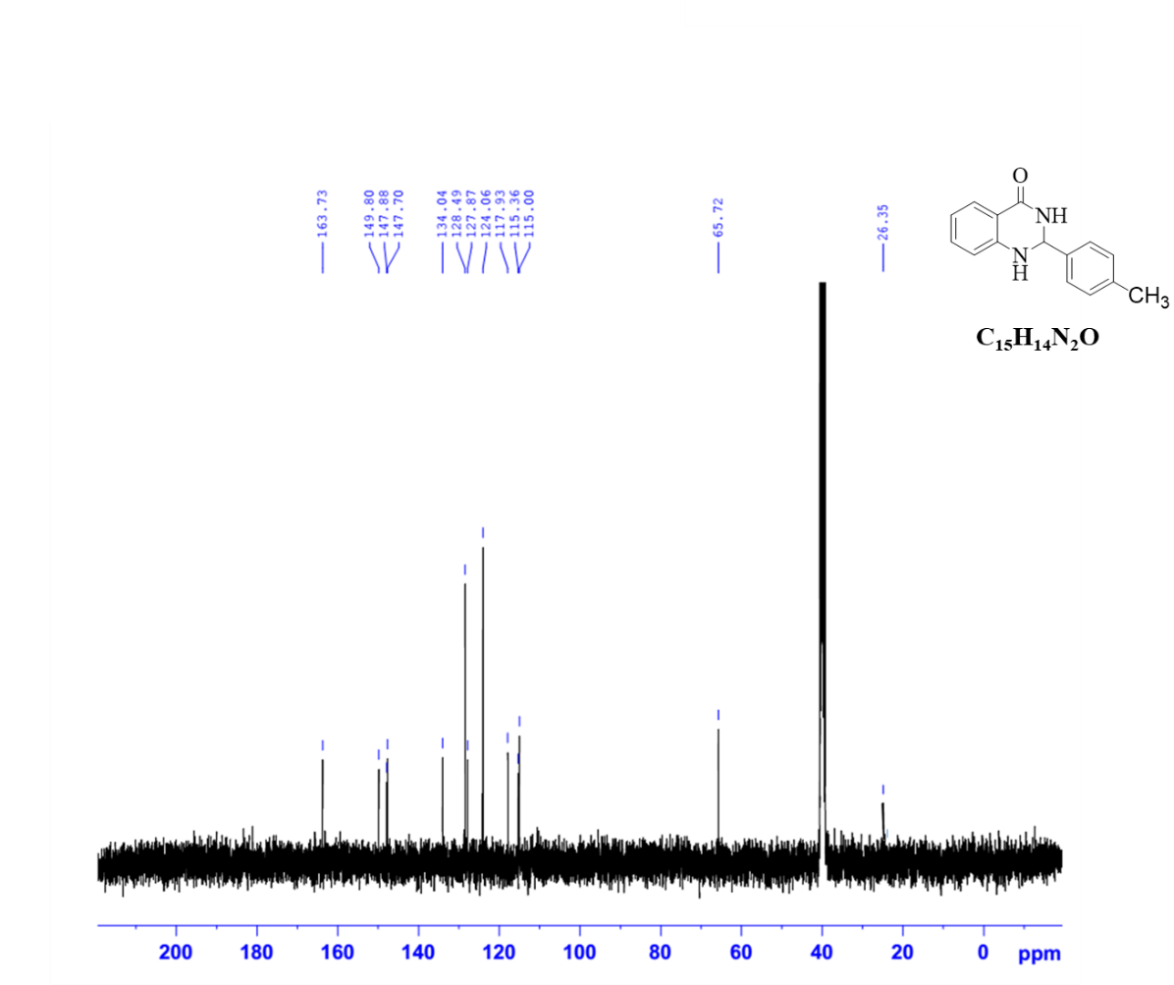
Fig. S12; ¹³C-NMR of 2.1f

