Urban forest remnants: key refuges for reptile conservation in the Highlands of Southern Mexico, the effect of local and landscape environmental factors
Urban Ecosystems
Erandi Monroy-Hernández¹; Susana Maza-Villalobos¹; Marco Tulio Oropeza-Sánchez²; José Rogelio Cedeño-Vázquez³.

¹El Colegio de La Frontera Sur, Unidad San Cristóbal de Las Casas. Carretera Panamericana y Periférico Sur s/n Barrio María Auxiliadora, CP 29290 San Cristóbal de Las Casas, Chiapas, México.
²Facultad de Estudios Superiores Iztacala (FES-Iztacala), Universidad Nacional Autónoma de México, Av. de los Barrios No. 1, CP 54090 Tlalnepantla de Baz, Estado de México, México.
³El Colegio de La Frontera Sur, Unidad Chetumal. Departamento de Sistemática y Ecología Acuática. Av. Centenario km 5.5, CP 77014 Chetumal, Q. Roo, México
Corresponding author: sumaza@ecosur.mx

Supplementary material
Table S1. General description of the land-use history, vegetation, canopy, and surrounding matrix of the studied sites.
Site | Conservation level | Disturbance level | Deforestation, year | Pine-rise level | Presence of non- native vegetationª | Canopy cover (%)^{b} | DAP (cm) ^{b} | Forest cover in surrounding matrix (%)^{b} | Dist. Urb. (m) ^{c}
ENC | Low | High | High, 2007*** | High | High | 58.1 | 13.9 | 94.5 | 698.5
MONT | Low | High | High, 1998* | High | Low | 61.0 | 17.4 | 82.2 | 80.6
CERR | Low | High | Total, ≤1940** | Inter | High | 71.5 | 28.9 | 33.4 | 102.0
MIR | Inter | Inter | Partial, 2017*** | Inter | Low | 68.1 | 14.3 | 88.2 | 367.7
CRUZ | Inter | Inter | Partial, <2007*** | Low | Low | 70.3 | 13.8 | 68.9 | 234.7
AGUA | Inter | Inter | Partial, 1998* | Inter | Low | 80.8 | 19.9 | 87.0 | 637.0
MOX | High | Low | Low, 2023*** | Absent | Absent | 73.7 | 18.6 | 92.2 | 863.7
HUIT | High | Low | Low, 2017*** | Absent | Absent | 83.7 | 16.9 | 91.0 | 751.7
ªThe non-native vegetations in these studied sites were represented by Eucalyptus camaldulensis and Cupressus lusitanica. ^{b}The showed values are means. ^{c}The closest distance to urbanization (Dist.Urb.) was calculated by the mean distances from the central point of each transect in each site to the urban settlement. *(Fernández Pérez 2011);**(Ruiz-Montoya et al. 2014):*** Information from owners and managers of forest areas.
Table S2. Recorded reptile’s species in the studied sites. Abundance and state of conservation are shown. Risk categories of the Mexican Official Standard Number 59 (NOM-059) are: Pr (Subject to special protection) and A (Threatened). Categories of the IUCN Red List of threatened species are LC (Least Concern) and DD (Data Deficient).
Taxon | Abundance of reptiles per studied site |  |  |  |  |  |  |  | State of Conservation
Taxon | ENC | MONT | MOX | CERR | AGUA | HUIT | MIR | CRUZ | NOM-059 | IUCN
Class Reptilia
Order Squamata
Suborder Sauria
Family Anolidae
Anolis anisolepis | 31 | 12 | 0 | 16 | 0 | 6 | 8 | 17 | Pr | LC
Family Scincidae
Subfamily Sphenomorphinae
Scincella incerta | 7 | 12 | 0 | 2 | 0 | 1 | 18 | 12 | - | LC
Family Phrynosomatidae
Subfamily Sceloporinae
Sceloporus taeniocnemis | 6 | 0 | 3 | 1 | 0 | 0 | 18 | 0 | - | LC
Family Anguidae
Subfamily Gerrhonotinae
Abronia lythrochila | 0 | 2 | 0 | 0 | 2 | 1 | 4 | 0 | A | LC
Abronia moreletii | 0 | 0 | 3 | 9 | 0 | 26 | 0 | 0 | Pr | LC
Suborder Serpentes
Family Colubridae
Subfamily Dipsadinae
Adelphicos visoninum | 0 | 2 | 0 | 6 | 0 | 0 | 0 | 0 | - | LC
Adelphicos nigrilatum | 0 | 0 | 0 | 4 | 0 | 1 | 0 | 1 | Pr | LC
Ninia diademata | 1 | 0 | 0 | 0 | 0 | 0 | 0 | 0 | - | LC
Rhadinella kanalchutchan | 0 | 0 | 0 | 0 | 0 | 1 | 0 | 0 | Pr | DD
Coniophanes alvarezi | 9 | 0 | 0 | 0 | 0 | 0 | 0 | 1 | - | DD
Subfamily Natricinae
Thamnophis fulvus | 3 | 0 | 0 | 0 | 1 | 0 | 0 | 0 | - | LC
Family Viperidae
Subfamily Crotalinae
Cerrophidion tzotzilorum | 0 | 0 | 1 | 0 | 1 | 1 | 0 | 0 | Pr | LC

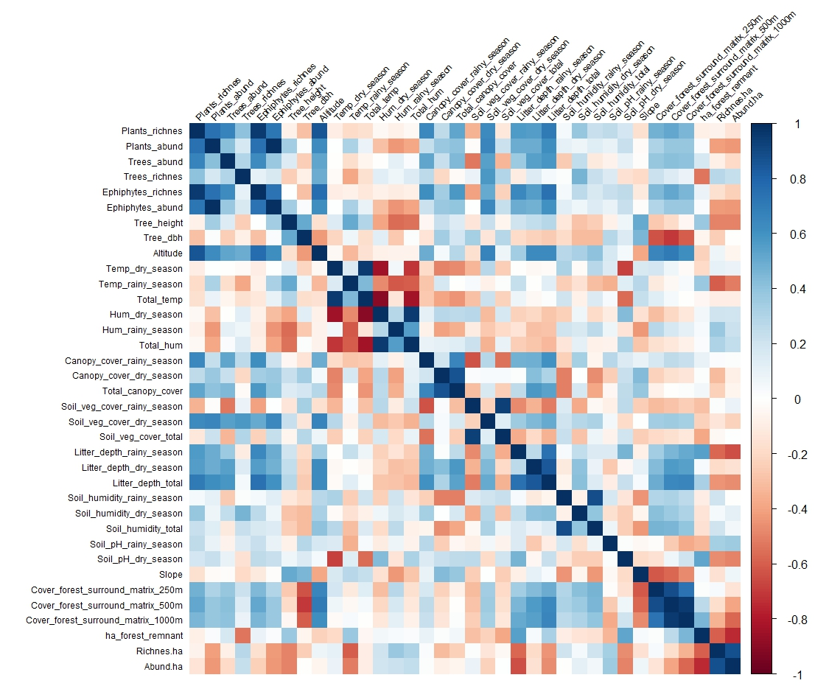

Figure S1. Correlation matrix. Covariates with correlation values ≥ |0.7| were not included in the NMDS analysis. Values close to 1 are indicated by darker shades of blue (positive correlation), while values close to -1 are indicated by darker shades of red (negative correlation).

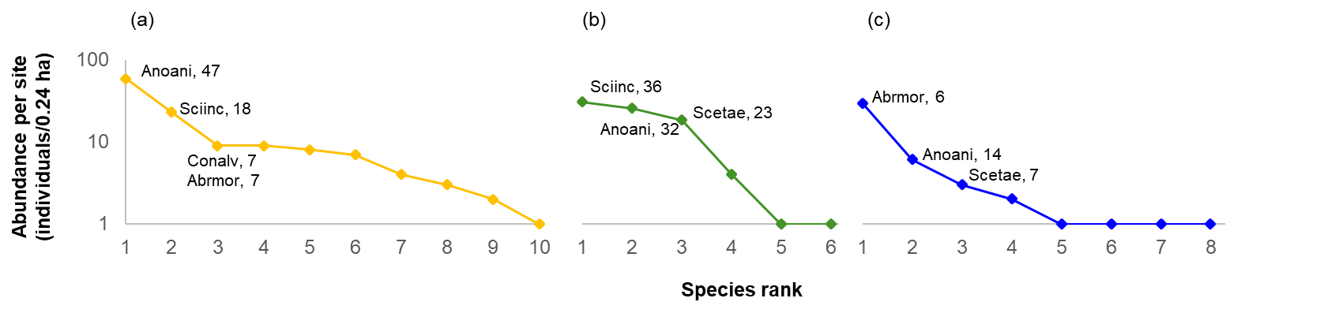
Figure S2. Rank-abundance curve for reptile’s communities in the studied sites. Each symbol represents the total abundance of species per category. The conservation categories are represented by different colors of line and symbols as follows: Low (yellow), Intermediate (green), and High (blue). Species acronym for the three most abundant species per category are showed: Abrmor (Abronia moreletii), Anoani (Anolis anisolepsis), Conalv (Coniophanes alvarezi), Scetae (Sceloporus taeniocnemis), Sciinc (Scincella incerta). The number after the acronym is the contribution (%) of each species per abundance. Note y-axis is scaled logarithmically.

