Supplementary material

Agrohydrological analysis of waterlogging impacts
and mitigation in Ethiopia

Mosisa Tujuba Wakjira^{1*}, Peter Molnar², Ruud Bartholomeus^{3,4} , Teklu Erkossa⁵ and Katrien Descheemaeker¹
¹Plant Production Systems Group, Wageningen University and Research, 6700AK Wageningen, The Netherlands
²Institute of Environmental Engineering, ETH Zurich, 8093 Zürich, Switzerland
³KWR Water Research Institute, 3433PE Nieuwegein, The Netherlands
⁴Soil Physics and Land Management (SLM), Wageningen University & Research (WUR), 6708PB Wageningen, The Netherlands
⁵Deutsche Gesellschaft für Internationale Zusammenarbeit (GIZ), Addis Ababa, Ethiopia
*Correspondence: Mosisa Tujuba Wakjira (email:mosisa.wakjira@wur.nl or mosisatujuba@gmail.com), Plant Production Systems Group, Wageningen University and Research, 6700AK Wageningen, The Netherlands

Table 1: List of surface runoff measurement and simulation sites and measurement periods collected from published literature for the calibration and validation of the water balance model.
Measurement site | Lat (° N) | Lon (° E) | Measurement periods | Reference
Maybar | 11.02 | 39.67 | 1982-1993 | ¹ ²
Hunde lafto | 9.07 | 41.00 | 1983-1993 | ¹ ²
Andit Tid | 9.80 | 39.72 | 1982-1992 | ¹ ²
Gununo | 6.92 | 37.65 | 1985-1993 | ¹ ²
Anjeni | 10.81 | 37.57 | 1985-1993 | ¹ ²
Dendi | 9.13 | 37.12 | 2007-2009 | ³
Holeta | 9.07 | 38.48 | 2009-2010 | ⁴
Debre Mawi | 11.33 | 37.43 | 2008-2009 | ⁵
Chefe donsa | 8.96 | 39.11 | 2001-2002 | ⁶
Dera | 8.36 | 39.34 | 2004 | ⁷
Yeku | 12.52 | 39.07 | 2003 | ⁸
Guder | 8.95 | 37.75 | 2003 | ⁹
Dodota | 11.50 | 39.92 | 1994-2000 | ¹⁰
Keleta | 8.12 | 39.46 | 1981, 1990 | ¹¹
Suluh | 13.80 | 39.50 | 1992-2003 | ¹²
Hare | 6.25 | 37.55 | 1990-1999 | ¹³
Bilate | 7.50 | 37.94 | 1990-1999 | ¹³
Hagere Selam | 13.65 | 39.17 | 2003-2004 | ¹⁴
Adigudem | 13.233 | 39.53 | 2005-2007 | ¹⁵
Jigjiga | 9.47 | 42.63 | 2004-2005 | ¹⁶
Gum Selasa | 13.25 | 39.53 | 2005-2007 | ¹⁷
Maileba | 13.23333 | 39.25 | 2007 | ¹⁷
Melkasa | 8.43 | 39.31 | 2004 | ¹⁸
May zeg zeg | 13.65 | 39.16667 | 2005-2010 | ¹⁹
Giba | 13.49 | 39.50333 | 2004-2009 | ²⁰
Haramaya | 9.418 | 41.037 | 2000-2001 | ²¹
Mettu | 8.334 | 35.537 | 1981-1998 | ²²
Jeldu | 9.371 | 37.975 | 1981-2010 | ²³
Gumera | 11.7833 | 37.65 | 1981-2010 | ²⁴
Guder-ARS | 11 | 36.9 | 1981-2010 | ²⁴
Kulumsa | 8.0833 | 39.1717 | 1987-2010 | ²⁵
Kizin | 11.733 | 37.65 | 1981-2010 | ²⁶
Wonzima | 11.74 | 37.675 | 1981-2010 | ²⁶
Samet | 10.116 | 39.879 | 1990-2013 | ²⁷
Shambu | 9.568 | 37.077 | 1996-2010 | ²⁸
Ketar | 7.681 | 39.27 | 1981-2010 | ²⁹
Daleti-Odagodere | 10.25 | 35 | 1981-2010 | ³⁰
Erer Gudda | 9.4333 | 42.1267 | 1984-1995 | ³¹
Mieso | 9.23 | 40.8 | 2003-2004 | ³²

Table 2: List of soil moisture measurements sites collected from published literature across the rainfed agricultural region of Ethiopia
Experimental site | Lat (°N) | Lon (°E) | Years of measurement | Reference
Delanta | 11.583 | 39.200 | 2005 | ³³
North Wollo | 11.840 | 39.731 | 2003-2004 | ³⁴
Melkawoba | 8.383 | 39.367 | 2005 | ³⁵
Bishoftu | 8.733 | 38.967 | 1986 | ³⁶
Koga | 11.300 | 37.150 | 2009 | ³⁷
Chefe donsa | 8.950 | 39.100 | 1999,2002 | ³⁸
Ginchi | 9 | 38 | 2002 | ³⁹
Zequala | 13.164 | 38.5 | 2009-2010 | ⁴⁰
Abergelle | 13.0285 | 38.9765 | 2010 | ⁴⁰
Tero Jemjem | 9.0180 | 38.219 | 1996-1999 | ⁴¹
Haramaya | 9.3686 | 42.0127 | 1999 | ⁴²
Melka Jebdu | 9.610082 | 41.77584 | 2000 | ⁴³
Bale mountains NP | 6.75 | 39.75 | 2005 | ⁴⁴

Table 3: List of soil drainage evaluation field trial sites used to develop the empirical model (Figure 5 of the manuscript) for assessing the effectiveness of soil drainage in mitigating waterlogging across the rainfed agricultural region of Ethiopia
Experimental site | Lat (°N) | Lon (°E) | Years of measurement | Reference
Akaki | 8.867 | 38.784 | 1988, 1990 | ^{45,46}
Bishoftu | 8.693 | 39.055 | 1986-1988, 1990, 1998 | ^{45–48}
Ginchi | 9.018 | 38.219 | 2000-2001 | ¹⁸
Enewari | 9.916 | 39.169 | 1986-1987 | ^{45,47,49}
Dogolo | 10.431 | 39.270 | 1986-1988 | ⁴⁵
Dejen | 10.209 | 38.133 | 1987, 1989 | ^{45,49}
Wereilu | 10.595 | 39.418 | 1986 | ⁴⁷
Bahir Dar | 11.550 | 37.340 | 2007 | ⁴⁹
Bichena | 10.444 | 38.188 | 1997 | ⁴⁹
Delanta | 11.583 | 39.200 | 2006 | ⁵⁰
Chefe donsa | 8.95 | 39.1 | 1997, 2000-2003 | ⁵¹
Kotu | 9.531 | 39.466 | 1996-1997 | ⁵²
Yilmana | 11.5 | 37.333 | 2007 | ⁵³
Sinana | 10.281 | 39.161 | 2017-2018 | ⁵⁴
Lume | 8.586 | 39.170 | 2022 | ⁵⁵
Sheno | 9.354 | 39.302 | 1987 | ⁴⁷

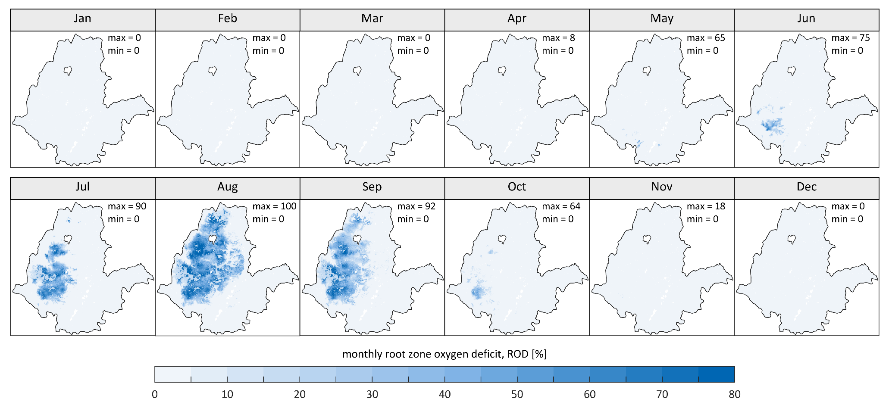
Figure 1: Climatological mean monthly root zone oxygen deficit (ROD) across the rainfed agricultural region of Ethiopia, calculated for the reference period 1981-2010 .
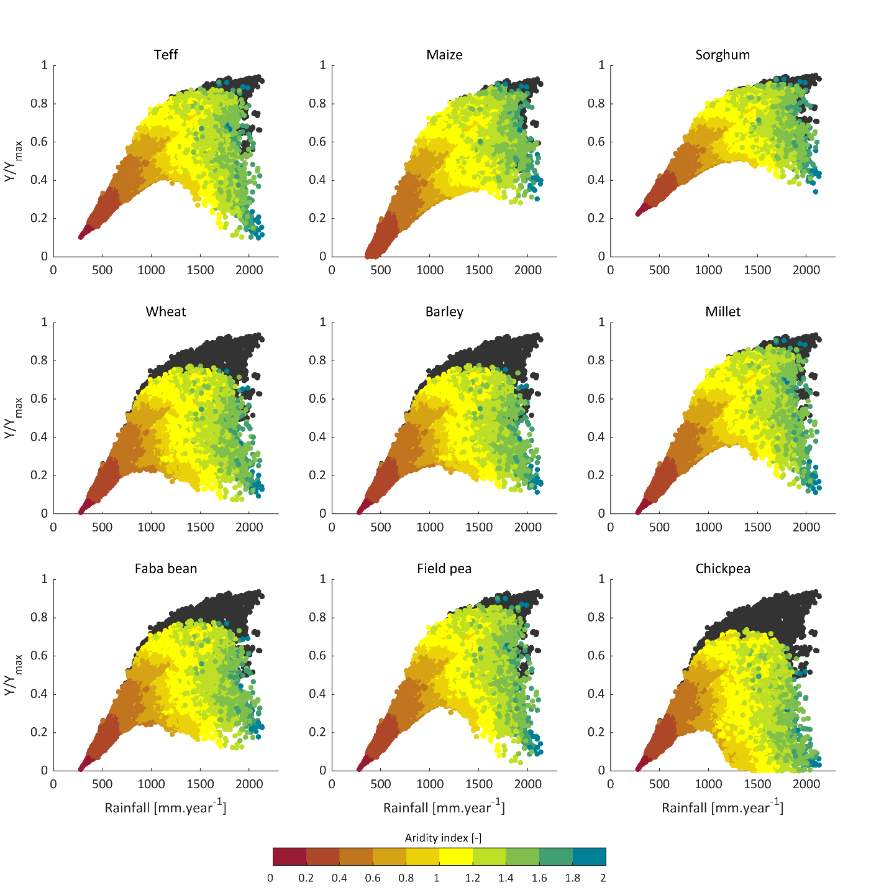
Figure 2: Relative yield (Y/Y_{max}) of nine crops under different climatic regimes (represented by mean annual rainfall). Y/Y_{max} without waterlogging effect was computed using the FAO crop water productivity function ⁵⁶: 1-Ky(1-ETa/ETo), where Ky is crop-specific yield response factor obtained from ⁵⁷, Y/Y_{max} with waterlogging effect was determined by subtracting the estimated waterlogging-induced yield loss from the non-waterlogged yield. The color gradient of the dots represents the aridity index of each grid cell. Each point corresponds to a 5 km x 5 km grid cell. Mean annual rainfall climatology (1981–2010) was obtained from CHIRPS.
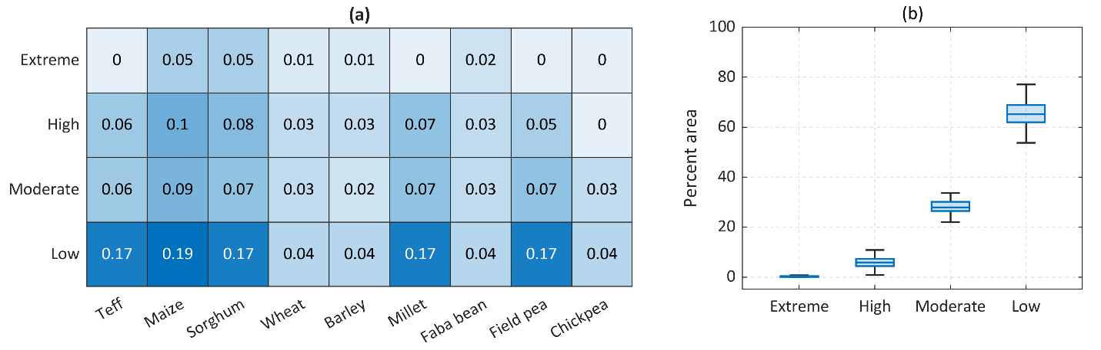
Figure 3: Spatio-temporal variability of yield losses under waterlogging. a) Heatmap of coefficients of variation (CV) of annual crop yield, losses under extreme, high, moderate, and low waterlogging conditions across the RFA region of Ethiopia. The color gradients represent the CV values. b) Box charts showing the interannual variability in the proportion of waterlogging-prone areas (%) classified as experiencing extreme, high, moderate, and low waterlogging conditions across the RFA region of Ethiopia during the period 1981–2010.

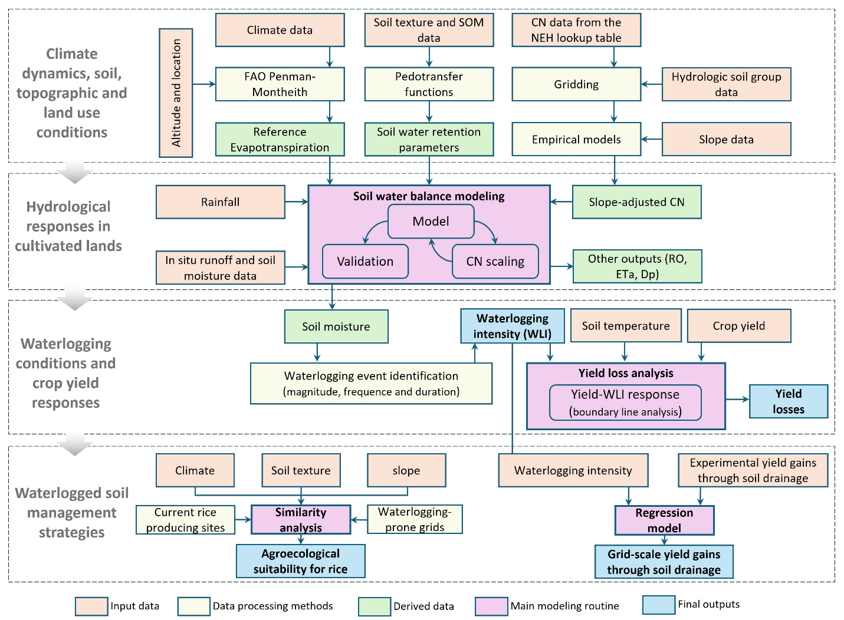
Figure 4: Agrohydrological analysis framework. CN: Curve Number, NEH: US Department of Agriculture National Engineering Handbook, ETa: actual evapotranspiration, RO: runoff, Dp: deep percolation

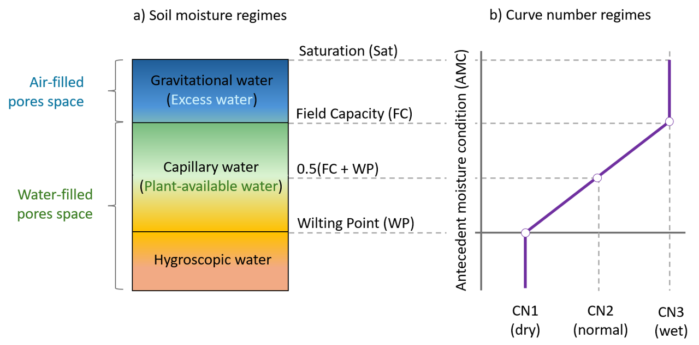
Figure 5: Conceptual representations of soil moisture and Curve number regimes. a) Soil moisture constants and regimes. b) Adjustment pattern for daily change in CN with antecedent moisture condition
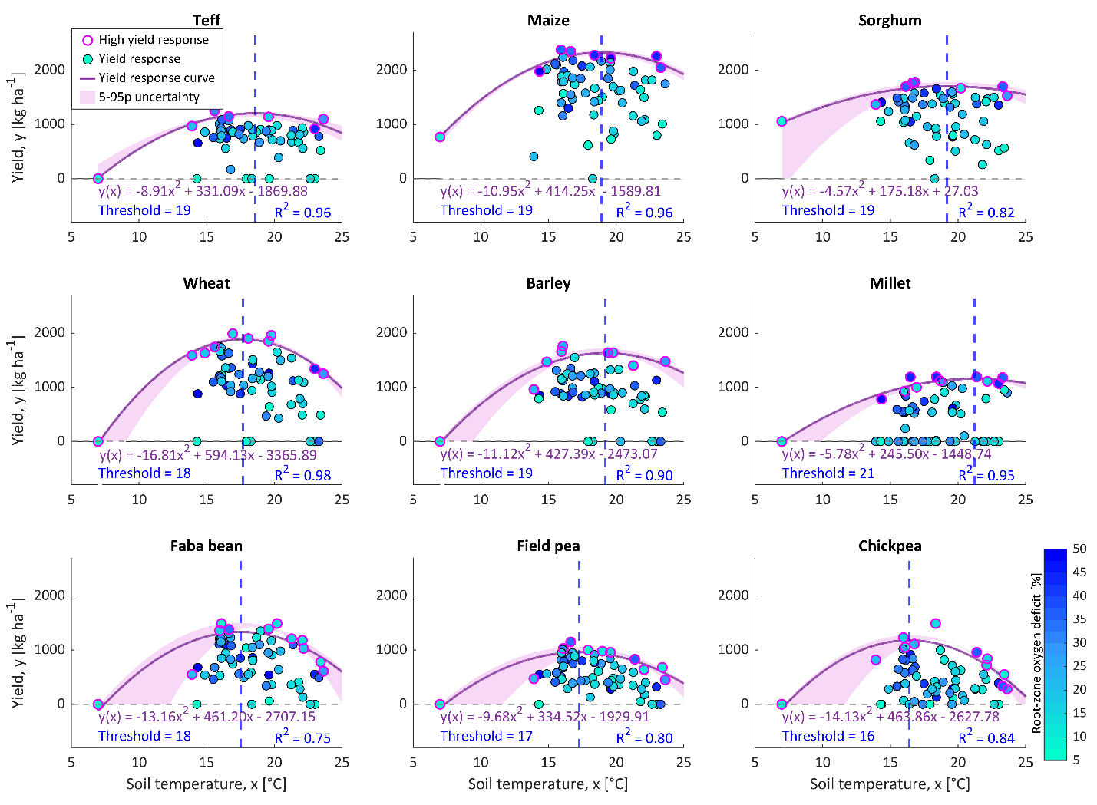
Figure 6: Effect of soil temperature. Yield responses of nine crops to mean annual soil temperature across the rainfed agricultural (RFA) region of Ethiopia. Each data point represents the zone-averaged yield for an administrative zone. The color gradient indicates average root-zone oxygen deficit. Pink circles represent the sampled high yield response (HYR) data used to define the model (purple line). The purple shade indicates the 5–95 percentile uncertainty band based on a leave-one-out uncertainty analysis. The blue dashed line marks the threshold soil temperature above which yield decreases.

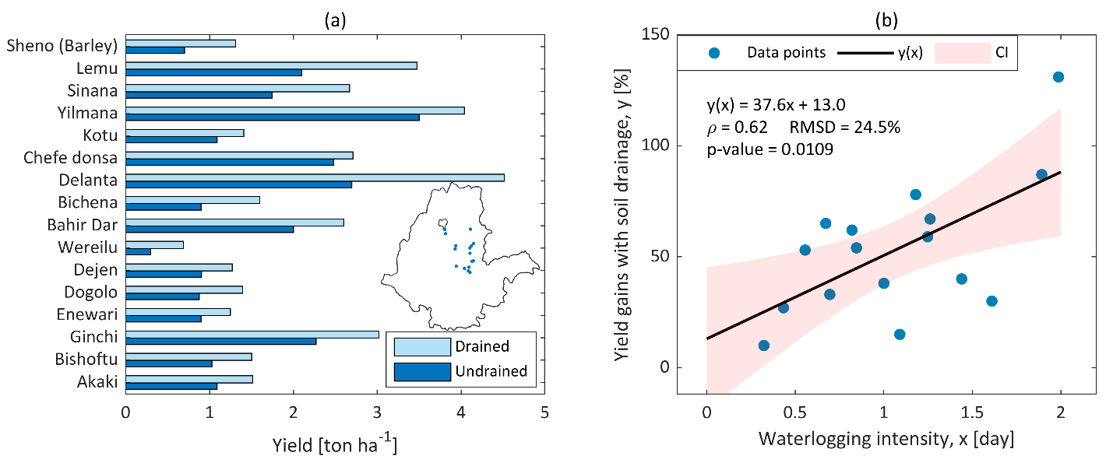
Figure 7: Field trial data and regression model of yield gains under improved soil drainage. a) Comparison of wheat yield under well-drained and undrained Vertisols at 16 field trial locations (shown in the inset map), based on published field trial data. b) linear regression model showing yield gains from improved soil drainage at the field trial sites under varying waterlogging intensity levels

References
1. Herweg, K. & Stillhardt, B. The Variability of Soil Erosion in the Highlands of Ethiopia and Eritrea: Average and Extreme Erosion Patterns. (1999).
2. Herweg, K. & Ludi, E. The performance of selected soil and water conservation measures - Case studies from Ethiopia and Eritrea. Catena 36, 99–114 (1999).
3. Adimassu, Z., Mekonnen, K., Yirga, C. & Kessler, A. Effect of soil bunds on runoff, soil and nutrient losses, and crop yield in the central highlands of ethiopia. L. Degrad. Dev. 25, 554–564 (2014).
4. Adimassu, Z., Alemu, G. & Tamene, L. Effects of tillage and crop residue management on runoff, soil loss and crop yield in the Humid Highlands of Ethiopia. Agric. Syst. 168, 11–18 (2019).
5. Amare, T. et al. Combined effect of soil bund with biological soil and water conservation measures in the northwestern Ethiopian highlands. Ecohydrol. Hydrobiol. 14, 192–199 (2014).
6. Erkossa, T., Stahr, K. & Gaiser, T. Effect of different methods of land preparation on runoff, soil and nutrient losses from a Vertisol in the Ethiopian highlands. Soil Use Manag. 21, 253–259 (2006).
7. Welderufael, W. A., Le Roux, P. A. L. & Hensley, M. Quantifying rainfall-runoff relationships on the Dera Calcic Fluvic Regosol ecotope in Ethiopia. Agric. Water Manag. 95, 1223–1232 (2008).
8. Collick, A. S. et al. A simple semi-distributed water balance model for the Ethiopian highlands. Hydrol. Process. 23, 3718–3727 (2009).
9. Tumsa, B. C., Kenea, G. & Tola, B. The application of SWAT+ model to quantify the impacts of sensitive LULC changes on water balance in Guder catchment, Oromia, Ethiopia. Heliyon 8, e12569 (2022).
10. Teso, E., Alamirew, T. & Olumana, M. Predicting Runoff Yield using SWAT Model and Evaluation of Boru Dodota Spate Irrigation Scheme , Arsi Zone , Southeastern Ethiopia. East Shoa Zone Irrigation Development Authority, Thesis, Adama, Ethiopia. 95–113 (2010).
11. Tibebe, D. & Bewket, W. Surface runoff and soil erosion estimation using the SWAT model in the Keleta Watershed, Ethiopia. L. Degrad. Dev. 22, 551–564 (2011).
12. Abebe, B. A. Modeling the Effect of Climate and Land Use Change on the Water Resources in Northern Ethiopia: The Case of Suluh River Basin. Department of earth secinces Institute of geographic scince, Freie University Berlin (2014).
13. Wagesho, N., Jain, M. K. & Goel, N. K. Effect of Climate Change on Runoff Generation: Application to Rift Valley Lakes Basin of Ethiopia. J. Hydrol. Eng. 18, 1048–1063 (2013).
14. Descheemaeker, K. et al. Runoff on slopes with restoring vegetation: A case study from the Tigray highlands, Ethiopia. J. Hydrol. 331, 219–241 (2006).
15. Araya, T. et al. Effects of conservation agriculture on runoff, soil loss and crop yield under rainfed conditions in Tigray, Northern Ethiopia. Soil Use Manag. 27, 404–414 (2011).
16. Welle, S., Chantawarangul, K. & Nontananandh, S. Effectiveness of Grass Strips as Barrier Against Runoff and Soil Loss in Jijiga Area. Eff. Grass Strips as Barrier Against Runoff Soil Loss Jijiga Area 558, 549–558 (2006).
17. Gebreegziabher, T. et al. Contour furrows for in situ soil and water conservation, Tigray, Northern Ethiopia. Soil Tillage Res. 103, 257–264 (2009).
18. Welderufael, W. A. & Woyessa, Y. E. Evaluation of surface water drainage systems for cropping in the Central Highlands of Ethiopia. Agric. Water Manag. 96, 1667–1672 (2009).
19. Araya, T. et al. Medium-term effects of conservation agriculture based cropping systems for sustainable soil and water management and crop productivity in the Ethiopian highlands. F. Crop. Res. 132, 53–62 (2012).
20. Araya, A. & Stroosnijder, L. Effects of tied ridges and mulch on barley (Hordeum vulgare) rainwater use efficiency and production in Northern Ethiopia. Agric. Water Manag. 97, 841–847 (2010).
21. Woyessa, Y. E. & Bennie, A. T. P. Tillage-crop residue management and rainfall-runoff relationships for the alemaya catchment in eastern ethiopia. South African J. Plant Soil 24, 8–15 (2007).
22. Bezuayehu, T., Ayele, G., Atnafe, Y., Jabbar, M. A. & Dubale, P. Nature and causes of land degradation in the Oromiya Region: A review. ILRI (International Livestock Research Institute), Nairobi, Kenya. Socio-economics Policy Res. Work. Pap. 36 82 (2002).
23. Jaleta, D., Mbilinyi, B. P., Mahoo, H. F. & Lemenih, M. Effect of Eucalyptus expansion on surface runoff in the central highlands of Ethiopia. Ecol. Process. 6, 1–8 (2017).
24. Ebabu, K. et al. Land use, management and climate effects on runoff and soil loss responses in the highlands of Ethiopia. J. Environ. Manage. 326, 116707 (2023).
25. Lindi, S., Hone, M., Eticha, B. & Nanesa, K. Estimation of Runoff Using CN Method and Arc GIS for Irrigation Water Accessibility at Kulumsa Watershed, Arsi Zone of Ethiopia. Glob. Res. Environ. Sustain. 2, 1–15 (2024).
26. Monsieurs, E. et al. Impact of draining hilly lands on runoff and on-site erosion: A case study from humid Ethiopia. Earth Surf. Process. Landforms 41, 513–525 (2016).
27. Beza, M., Hailu, H. & Teferi, G. Modeling and Assessing Surface Water Potential Using Combined SWAT Model and Spatial Proximity Regionalization Technique for Ungauged Subwatershed of Jewuha Watershed, Awash Basin, Ethiopia. Adv. Civ. Eng. 2023, (2023).
28. Debela, S. K. & Feyessa, F. F. Rainfall-Runoff Modeling and Its Prioritization At Sub-Watershed Level Using Swat Model: a Case of Finca’Aa, Oromia, Western Ethiopia. Water Conserv. Manag. 6, 22–29 (2022).
29. Sime, C. H., Demissie, T. A. & Tufa, F. G. Surface runoff modeling in Ketar watershed, Ethiopia. J. Sediment. Environ. 5, 151–162 (2020).
30. Kassa, Y. Performance Assessment of Road Drainage Structures and Proposed Mitigation Measures: The case of Daleti-Odagodere Gravel Road in Benishangul-Gumuz Region. (Addis Ababa University, 2013).
31. Lindi, S. & Megersa, S. L. Prediction of Runoff and Sediment Yield Using AnnAGNPS Model: Case of Erer-Guda Catchment, East Hararghe, Ethiopia. 4, (2014).
32. Welderufael, W. A. Quantifying rainfall-runoff relationships on selected benchmark ecotopes in Ethiopia: a primary step in water harvesting research. Na vol. NA (Wageningen University and Research, 2006).
33. Kebede, K. & Bekelle, E. Tillage Effect on Soil Moisture Storage and Wheat Yield on the Vertisols of North Central Highlands of Ethiopia. Ethiop. J. Environ. Stud. Manag. 1, 49–55 (2008).
34. McHugh, O. V., Steenhuis, T. S., Berihun Abebe & Fernandes, E. C. M. Performance of in situ rainwater conservation tillage techniques on dry spell mitigation and erosion control in the drought-prone North Wello zone of the Ethiopian highlands. Soil Tillage Res. 97, 19–36 (2007).
35. Temesgen, M., Savenije, H. H. G., Rockström, J. & Hoogmoed, W. B. Assessment of strip tillage systems for maize production in semi-arid Ethiopia: Effects on grain yield, water balance and water productivity. Phys. Chem. EARTH 47–48, 156–165 (2012).
36. Kamara, S. C. & Haque, I. Kamara.Pdf. (1989).
37. Chanie, T., Collick, A. S., Adgo, E., Lehmann, C. J. & Steenhuis, T. S. Eco-hydrological impacts of Eucalyptus in the semi humid Ethiopian Highlands: The Lake Tana Plain. J. Hydrol. Hydromechanics 61, 21–29 (2013).
38. Teklu Erkossa. Tillage effects on physical qualities of a vertisol in the central highlands of Ethiopia. African J. Environ. Sci. Technol. 5, 1008–1016 (2011).
39. Kidanu, S., Mamo, T. & Stroosnijder, L. Eucalyptus-wheat interaction on Ethiopian Nitosols. Agric. Syst. 80, 151–170 (2004).
40. Zelelew, D. G., Ayimute, T. A. & Melesse, A. M. Evaluating the Response of In Situ Moisture Conservation Techniques in Different Rainfall Distributions and Soil-Type Conditions on Sorghum Production and Soil Moisture Characteristics in Drought-Prone Areas of Northern Ethiopia. Water Conserv. Sci. Eng. 3, 157–167 (2018).
41. Taddese, G., Mohamed Saleem, M. A., Abyie, A. & Wagnew, A. Impact of grazing on plant species richness, plant biomass, plant attribute, and soil physical and hydrological properties of vertisol in East African highlands. Environ. Manage. 29, 279–289 (2002).
42. Woldetsadik, K., Gertsson, U. & Ascard, J. Response of shallots to mulching and nitrogen fertilization. HortScience 38, 217–221 (2003).
43. Abdelkdair, A. & Schultz, R. C. Water harvesting in a ‘runoff-catchment’ agroforestry system in the dry lands of Ethiopia. Agrofor. Syst. 63, 291–298 (2005).
44. Yimer, F., Messing, I., Ledin, S. & Abdelkadir, A. Effects of different land use types on infiltration capacity in a catchment in the highlands of Ethiopia. Soil Use Manag. 24, 344–349 (2008).
45. Mamo, T., Astatke, A., Srivastava, K. L. & Dibabe, A. Improved Management of Vertisols for Sustainable Crop-Livestock Production in the Ethiopian Highlands : Synthesis Report 1986-92. (1993).
46. Abebe, M., Mamo, T., Duffera, M. & Kidanu, S. Y. Crop Response to Improved Drainage of Vertisols in the Ethiopian Highlands. J. Agron. Crop Sci. 172, 217–222 (1994).
47. Asamenew, G., Jutzi, S. C., Tedla, A. & J., M. Economic evaluation of improved vertisol drainage for food crop production in the Ethiopian Highlands. in Management of Vertisols in sub-Saharan Africa 263–283 (Addis Ababa, 1988).
48. Astatke, A., Jabbar, M., Saleem, M. A. M. & Erkossa, T. Technical and economic performance of animal-drawn implements for minimum tillage: Experience on vertisols in Ethiopia. 38, (2002).
49. Erkossa, T., Haileslassie, A. & MacAlister, C. Enhancing farming system water productivity through alternative land use and water management in vertisol areas of Ethiopian Blue Nile Basin (Abay). Agric. Water Manag. 132, 120–128 (2014).
50. Mekonen, M., Tesfaye, K. & Bayu, W. Soil Drainage and Nutrient Management to Improve Productivity of Waterlogged Vertisols for Small-scale Farmers. Eng. Int. 1, 80–92 (2013).
51. Erkossa, T., Menker, M. & Betrie, G. D. Effects of bed width and planting date on water productivity of wheat grown on vertisols in the Ethiopian Highlands. Irrig. Drain. 60, 635–643 (2011).
52. Abera, T. et al. Research achievements in barley cultural practices in Ethiopia. in Barley research and development in Ethiopia 113–126 (2011).
53. Rutherford, A. S. Broad Bed Maker Technology Package Innovations in Ethiopian Farming Systems: An. (2008).
54. Lebay, M., Abiye, W., Taye, T. & Belay, S. Evaluation of Soil Drainage Methods for the Productivity of Waterlogged Vertisols in Jama District, Eastern Amhara Region, Ethiopia. Int. J. Agron. 2021, (2021).
55. Fetene, S., Ahmed, M., Gonfa, A. & Amsalu, S. Participatory Demonstration of Durum Wheat Production Blending Vertisols Management Technologies in Lume District, East Shewa, Ethiopia. Int. J. Agric. Econ. 9, 203–209 (2024).
56. Doorenbos, J. & Kassam, A. H. Paper 33. Yield Response to Water. FAO Irrigation and Drainage Paper (1979).
57. Allen, R. G., Pereira, L. S., Raes, D. & Smith, M. Crop Evapotranspiration. Irrigation and Drainage Paper No. 56 (1998).

