Supplementary Material
Table 1 | Overview stain I for T cell staining in blood, BM, spleen, and thymus
 | AF488 | PE | PE-Texas red | PeCy7 | APC | APC-Cy7
Stain | CD3 | CD3 | CD44-biotin | CD8 | CD45 | CD62L
Isotype | Isotype | Isotype | Isotype-biotin | Isotype | Isotype | Isotype
FMO | Isotype | CD3 | Isotype-biotin | Isotype | CD45 | Isotype

Table 2 | Overview stain II for B cell staining in blood, BM, and spleen
 | FITC | PE | PE-Texas red | PerCP | PeCy7 | APC | APC-Cy7 | AF700
Stain | CD21 | IgM | CD23-biotin | CD73 | B220 | AA4.1 | CD45 | CD86
Isotype | Isotype | Isotype | Isotype-biotin | Isotype | Isotype | Isotype | Isotype | Isotype
FMO | Isotype | Isotype | Isotype-biotin | Isotype | B220 | Isotype | CD45 | Isotype
Table 3 | Properties of fluorophores using the FACS Diva with 2 lasers
Laser | Fluorophore | Emission(nm) | Color
Blue | Alexa Fluor 488 (AF-488) | 519 | Green
488 nm | Fluorescein isothiocyanate (FITC) | 518 | Green
488 nm | Phycoerythrin (PE) | 578 | Yellow
488 nm | Phycoerythrin-Texas red (PE-Texas red) | 612 | Orange
488 nm | Peridinin chlorophyll protein (PerCP) | 677 | Red
488 nm | Phycoerythrin-Cyanine7 (PE-Cy7) | 785 | Infrared
Red | Allophycocyanin (APC) | 660 | Red
Red | Allophycocyanin-Cyanine7 (APC-Cy7) | 785 | Infrared
633 nm | Alexa Fluor 700 (AF-700) | 719 | Deep red

Table 4 | Overview of T cell subsets in BM, blood, and thymus (20-24 Months)
Cell % of parent population |  | C57BL/6 WT(n=10) |  |  |  | GHR-/- (n=12)
 |  | (Cell?) Mean SD |  |  |  | Mean SD |  | P value
Spleen
Leukocytes |  | 8.151 |  |  |  | 2.523 |  | <0.0001
T cell |  | 7.414 |  |  |  | 3.064 |  | 0.0840
Helper T cell |  | 9.869 |  |  |  | 9.793 |  | 0.7437
Cytotoxic T cell |  | 7.981 |  |  |  | 12.61 |  | 0.0384
Helper EM T cell |  | 2.667 |  |  |  | 7.696 |  | <0.0001
Helper CM T cell |  | 1.880 |  |  |  | 6.864 |  | 0.0001
Cytotoxic EM T cell |  | 9.394 |  |  |  | 4.771 |  | 0.0008
Cytotoxic CM T cell |  | 7.981 |  |  |  | 12.61 |  | 0.0002
Naïve 1 helper T cell |  | 0.263 |  |  |  | 0.609 |  | 0.0303
Naïve 2 helper T cell |  | 1.351 |  |  |  | 1.224 |  | 0.0072
Naïve 1 cytotoxic T cell |  | 3.693 |  |  |  | 12.76 |  | <0.0001
Naïve 2 cytotoxic T cell |  | 1.592 |  |  |  | 4.408 |  | 0.0072
BM
Leukocytes |  | 2.210 |  |  |  | 4.601 |  | <0.0001
T cell |  | 9.671 |  |  |  | 4.354 |  | <0.0001
Helper T cell |  | 4.668 |  |  |  | 7.287 |  | 0.6972
Cytotoxic T cell |  | 7.796 |  |  |  | 7.365 |  | 0.2287
Helper EM T cell |  | 1.295 |  |  |  | 5.236 |  | 0.0002
Helper CM T cell |  | 0.9555 |  |  |  | 2.982 |  | 0.0002
Cytotoxic EM T cell |  | 5.122 |  |  |  | 5.679 |  | 0.0274
Cytotoxic CM T cell |  | 5.049 |  |  |  | 3.726 |  | <0.0001
Naïve 1 helper T cell |  | 0.2676 |  |  |  | 1.442 |  | 0.0542
Naïve 2 helper T cell |  | 1.020 |  |  |  | 1.141 |  | <0.0001
Naïve 1 cytotoxic T cell |  | 1.141 |  |  |  | 6.454 |  | <0.0001
Naïve 2 cytotoxic T cell |  | 0.2076 |  |  |  | 1.110 |  | <0.0001
Blood
Leukocytes |  | 6.524 |  |  |  | 5.180 |  | 0.0022
T cell |  | 5.960 |  |  |  | 4.620 |  | 0.5502
Helper T cell |  | 2.958 |  |  |  | 3.646 |  | <0.0001
Cytotoxic T cell |  | 7.057 |  |  |  | 6.610 |  | 0.2093
Helper EM T cell |  | 7.609 |  |  |  | 13.37 |  | 0.0177
Helper CM T cell |  | 4.774 |  |  |  | 6.381 |  | 0.0687
Cytotoxic EM T cell |  | 21.24 |  |  |  | 15.63 |  | 0.1938
Cytotoxic CM T cell |  | 18.72 |  |  |  | 6.687 |  | 0.0472
Naïve 1 helper T cell |  | 2.656 |  |  |  | 3.989 |  | 0.8913
Naïve 2 helper T cell |  | 5.341 |  |  |  | 6.043 |  | 0.0078
Naïve 1 cytotoxic T cell |  | 5.539 |  |  |  | 16.77 |  | 0.0074
Naïve 2 cytotoxic T cell |  | 1.848 |  |  |  | 5.125 |  | 0.0002
Thymus
Leukocytes |  | 25.43 |  |  |  | 30.85 |  | 0.54234
T cell |  | 7.547 |  |  |  | 7.974 |  | 0.5046
SP helper T cell |  | 7.099 |  |  |  | 4.959 |  | 0.3798
SP cytotoxic T cell |  |  | 1.462 |  |  | 3.081 |  |  | 0.2920
DN T cell |  |  | 3.065 |  |  | 2.851 |  |  | 0.9948
DP T cell | 11.63 |  |  |  | 12.56 |  | 0.8171
Helper T cell | 11.43 |  |  |  | 10.46 |  | 0.7642
Cytotoxic T cell | 8.988 |  |  |  | 13.53 |  | 0.4572
Helper EM T cell | 18.45 |  |  |  | 9.655 |  | 0.4727
Helper CM T cell | 0.3797 |  |  |  | 1.277 |  | 0.0306
Cytotoxic EM T cell | 8.874 |  |  |  | 5.463 |  | 0.1798
Cytotoxic CM T cell | 11.13 |  |  |  | 5.519 |  | 0.6932
Naïve 1 helper T cell | 1.168 |  |  |  | 1.277 |  | 0.7681
Naïve 2 helper T cell | 19.45 |  |  |  | 10.23 |  | 0.5764
Naïve 1 cytotoxic T cell | 11.72 |  |  |  | 15.65 |  | 0.8690
Naïve 2 cytotoxic T cell | 14.32 |  |  |  | 13.94 |  | 0.7548
20–24-month vs GHR-/-, n=10/12

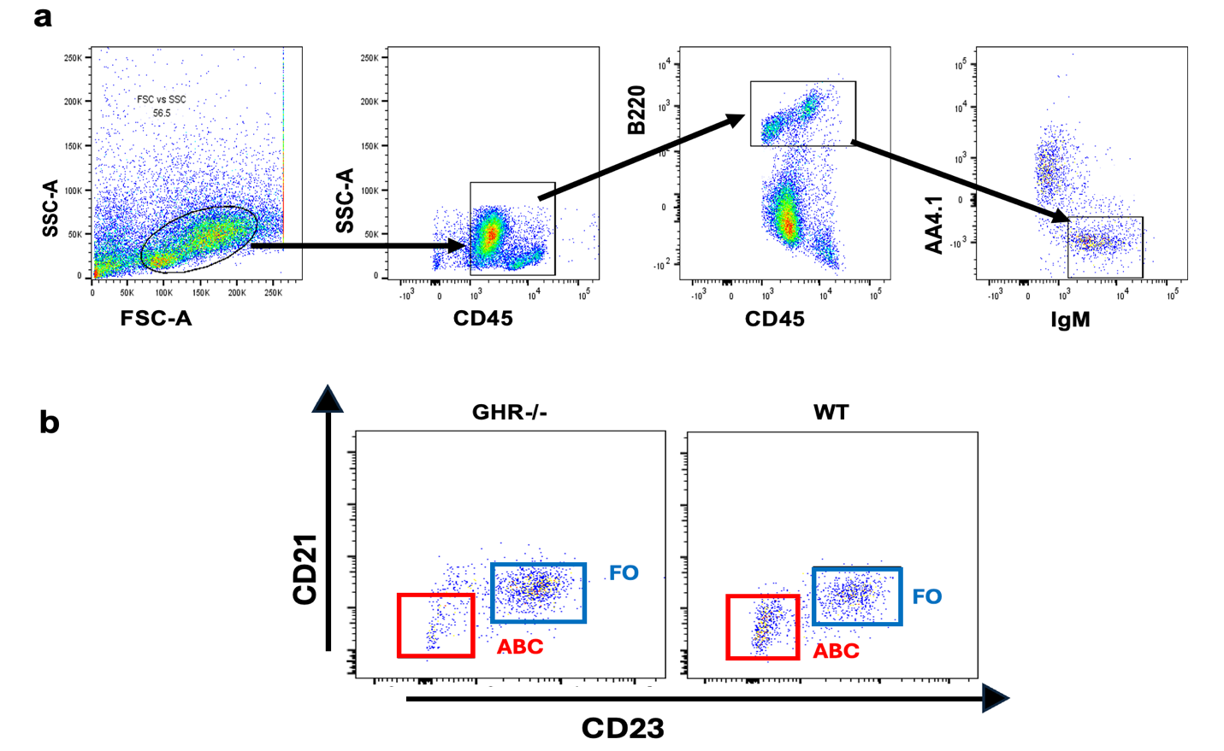
Supplemental Fig. 1 Composition of the BM B cell pool of old, age-matched GHR-/- and WT mice. The spleens of 21 to 24-month-old female GHR-/- and WT mice (n=6-7/genotype) were stained to evaluate percentages of the major B cell subsets by flow cytometry. (a) The gating strategy included sorting cells first by CD45+ and then by B220+ AA4.1-IgM+ cells to exclude transitional (AA4.1+) B cells. (b) A representative dot plot of splenic B cells from a single WT and GHR-/- spleen

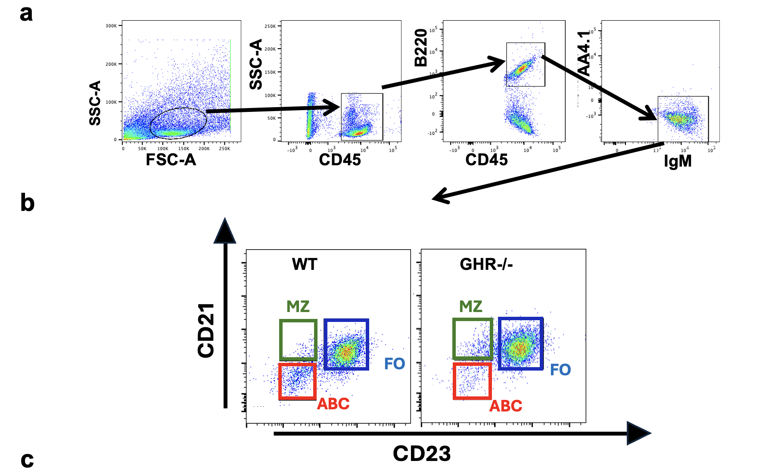
Supplemental Fig.2 Composition of the Blood B cell pool of old, age-matched GHR-/- and WT mice. The blood from 21 to 24-month-old female GHR-/- and WT mice (n=6-7/genotype) were stained to evaluate percentages of the major B cell subsets by flow cytometry. (a) The gating strategy included sorting cells first by CD45+ and then by B220+ AA4.1-IgM+ cells to exclude transitional (AA4.1+) B cells. (b) A representative dot plot of blood B cells from a single WT and GHR-/- spleen
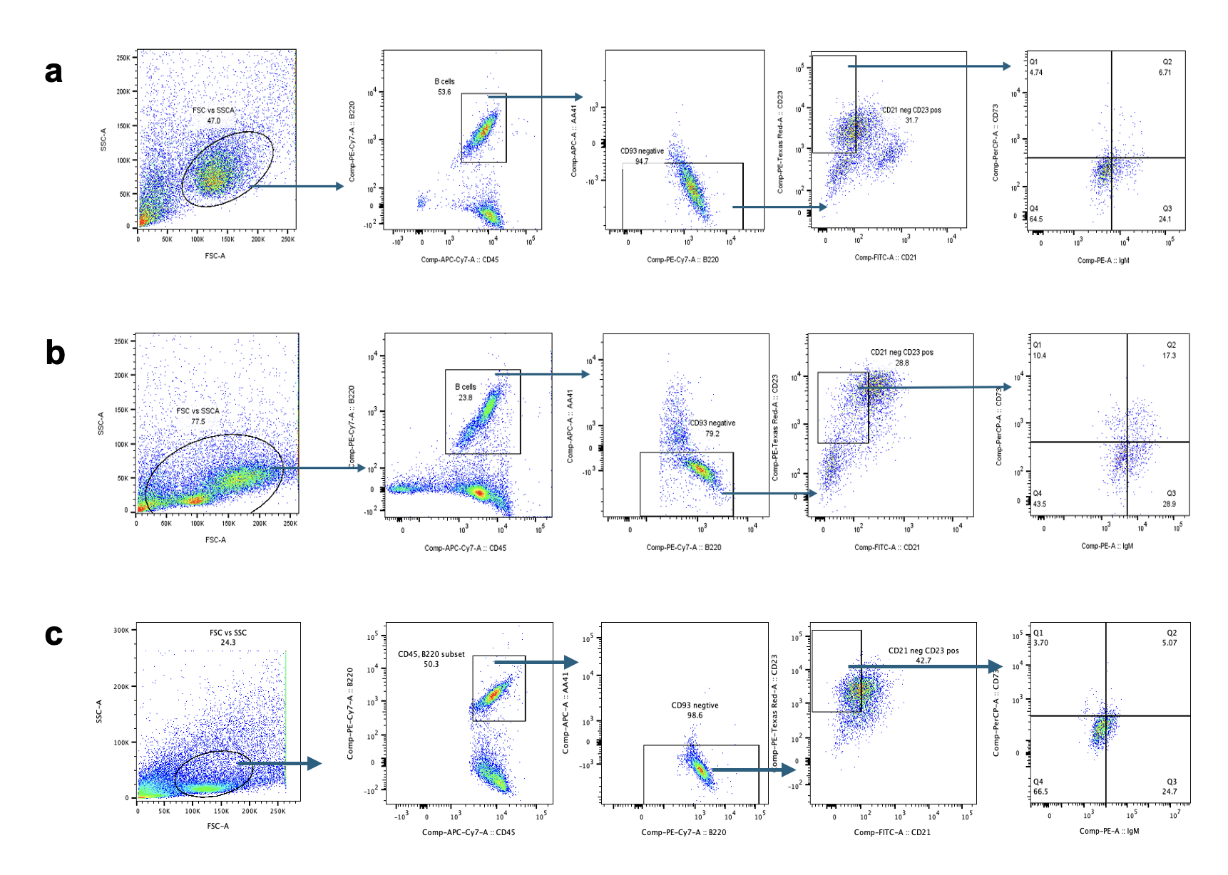

Supplemental Fig.3 Gating strategy for identification of memory B cells in a) spleen, b) bone marrow, and c) blood samples from female GHR -/- and WT mice at 21-24 month of age. To identify memory (CD45+ B220+ IgM+/-CD73+) B cells are first gated by CD45+(leukocytes), B220+(B cell), then by CD73+and as IgM+ and IgM- for identifying the unswitched and the switched populations. The same gating strategy was used for all tissue samples.

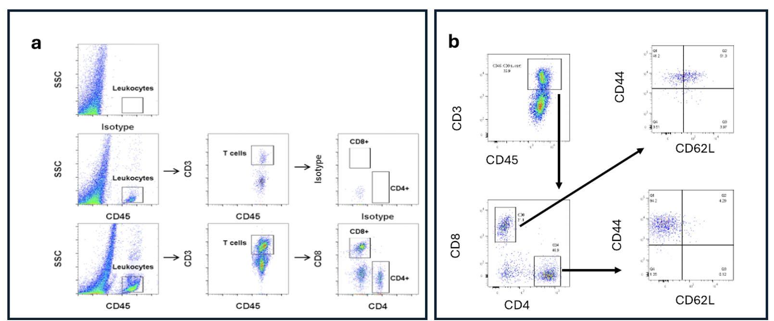
Supplemental Fig. 4 Composition of the spleen T cell pool of old, age-matched GHR-/- and WT mice. (a) Gating strategy was set for leukocytes (CD45+), T cells (CD45+CD3+), cytotoxic (CD8+) and helper (CD4+) T cells in spleen. (b) The memory cells were identified as CD44+. Subsequently, the CD44- cells were gated, after which CD62L+ cells were identified as naïve cells.

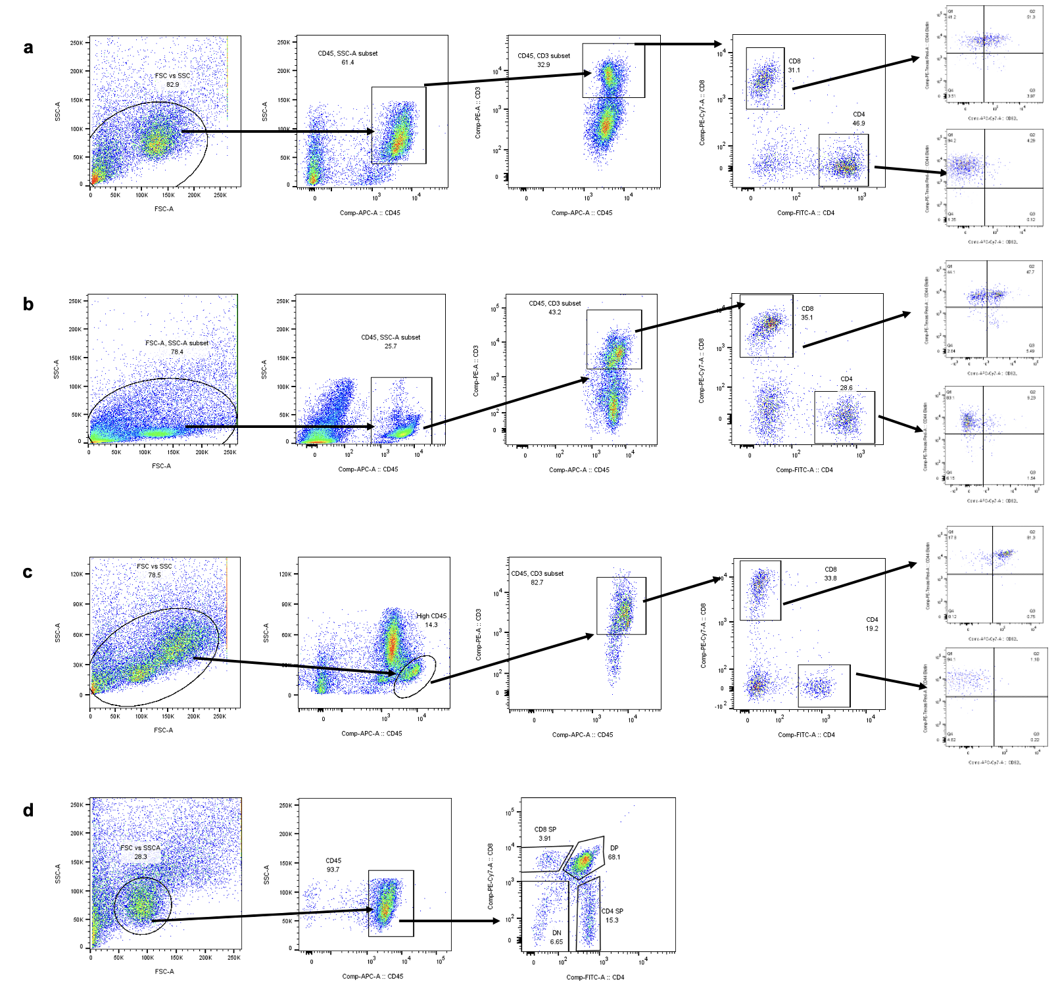
Supplemental Fig. 5 Composition of the T cell pool of old, age-matched GHR-/- and WT mice in spleen(a), BM(b), blood(c) and thymus(d). The tissues of 20 to 24-month-old female GHR-/- and WT mice (n=6-9/genotype) were stained to evaluate percentages of the major T cell subsets by flow cytometry. The gating strategy included gating cells first by CD45⁺ (Leukocytes), CD45⁺ CD3⁺ (T cells), CD4⁺ (Helper T cells), CD8⁺ (Cytotoxic T cells), CD4⁺ CD44⁺CD62L⁻ (EM; Effector memory helper T cells), CD4⁺ CD44⁺, CD62L⁺ (CM;CM; Central memory helper T cells), CD8⁺ CD44⁺CD62L⁻ (EM; Effector memory cytotoxic T cells ), CD8⁺ CD44⁺, CD62L⁺ (CM; Central memory cytotoxic T cells), CD4⁺CD44⁻CD62L⁺ (Naïve 1 helper T cells), CD4⁺CD44⁻CD62L⁻ (Naïve 2 helper T cells), CD8⁺CD44⁻CD62L⁺ (Naïve 1 cytotoxic T cells); and CD8⁺CD44⁻CD62L⁻ (Naïve 2 cytotoxic T cells). DP: double positive (CD4 and CD8 positive), DN: double negative (CD4 and CD8 negative), SP: single positive (CD4 or CD8), and DN are the most immature and SPs are mature T cells populations in thymus Fig. 5d

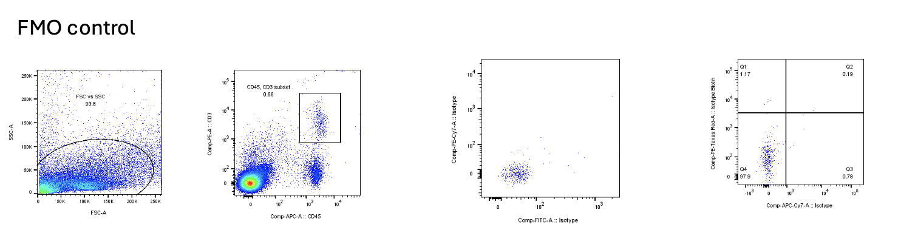
Supplemental Fig. 6 Representative florescence minus one control plots used to define positive gating thresholds for the indicated markers. This was performed to avoid fluorescence bleeding from the CD45 and CD3 channels when analyzing T cells. For that purpose, cells were stained with CD45 and CD3, and positive and negative boundaries for CD45 and CD3 were determined using corresponding isotype controls. Then, sample analysis, in addition to CD45 and CD3 isotype controls, we used this FMO control, with isotypes for the other fluorochromes to determine the boundaries for expression of different molecules within the CD45-CD3 gate. This provides better accuracy that only using isotype controls for all samples.

