Supporting Information

Effect of Chitosan loading towards structural, optoelectronic and photocatalytic degradation of flakes like CuO-Chitosan nanocomposite

Laraib Bibiª, Saba Afzal*ª, Madinaª, , Ishrat Fatima ^{b} ,Rabia Naeem*^{b}, Bibi Sherinoª, Huma Tareenª
ªDepartment of Chemistry, Sardar Bahadur Khan Women’s University, Quetta, Pakistan.
^{b}Department of Chemistry Government College University Lahore, Pakistan
*Corresponding authors: Saba Afzal*^{a ,} Rabia Naeem*^{b}
sag_dec@hotmail.com, rabianaeem@gcu.edu.pk
Contact No: 009233239495

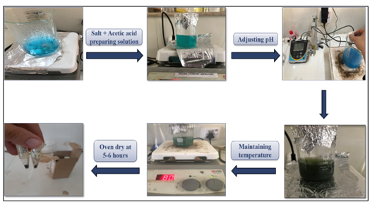
Fig.S1. Synthesis of CuO NPs at different temperatures (30 °C, 60 °C, 80 °C).

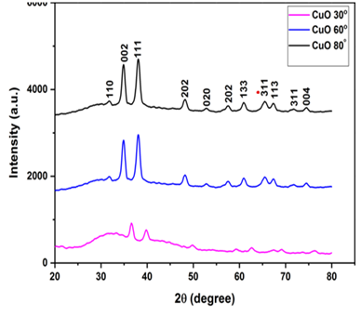
Fig.S2 XRD pattern of CuO NPs (30 °C, 60 °C and 80 °C)

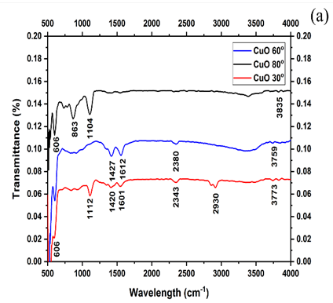

Fig S3 FTIR spectra of CuO NPs samples

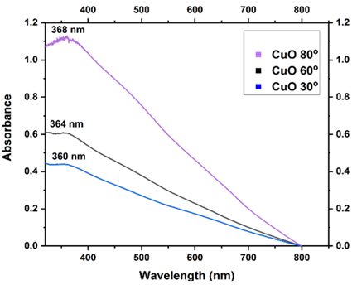
Fig.S4 UV-Visible spectra of CuO NPs synthesized on various temperatures (30 °C, 60 °C and 80 °C),

