Appendix S3
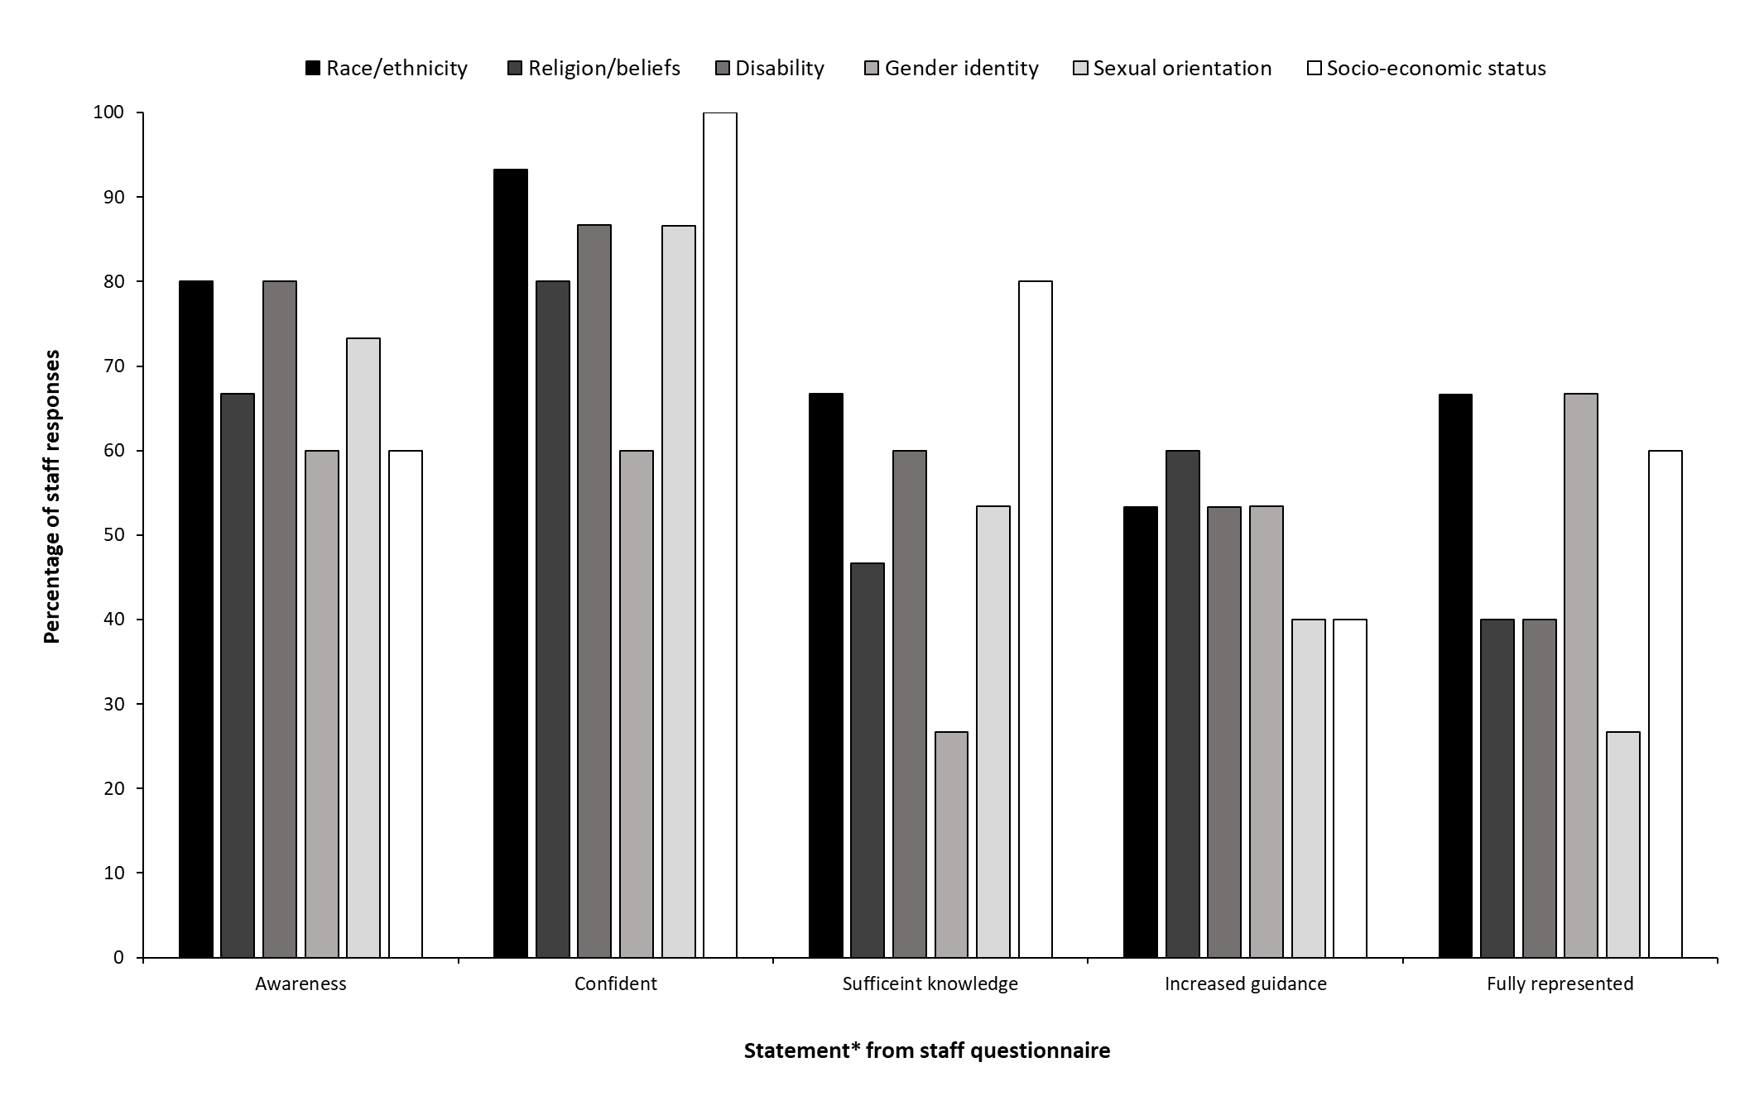
Appendix S3 Figure: Percentage of staff involved in teaching on the year 1 and/or 2 medical programme who strongly agree/agree with questionnaire statements in relation to each theme. * Full statements in questionnaire: ‘Appropriate language’ = I am aware of the appropriate (i.e. not offensive/harmful) language to use in relation to [theme]; ‘Confident’ = I feel confident discussing with students health issues related to [theme]; ‘Sufficient knowledge’ = I feel I have sufficient knowledge about health issues related to [theme] for my stage of training; ‘Increased guidance’ = I feel I have sufficient knowledge to teach students about health issues related to [theme]; ‘Fully represented’ = Healthcare issues related to [theme] are fully represented in the BMBS teaching content.

