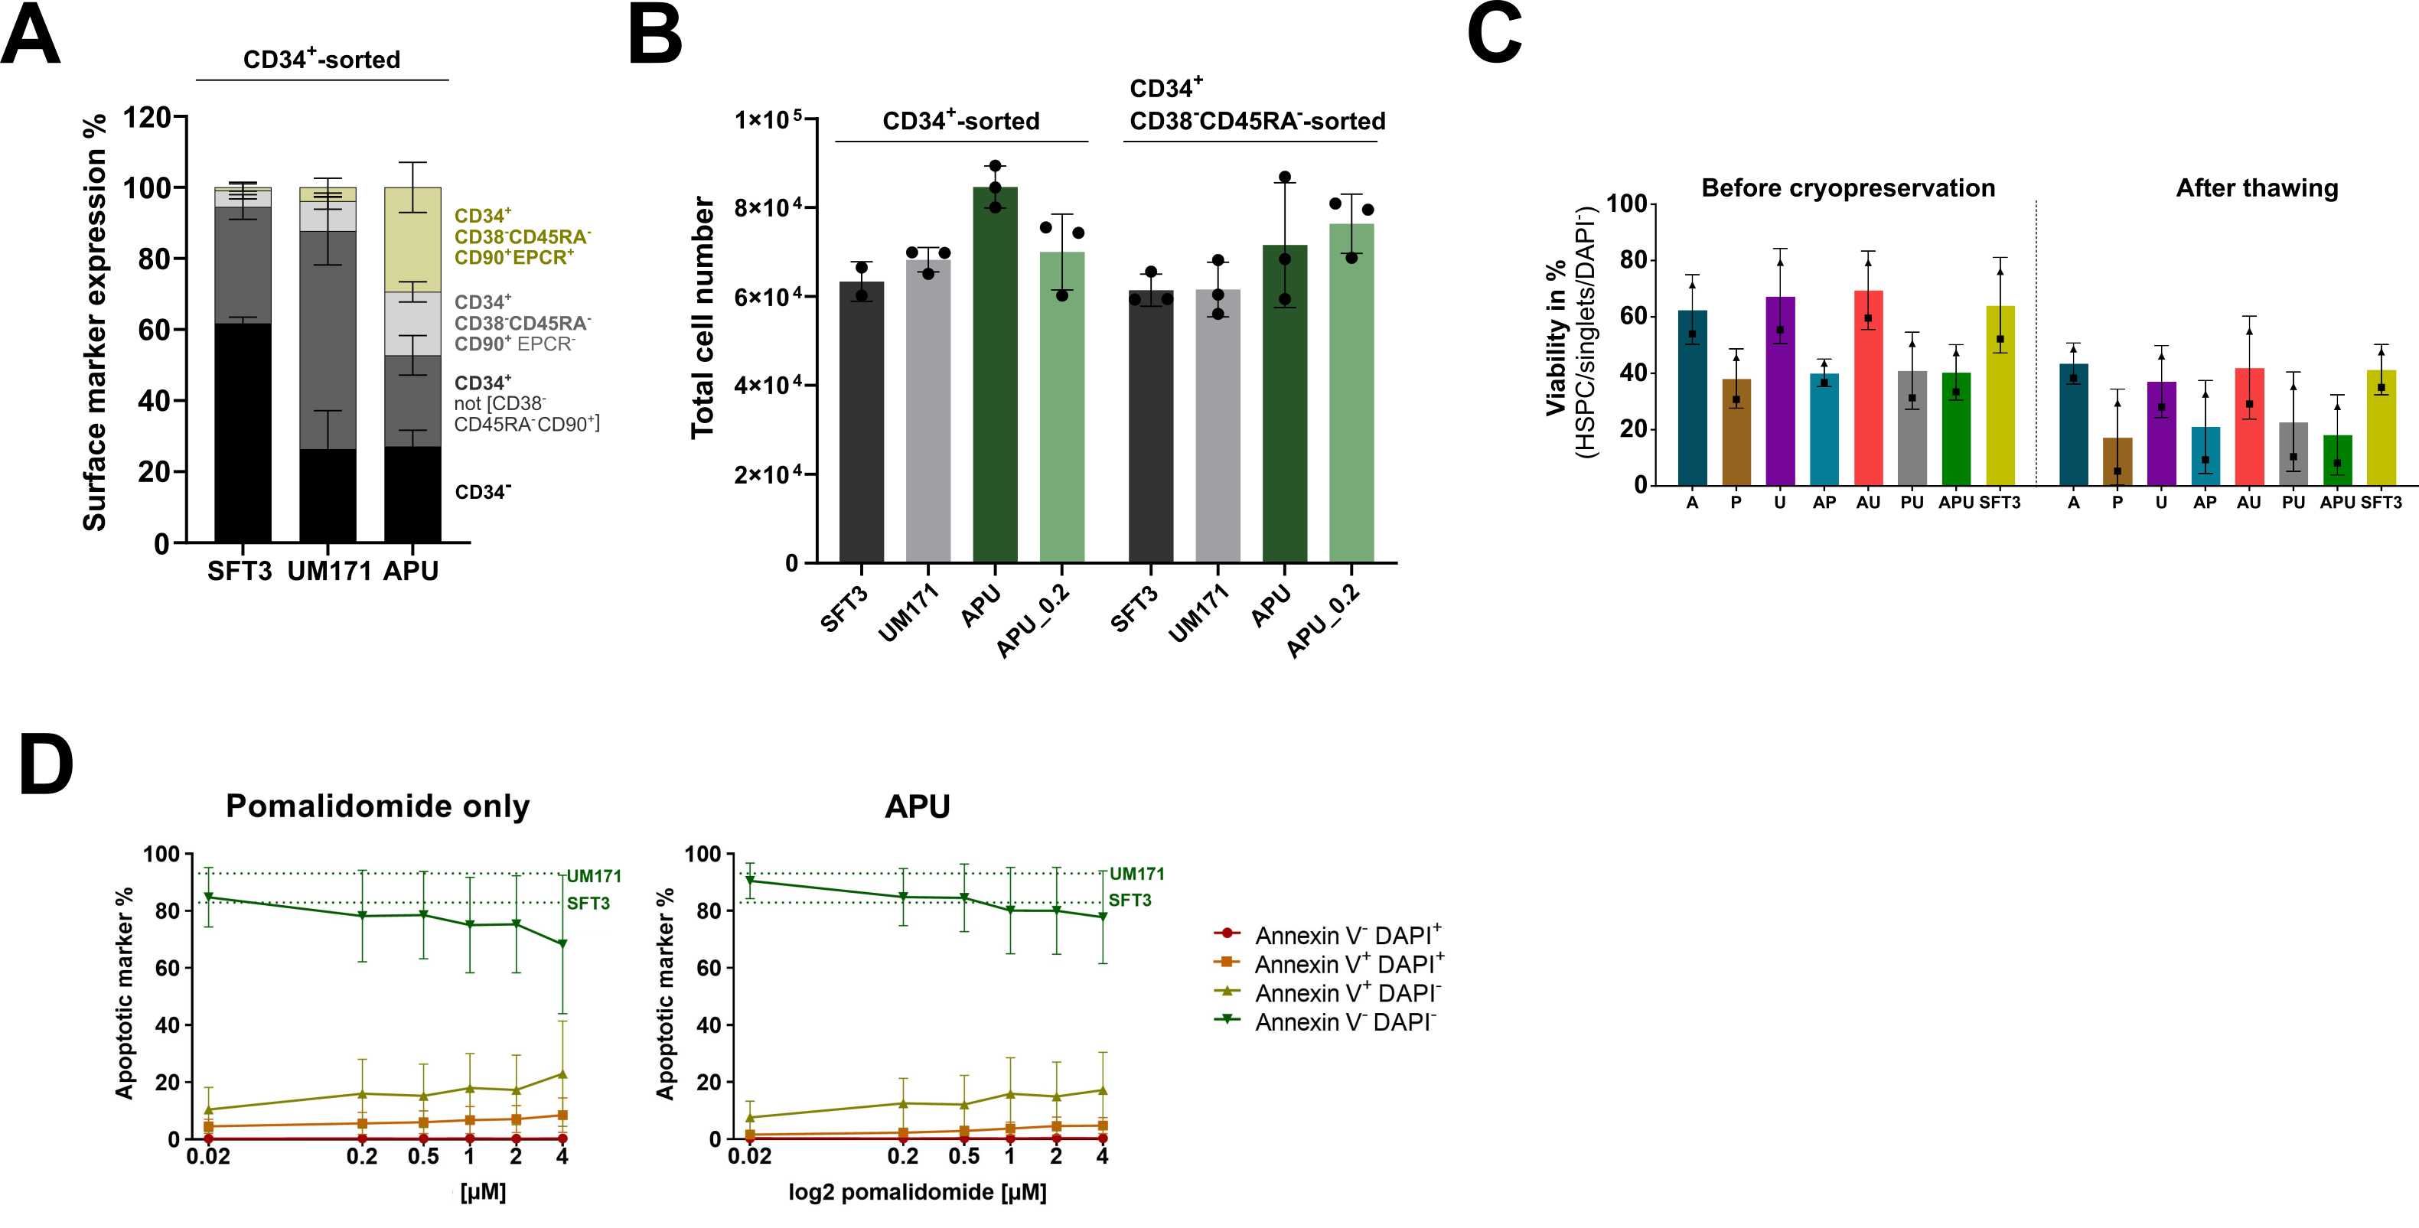
Supplementary Figure 1: Optimizing HSPC expansion in APU medium by sorting for CD34⁺CD38⁻CD45RA⁻ cells and reducing the pomalidomide concentration. (A) Surface marker expression of CD34, CD38, CD45RA, CD90, and EPCR in N = 3 UCB donors after 7-day expansion of CD34⁺ cells in SFT3, UM171, and APU with 2 µM pomalidomide. (B) Cell count in a single 96-well after 7 days of expansion of either sorted CD34⁺ or CD34⁺CD38⁻CD45RA⁻ cells in SFT3, UM171, APU, or APU_0.2 medium. N = 1 UCB donor in technical replicates. (C) Viability of 14-day expanded HSPCs in the single, minus-one, and complete APU medium determined by the percentage of DAPI – cells via flow cytometry. Expanded cells were assessed before cryopreservation and afterwards. N = 2 UCB donors. (D) Annexin V and DAPI staining was performed on 14-day expanded HSPCs (N = 2 UCB donors). Pomalidomide only and APU contained Pomalidomide concentrations ranging between 0.02 µM and 4 µM. The percentage of Annexin V⁻DAPI⁻ cells in SFT3 and UM171 medium is plotted with the dotted line as a reference.
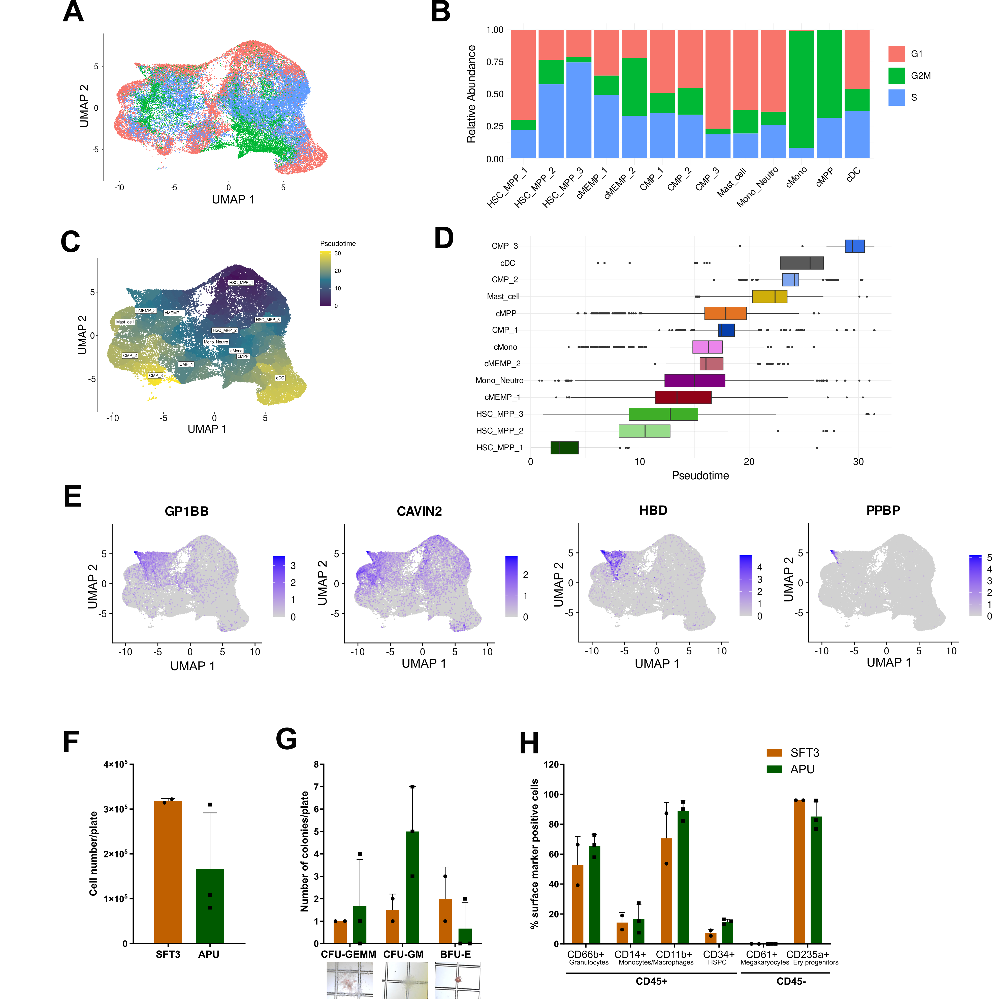
Supplementary Figure 2: Characterization of 7-day expanded, 24h cultivated, and uncultivated HSPCs on scRNA seq level. (A-B) Cell cycle analysis of the clusters. The UMAP (A) displays the cell cycle state of each cell, and the bar plot (B) displays the relative abundance of cells in G1, G2M, and S phase. (C) UMAP with pseudotime. (D) Pseudotime of each cluster is ranked by its median pseudotime. The box indicates where 50% of the data points are distributed. Whiskers give the 95% interval, and the remaining outliers are depicted as dots. (E) Feature plots displaying the expression of erythroid marker genes GP1BB, CAVIN2, HBD, and PPBP. (F-H) Colony-forming assay of 7-day expanded HSPCs in SFT3 or APU medium. 150 expanded HSPCs were seeded in the Methocult™ H4034 methylcellulose medium for 2 weeks according to the manufacturer’s protocol (StemCell Technologies, Vancouver, Canada). (F) Cell number per plate after resuspending the medium. (G) Microscopic count of colonies per plate. Colony-forming units (CFU) for multipotential granulocyte, erythroid, macrophage, megakaryocyte progenitors (GEMM), granulocyte-macrophage progenitor cells (GM), and blood-forming unit of erythroid progenitor cells were assessed. (H) Flow cytometric analysis of myeloid differentiation marker in each well. N = 1 UCB donor in technical replicates.

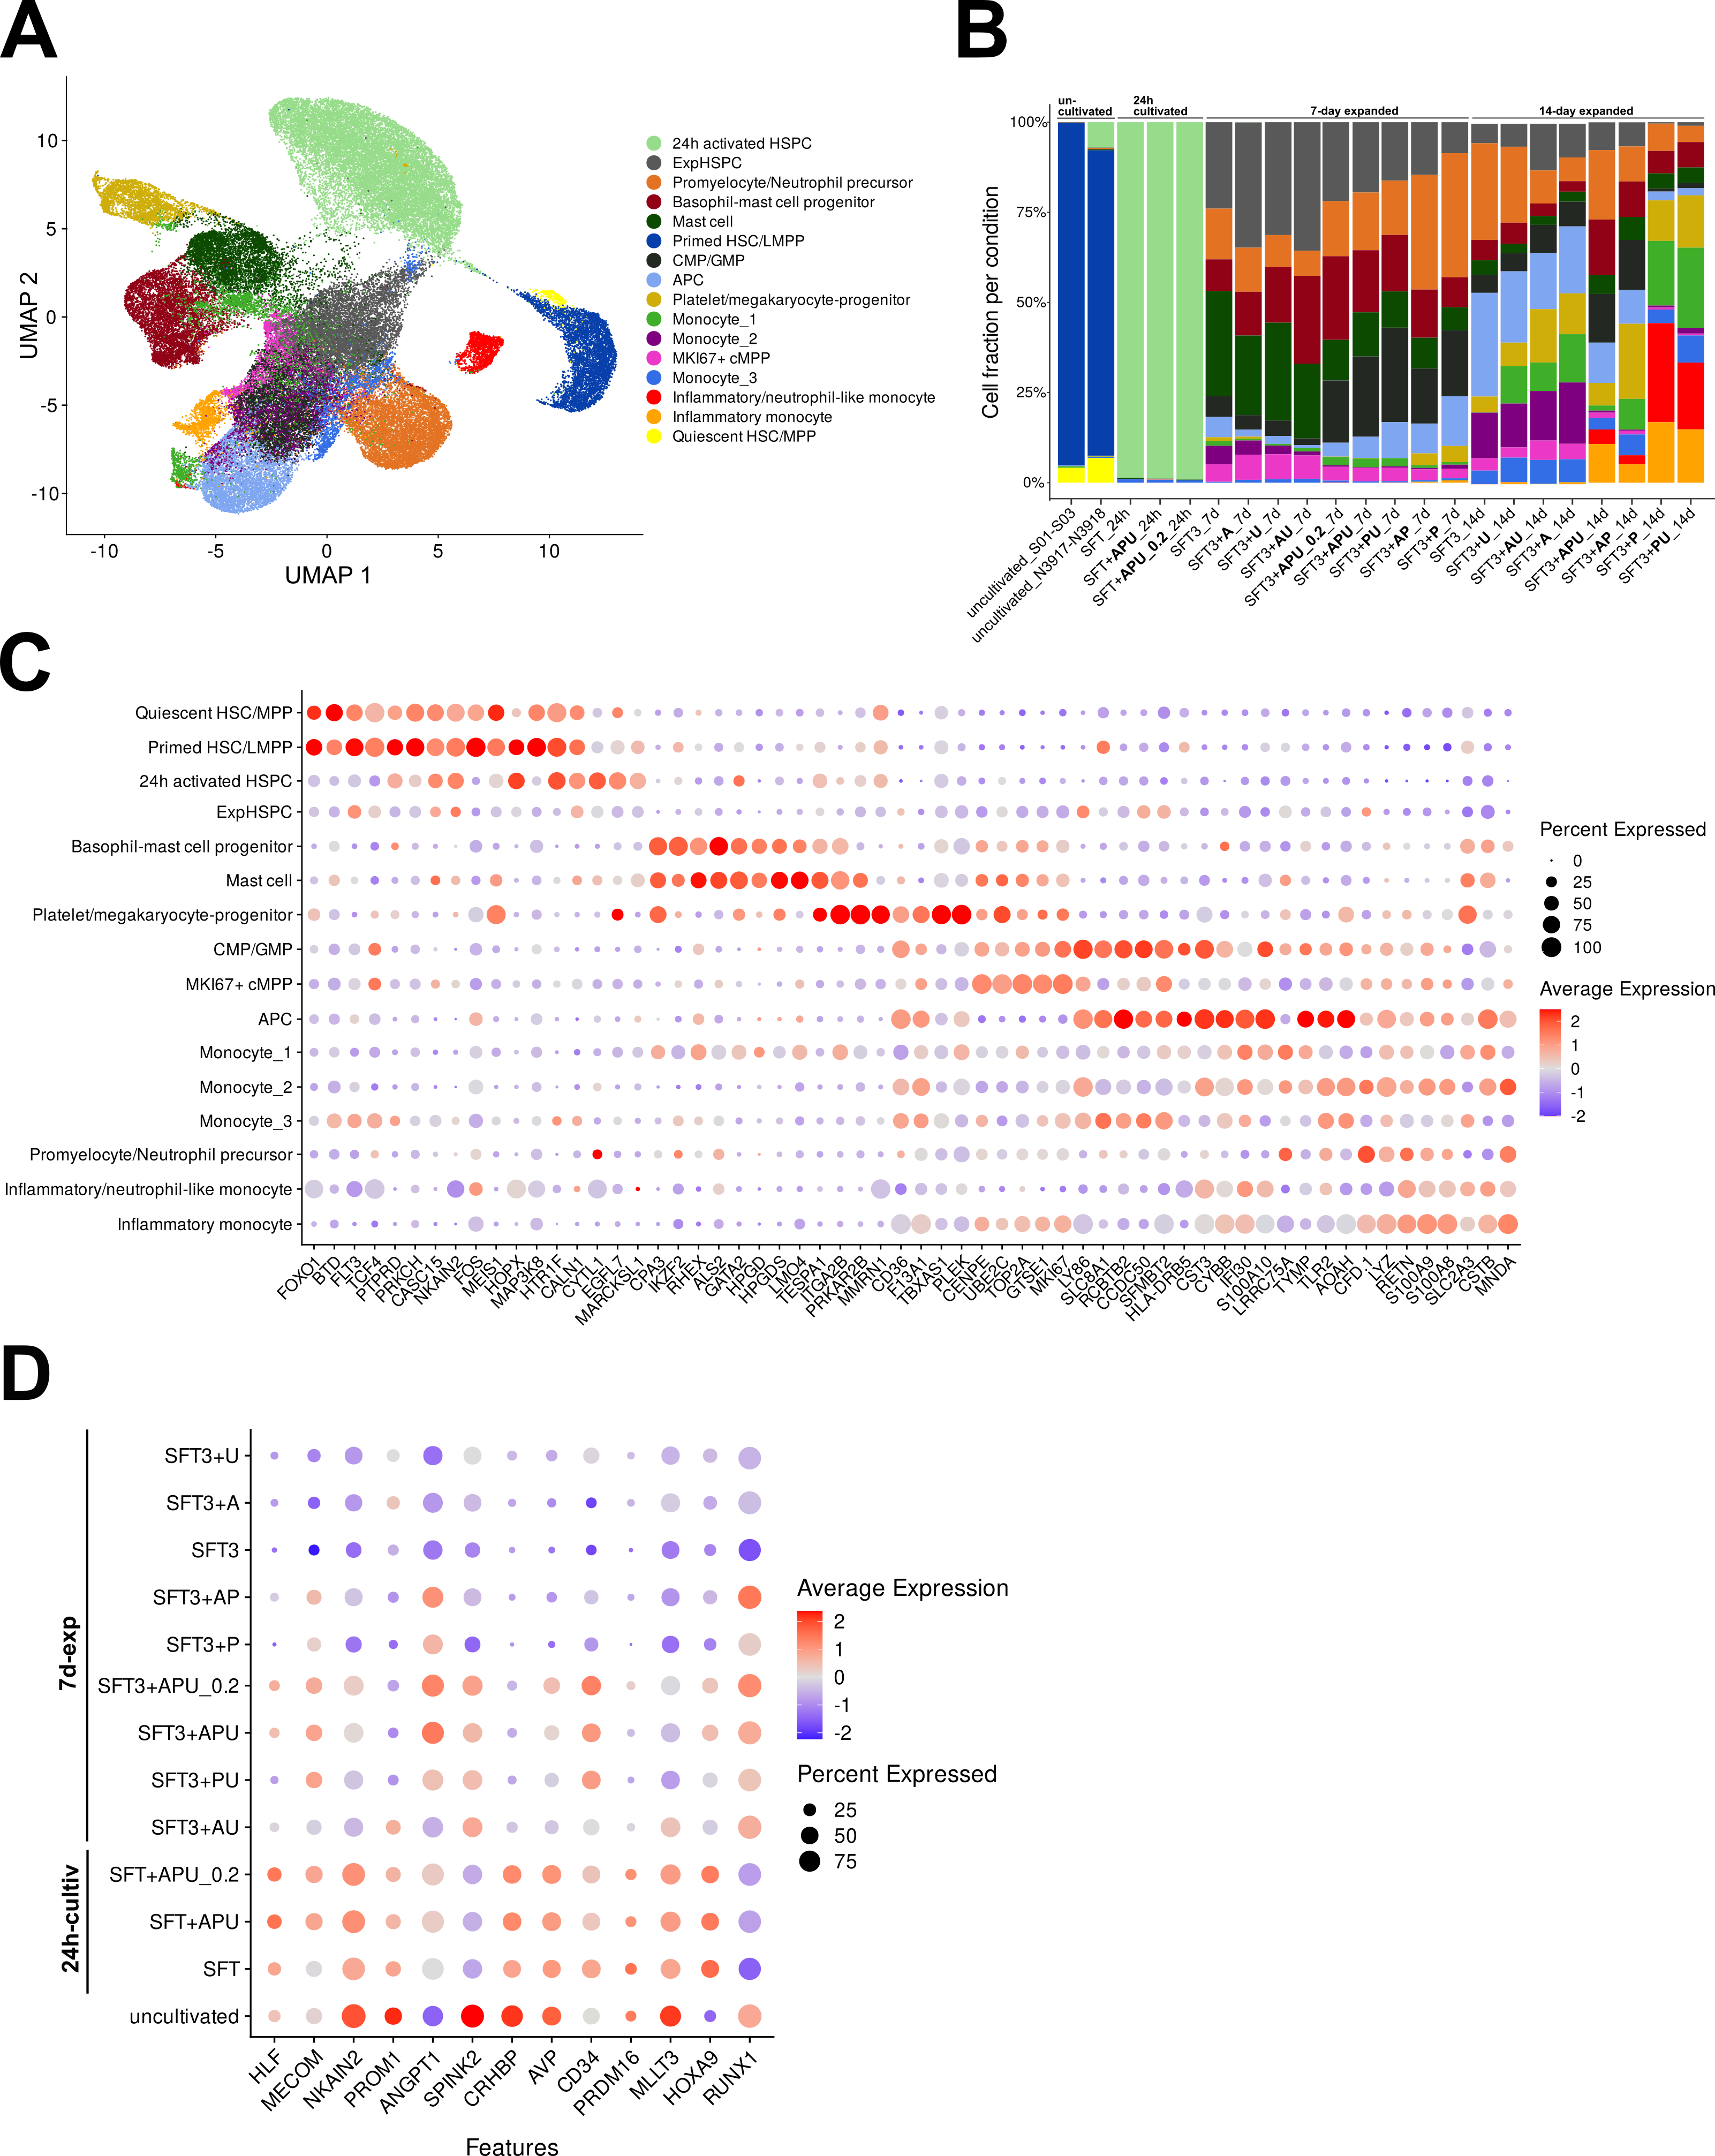
Supplementary 3: scRNA seq analysis of 14-day expanded HSPCs integrated with 7-day, 24h, and uncultivated HSPCs. (A) UMAP displaying the integrated samples from two scRNA seq experiments. Experiment S01-S03 harbors 7-day expanded, 24h cultivated and uncultivated HSPCs. Experiment N3917-N3918 harbors 14-day expanded HSPCs and uncultivated HSPCs from a different donor. (B) Bar plot displaying the frequency of each cell fraction (in %) per condition. (C) Dotplot showing the marker genes of the respective clusters responsible for the cell type annotation. (D) Average expression of HSC signature genes in all 24h cultivated, expanded, and uncultivated samples.
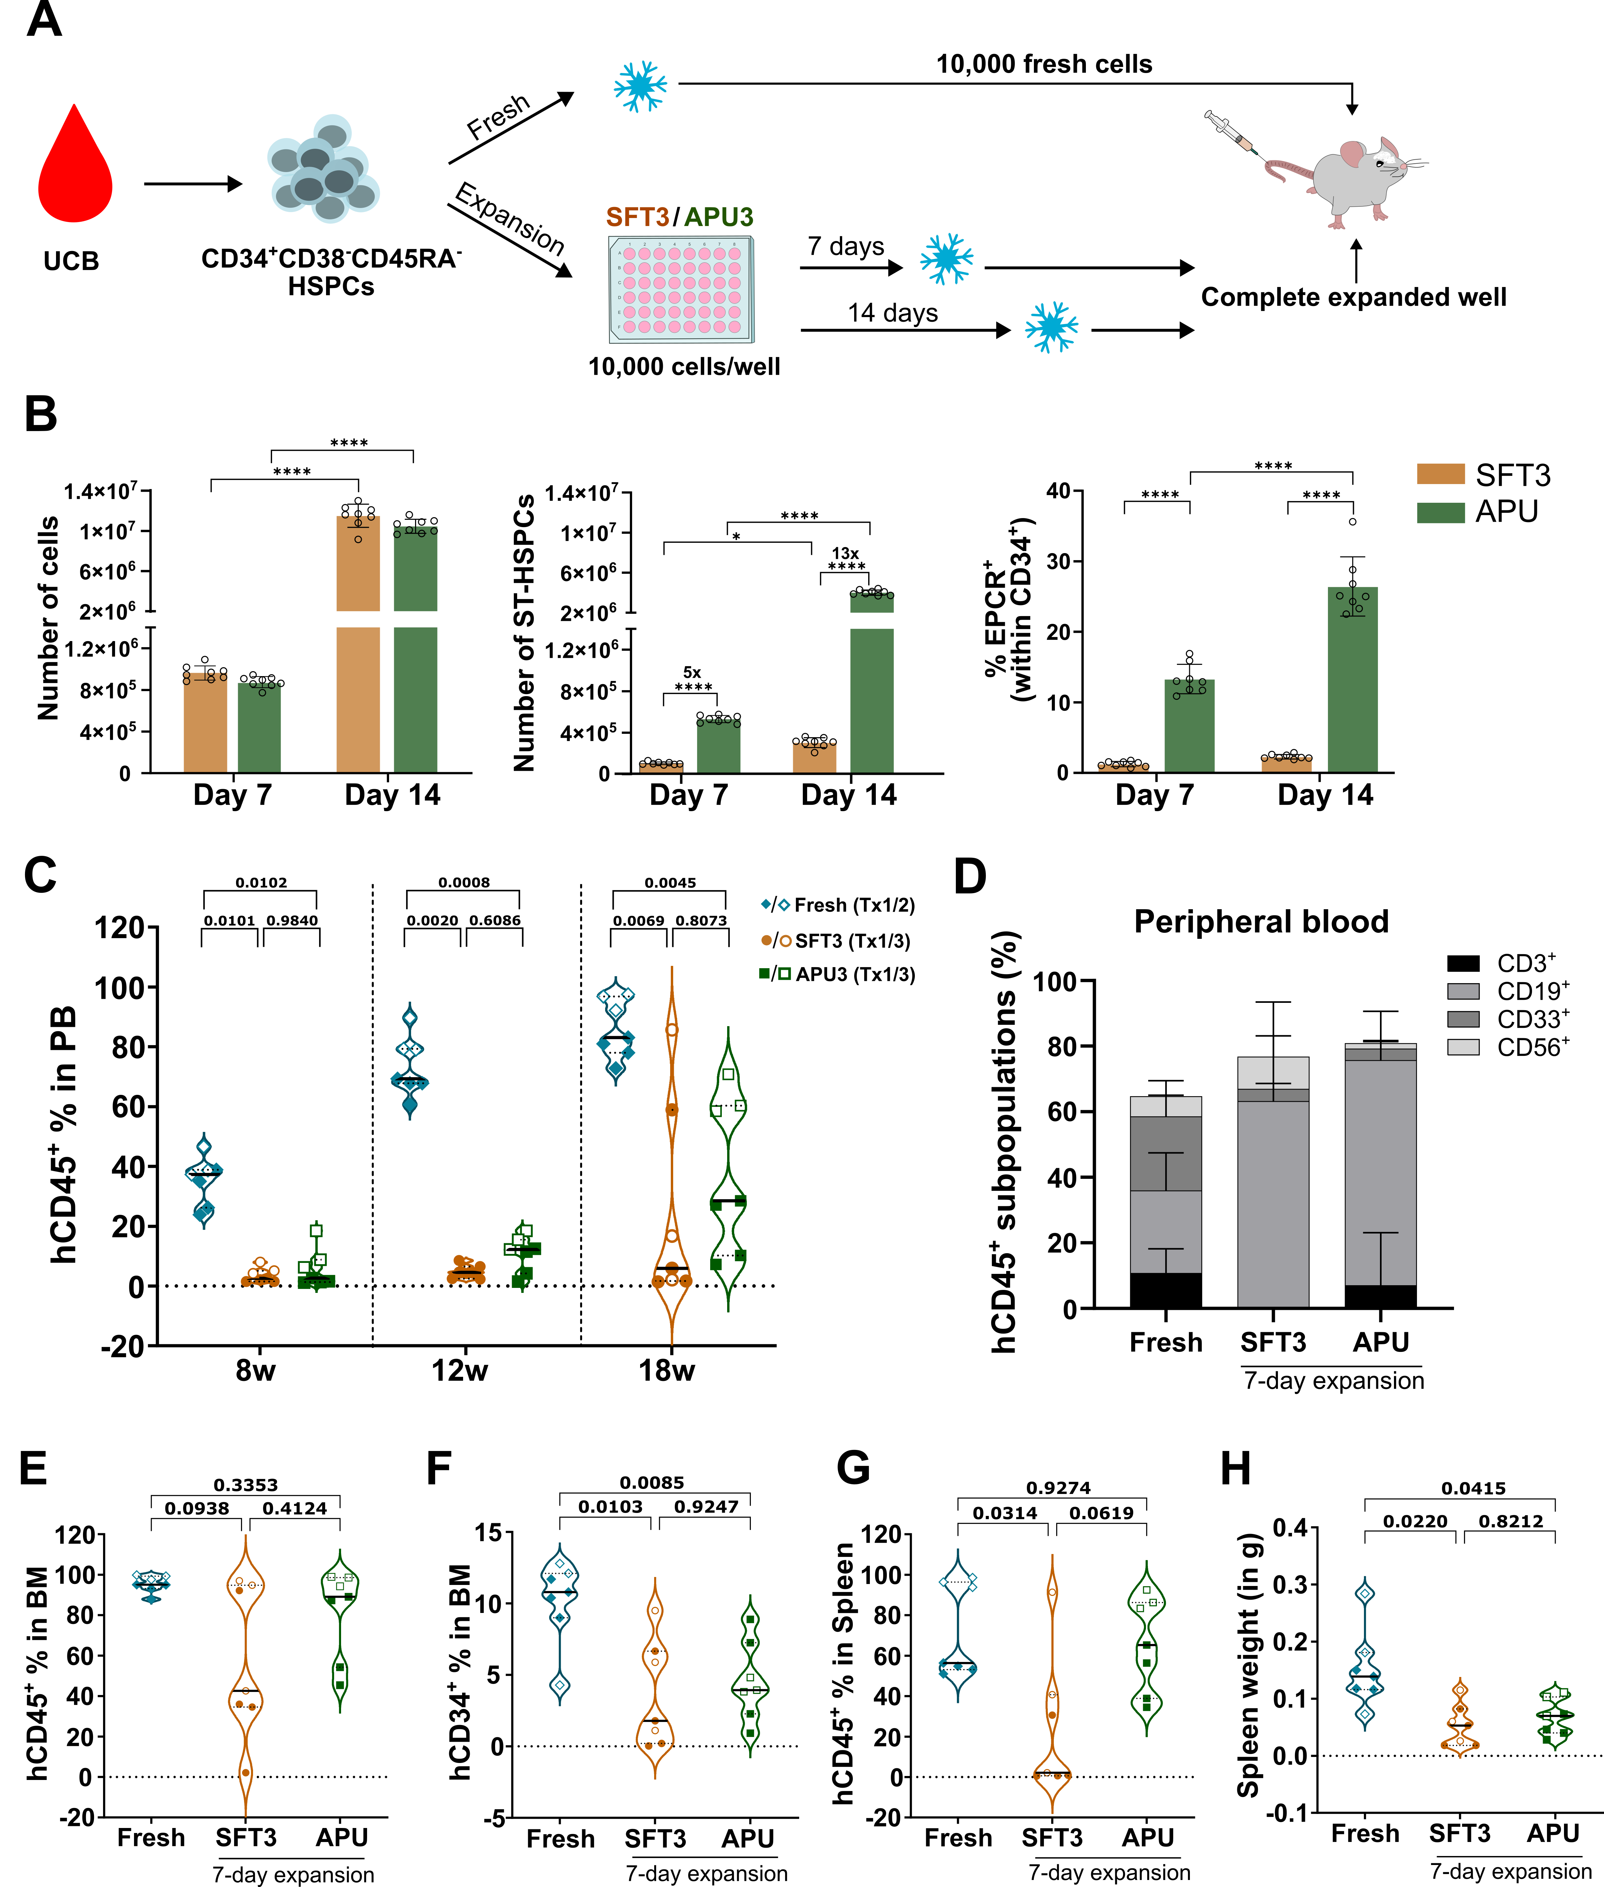Supplementary Figure 4: 7-day expansion in APU increased chimerism superior to the basal medium. (A) 10,000 UCB-derived CD34⁺CD38⁻CD45RA⁻ cells were either directly cryopreserved (fresh) for transplantation (Tx) or expanded in SFT3 or APU media for 7 and 14 days before cryopreservation. The complete expanded material was transplanted into non-irradiated 8- to 12-week-old NBSGW mice to determine the engraftment potential compared to fresh cells. (B) The number of total expanded cells (left) after 7 and 14 days was determined by Casy and multiplied by their percentage of immune phenotypic ST-HSC marker expression (CD34⁺CD38⁻CD45RA⁻CD90⁺, middle). The percentage of endothelial protein C receptor (EPCR, right) expression was assessed within the CD34⁺ fraction. Statistical analysis was performed with Two-way ANOVA and corrected with Bonferroni's test for multiple comparisons. Each data point represents a technical replicate from one UCB donor. Error bars indicate the SD of the mean; p < 0.05 = *, p < 0.0001 = ****. (C-H) Human chimerism was assessed by human CD45⁺ (hCD45⁺) surface marker expression. Filled and unfilled data points represent different time points of transplantation cohorts (Tx1-3) as described in the following legend: / Fresh (Tx1/2), □/□= SFT3 (Tx1/3), / = APU3 (Tx1/3). The black line marks the median, and the dotted line the quartiles within the violin plots. P values above the brackets were determined by the Brown-Forsythe and Welch ANOVA test. (C) Human chimerism in peripheral blood (PB) 8, 12, and 18 weeks post-Tx. (D)-(H) Endpoint analysis 18-weeks post-Tx. (D) Distribution of CD3⁺, CD19⁺, CD33⁺ CD56⁺ within the hCD45⁺ population of PB cells. (E) Human chimerism in the bone marrow (BM). Similar median chimerism in APU3-Exp and fresh transplant groups. (F) Frequency of CD34⁺ cells in the BM. (G) Human chimerism in the spleen. (H) Weight of the mice’s spleens (in g) from the 7-day expanded group.

Supplementary Figure 5: Human chimerism of 14-day expanded HSPCs and uncultivated CD34⁺CD38⁻ CD45RA⁻ cells in NBSGW mice. Human chimerism was assessed by human CD45⁺ (hCD45⁺) surface marker expression. Filled and unfilled data points represent different time points of transplantation cohorts (Tx1-3) as described in the following legend: / Fresh (Tx1/2), □/□= SFT3 (Tx1/3), / = APU3 (Tx1/3). The black line marks the median, and the dotted line the quartiles within the violin plots. P values above the brackets were determined by Brown-Forsythe and Welch ANOVA test. (A) Human chimerism in the bone marrow (BM) 18 weeks post-Tx. (B) Frequency of CD34⁺ cells in the BM. (C) Distribution of CD3⁺, CD19⁺, CD33⁺, and CD56⁺ within the hCD45⁺ population of the BM. (D) Human chimerism in peripheral blood (PB) 8, 12, and 18 weeks post-Tx. (E) Distribution of CD3⁺, CD19⁺, CD33⁺, and CD56⁺ within the hCD45⁺ population of PB cells. (F) Human chimerism in the spleen 18 weeks post-Tx. (G) Weight of spleens (in g) after transplantation. (H) Distribution of CD3⁺, CD19⁺, CD33⁺, and CD56⁺ within the hCD45⁺ population of the Spleen.

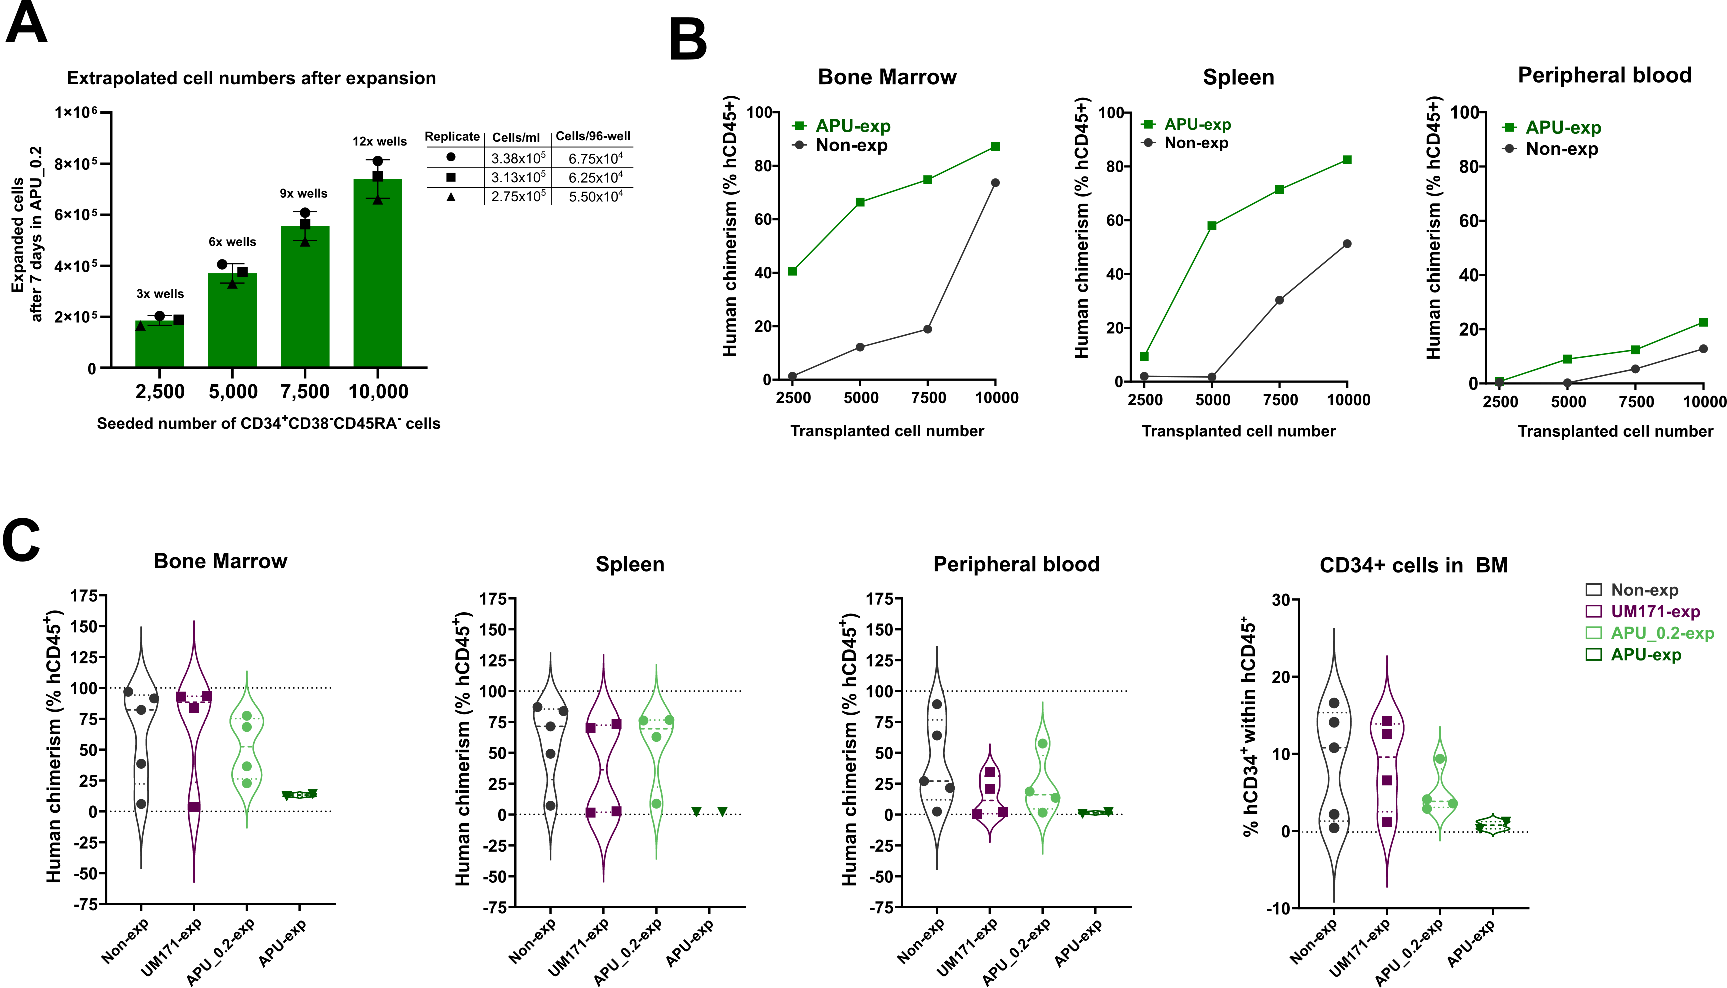Supplementary Figure 6: Adjustment of transplanted cell numbers to reduce oversaturation of the BM niche. (A) Expanded number of cells after seeding different numbers of CD34⁺CD38⁻CD45RA⁻ cells (2,500; 5,000; 7,500; 10,000). Three exemplary 96-wells were counted to extrapolate the number of transplanted cells. Cells were expanded in low cell density (~833 cells/96-well) for 7 days. The respective number of wells was harvested and cryopreserved for transplantation. (B) Titration of different cell numbers (2,500; 5,000; 7,500; 10,000), which were either not expanded or seeded for expansion in low-cell-density conditions in the 96-well format with APU medium for 7 days before xenotransplantation. Both conditions were thawed 16-18h before transplantation and seeded in SFT medium. Human chimerism (frequency of hCD45⁺ cells) was determined in the BM, spleen, and PB. Each dot represents one mouse. (C) Xenotransplantation of 5,000 non-exp HSPCs or the expanded outcome of 5,000 seeded CD34⁺CD38⁻CD45RA⁻ cells in medium containing UM171, APU, or APU_0.2 for 7 days in low-cell density. Human chimerism (frequency of hCD45⁺ cells) was determined in the BM, spleen, and PB. The frequency of CD34⁺ cells was determined in the BM. Each dot represents one mouse.

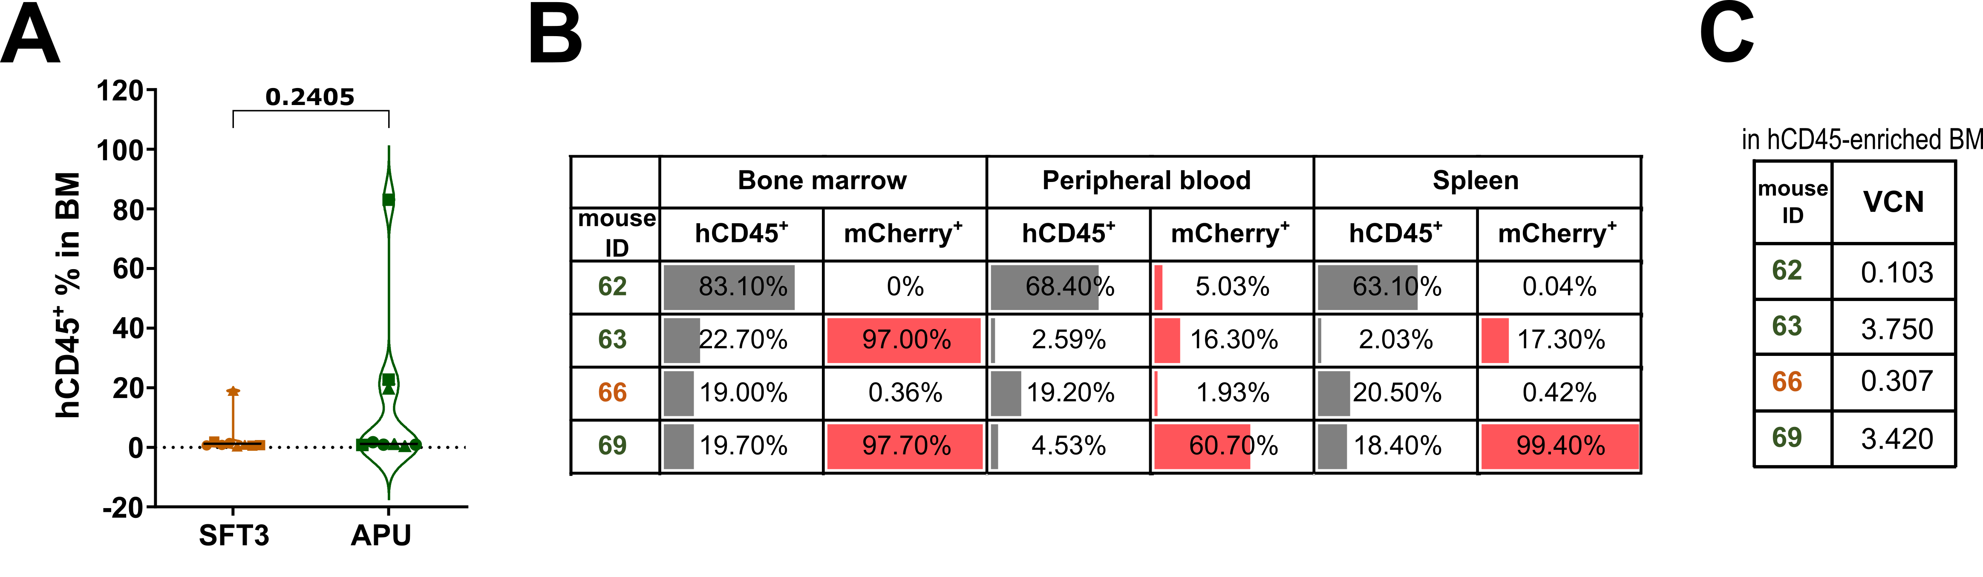Supplementary Figure 7: Low human chimerism and low clonality of transduced CD34⁺ cells after xenotransplantation. (A) Human chimerism was determined by the frequency of hCD45⁺ cells in the BM 16 weeks post-Tx. Statistical testing performed with an unpaired t-test with Welch’s correction (p > 0.05 = n.s.). N= 9 mice per condition. (B) Frequency of mCherry⁺ cells within the BM of mice having a human chimerism >5% (62, 63, 66, 69). (C) VCN in hCD45-enriched BM of the mice 62, 63, 66, and 69.

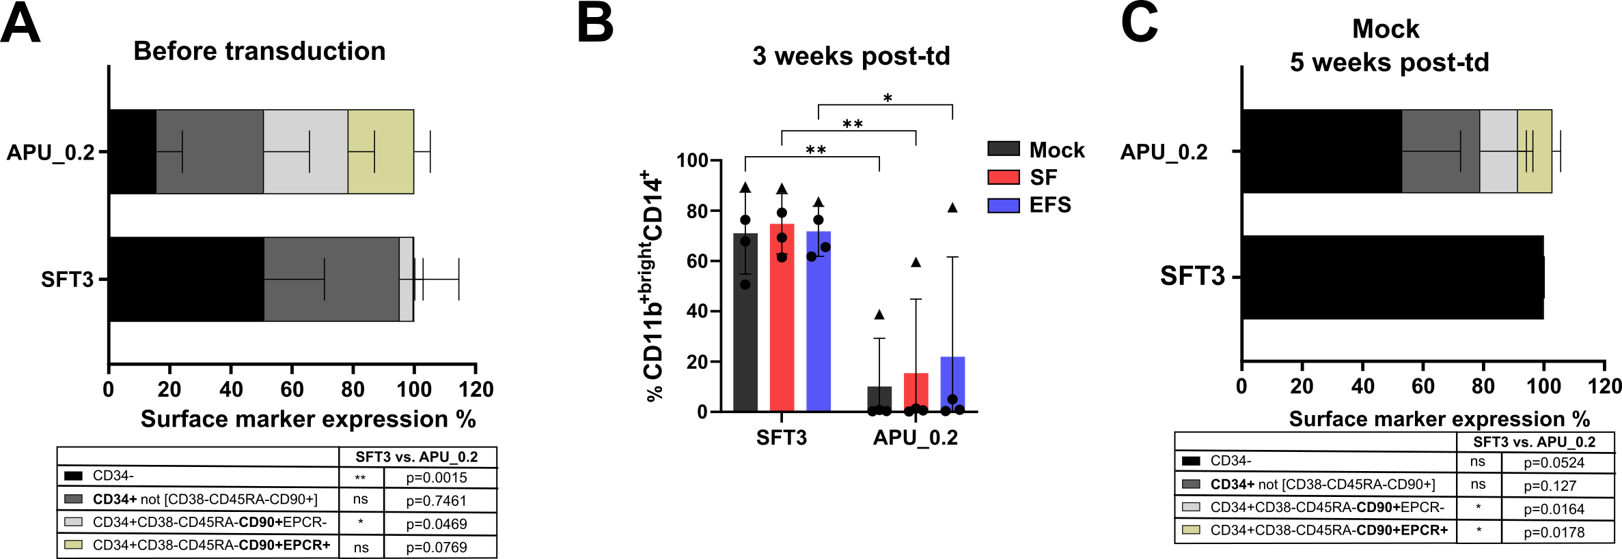
Supplementary Figure 8: Immune phenotype of HSPCs before and after transduction. (A) Surface marker expression of CD34, CD38, CD45RA, CD90, and EPCR in N = 4 UCB donors after 7-day expansion of CD34⁺CD38⁻CD45RA⁻ cells in SFT3 or APU_0.2. Statistical analysis was performed with Two-way ANOVA Šídák's multiple comparisons test. (B) Frequency of CD11b^{+bright}CD14⁺ cells in culture 3 weeks post-transduction either in SFT3 or APU_0.2. Statistical analysis was performed with two-way ANOVA and Šídák’s test for multiple comparisons (p<0.05=*, p<0.01 = **). (C) Surface marker expression of CD34, CD38, CD45RA, CD90, and EPCR in N = 3 UCB donors in mock cells 5 weeks post-transduction of SFT3- or APU_0.2-exp HSPCs. Statistical analysis was performed with a paired t-test for each sub-phenotype and the resulting p-values are stated below.
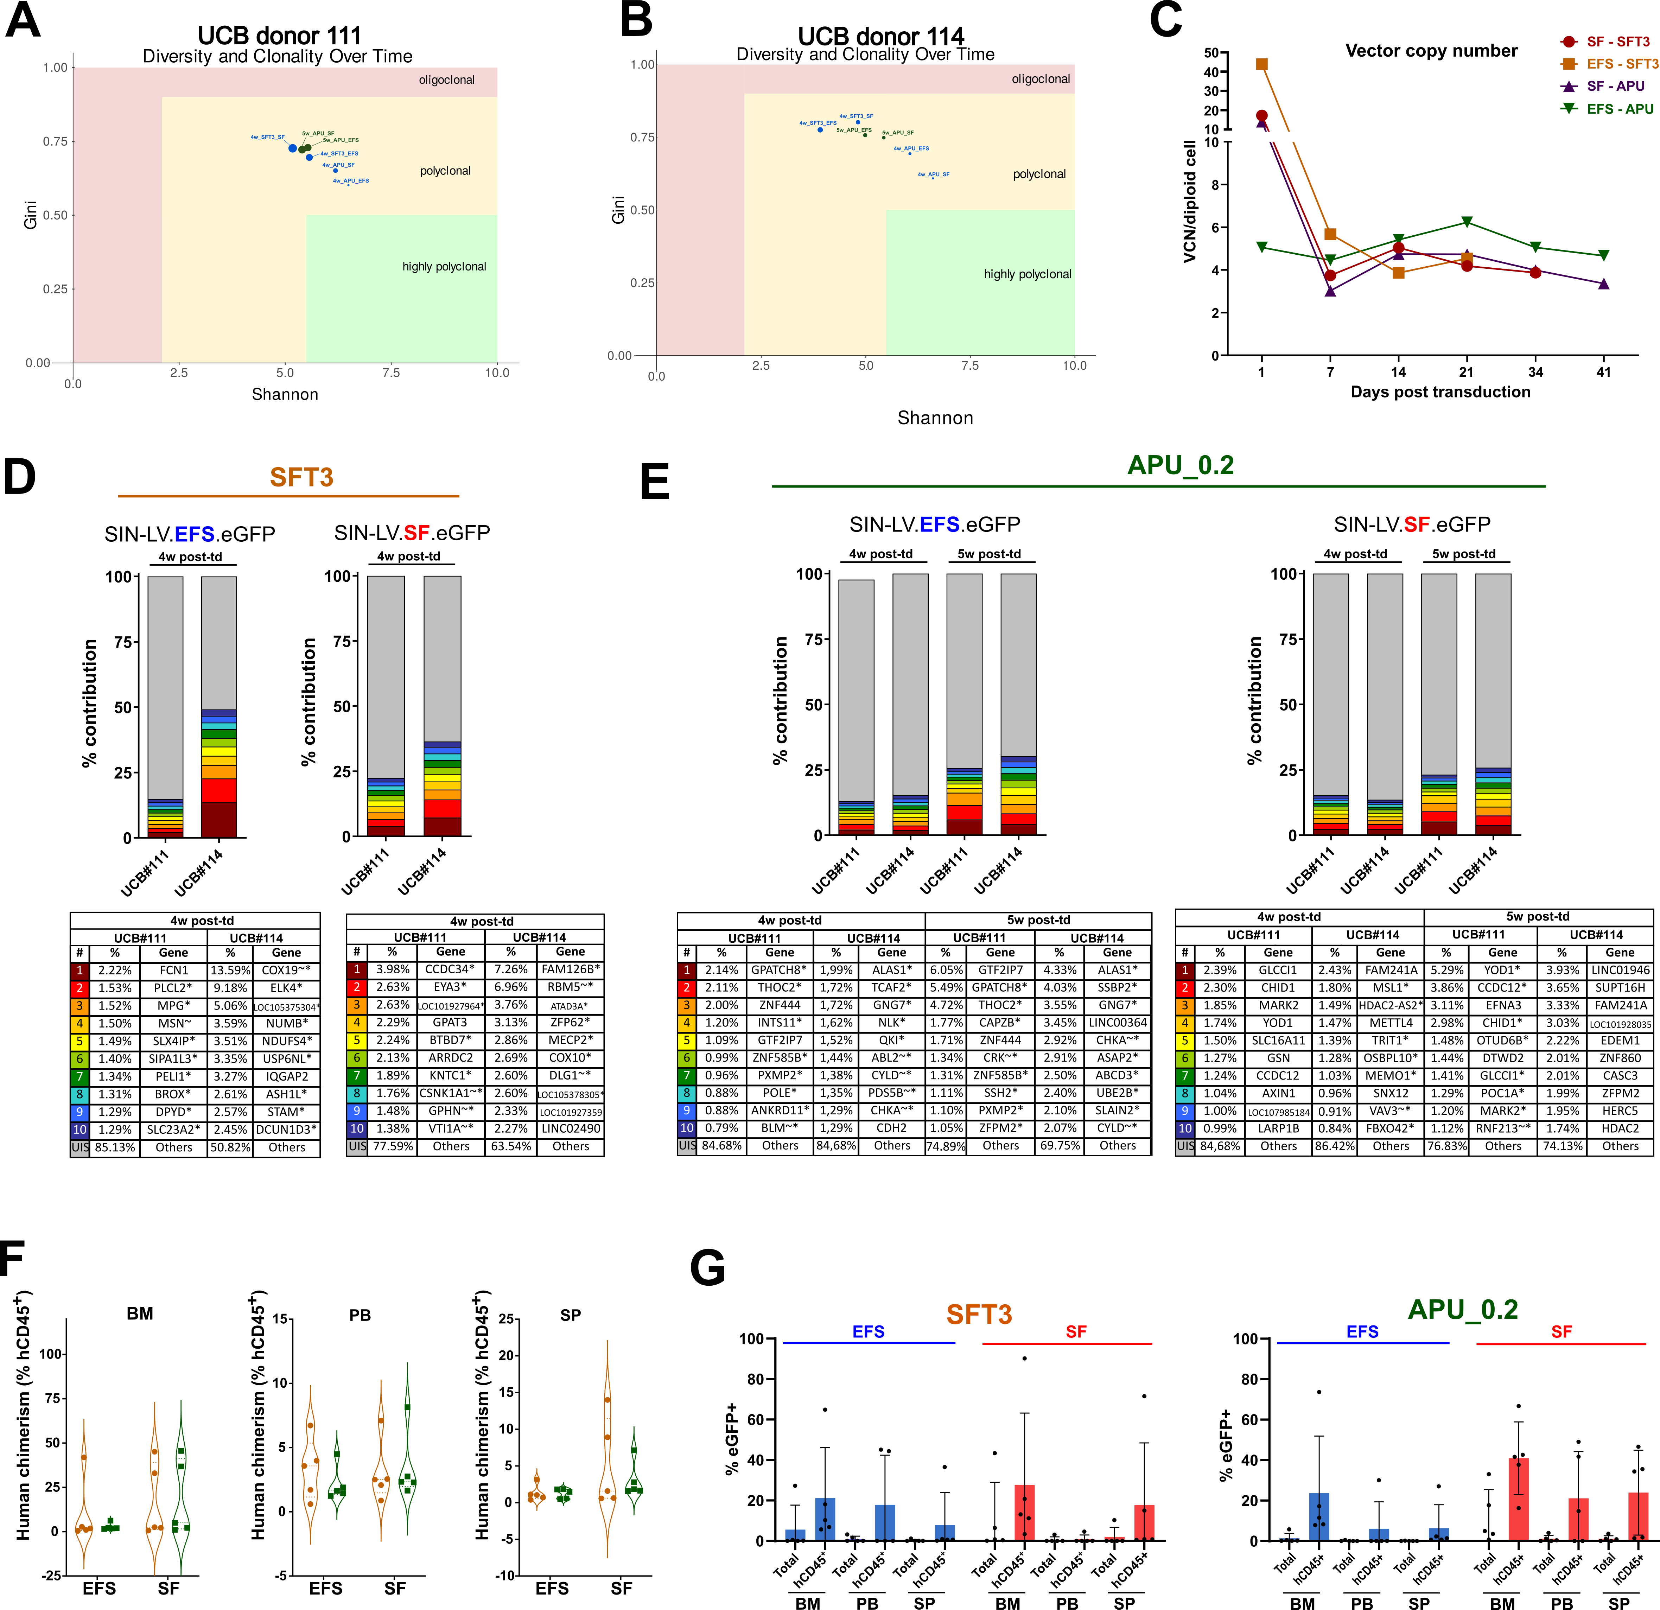
Supplementary Figure 9: Transduced HSPCs after long-term culture in vitro and after xenotransplantation in vivo. (A-B) ISA of UCB donors 111 and 114 after transducing expanded HSPCs and culturing them for 4-5 weeks. HSPCs were transduced either with the SIN-LV.EFS.eGFP (EFS) or the mutagenic SIN-LV.SF.eGFP (SF) vector. (C) Vector copy number (VCN) during long-term culture. (D) ISA after 4 weeks post-transduction (-td) of SFT3-exp HSPCs. (E) ISA after 4- and 5-weeks post-td of APU_0.2-exp HSPCs. (F) Human chimerism (hCD45⁺) in the BM, PB, and spleen 16 weeks after transplanting transduced SFT3- or APU_0.2-exp HSPCs. (G) Frequency of eGFP⁺ cells in the whole population or within the hCD45⁺ population of BM, PB, and SP.

