 | AD |  |  |  |  |  | NND |  |  |  |  |  | OND
 | Aβ42/40 ratio |  | pTau 181 |  | Total Tau |  | Aβ42/Aβ40 ratio |  | pTau 181 |  | Total Tau |  | Aβ42/Aβ40 ratio |  | pTau 181 |  | Total Tau
 | Estimate (CI) | p | Estimate (CI) | p | Estimate (CI) | p | Estimate (CI) | p | Estimate (CI) | p | Estimate (CI) | p | Estimate (CI) | p | Estimate (CI) | p | Estimate (CI) | p
BMI | 0.30 (-0.07 ; 0.67) | 0.11 | -0.14 (-0.25 ; -0.02) | 0.024 | -0.15 (-0.27 ; -0.03) | 0.011 | 0.10 (-0.25 ; 0.44) | 0.58 | -0.39 (-1.35 ; 0.57) | 0.42 | -0.40 (-1.09 ; 0.30) | 0.25 | 0.33 (0.08 ; 0.58) | 0.011 | -0.12 (-1.63 ; 1.40) | 0.81 | 0.17(-1.07 ; 1.41) | 0.79
FMI | 0.21 (-0.15 ; 0.58) | 0.24 | -0.10 (-0.22 ; 0.01) | 0.074 | -0.12 (-0.24 ; -0.01) | 0.032 | 0.19 (-0.22 ; 0.61) | 0.35 | 0.23 (-0.94 ; 1.39) | 0.70 | 0.21 (-0.64 ; 1.06) | 0.30 | 0.27 (0.04 ; 0.49) | 0.021 | -0.19 (-1.53 ; 1.14) | 0.77 | 0.44 (-0.65 ; 1.52) | 0.42
FFMI | 0.22 (-0.06 ; 0.51) | 0.12 | -0.08 (-0.17 ; 0.01) | 0.079 | -0.08 (-0.17 ; 0.01) | 0.074 | -0.04 (-0.39 ; 0.31) | 0.81 | 0.28 (-0.69 ; 1.24) | 0.57 | 0.17 (-0.53 ; 0.88) | 0.63 | 0.17 (-0.02 ; 0.36) | 0.085 | 0.15 (-0.96 ; 1.26) | 0.79 | -0.27 (-1.17 ; 0.64) | 0.55
ASMI | 0.19 (-0.10 ; 0.48) | 0.19 | -0.10 (-0.20 ; -0.01) | 0.028 | -0.11 (-0.20 ; -0.01) | 0.024 | -0.03 (-0.37 ; 0.30) | 0.84 | 0.64 (-0.28 ; 1.55) | 0.17 | 0.42 (-0.24 ; 1.09) | 0.21 | 0.16 (-0.01 ; 0.33) | 0.064 | -0.03 (-1.01 ; 0.95) | 0.95 | -0.06 (-0.86 ; 0.74) | 0.88
Supplementary table 1 Association of Aβ-42/Aβ-40 ratio, pTau 181, and total Tau with body composition according to etiologic diagnosis.
Model 2 with adjustment for age, sex, modified Charlson score (excluding age), MMSE, and the presence of a caregiver at home. All variables have been centered and scaled. BMI: body mass index, FMI: fat mass index, ASMI: appendicular skeletal muscle mass index, FFMI: Fat free mass index, FMR: fat to muscle ratio
All continuous variables were standardized for analysis. Results should therefore be interpreted as “the concerned body composition parameters increases by β standard deviation units for each one-standard deviation increase in the corresponding biomarker, after adjustment for confounding variable
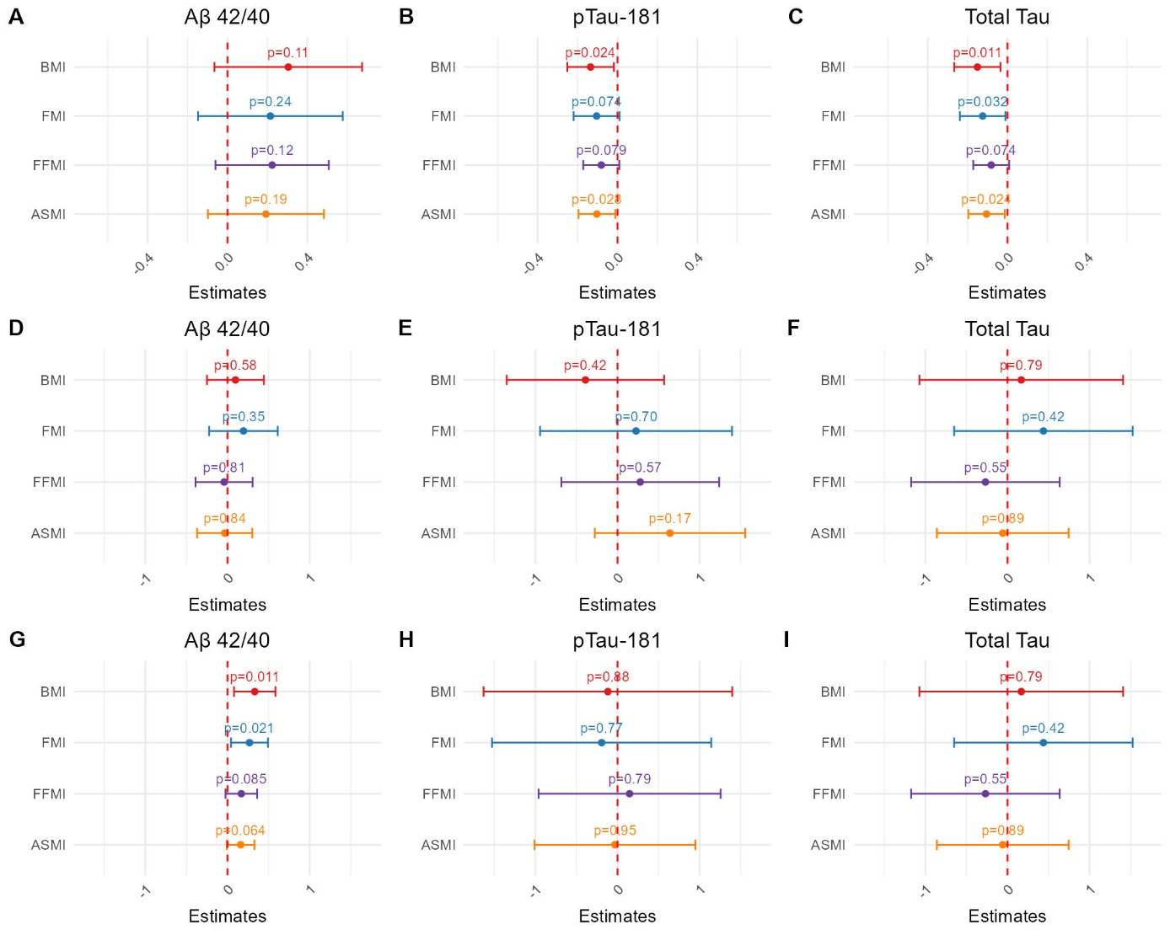Supplementary Figure 1. Body composition and AD CSF biomarkers across diagnosis.
A: Relation between Aβ42/40 ratio and body composition in AD
B: Relation between pTau-181 and body composition in AD
C: Relation between Total Tau and body composition in AD
D: Relation between Aβ42/40 ratio and body composition in NND
E: Relation between pTau-181 and body composition in NND
F: Relation between Total Tau and body composition in NND
G: Relation between Aβ42/40 ratio and body composition in OND
H: Relation between pTau-181 and body composition in OND
I: Relation between Total Tau and body composition in OND
BMI: body mass index, FMI: fat mass index, ASMI: skeletal muscle mass index, FFMI: Fat free mass index,
analysis
 | Malnutrition (n=133) | No malnutrition (n=287) | p
Age (Mean, sd) | 76.5 (7.17) | 74.1 (8.21) | 0.0031*
Female (n, %) | 89 (66.9%) | 151 (52.6%) | 0.0059†
Activities of daily living score (Median, IQR) | 6.0 (5.5 ; 6.0) | 6.0 (6.0 ; 6.0) | 0.044‡
Instrumental activities of daily living score (Median, IQR) | 3.0 (2.0 ; 4.0) | 4.0 (2.0 ; 4.0) | <0.001‡
Charlson Comorbidity Index (mean, sd) | 4.51 (1.35) | 4.16 (1.59) | 0.031*
Professional caregiver (n, %) | 44 (33.1%) | 78 (27.2%) | 0.24†
Living alone (n,%) | 66 (49.6%) | 97 (33.8%) | 0.0035†
MMSE (median, IQR) | 22 (19 ; 25) | 24 (20 ; 27) | 0.0096‡
Stage of cognitive impairment (n,%) |  |  | <0.001†
Mild cognitive impairment | 25 (18.8%) | 146(50.9%)
Major neurocognitive disorder | 108 (81.2%) | 135 (47.0%)
Missing | 0 (0%) | 6 (2.1%)
Diagnostic groups (n,%) |  |  | 0.026†
Alzheimer’s disease | 85 (63.9%) | 156 (54.4%) | 0.083§
Other Neurodegenerative disease | 19 (14.3%) | 32 (11.1%) | 0.45§
Non-neurodegenerative disease | 9 (6.8%) | 48 (16.7%) | 0.0089§
Unclassified dementia | 20 (15.0%) | 51 (17.8%) | 0.58
Aβ 42/40 Ratio | 0.052 (0.040 ; 0.083) | 0.063 (0.047 ; 0.10) | 0.0051‡
pTau-181 (pg/mL, median, IQR) | 25.1 (18.1 ; 36.4) | 22.6 (14.6 ; 30.4) | 0.0026‡
Total Tau (pg/mL, median, IQR) | 272.0 (210 ; 348) | 238.0 (175.5 ; 316.5) | 0.0019‡

Supplementary Table 2. Univariate analysis of clinical and social factors associated with malnutrition
* t test, † χ² test, ‡ Wilcoxon test, § subgroup univariate χ² test

