SUPPLEMENTARY INFORMATION
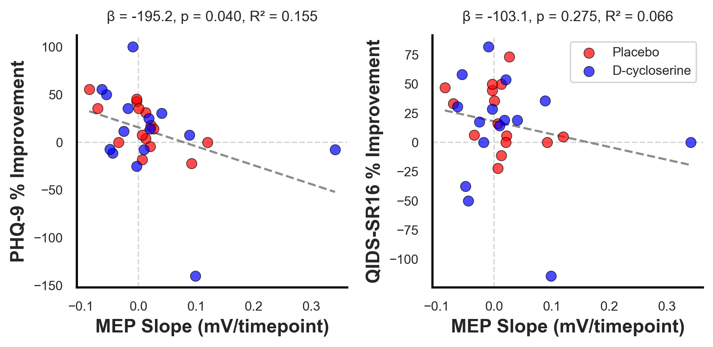
Supplementary Figure 1. MEP trajectory (pre-treatment #1 to post-treatment #10) vs clinical improvement. Left: PHQ-9 (Pearson r = -0.369, p = 0.045). Right: QIDS-SR16 (Pearson r = -0.315, p = 0.090). Red circles = placebo (n = 15); blue circles = D-cycloserine (n = 15). Dashed black line = linear regression fit. Horizontal and vertical gray dashed lines indicate zero change.
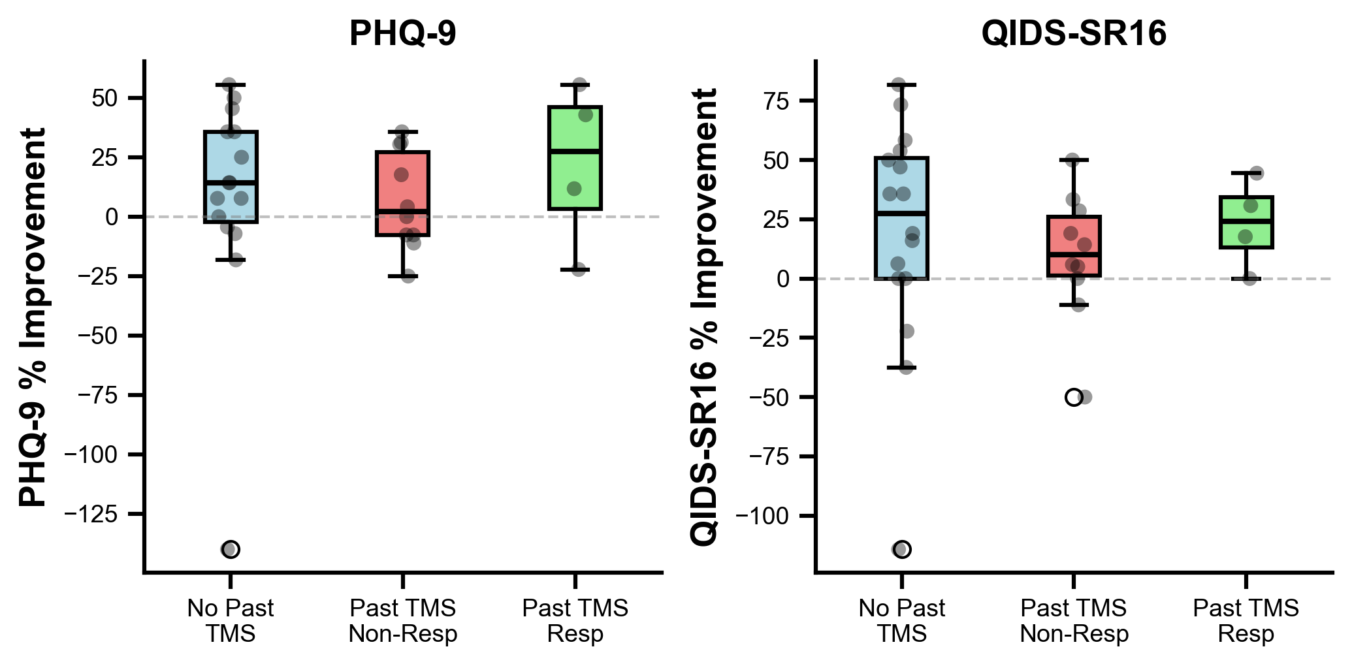
Supplementary Figure 2. Clinical improvement by past TMS treatment history. Box plots show percent improvement from baseline to 1-week follow-up stratified by prior TMS exposure. Left panel: PHQ-9 (Kruskal-Wallis H = 1.537, p = 0.464). Right panel: QIDS-SR16 (one-way ANOVA F = 0.238, p = 0.790). No past TMS (blue, n = 15-16); past TMS non-responders (red, n = 10); past TMS responders (green, n = 4). Box plots show median (black line), interquartile range (box), and whiskers extending to 1.5× IQR. Individual data points shown as black circles. Horizontal dashed line indicates zero change. No significant differences were observed across groups for either clinical measure.

