Supplementary Fig. 1: RAR evaluation on different percentages of salient data

RAR employs an SVM to validate FNCs computed using different percentages of the salient input data (5% - 30%) as computed from the whole MILC model's predictions. When an independent classifier (SVM) was trained on every subject's most salient 5% - 10% data, the predictive power was significantly higher compared to the same SVM classifier trained on randomly chosen identical amounts of data. If we retain a minimal amount of data (5% - 10%), the poor performance with randomly selected data parts indicates that these (randomly chosen) data parts are not exclusively discriminative as the whole MILC estimated salient (5% - 10%) data parts. However, if we retain a higher percentage (e.g., 20% - 30%) of data coverage, the performance gap between the SVM models trained respectively with saliency-based data coverage and randomly selected data coverage diminishes. This observation is reasonable as a higher percentage of random data selection eventually captures lots of salient data parts and improves the SVM model's performance comparably. However, as our results in Figure 2 of the main paper demonstrate, SVM will again fail to predict the class as the input data dimension grows and cover the complete time courses. Precisely, we show that the most salient localized data identified by the whole MILC model are indeed highly discriminative for the underlying disorder.
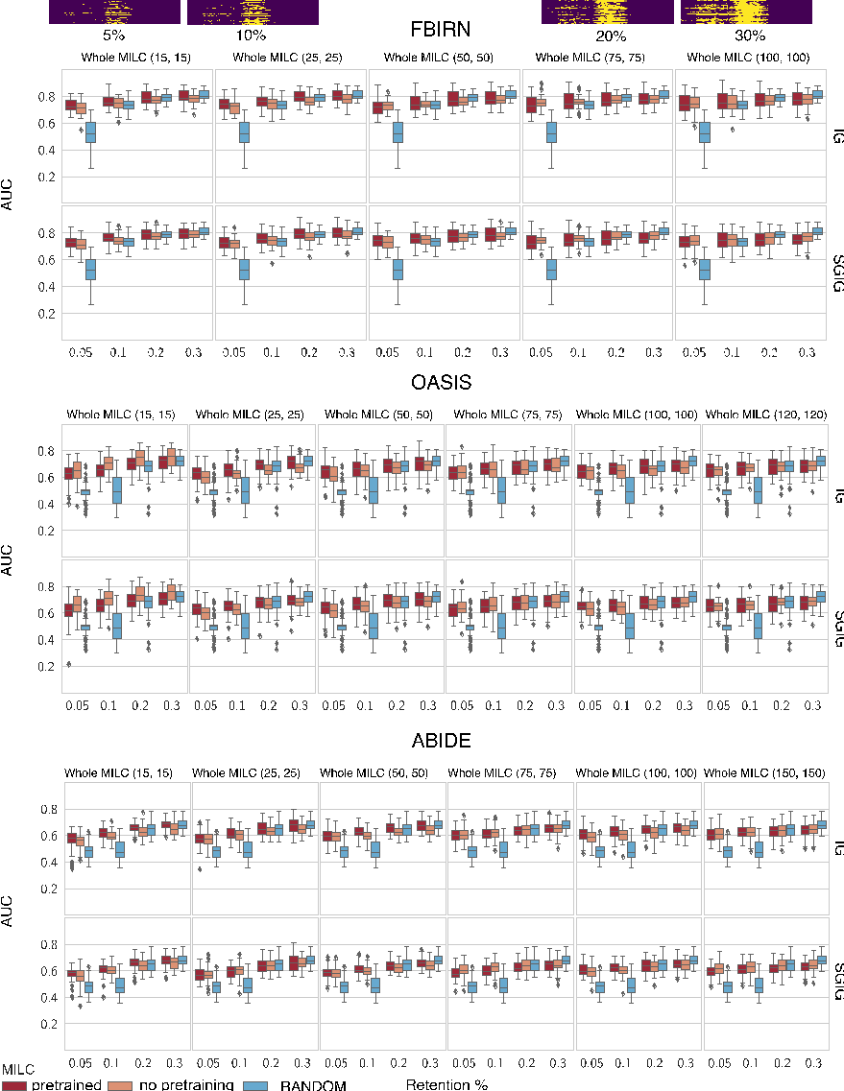

Supplementary Fig. 2: FNC analysis for all disorders based on most salient 5% data parts

A: FNC of patients computed using 5% of the salient data as determined according to the feature importance values (saliency maps) for different disorders. These plots demonstrate in detail the observational conclusions about the FNC of different brain components as we presented in the connectograms (see Figure 4). These conclusions largely agree with prior work.

B: Pairwise difference in FNC maps between any two disorders. As reflected in the difference maps, the relationship between schizophrenia and any other disorder (Alzheimer's, autism spectrum disorder) mainly lies in the corresponding interaction between the subcortical, sensorimotor, and visual domains. Autism and Alzheimer's disease differences are mainly reflected in the interconnection within sensorimotor changes.

