SUPPLEMENTAL MATERIAL
Exploring genetic variability in FOXE1 through in silico approaches: new insights on UTR variants

Supplementary Table 1. Algorithms used by bioinformatic tools.

Tool | Algorithm | Input | Output | Score | Reference
PolyPhen-2 | Sequence-based prediction using a Naive Bayes classifier | Protein sequence, variant information | Probabilistic score (0 to 1) | Ranges from "Benign" to "Probably damaging" | Adzhubei et al., 2010 ^{[33]}.
SIFT | Sequence-based prediction using a position-specific scoring matrix (PSSM) | Protein sequence, variant information | Score (0 to 1), with <0.05 indicating "Damaging" | Ranges from 0 to 1 | Ng & Henikoff, 2003 ^{[34]}.
Phanter PSEP | Sequence-based prediction using a combination of various algorithms | Protein sequence, variant information | Probability score, pathogenicity prediction | Ranges from 0 to 1 | Tang et al. 2016 ^{[35]}.
MutPred2 | Uses structural and functional information to predict the impact of mutations | Protein sequence, variant information, 3D structures | Functional impact prediction, pathogenicity score | Ranges from 0 to 1 | Pejaver et al., 2017 ^{[36]}.
MetaSNP | Aggregates predictions from multiple SNP effect prediction tools | Protein sequence, variant information | Combined score, pathogenicity prediction | Ranges from 0 to 1 | Capriotti et al., 2013 ^{[37]}.
SNP&GO | Integrates functional annotations and sequence information | Protein sequence, variant information | Probability score, functional impact | Ranges from 0 to 1 | Calabrese et al., 2009 ^{[38]}.
PhD-SNP | Combines sequence and structural data using machine learning | Protein sequence, variant information | Probability of being pathogenic | Ranges from 0 to 1 | Calabrese et al., 2017 ^{[39]}.
PredictSNP | Uses a combination of prediction tools and machine learning | Protein sequence, variant information | Functional impact prediction, pathogenicity score | Ranges from 0 to 1 | Bendl et al., 2014 [^{40]}.
HOPE | Analyzes the impact of mutations on protein structure and function | Protein sequence, variant information, 3D structures | Structural impact prediction | Qualitative assessment (e.g., "Benign", "Damaging") | Venselaar et al., 2010 ^{[41]}.
iMutant | Predicts changes in protein stability due to mutations | Protein sequence, variant information, 3D structures | Stability change prediction | Ranges from 0 to 1 | Capriotti et al., 2005 ^{[42]}.
RegulomeDB | Integrates data from various sources to predict regulatory potential (e.g., transcription factor binding sites, chromatin states) | Genomic coordinates, variant information | Regulatory potential with annotated evidence levels | Categorical score from 1 (likely regulatory) to 7 (minimal evidence) | Boyle et al., 2012 ^{[43]}.
RegVar | Analyzes eQTL data to assess the impact of variants on gene expression | Variant information, genomic coordinates | Association between variants and gene expression | P-values indicating the strength of association | Lu et al., 2023 ^{[44]}.

Supplementary Table 2. Annotations and Functional Consequences of variants in the 5' UTR region of the FOXE1 gene using UTRannotator plugin.
rsID | 5UTR_annotation | 5UTR_consequence
rs545190501 | Type: uORF; Cap Distance to Start: 178; Kozak Strength: Strong; Distance to CDS: 511; Evidence: NA; Distance to Stop: 36; Kozak Context: GGCATGG | 5_prime_UTR_premature_start_codon_loss_variant
rs1305296231 | Alt Type Length: 93; Ref Type: uORF; Kozak Context: GGCATGG; Evidence: NA; Kozak Strength: Strong; Ref Start Distance to CDS: 511; Ref Type Length: 39; Alt Type: uORF | 5_prime_UTR_uORF_frameshift_variant
rs900786273 | Ref Type: uORF; New STOP Distance to CDS: 496; Kozak Strength: Strong; Ref Start Distance to CDS: 511; Evidence: NA; Kozak Context: GGCATGG | 5_prime_UTR_uORF_stop_codon_gain_variant
rs914747730 | Kozak Context: GGCATGG; Evidence: NA; Ref Start Distance to CDS: 511; Kozak Strength: Strong; New STOP Distance to CDS: 481; Ref Type: uORF | 5_prime_UTR_uORF_stop_codon_gain_variant
rs1226791618 | Type: OutOfFrame oORF; Distance to CDS: 157; Distance to Stop: 522; Kozak Context: CGCATGC; Kozak Strength: Weak; Cap Distance to Start: 532 | 5_prime_UTR_premature_start_codon_gain_variant
rs1166470714 | Kozak Context: CAGATGG; Distance to Stop: 459; Distance to CDS: 94; Cap Distance to Start: 595; Kozak Strength: Moderate; Type: OutOfFrame oORF | 5_prime_UTR_premature_start_codon_g

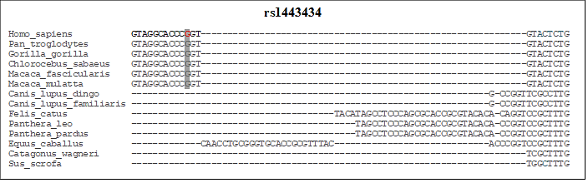
Supplementary Figure 1. Alignment of several species for the SNV rs1443434 in the UTR region of the FOXE1 gene.

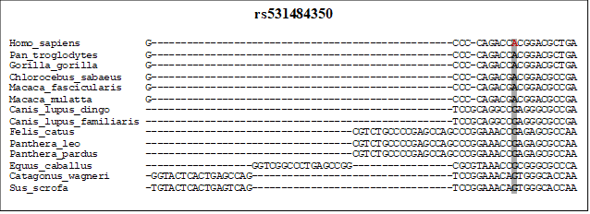
Supplementary Figure 2. Alignment of several species for the SNV rs531484350 in the UTR region of the FOXE1 gene.

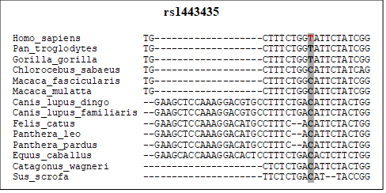

Supplementary Figure 3. Alignment of several species for the SNV rs1443435 in the UTR region of the FOXE1 gene.
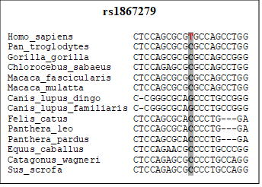

Supplementary Figure 4. Alignment of several species for the SNV rs1867279 in the UTR region of the FOXE1 gene.
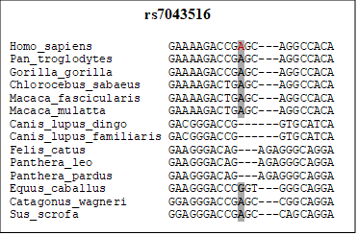
Supplementary Figure 5. Alignment of several species for the SNV rs7043516 in the UTR region FOXE1 gene.

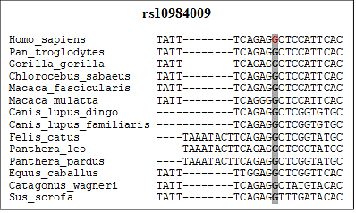
Supplementary Figure 6. Alignment of several species of the SNV rs10984009 in the UTR region FOXE1 gene.
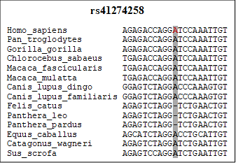
Supplementary Figure 7. Alignment of several species of the SNV rs41274258 in the UTR region FOXE1 gene.

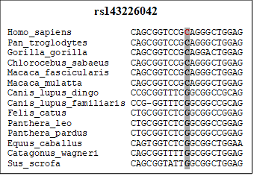
Supplementary Figure 8. Alignment of several species of the SNV rs143226042 in the UTR region FOXE1 gene.

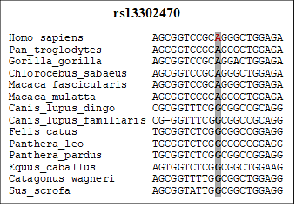
Supplementary Figure 9. Alignment of several species of the SNV rs13302470 in the UTR region FOXE1 gene.
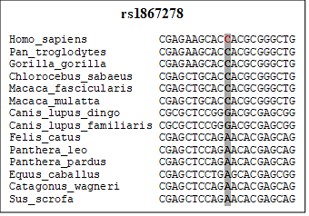
Supplementary Figure 10. Alignment of several species of the SNV rs1867278 in the UTR region FOXE1 gene.

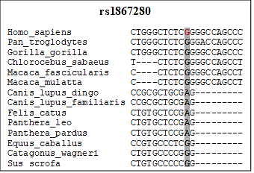

Supplementary Figure 11. Alignment of several species of the SNV rs1867280 in the UTR region FOXE1 gene.

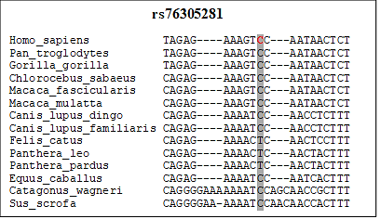
Supplementary Figure 12. Alignment of several species of the SNV rs76305281 in the UTR region FOXE1 gene.

