Supporting Information For

A multi-region flexible neural interface for behavioral state decoding in freely moving mice
Ye Tian^{1, 2, 3, †}, Gen Li^{1, 2, 3, 4, †}, Haoyang Su^{1, 2, 3, †}, Luyue Jiang¹, Yunfu Luo¹, Yingkang Yang^{1, 2, 3}, Lei Huang¹, Jiazhi Li¹, Shuang Jin¹, Peijie Chen^{1, 2, 3}, Yiming Gao^{1, 2, 3}, Yike Xiang^{1, 2, 3}, Yi Wei^{1, 2, 3}, Yifei Ye^{1, 2, 3,} *, Liuyang Sun^{1, 2, 3,} *

¹ State Key Laboratory of Transducer Technology, Shanghai Institute of Microsystem and Information Technology, Chinese Academy of Sciences, Shanghai 200050, China
² 2020 X-Lab, Shanghai Institute of Microsystem and Information Technology, Chinese Academy of Sciences, Shanghai 200050, China
³ Center of Materials Science and Optoelectronics Engineering, University of Chinese Academy of Sciences, Beijing 100049, China
⁴ Shanghai Innovation Institute, Shanghai 200231, China

† These authors contributed equally to this work: Ye Tian, Gen Li, Haoyang Su
* Corresponding authors:
yeyifei@mail.sim.ac.cn (Yifei Ye)
liuyang.sun@mail.sim.ac.cn (Liuyang Sun)

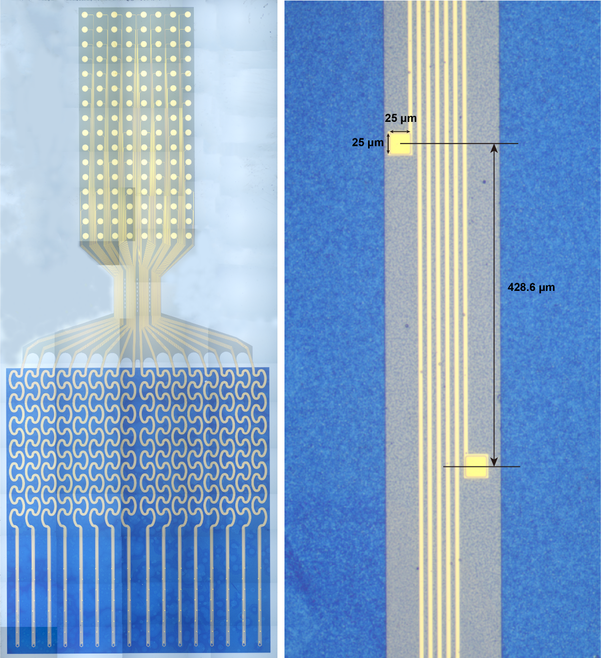
Fig.S1 MRFP of configuration with 16 shanks. The size of electrode is 25x25 μm and the pitch between each electrode is 428.6 μm.

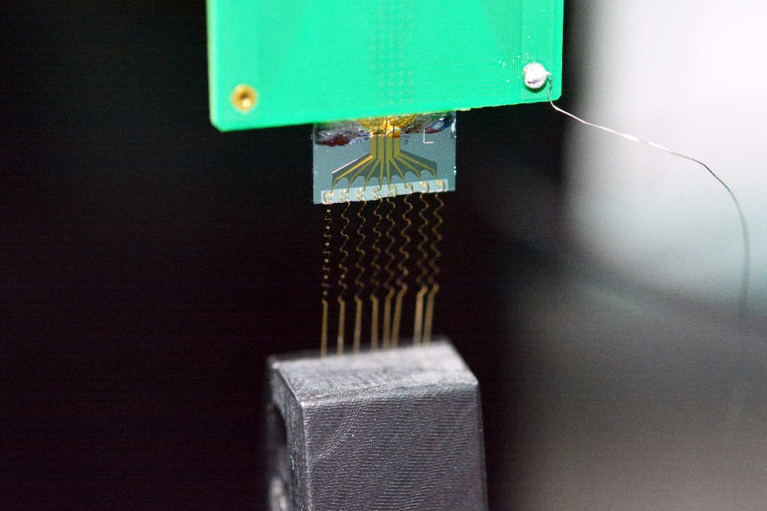
Fig. S2 Picture of uniaxial stretching test of a MRFP. The MRFP endured tensile strains up to 50% without fracture.

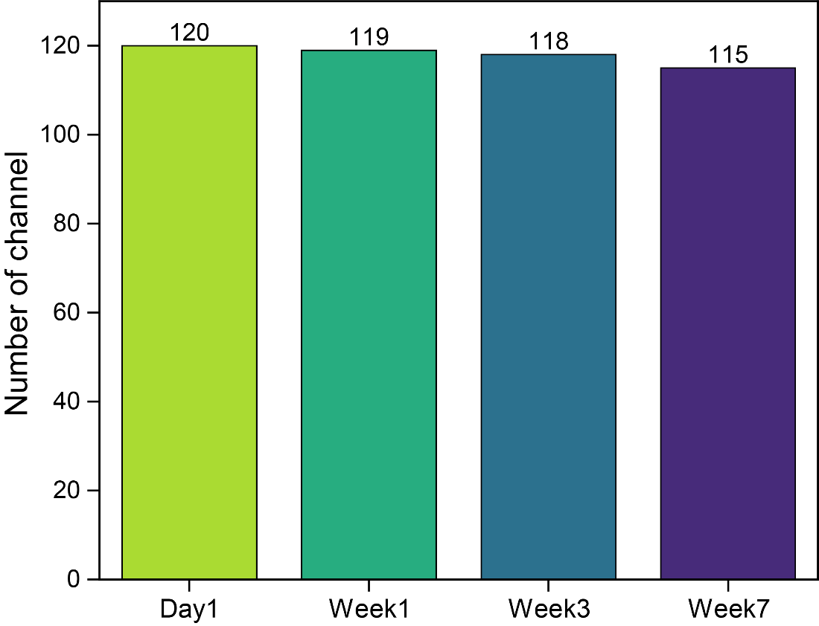
Fig. S3 Number of conducting channels over a 7-week recording session from Mice01. Only five electrodes failed over that period, underscoring the robust in-vivo stability of the probe.

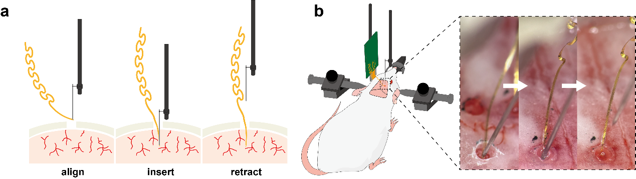
Fig. S4 Implantation procedure of WBFP on mice. a Schematic diagram of the implantation. The shank was firstly detached from the backend and placed on top of the microhole by tweezers. The tungsten wire was aligned towards the pinhole at tip of the shank and the microhole. Then the shank was inserted by a stereotaxic frame, and the depth was precise controlled. Finally, the wire was retracted, leaving the shank in the desired implantation site. b Pictures of implantation during a surgery.

