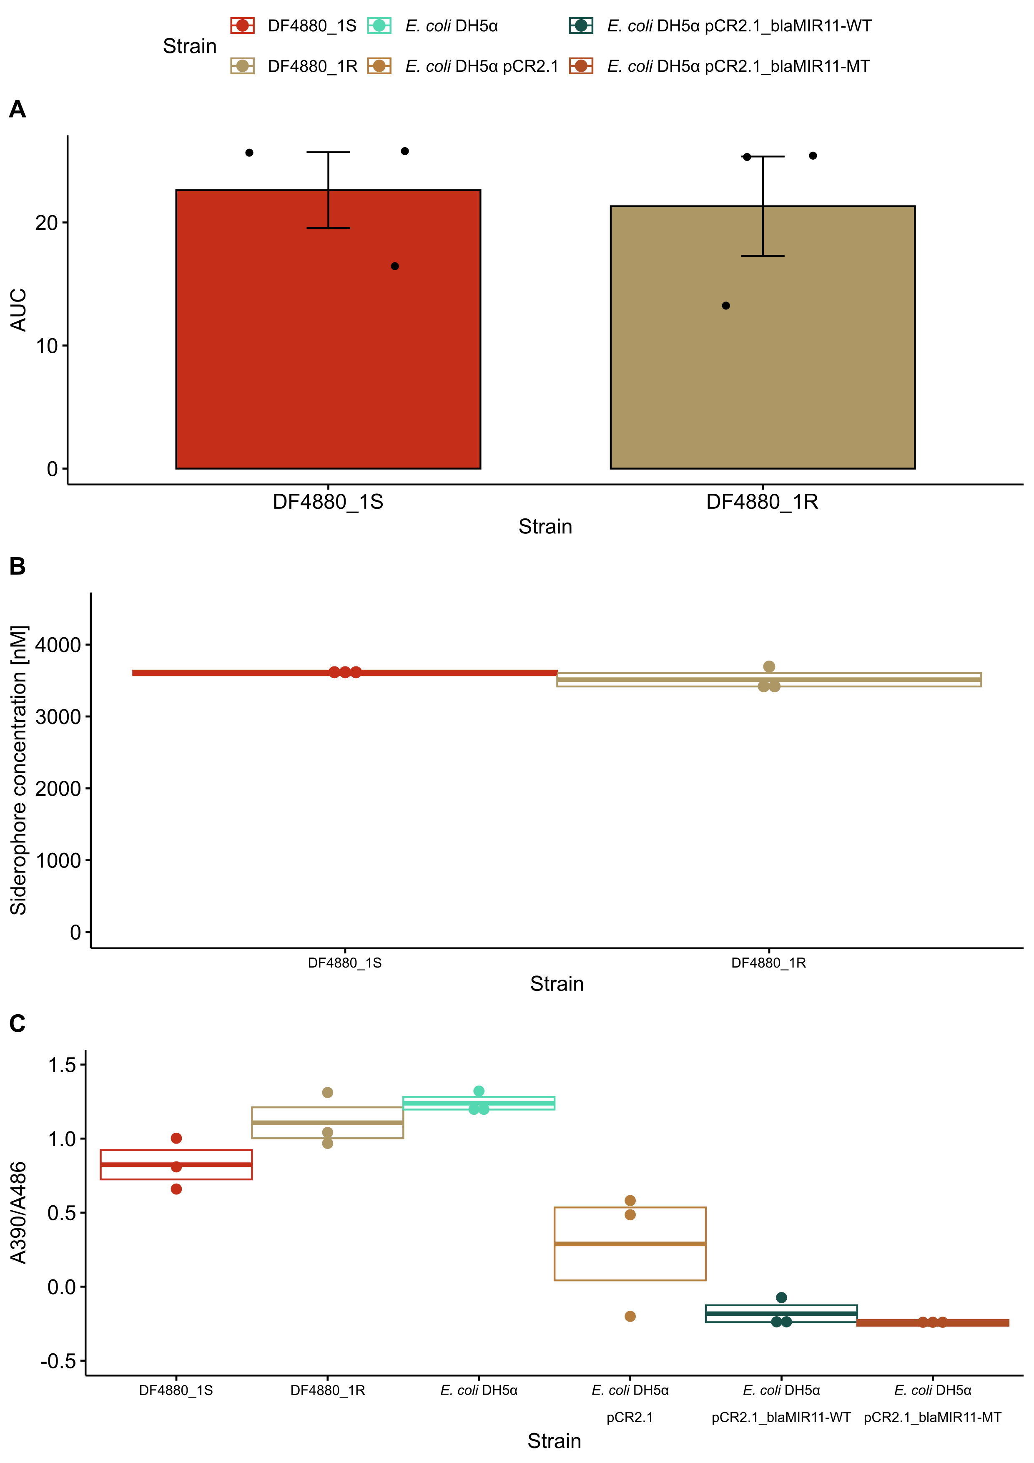
Supplementary Figure S1: Comparative fitness and virulence assays of the cefiderocol resistant evolvant (DF4880_1R) and respective parent strain (DF4880_1S). A: Area under the curve (AUC) of the growth kinetics in LB measured for 22 h at 37 °C every 15 min. Error bars represent standard error of the mean. B: Siderophore concentration as determined by the SideroTec-HiSens™ Assay kit (Accuplex 167 Diagnostics Ltd., Ireland). C: Ratio of the absorption at 390 nm and 486 nm of bacterial suspensions adjusted to an optical density (600 nm) of 0.5 with 0.25 mM nitrocefin after 20 min of incubation at 37 °C, normalized to the optical density (600 nm).

Supplementary Table S1: Overview of the phenotypic resistance profile of the three initial Enterobacter cloacae complex strains used in the experimental evolution as well as the cefiderocol resistant evolvant strain and the respective parent strain. Minimum inhibitory concentrations were determined by the ¹VITEK® 2 COMPACT (bioMérieux) platform, broth microdilution assays, ²ComASP® Cefiderocol 0.008-128 μg/mL Kit (Liofilchem, Roseto degli Abruzzi, Italy), or ³Colistin Ezy MIC™ Strip (CL) 0.016 – 256 mcg/ml (HiMedia Laboratories, Mumbai, India) and interpreted according to EUCAST v15 guidelines¹⁹. n.a., not applicable.
Antibiotic | DF4880_1R | DF4880_1S | PBIO4880 | PBIO4886 | PBIO4914
Ampicillin | n.a. | n.a. | ≥32 (R) | ≥32 (R) | ≥32 (R)
Cefepime¹ | >16 (R) | 0.25 (S) | 0.25 (S) | 0.5 (S) | 2 (S)
Cefiderocol² | >128 (R) | 2 (S) | 0.5 (S) | 0.25 (S) | 1 (S)
Cefotaxime | ≥64 (R) | 32 (R) | ≥64 (R) | ≥64 (R) | ≥64 (R)
Cefpodoxime | n.a. | n.a. | ≥8 (R) | ≥8 (R) | ≥8 (R)
Ceftazidime | ≥64 (R) | ≥64 (R) | ≥64 (R) | ≥64 (R) | ≥64 (R)
Ceftazidime/Avibactam | ≥16 (R) | 0.25 (S) | 0.5 (S) | 0.5 (S) | 0.5 (S)
Ceftolozane/Tazobactam | 4 (R) | 8 (R) | 8 (R) | 8 (R) | ≥32 (R)
Cefuroxime | n.a. | n.a. | ≥64 (R) | ≥64 (R) | ≥64 (R)
Ciprofloxacin | ≤0.06 (S) | ≤0.06 (S) | ≤0.06 (S) | ≤0.06 (S) | ≤0.06 (S)
Colistin³ | 1 (S) | 1 (S) | n.a. | n.a. | n.a.
Ertapenem | 0.25 (S) | 1 (R) | n.a. | n.a. | n.a.
Fosfomycin | n.a. | n.a. | ≥256 (R) | 32 (S) | ≤16 (S)
Gentamicin | ≤1 (S) | ≤1 (S) | ≤1 (S) | ≤1 (S) | ≤1 (S)
Imipenem | 1 (S) | 1 (S) | 1 (S) | 1 (S) | ≤0.25 (S)
Imipenem/Relebactam | 1 (S) | 1 (S) | 1 (S) | ≤0.25 (S) | ≤0.25 (S)
Meropenem | ≤0.25 (S) | ≤0.25 (S) | 0.5 (S) | ≤0.25 (S) | 1 (S)
Meropenem/Vaborbactam | ≤0.5 (S) | ≤0.5 (S) | ≤0.5 (S) | ≤0.5 (S) | ≤0.5 (S)
Piperacillin | ≥128 (R) | ≥128 (R) | n.a. | n.a. | n.a.
Piperacillin/Tazobactam | 64 (R) | ≥128 (R) | ≥128 (R) | ≥128 (R) | ≥128 (R)
Trimethoprim/Sulfamethoxazole | ≤20 (S) | ≤20 (S) | ≤20 (S) | ≤20 (S) | ≤20 (S)

Supplementary Table S2: Overview of strains used in this study. ST, sequence type.
Strain | Characteristics | Citation
PBIO4880 | E. roggenkampii ST165 | This study
PBIO4886 | E. hormaechei ST1131 | This study
PBIO4914 | E. hormaechei ST108 | This study
DF4880_1S | Parent strain of first PBIO4880 replicate | This study
DF4880_1R | Evolvant strain of first PBIO4880 replicate | This study
DF4880_2S | Parent strain of second PBIO4880 replicate | This study
DF4880_2R | Evolvant strain of second PBIO4880 replicate | This study
DF4880_3S | Parent strain of third PBIO4880 replicate | This study
DF4880_3R | Evolvant strain of third PBIO4880 replicate | This study
DF4886_1S | Parent strain of first PBIO4886 replicate | This study
DF4886_1R | Evolvant strain of first PBIO4886 replicate | This study
DF4886_2S | Parent strain of second PBIO4886 replicate | This study
DF4886_2R | Evolvant strain of second PBIO4886 replicate | This study
DF4886_3S | Parent strain of third PBIO4886 replicate | This study
DF4886_3R | Evolvant strain of third PBIO4886 replicate | This study
DF4914_1S | Parent strain of first PBIO4914 replicate | This study
DF4914_1R | Evolvant strain of first PBIO4914 replicate | This study
DF4914_2S | Parent strain of second PBIO4914 replicate | This study
DF4914_2R | Evolvant strain of second PBIO4914 replicate | This study
DF4914_3S | Parent strain of third PBIO4914 replicate | This study
DF4914_3R | Evolvant strain of third PBIO4914 replicate | This study
E. coli DH5α | F– φ80lacZΔM15 Δ(lacZYA-argF)U169 recA1 endA1 hsdR17(r_{K}–, m_{K}⁺) phoA supE44 λ–thi-1 gyrA96
E. coli DH5α^{pCR2.1} | E. coli DH5α transformed with empty pCR™2.1 Vector (Invitrogen, Waltham, United States) | This study
E. coli DH5α^{pCR2.1_blaMIR11-WT} | E. coli DH5α transformed with pCR™2.1 Vector (Invitrogen, Waltham, United States)  containing the wild-type bla_{MIR-11} gene including native promotor and terminator | This study
E. coli DH5α^{pCR2.1_blaMIR11-MT} | E. coli DH5α transformed with pCR™2.1 Vector (Invitrogen, Waltham, United States)  containing the mutated bla_{MIR-11} gene including native promotor and terminator | This study

Supplementary Table S3: Overview of primers used in this study.
Primer | Sequences (5’-3’) | Usage
MIR11_For | CGCGAAGCGAATTAAGCG | Cloning
MIR11_Rev | GCGATTTCATACCATGTTCC | Cloning
M13_For | GTAAAACGACGGCCAGT | Cloning confirmation
M13_Rev | GGAAACAGCTATGACCATG | Cloning confirmation

