Test | Units | Lower Reference Range | Upper Reference Range
Hemoglobin | g/dL | Female: 12.0  Male: 13.5 | Female: 15.5  Male: 17.5
White blood cell | 10³/µL | 4.0 | 10.0
Neutrophil | 10³/µL | 1.5 | 7.5
Lymphocyte | 10³/µL | 1.0 | 3.5
Platelet | 10³/µL | 150 | 400
Neutrophil/ Lymphocyte Ratio | NA | NA | NA
Platelet/Lymphocyte Ratio | NA | NA | NA
Mean Corpuscular Volume | fL | 80 | 100
Red Distribution Width | % | 11.5 | 14.5
C-Reactive Protein | mg/L | 0 | 5
Albumin | g/L | 35 | 50
Ferritin | ng/mL | Female: 15  Male: 30 | Female: 150  Male: 400
Iron | µg/dL | 60 | 170
B12 | pg/mL | 320 | 900
Folate | ng/mL | 3 | 20
Creatinine | mg/dL | Female: 0.59  Male: 0.74 | Female: 1.04  Male: 1.35
Aspartate Aminotransferase | U/L | 10 | 40
Alanine Aminotransferase | U/L | 10 | 45
Table SM1. Reference ranges determined for the tests included in the study
NA: not applicable

Table SM2. Calibration Results (Test and External Datasets)
Dataset | Intercept (α) [95% CI] | Slope (β) [95% CI] | CITL [95% CI]
TEST | 0.28 (0.23 – 0.33) | 0.92 (0.89 – 0.94) | 0.34 (0.29 – 0.38)
EXTERNAL | 0.06 (0.01 – 0.12) | 1.01 (0.98 – 1.04) | 0.06 (0.01 – 0.11)
Note: α = calibration intercept, β = calibration slope, CITL = calibration-in-the-large. Ideal values are α=0, β=1, CITL=0.

Table SM3. Test and external test set subgroup analyses by gender and age tertiles
Dataset | TEST SET |  |  |  |  | EXTERNAL TEST SET
 | Gender |  | Age |  |  | Gender |  | Age
 | 1 | 2 | T1 | T2 | T3 | 1 | 2 | T1 | T2 | T3
TP | 2848 | 1904 | 320 | 1006 | 3426 | 2628 | 1786 | 277 | 925 | 3212
FP | 1096 | 852 | 76 | 599 | 1273 | 1223 | 905 | 113 | 631 | 1384
FN | 287 | 539 | 212 | 429 | 185 | 224 | 381 | 158 | 291 | 156
TN | 3331 | 7620 | 5554 | 4259 | 1138 | 3530 | 7801 | 5839 | 4327 | 1165
Sensitivity | 0,91 | 0,78 | 0,60 | 0,70 | 0,95 | 0,92 | 0,82 | 0,64 | 0,76 | 0,95
Specificity | 0,75 | 0,90 | 0,99 | 0,88 | 0,47 | 0,74 | 0,90 | 0,98 | 0,87 | 0,46
PPV | 0,72 | 0,69 | 0,81 | 0,63 | 0,73 | 0,68 | 0,66 | 0,71 | 0,59 | 0,70
NPV | 0,92 | 0,93 | 0,96 | 0,91 | 0,86 | 0,94 | 0,95 | 0,97 | 0,94 | 0,88
Accuracy | 0,82 | 0,87 | 0,95 | 0,84 | 0,76 | 0,81 | 0,88 | 0,96 | 0,85 | 0,74
F1 | 0,80 | 0,73 | 0,69 | 0,66 | 0,82 | 0,78 | 0,74 | 0,67 | 0,67 | 0,81
MCC | 0,65 | 0,65 | 0,67 | 0,56 | 0,50 | 0,64 | 0,67 | 0,65 | 0,58 | 0,49
AUC | 0,91 | 0,92 | 0,95 | 0,87 | 0,84 | 0,92 | 0,94 | 0,95 | 0,90 | 0,86
AUPR | 0,85 | 0,77 | 0,71 | 0,70 | 0,86 | 0,86 | 0,80 | 0,71 | 0,74 | 0,88
PLR | 3,67 | 7,75 | 44,56 | 5,69 | 1,80 | 3,58 | 7,93 | 33,54 | 5,98 | 1,76
NLR | 0,12 | 0,25 | 0,40 | 0,34 | 0,11 | 0,11 | 0,20 | 0,37 | 0,27 | 0,10
DOR | 30,16 | 31,59 | 110,31 | 16,67 | 16,56 | 33,86 | 40,41 | 90,59 | 21,80 | 17,33
R2_McFadden | 0,44 | 0,44 | 0,47 | 0,33 | 0,29 | 0,48 | 0,51 | 0,52 | 0,41 | 0,33
R2_CoxSnell | 0,45 | 0,38 | 0,24 | 0,30 | 0,32 | 0,47 | 0,40 | 0,23 | 0,34 | 0,36
R2_Nagelkerke | 0,60 | 0,58 | 0,55 | 0,45 | 0,44 | 0,64 | 0,63 | 0,58 | 0,53 | 0,49

Table SM4. Clinical course according to risk groups
Dataset | Subset | Outcome | n_event | n_available | percent | ci95_low | ci95_high
TEST | Pred=1 | Admission (30d) | 3001 | 6700 | 44,79 | 43,60 | 45,98
TEST | Pred=1 | Transfusion (90d) | 1031 | 6700 | 15,39 | 14,54 | 16,27
TEST | Pred=1 | Death (180d) | 201 | 6700 | 3,00 | 2,62 | 3,44
TEST | Pred=0 | Admission (30d) | 1724 | 11777 | 14,64 | 14,01 | 15,29
TEST | Pred=0 | Transfusion (90d) | 232 | 11777 | 1,97 | 1,73 | 2,24
TEST | Pred=0 | Death (180d) | 10 | 11777 | 0,08 | 0,05 | 0,16
TEST | True ED=1 | Admission (30d) | 2727 | 5578 | 48,89 | 47,58 | 50,20
TEST | True ED=1 | Transfusion (90d) | 948 | 5578 | 17,00 | 16,03 | 18,00
TEST | True ED=1 | Death (180d) | 173 | 5578 | 3,10 | 2,68 | 3,59
TEST | Pred=1 & ED=1 | Admission (30d) | 2471 | 4752 | 52,00 | 50,58 | 53,42
TEST | Pred=1 & ED=1 | Transfusion (90d) | 881 | 4752 | 18,54 | 17,46 | 19,67
TEST | Pred=1 & ED=1 | Death (180d) | 171 | 4752 | 3,60 | 3,11 | 4,17
EXTERNAL | Pred=1 | Admission (30d) | 2893 | 6542 | 44,22 | 43,02 | 45,43
EXTERNAL | Pred=1 | Transfusion (90d) | 983 | 6542 | 15,03 | 14,18 | 15,91
EXTERNAL | Pred=1 | Death (180d) | 183 | 6542 | 2,80 | 2,42 | 3,23
EXTERNAL | Pred=0 | Admission (30d) | 1756 | 11936 | 14,71 | 14,09 | 15,36
EXTERNAL | Pred=0 | Transfusion (90d) | 227 | 11936 | 1,90 | 1,67 | 2,16
EXTERNAL | Pred=0 | Death (180d) | 10 | 11936 | 0,08 | 0,05 | 0,15
EXTERNAL | True ED=1 | Admission (30d) | 2524 | 5019 | 50,29 | 48,91 | 51,67
EXTERNAL | True ED=1 | Transfusion (90d) | 896 | 5019 | 17,85 | 16,82 | 18,94
EXTERNAL | True ED=1 | Death (180d) | 163 | 5019 | 3,25 | 2,79 | 3,77
EXTERNAL | Pred=1 & ED=1 | Admission (30d) | 2352 | 4414 | 53,29 | 51,81 | 54,75
EXTERNAL | Pred=1 & ED=1 | Transfusion (90d) | 849 | 4414 | 19,23 | 18,10 | 20,42
EXTERNAL | Pred=1 & ED=1 | Death (180d) | 161 | 4414 | 3,65 | 3,13 | 4,24
ALL | Pred=1 | Admission (30d) | 5894 | 13242 | 44,51 | 43,67 | 45,36
ALL | Pred=1 | Transfusion (90d) | 2014 | 13242 | 15,21 | 14,61 | 15,83
ALL | Pred=1 | Death (180d) | 384 | 13242 | 2,90 | 2,63 | 3,20
ALL | Pred=0 | Admission (30d) | 3480 | 23713 | 14,68 | 14,23 | 15,13
ALL | Pred=0 | Transfusion (90d) | 459 | 23713 | 1,94 | 1,77 | 2,12
ALL | Pred=0 | Death (180d) | 20 | 23713 | 0,08 | 0,05 | 0,13
ALL | True ED=1 | Admission (30d) | 5251 | 10597 | 49,55 | 48,60 | 50,50
ALL | True ED=1 | Transfusion (90d) | 1844 | 10597 | 17,40 | 16,69 | 18,13
ALL | True ED=1 | Death (180d) | 336 | 10597 | 3,17 | 2,85 | 3,52
ALL | Pred=1 & ED=1 | Admission (30d) | 4823 | 9166 | 52,62 | 51,60 | 53,64
ALL | Pred=1 & ED=1 | Transfusion (90d) | 1730 | 9166 | 18,87 | 18,09 | 19,69
ALL | Pred=1 & ED=1 | Death (180d) | 332 | 9166 | 3,62 | 3,26 | 4,02

Figure SM1. Pearson and Spearman correlations between variables
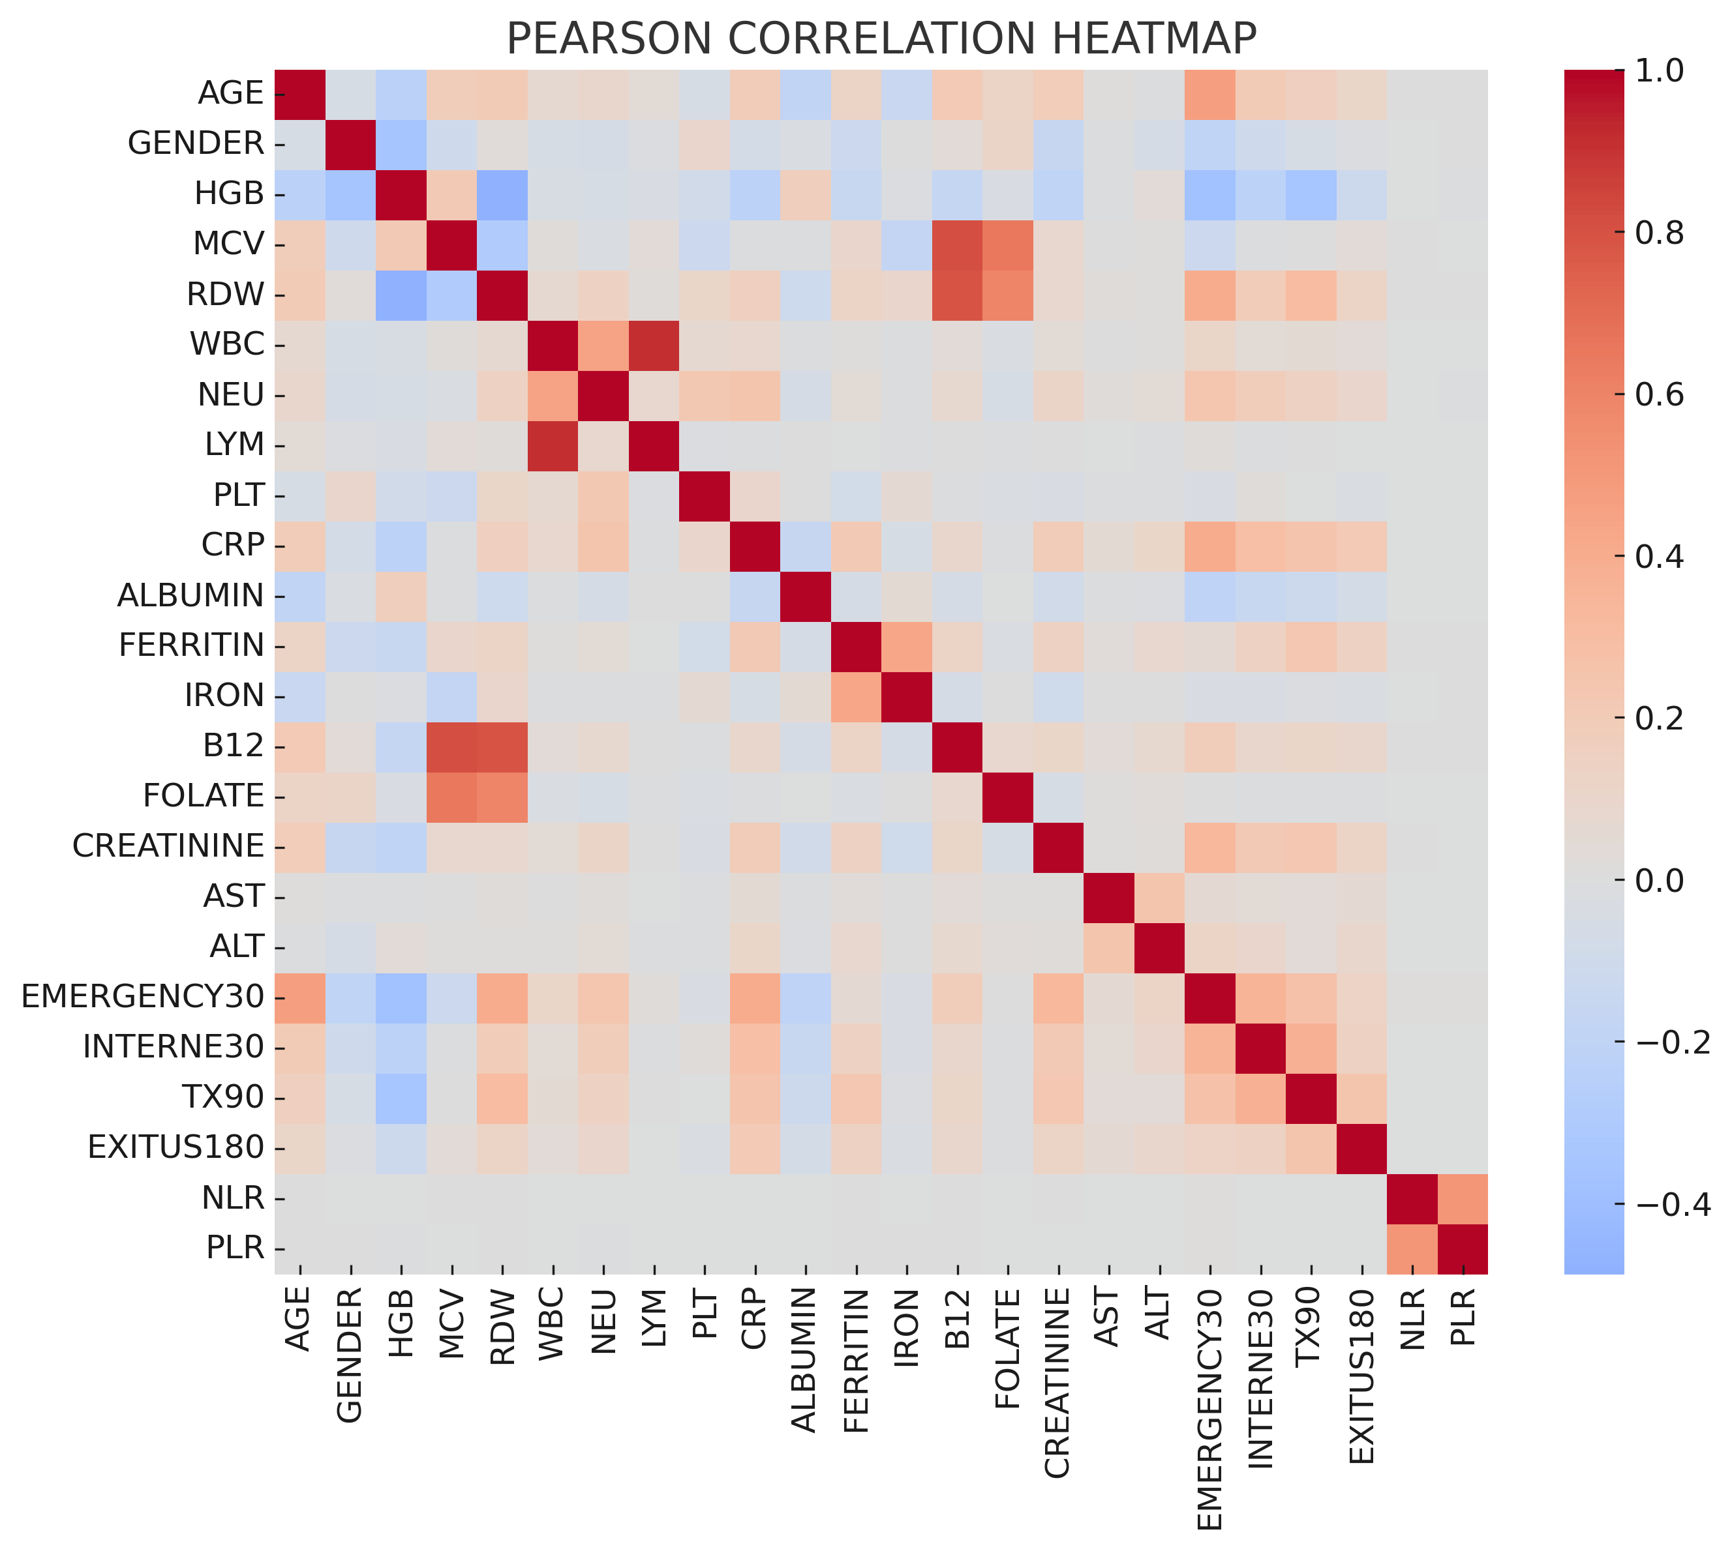 | 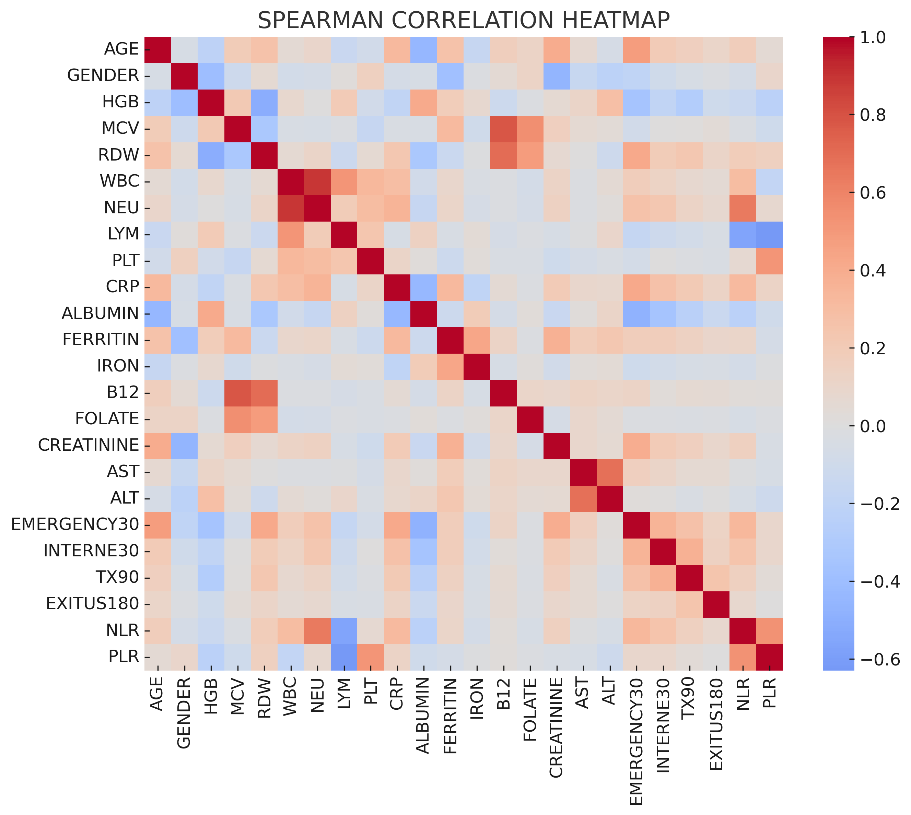
Figure SM2. Calibration plots of the AXIS-2 logistic regression model in the training, internal test, and external validation datasets.
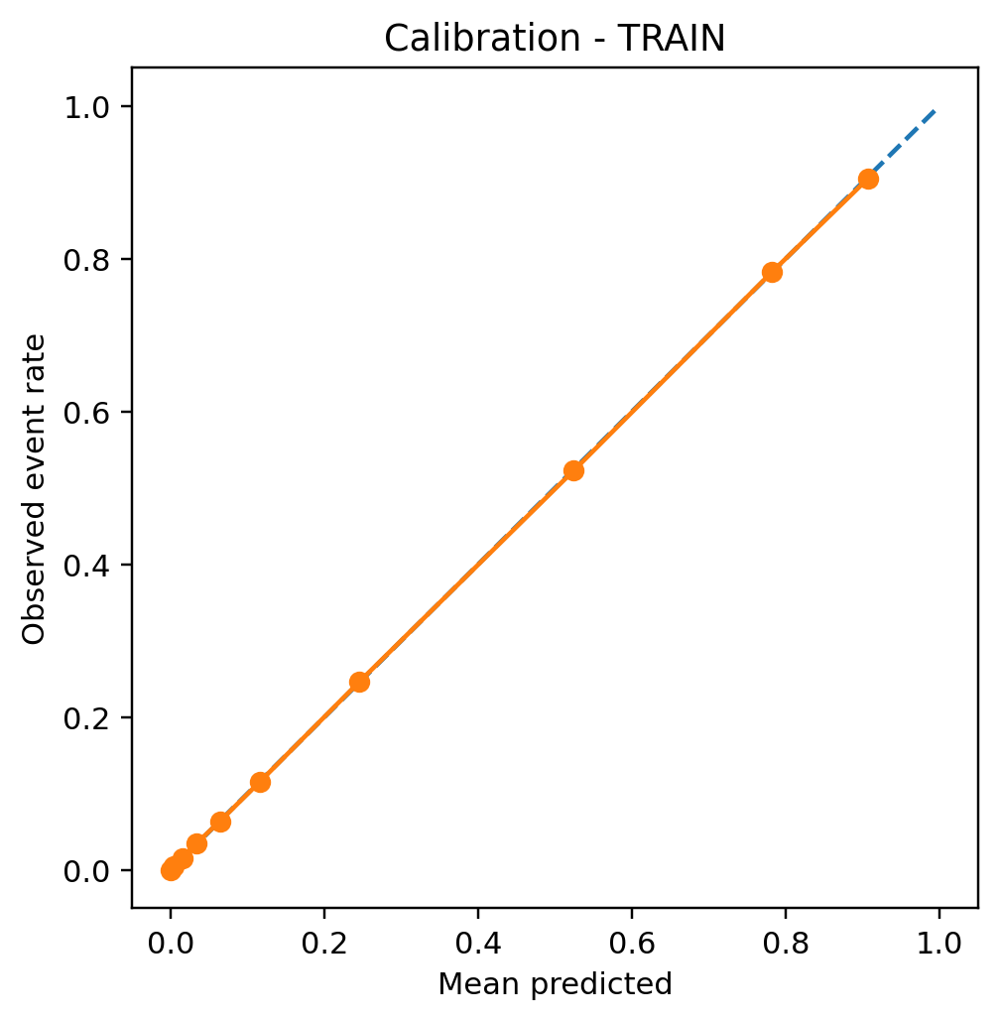 | 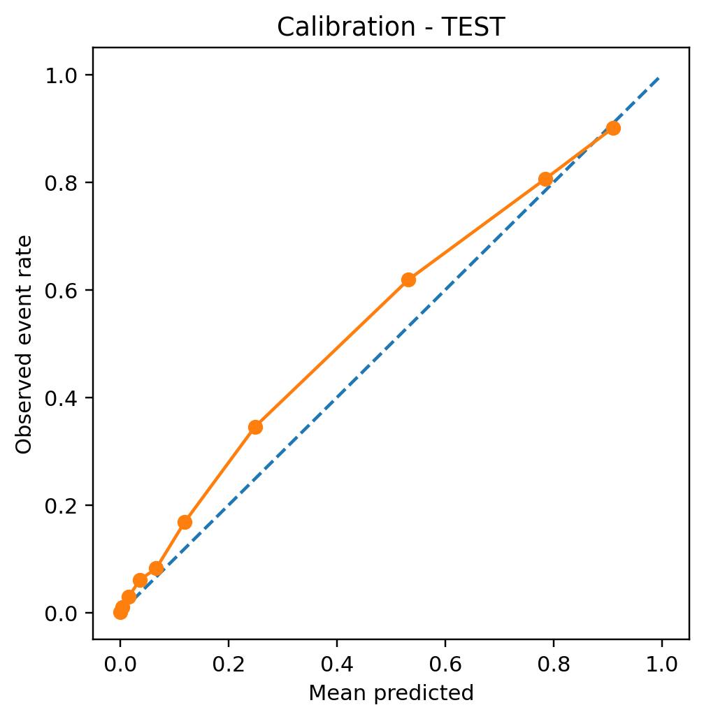 | 