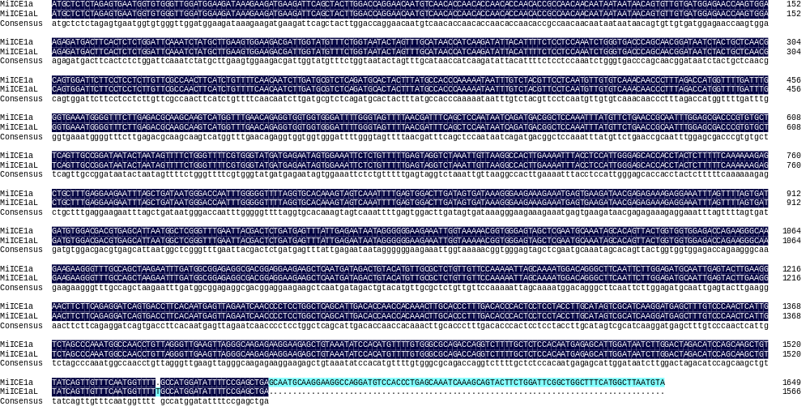
Appendix B. The nucleotide sequences alignment of MiICE1a and MiICE1aL.
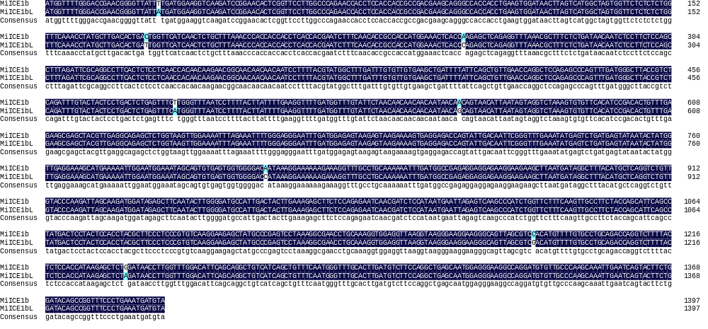
Appendix C. The nucleotide sequences alignment of MiICE1b and MiICE1bL.
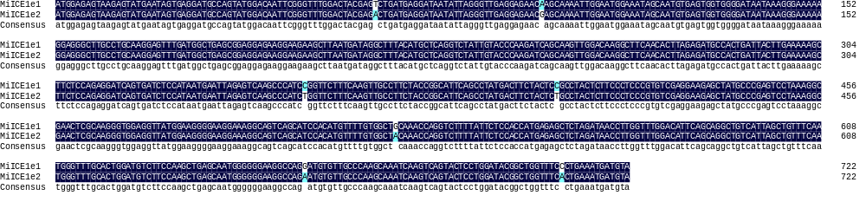
Appendix D. The nucleotide sequences alignment of MiICE1e and MiICE1eL.
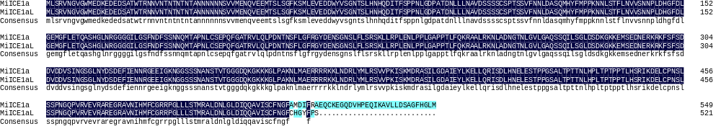

Appendix E. The protien sequences alignment of MiICE1a and MiICE1aL.
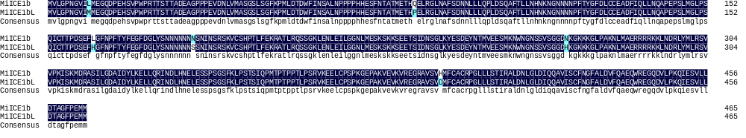
Appendix F. The protien sequences alignment of MiICE1b and MiICE1bL.
Appendix G. The protien sequences alignment of MiICE1e and MiICE1eL.

