Oligomer self-assembly is a major source of nanoplastic release from household plastic cutting boards

Mengjing Wang^{1,2}*, Youdong Xu³, Jini Yang⁴, Xiangyu Meng⁵, Jessica Chen², Hao Li⁶, Xiangrui Wang⁷, Bo Xu⁸

Affiliations:
¹Department of Environmental Science and Engineering, University of Science and Technology of China, Hefei 230026, China.
²Department of Obstetrics, Gynecology, and Reproductive Sciences, Center for Reproductive Sciences, University of California, San Francisco, San Francisco, CA 94143, United States
³State Key Laboratory of Proteomics, Beijing Proteome Research Center, National Center for Protein Sciences (Beijing), Beijing Institute of Lifeomics, Beijing 102206, China.
⁴Foreign Environmental Cooperation Center, Ministry of Ecology and Environment of the People’s Republic of China, Beijing 100035, China.
⁵Department of Urology, Shanghai General Hospital, Shanghai Jiao Tong University School of Medicine, Shanghai 200080, China.
⁶School of Economics, Hefei University of Technology, Hefei 230601, China.
⁷School of Materials Science and Engineering, Beihang University, Beijing 100191, China.
⁸School of Civil and Environmental Engineering, Nanyang Technological University, Singapore 639798, Singapore.

*Correspondence and requests for materials should be addressed to MW (email: wangmengjing@ustc.edu.cn).

Supplementary Methods
Chopping experiments and MPs/NPs collection
Six polypropylene (PP) and one polyethylene (PE) plastic cutting boards (PChBs) were purchased in 2020 via Shopee (Singapore). Non-white boards were selected to facilitate visual discrimination of released particles. Brands were anonymized as P1–P7. Before testing, each new board was rinsed with ultrapure water (18.2 MΩ·cm), washed with 0.1% laboratory detergent, thoroughly rinsed with ultrapure water, and air-dried in a clean hood for 12 h; all rinsates were discarded.
A single operator (female, 25 years, 45 kg, 160 cm) performed all chopping after a one-week force-stabilization training using a custom pressure-sensing platform (45 cm × 45 cm wooden base with four corner sensors; range 0–100 N; resolution 0.01 N) connected to an impact-force acquisition unit that recorded each strike. Chopping frequency was maintained at 1 Hz (verified in preliminary trials). A 15 cm × 5 cm marked area on each board received 600 strikes per 10-minute cycle. Three independent cycles were performed on fresh areas of each board; to simulate prolonged use, nine consecutive cycles were then performed on the same region. A single commercial steel kitchen knife was used throughout without resharpening; potential changes in blade sharpness were not evaluated.
Chopping protocols were informed by a questionnaire survey (n = 201; 84 cities, 19 provinces, China) covering household size, chopping duration, board-replacement frequency, and oil-cooking habits. After each cycle, the knife and board were rinsed with 500 mL of ultrapure water into a clean rectangular glass tray, transferred to a 500 mL glass beaker, and immediately filtered through a 47 mm-diameter, 1.0 µm pore-size black membrane using a glass vacuum filtration system.

Characterization of MPs and NPs
Raman spectroscopy. Raman spectra of MPs were acquired on a Renishaw InVia system. To minimize substrate background, particles were transferred from collection membranes onto silicon wafers before analysis.
Electron microscopy. For morphology and size, samples were drop-cast onto silicon wafers and sputter-coated with a Au layer prior to SEM (JSM-7600F, JEOL). TEM (JEM-2100F, JEOL) was used for nanoscale characterization; NPs were adsorbed onto 400-mesh carbon-coated Cu grids at room temperature for 5 min before imaging.
AFM. Three-dimensional topography was obtained with an AFM (Dimension Icon, Bruker) in intermittent-contact mode using SHR300 tapping probes (BudgetSensors; diamond-like carbon coating; nominal tip radius ~1 nm).
DLS. Hydrodynamic diameters were measured by DLS (Zetasizer Nano S, Malvern Panalytical) at 25 °C and a 173° backscatter angle. z-average diameter and PDI were derived by cumulative analysis following ISO 22412.
NTA. NP concentrations were quantified on a NanoSight NS300 (Malvern; software v3.4.003) using a 488 nm laser and sCMOS camera. Unless otherwise stated, measurements were performed at 25 °C in water; ethanol-treated samples were handled according to the ethanol-partition protocol described elsewhere in Methods.
Optical imaging and counting. Composite images of 1.0 µm membranes were acquired with a Keyence digital microscope, stitched, and analyzed in ImageJ to obtain MP counts and size distributions. All samples were standardized to a 500 mL rinse volume as defined in the chopping protocol; counts were normalized accordingly.
Mass estimation. Assuming spherical particles, the mass of released MPs/NPs was estimated as
$$\text{m = N × }\frac{\text{π}}{6}\text{ × }D^{3} \text{× ρ}$$
where N is the particle number released per 10-minute cycle, D is the number-weighted mean diameter (from optical microscopy for MPs or NTA for NPs), and ρ is the polymer density (PP ≈ 0.90 g cm⁻³; PE ≈ 0.94 g cm⁻³). This calculation provides an order-of-magnitude estimate under the sphericity assumption.

Influence of hot water and oil on MPs and NPs release
To evaluate cooking-related media effects, a PP PChB (product 7) was chopped and released particles were collected as described above. For hot-water treatment, PP MPs were suspended in deionized water at 95 °C and stirred on a magnetic hotplate for 2 h or 24 h; aliquots were subsequently analyzed for MP counts/size and NP concentration/size. Gel permeation chromatography (GPC) was used to analyze low-molecular-weight products after hot-water treatment of MPs. For the oil treatment, PP MPs were mixed with peanut oil at 200 °C for 20 min (per questionnaire practices) and then analyzed for MP abundance and morphology; NP quantification was not performed due to medium incompatibility with NTA/DLS. All treatments were conducted in triplicate.

GPC analysis
GPC was performed at room temperature on an organic-phase SEC column (PLgel MIXED-B, 10 µm, 300 × 7.5 mm) using HPLC-grade chloroform as the mobile phase at 1.0 mL min⁻¹. The aqueous supernatant obtained after hot-water treatment of MPs was freeze-dried; the residue was dissolved in chloroform and filtered through a 0.22 µm PTFE membrane prior to injection (20 µL).

Photoaging of PChBs
A polypropylene PChB (product 7) was aged in a xenon-arc test chamber (500 W; Sailham, China) for 31 days at 55 °C and 40% RH. The lamp spectrum approximates natural sunlight; the broadband irradiance at the sample plane was 4.0 mW cm⁻², comparable to reported sunlight of 4.36 mW cm⁻² ¹. The board was sampled at days 1, 3, 6, 9, 13, 17, 21, 26, and 31 for subsequent chopping-release tests and particle characterization. An identical PP PChB kept under the same temperature and humidity without illumination served as the control.

Ethanol treatment of released NPs
Plastic oligomers are soluble in ethanol ^{2, 3}. We operationally separated an ethanol-soluble, oligomer-enriched fraction from an ethanol-insoluble, polymer-enriched fraction. For NTA measurements in ethanol-containing media, the instrument’s linear range was checked with 100–200 nm polystyrene standards prepared in 50% (v/v) ethanol, and the viscosity was set to the value for 50% ethanol at 25 °C.
For compositional separation, 1.0 mL of filtrate was mixed 1:1 with absolute ethanol to a final ethanol content of 50% (v/v), vortexed at 1,500 rpm for 60 s. The supernatant (ethanol-soluble) was either (i) analyzed by NTA directly in 50% ethanol (with viscosity correction as above) or (ii) evaporated under nitrogen at room temperature and the residue reconstituted in the appropriate solvent/mobile phase for pyrolysis–gas chromatography–mass spectrometry (pyrolysis–GC–MS) and HPLC-CAD. All analyses were performed in triplicate at room temperature.

Pyrolysis–GC–MS and HPLC-CAD analysis
To distinguish oligomers from polymeric nanoparticles, we performed pyrolysis–GC–MS following established protocols ⁴. Samples were pyrolyzed at 550 °C under nitrogen flow (50 mL/min), and products were trapped, thermally desorbed, and analyzed using an Agilent 7890B/5977B GC–MS system equipped with a DB-624 column. Identification was based on spectral matching against a pyrolysis database ⁵.
Ethanol-extracted oligomers were further characterized by HPLC coupled with a charged aerosol detector (HPLC-CAD; Dionex Ultimate 3000, Thermo Fisher Scientific). Separation was achieved on an Eclipse XDB-C18 column (4.6 mm × 150 mm, 3.5 μm particle size). The mobile phase consisted of 10% acetonitrile and 90% water, with a flow rate of 1 mL/min. The column temperature was maintained at 30 °C, and the total run time was 15 minutes.

Molecular Dynamics Simulation of Aggregation of PP and PE Oligomers
Molecular dynamics (MD) simulations were performed using YASARA Structure (v.22.5.22) with the standard md_run macro and the AMBER14 force field. Three-dimensional structures of polypropylene (PP) and polyethylene (PE) comprising 2, 4, 6, 8, and 10 monomer units were constructed in YASARA. Each simulation system contained 300 copies of the respective polymer, solvated in a periodic cuboid box filled with TIP3P water at pH 7.4 and 298 K. An ionic concentration of 0.9% NaCl was applied. The periodic boundary conditions employed a 5 Å margin, an 8 Å particle mesh Ewald (PME) cut-off, and a 2.5 fs integration timestep. Systems were subjected to energy minimization, followed by 300 ns production runs in the NPT ensemble (298 K, 1 atm). Simulation snapshots were recorded every 100 ps. Trajectory analysis was conducted using the md_analyze macro in YASARA.

Physicochemical Properties and Toxicity Prediction
Cytochrome P450 (CYP) is a hemeprotein that plays a crucial role in xenobiotic metabolism ⁶. Using the ADMET Predictor software (version 10.4) from Simulations Plus, the CYP-mediated metabolism of two-ten-units PP and PE oligomers was evaluated. Additionally, the toxicity of these oligomers and their CYP metabolites, were analyzed using the same software. The calculated results were obtained by inputting the 2D Simplified Molecular Input Line Entry System (SMILES) structures of these chemicals into the two software programs.

Tg(cmlc2:GFP) zebrafish cardiotoxicity and developmental assay
Embryos from Tg(cmlc2:GFP) adults were obtained from the Shanghai FishBio Co., Ltd (Shanghai, China) and maintained in E3 medium at 28.5 °C. The ethanol-extracted oligomeric fraction from 31-day-aged plastic particles was filtered (0.22 μm PTFE), evaporated under nitrogen, and dissolved in DMSO.
At 2 h post-fertilization (hpf), nonviable embryos were removed. At 6 hpf, healthy embryos were exposed in 6-well plates to 0.01, 0.1, 1, or 10 mg L⁻¹ extract in E3 medium with 0.1% DMSO; controls received E3 with 0.1% DMSO. Concentrations were selected based on published toxicity data ⁷. Survival was assessed at 24 and 48 hpf. Methylene blue in E3 enabled distinction of live (clear) and dead (opaque, pale blue) embryos. At 48 hpf, pericardial area and body length were measured by fluorescence microscopy and ImageJ. Heart rate (bpm) was quantified from ≥60 fps GFP videos (30 s, n = 10/group) at 28.5 °C using ImageJ. At 72 hpf, hatching rate was determined as the proportion of hatched larvae among 30 embryos per replicate (three replicates). Larval morphology was recorded with a stereomicroscope; key endpoints (body shape, tail, heart, and swim bladder) were scored for abnormalities.

Assessment of MPs and NPs exposure from home-cooked meals associated with PChB use
We estimated global ingestion of MPs and NPs using release rates determined in this study, combined with cooking frequency and home-cooked meal consumption data obtained from A Global Analysis of Cooking Around the World 2018–2021 (Gallup & Cookpad; Table S3). For each region, MP and NP exposure was calculated according to equation (2):
where MPⅰ and NPⅰ represent the annual ingestion of MPs and NPs, respectively; Ndhcm denotes the number of days meals were cooked at home in the past seven days; and Phcmc (%) represents the proportion of home-cooked meals consumed during the same period in each region. A strong linear relationship between the number of chopping cycles and particle release during prolonged use of PChBs was observed, with parameters A and B determined experimentally (Tables S1 and S2). We assumed one chopping cycle per day per individual for food preparation.

Quality control for MP and NP quantification
White polystyrene microspheres (10 µm diameter; Fig. S5A) were used to assess recovery and counting accuracy. A total mass of 0.1 mg microspheres was dispersed onto a PChB surface and processed using the same rinse–filtration–imaging workflow as test samples. All QC experiments were performed in triplicate to evaluate recovery reproducibility and analytical consistency.
To minimize external contamination, 1.5 mm-thick rubber sheets were placed beneath the chopping platform and the board. All glassware and tools were thoroughly rinsed with ultrapure water before use. Operators wore nitrile gloves and protective suits, and sample handling was conducted under low-airflow conditions. Procedural blanks were run regularly: ultrapure-water blanks and ethanol-step blanks (50% v/v) were included, and laboratory blanks were collected every third sample. For MPs, blank counts were < 5 particles per filter (below the image-analysis detection threshold). For NPs, NTA signals in water and 50% ethanol blanks were negligible relative to samples and did not affect quantification.

Supplementary References
(1) Jiang, W.; Zhu, K.; Ma, H.; Liu, J.; Zhang, C.; Dai, Y.; Jia, H. Sulfur-Containing Persistent Free Radicals and Reactive Species on Photoaged Microplastics: Identification and the Formation Mechanism. Environ. Sci. Technol. 2023, 57 (23), 8680–8690.
(2) Yang, T.; Xu, Y.; Liu, G.; Nowack, B. Oligomers are a major fraction of the submicrometre particles released during washing of polyester textiles. Nature Water 2024, 2 (2), 151–160.
(3) Ubeda, S.; Aznar, M.; Nerin, C. Determination of oligomers in virgin and recycled polyethylene terephthalate (PET) samples by UPLC-MS-QTOF. Anal. Bioanal. Chem. 2018, 410 (9), 2377–2384.
(4) Zhu, L.; Wu, Z. X.; Dong, J.; Zhao, S. Y.; Zhu, J. Y.; Wang, W. P.; Ma, F. J.; An, L. H. Unveiling Small-Sized Plastic Particles Hidden behind Large-Sized Ones in Human Excretion and Their Potential Sources. Environ. Sci. Technol. 2024, 58 (27), 11901–11911.
(5) Gomiero, A.; Oysaed, K. B.; Palmas, L.; Skogerbo, G. Application of GCMS-pyrolysis to estimate the levels of microplastics in a drinking water supply system. J. Hazard. Mater. 2021, 416, 125708.
(6) Estabrook, R. W. A passion for P450s (remembrances of the early history of research on cytochrome P450). Drug Metab. Dispos. 2003, 31 (12), 1461–1473.
(7) Shi, C.; Guo, A.; Pang, S.; Yang, J.; Liu, M.; Zhao, F.; Wang, M.; Dou, X.; Sui, Q.; Xu, C.; et al. Precise characterization of the presence and fate of plastic oligomers in water. Nature Water 2025, 3, 461–472.

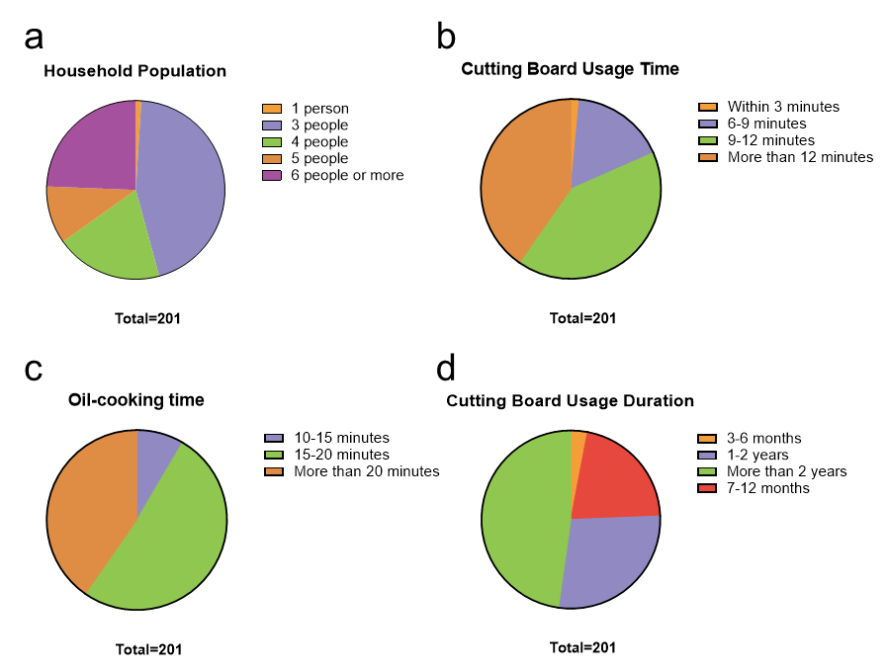
Figure S1. a, Household size. b, Chopping time per session on a cutting board (min). c, Oil-cooking time per session (min). d, Cutting-board usage duration before replacement. Percentages indicate the share of respondents (total respondents per panel = 201).
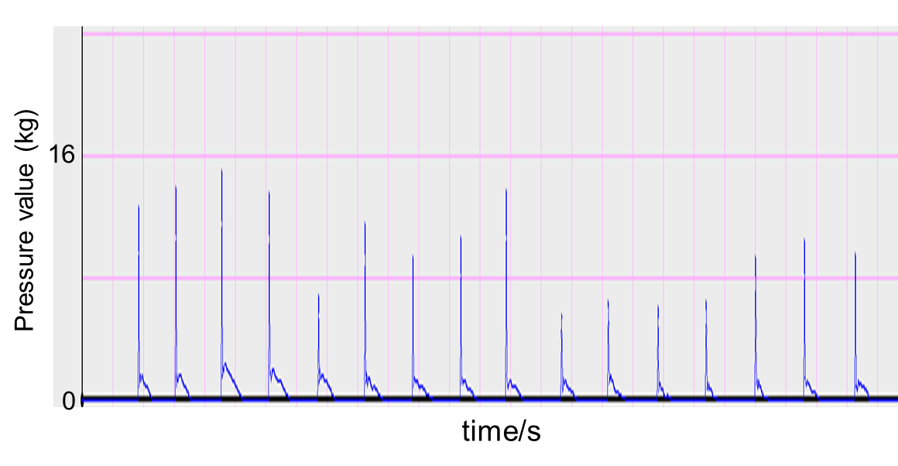
Figure S2. Time series of knife impact force during standardized chopping.

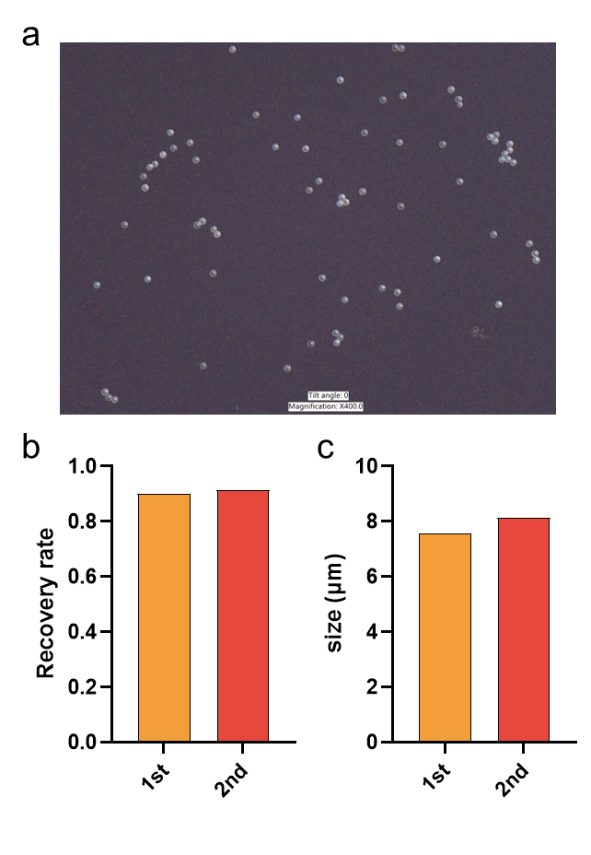
Figure S3. a, Representative micrograph of microspheres processed through the rinse–filtration–imaging workflow. b, Recovery of particle counts after processing. c, Measured particle size after processing. Two independent runs (1st, 2nd) are shown.

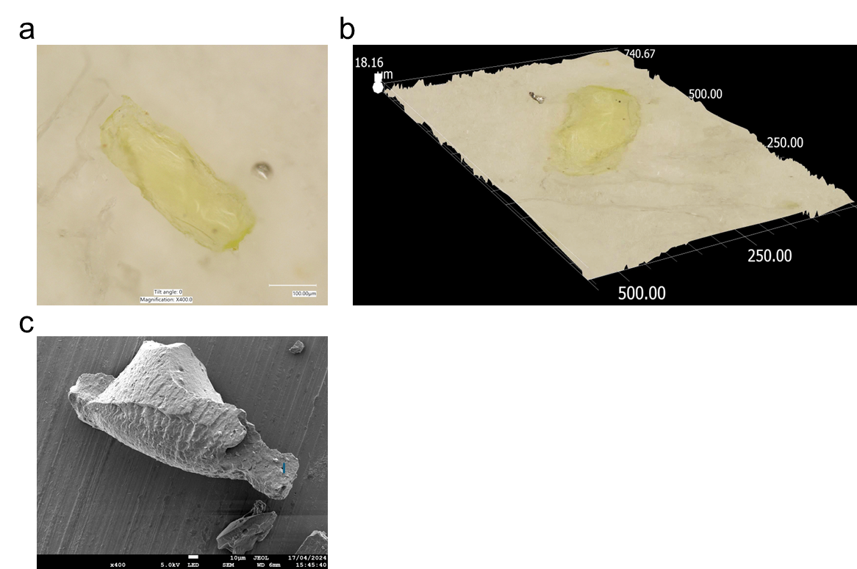
Figure S4. Morphology of microplastics released from PChB product 7. a, Bright-field optical micrograph. b, Three-dimensional topographic reconstruction from digital microscopy of the same region (axes in µm). c, Scanning electron micrograph showing a flake-like particle with a rough, layered surface.

Figure S5. Size distribution of MPs released from PChB products 1–6 after one 10-min chopping cycle (600 strikes).

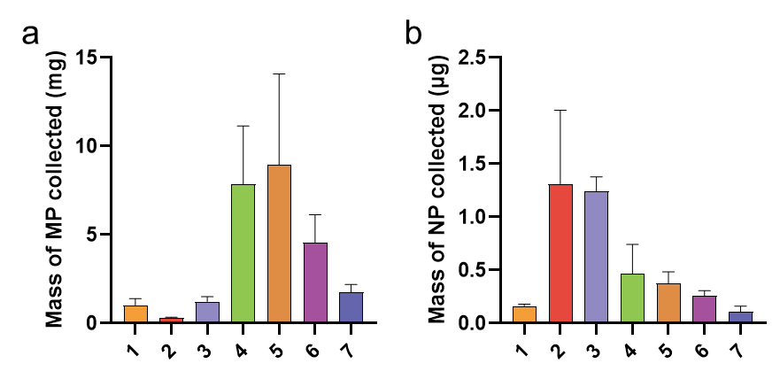
Figure S6. Mass of MPs and NPs released from PChB products 1–7 after one standardized chopping cycle (10 min, 600 strikes). a, MP mass (mg). b, NP mass (µg).
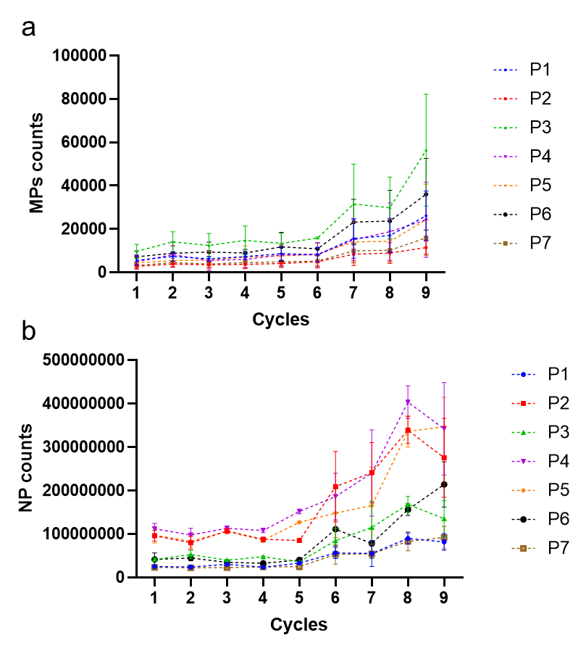
Figure S7. Release of MPs and NPs from PChB products 1–7 across nine chopping cycles. Each cycle lasted 10 min at 1 Hz (600 strikes), performed consecutively on the same surface. a, MP counts per cycle. b, NP counts per cycle. Linear regression results for each product are summarized in Tables S1–S2.

Figure S8. Pyrolysis–GC–MS chromatograms of a polypropylene (PP) standard and its 50% (v/v) ethanol extract.

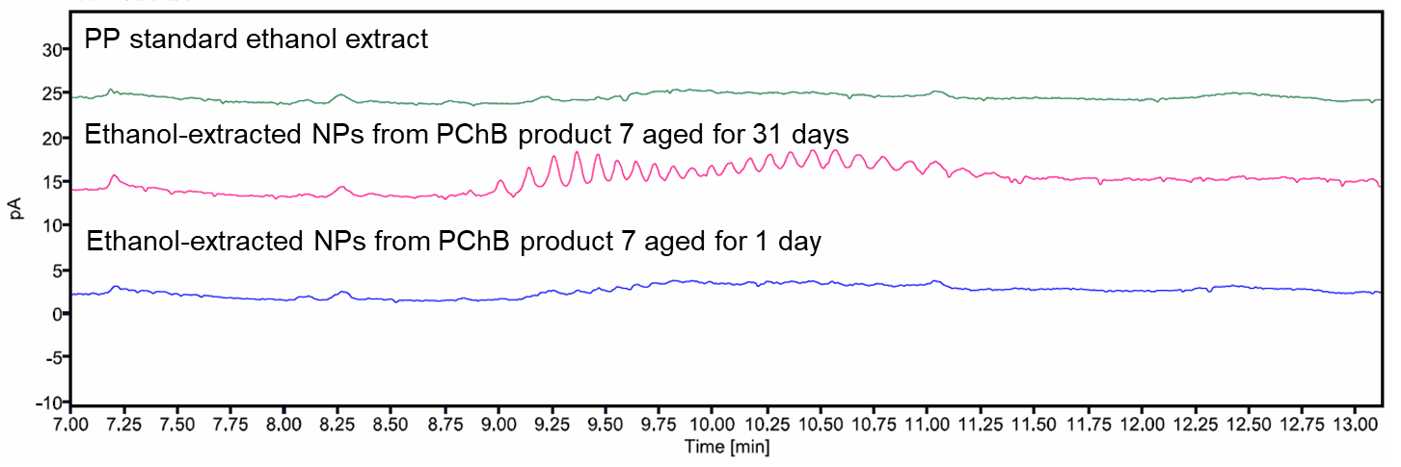
Figure S9. HPLC-CAD chromatograms of ethanol extracts. Shown are 50% (v/v) ethanol extracts of a PP standard (top), and ethanol-extracted NPs from PChB product 7 after 1 day (bottom) and 31 days (middle) of photoaging.
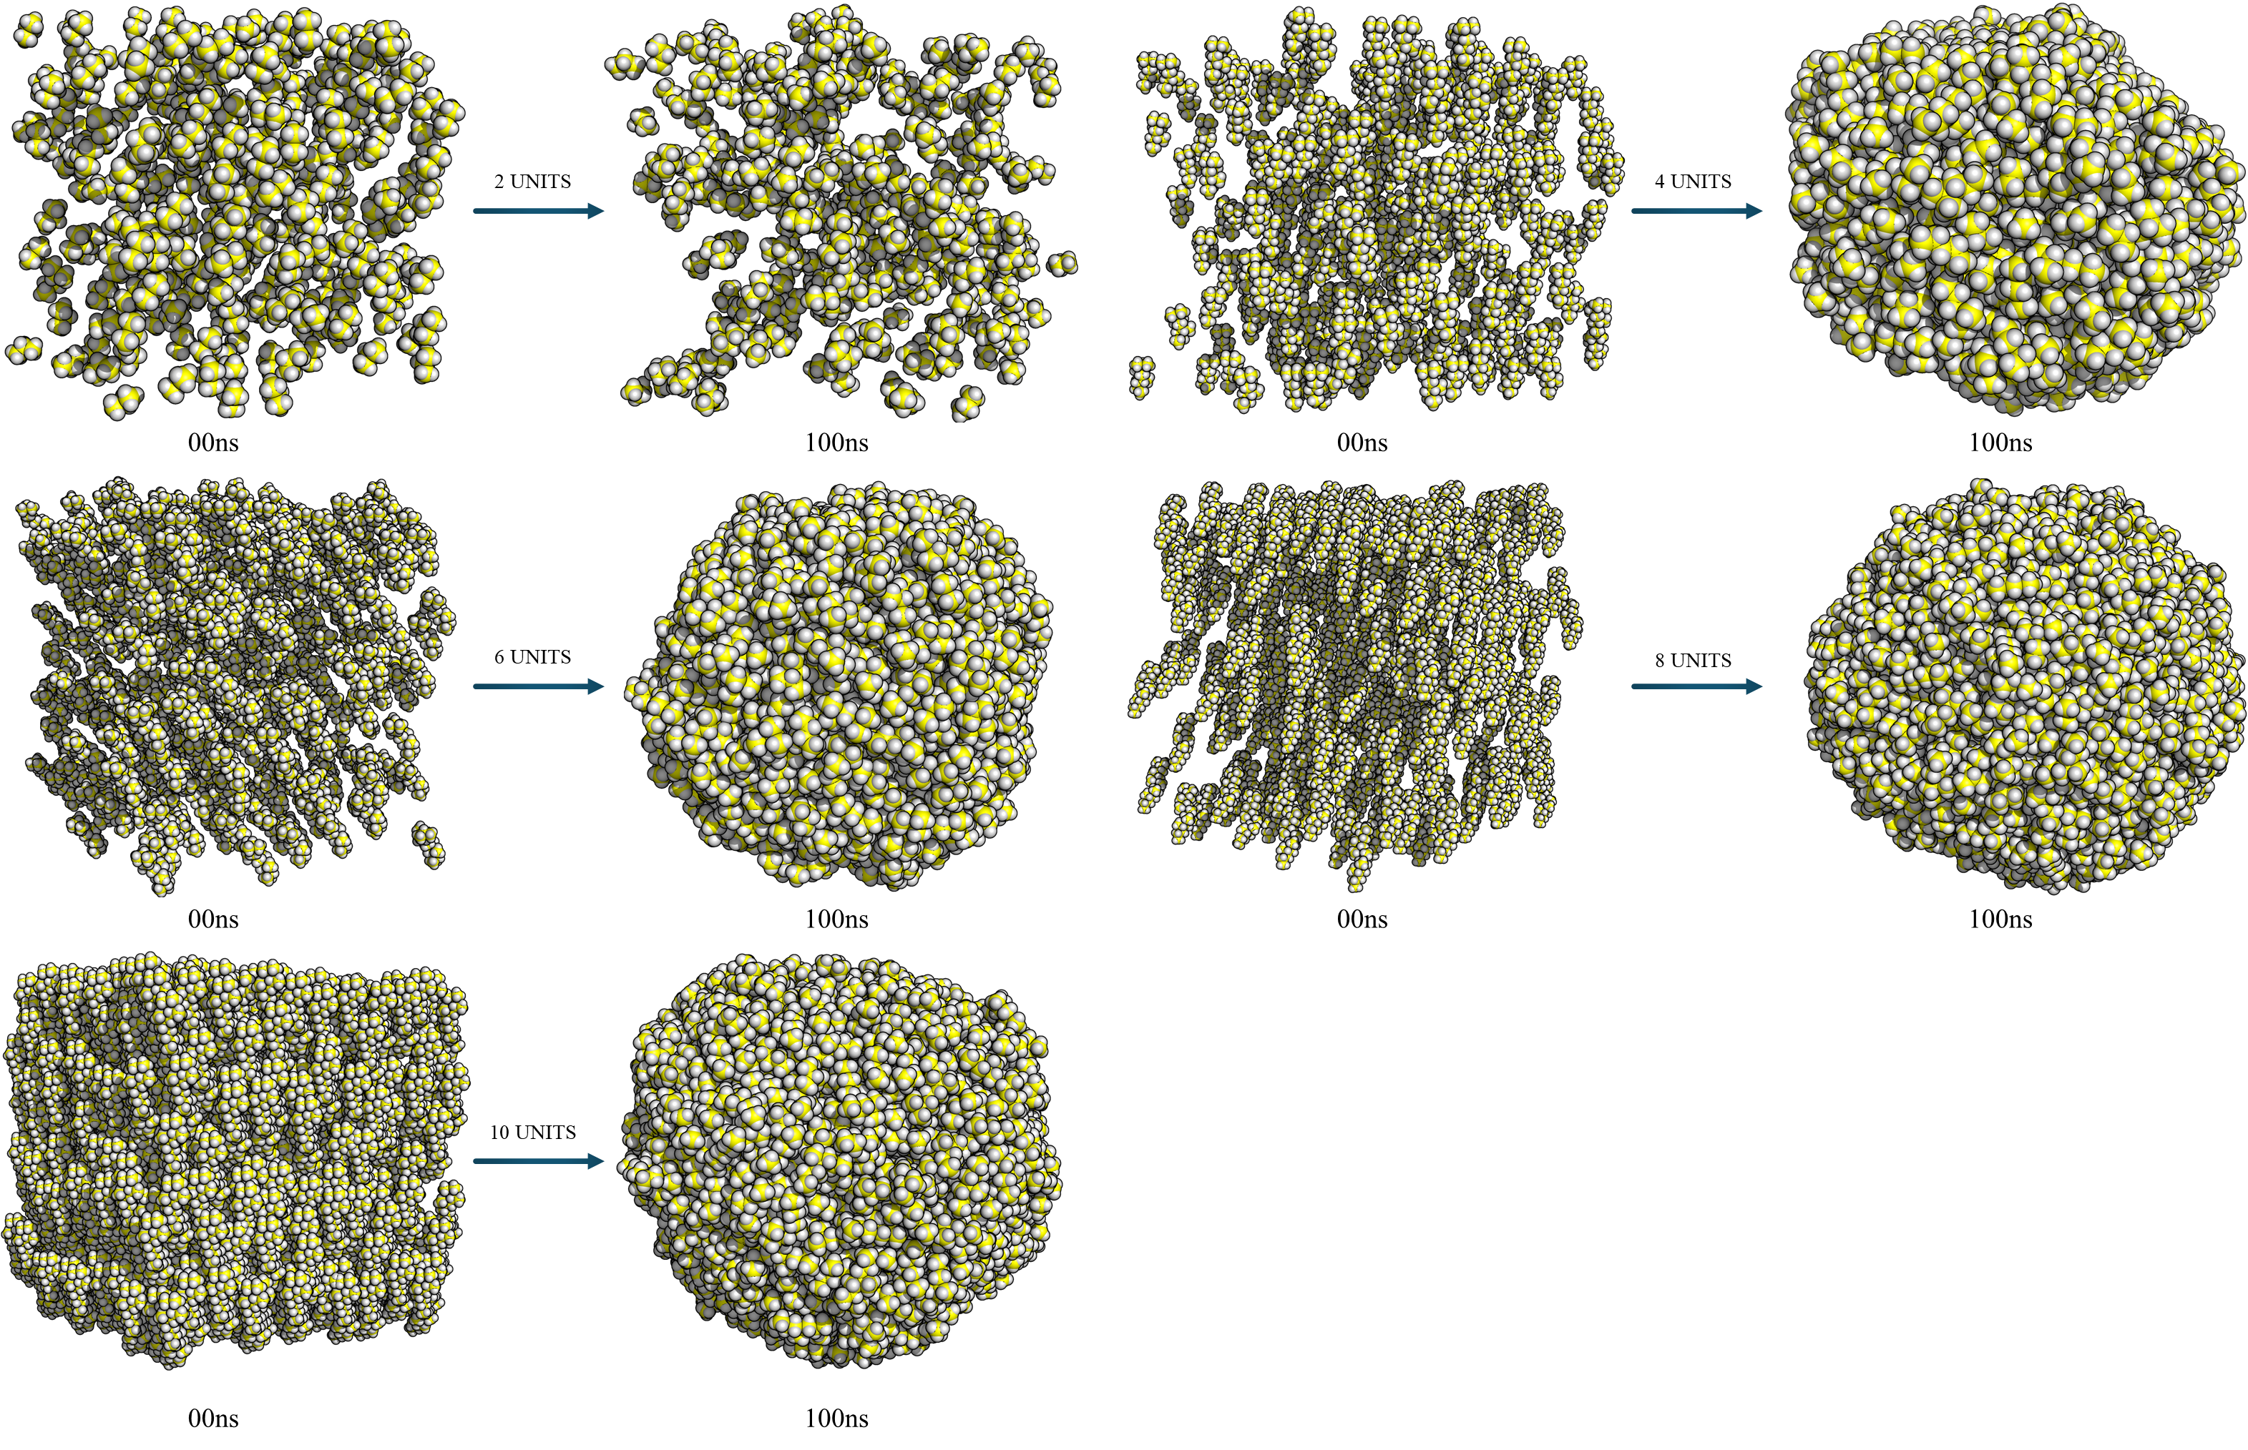
Figure S10. Trajectories depicting the aggregation of PP oligomers with different units at 0 and 100 ns. PP oligomers shown as spherical model (carbon, yellow; hydrogen, grey).
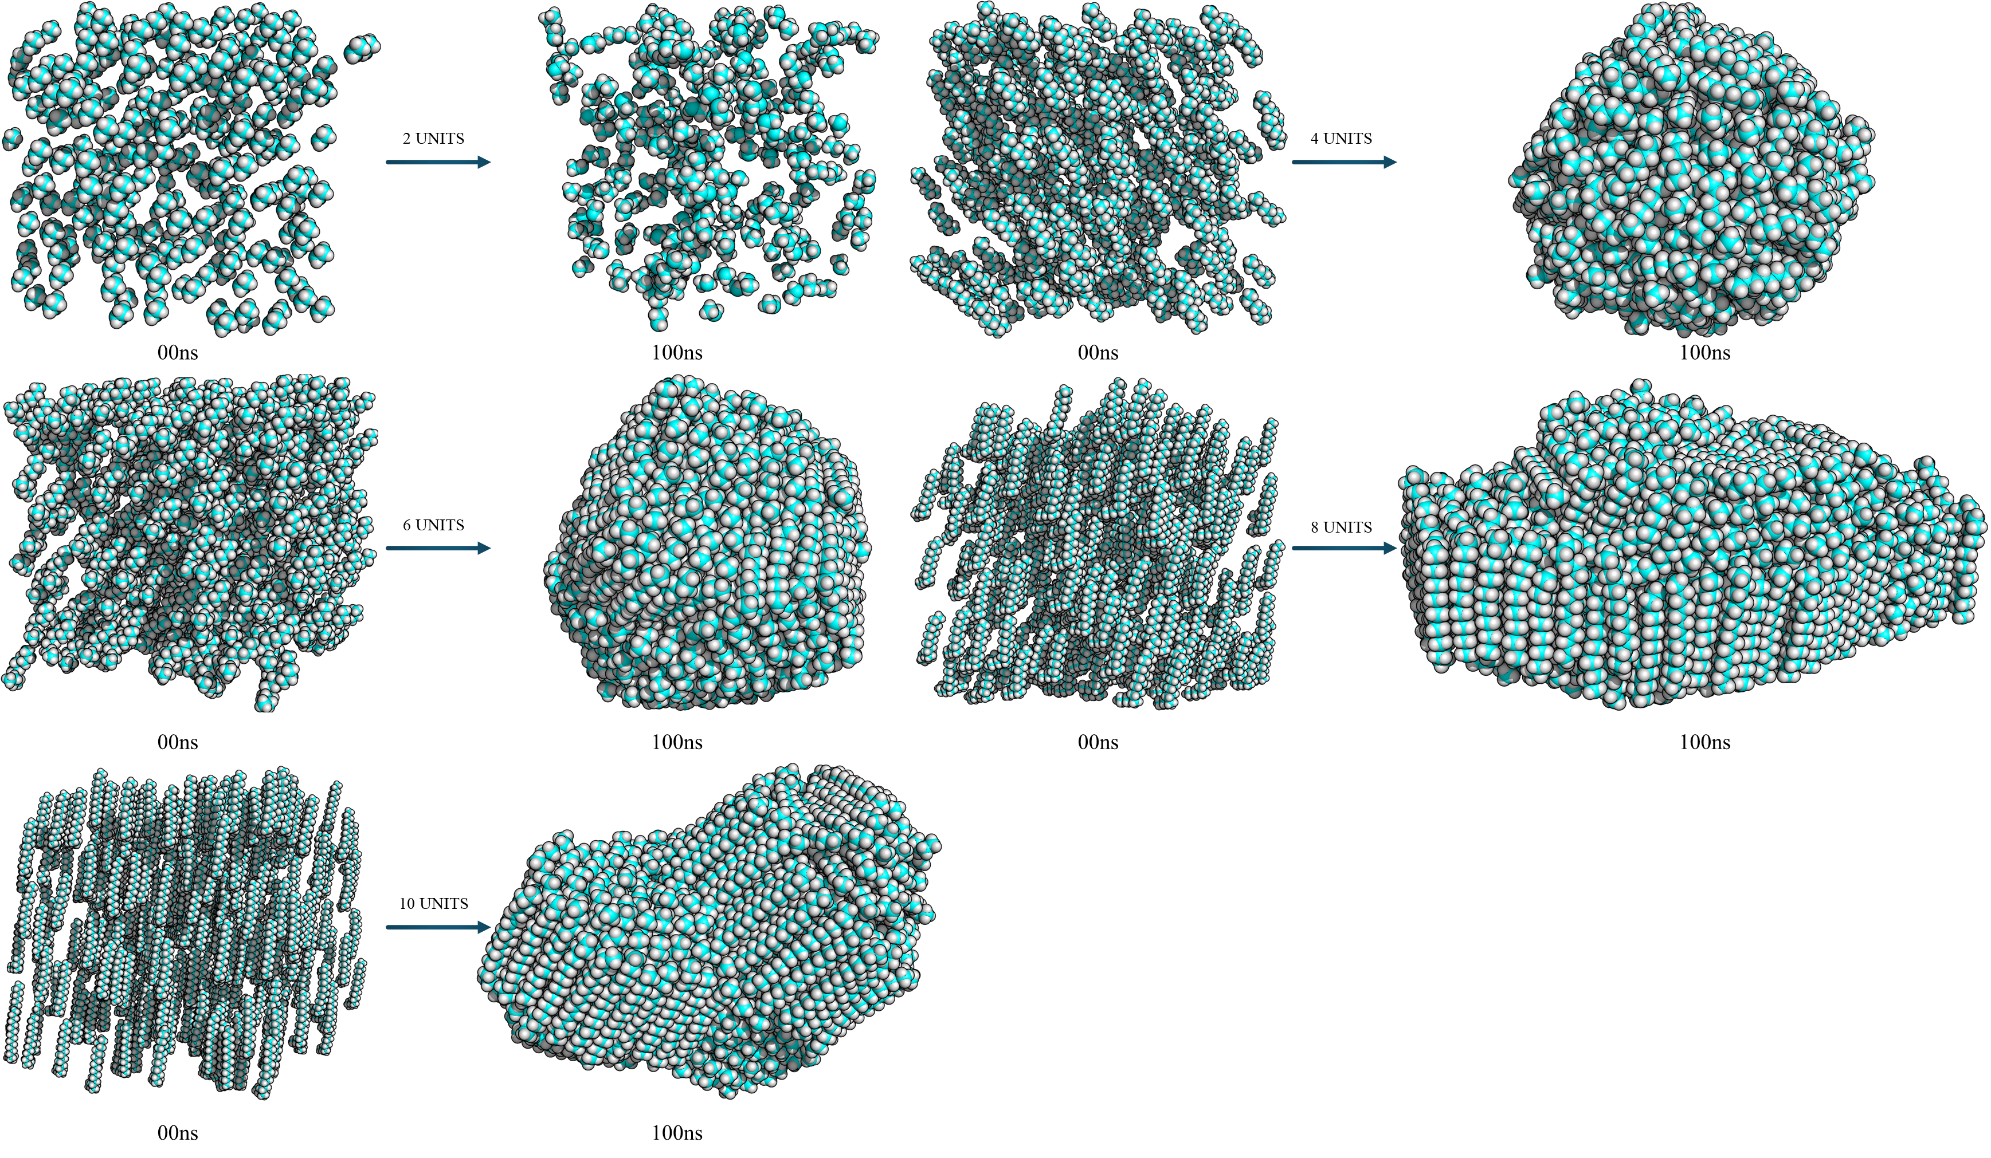
Figure S11. Trajectories depicting the aggregation of PE oligomers with different units at 0 and 100 ns. PE oligomers shown as spherical model (carbon, cyan; hydrogen, grey).

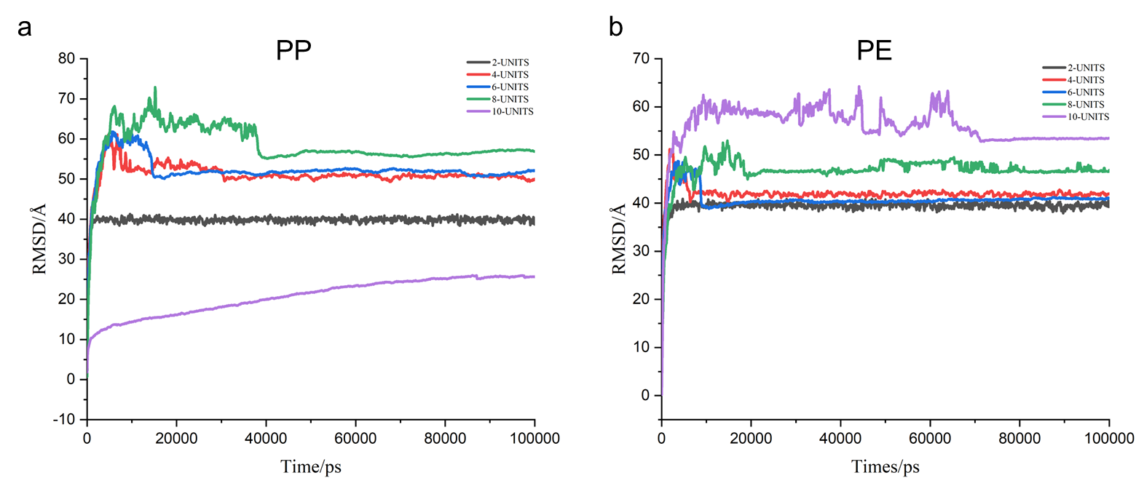
Figure S12. Root-mean-squared deviation (RMSD) of PP and PE oligomer aggregation. a, RMSD of two- to ten-unit PP oligomers over 0–100 ns. b, RMSD of two- to ten-unit PE oligomers over 0–100 ns.

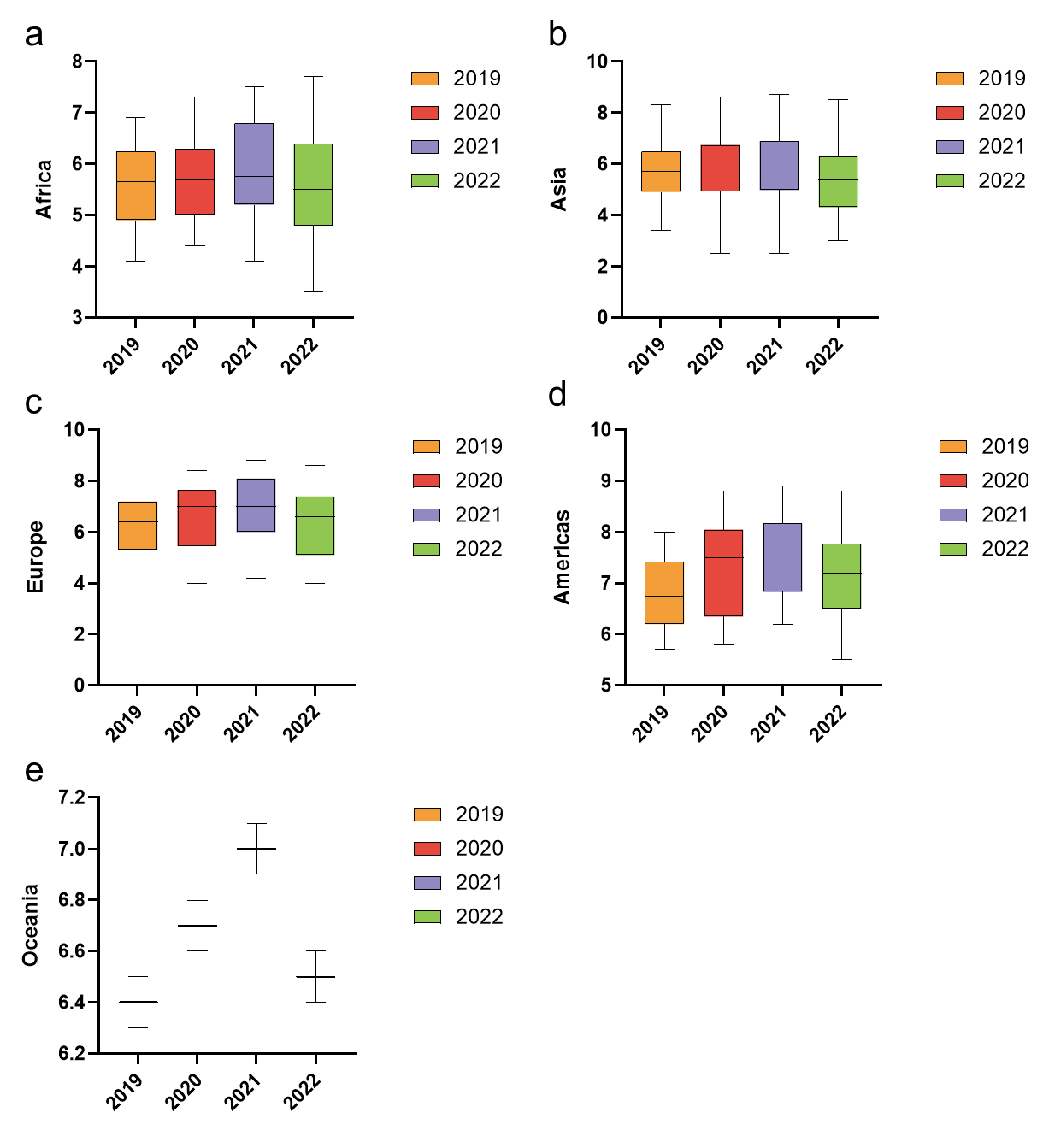
Figure S13. Frequency of cooking at home by continent from 2019 to 2022.
Figure S14. Cooked food consumption at home by continent in 2022.

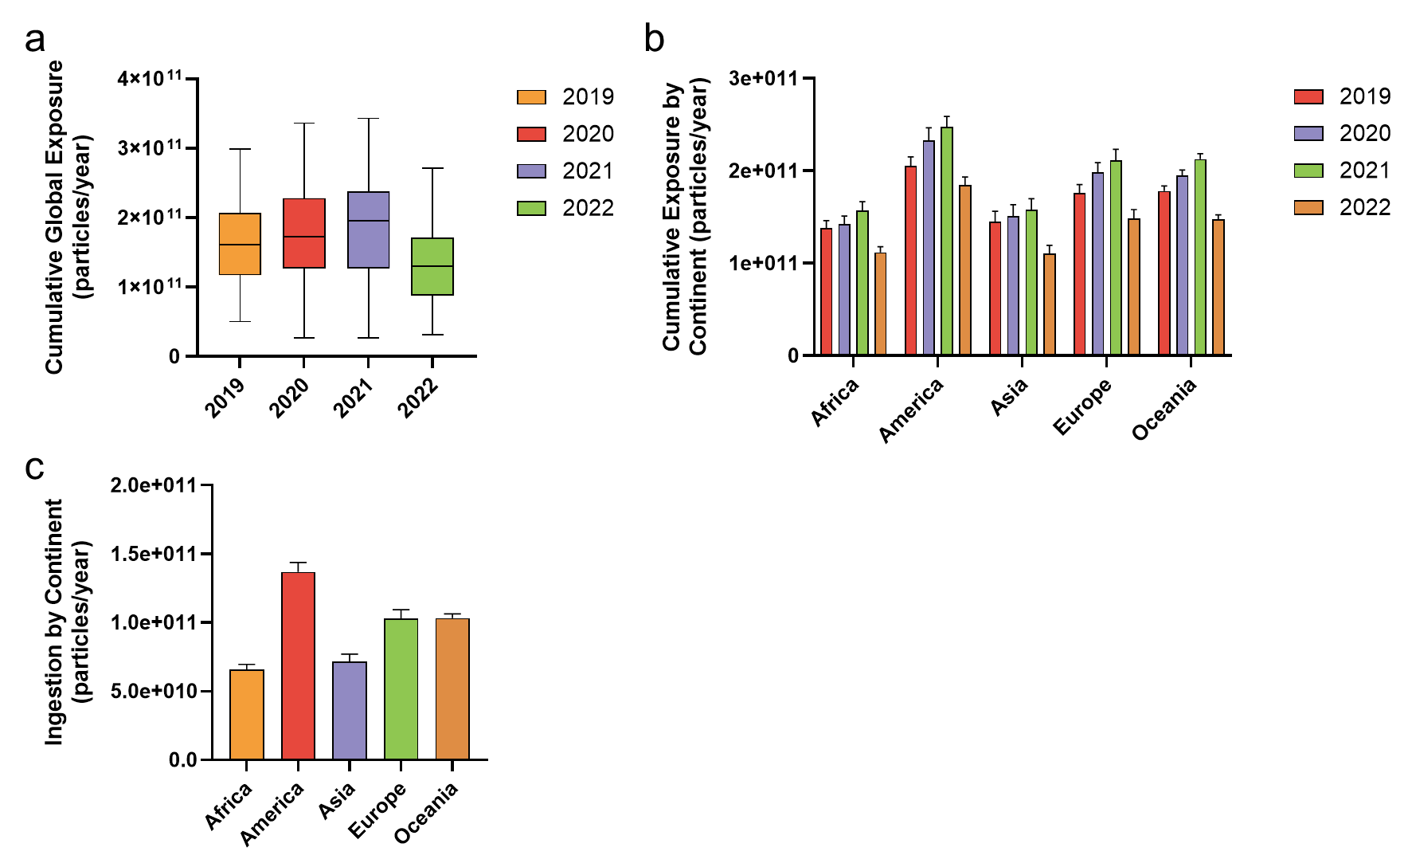
Figure S15. Cumulative annual exposure and ingestion of NPs worldwide. a, Average cumulative annual global exposure to NPs from 2019 to 2022. b, Average cumulative annual exposure to NPs by continent from 2019 to 2022. c, Average cumulative annual ingestion of NPs by continent in 2022.
Table S1. Linear Regression and ANOVA Analyses of MP Release During Nine Chopping Cycles on Seven Chopping Boards (p < 0.05 Considered Significant)
 | P1 | P2 | P3 | P4 | P5 | P6 | P7
R Square | 0.76 | 0.83 | 0.69 | 0.76 | 0.79 | 0.77 | 0.76
p | < 0.05 | < 0.05 | < 0.05 | < 0.05 | < 0.05 | < 0.05 | < 0.05

Table S2. Linear Regression and ANOVA Analyses of NP Release During Nine Chopping Cycles on Seven Chopping Boards (p < 0.05 Considered Significant)
 | P1 | P2 | P3 | P4 | P5 | P6 | P7
R Square | 0.82 | 0.76 | 0.73 | 0.79 | 0.73 | 0.71 | 0.82
p | < 0.05 | < 0.05 | < 0.05 | < 0.05 | < 0.05 | < 0.05 | < 0.05

Table S3. Number of Home-Cooked Meals per Week by Country, 2019–2022
Countries or areas | Continents | 2019 | 2020 | 2021 | 2022
Algeria | Africa | 4.90 | 4.80 | 4.80 | 4.80
Benin | Africa | 6.10 | 5.50 | 6.30 | 5.50
Botswana | Africa | NA | NA | NA | 5.80
Burkina Faso | Africa | 4.50 | 5.50 | 5.60 | NA
Cameroon | Africa | 4.10 | 4.60 | 4.70 | 4.50
Chad | Africa | NA | NA | NA | 5.90
Comoros | Africa | NA | NA | NA | 5.40
Côte d'Ivoire | Africa | NA | NA | 5.70 | 5.20
Democratic Republic of the Congo | Africa | NA | NA | NA | 3.90
Egypt | Africa | 5.20 | 4.40 | 4.90 | 4.80
Eswatini | Africa | NA | NA | NA | 5.40
Ethiopia | Africa | 6.30 | NA | NA | 6.50
Gabon | Africa | 4.90 | 4.60 | 4.60 | 4.60
Gambia | Africa | NA | NA | 4.20 | 4.20
Ghana | Africa | 5.60 | 5.80 | 5.80 | 4.80
Guinea | Africa | 4.70 | 4.90 | 5.20 | 4.50
Kenya | Africa | 6.90 | 6.50 | 7.20 | 6.10
Lesotho | Africa | NA | NA | NA | 6.40
Liberia | Africa | NA | NA | NA | 3.50
Libya | Africa | NA | NA | NA | 5.50
Madagascar | Africa | NA | NA | NA | 7.70
Malawi | Africa | NA | NA | 7.40 | 6.60
Mali | Africa | 5.40 | 7.30 | 7.50 | 7.10
Mauritania | Africa | NA | NA | NA | 5.90
Mauritius | Africa | 5.90 | 5.70 | 5.70 | 5.40
Morocco | Africa | 5.00 | 5.50 | 5.70 | 5.10
Mozambique | Africa | NA | NA | 6.90 | 6.60
Namibia | Africa | 5.70 | 6.00 | 6.00 | 6.30
Niger | Africa | 5.90 | 6.30 | NA | 5.40
Nigeria | Africa | 5.90 | 6.30 | 6.80 | 6.20
Republic of the Congo | Africa | 4.60 | 4.50 | 4.10 | 4.60
Senegal | Africa | 4.70 | 5.10 | 5.20 | 5.60
Sierra Leone | Africa | NA | NA | 5.70 | 4.10
South Africa | Africa | 6.60 | 6.80 | 6.80 | 7.00
Tanzania | Africa | 6.90 | 6.80 | 7.30 | 7.00
Togo | Africa | NA | NA | 6.80 | 6.20
Tunisia | Africa | 5.00 | 5.40 | 5.40 | 5.10
Uganda | Africa | 6.70 | 5.40 | 6.70 | 6.40
Zambia | Africa | 6.10 | 6.10 | 6.60 | 6.60
Zimbabwe | Africa | 6.30 | 6.30 | 6.60 | 5.10
Argentina | Americas | 7.40 | 7.60 | 7.60 | 7.30
Bolivia | Americas | 6.00 | 5.80 | 6.30 | 6.50
Brazil | Americas | 6.20 | 7.10 | 7.20 | 6.80
Canada | Americas | 7.30 | 7.90 | 7.90 | 7.60
Chile | Americas | 5.70 | 6.00 | 6.30 | 6.20
Colombia | Americas | 7.30 | 7.70 | 7.70 | 7.30
Costa Rica | Americas | 7.40 | 8.20 | 8.40 | 8.00
Dominican Republic | Americas | 6.20 | 7.20 | 7.30 | 6.90
Ecuador | Americas | 6.90 | 8.10 | 8.20 | 7.40
El Salvador | Americas | 7.70 | 8.20 | 8.30 | 8.80
Guatemala | Americas | NA | NA | NA | 7.60
Honduras | Americas | NA | NA | 7.70 | 8.20
Jamaica | Americas | 6.60 | 6.10 | 6.20 | 5.50
Mexico | Americas | 7.50 | 7.80 | 8.50 | 7.70
Nicaragua | Americas | 7.80 | 7.30 | 8.10 | 7.00
Panama | Americas | NA | NA | 7.90 | 8.30
Paraguay | Americas | 5.90 | 5.80 | 6.40 | 6.50
Peru | Americas | 6.60 | 7.40 | 7.40 | 7.00
Puerto Rico | Americas | NA | NA | NA | 6.30
United States | Americas | 6.20 | 6.80 | 6.70 | 6.10
Uruguay | Americas | 6.50 | 7.20 | 7.20 | 7.10
Venezuela | Americas | 8.00 | 8.80 | 8.90 | 8.60
Afghanistan | Asia | NA | NA | 5.10 | 4.00
Armenia | Asia | NA | NA | 6.90 | 6.20
Azerbaijan | Asia | NA | NA | NA | 5.70
Bangladesh | Asia | 4.90 | 4.80 | 4.90 | 4.30
Cambodia | Asia | 6.10 | 6.90 | 6.90 | 6.80
China | Asia | 8.30 | 6.30 | 6.90 | 6.90
Georgia | Asia | 5.30 | 5.50 | 5.50 | 5.50
Hong Kong | Asia | 5.50 | 5.20 | 5.20 | 5.00
India | Asia | 7.50 | 6.80 | 6.80 | 5.90
Indonesia | Asia | 6.20 | 7.20 | 7.20 | 7.20
Iran | Asia | 4.60 | 5.00 | 5.00 | 5.00
Iraq | Asia | 5.40 | 5.50 | 5.50 | 5.20
Israel | Asia | 4.50 | 4.20 | 4.20 | 4.10
Japan | Asia | 6.10 | 6.30 | 6.40 | 6.00
Jordan | Asia | 3.40 | 2.50 | 2.50 | 3.10
Kazakhstan | Asia | 6.00 | 5.70 | 6.90 | 6.30
Kuwait | Asia | NA | NA | NA | 4.80
Kyrgyzstan | Asia | 5.90 | 5.60 | 5.60 | 5.20
Laos | Asia | 8.00 | 8.60 | 8.70 | 8.50
Lebanon | Asia | 3.80 | 3.20 | 3.20 | 3.60
Malaysia | Asia | 5.40 | 7.10 | 7.40 | 5.50
Mongolia | Asia | 5.90 | 6.60 | 6.60 | 6.50
Myanmar | Asia | 6.00 | 6.00 | 6.20 | 6.00
Nepal | Asia | 6.50 | 6.60 | 6.70 | 7.20
Northern Cyprus | Asia | NA | NA | NA | 5.20
Pakistan | Asia | 5.40 | 4.60 | 4.80 | 4.40
Palestinian Territories | Asia | NA | NA | NA | 3.00
Philippines | Asia | 6.90 | 8.00 | 8.00 | 7.60
Saudi Arabia | Asia | 3.40 | 4.80 | 5.20 | 5.00
Singapore | Asia | NA | NA | 4.40 | 4.00
South Korea | Asia | 3.60 | 4.50 | 4.00 | 4.40
Sri Lanka | Asia | 6.60 | 6.50 | 6.90 | 6.30
Taiwan | Asia | 4.10 | 4.20 | 5.20 | 3.40
Tajikistan | Asia | 5.00 | 4.90 | 5.00 | 5.40
Thailand | Asia | 7.00 | 6.50 | 6.60 | 7.60
United Arab Emirates | Asia | 4.90 | 6.10 | 4.90 | 4.30
Uzbekistan | Asia | 5.70 | 5.30 | 6.10 | 5.50
Vietnam | Asia | 6.90 | 7.40 | 8.30 | 8.00
Yemen | Asia | NA | NA | NA | 4.20
Albania | Europe | 6.00 | 6.80 | 6.10 | 5.70
Austria | Europe | 6.30 | 7.00 | 7.00 | 6.90
Belgium | Europe | 7.10 | 8.30 | 8.70 | 8.10
Bosnia and Herzegovina | Europe | 6.20 | 6.80 | 6.80 | 6.40
Bulgaria | Europe | 5.20 | 6.20 | 6.60 | 4.80
Croatia | Europe | 4.70 | 5.50 | 5.70 | 4.50
Cyprus | Europe | 5.40 | 5.70 | 6.20 | 5.60
Czech Republic | Europe | NA | 5.20 | 5.20 | 5.40
Denmark | Europe | 7.40 | 7.30 | 7.40 | 7.00
Estonia | Europe | 7.20 | 6.70 | 7.40 | 6.20
Finland | Europe | 5.70 | 5.60 | 6.00 | 5.80
France | Europe | 6.80 | 7.60 | 8.30 | 8.60
Germany | Europe | 7.00 | 7.90 | 8.20 | 8.30
Greece | Europe | 4.40 | 5.20 | 5.20 | 4.00
Hungary | Europe | 3.70 | 4.00 | 4.20 | 4.00
Iceland | Europe | NA | 4.60 | 4.80 | 4.10
Ireland | Europe | 7.10 | 8.20 | 8.40 | 8.50
Italy | Europe | 7.60 | 8.00 | 8.10 | 8.20
Kosovo | Europe | 4.90 | 5.20 | 5.20 | 4.90
Latvia | Europe | 6.40 | 6.70 | 7.30 | 7.40
Lithuania | Europe | 6.30 | 7.40 | 8.80 | 6.60
Luxembourg | Europe | NA | NA | NA | 6.70
Malta | Europe | 6.10 | 6.20 | 7.00 | 6.90
Moldova | Europe | 7.00 | 7.40 | 7.40 | 7.00
Montenegro | Europe | 4.60 | NA | NA | 4.70
Netherlands | Europe | 7.00 | 7.00 | 6.10 | 6.90
North Macedonia | Europe | 5.20 | 5.90 | 6.50 | 5.20
Norway | Europe | 7.40 | 8.40 | 8.60 | 7.40
Poland | Europe | 7.50 | 7.10 | 7.10 | 5.90
Portugal | Europe | 7.20 | 8.00 | 8.50 | 7.70
Romania | Europe | 6.70 | 7.10 | 7.10 | 6.80
Russia | Europe | 7.20 | 7.20 | 7.30 | 7.40
Serbia | Europe | 5.10 | 5.20 | 5.20 | 4.90
Slovakia | Europe | 4.60 | 5.20 | 5.20 | 4.30
Slovenia | Europe | 6.50 | 6.40 | 6.40 | 6.40
Spain | Europe | 7.80 | 7.80 | 8.00 | 8.10
Sweden | Europe | 6.30 | 7.00 | 7.00 | 6.00
Switzerland | Europe | 7.20 | 8.00 | 8.40 | 8.00
Türkiye | Europe | NA | 5.30 | 5.30 | 5.00
Ukraine | Europe | 7.50 | 7.30 | 7.30 | 7.20
United Kingdom | Europe | 6.10 | 7.60 | 8.20 | 8.00
Australia | Oceania | 6.30 | 6.80 | 7.10 | 6.60
New Zealand | Oceania | 6.50 | 6.60 | 6.90 | 6.40
Note: "NA" indicates that data is not available.

