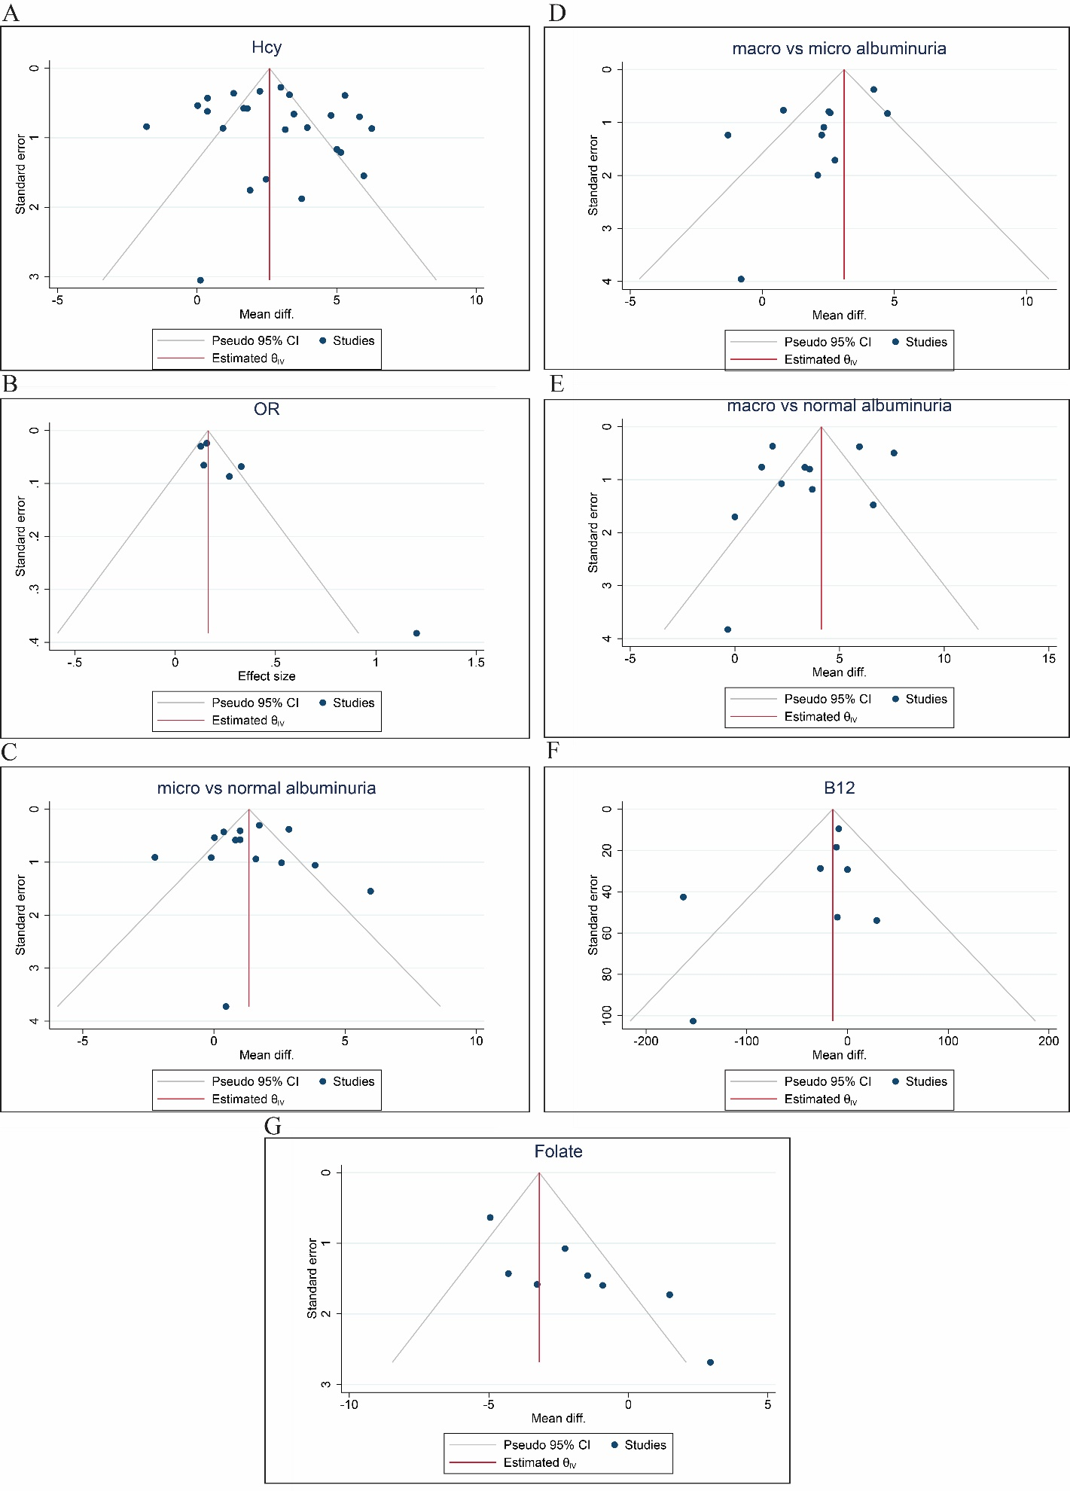
Figure S1. Assessment of publication bias for homocysteine-related and, Folate and vitamin B12. (A) Funnel plot for Hcy mean difference studies. (B) Funnel plot for OR estimate. (C) Funnel plot for serum Hcy level in microalbuminuria vs. normoalbuminuria. (D) Funnel plot for serum Hcy level Macroalbuminuria vs. microalbuminuria. (E) Funnel plot for serum Hcy level macro albuminuria vs. normal albuminuria. (F) funnel plot for vitamin B12. (G) Funnel plot for Folate acid.
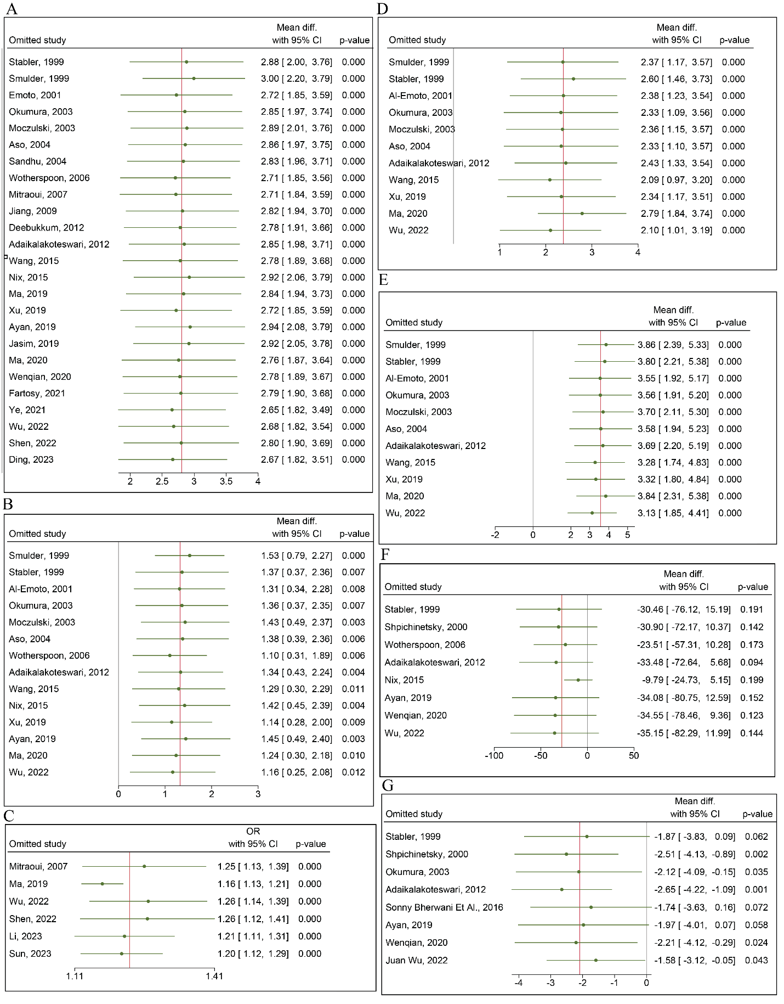
Figure S2. Sensitivity Analyses for Homocysteine, Folate, and Vitamin B12-Related Outcomes. (A) Sensitivity analysis for studies reporting mean differences in homocysteine. (B) Sensitivity analysis for homocysteine: microalbuminuria vs. normoalbuminuria. (C) Sensitivity analysis for homocysteine odds ratio (OR) estimates. (D) Sensitivity analysis for homocysteine: macroalbuminuria vs. microalbuminuria. (E) Sensitivity analysis for homocysteine: macroalbuminuria vs. normoalbuminuria. (F) Sensitivity analysis for vitamin B12. (G) Sensitivity analysis for folate.

