Supplementary materials:

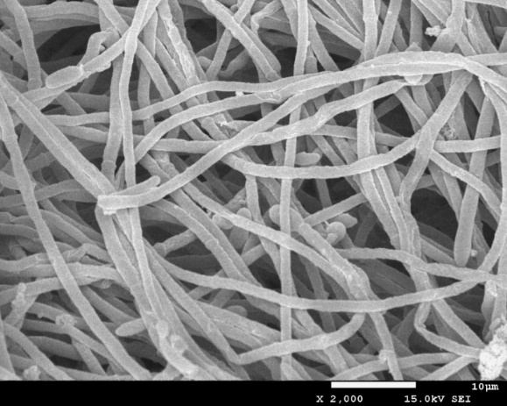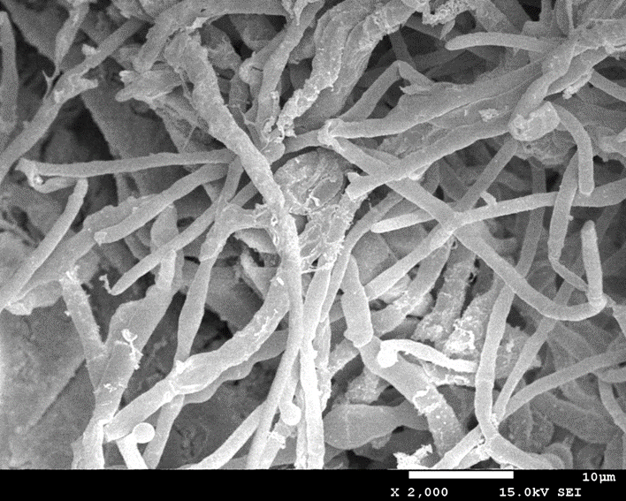
Fig.1 Scanning electron microscope of strain ZI (left) and strain ZI under Cd²⁺ stress(right)

reverse view obverse view
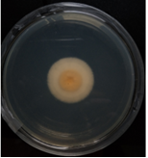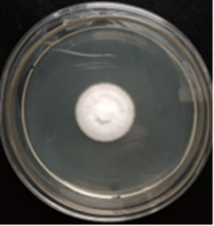
Fig.2 The obverse and reverse morphological characteristics of strain Z1 on LB medium

