SUPPLEMENTARY MATERIALS
GWAS metanalysis of atrial fibrillation reveals significant sex-related heterogeneity effects of the PITX2 and CFL2 loci
Jara Cárcel-Márquez¹†* PhD, Paula Boldo¹* MSc, Laia Llucià-Carol¹ MSc, Elena Muiño^{1,2} PhD, Cristina Gallego-Fabrega¹ PhD, Natalia Cullell^{1,3} PhD, Miquel Lledós¹ PhD, Jesús M. Martín-Campos¹ PhD, Paula Villatoro-González¹ MSc, Laia Mariné¹ MSc, Julia Carrasco-Zanini PhD⁴, Ramón Iglesias-Rey PhD⁵, Francisco Campos⁵ PhD, Antonio J. Mosqueira⁶ PhD, Marimar Freijo⁷ PhD, Juan Francisco Arenillas⁸ PhD, Victor Obach⁹ PhD, José Álvarez-Sabín¹⁰ PhD, Carlos A. Molina¹⁰ PhD, Marc Ribó¹⁰ PhD, Jordi Jiménez-Conde¹¹ PhD, Lucia Muñoz-Narbona¹² PhD, Elena Lopez-Cancio¹³ PhD, Mònica Millán¹² PhD, Rosa Diaz-Navarro¹⁴ PhD, Silvia Tur-Campos¹⁴ PhD, Cristòfol Vives-Bauza¹⁴ PhD, Gemma Serrano-Heras¹⁵ PhD, Tomás Segura¹⁵ PhD, Laura Ibañez^{16,17,18} PhD, Laura Heitsch^{17,19} MD, Pilar Delgado²⁰ PhD, Rajat Dhar¹⁷ PhD, Jerzy Krupinski²¹ PhD, Luis Prats-Sánchez²² PhD, Joan Martí-Fàbregas²² PhD,Marina Guasch²² MD, Garbiñe Ezcurra²² MD, Natalia Blay²³ PhD, Lauro Sumoy²⁴ PhD, Rafael de Cid²³ PhD, Elena Casiraghi²⁵ PhD, Giorgio Valentini^{25,26,27} PhD, Alejandro Fernández-Vega²⁸ PhD, PhD, Joan Montaner²⁷ PhD, Xabier Urra²⁹ PhD, María del Mar Castellanos-Rodrigo³⁰ PhD, Anna Penalba Morenilla³¹, Claudia Langenberg PhD^{32,33,34}, José Castillo⁴ PhD, Tomás Sobrino^{4,35} PhD, Carlos Cruchaga^{15,17} PhD, Jin-Moo Lee¹⁷ PhD, Pol Camps-Renom²² PhD, Israel Férnandez-Cadenas¹† PhD.

Replication cohort quality control
DNA samples for all subjects were obtained from whole blood. A total of 14,317 samples were genotyped in the study. After quality control, 12,614 samples fulfilled the quality control criteria and were not missing data for the analyzed phenotypes and covariates: atrial fibrillation (AF), sex, and age.
DNA samples were genotyped with commercial arrays from Illumina and ThermoFisher (San Diego, CA) (Supplementary Table S3). Quality control was performed using PLINK v1.9 and KING v2.1.3 software. For all datasets, samples were excluded in the following circumstances: a mismatch between the genetic and reported sex, genotype call rate <95%, excess or loss of heterozygosity, non-Europeans detected as outliers in the Phase 3 1000 Genomes Project dataset, and duplicated or related samples (PI-HAT>0.20). Single nucleotide polymorphisms (SNPs) were excluded in the following circumstances: call rate <95%, non-autosome location, non-biallelic, strand-ambiguous, monomorphic, and deviation from the Hardy-Weinberg equilibrium (p <10⁻⁶ in controls, p<10⁻¹⁰ in ischemic stroke (IS) cases).
Imputation was performed in the Michigan Imputation Server¹ using Minimac4 and the reference panel HRC r1.1 2016 (GRCh37/hg19) with European ancestry. Eagle v2.4 was used for phasing. After imputation, we removed SNPs with imputation scores <0.6 and minor allele frequency (MAF) <1%. SNPs not present in ≥95% of the individuals were removed.
Replication population
Patients with IS were recruited via hospital-based studies between 2003 and 2020 if they had a measurable neurologic deficit as per the National Institutes of Health Stroke Scale (NIHSS) within 6 hours of the last known asymptomatic status, had been diagnosed with stroke by an experienced neurologist, and the diagnosis had been confirmed by neuroimaging. The recruited patients were participants in the following studies: Genetics of Early Neurological Instability After Ischemic Stroke (GENISIS)², Genetic Contribution to Functional Outcome and Disability after Stroke (GODS)³, Genetic Study in Ischemic Stroke Patients Treated with Tissue Plasminogen Activator (GenoTPA)⁴, CONtrol ICtus (CONIC)⁵, and SEDMAN⁶.
Controls were subjects with no history of IS who declared themselves to be free of neurovascular diseases before recruitment. The control cohort was recruited via a blood donation program at primary care centers in Barcelona and in hospitals throughout Spain as part of the following projects: Genomes for Life-Cohort Study of Genomes of Catalonia Study (GCAT)^{7,8}, CONIC⁵, Genotyping Recurrence Risk of Stroke (GRECOS)⁹, and Investigating Silent Stroke in Hypertensives: A Magnetic Resonance Imaging Study (ISSYS)¹⁰. Array information, hospital contributions, and clinical details of the cohort are described in Supplementary Tables S1 S2 and S3.
Cohort descriptions
GENISIS² is an international study currently recruiting patients from 4 different locations: USA, Finland, Poland, and Spain. Inclusion criteria are patients with IS (aged ≥18 years) recruited from 2003 to 2016 with a measurable neurologic deficit as per the NIHSS within 6 hours of the last known normal. Excluded were patients who received endovascular thrombectomy and for whom consent and/or a blood sample could not be obtained. For our study we only included Spanish patients. Genotyping was performed with the Human Core Exome chip (Illumina).
GODS³ is a study that aims to find genetic factors associated with stroke outcomes. All participants met the following criteria: (1) European descent, aged >18 years, diagnosis of IS in the anterior vascular territory; (2) assessed by a neurologist during the acute stroke phase; (3) initial stroke severity >4 as per the NIHSS; (4) information on post-stroke functional status at 3 months (or alternatively between 3-6 months); (5) evidence of acute IS in a neuroimaging study; and (6) lack of any concomitant pathology. Excluded were individuals with stroke recurrence during the follow-up period and with posterior vascular territory and lacunar strokes. Samples were genotyped at the Genetic and Molecular Epidemiology Laboratory of McMaster University (David Braley Research Institute) in Ontario (Canada) with Human Core Exome chip (Illumina).
CONIC⁵ is a national study that recruited controls and IS cases in Vall d’Hebron Hospital (Spain) between 2007 and 2008. All controls were >65 years and declared free of dementia, neurovascular and/or cardiovascular disease, as self-reported in a face-to-face interview before recruitment. Excluded were individuals with a history of first and/or second-degree neurovascular disorder. The IS cases had been admitted to the emergency department of a university hospital with a documented middle cerebral artery occlusion on transcranial Doppler ultrasonography and received tissue plasminogen activator (tPA) in a standard 0.9-mg/kg dose (10% bolus, 90% continuous infusion during 1 hour) within 3 hours of symptom onset, following National Institute of Neurological Disorders and Stroke (NINDS) recommendations. Cases and controls were genotyped with Human Core Exome chip (Illumina).
GRECOS⁹ is a national study that aims to find genetic factors associated with stroke recurrence. Controls, selected from relatives of patients (wife or husband, with no consanguinity among cases and controls) and healthy volunteers visiting the same hospital for routine testing, were aged >65 years and classified as free of neurovascular and cardiovascular history and with no family history of stroke following a pre-recruitment interview. All samples were genotyped with Human Core Exome chip (Illumina).
ISSYS¹⁰ is an observational prospective study of individuals with hypertension to determine the prevalence of silent or magnetic resonance imaging (MRI)–defined brain infarcts and cognitive impairment. This cohort comprises 1,000 non-demented individuals, aged 50-70 years, diagnosed with essential hypertension at least 1 year before inclusion in the study. The individuals were genotyped with Human Core Exome chip (Illumina).
GCAT^{7,8}, a health databank containing data and samples from participants, is used to study the genetic and environmental factors that lead to chronic diseases in the general population. The study is conducted in several data collection waves, including GCAT1 (baseline survey from 2014-2017) and GCAT2 (GCAT second-year follow-up). Data are collected through web-based self-administered questionnaires, direct interviews, clinical data, and DNA analyses of blood-derived samples. Genome-wide genotypes have been generated using Illumina Infinium single nucleotide variant (SNV)-bead array technology and the Multi-Ethnic Global (MEGAEX, v.2) consortium array. In our study, we included only GCAT1 genotyped patients and we excluded individuals with heart infarction and diseases and with non-Caucasian ancestry.
GenoTPA⁴ consecutively recruited patients with acute IS admitted to the emergency room who received recombinant tPA within 4.5 hours of symptom onset. Patients were enrolled between 2002 to 2012 from Spanish hospitals (Vall d’Hebron University Hospital, Hospital Clínic, Hospital Universitari de Girona Doctor Josep Trueta, Hospital de la Santa Creu i Sant Pau, Hospital Universitari Germans Trias i Pujol, Hospital Universitari del Mar, Hospital de Basurto). The study protocol was approved by the ethics committee of each center and patients or legal representatives signed the informed consent. Patients were identified by medical evaluation on emergency room arrival; stroke diagnosis was by trained neurologists, confirmed by neuroimaging. There were no exclusion criteria regarding age, sex, or ethnicity. Follow-up computed tomography (CT) scans, at 24 hours after onset of symptoms or in the event of neurological deterioration, were classified according to the European Cooperative Acute Stroke Study (ECASS)¹¹.
SEDMAN⁶ includes patients aged ≥18 years, treated with acenocoumarol or dabigatran for stroke or systemic embolism prevention following local recommendations. All patients had a stroke or transient ischemic attack in the 14 days before initiation of anticoagulation treatment and had a diagnosis of non-valvular atrial fibrillation. Included were patients with mild to moderate stroke (less than 2/3 of the vascular territory) with an initial Alberta Stroke Program Early CT Score (ASPECTS) >6 in the first CT/MRI and with NIHSS <25. All patients had a general condition that allowed 12 months of follow-up. Only patients with established stroke were used in the analysis.
CEGEN is a population-based cohort study by means of collaboration between the technological platforms "Banco Nacional de ADN Carlos III (BNADN);www.bancoadn.org)) and the “Centro Nacional de Genotipado-Fundación Pública Galega de Medicina Xenómica". Genotyping from the Spanish control population was performed using the Axiom Spanish Biobank Array (Affymetrix Platform, ThermoFisher Scientific). Participants were selected from unrelated healthy volunteers drawn from the general population who underwent routine medical check-ups. These individuals were matched by age, sex, and geographical location, and were free of any history of cardiovascular or neurovascular diseases, following a pre-recruitment assessment. SANT PAU cohort is a study that brings together samples from participants recruited at the Hospital de la Santa Creu y Sant Pau in Barcelona (Spain). The inclusion criteria for patients age >18 years and having experienced IS. Controls were healthy individuals with no history of stroke or cardiovascular disease. All samples were genotyped using the Axiom Spain Biobank Array. This cohort aims to investigate not only genetic factors underlying IS, but to contribute to a more comprehensive understanding of stroke risk and related mechanisms.
IBIOSTROKE project (Clinical Validation of Biomarkers for Long-term Outcome after Cerebral Ischemia) includes European IS cases and population controls aged >18 years with no prior history of cognitive impairment, assessed using the Montreal Cognitive Assessment (MoCA). To date, the cohort consists of patients recruited from Hospital Mútua de Terrassa in Terrassa (Spain). All samples have been genotyped with the Axiom Spain Biobank Array.
COLISEUM¹² is a cohort study focused on patients with acute IS and large vessel occlusion (LVO) who have undergone endovascular treatment. The study aims to assess the association between collateral circulation, blood pressure on admission, and clinical outcomes. Participants were evaluated using automated collateral scoring based on CT angiography, and genotyping was performed using the Axiom Spain Biobank Array. The study included consecutive IS cases from January 2018 to December 2019, aged ≥18 years, with intracranial anterior circulation LVO (M1, M2, or TICA) receiving endovascular therapy (EVT). Patients were excluded if they had additional occlusions, intracranial hemorrhage on baseline CT, previous anterior circulation infarct, or technical issues precluding image analysis.

Supplementary figures
Figure S1. Manhattan plots of GWAS analysis and metanalysis of AF in the independent cohort. Panel A: female-only GWAS. Panel B: male-only GWAS. Panel C: GWAS metanalysis.
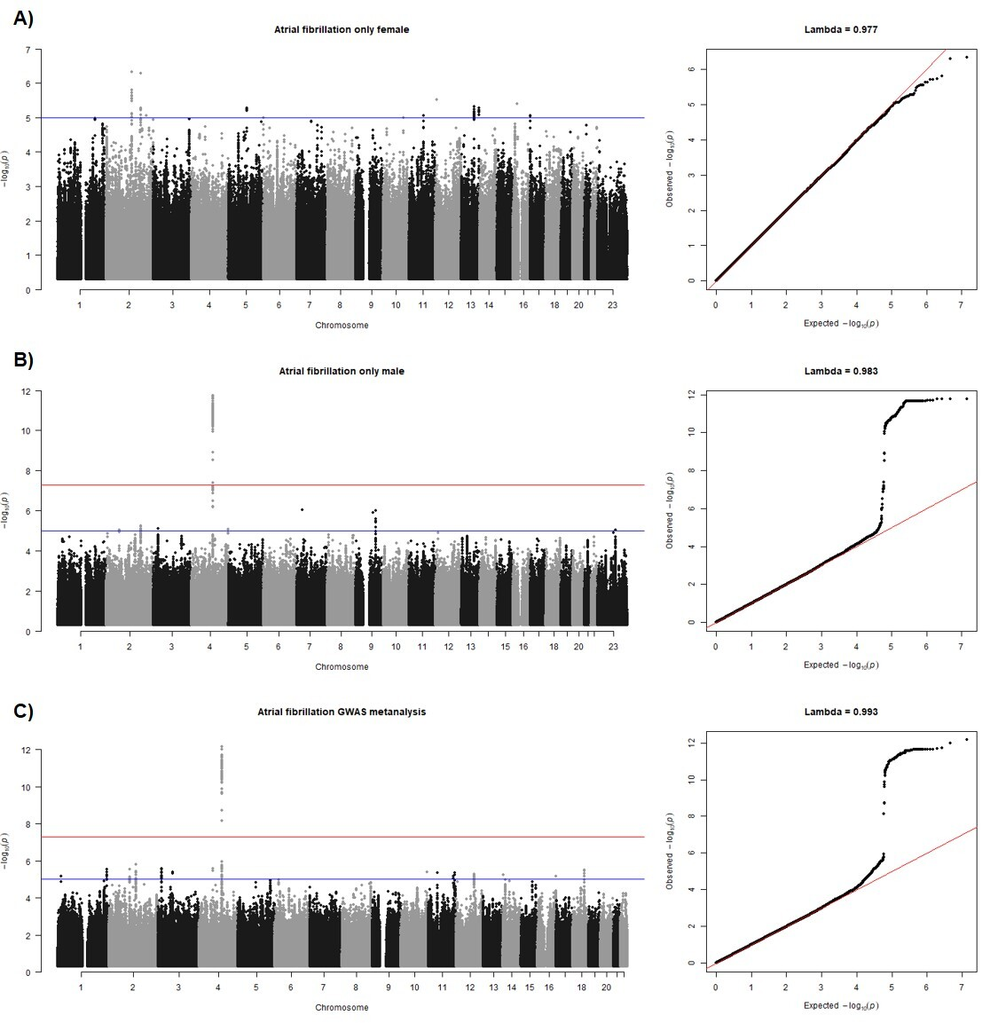

Figure S2. MYL1 protein level interaction analysis between rs6843082 and sex adjusted by sex and stratified by atrial fibrillation status.
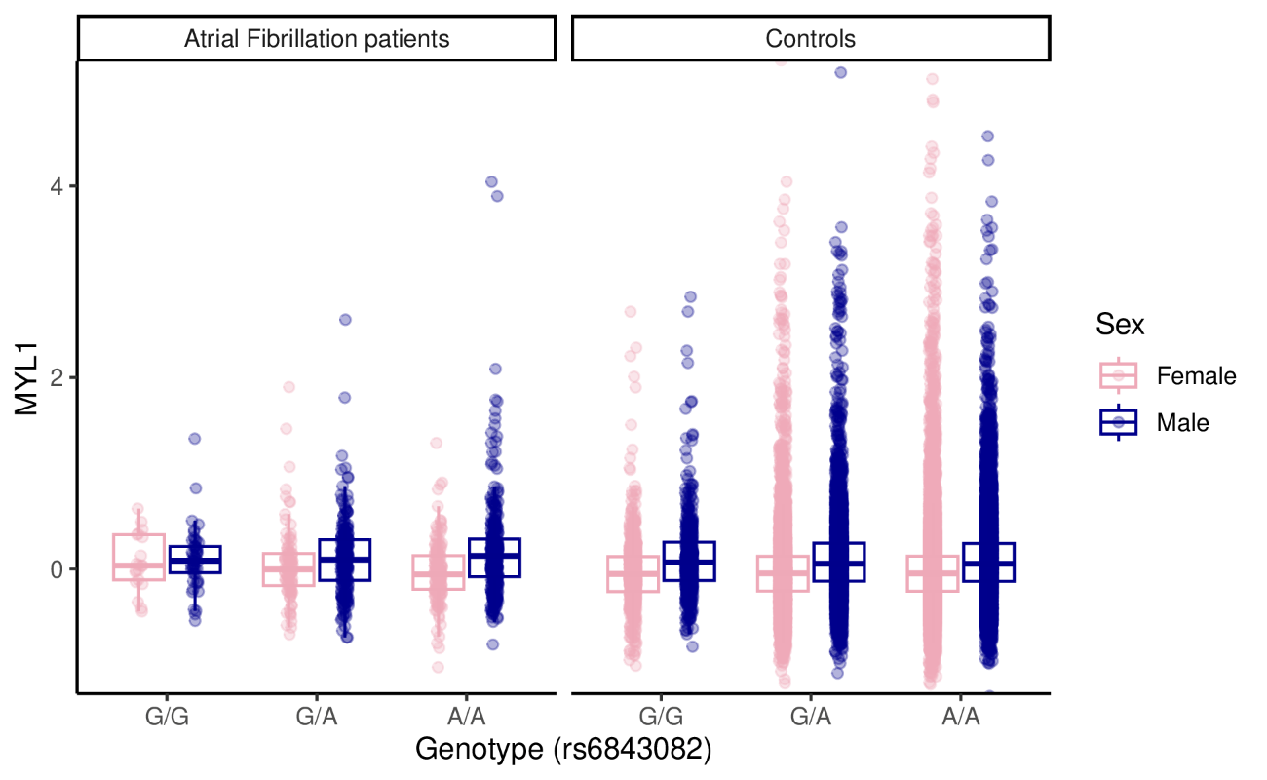
Figure S3. BLOC1S2 protein level interaction analysis between rs6571678 and sex adjusted by sex and stratified by atrial fibrillation status.
