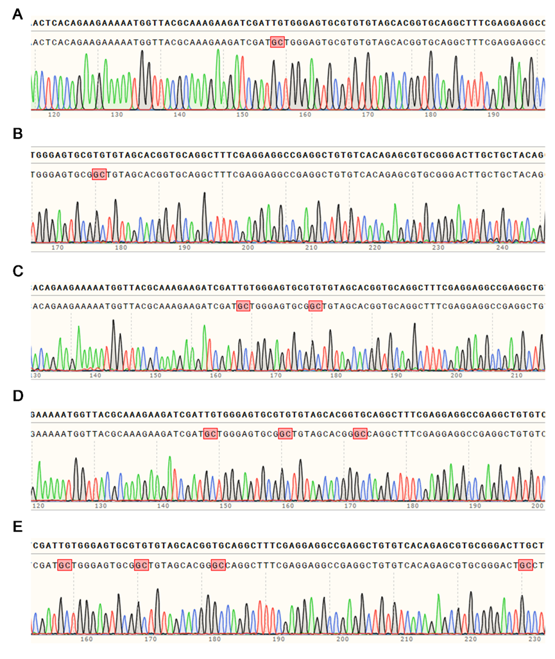
Figure 1. Schematic diagram of site-directed mutagenesis of AtGASA1. (A) Sequencing results of AtGASA1^{C40A}. (B) Sequencing results of AtGASA1^{C44A}. (C) Sequencing results of AtGASA1^{C40,44A}. (D) Sequencing results of AtGASA1^{C40,44,48A}. (E) Sequencing results of AtGASA1^{C40,44,48,64A}.

