Sterically Controlled 5-exo-dig Cyclization Enables Modular Synthesis of Non-benzenoid Polycyclic Aromatic Hydrocarbons with Intriguing (Anti)aromaticity and Diradical
Liangliang Chen,‡,*^{,[a]} Zhichun Shangguan,^{‡,[b]} Tianyu Shi,^{‡,[c]} Liyuan Qin,^{‡,[c]} Yiyun Zeng,^{[a]} Qinqiu Zhu,^{[a]} Jin Chen,^{[a]} Junhong Liang,^{[a]} Xiaosong Qiu,^{[a]} Xunchang Wang,^{[a]} Deqing Zhang,^{[c]} Renqiang Yang*^{[a]}
[a] Key Laboratory of Flexible Optoelectronic Materials and Technology (Ministry of Education), School of Optoelectronic Materials & Technology, Jianghan University, Wuhan, 430056, China
[b] College of Chemistry and Materials Engineering, Wenzhou University, Key Lab of Biohealth Materials and Chemistry of Wenzhou, Wenzhou, 325027, China.
[c] Beijing National Laboratory for Molecular Sciences, Institute of Chemistry, Chinese Academy of Sciences, Beijing, 100190, China.
[‡] These authors contribute equally to this work.

CONTENTS
1. Materials and characterization techniques S2
2. Synthesis and characterization S4
3. The ¹H-¹H NOESY of compounds S19
4. Crystallographic data S22
5. Thermogravimetric analysis (TGA) analysis S31
6. Calculations on electronic properties S32
7. The stabilities of 1, 2 and 3 S43
8. The variable-temperature ¹H NMR S44
9. The magnetic properties S46
10. OFETs fabrication and characterization S48
11. Other substrates used for this synthetic strategy S50
12. Atomic Cartesian coordinates of the optimized geometry S91
13. ¹H NMR and ¹³C NMR spectra S129
14. HRMS spectra S158
15. Reference S168

1. Materials and characterization techniques
All reagents and starting materials were purchased from commercial suppliers and used without further purification unless otherwise specified.
¹H NMR and ¹³C NMR spectra were recorded on AVANCE III 400 MHz, AVANCE III 500 MHz 600MHz and Bruker NEO 700 WB spectrometers. High-resolution mass spectral (HRMS) data were collected on either 9.4T Solarix Mass instrument or APEX Ⅱ Mass instrument. Elemental analyses (EA) were performed on a Carlo-Erba-1106 instrument. Thermogravimetric analysis (TGA) analysis was carried on a PerkinElmer TGA 8000 Thermogravimetric Analyzer instrument under N₂ at a heating rate of 10 °C/min from 50 °C to 600 °C. UV-vis-NIR absorption spectra were collected on a HITACHI UH4150 UV-vis spectrophotometer. Cyclic voltammograms (CV) and differential pulse voltammograms (DPV) measurements were carried out in a conventional three-electrode cell using a glassy carbon as the working electrode, Pt as the counter electrode, and Ag/AgCl (saturated KCl) as the reference electrode on a computer-controlled CHI660C instrument at ambient temperature; n-Bu₄NPF₆ (0.1 M in dichloromethane) was used as the supporting electrolyte. For calibration, the redox potential of ferrocene/ferrocenium (Fc/Fc⁺) was measured under the same conditions. HOMO and LUMO energies of these conjugated polymers were estimated with the following equations: HOMO = - (E_{ox}^{onset} -E_{Fc}^{1/2} + 4.8) eV, LUMO = -(E_{red}^{onset} -E_{Fc}^{1/2} + 4.8) eV. The single-crystal X-ray diffraction was carried out on a Rigaku Synergy-R diffractometer. XRD measurements were conducted on a PANalytical Empyrean with X-ray wavelength of 1.54 Å. The electron-spin resonance (ESR) spectra of solution and solid were conducted on Bruker E 500. The superconducting quantum interference device (SQUID) magnetometry was measured on MPMS3. The FET device performances were evaluated on a Keithley 4200 SCS semiconductor parameter analyzer.
Density functional theory (DFT) calculations were employed with the Gaussian 09 package.^{[S1]} The geometry optimization and frequency analysis were calculated at the (U)B3LYP-D3(BJ)/6-31G(d,p) level of theory.^{[S2-S4]} The vertical electronic excitation energies were calculated using time-dependent density functional theory (TDDFT)^{[S5]}, and 30 lowest-lying singlet excited states were considered at (U)B3LYP-D3(BJ)/6-31G(d,p) level of theory. Nucleus-independent chemical shifts (NICS)^{[S6]}, the anisotropy of current-induced density (ACID)^{[S7]}, and the iso-chemical shielding surfaces (ICSS)^{[S8]} were calculated at the (U)B3LYP/6-31G(d,p) level of theory, with the assistance of the Multiwfn program^{[S9]}. The diradical character (y₀) was calculated according to following equation^{[S10]}:
$$y_{0}=1-\frac{2T}{1+T^{2}}$$
where T is defined as:
$$T=\frac{n_{HOMO}{-n}_{LUMO}}{2}$$
Here, n_{HOMO} and n_{LUMO} represent the occupation numbers of the HOMO and LUMO orbitals, respectively.

2. Synthesis and characterization
2.1 Synthesis and characterization of compound 1
Scheme S1 The synthetic routes of compound 1
Synthesis of compound 5
To a 100 mL two-necked flask equipped with a magnetic stir bar, 1,4-Dibromo-2,5-diiodobenzene (compound 4, 3 g, 6.15 mmol), Pd(PPh₃)₂Cl₂ (440 mg, 0.62 mmol) and CuI (240 mg, 1.24 mmol) were added. The mixture was degassed and charged with nitrogen for three times and then 1-(tert-butyl)-4-ethynylbenzene (1.943 g, 12.3 mmol), diisopropylamine (20 mL) and DMF (20 mL) were added subsequently. The mixture was stirred at room temperature overnight. The reaction was quenched with hydrochloric acid solution (2 M, 60 mL), and the mixture was extracted with dichloromethane (100 mL×3) and washed with hydrochloric acid solution (2 M, 60 mL×3). The organic layer was dried by anhydrous Na₂SO₄ and concentrated under reduced pressure. The crude product was then purified by flash column chromatography using petroleum ether (b.p. 60-90 ºC) as eluent to give compound 5 as a white solid (2.7 g, 80.1% yield).
¹H NMR (400 MHz, CDCl₃, 298 K) δ (ppm) 7.77 (s, 2H), 7.51 (d, J = 8.4 Hz, 4H), 7.39 (d, J = 8.4 Hz, 4H), 1.33 (s, 18H).
¹³C NMR (101 MHz, CDCl₃, 298 K) δ (ppm) 152.6, 135.9, 131.6, 126.5, 125.5, 123.7, 119.3, 96.9, 86.4, 34.9, 31.2.
HRMS (MALDI- FTICR) m/z: [M]⁺ calcd for C₃₀H₂₈Br₂ 546.0552; found 546.0557.
Synthesis of compound 6
To a 250 mL three-necked flask equipped with a magnetic stir bar, compound 5 (1.5 g, 2.75 mmol), 2-Methoxy-5-formylphenylboronic acid (1.98 g, 11mmol), Na₂CO₃ (1.75 g, 16.5 mmol) and Pd(PPh₃)₄ (318 mg, 0.275 mmol) were added. The mixture was degassed and charged with nitrogen for three times. Then toluene (80 mL), ethanol (15 mL) and water (15 mL) were added into the flask. The mixture was heated at 110 ºC (oil bath) for 15 h. After cooling to room temperature, the solvent was removed by rotary evaporation. The crude product was then purified by flash column chromatography using petroleum ether (b.p. 60-90 ºC) and dichloromethane (2/1, v/v) as eluent to give compound 6 as a light-yellow solid. (1.58 g, 87.3% yield).
¹H NMR (400 MHz, CDCl₃, 298 K) δ (ppm) 9.97 (s, 2H), 8.01-7.96 (m, 4H), 7.65 (s, 2H), 7.27 (d, J = 8.5 Hz, 4H), 7.15 (d, J = 9.1 Hz, 2H), 7.11 (d, J = 8.5 Hz, 4H), 3.92 (s, 6H), 1.28 (s, 18H).
¹³C NMR (101 MHz, CDCl₃) δ 190.8, 162.1, 151.7, 138.9, 133.7, 133.5, 131.5, 131.1, 129.7, 129.5, 125.3, 123.1, 120.0, 111.0, 94.0, 88.0, 56.1, 34.8, 31.1.
HRMS (MALDI- FTICR) m/z: [M]⁺ calcd for C₄₆H₄₂O₄ 658.3077; found 658.3076.
Synthesis of compound 7
To a Pyrex tube equipped with a magnetic stir bar, compound 6 (50 mg×25, 1.82 mmol), Pd(OAc)₂ (2.2 mg×24, 0.23 mmol), 2-dicyclohexylphosphino-2',6'-dimethoxybiphenyl (Sphos, 6.8 mg×24, 0.41 mmol), Tri-n-butylphosphine (20 μL×24, 1.92 mmol) and toluene (2 mL×24) were added sequentially. Then through a freeze-pump-thaw cycle, the tube was charged with nitrogen for three times again. After rising to room temperature, the mixture was heated at 120 ºC for 24 h. After cooling to room temperature, a large amount of precipitation was generated and filtered off. The precipitation was washed with MeOH. The residue was collected and dried under vacuum to afford compound 7 (985 mg, 82.1%), which was directly used for the next step without further purification.
¹H NMR (400 MHz, CDCl₃, 298 K) δ (ppm) 10.37 (s, 2H), 8.70 (s, 2H), 8.54 (s, 2H), 7.79 (d, J = 8.5 Hz, 2H), 7.72 -7.66 (m, 4H), 7.57-7.52 (m, 4H), 6.92 (d, J = 8.6 Hz, 2H), 3.83 (s, 6H), 1.43 (s, 18H).
¹³C NMR (176 MHz, CDCl₃, 298 K) δ (ppm) 190.8, 159.2, 151.4, 143.2, 137.2, 137.1, 136.3, 136.0, 134.1, 133.8, 130.0, 128.6, 126.8, 125.4, 119.0, 109.4, 55.5, 34.9, 31.5.
HRMS (MALDI- FTICR) m/z: [M]⁺ calcd for C₄₆H₄₂O₄ 658.3077; found 658.3080.
Synthesis of compound 9
First step: To a 100 mL three-necked flask equipped with a magnetic stir bar, compound 7 (250 mg, 0.38 mmol) and THF (30 mL) were added. The mixture was degassed and charged with nitrogen for three times and stirred at 0 ºC (ice-water bath) for 5 min. Then, 2-mesitylmagnesium bromide (1 M solution in THF, 3.8 mL, 3.8 mmol) was added to the mixture at 0 ºC. After dripping completely, the mixture was warmed to room temperature for 2 h. Then, H₂O was added to quench the reaction. The residual was extracted by ethyl acetate three times (50 mL×3), and washed with saturated sodium chloride aqueous solution (50 mL×3). The organic layer was dried by anhydrous Na₂SO₄. The crude product of compound 8 was obtained by the removal of solvent and used directly for the next step.
HRMS (MALDI- FTICR) m/z: [M]⁺ calcd for C₆₄H₆₆O₄ 898.4955; found 898.4960.
Second step: A 100 mL three-necked flask containing the obtained crude product was under vacuum for 15 min. Then, 20 mL of dry dichloromethane (DCM) was added, and 0.6 mL of BF₃·OEt₂ was added dropwise through the syringe (turned dark immediately). The mixture was stirred for 5 h at room temperature. Then, 5 mL of saturated sodium carbonate (Na₂CO₃) solution was added to quench the reaction. The mixture was extracted by DCM (50 mL×3), and washed with saturated sodium chloride aqueous solution (50 mL×3). The organic layer was dried with anhydrous Na₂SO₄. The solvent was removed under reduced pressure and the residual, containing a small amount DCM solvent, was added to MeOH to precipitate the solid. The precipitation was filtered and the filter residue was washed with MeOH. After drying under the vacuum, the obtained orange crude product of compound 9 was directly used for the next reaction.
HRMS (MALDI- FTICR) m/z: [M]⁺ calcd for C₆₄H₆₂O₂ 862.4744; found 862.4745.
Synthesis of compound 1
To a 100 mL three-necked flask equipped with a magnetic stir bar, compound 9 (crude product obtained from the above-mentioned two steps) and 20 mL dry toluene were added. The mixture was degassed and charged with nitrogen for three times and stirred at 0 ºC (ice-water bath) for 3 min. Then, 2,3-dichloro-5,6-dicyano-1,4-benzoquinone (DDQ) (250 mg, 1.1 mmol) in 5 mL dry toluene was added to the mixture and the mixture was stirred under N₂ at room temperature for 1 h (the color of the mixture turned to red-brown). Then H₂O was added to quench the reaction. The mixture was extracted by DCM (50 mL×3), and washed with saturated sodium chloride aqueous solution (50 mL×3). The organic layer was dried by anhydrous Na₂SO₄. The crude product was further purified by a short silica gel column (PE/DCM = 1/1, v/v). Compound 1 was obtained as an army green solid (57 mg, 17.3% yield in three steps).
¹H NMR (700 MHz, C₂D₂Cl₄, 298 K) δ (ppm) 7.55 (s, 2H), 7.24 (d, J = 8.5 Hz, 4H), 7.14 (d, J = 8.4 Hz, 4H), 6.84 (s, 4H), 6.63 (d, J = 7.6 Hz, 2H), 6.44 (d, J = 7.7 Hz, 2H), 3.79 (s, 6H), 2.28 (s, 6H), 2.02 (s, 12H), 1.26 (s, 18H).
¹³C NMR (176 MHz, C₂D₂Cl₄, 298 K) δ (ppm) 155.5, 153.7, 153.3, 149.9, 147.5, 145.4, 137.3, 136.3, 133.7, 132.9, 132.4, 132.1, 128.5, 128.0, 127.3, 125.8, 125.3, 121.8, 116.5, 110.6, 56.0, 34.6, 31.5, 21.5, 20.5.
HRMS (MALDI- FTICR) m/z: [M]⁺ calcd for C₆₄H₆₀O₂ 860.4587; found 860.4584.
2.2 Synthesis and characterization of compound 2
Scheme S2 The synthetic routes of compound 2
Synthesis of compound Na-4Br-2OH
In a 500 mL three-necked flask equipped with a magnetic stir bar, 2,6-dihydroxynaphthalene (10 g, 62.4 mmol) was dissolved in 250 mL of acetic acid. Elemental bromine (59.8 g, 374 mmol) was then slowly added and the dark orange solution was refluxed for 24 h. Then, iron dust (401.4 mg, 7.16 mmol) was added slowly. The mixture was refluxed for 92 h. After cooling to room temperature, 400 mL of water was added and the precipitate was collected by filtration, washed with acetone and dried under reduced pressure to afford compound Na-4Br-2OH as a gray solid (24 g, 80.9 % yield), which was directly used for the next step without further purification.
HRMS (MALDI- ESI) m/z: [M]⁺ calcd for C₁₀H₄O₂Br₄ 475.6898; found 475.6897.
Synthesis of compound Na-2Br-2OH
In a 250 mL three-necked flask equipped with a magnetic stir bar, compound Na-4Br-2OH (5.0 g, 10.6 mmol) and tin (2.5 g, 21.2 mmol) were added. The mixture was degassed and charged with nitrogen for three times and AcOH (60 mL) was added. The mixture was heated at 120 ºC for 48 h. After cooling to room temperature, the mixture was filtered off. The filtrate was then poured into 300 mL H₂O and a large amount of precipitation was generated. The precipitation was washed with H₂O. The residue was collected and dried under vacuum to afford compound Na-2Br-2OH (1.83 g, 54.8% yield), which was directly used for the next step without further purification.
¹H NMR (400 MHz, DMSO-d₆, 298 K) δ (ppm) 10.34 (s, 2H), 7.99 (s, 2H), 7.18 (s, 2H).
¹³C NMR (101 MHz, DMSO-d₆, 298 K) δ (ppm) 150.3, 130.3, 129.2, 114.1, 109.5.
HRMS (MALDI- ESI) m/z: [M]⁺ calcd for C₁₀H₆O₂Br₂ 317.8709; found 317.8706.
Synthesis of compound 10
To a 250 mL three-necked flask equipped with a magnetic stir bar, compound Na-2Br-2OH (5 g, 15.87 mmol), CH₂Cl₂ (250 mL) and pyridine (25 mL) were added. The mixture was degassed and charged with nitrogen for three times and then cooled to 0 ºC (ice-water bath) for 3 min. Then, Trifluoromethanesulfonic anhydride (13.4 g, 47.6 mmol) was added slowly to the mixture under ice-water bath. After that, it was warmed to room temperature overnight. The reaction was quenched with hydrochloric acid solution (1 M, 200 mL), and the mixture was extracted with dichloromethane (200 mL×3) and washed with hydrochloric acid solution (1 M, 200 mL×3). The organic layer was dried with anhydrous Na₂SO₄ and concentrated under reduced pressure. The crude product was then purified by flash column chromatography using petroleum ether (b.p. 60-90 ºC) and dichloromethane (8/1, v/v) as eluent to give compound 10 as a white solid (4.18 g, 45.5% yield).
¹H NMR (400 MHz, CDCl₃, 298 K) δ (ppm) 8.23 (s, 2H), 7.80 (s, 2H).
¹³C NMR (101 MHz, CDCl₃, 298 K) δ (ppm) 145.7, 133.7, 131.8, 119.8, 118.7 (q, J = 322 Hz), 116.1.
HRMS (MALDI- ESI) m/z: [M]⁺ calcd for C₁₂H₄O₆Br₂F₆S₂ 581.7694; found 581.7697.
Synthesis of compound 11
To a 100 mL three-necked flask equipped with a magnetic stir bar, compound 10 (3 g, 5.18 mmol), Pd(PPh₃)₂Cl₂ (363 mg, 0.518 mmol) and CuI (198 mg, 1.036 mmol). The mixture was degassed and charged with nitrogen for three times and then 1-(tert-butyl)-4-ethynylbenzene (1.637 g, 10.36 mmol), diisopropylamine (30 mL) and DMF (30 mL) were added subsequently. The mixture was stirred at room temperature overnight. The reaction was quenched with hydrochloric acid solution (1 M, 100 mL), and the mixture was extracted with dichloromethane (100 mL×3) and washed with hydrochloric acid solution (1 M, 100 mL×3). The organic layer was dried with anhydrous Na₂SO₄ and concentrated under reduced pressure. The crude product was then purified by flash column chromatography using petroleum ether (b.p. 60-90 ºC) and dichloromethane (10/1, v/v) as eluent to give compound 11 as a light-yellow solid (2.358 g, 76.4% yield).
¹H NMR (400 MHz, CDCl₃, 298 K) δ (ppm) 8.04 (s, 2H), 7.93 (s, 2H), 7.56 (d, J = 8.1 Hz, 4H), 7.41 (d, J = 8.4 Hz, 4H), 1.34 (s, 18H).
¹³C NMR (101 MHz, CDCl₃, 298 K) δ (ppm) 152.4, 131.8, 131.6, 131.3, 130.5, 125.5, 124.6, 123.3, 119.7, 95.4, 87.5, 34.9, 31.2.
HRMS (MALDI- FTICR) m/z: [M]⁺ calcd for C₃₄H₃₀Br₂ 596.0717; found 596.0708.
Synthesis of compound 12
To a 100 mL three-necked flask equipped with a magnetic stir bar, compound 11 (2 g, 3.35 mmol), 2-methoxy-5-formylphenylboronic acid (1.81 g, 10 mmol), K₂CO₃ (2.311 g, 16.75 mmol) and Pd(PPh₃)₄ (194 mg, 0.167 mmol) were added. The mixture was degassed and charged with nitrogen for three times. Then toluene (80 mL), ethanol (15 mL) and water (15 mL) were added to the flask. The mixture was heated at 110 ºC (oil bath) overnight. After cooling to room temperature, the solvent was removed by rotary evaporation. The crude product was then purified by flash column chromatography using petroleum ether (b.p. 60-90 ºC) and dichloromethane (2/1, v/v) to dichloromethane and ethyl acetate (20:1, v/v) as eluent to give a light-yellow solid 12 (1.227 g, 51.7% yield).
¹H NMR (400 MHz, CDCl₃, 298 K) δ (ppm) 9.99 (s, 2H), 8.11 (s, 2H), 8.02 (dt, J = 8.5, 1.7 Hz, 2H), 7.97 (t, J = 1.6 Hz, 2H), 7.83 (s, 2H), 7.28 (d, J = 7.6 Hz, 4H), 7.17 (d, J = 8.5 Hz, 2H), 7.12 (d, J = 8.6 Hz, 4H), 3.88 (s, 6H), 1.29 (s, 18H).
¹³C NMR (101 MHz, CDCl₃, 298 K) δ (ppm) 191.0, 162.5, 151.6, 137.6, 133.4, 131.7, 131.5, 131.1, 130.6, 129.6, 128.4, 125.4, 122.6, 120.1, 110.9, 93.0, 88.4, 56.1, 34.8, 31.1.
HRMS (MALDI- FTICR) m/z: [M]⁺ calcd for C₅₀H₄₄O₄ 708.3234; found 708.3239.
Synthesis of compound 13
To a Pyrex tube equipped with a magnetic stir bar, compound 12 (50 mg × 22, 1.55 mmol), Pd(OAc)2 (2.2 mg × 22, 0.21 mmol), 2-dicyclohexylphosphino-2',6'-dimethoxybiphenyl (Sphos, 6.8 mg × 22, 0.36 μmol), Tri-n-butylphosphine (20 μL × 22, 1.76 mmol) and toluene (2 mL × 22) were added sequentially. Then through a freeze-pump-thaw cycle, the tube was charged with nitrogen for three times again. After raising to room temperature, the mixture was heated at 120 ºC for 12 h. After cooling to room temperature, a large amount of precipitation was generated and filtered off. The precipitation was washed with MeOH. The residue was collected and dried under vacuum to afford compound 13 (952 mg, 86.5%), which was directly used for the next step without further purification.
¹H NMR (400 MHz, CDCl₃, 298 K) δ (ppm) 10.47 (s, 2H), 8.47 (s, 2H), 8.15 (s, 2H), 7.89 (d, J = 8.5 Hz, 2H), 7.79 (s, 2H), 7.57 (s, 8H), 7.04 (d, J = 8.6 Hz, 2H), 4.08 (s, 6H), 1.49 (s, 18H).
¹³C NMR (176 MHz, CDCl₃, 298 K) δ (ppm) 190.7, 160.0, 151.6, 143.8, 136.5, 136.3, 136.0, 135.0, 134.7, 134.1, 132.4, 128.9, 128.5, 127.1, 126.4, 125.7, 123.7, 123.1, 109.7, 55.7, 34.9, 31.5.
HRMS (MALDI- FTICR) m/z: [M]⁺ calcd for C₅₀H₄₄O₄ 708.3234; found 708.3233.
Synthesis of compound 15
First step: To a 100 mL three-necked flask equipped with a magnetic stir bar, compound 13 (380 mg, 0.53 mmol) and THF (80 mL) were added. The mixture was degassed and charged with nitrogen for three times and stirred at 0 ºC (ice-water bath) for 5 min. Then, 2-mesitylmagnesium bromide (1 M solution in THF, 5.3 ml, 5.3 mmol) was added to the mixture at 0 ºC. After dripping completely, the mixture was warm to room temperature overnight. H₂O was added to quench the reaction. The residual was extracted by DCM and washed with saturated sodium chloride aqueous solution. The organic layer was dried with anhydrous Na₂SO₄. The crude product of compound 14 was obtained by removal of solvent and used to conduct the next reaction as a yellow solid.
HRMS (MALDI- FTICR) m/z: [M]⁺ calcd for C₆₈H₆₈O₄ 948.5112; found 948.5115.
Second step: A 100 mL three-necked flask containing the obtained crude product (14) was under vacuum for 15 min, then 40 mL of dry DCM was added, and 0.8 mL of BF₃·OEt₂ was added dropwise through the syringe (turned to dark brown immediately). The mixture was stirred for 30 min at room temperature. Then 5 mL of saturated sodium carbonate (Na₂CO₃) solution was added to quench the reaction, the color of the mixture turned green. The mixture was extracted by DCM, and washed with saturated sodium chloride aqueous solution. The organic layer was dried with anhydrous Na₂SO₄. The solvent was removed under reduced pressure and the residue was directly used for the next reaction (compound 15).
HRMS (MALDI- FTICR) m/z: [M]⁺ calcd for C₆₈H₆₄O₂ 912.4900; found 912.4899.
Synthesis of compound 2
To a 100 mL Schlenk flask equipped with a magnetic stir bar, compound 15 (crude product obtained from the above-mentioned second step) and 30 mL dry toluene were added. Then, through a freeze-pump-thaw cycle, the tube was charged with nitrogen for three times again. After the mixture had thawed, 2,3-dichloro-5,6-dicyano-1,4-benzoquinone (DDQ) (430 mg, 1.89 mmol) in 4 mL dry toluene was added to the mixture and the mixture was stirred under N₂ at room temperature for 2 h (the color of the mixture turned to blue-green). After the reaction finished, the mixture was poured into hexane (300 mL) and a large amount of precipitation was generated and filtered off. The precipitation was washed with MeOH. The crude product was further purified by a short silica gel column (DCM/toluene = 4/1, v/v). Compound 2 was obtained as a purple solid (305 mg, 63.3% yield in three steps).
¹H NMR (700 MHz, C₂D₂Cl₄, 298 K) δ (ppm) 7.75 (s, 2H), 7.62 (s, 2H), 7.39 (d, J = 8.5 Hz, 4H), 7.26 (d, J = 8.3 Hz, 4H), 6.95 (s, 4H), 6.81 (d, J = 7.5 Hz, 2H), 6.59 (d, J = 7.7 Hz, 2H), 4.03 (s, 6H), 2.39 (s, 6H), 2.13 (s, 12H), 1.39 (s, 18H).
¹³C NMR (176 MHz, C₂D₂Cl₄, 298 K) δ (ppm) 154.7, 154.6, 152.3, 149.8, 144.2, 143.7, 137.2, 136.4, 134.4, 133.0, 132.7, 132.5, 130.8, 129.6, 128.5, 127.7, 127.3, 125.4, 122.6, 120.4, 116.7, 110.1, 56.3, 34.7, 31.5, 21.5, 20.6.
HRMS (MALDI- FTICR) m/z: [M]⁺ calcd for C₆₈H₆₂O₂ 910.4744; found 910.4743.

2.3 Synthesis and characterization of compound 3
Scheme S3 The synthetic routes of compound 3
Synthesis of compound 16
In a 250 mL three-necked flask equipped with a magnetic stir bar, 2,6-dibromo-1,5-dihydroxynaphthalene (10 g, 31.4 mmol), CH₂Cl₂ (100 mL) and pyridine (10 mL) were added. The mixture was degassed and charged with nitrogen for three times and then cooled to 0 ºC (ice-water bath) for 3 min. Then, Trifluoromethanesulfonic anhydride (26.6 g, 94.3 mmol) was added slowly to the mixture under an ica-water bath. After that, it was warmed to room temperature for 12 h. The reaction was quenched with hydrochloric acid solution (1 M, 100 mL), and the mixture was extracted with dichloromethane (100 mL× 3) and washed with water (100 mL× 3). The organic layer was dried with anhydrous Na₂SO₄ and concentrated under reduced pressure. The crude product was then purified by flash column chromatography using petroleum ether (b.p. 60-90 ºC) and dichloromethane (10:1, v/v) as eluent to give a white solid 16 (11.904 g, 65.5% yield).
¹H NMR (400 MHz, CDCl₃, 298 K) δ (ppm): 8.02 (d, J = 9.0 Hz, 2H), 7.88 (d, J = 9.1 Hz, 2H).
¹³C NMR (101 MHz, CDCl₃, 298 K) δ (ppm): 142.5, 133.1, 128.6, 122.9, 122.9, 118.6 (q, 12.8 Hz), 116.6.
Synthesis of compound 17
In a 250 mL three-necked flask equipped with a magnetic stir bar, compound 16 (5.2 g, 8.9 mmol), Pd(PPh₃)₂Cl₂ (627 mg, 0.9 mmol) and CuI (343 mg, 1.8 mmol). The mixture was degassed and charged with nitrogen for three times and then 1-(tert-butyl)-4-ethynylbenzene (2.8 g, 17.9 mmol), diisopropylamine (20 mL) and DMF (50 mL) were added subsequently. The mixture was stirred at room temperature overnight. The reaction was quenched with hydrochloric acid solution (3 M, 50 mL), and the mixture was extracted with dichloromethane (100 mL×3) and washed with hydrochloric acid solution (3 M, 50 mL×3). The organic layer was dried by anhydrous Na₂SO₄ and concentrated under reduced pressure. The crude product was then purified by flash column chromatography using petroleum ether (b.p. 60-90 ºC) as eluent to give a light-yellow solid 17 (4.6 g, 85.3% yield).
¹H NMR (400 MHz, CDCl₃, 298 K) δ (ppm) 8.22 (d, J = 8.9 Hz, 2H), 7.75 (d, J = 8.9 Hz, 2H), 7.65-7.60 (m, 4H), 7.47-7.42 (m, 4H), 1.36 (s, 18H).
¹³C NMR (101 MHz, CDCl₃, 298 K) δ (ppm) 152.5, 132.9, 131.6, 131.6, 131.3, 127.6, 125.6, 125.5, 123.2, 119.7, 100.2, 85.4, 34.9, 31.2.
HRMS (MALDI- FTICR) m/z: [M]⁺ calcd for C₃₄H₃₀Br₂ 596.0708; found 596.0716.
Synthesis of compound 18
In a 250 mL three-necked flask equipped with a magnetic stir bar, compound 17 (3 g, 5 mmol), 2-Methoxy-5-formylphenylboronic acid (2.7 g, 15 mmol), K₂CO₃ (3.5 g, 25 mmol) and Pd(PPh₃)₄ (290 mg, 0.25 mmol) were added. The mixture was degassed and charged with nitrogen for three times. Then toluene (120 mL), ethanol (20 mL) and water (20 mL) were added into the flask. The mixture was heated at 110 ºC (oil bath) overnight. After cooling to room temperature, the solvent was removed by rotary evaporation. The crude product was then purified by flash column chromatography using petroleum ether (b.p. 60-90 ºC) and dichloromethane (2/1, v/v) as eluent to give a light-yellow solid 18 (1.6 g, 44.1% yield).
¹H NMR (400 MHz, CDCl₃, 298 K) δ (ppm) 10.00 (s, 2H), 8.57 (d, J = 8.5 Hz, 2H), 8.09 (d, J = 2.2 Hz, 2H), 8.01 (dd, J = 8.5, 2.1 Hz, 2H), 7.64 (d, J = 8.5 Hz, 2H), 7.34-7.31(m, 4H), 7.26-7.22 (m, 4H), 7.18 (d, J = 8.6 Hz, 2H), 3.90 (s, 6H), 1.31 (s, 18H). .
¹³C NMR (101 MHz, CDCl₃, 298 K) δ (ppm) 191.0, 162.2, 151.8, 138.8, 134.1, 132.6, 131.5, 131.1, 130.8, 129.5, 128.9, 126.6, 125.4, 120.9, 120.2, 111.1, 98.4, 86.1, 56.1, 34.8, 31.2.
HRMS (MALDI- FTICR) m/z: [M]⁺ calcd for C₅₀H₄₄O₄ 708.3234; found 708.3231.
Synthesis of compound 19
To a Pyrex tube equipped with a magnetic stir bar, compound 18 (50 mg × 20, 1.41 mmol), Pd(OAc)₂ (2.2 mg × 20, 0.19 mmol), 2-dicyclohexylphosphino-2',6'-dimethoxybiphenyl (Sphos, 6.8 mg × 20, 0.32 mmol), Tri-n-butylphosphine (20 μL × 20, 1.6 mmol) and toluene (2 mL × 20) were added sequentially. Then, through a freeze-pump-thaw cycle, the tube was charged with nitrogen for three times again. After raising to room temperature, the mixture was heated at 120 ºC for 12 h. After cooling to room temperature, a large amount of precipitation was generated and filtered off. The precipitation was washed with MeOH. The residue was collected and dried under vacuum to afford compound 19 (967 mg, 96.7%), which was directly used for the next step without further purification.
¹H NMR (400 MHz, CDCl₃, 298 K) δ (ppm) 9.74 (s, 2H), 8.63 (d, J = 8.8 Hz, 2H), 8.47 (d, J = 8.7 Hz, 2H), 8.23 (s, 2H), 7.70 (d, J = 8.6 Hz, 2H), 7.37 (s, 8H), 7.02 (d, J = 8.6 Hz, 2H), 4.15 (s, 6H), 1.33 (s, 18H).
¹³C NMR (101 MHz, CDCl₃, 298 K) δ (ppm) 188.3, 159.2, 152.1, 142.2, 138.5, 138.2, 137.3, 133.9, 129.4, 128.7, 127.7, 127.3, 126.3, 125.1, 124.8, 123.2, 110.9, 55.8, 34.8, 31.2.
HRMS (MALDI- FTICR) m/z: [M]⁺ calcd for C₅₀H₄₄O₄ 708.3234; found 708.3232.
Synthesis of compound 3
First step: To a 50 mL three-necked flask equipped with a magnetic stir bar, compound 9 (200 mg, 0.28 mmol) and THF (25 mL)were added. The mixture was degassed and charged with nitrogen for three times and stirred at 0 ºC (ice-water bath) for 5 min. Then, 2-Mesitylmagnesium bromide (1 M solution in THF, 4.5 mL, 4.5 mmol) was added to the mixture at 0 ºC. After dripping completely, the mixture was warm to room temperature overnight. Then, H₂O was added to quench the reaction. The residual was extracted by DCM, and washed with saturated sodium chloride aqueous solution. The organic layer was dried with anhydrous Na₂SO₄. The crude product of compound 20 was obtained by removal of solvent and used to conduct the next reaction as a yellow solid.
HRMS (MALDI- FTICR) m/z: [M]⁺ calcd for C₆₈H₆₈O₄ 948.5112; found 948.5115.
Second step: A 100 mL three-necked flask containing the obtained crude product was under vacuum for 15 min, then 25 mL of dry DCM was added, 0.4 mL of BF₃·OEt₂ was added dropwise through syringe (turned to dark brown immediately) under 0 ºC (ice-water bath). Then, the mixture was kept stirred for 4 h at 50 ºC. Then 2 mL of saturated sodium carbonate (Na₂CO₃) solution was added to quench the reaction. The mixture was extracted by DCM, and washed with saturated sodium chloride aqueous solution. The organic layer was dried with anhydrous Na₂SO₄. The solvent was removed under reduced pressure and the residue was directly used for the next reaction (compound 21).
HRMS (MALDI- FTICR) m/z: [M]⁺ calcd for C₆₈H₆₄O₂ 912.4900; found 912.4899.
Third step: To a 50 mL Schlenk flask equipped with a magnetic stir bar, compound 21 (crude product obtained from the second step) and 15 mL dry toluene were added. Then, through a freeze-pump-thaw cycle, the tube was charged with nitrogen for three times. After the mixture had thawed, 2,3-dichloro-5,6-dicyano-1,4-benzoquinone (DDQ) (71.8 mg, 0.32 mmol) in 2 mL dry toluene was added to the mixture and the mixture was stirred under N₂ at room temperature for 0.5 h. Then, H₂O (5 mL) and Et₃N (2 mL) were added to quench the reaction. The residual was extracted by DCM, and washed with saturated sodium chloride aqueous solution. The organic layer was dried with anhydrous Na₂SO₄ and the solvent was removed by rotary evaporation. The crude product was then purified by flash column chromatography using dichloromethane and methanol (1/0~20/1, v/v) as eluent to give a brown solid of 3 (19 mg, 19.7% yield).
¹H NMR (700 MHz, CDCl₃, 298 K) δ (ppm) 9.85 (s, 2H), 9.32 (d, J = 8.6 Hz, 2H), 9.23 (d, J = 8.5 Hz, 2H), 8.46 (d, J = 8.2 Hz, 2H), 8.02 (dd, J = 8.1, 1.9 Hz, 2H), 7.89 (d, J = 1.9 Hz, 2H), 7.54 (d, J = 10.0 Hz, 2H), 7.14 (s, 4H), 6.93 (d, J = 10.0 Hz, 2H), 2.50 (s, 6H), 1.88 (s, 12H), 1.25 (s, 18H).
¹³C NMR (176 MHz, CDCl₃, 298 K) δ (ppm) 154.4, 141.6, 140.3, 139.2, 138.2, 138.0, 137.9, 137.6, 137.4, 136.1, 135.9, 134.2, 133.4, 130.3, 130.2, 129.1, 129.0, 128.9, 128.6, 126.7, 126.0, 123.7, 35.3, 30.9, 21.3, 20.1.
HRMS (MALDI- FTICR) m/z: [M]⁺ calcd for C₆₆H₅₆O₂ 880.4274; found 880.4269.

3. The ¹H-¹H NOESY of compounds
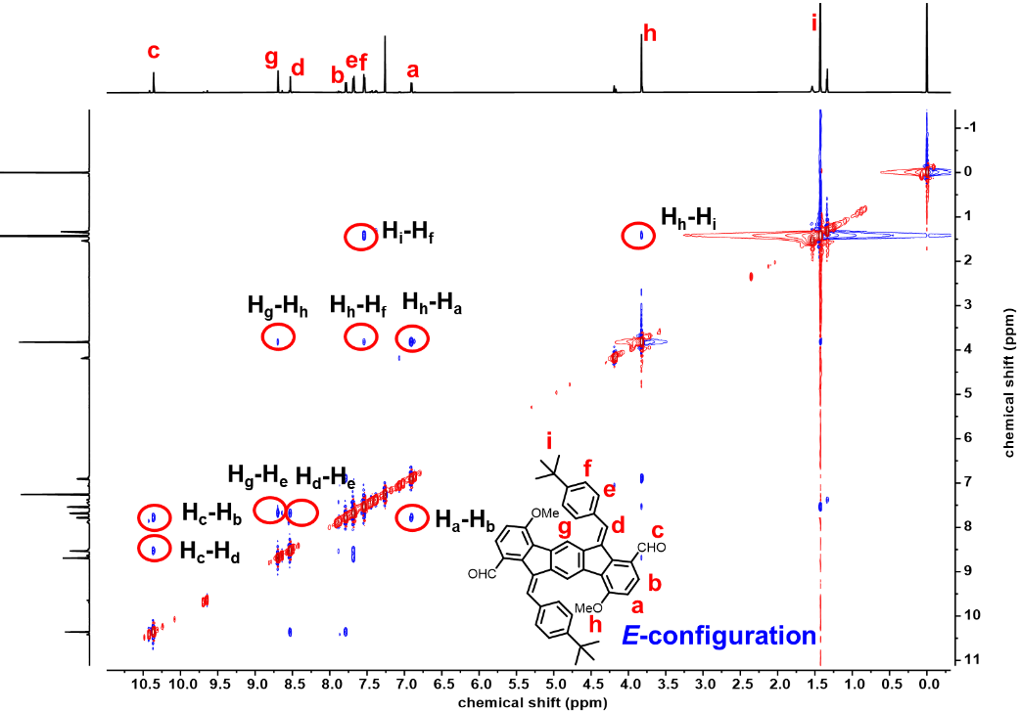
Figure S1 The NOESY of compound 7 (700 MHz, C₂D₂Cl₄, 298 K).

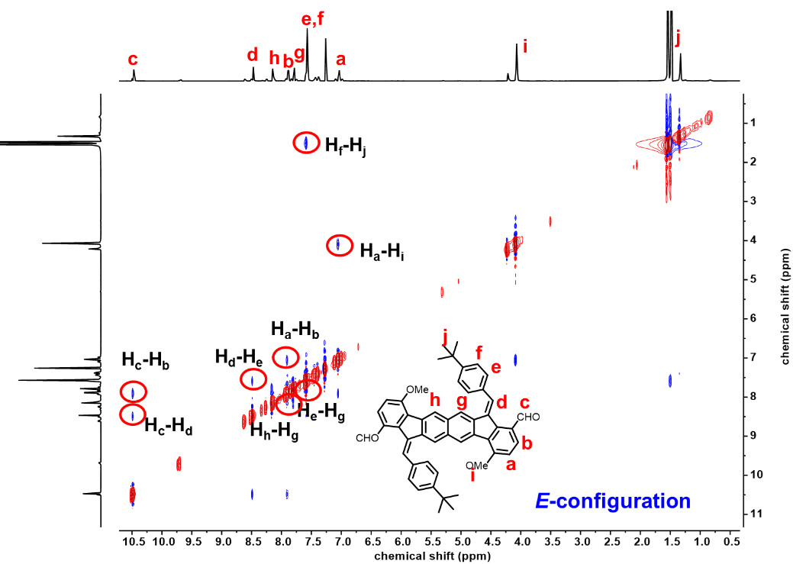
Figure S2 The NOESY of compound 13 (700 MHz, C₂D₂Cl₄, 298 K).

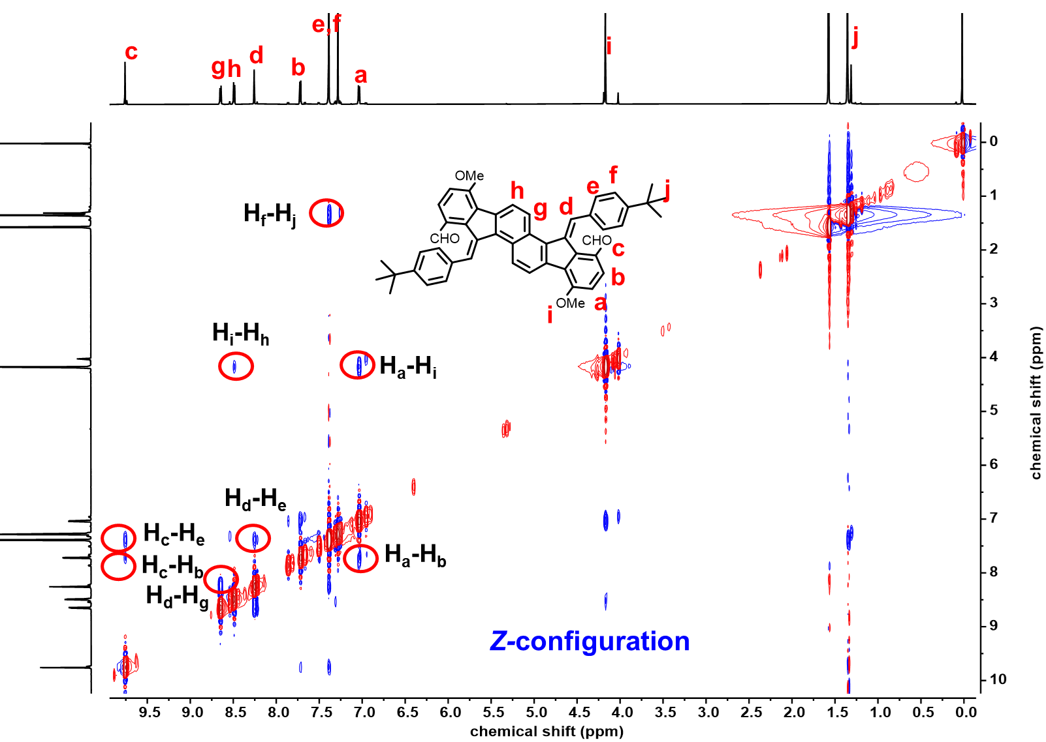
Figure S3 The NOESY of compound 19 (700 MHz, C₂D₂Cl₄, 298 K).

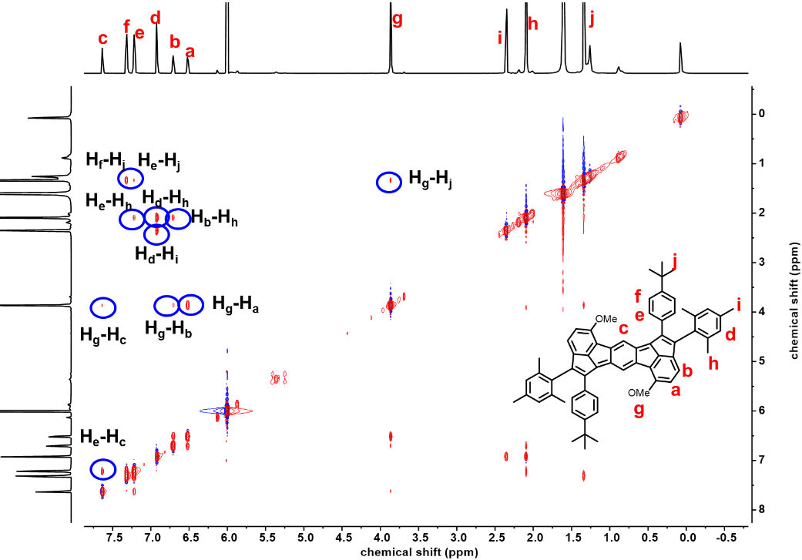
Figure S4 The NOESY of compound 1 (700 MHz, C₂D₂Cl₄, 298 K).

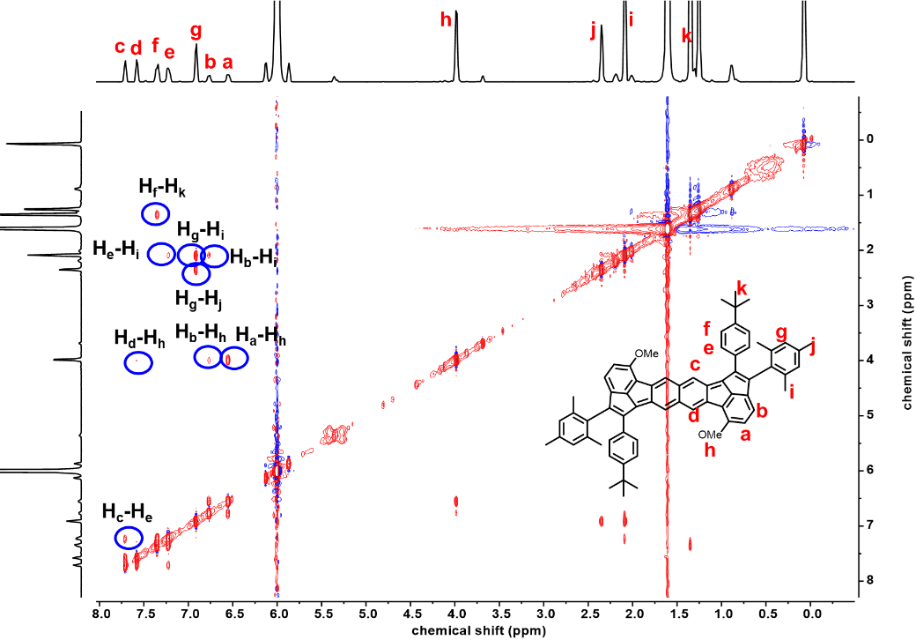
Figure S5 The NOESY of compound 2 (700 MHz, C₂D₂Cl₄, 298 K).
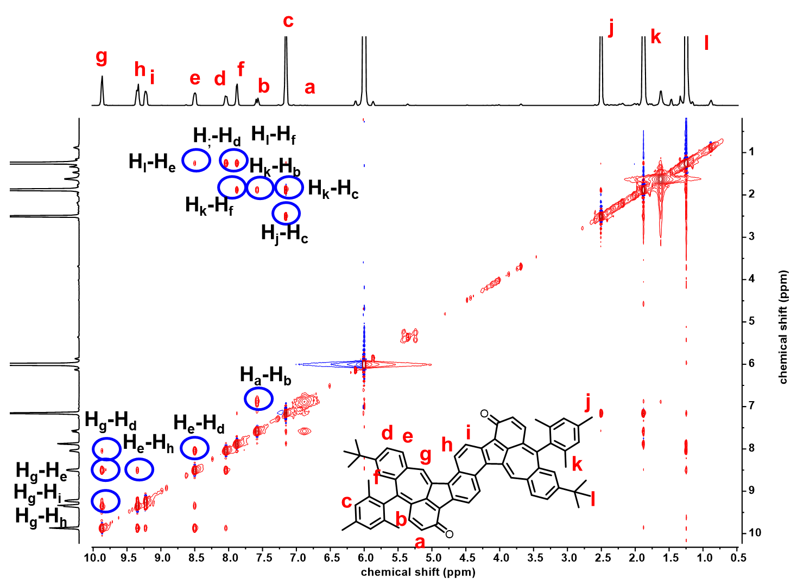
Figure S6 The NOESY of compound 3 (700 MHz, C₂D₂Cl₄, 298 K).

4. Crystallographic data
Figure S7 X-ray single-crystal crystallographic analysis. Structure of (a) top view, (b) side view and (c) intermolecular packing mode and interaction of intermediate 7. Displacement ellipsoids are drawn at 50% probability level. The solvent molecule of CHCl₃ was omitted for clarity.

Figure S8 X-ray single-crystal crystallographic analysis. Structure of (a) top view, (b) side view and (c) intermolecular packing mode and interaction of intermediate 13. Displacement ellipsoids are drawn at 50% probability level.

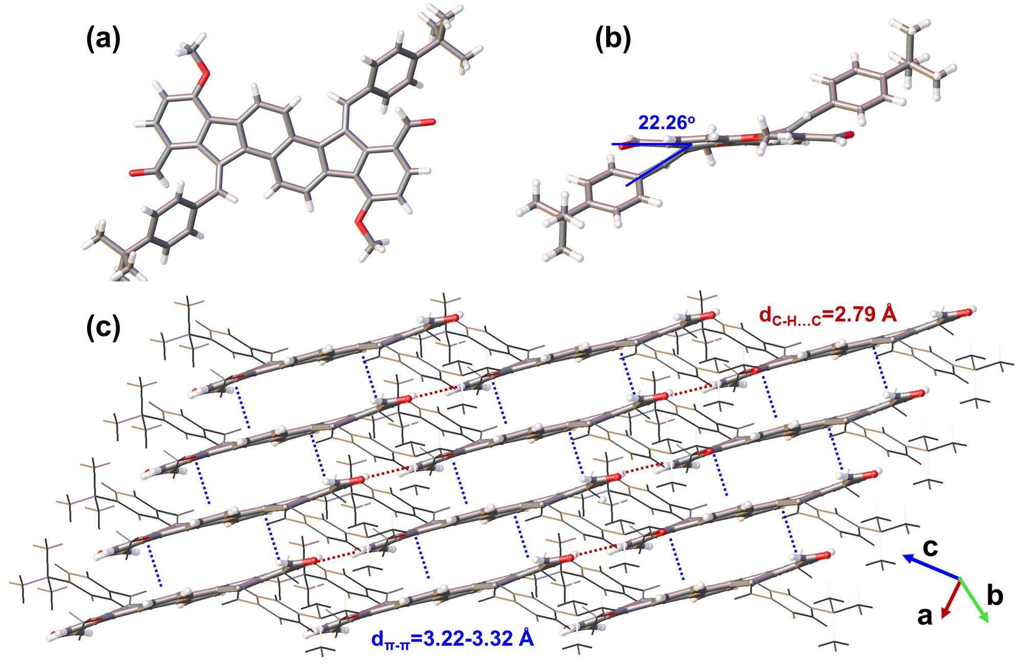
Figure S9 X-ray single-crystal crystallographic analysis. Structure of (a) top view, (b) side view and (c) intermolecular packing mode and interaction of intermediate 19. Displacement ellipsoids are drawn at 50% probability level.

Table S1 Crystallographic data of compound 7.
Compound | 7
CCDC deposition NO. | 2478865
Empirical formula | C₉₄H₈₆Cl₆O₈
Formula weight | 1556.32
Temperature/K | 170 (1)
Crystal system | triclinic
Space group | P-1
a/Å | 14.54950(10)
b/Å | 15.2378(2)
c/Å | 19.4658(2)
α/° | 97.6160(10)
β/° | 100.2140(10)
γ/° | 108.7880(10)
Volume/Å³ | 3936.74(8)
Z | 2
ρ_{calc}g/cm³ | 1.313
μ/mm⁻¹ | 2.458
F(000) | 1632.0
Crystal size/mm³ | 0.33× 0.23 × 0.15
Radiation | CuKα (λ = 1.54184)
2Θ range for data collection/° | 4.712 to 151.864
Index ranges | -18 ≤ h ≤ 16, -18≤ k ≤ 19, -24 ≤ l ≤ 23
Reflections collected | 56938
Independent reflections | 15942 [R_{int} = 0.0285, R_{sigma} = 0.0291]
Data/restraints/parameters | 15942/0/989
Goodness-of-fit on F² | 1.071
Final R indexes [I>=2σ (I)] | R₁ = 0.0649, wR₂ = 0.1821
Final R indexes [all data] | R₁ = 0.0739, wR₂ = 0.1906
Largest diff. peak/hole / e Å⁻³ | 1.50/-1.19

Table S2 Crystallographic data of compound 13.
Compound | 13
CCDC deposition NO. | 2478866
Empirical formula | C₂₅H₂₂O₂
Formula weight | 354.42
Temperature/K | 170.00 (10)
Crystal system | monoclinic
Space group | P2₁/c
a/Å | 16.3766(3)
b/Å | 10.38959(18)
c/Å | 11.4772(3)
α/° | 90
β/° | 103.825(10)
γ/° | 90
Volume/Å³ | 1896.22(7)
Z | 4
ρ_{calc}g/cm³ | 1.241
μ/mm⁻¹ | 0.605
F(000) | 752.0
Crystal size/mm³ | 0.5× 0.3 × 0.1
Radiation | CuKα (λ = 1.54184)
2Θ range for data collection/° | 5.558 to 155.072
Index ranges | -20 ≤ h ≤ 19, -11≤ k ≤ 13, -14 ≤ l ≤ 14
Reflections collected | 14107
Independent reflections | 3878 [R_{int} = 0.0264, R_{sigma} = 0.0257]
Data/restraints/parameters | 3878/0/248
Goodness-of-fit on F² | 1.066
Final R indexes [I>=2σ (I)] | R₁ = 0.0592, wR₂ = 0.1581
Final R indexes [all data] | R₁ = 0.0667, wR₂ = 0.1637
Largest diff. peak/hole / e Å⁻³ | 0.71/-0.40

Table S3 Crystallographic data of compound 19.
Compound | 19
CCDC deposition NO. | 2478867
Empirical formula | C₂₅H₂₂O₂
Formula weight | 354.42
Temperature/K | 170.00 (3)
Crystal system | triclinic
Space group | P-1
a/Å | 5.6358(3)
b/Å | 12.7956(6)
c/Å | 12.9671(5)
α/° | 97.392(4)
β/° | 93.846(4)
γ/° | 97.333(4)
Volume/Å³ | 916.43(8)
Z | 2
ρ_{calc}g/cm³ | 1.284
μ/mm⁻¹ | 0.626
F(000) | 376.0
Crystal size/mm³ | 0.25× 0.15 × 0.12
Radiation | CuKα (λ = 1.54184)
2Θ range for data collection/° | 6.898 to 151.448
Index ranges | -7 ≤ h ≤ 7, -15≤ k ≤ 15, -16 ≤ l ≤ 12
Reflections collected | 10280
Independent reflections | 3649 [R_{int} = 0.0338, R_{sigma} = 0.0420]
Data/restraints/parameters | 3649/0/248
Goodness-of-fit on F² | 1.089
Final R indexes [I>=2σ (I)] | R₁ = 0.0762, wR₂ = 0.2130
Final R indexes [all data] | R₁ = 0.0892, wR₂ = 0.2262
Largest diff. peak/hole / e Å⁻³ | 0.42/-0.23

Table S4 Crystallographic data of compound 1.
Compound | 1
CCDC deposition NO. | 2478868
Empirical formula | C₃₂H₃₀O
Formula weight | 430.56
Temperature/K | 170.00 (10)
Crystal system | triclinic
Space group | P-1
a/Å | 9.8909(4)
b/Å | 10.4826(5)
c/Å | 13.2687(3)
α/° | 108.996(3)
β/° | 97.316(3)
γ/° | 109.909(4)
Volume/Å³ | 1178.35(9)
Z | 2
ρ_{calc}g/cm³ | 1.213
μ/mm⁻¹ | 0.543
F(000) | 460.0
Crystal size/mm³ | 0.1× 0.08 × 0.03
Radiation | CuKα (λ = 1.54184)
2Θ range for data collection/° | 7.314 to 154.992
Index ranges | -12 ≤ h ≤ 12, -12≤ k ≤ 13, -16 ≤ l ≤ 16
Reflections collected | 14522
Independent reflections | 4796 [R_{int} = 0.0460, R_{sigma} = 0.0462]
Data/restraints/parameters | 4796/0/305
Goodness-of-fit on F² | 1.052
Final R indexes [I>=2σ (I)] | R₁ = 0.0700, wR₂ = 0.1989
Final R indexes [all data] | R₁ = 0.0870, wR₂ = 0.2173
Largest diff. peak/hole / e Å⁻³ | 0.44/-0.24

Table S5 Crystallographic data of compound 2.
Compound | 2
CCDC deposition NO. | 2478869
Empirical formula | C₇₂H₆₆Cl₁₂O₂
Formula weight | 1388.64
Temperature/K | 100.00 (10)
Crystal system | monoclinic
Space group | P2₁/n
a/Å | 15.5670(4)
b/Å | 13.0056(2)
c/Å | 18.0182(4)
α/° | 90
β/° | 113.360(3)
γ/° | 90
Volume/Å³ | 3348.92(14)
Z | 2
ρ_{calc}g/cm³ | 1.377
μ/mm⁻¹ | 4.897
F(000) | 1436.0
Crystal size/mm³ | 0.2× 0.12 × 0.08
Radiation | CuKα (λ = 1.54184)
2Θ range for data collection/° | 6.372 to 155.974
Index ranges | -19 ≤ h ≤ 19, -9≤ k ≤ 16, -22 ≤ l ≤ 22
Reflections collected | 23526
Independent reflections | 6916 [R_{int} = 0.0440, R_{sigma} = 0.0413]
Data/restraints/parameters | 6916/0/395
Goodness-of-fit on F² | 1.063
Final R indexes [I>=2σ (I)] | R₁ = 0.0592, wR₂ = 0.1578
Final R indexes [all data] | R₁ = 0.0708, wR₂ = 0.1652
Largest diff. peak/hole / e Å⁻³ | 1.36/-0.85

Table S6 Crystallographic data of compound 3.
Compound | 3
CCDC deposition NO. | 2478870
Empirical formula | C₁₉₈H₁₆₈O₆
Formula weight | 2643.31
Temperature/K | 169.97 (12)
Crystal system | triclinic
Space group | P-1
a/Å | 18.9545(5)
b/Å | 20.8030(7)
c/Å | 21.5827(6)
α/° | 88.929(2)
β/° | 65.138(3)
γ/° | 80.456(3)
Volume/Å³ | 7602.3(4)
Z | 2
ρ_{calc}g/cm³ | 1.155
μ/mm⁻¹ | 0.519
F(000) | 2808.0
Crystal size/mm³ | 0.2× 0.14 × 0.005
Radiation | CuKα (λ = 1.54184)
2Θ range for data collection/° | 4.314 to 151.922
Index ranges | -23 ≤ h ≤ 23, -25 ≤ k ≤ 26, -26 ≤ l ≤ 26
Reflections collected | 98493
Independent reflections | 30211 [R_{int} = 0.1595, R_{sigma} = 0.1264]
Data/restraints/parameters | 30211/0/1874
Goodness-of-fit on F² | 0.963
Final R indexes [I>=2σ (I)] | R₁ = 0.0746, wR₂ = 0.1791
Final R indexes [all data] | R₁ = 0.1599, wR₂ = 0.2221
Largest diff. peak/hole / e Å⁻³ | 0.40/-0.24

5. Thermogravimetric analysis (TGA) analysis
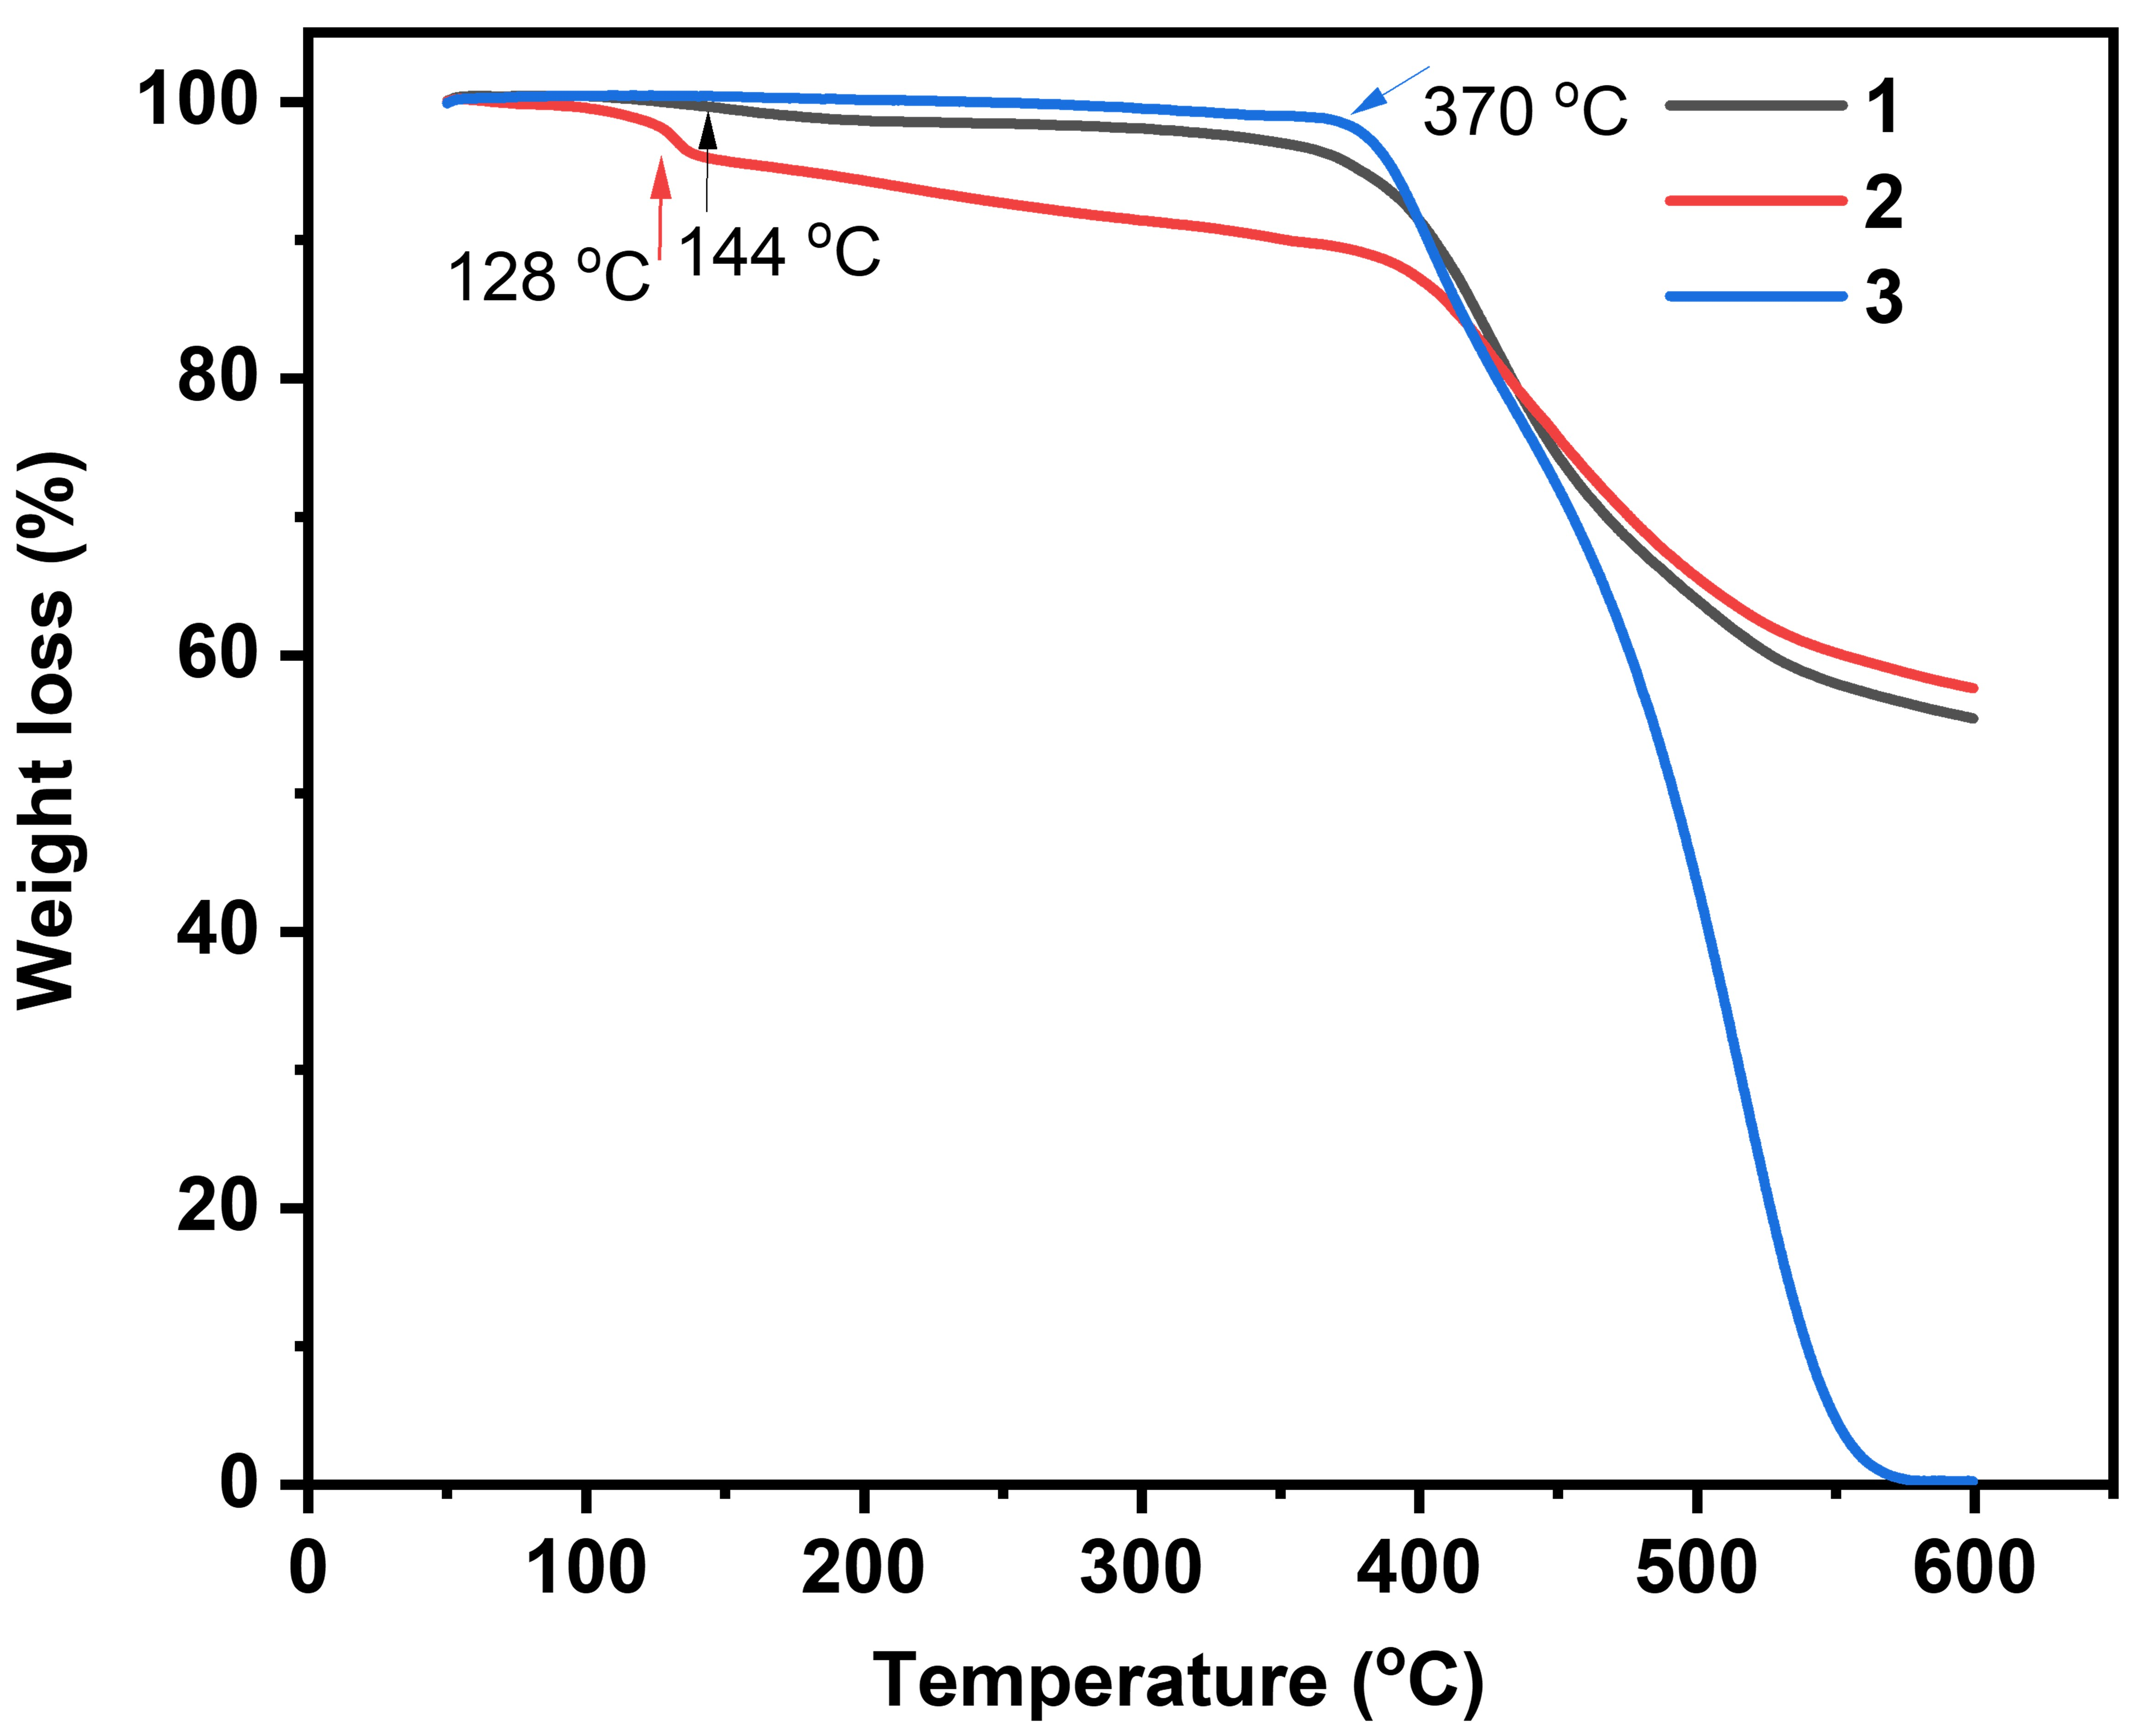
Figure S10 TGA curves of 1, 2 and 3; heating rate: 10 ºC/min from 50 ºC to 600 ºC under nitrogen atmosphere.

6. Calculations on electronic properties
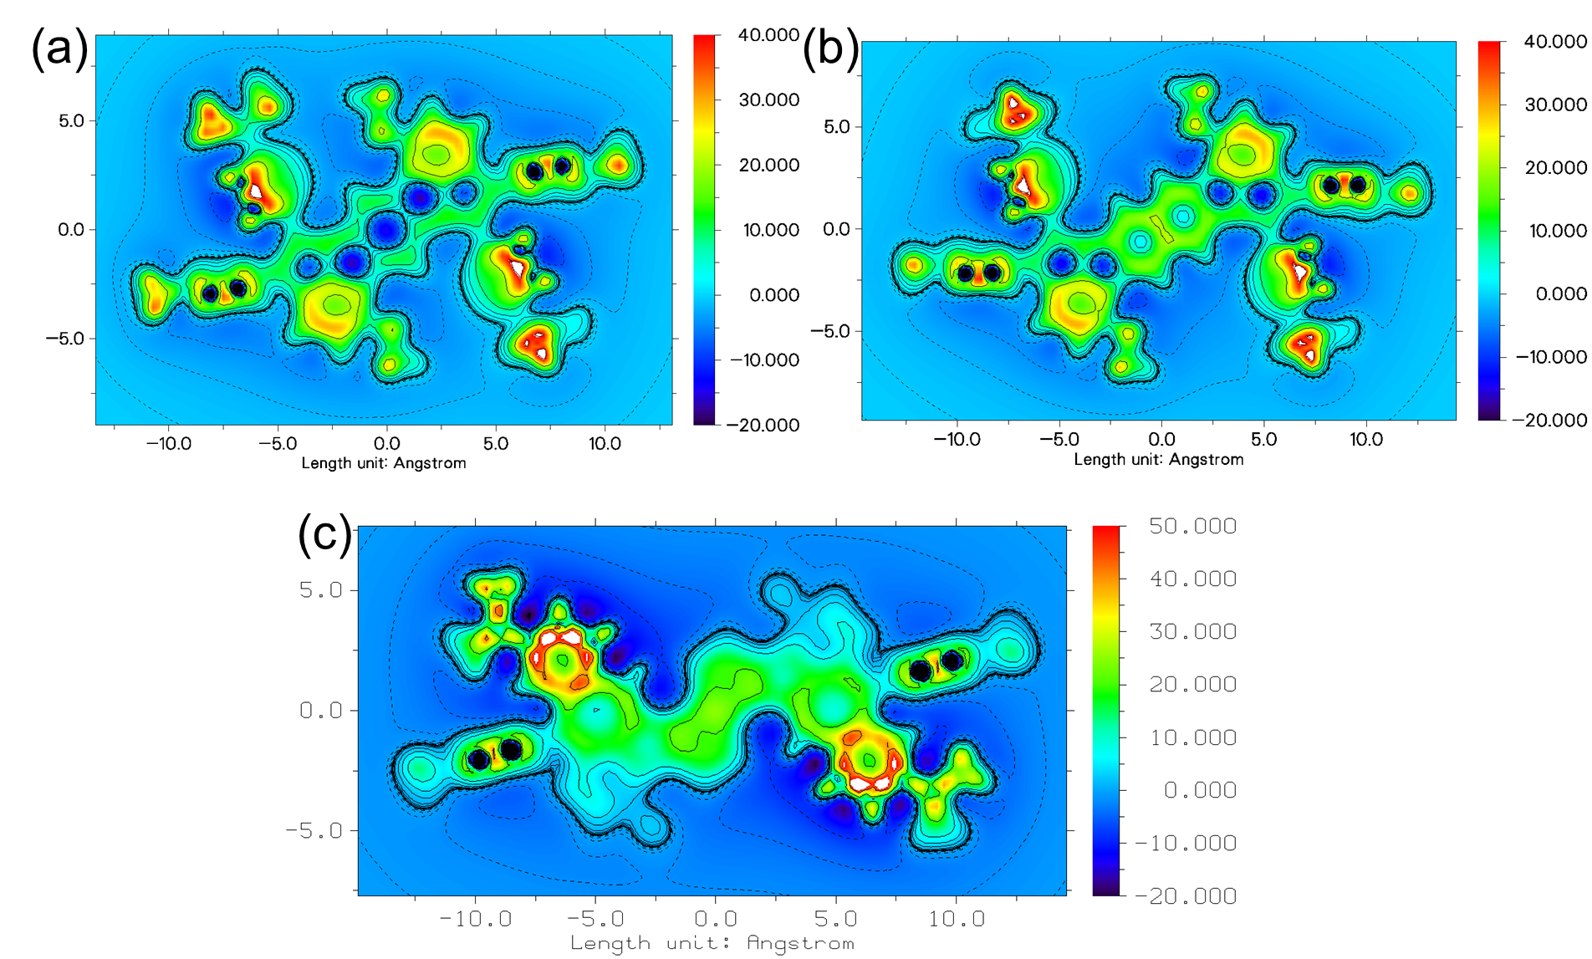
Figure S11 Isotropic Chemical Shielding Surface at 1 Å of Z axis (ICSS(1)_{zz}) for (a) 1, (b) 2 and (c) 3.
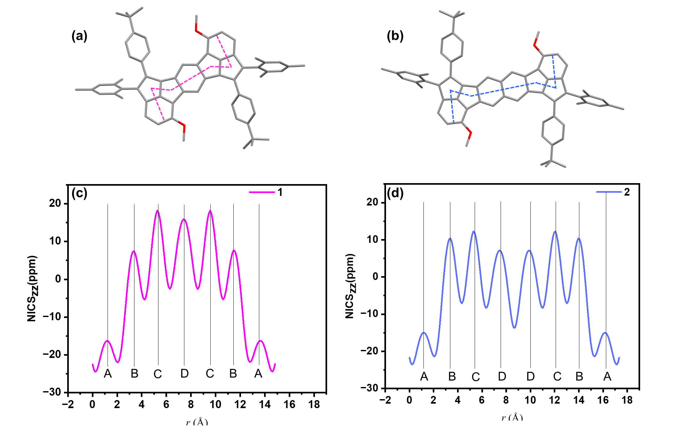
Figure S12 The NICS-XY scan lines of two antiaromatic compounds of (a) 1 and (b) 2. The corresponding NICS values of (c) 1 and (d) 2 along the scan lines
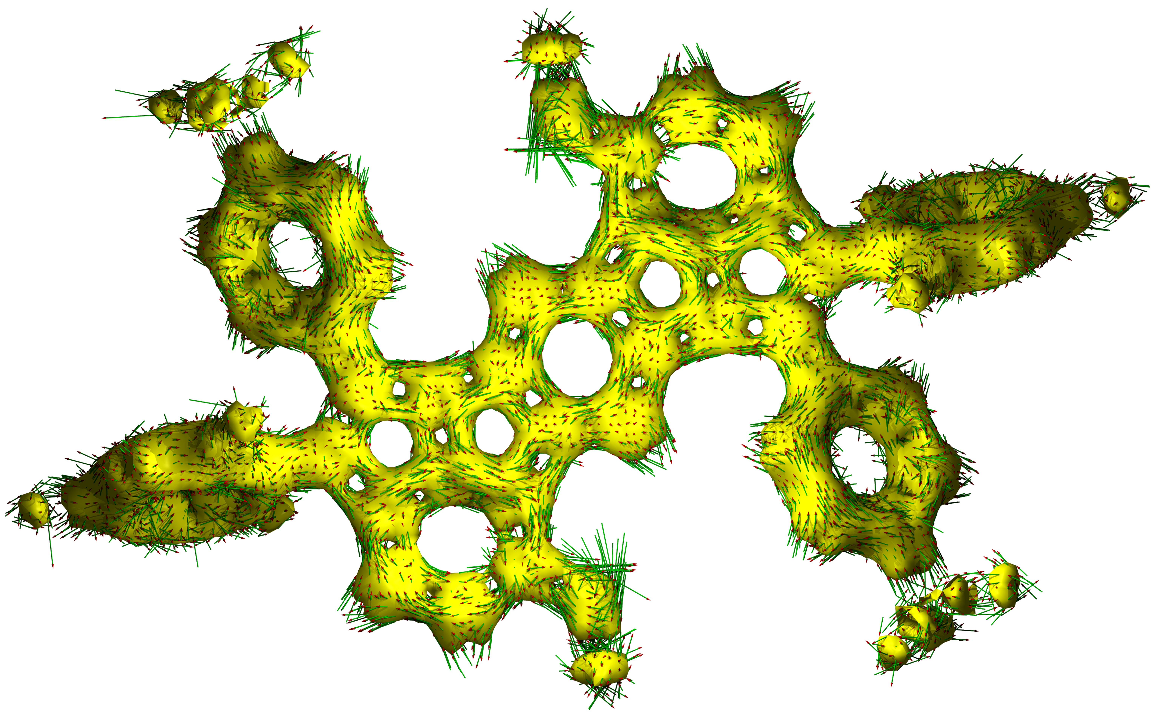
Figure S13 The calculated ACID plots of compound 1 (closed-shell state)
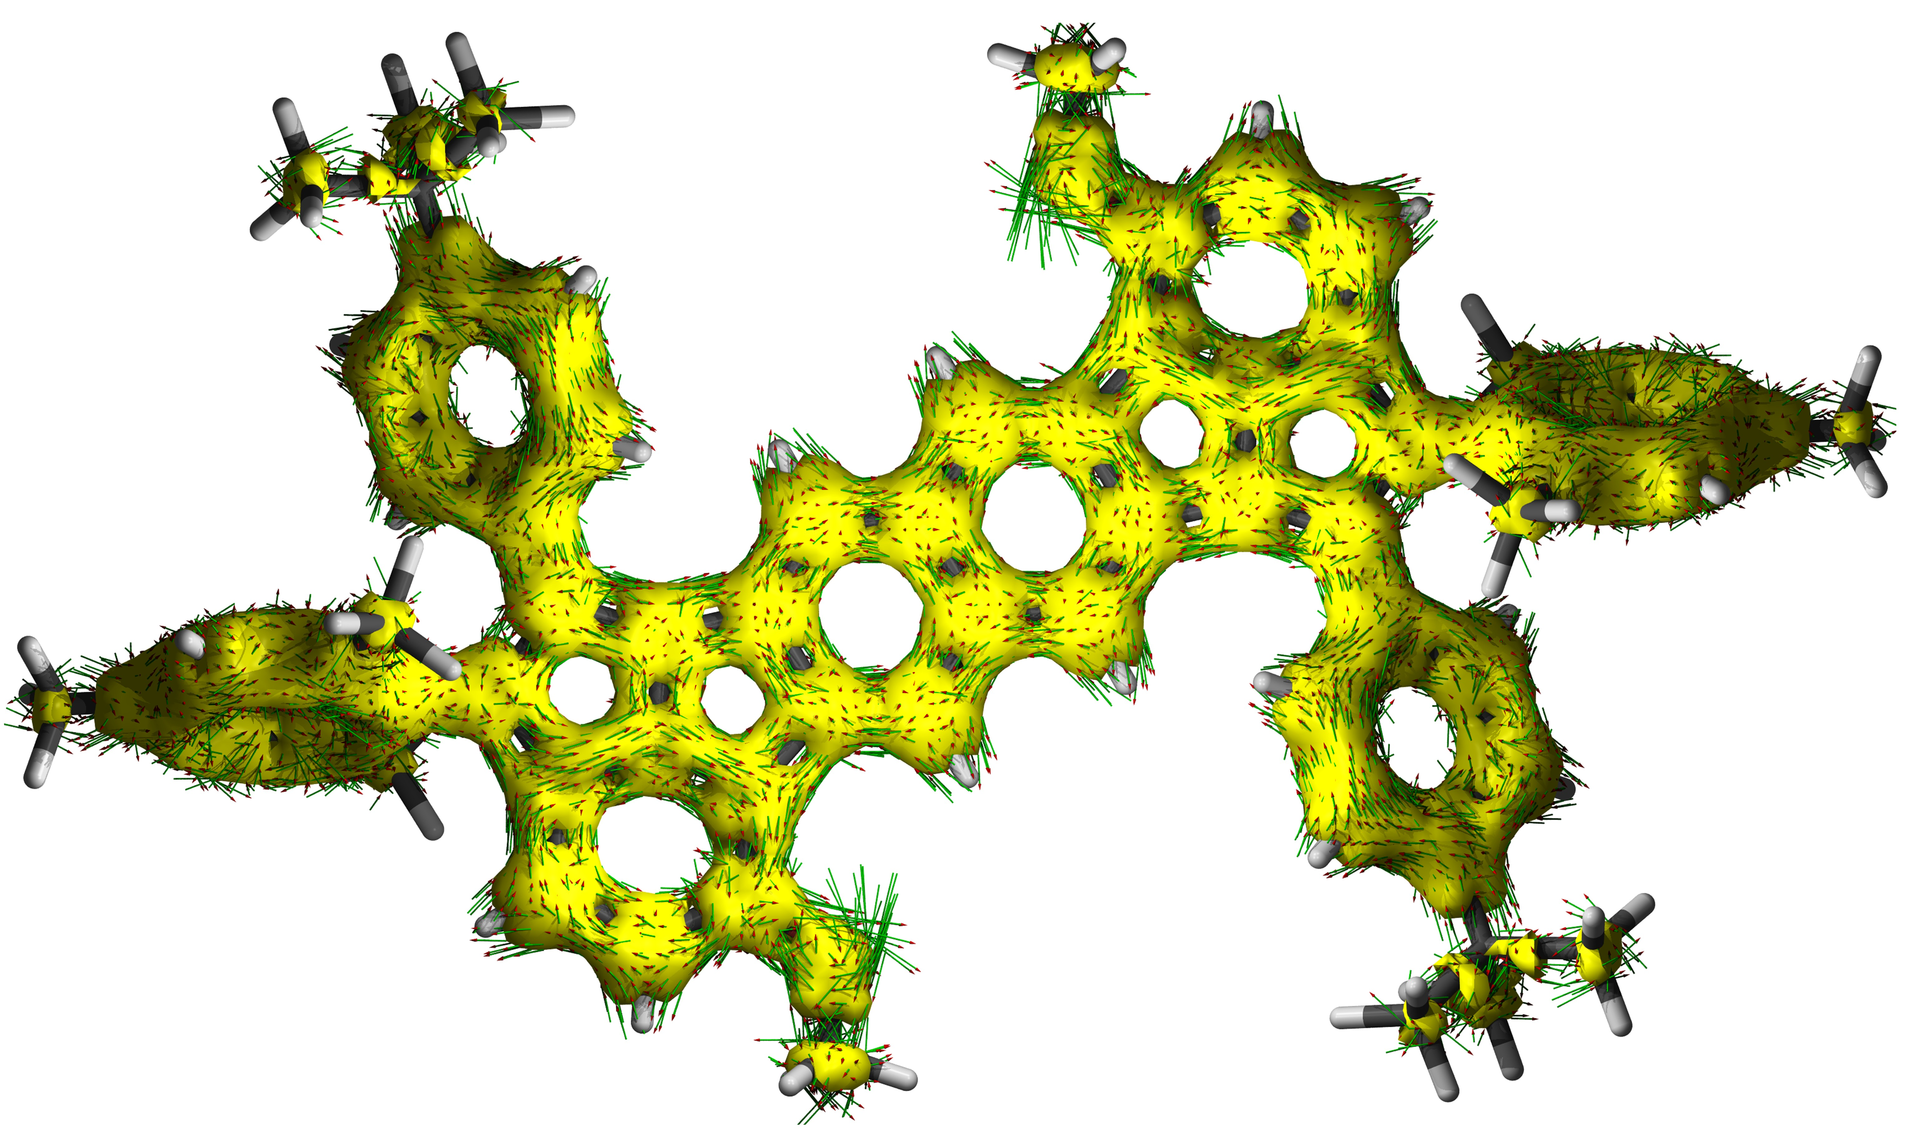
Figure S14 The calculated ACID plots of compound 2 (open-shell state)

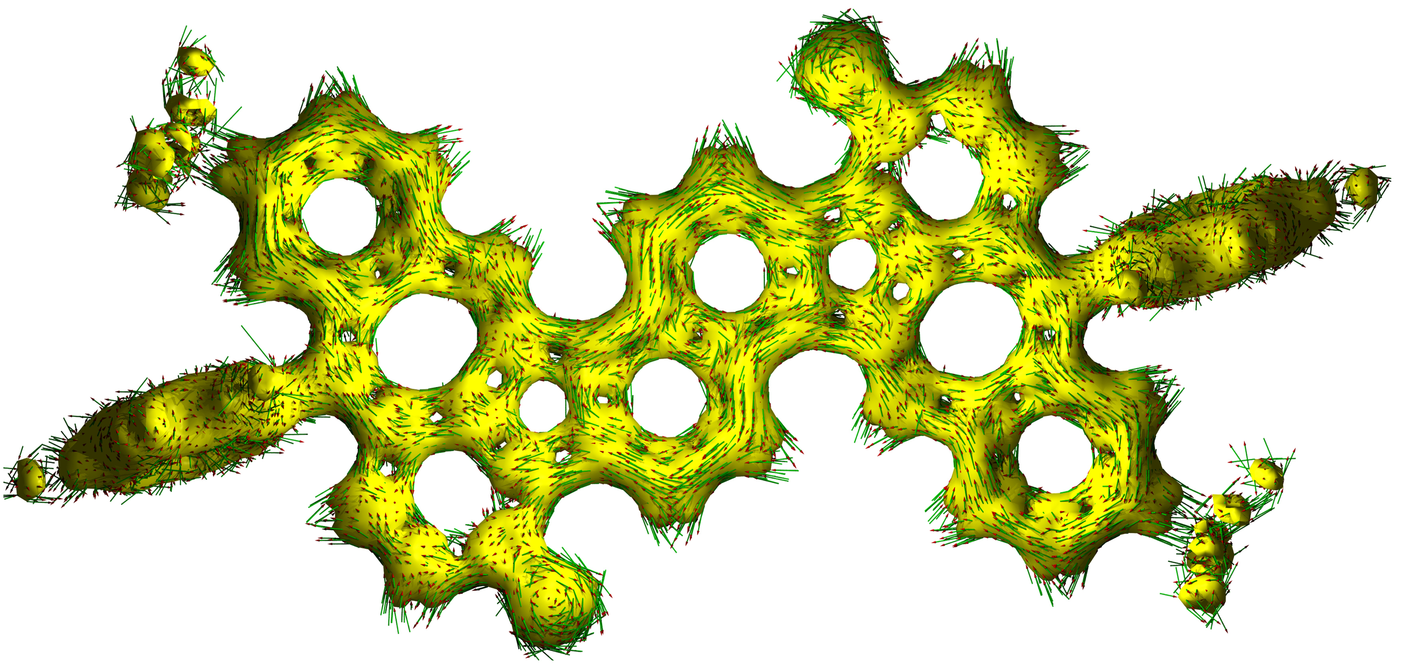
Figure S15 The calculated ACID plots of compound 3 (closed-shell state)

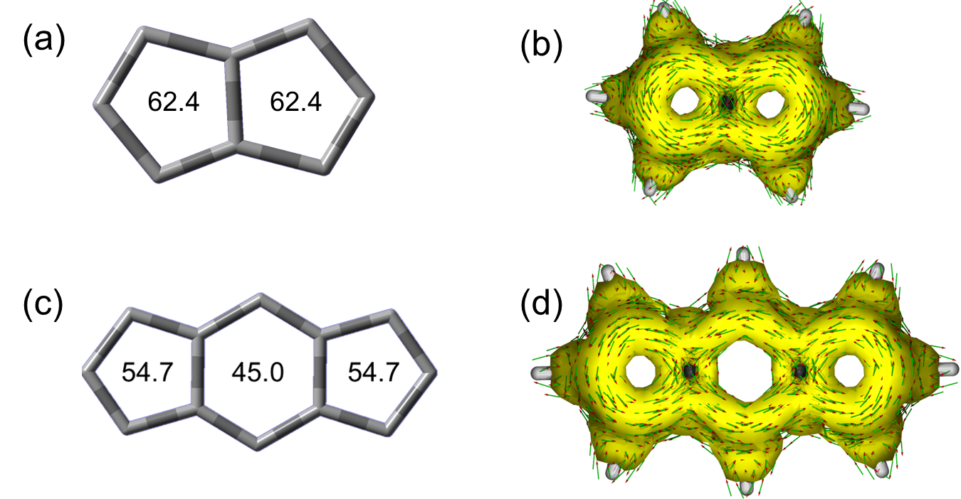
Figure 16 The calculated NICS (a, c) and ACID plots (b, d) of pristine pentalene (a, b) and s-indacene (c, d) units.
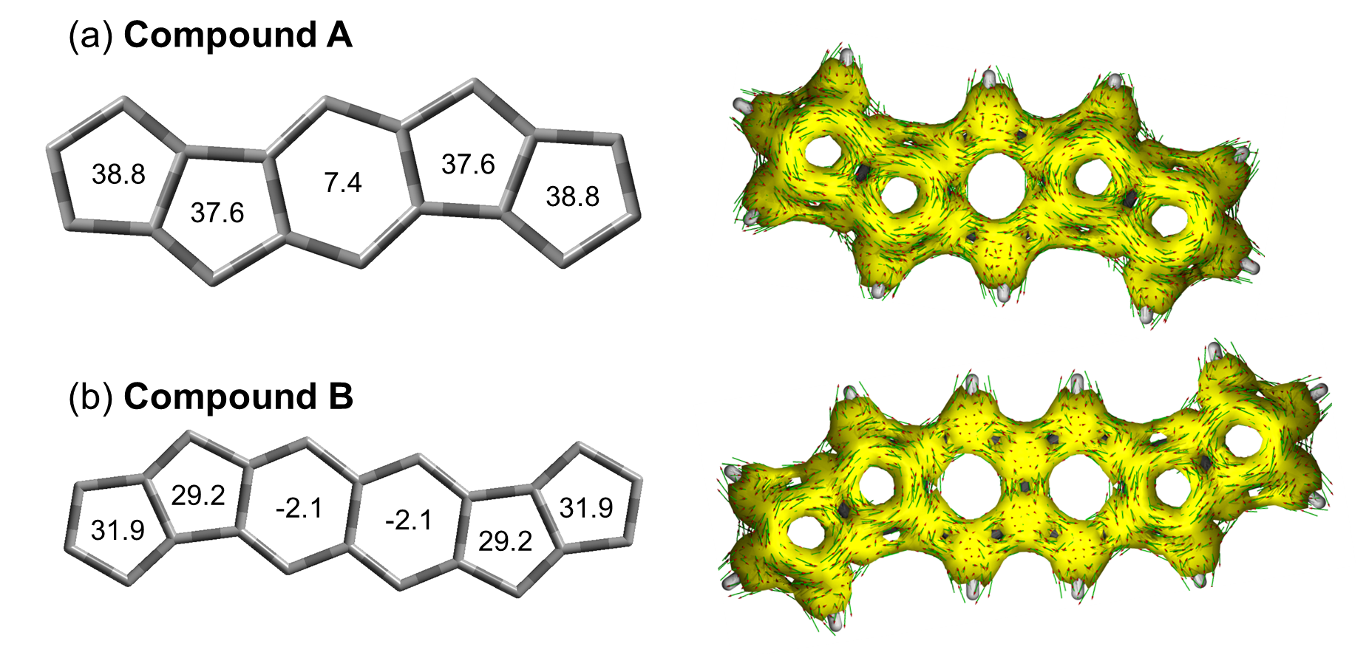
Figure S17 The model compounds of (a) bis(pentalene)-fused benzene or (b) naphthalene derivatives.

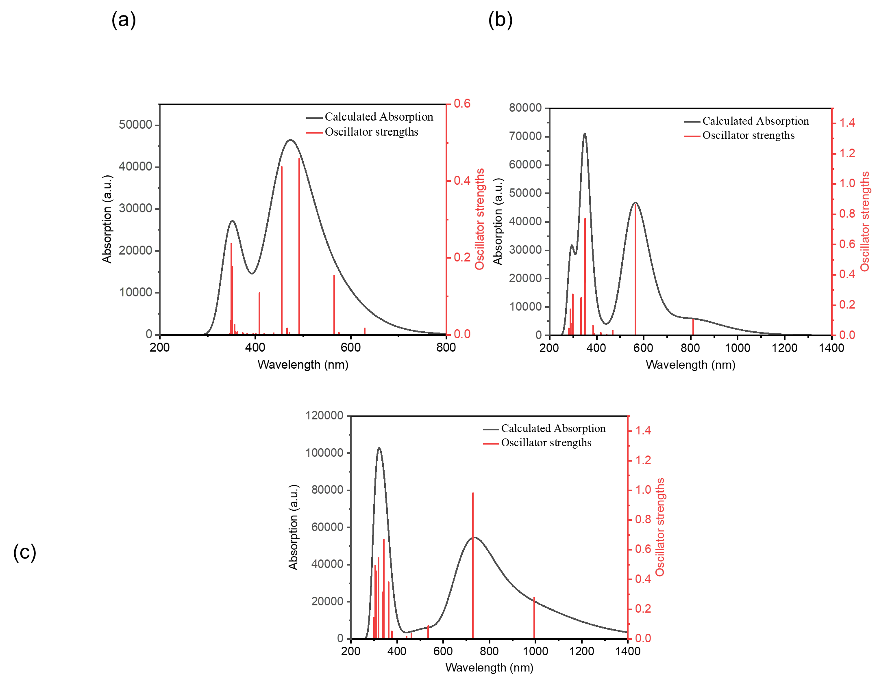
Figure S18 Calculated UV-vis absorption spectra of the 1 (closed-shell single state)

Table S7 Excitation energies, oscillator strengths and orbital contribution of the S₀ → S_{n} excitations of 1 calculated at the TD-B3LYP-D3(BJ)/6-31G(d,p) level of theory.
transition | energy [eV] | energy [nm] | oscillator  strength | orbital contribution
S₀ → S₁ | 1.4772 | 839.32 | 0.00010 | H-1 → L | 95.9%
S₀ → S₂ | 1.5298 | 810.46 | 0.10370 | H → L  H-3 → L | 74.2%  25.3%
S₀ → S₃ | 1.6801 | 737.96 | 0.00000 | H-2 → L | 96.0%
S₀ → S₄ | 2.1946 | 564.95 | 0.86380 | H-3 → L  H → L | 70.8%  23.4%
S₀ → S₅ | 2.6274 | 471.89 | 0.00010 | H-4 → L | 97.9%
S₀ → S₆ | 2.6429 | 469.12 | 0.03100 | H-5 → L | 96.1%
S₀ → S₇ | 2.8008 | 442.67 | 0.00510 | H-6 → L | 98.0%
S₀ → S₈ | 2.8057 | 441.90 | 0.00150 | H-7 → L | 98.4%
S₀ → S₉ | 2.9678 | 417.76 | 0.01880 | H-8 → L | 92.5%
S₀ → S₁₀ | 2.9818 | 415.80 | 0.00260 | H-9 → L  H → L+1 | 87.6%  7.1%

Figure S19 Calculated UV-vis absorption spectra of the 2 (open-shell single state)
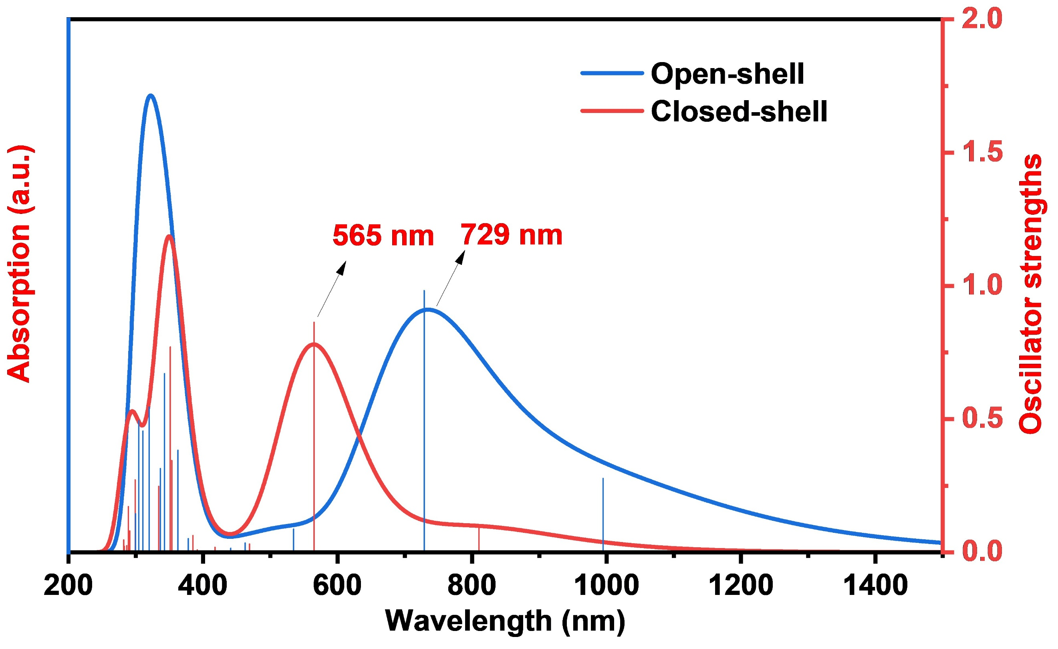
Figure S20 Calculated UV-vis absorption spectra of the compound 2 in open-shell (blue line) and closed-shell states (red line).

Table S8 Excitation energies, oscillator strengths and orbital contribution of the S₀ → S_{n} excitations of 2 calculated at the TD-UB3LYP-D3(BJ)/6-31G(d,p) level of theory.
transition | energy [eV] | energy [nm] | oscillator  strength | orbital contribution
S₀ → S₁ | 1.2465 | 994.66 | 0.27740 | H → L  H-2 → L | 56.2%  45.8%
S₀ → S₂ | 1.2868 | 963.51 | 0.00000 | H-1 → L | 99.0%
S₀ → S₃ | 1.4414 | 860.17 | 0.00000 | H-3 → L | 98.9%
S₀ → S₄ | 1.7014 | 728.72 | 0.98210 | H-2 → L  H → L | 53.0%  48.1
S₀ → S₅ | 2.3186 | 534.74 | 0.08730 | H-4 → L | 98.5%
S₀ → S₆ | 2.3408 | 529.67 | 0.00010 | H-5 → L | 96.8%
S₀ → S₇ | 2.5099 | 493.98 | 0.00320 | H-6 → L | 99.4%
S₀ → S₈ | 2.5159 | 492.80 | 0.00110 | H-7 → L | 99.3%
S₀ → S₉ | 2.6810 | 462.46 | 0.03480 | H-8 → L | 95.6%
S₀ → S₁₀ | 2.6902 | 460.87 | 0.00010 | H-9 → L  H → L+1 | 73.9%  22.5%

Figure S21 Calculated UV-vis absorption spectra of the 3 (closed-shell single state)

Table S9 Excitation energies, oscillator strengths and orbital contribution of the S₀ → S_{n} excitations of 3 calculated at the TD-B3LYP-D3(BJ)/6-31G(d,p) level of theory.
transition | energy [eV] | energy [nm] | oscillator  strength | orbital contribution
S₀ → S₁ | 1.9697 | 629.46 | 0.01680 | H → L  H→ L+2 | 71.4%  20.9%
S₀ → S₂ | 2.1561 | 575.04 | 0.00480 | H → L+1  H → L+3 | 79.6%  8.5%
S₀ → S₃ | 2.1946 | 564.95 | 0.15430 | H → L+2  H → L | 68.8%  20.8%
S₀ → S₄ | 2.4113 | 514.18 | 0.00010 | H → L+3  H → L+1 | 80.8%  8.9%
S₀ → S₅ | 2.5209 | 491.83 | 0.45790 | H-1 → L | 94.6%
S₀ → S₆ | 2.6278 | 471.82 | 0.00630 | H-1 → L+1 | 79.0%
S₀ → S₇ | 2.6573 | 466.58 | 0.01670 | H-3 → L  H-4 →L+1  H-3 → L+2  H-3 → L+1 | 47.0%  22.9%  10.3%  6.9%
S₀ → S₈ | 2.6674 | 464.81 | 0.00030 | H-4 → L  H-3 → L+1  H-4 → L+1  H-1 → L+1 | 33.5%  26.2%  22.7%  9.2%
S₀ → S₉ | 2.7240 | 455.15 | 0.43700 | H-1 → L+2  H-2 → L+1 | 84.1%  5.1%
S₀ → S₁₀ | 2.8298 | 438.14 | 0.00400 | H-2 → L  H-2 → L+2 | 75.4%  10.6%
Table S10 Summary of the absorption and electrochemistry parameters
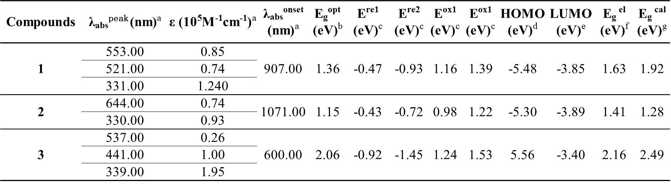
a. Absorption maxima, molar extinction coefficient and onset absorption in 10⁻⁵ mol/L dichloromethane solution.
b. Based on the onset absorption (E_{g}^{opt} = 1240/λ_{abs}^{onset}).
c. Oxidative and reductive potential based on cyclic voltammograms (CV) with ferrocene as an external standard.
d. Calculated the HOMO and LUMO energy levels based on the reference of Fc/Fc⁺.
f. Estimated using the equation: E_{g}^{el} = LUMO-HOMO.
g. DFT calculation at (U)B3LYP-D3(BJ)/6-31G(d, p) level.

7. The stabilities of 1, 2 and 3
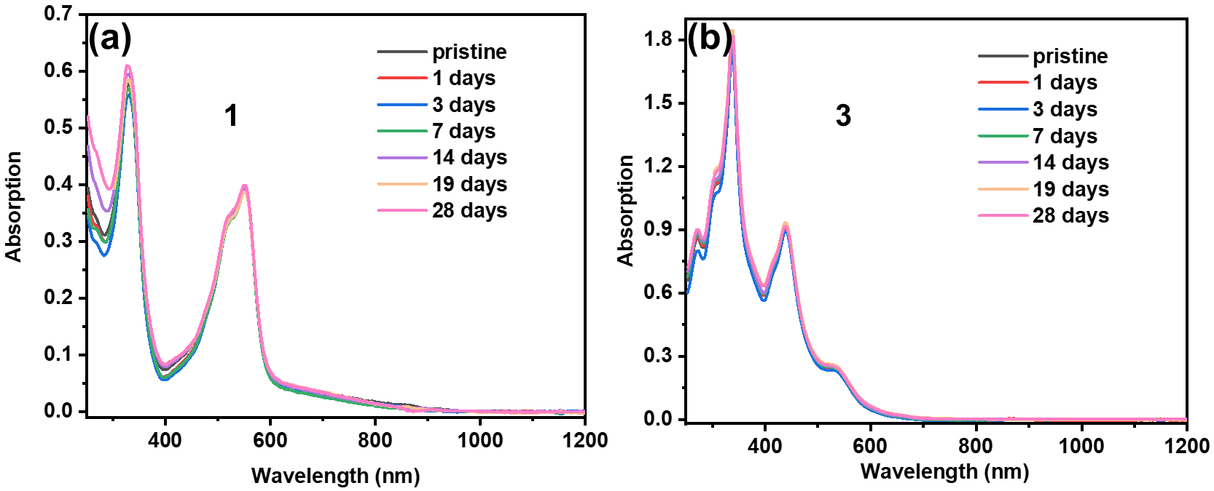
Figure S22 Time-dependent UV-vis measurements were performed under ambient conditions for compound (a) 1 and (b) 3. Single-crystal samples of 1 and 3 were dissolved in HPLC-grade CH₂Cl₂ open to the atmosphere. The cuvette was sealed with a Teflon cap and kept on the bench top.
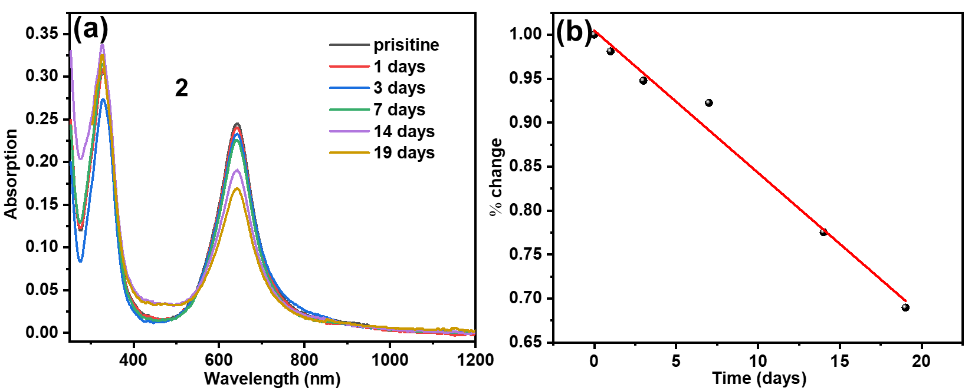
Figure S23 (a) Time-dependent UV−vis measurements were performed under ambient conditions for compound 2. (b) Time-dependent UV-vis absorbance of 2 in CH₂Cl₂ solution. Linear regression and extrapolation to % change = 0.50 gives a half-life of ca. 32 days.

8. The variable-temperature ¹H NMR
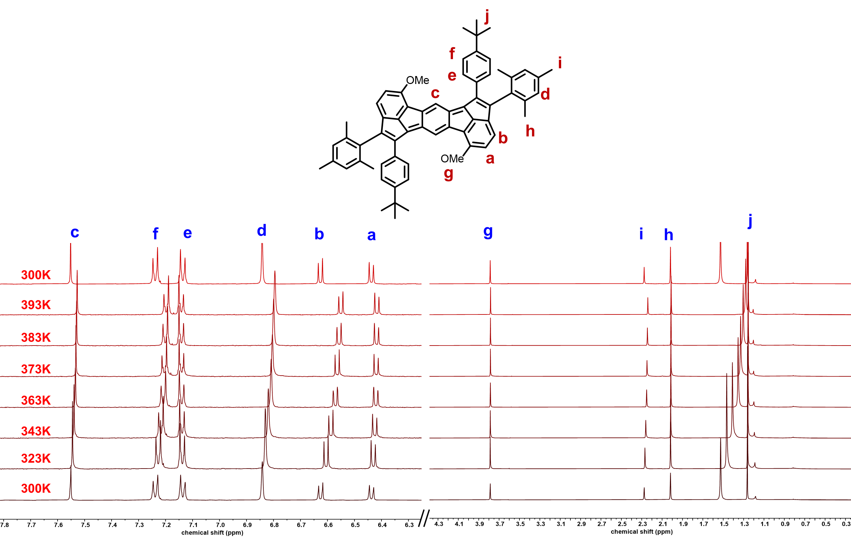
Figure S24 The VT ¹H NMR of 1 from 300 K to 393 K and then cooling to 300 K in C₂D₂Cl₄ (500 MHz).

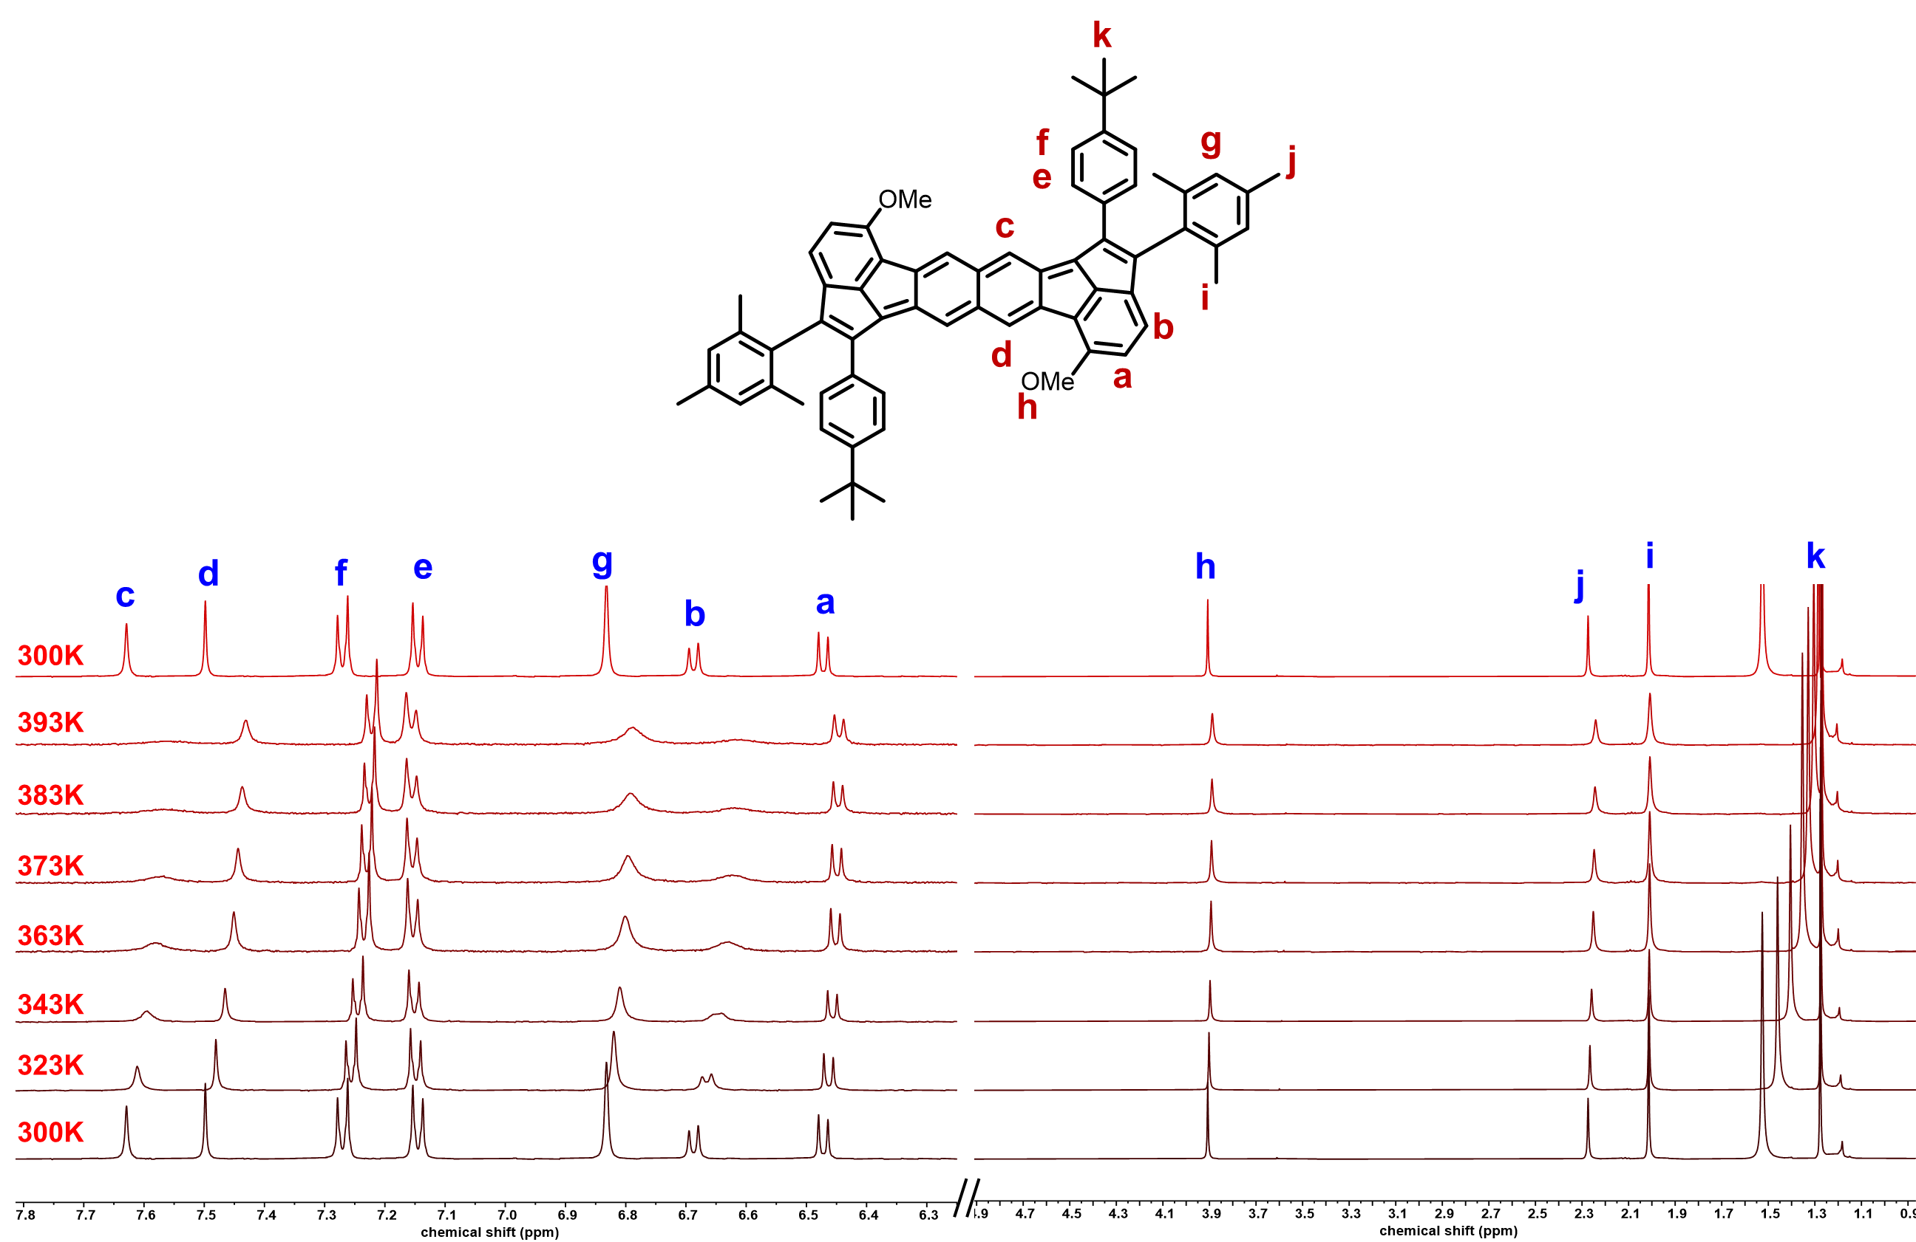
Figure S25 The VT ¹H NMR of 2 from 300 K to 393 K and then cooling to 300 K in C₂D₂Cl₄ (500 MHz).
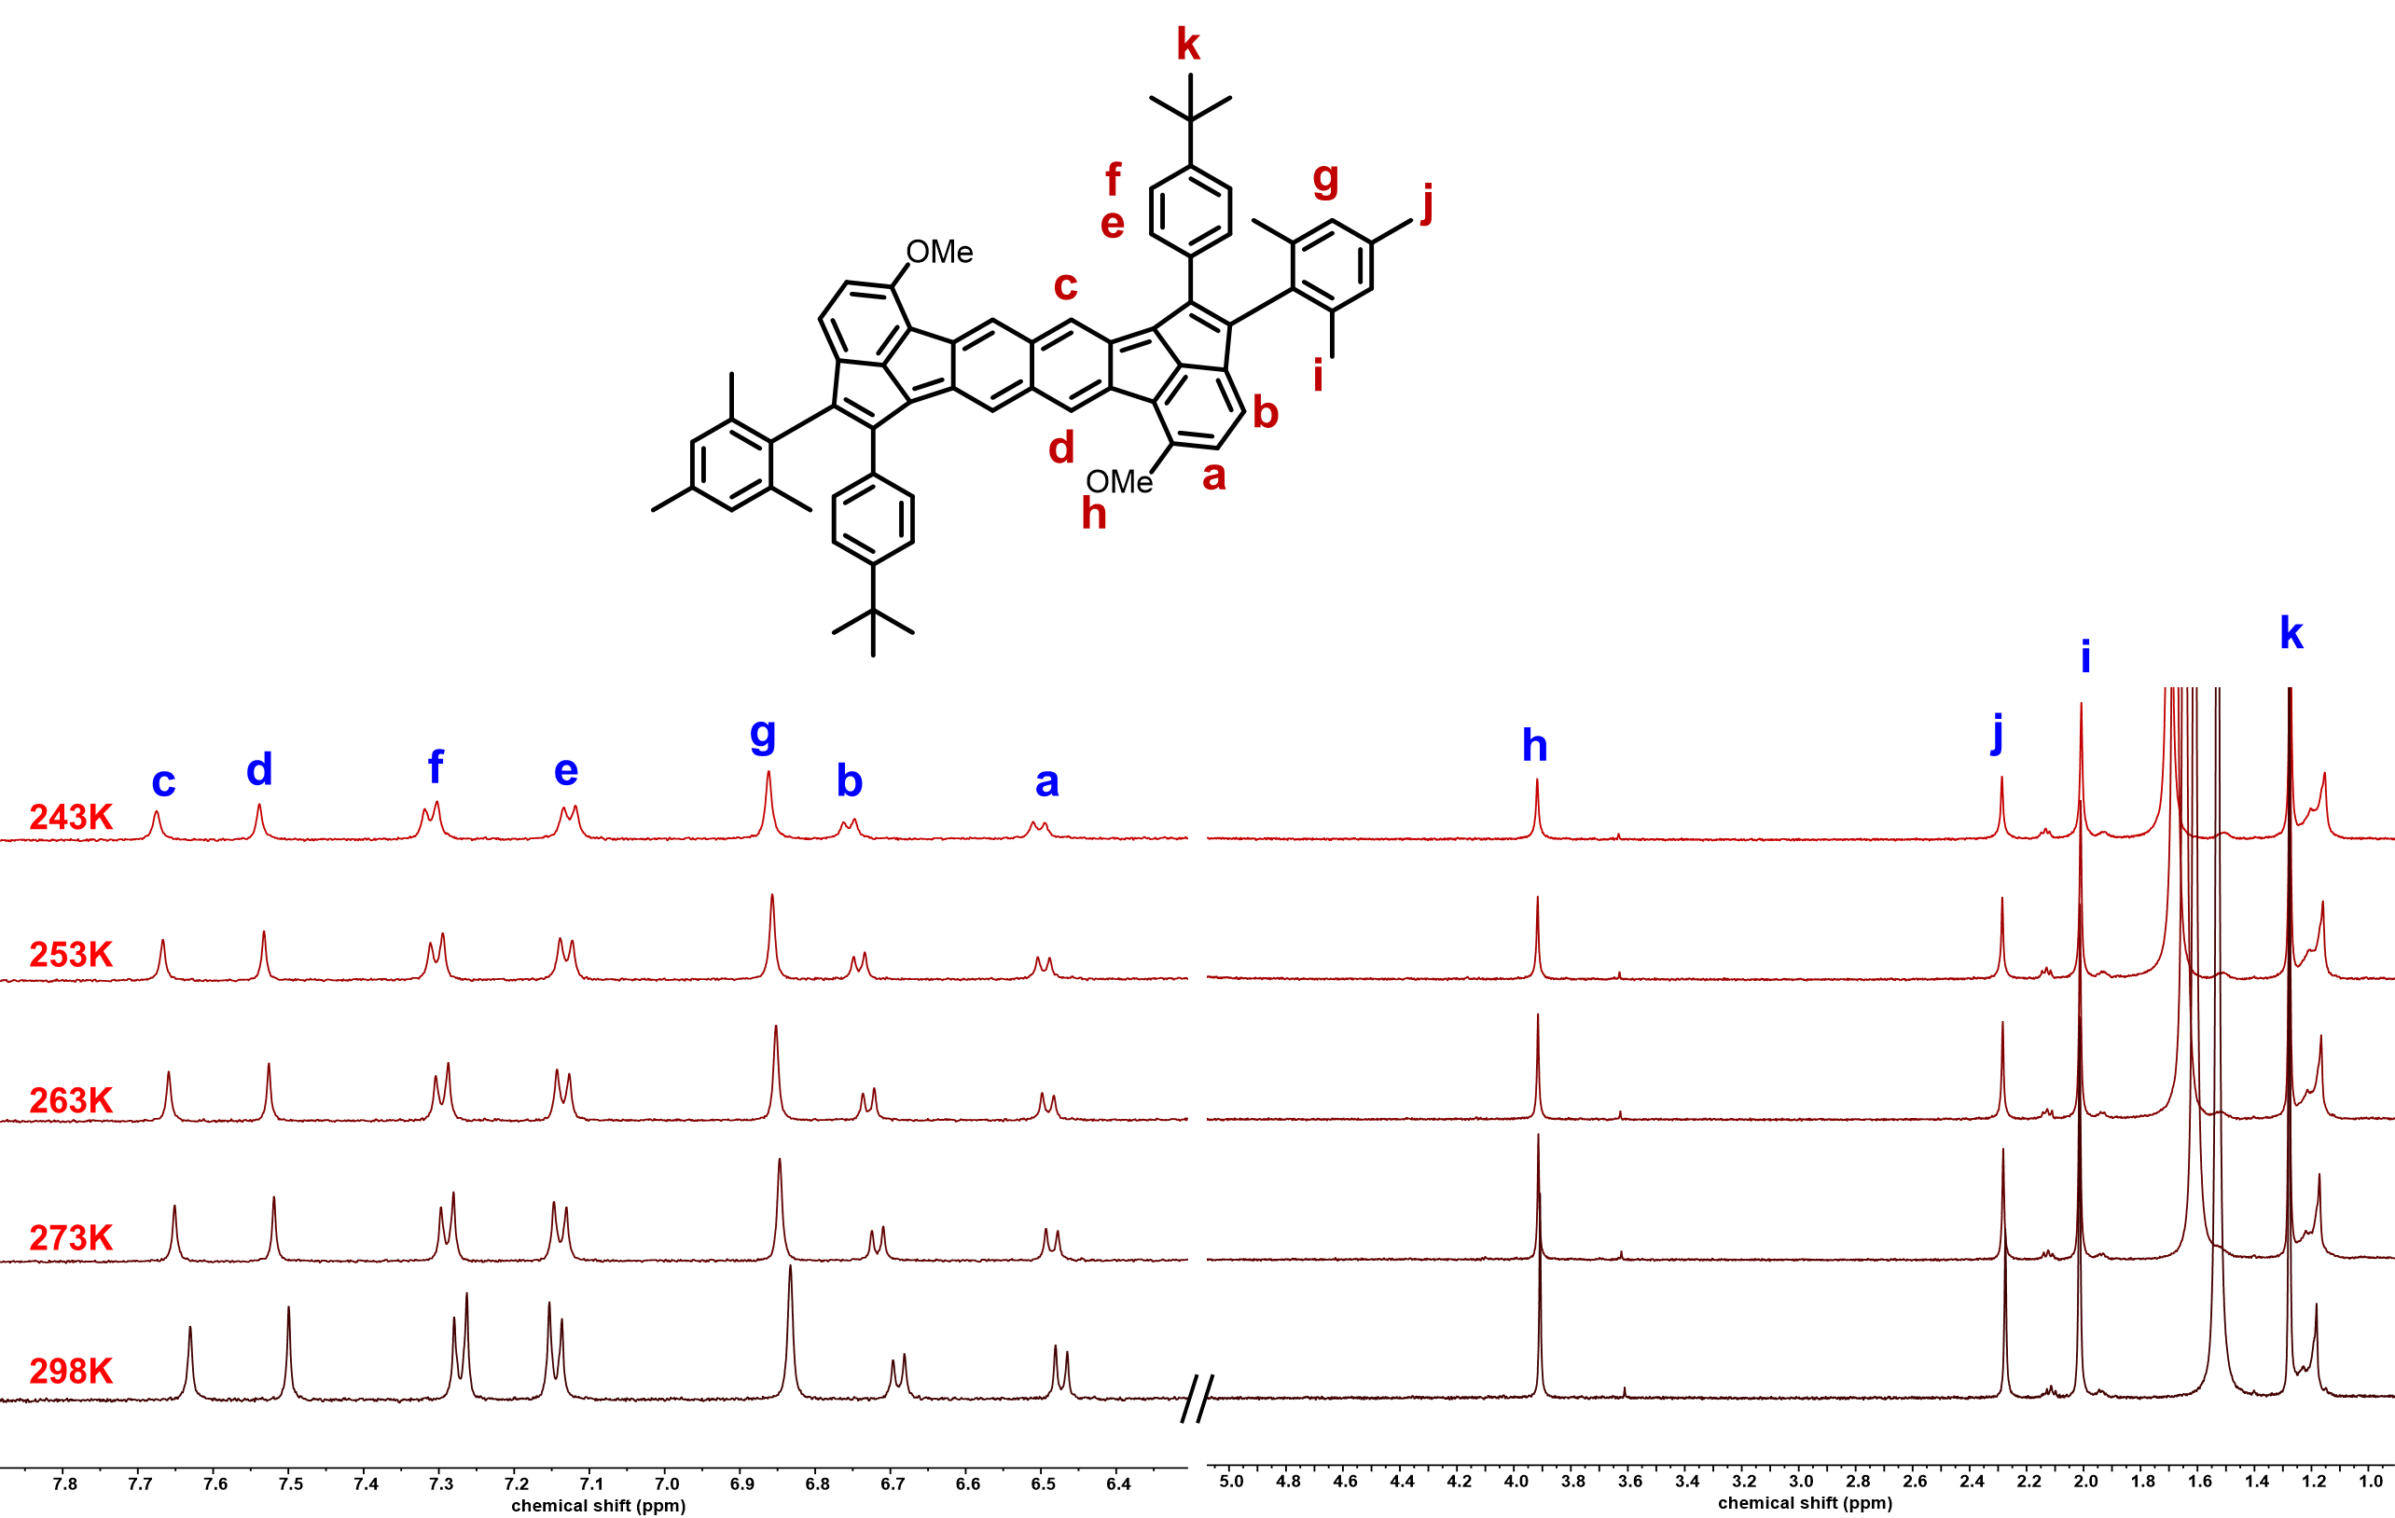
Figure S26 The VT ¹H NMR of 2 from 298 K to 243 K in C₂D₂Cl₄ (500 MHz).

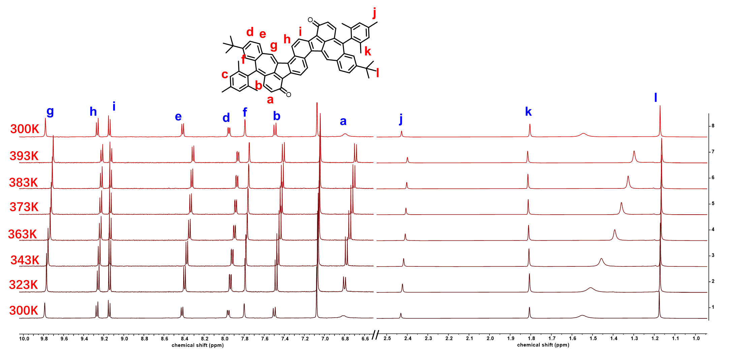
Figure S27 The VT ¹H NMR of 3 from 300 K to 393 K and then cooling to 300 K in C₂D₂Cl₄ (500 MHz).

9. The magnetic properties
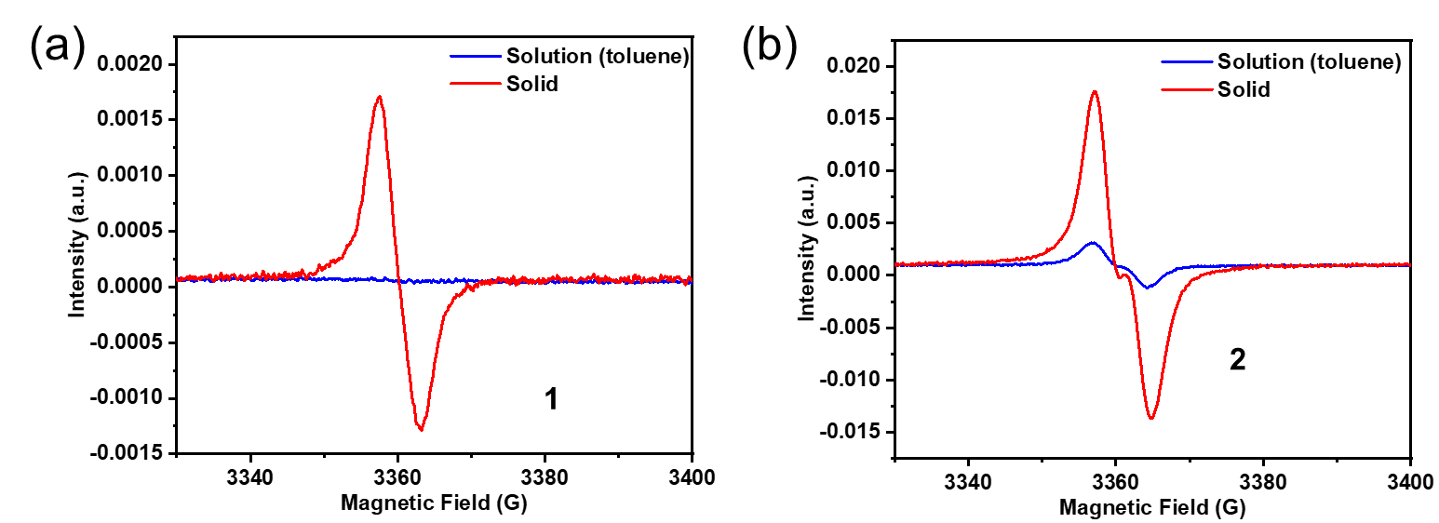
Figure S28 The electron-spin resonance (ESR) spectra of (a) 1 and (b) 2 in toluene solution and powder at room temperature.

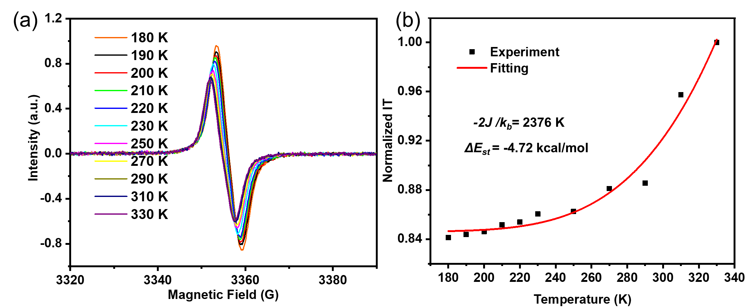
Figure S29 (a) Temperature dependence of the ESR signals of 1 in powder state. (b) The integrated signal multiplied by temperature and fitted with the Bleaney-Bowers equation of 1.

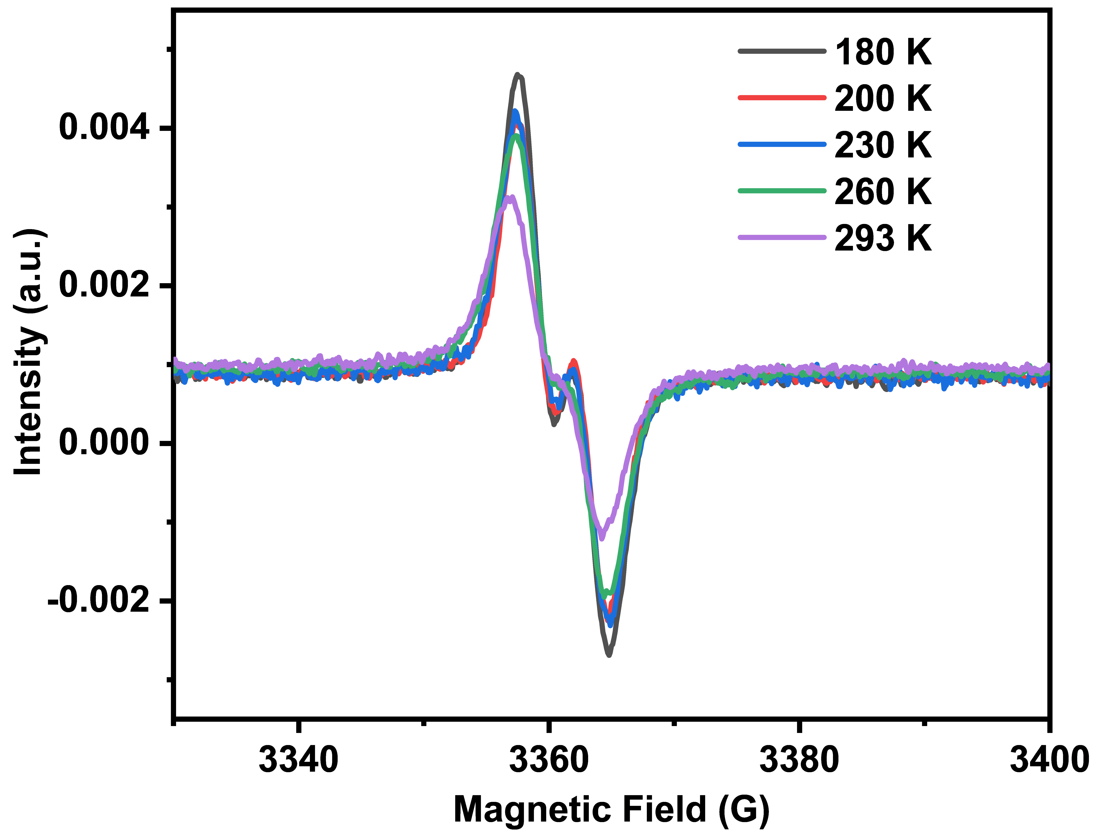
Figure S30 VT ESR of 2 from 180 K to 293 K in toluene solution.

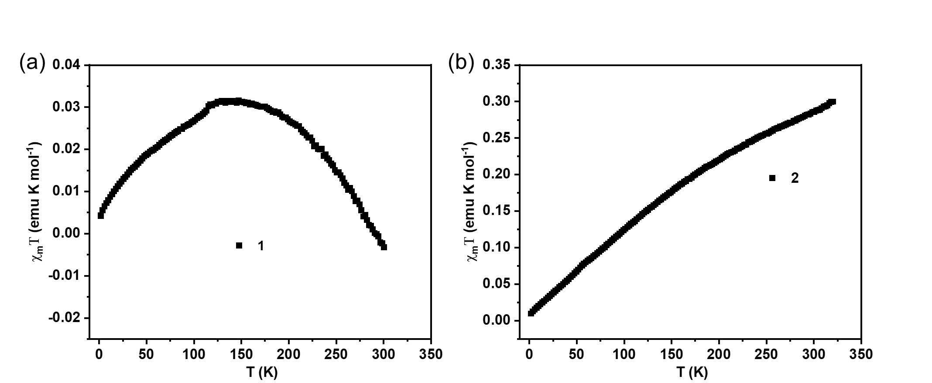
Figure S31 SQUID measurements (black square) of the magnetic susceptibility of (a) 1 and (b) 2 from 2 to 300 K.

Table S11 The ΔE_{st} and y₀ value were calculated based on (U)B3LYP-D3(BJ)/6-31G** and UCAM-B3LYP/6-31G* level, respectively.
Compounds | E_{s} (Hartree) | E_{s} (Hartree) | E_{t} (Hartree) | y₀ | ΔE_{st}
Compounds | (Close-Shell) | (Open-Shell) |  | (UCAM-B3LYP/6-31G*) | (kcal mol⁻¹)
1 | -2625.795129 |  | -2625.778545
2 | -2779.453351 | -2779.455595 | -2779.447994 | 0.38 | -7.22
3 | -2699.687238 |  | -2699.636498

10. OFETs fabrication and characterization
A heavily doped n-type Si wafer with a dry oxidized SiO₂ layer of 300 nm was employed as the gate electrode and dielectric layer. The drain-source (D-S) gold contacts were fabricated by photo-lithography. The substrates were first cleaned by sonication in acetone and water for 5 min, and immersed in Piranha solution (7:3 mixture of sulfuric acid and 30% hydrogen peroxide) for 30 min. The substrates were further rinsed with deionized water and isopropyl alcohol for three times and they were blow-dried with nitrogen. Then, the substrate was processed by UV ozone for about 10 min. After that, the substrates were placed into a petri dish, and one drop of n-octadecyltrichlorosilane (OTS) was dropped into the middle of petri dish. The system was stored under vacuum at 120 ºC for 4 h to form an OTS self-assembled monolayer. After the substrate surfaces were modified with OTS, they were washed with n-hexane, CHCl₃ and isopropyl alcohol sequentially. Next, thin films of 2 were prepared by drop-coating of their toluene solutions (8.0 mg/mL, 10 μL) onto the modified substrates, and the substrate was pre-heated at 100 ºC. After the solvent dried, the devices can be measured directly under an air atmosphere. The transfer and output curves of FETs were measured at room temperature in an air atmosphere using a Keithley 4200 SCS semiconductor parameter analyzer. The charge mobility of the OFETs in the saturation region was extracted from the following equation:
I_{DS}= μC_{i}(V_{GS}-V_{Th})² W/2L
Where I_{DS} is the current collected by the drain electrode; L and W are the channel length and width, respectively; μ is the mobility of the device; C_{i} is the capacitance per unit area of the gate dielectric layer (11 nF/cm²); V_{GS} is the gate voltage, and V_{Th} is the threshold voltage, respectively. The V_{Th} of the device was obtained by extrapolating the (I_{DS},sat)^{1/2} vs. V_{GS} plot to I_{DS} = 0.

Table S12 The FETs performance of BGBC devices based on the 2 thin films. The width (W) and length (L) of the conductive channel are 1440 μm, and 5 μm, respectively.
Compound | μ_{max}(cm²V⁻¹s⁻¹)ª | μ_{ave}(cm²V⁻¹s⁻¹)^{b} | V_{th}(V)^{c} | I_{on}/I_{off}^{d}
2 | 0.083 | 0.064 | 0.6-3.3 | 10³-10⁴
ª maximum hole mobility; ^{b} average hole mobility; ^{c} threshold voltage; ^{d} current on/off ratio. The average mobility was obtained based on 13 FET devices.

11. Other substrates used for this synthetic strategy
12.1 Synthesis and characterization of 25-1a, 25-2a, 25-3a and 26-1a
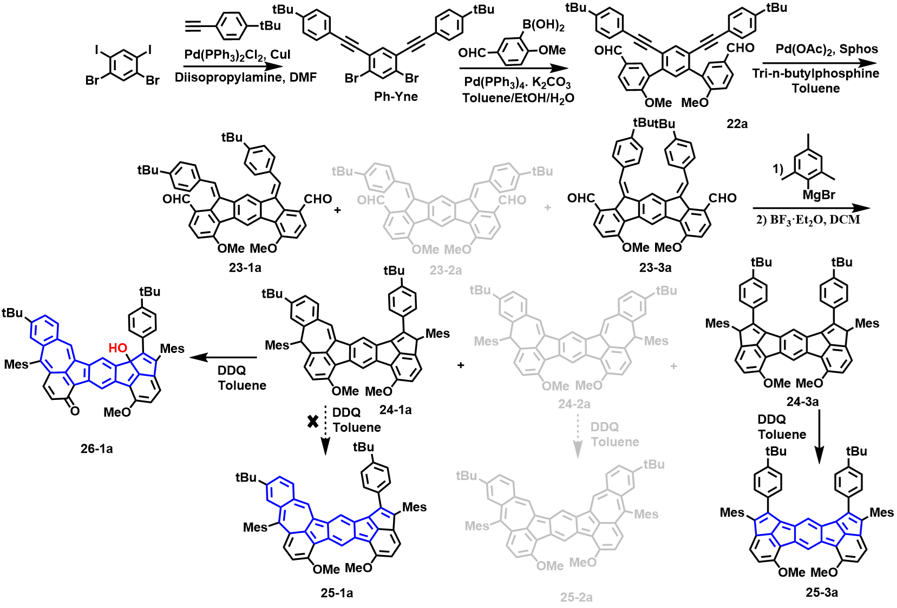
Scheme S4 The synthetic routes of compound 25-1a, 25-2a, 25-3a and 26-1a.
Synthesis of compound Ph-Yne
A 250 mL two-necked flask equipped with a magnetic stir bar was added 1,5-Dibromo-2,4-diiodobenzene (4 g, 8.2 mmol), Pd(PPh₃)₂Cl₂ (595 mg, 0.82 mmol) and CuI (311 mg, 1.64 mmol). The mixture was degassed and charged with nitrogen for three times and then 1-(tert-butyl)-4-ethynylbenzene (2.591 g, 16.4 mmol), diisopropylamine (20 mL) and DMF (40 mL) were added subsequently. The mixture was stirred at room temperature overnight. The reaction was quenched with hydrochloric acid solution (1 M, 100 mL), and the mixture was extracted with dichloromethane (100 mL×3) and washed with hydrochloric acid solution (1 M, 100 mL×2). The organic layer was dried with anhydrous Na₂SO₄ and concentrated under reduced pressure. The crude product was then purified by flash column chromatography using petroleum ether (b.p. 60-90 ºC) and dichloromethane (1/0~5/1, v/v) as eluent to give compound Ph-Yne as a white solid (4.323 g, 96.5% yield).
¹H NMR (400 MHz, CDCl₃, 298 K) δ (ppm) 7.87 (s, 1H), 7.71 (s, 1H), 7.51 (d, J = 7.0 Hz, 4H), 7.39 (d, J = 7.0 Hz, 4H), 1.33 (s, 18H).
¹³C NMR (101 MHz, CDCl₃ 298 K) δ (ppm) 152.4, 136.4, 135.7, 132.3, 131.5, 125.5, 125.0, 119.5, 95.5, 86.1, 34.9, 31.2.
HRMS (MALDI-FTICR) m/z: [M]⁺ calcd for C₃₀H₂₈Br₂ 546.0552; found 546.0551.
Synthesis of compound 22a
To a 250 mL three-necked flask equipped with a magnetic stir bar, compound Ph-Yne (3.0 g, 5.5 mmol), 2-methoxy-5-formylphenylboronic acid (2.97 g, 16.5 mmol), K₂CO₃ (3.795 g, 27.5 mmol) and Pd(PPh₃)₄ (317 mg, 0.275 mmol) were added. The mixture was degassed and charged with nitrogen for three times. Then toluene (100 mL), ethanol (15 mL) and water (15 mL) were added to the flask. The mixture was heated at 110 ºC (oil bath) overnight. After cooling to room temperature, the solvent was removed by rotary evaporation. The crude product was then purified by flash column chromatography using dichloromethane and ethyl acetate (1/0~20/1, v/v) as eluent to give compound 22a as a light-yellow solid. (2.972 g, 82.1% yield).
¹H NMR (400 MHz, CDCl₃, 298 K) δ (ppm) 9.96 (s, 2H), 7.99 (s, 2H), 7.97 (d, J = 8.4 Hz, 2H), 7.91 (s, 1H), 7.43 (s, 1H), 7.29 (d, J = 8.6 Hz, 4H), 7.14 (m, 6H), 3.90 (s, 6H), 1.29 (s, 18H).
¹³C NMR (101 MHz, CDCl₃ 298 K) δ (ppm) 190.9, 162.1, 151.7, 139.0, 135.4, 133.5, 131.8, 131.7, 131.1, 129.9, 129.5, 125.4, 123.0, 120.1, 111.0, 93.0, 87.4, 56.1, 34.8, 31.2.
HRMS (MALDI-FTICR) m/z: [M]⁺ calcd for C₄₆H₄₂O₄ 658.3077; found 658.3078.
Synthesis of compound 23a
To a Pyrex tube equipped with a magnetic stir bar, compound 22a (50 mg × 25, 1.90 mmol), Pd(OAc)₂ (2.2 mg × 25, 0.24 mmol), 2-dicyclohexylphosphino-2',6'-dimethoxybiphenyl (Sphos, 6.8 mg × 25, 0.43 mmol), Tri-n-butylphosphine (20 μL × 25, 2.0 mmol) and toluene (2 mL × 25) were added sequentially. Then, through a freeze-pump-thaw cycle, the tube was charged with nitrogen for three times again. After rising to room temperature, the mixture was heated at 120 ºC for 12 h. After cooling to room temperature, a large amount of precipitation was generated and filtered off. The precipitation was washed with MeOH. The residue was collected and dried under vacuum to afford compound 23a (1.09 g, 87.2%), which was directly used for the next step without further purification. The mixture mainly contains 23-1a and 23-3a with a molar ratio of 1:0.6 and 23-2a is trace. After recrystallization of the mixture in heated toluene, the pure asymmetric Z/E-configuration product 23-1a was obtained.
For 23-1a: ¹H NMR (400 MHz, CDCl₃, 298 K) δ (ppm) 10.43 (s, 1H), 9.57 (s, 1H), 8.82 (d, J = 0.7 Hz, 1H), 8.72 (s, 1H), 7.88 (d, J = 8.5 Hz, 1H), 7.73 (d, J = 2.6 Hz, 1H), 7.70 (d, J = 8.6 Hz, 1H), 7.56 (s, 4H), 7.35 – 7.30 (m, 2H), 7.28 (d, J = 2.4 Hz, 1H), 7.18 (s, 1H), 7.07 (d, J = 8.6 Hz, 1H), 6.98 (d, J = 8.6 Hz, 1H), 4.18 (s, 3H), 4.13 (s, 3H), 1.45 (s, 10H), 1.32 (s, 9H).
HRMS (MALDI-FTICR) m/z: [M]⁺ calcd for C₄₆H₄₂O₄ 658.3077; found 658.3075.
Synthesis of compound 24a
First step: To a 250 mL three-necked flask equipped with a magnetic stir bar, the mixture of 23a (560 mg, 0.85 mmol) and THF (100 mL) were added. The mixture was degassed and charged with nitrogen for three times and stirred at 0 ºC (ice-water bath) for 5 min. Then, 2-mesitylmagnesium bromide (1M solution in THF, 8.5 ml, 8.5 mmol) was added to the mixture at 0 ºC. After dripping completely, the mixture was warmed to room temperature for 2 h. Then, H₂O was added to quench the reaction. The residual was extracted by ethyl acetate three times (50 mL × 3), and washed with saturated sodium chloride aqueous solution (50 mL × 3). The organic layer was dried with anhydrous Na₂SO₄. The crude product was obtained by removal of solvent and used for the next step directly.
HRMS (MALDI- FTICR) m/z: [M]⁺ calcd for C₆₄H₆₆O₄ 898.4955; found 898.4960.
Second step: A 100 mL three-necked flask containing the obtained crude product was under vacuum for 15 min, then 20 mL of dry DCM was added, and 0.8 mL of BF₃·OEt₂ was added dropwise through the syringe (turned dark immediately). The mixture was stirred for 5 h at room temperature. Then 5 mL of saturated sodium carbonate (Na₂CO₃) solution was added to quench the reaction. The mixture was extracted by DCM (50 mL×3), and washed with saturated sodium chloride aqueous solution (50 mL × 3). The organic layer was dried with anhydrous Na₂SO₄. The solvent was removed under reduced pressure, and the residue containing a small amount of DCM solvent was added to MeOH to precipitate the solid. The precipitation was filtered and the filter residue was washed with MeOH to obtain the crude product (total: 685 mg). Then, the crude was further purified by flash column chromatography using petroleum ether (b.p. 60-90 ºC) and dichloromethane (5/1~2/1, v/v) as eluent to give compound 24-1a as a yellow solid. (409 mg, 55.9% yield) and compound 24-3a as a yellow solid (236 mg, 32.2% yield). Compound 24-2a was not obtained under these conditions.
For 24-1a: ¹H NMR (400 MHz, CDCl₃, 298 K) δ (ppm) 8.62 (s, 1H), 8.56 (s, 1H), 7.67 (dd, J = 8.4, 2.8 Hz, 2H), 7.50 (s, 1H), 7.48 – 7.43 (m, 2H), 7.34 (dd, J = 10.8, 8.0 Hz, 1H), 7.21 (td, J = 6.1, 3.1 Hz, 1H), 7.05 (s, 1H), 7.01 – 6.97 (m, 4H), 6.78 – 6.67 (m, 3H), 6.61 (d, J = 15.0 Hz, 1H), 6.26 (s, 1H), 6.03 (d, J = 14.1 Hz, 1H), 4.04 (s, 3H), 4.00 (s, 3H), 2.73 (d, J = 14.0 Hz, 3H), 2.37 (d, J = 2.0 Hz, 3H), 2.28 – 2.24 (m, 9H), 1.57 (d, J = 13.7 Hz, 3H), 1.37 (s, 9H), 1.13 (d, J = 3.2 Hz, 9H).
¹³C NMR (101 MHz, CDCl₃, 298 K) δ (ppm) 156.7, 154.3, 154.1, 152.2, 151.1, 151.0, 147.9, 147.5, 146.3, 139.5, 138.7, 138.4, 137.8, 137.4, 137.0, 136.5, 136.4, 135.9, 134.0, 133.9, 133.1, 132.8, 132.6, 132.3, 130.4, 130.0, 129.2, 129.1, 128.7, 128.2, 128.1, 127.9, 126.6, 125.7, 123.3, 121.9, 120.0, 118.2, 115.9, 113.8, 111.7, 110.0, 60.1, 59.8, 56.0, 55.8, 47.3, 47.3, 34.8, 34.7, 31.3, 30.9, 29.7, 22.1, 21.9, 21.0, 20.9, 18.9.
HRMS (MALDI-FTICR) m/z: [M]⁺ calcd for C₆₄H₆₂O₂ 862.4744; found 862.4747.
For 24-3a: ¹H NMR (400 MHz, CDCl₃, 298 K) δ (ppm) 9.01 (s, 1H), 8.61 (s, 1H), 7.71 (d, J = 7.3 Hz, 4H), 7.40 (d, J = 8.0 Hz, 4H), 7.00 (d, J = 7.5 Hz, 4H), 6.78 (d, J = 7.8 Hz, 2H), 6.58 (s, 2H), 6.03 (s, 2H), 4.07 (s, 6H), 2.75 (s, 6H), 2.25 (s, 6H), 1.56 (s, 6H), 1.34 (s, 18H).
¹³C NMR (101 MHz, CDCl₃, 298 K) δ (ppm) 157.2, 154.5, 151.1, 148.5, 148.3, 146.8, 138.2, 136.7, 136.6, 136.2, 135.8, 135.8, 133.7, 133.6, 133.2, 133.2, 132.0, 130.5, 129.9, 129.1, 128.2, 125.6, 125.5, 122.2, 122.0, 121.0, 117.7, 117.6, 109.8, 60.2, 60.1, 56.0, 56.0, 34.8, 31.4, 22.0, 20.9, 19.1.
HRMS (MALDI-FTICR) m/z: [M]⁺ calcd for C₆₄H₆₂O₂ 862.4744; found 862.4744.
Synthesis of compound 25-3a
To a 100 mL three-necked flask equipped with a magnetic stir bar, compound 25-3a (50 mg, 0.058 mmol) and 10 mL dry toluene were added. The mixture was degassed and charged with nitrogen for three times and stirred at 0 ºC (ice-water bath) for 3 min. Then, 2,3-dichloro-5,6-dicyano-1,4-benzoquinone (DDQ) (50 mg, 0.22 mmol) in 2 mL dry toluene was added to the mixture and the mixture was stirred under N₂ at room temperature for 30 min. Then, the mixture was poured into petroleum ether. A large amount of precipitation was generated and filtered off. The precipitation was washed with petroleum to obtain the crude product. The crude product was then further purified by a short silica gel column with dichloromethane to dichloromethane and methanol (1/0~20/1, v/v) to obtain a brown solid (unstable).
HRMS (MALDI-FTICR) m/z: [M]⁺ calcd for C₆₄H₆₀O₂ 860.4583; found 860.4587.
Synthesis of compound 26-1a
To a 100 mL three-necked flask equipped with a magnetic stir bar, compound 24-1a (50 mg, 0.058 mmol) and 10 mL dry toluene were added. The mixture was degassed and charged with nitrogen for three times and stirred at 0 ºC (ice-water bath) for 3 min. Then, 2,3-dichloro-5,6-dicyano-1,4-benzoquinone (DDQ) (50 mg, 0.22 mmol) in 2 mL dry toluene was added to the mixture and the mixture was stirred under N₂ at room temperature for 2 h (The color of the mixture turned to dark green). Then, the mixture was poured into petroleum ether. A large amount of precipitation was generated and filtered off. The precipitation was washed with petroleum to obtain the crude product. The crude product was then further purified by a short silica gel column with dichloromethane to dichloromethane and methanol (1/0~20/1, v/v) to obtain a brown solid (unstable). After placing this solid under ambient conditions for 3 days, a new product of 26-1a was obtained as a brown solid by a silica gel column with petroleum and dichloromethane (5/1~1/3, v/v) as eluent (9 mg, 8.6% yield).
¹H NMR (400 MHz, CDCl₃, 298 K) δ (ppm) 8.93 (s, 1H), 8.63 (s, 1H), 8.50 (s, 1H), 7.98 (d, J = 8.3 Hz, 1H), 7.76 (d, J = 8.2 Hz, 1H), 7.67 (s, 1H), 7.54 (d, J = 8.1 Hz, 2H), 7.30 (d, J = 8.6 Hz, 2H), 7.15 (s, 2H), 6.98 (d, J = 5.5 Hz, 3H), 6.87 (s, 1H), 6.76 (s, 1H), 6.65 (d, J = 9.9 Hz, 1H), 6.60 (d, J = 7.7 Hz, 1H), 6.49 (d, J = 7.7 Hz, 1H), 3.91 (s, 3H), 2.79 (s, 1H), 2.35 (s, 3H), 2.28 (s, 3H), 2.23 (s, 3H), 1.73 (d, J = 11.2 Hz, 9H), 1.28 (s, 9H), 1.08 (s, 9H).
¹³C NMR (101 MHz, CDCl₃, 298 K) δ (ppm) 182.1, 161.9, 154.9, 152.6, 151.6, 149.0, 145.4, 144.6, 144.1, 141.9, 139.9, 137.3, 137.3, 137.0, 137.0, 136.9, 135.9, 135.1, 135.0, 134.9, 134.7, 134.0, 133.1, 132.8, 132.5, 131.4, 130.5, 129.5, 129.1, 127.6, 127.5, 127.2, 126.8, 126.8, 126.6, 124.2, 120.9, 118.1, 117.7, 112.2, 55.0, 34.2, 33.6, 30.4, 29.9, 29.2, 28.7, 20.2, 19.3, 19.0, 18.8.
HRMS (MALDI-FTICR) m/z: [M+H]⁺ calcd for C₆₃H₅₉O₃ 863.4458; found 863.4458.

12.2 Synthesis and characterization of 25-1b, 25-2b, 25-3b and 26-1b.
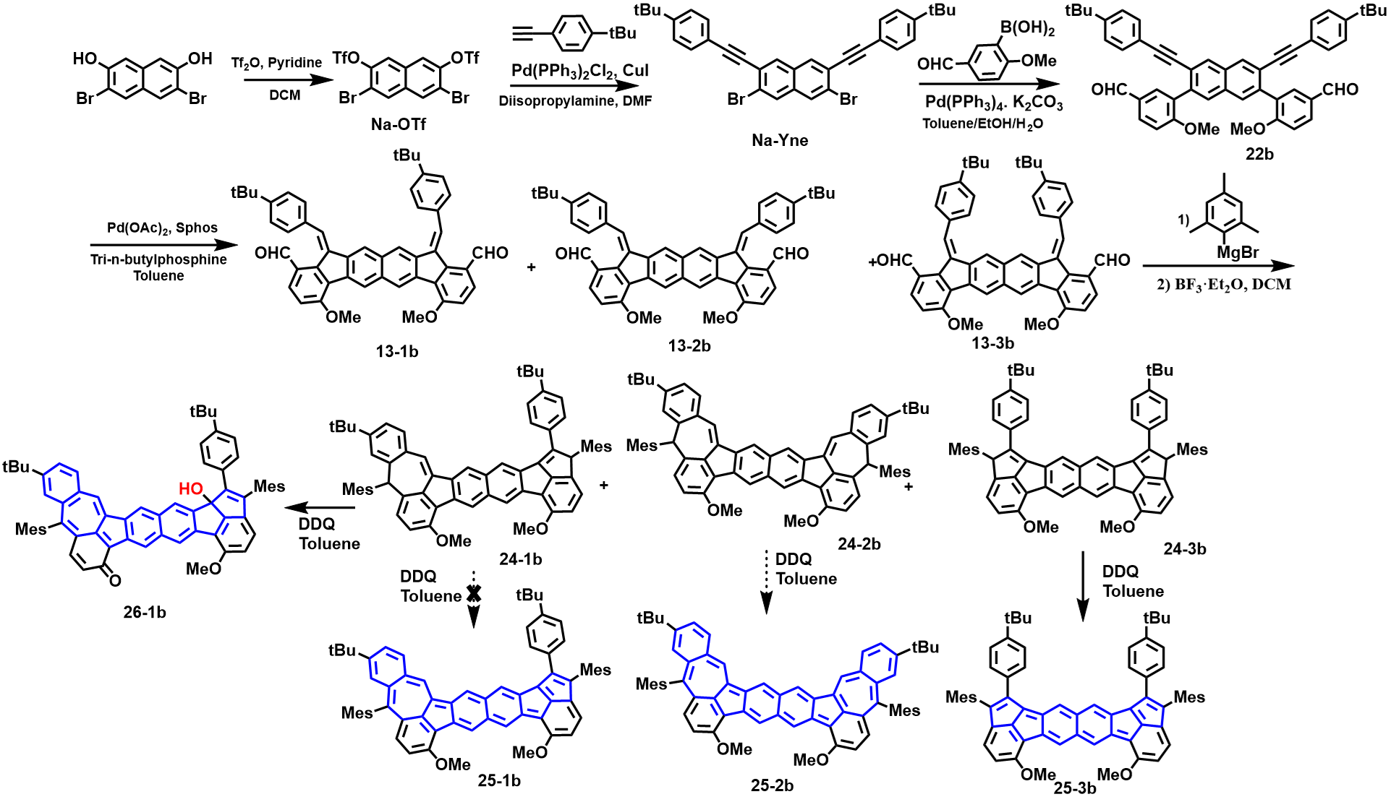
Scheme S5 The synthetic routes of compound 25-1b, 25-2b, 25-3b and 26-1b.
Synthesis of compound Na-OTf
To a 250 mL three-necked flask equipped with a magnetic stir bar, compound 3,6-Dibromonaphthalene-2,7-diol (2 g, 6.33 mmol), CH₂Cl₂ (50 mL) and pyridine (5 mL) were added. The mixture was degassed and charged with nitrogen for three times and then cooled to 0 ºC (ica-water bath) for 3 min. Then, Trifluoromethanesulfonic anhydride (5.35 g, 18.9 mmol) was added slowly to the mixture under an ice-water bath. After that, it was warmed to room temperature overnight. The reaction was quenched with hydrochloric acid solution (1 M, 50 mL), and the mixture was extracted with dichloromethane (50 mL × 3) and washed with hydrochloric acid solution (1 M, 50 mL × 3). The organic layer was dried with anhydrous Na₂SO₄ and concentrated under reduced pressure. The crude product was then purified by flash column chromatography using petroleum ether (b.p. 60-90 ºC) and dichloromethane (4/1, v/v) as eluent to give a white solid Na-OTf (2.43 g, 66.1% yield).
¹H NMR (400 MHz, CDCl₃, 298 K) δ (ppm) 8.18 (s, 1H), 7.85 (s, 1H).
¹³C NMR (101 MHz, CDCl₃ 298 K) δ (ppm) δ 145.6, 132.7, 132.3, 131.2, 120.9, 120.3, 117.1, 116.3.
Synthesis of compound Na-Yne
To a 250 mL three-necked flask equipped with a magnetic stir bar, compound Na-OTf (2 g, 3.45 mmol), Pd(PPh₃)₂Cl₂ (242 mg, 0.345 mmol) and CuI (132 mg, 0.69 mmol). The mixture was degassed and charged with nitrogen for three times and then 1-(tert-butyl)-4-ethynylbenzene (1.09 g, 6.9 mmol), diisopropylamine (20 mL) and DMF (20 mL) were added subsequently. The mixture was stirred at room temperature overnight. The reaction was quenched with hydrochloric acid solution (1 M, 100 mL), and the mixture was extracted with dichloromethane (100 mL × 3) and washed with hydrochloric acid solution (1 M, 100 mL × 3). The organic layer was dried with anhydrous Na₂SO₄ and concentrated under reduced pressure. The crude product was then purified by flash column chromatography using petroleum ether (b.p. 60-90 ºC) and dichloromethane (1/0~4/1, v/v) as eluent to give a light-yellow solid Na-Yne (1.654 g, 80.4% yield).
¹H NMR (400 MHz, CDCl₃, 298 K) δ (ppm) 8.00 (s, 2H), 7.97 (s, 2H), 7.56 (d, J = 6.7 Hz, 4H), 7.41 (d, J = 8.3 Hz, 4H), 1.34 (s, 18H).
¹³C NMR (101 MHz, CDCl₃, 298 K) δ (ppm) 152.3, 133.2, 132.3, 132.1, 131.5, 130.2, 129.9, 125.5, 124.1, 124.0, 119.7, 94.9, 87.4, 34.9, 31.2.
HRMS (MALDI-FTICR) m/z: [M]⁺ calcd for C₃₄H₃₀Br₂ 596.0716; found 596.0708.
Synthesis of compound 22b
To a 250 mL three-necked flask equipped with a magnetic stir bar, compound Na-Yne (1.57 g, 2.63 mmol), 2-methoxy-5-formylphenylboronic acid (1.42 g, 7.89 mmol), K₂CO₃ (1.817 g, 13.17 mmol) and Pd(PPh₃)₄ (152 mg, 0.131 mmol) were added. The mixture was degassed and charged with nitrogen for three times. Then toluene (80 mL), ethanol (15 mL) and water (15 mL) were added to the flask. The mixture was heated at 110 ºC (oil bath) overnight. After cooling to room temperature, the solvent was removed by rotary evaporation. The crude product was then purified by flash column chromatography using dichloromethane and ethyl acetate (1/0~20/1, v/v) as eluent to give a light-yellow solid 22b (1.21 g, 65.0% yield).
¹H NMR (400 MHz, CDCl₃, 298 K) δ (ppm) 9.98 (s, 2H), 8.14 (s, 2H), 8.01 (d, J = 8.5 Hz, 2H), 7.97 (s, 2H), 7.82 (s, 2H), 7.29 (d, J = 7.3 Hz, 4H), 7.17-7.13 (m, 6H), 3.89 (s, 6H), 1.30 (s, 18H).
¹³C NMR (101 MHz, CDCl₃, 298 K) δ (ppm) 190.9, 162.5, 151.6, 137.8, 133.4, 131.9, 131.7, 131.6, 131.1, 130.6, 129.6, 128.8, 125.4, 122.5, 120.1, 110.9, 92.8, 88.3, 56.1, 34.8, 31.2.
HRMS (MALDI-FTICR) m/z: [M]⁺ calcd for C₅₀H₄₄O₄ 708.3234; found 708.3240.
Synthesis of compound 23b
To a Pyrex tube equipped with a magnetic stir bar, compound 22b (50 mg × 20, 1.41 mmol), Pd(OAc)₂ (2.2 mg × 20, 0.19 mmol), 2-dicyclohexylphosphino-2‘,6’-dimethoxybiphenyl (Sphos, 6.8 mg × 20, 0.34 mmol), Tri-n-butylphosphine (20 μL × 20, 1.6 mmol) and toluene (2 mL × 20) were added sequentially. Then, through a freeze-pump-thaw cycle, the tube was charged with nitrogen for three times again. After rising to room temperature, the mixture was heated at 120 ºC for 12 h. After cooling to room temperature, a large amount of precipitation was generated and filtered off. The precipitation was washed with MeOH. The residue was collected and dried under vacuum to afford compound 23b (707 mg, 71.1%). The filtrate was collected and passed through a short column to obtain the product (201 mg) and the total yield is 90.8%, which was directly used for the next step without further purification. The mixture mainly contains 23-1b, 23-2b and 23-3b with a molar ratio of 0.56:0.1:1 (¹H NMR confirmed). After recrystallization of the mixture in heated toluene, the pure Z/Z-configuration product 23-3b was obtained.
For 23-3b: ¹H NMR (300 MHz, CDCl₃, 298 K) δ (ppm) 10.40 (s, 2H), 8.50 (s, 2H), 8.28 (s, 2H), 7.85 (d, J = 8.6 Hz, 2H), 7.75 (s, 2H), 7.54 (d, J = 8.2 Hz, 4H), 7.41 (d, J = 8.4 Hz, 4H), 7.02 (d, J = 8.6 Hz, 2H), 4.16 (s, 6H), 1.38 (s, 18H).
¹³C NMR (75 MHz, CDCl₃, 298 K) δ (ppm) 190.5, 160.1, 151.7, 144.8, 136.8, 136.0, 135.4, 134.5, 134.2, 134.0, 130.9, 129.3, 128.1, 126.6, 125.4, 123.8, 122.7, 109.6, 55.9, 34.8, 31.4.
HRMS (MALDI-FTICR) m/z: [M]⁺ calcd for C₅₀H₄₄O₄ 708.3234; found 708.3234.
Synthesis of compound 24b
First step: To a 250 mL three-necked flask equipped with a magnetic stir bar, the mixture of 23b (360 mg, 0.50 mmol) and THF (80 mL) were added. The mixture was degassed and charged with nitrogen for three times and stirred at 0 ºC (ice-water bath) for 5 min. Then, 2-mesitylmagnesium bromide (1M solution in THF, 5.0 ml, 5.0 mmol) was added to the mixture at 0 ºC. After dripping completely, the mixture was warmed to room temperature and stirred overnight. Then, H₂O was added to quench the reaction. The residual was extracted by ethyl acetate three times (50 mL × 3), and washed with saturated sodium chloride aqueous solution (50 mL × 3). The organic layer was dried with anhydrous Na₂SO₄. The crude product was obtained by removal of solvent and used for the next step directly (430 mg crude product).
HRMS (MALDI- FTICR) m/z: [M]⁺ calcd for C₆₈H₆₈O₄ 948.5112; found 948.5118.
Second step: A 100 mL three-necked flask containing the obtained crude product was under vacuum for 15 min, then 40 mL of dry DCM was added, and 0.7 mL of BF₃·OEt₂ was added dropwise through the syringe (turned dark immediately). The mixture was stirred for 30 min at room temperature. Then, 5 mL of saturated sodium carbonate (Na₂CO₃) solution was added to quench the reaction. The mixture was extracted by DCM (50 mL × 3), and washed with saturated sodium chloride aqueous solution (50 mL × 3). The organic layer was dried with anhydrous Na₂SO₄. The solvent was removed under reduced pressure, and the residue containing a small amount DCM solvent was added to MeOH to precipitate the solid. The precipitation was filtered and the filter residue was washed with MeOH to obtain the crude product (total: 385 mg). Then, the crude was further purified by flash column chromatography using petroleum ether (b.p. 60-90 ºC) and dichloromethane (5/1~2/1, v/v) as eluent to give compound 24-1b as a yellow solid. (118 mg, 25.6% yield for two steps), compound 24-2b as a yellow solid (15 mg, 3.3% yield for two steps), and compound 24-3b as a yellow solid (187 mg, 40.6% yield for two steps)
For 24-1b: ¹H NMR (400 MHz, CDCl₃, 298 K) δ (ppm) 8.68 (s, 1H), 8.58 (s, 1H), 8.43 (s, 1H), 8.32 (s, 1H), 7.70-7.68 (m, 2H), 7.64 (d, J = 4.2 Hz, 1H), 7.48-7.46 (m, 2H), 7.40 (t, J = 7.9 Hz, 1H), 7.23-7.20 (m, 1H), 7.05 (s, 1H), 7.03-7.00 (m, 4H), 6.79-6.72 (m, 3H), 6.61 (s, 1H), 6.27 (d, J = 4.3 Hz, 1H), 6.02 (s, 1H), 4.08 (s, 3H), 4.03 (s, 3H), 2.74 (s, 3H), 2.37 (s, 3H), 2.27-2.26 (m, 9H), 1.59 (s, 3H), 1.39 (s, 9H), 1.14 (d, J = 1.1 Hz, 9H).
¹³C NMR (101 MHz, CDCl₃, 298 K) δ (ppm) 157.8, 154.7, 154.6, 152.0, 150.9, 146.7, 143.4, 139.3, 138.4, 138.4, 137.8, 137.6, 137.5, 137.1, 137.1, 136.6, 136.5, 136.4, 136.0, 135.9, 134.3, 133.8, 133.2, 133.1, 132.9, 132.5, 131.0, 130.7, 130.4, 130.0, 129.3, 129.2, 129.1, 127.9, 126.3, 125.7, 124.6, 123.6, 123.3, 122.7, 119.1, 117.7, 111.6, 109.9, 59.8, 55.9, 55.4, 47.3, 34.8, 34.7, 31.3, 30.9, 22.1, 21.9, 21.0, 20.9, 18.9, 18.9.
HRMS (MALDI-FTICR) m/z: [M]⁺ calcd for C₆₈H₆₄O₂ 912.4900; found 912.4900.
For 24-2b: ¹H NMR (400 MHz, CDCl₃, 298 K) δ (ppm) 8.54 (s, 2H), 8.31 (s, 2H), 7.62 (s, 2H), 7.39 (d, J = 8.0 Hz, 2H), 7.23 (d, J = 7.9 Hz, 2H), 7.06 (s, 2H), 7.01 (s, 4H), 6.76 (d, J = 8.7 Hz, 2H), 6.72 (d, J = 8.7 Hz, 2H), 6.27 (s, 2H), 4.03 (s, 6H), 2.37 (s, 6H), 2.27 (s, 12H), 1.15 (s, 18H).
¹³C NMR (101 MHz, CDCl₃, 298 K) δ (ppm) 154.6, 151.9, 139.2, 138.4, 137.8, 137.5, 137.2, 137.1, 136.8, 136.6, 135.9, 134.6, 133.2, 132.5, 130.0, 129.3, 129.0, 127.8, 127.7, 126.4, 123.2, 122.9, 118.5, 111.6, 55.4, 47.3, 34.7, 30.9, 22.1, 21.0.
HRMS (MALDI-FTICR) m/z: [M]⁺ calcd for C₆₈H₆₄O₂ 912.4900; found 912.4901.
For 24-3b: ¹H NMR (400 MHz, CDCl₃, 298 K) δ (ppm) 8.64 (s, 2H), 8.47 (s, 2H), 7.63 (dd, J = 8.6, 2.4 Hz, 4H), 7.44-7.41 (m, 4H), 7.05-7.00 (m, 4H), 6.79 (d, J = 7.8 Hz, 2H), 6.62 (d, J = 11.1 Hz, 2H), 6.03 (d, J = 9.8 Hz, 2H), 4.08 (s, 6H), 2.73 (d, J = 8.3 Hz, 6H), 2.26 (d, J = 5.6 Hz, 6H), 1.59 (s, 6H), 1.35 (s, 18H).
¹³C NMR (101 MHz, CDCl₃, 298 K) δ (ppm) 157.8, 154.8, 150.9, 150.9, 146.9, 146.7, 144.1, 138.4, 136.8, 136.7, 136.6, 136.5, 136.0, 136.0, 134.1, 134.0, 133.9, 132.8, 132.8, 130.8, 130.8, 130.5, 130.4, 129.1, 127.9, 127.9, 125.7, 125.7, 125.1, 123.3, 122.9, 117.6, 109.9, 59.9, 55.9, 34.8, 31.2, 21.9, 20.9, 18.8.
HRMS (MALDI-FTICR) m/z: [M]⁺ calcd for C₆₈H₆₄O₂ 912.4900; found 912.4898.
Synthesis of compound 25-3b
To a 100 mL three-necked flask equipped with a magnetic stir bar, compound 24-3b (50 mg, 0.055 mmol) and 10 mL dry toluene were added. The mixture was degassed and charged with nitrogen for three times and stirred at 0 ºC (ice-water bath) for 3 min. Then, 2,3-dichloro-5,6-dicyano-1,4-benzoquinone (DDQ) (50 mg, 0.22 mmol) in 2 mL dry toluene was added to the mixture and the mixture was stirred under N₂ at room temperature for 20 min. Then, the mixture was poured into petroleum ether (150 mL). A large amount of precipitation was generated and filtered off. The precipitation was washed with petroleum to obtain the crude product. The crude product was then further purified by a short silica gel column with dichloromethane and methanol (1/0~20/1, v/v) to obtain a black solid (unstable).
HRMS (MALDI-FTICR) m/z: [M+H]⁺ calcd for C₆₈H₆₂O₂ 910.4744; found 910.4741.
Synthesis of compound 26-1b
To a 100 mL three-necked flask equipped with a magnetic stir bar, compound 26-1b (50 mg, 0.055 mmol) and 10 mL dry toluene were added. The mixture was degassed and charged with nitrogen for three times and stirred at 0 ºC (ice-water bath) for 3 min. Then, 2,3-dichloro-5,6-dicyano-1,4-benzoquinone (DDQ) (50 mg, 0.22 mmol) in 2 mL dry toluene was added to the mixture and the mixture was stirred under N₂ at room temperature for 3 h (The color of the mixture turned to dark green). Then, the mixture was poured into petroleum ether (150 mL). A large amount of precipitation was generated and filtered off. The precipitation was washed with petroleum to obtain the crude product. The crude product was then further purified by a short silica gel column with dichloromethane and methanol (1/0~20/1, v/v) to obtain a black solid (unstable). After placing this solid under ambient conditions for 3 days, a new product of 26-1b as a brown solid was obtained by a silica gel column with petroleum and dichloromethane (5/1~1/3, v/v) as eluent (6 mg, 12.1% yield).
¹H NMR (600 MHz, CDCl₃, 298 K) δ (ppm) 9.09 (s, 1H), 8.79 (s, 1H), 8.67 (s, 1H), 8.47 (s, 1H), 8.40 (s, 1H), 8.17 (d, J = 8.3 Hz, 1H), 7.84 (dd, J = 8.2, 2.0 Hz, 1H), 7.73 (d, J = 2.0 Hz, 1H), 7.66-7.65 (m, 2H), 7.41-7.38 (m, 3H), 7.10 (d, J = 5.5 Hz, 2H), 6.98 (s, 1H), 6.89 (s, 1H), 6.83 (d, J = 10.1 Hz, 1H), 6.72 (d, J = 7.9 Hz, 1H), 6.62 (d, J = 7.8 Hz, 1H), 4.04 (s, 3H), 2.90 (s, 1H), 2.47 (s, 3H), 2.35 (d, J = 3.4 Hz, 6H), 1.89-1.85 (m, 9H), 1.39 (s, 9H), 1.19 (s, 9H).
¹³C NMR (151 MHz, CDCl₃, 298 K) δ (ppm) 183.1, 162.6, 156.1, 154.5, 153.3, 149.9, 146.3, 145.1, 142.4, 141.8, 140.6, 139.0, 138.2, 138.1, 138.0, 137.2, 137.0, 136.2, 136.0, 135.9, 135.9, 135.9, 135.8, 135.7, 135.3, 134.6, 134.2, 133.8, 133.2, 132.6, 131.7, 130.9, 130.2, 129.9, 128.9, 128.7, 128.6, 128.6, 128.3, 127.5, 127.1, 125.3, 123.9, 122.2, 121.8, 120.3, 113.0, 88.1, 76.8, 56.1, 35.1, 34.7, 31.4, 30.9, 29.7, 21.2, 20.3, 19.9, 19.9, 19.9.
HRMS (MALDI-FTICR) m/z: [M+H]⁺ calcd for C₆₇H₆₁O₃ 913.4615; found 913.4620.

12.3 Single crystal analysis of compound 25-3a and 26-1b
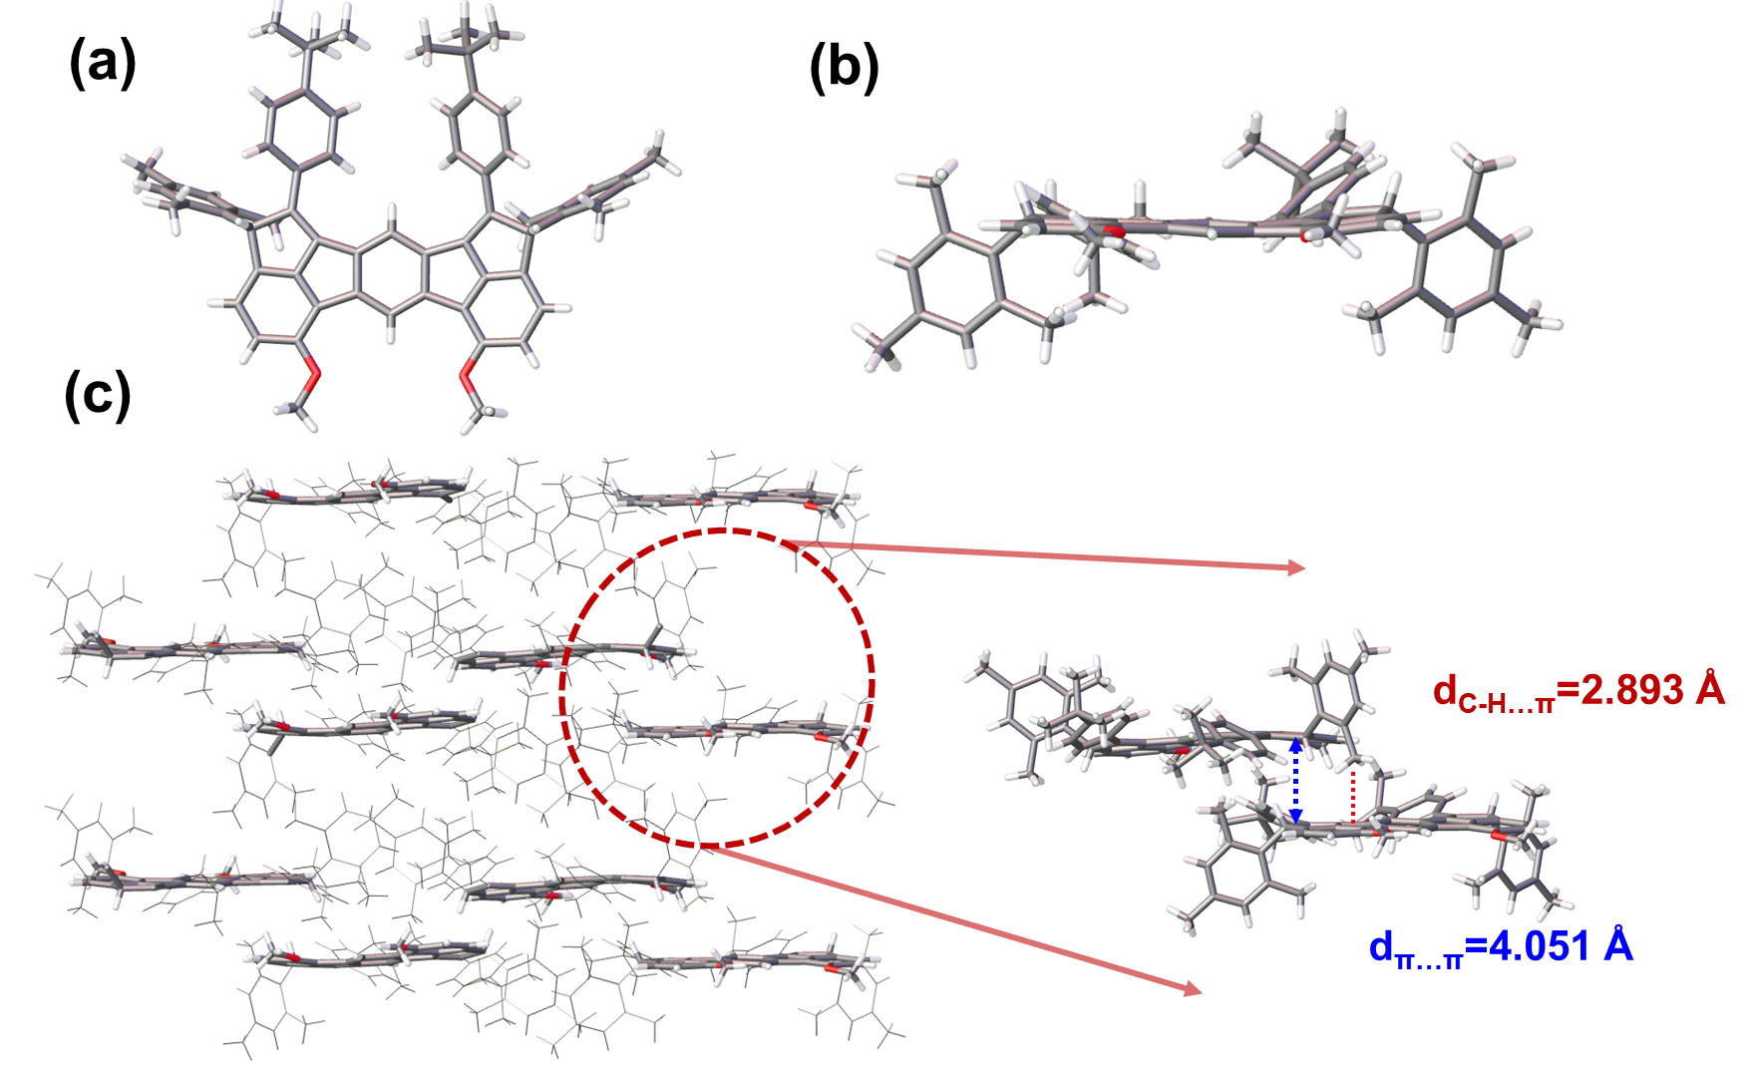
Figure S32 X-ray single-crystal crystallographic analysis. Structure of (a) top view, (b) side view and (c) intermolecular packing mode and interaction of compound 25-3a. Displacement ellipsoids are drawn at 50% probability level.
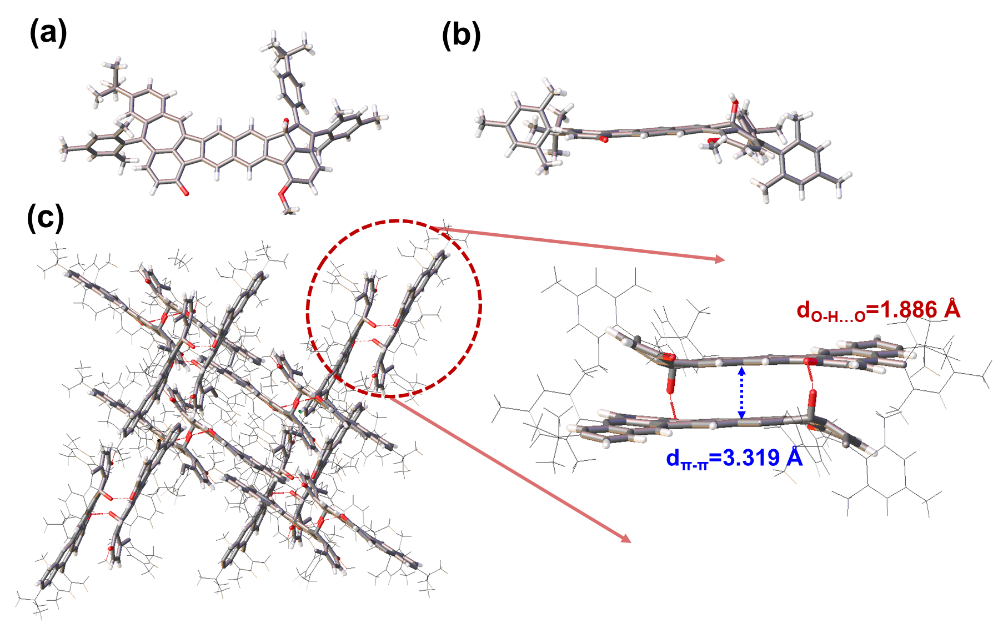
Figure S33 X-ray single-crystal crystallographic analysis. Structure of (a) top view, (b) side view and (c) intermolecular packing mode and interaction of compound 26-1b. Displacement ellipsoids are drawn at 50% probability level.

Table S13 Crystallographic data of compound 25-3a.
Compound | 25-3a
CCDC deposition NO. | 2493835
Empirical formula | C₁₃₀H₁₂₆Cl₆O₄
Formula weight | 1842.26
Temperature/K | 170.00 (10)
Crystal system | monoclinic
Space group | P2₁/n
a/Å | 32.1086(4)
b/Å | 11.31470(10)
c/Å | 33.6187(4)
α/° | 90
β/° | 118.247(2)
γ/° | 90
Volume/Å³ | 10759.2(3)
Z | 4
ρ_{calc}g/cm³ | 1.137
μ/mm⁻¹ | 0.566
F(000) | 3929.0
Crystal size/mm³ | 0.3× 0.1 × 0.05
Radiation | CuKα (λ = 1.54184)
2Θ range for data collection/° | 5.244 to 152.272
Index ranges | -35 ≤ h ≤ 39, -10≤ k ≤ 14, -42 ≤ l ≤ 41
Reflections collected | 81717
Independent reflections | 21642 [R_{int} = 0.0394, R_{sigma} = 0.0375]
Data/restraints/parameters | 21642/0/1290
Goodness-of-fit on F² | 1.722
Final R indexes [I>=2σ (I)] | R₁ = 0.1232, wR₂ = 0.3813
Final R indexes [all data] | R₁ = 0.1402, wR₂ = 0.4017
Largest diff. peak/hole / e Å⁻³ | 2.74/-1.47

Table S14 Crystallographic data of compound 26-1b.
Compound | 26-1b
CCDC deposition NO. | 2478871
Empirical formula | C₆₇H₆₀O₃
Formula weight | 1071.06
Temperature/K | 109 (14)
Crystal system | monoclinic
Space group | P2₁/c
a/Å | 18.7257(9)
b/Å | 11.9599(5)
c/Å | 29.4188(8)
α/° | 90
β/° | 106.581(4)
γ/° | 90
Volume/Å³ | 6314.6(5)
Z | 4
ρ_{calc}g/cm³ | 1.127
μ/mm⁻¹ | 0.690
F(000) | 2261.0
Crystal size/mm³ | 0.2× 0.05 × 0.02
Radiation | CuKα (λ = 1.54184)
2Θ range for data collection/° | 4.924 to 152.304
Index ranges | -23 ≤ h ≤ 23, -14≤ k ≤ 14, -24 ≤ l ≤ 36
Reflections collected | 55155
Independent reflections | 12716 [R_{int} = 0.00744, R_{sigma} = 0.0533]
Data/restraints/parameters | 12716/0/646
Goodness-of-fit on F² | 3.272
Final R indexes [I>=2σ (I)] | R₁ = 0.3507, wR₂ = 0.6993
Final R indexes [all data] | R₁ = 0.4008, wR₂ = 0.7300
Largest diff. peak/hole / e Å⁻³ | 6.01/-0.99

12.4 Calculations of compounds 25 and 26
Table S15 Calculated ΔE_{st} value based on (U)B3LYP-D3(BJ)/6-31G** level
Compounds | E_{s} (Hartree) | E_{s} (Hartree) | E_{t} (Hartree) | ΔE_{st}
Compounds | (Close-Shell) | (Open-Shell) |  | (kcal mol⁻¹)
25-1a | -2625.7998 | -2625.81105 | -2625.812056 | 7.70644
25-2a | -2625.8253 | -2625.84618 | -2625.846397 | 13.2474
25-3a | -2625.7736 | -2625.78617 | -2625.788926 | 9.60842
26-1a | -2661.7368 |  | -2661.684975
25-1b | -2779.463 | -2779.47739 | -2779.477772 | 9.25388
25-2b | -2779.4877 | -2779.51173 | -2779.511838 | 15.1161
25-3b | -2779.441 | -2779.45231 | -2779.452937 | 7.50752
26-1b | -2815.3995 |  | -2815.350041

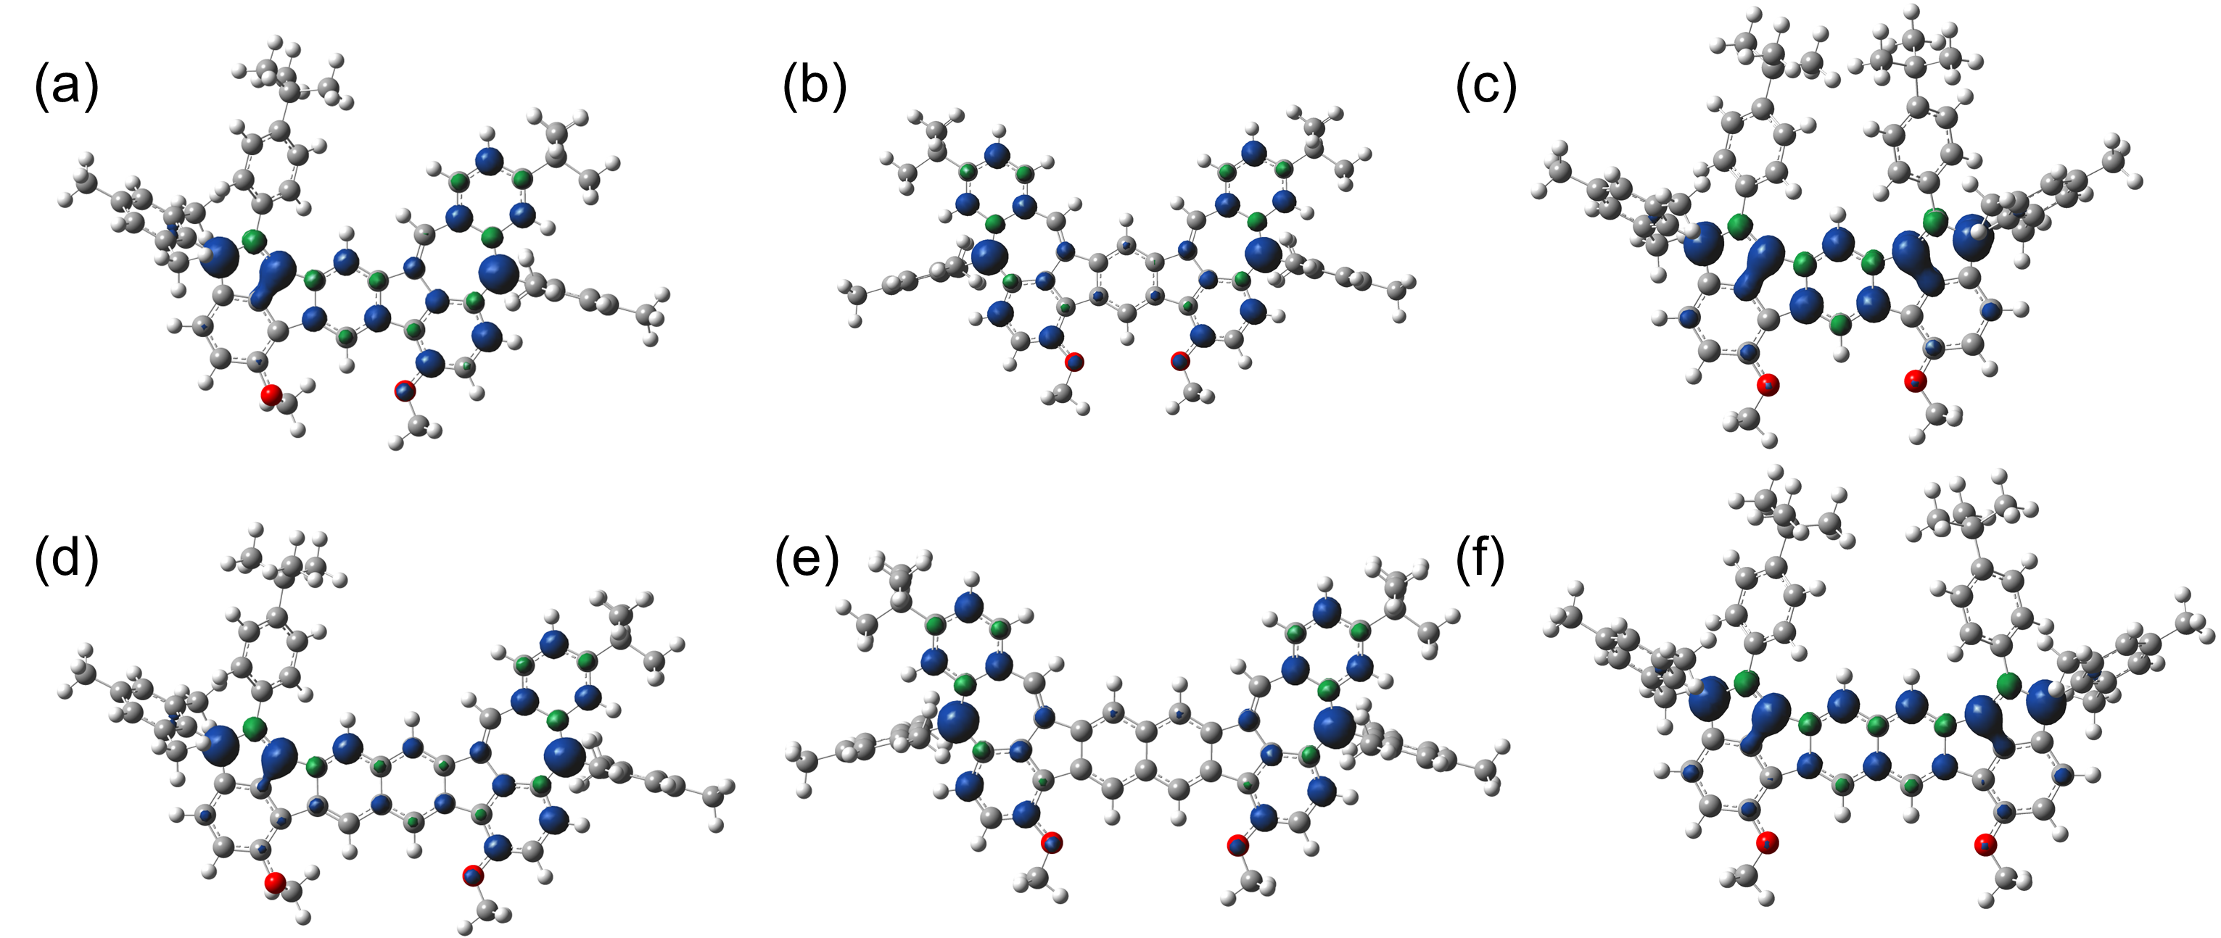
Figure S34 Spin density surfaces calculated by DFT UB3LYP-D3(BJ)/6-31G(d,p) in the triplet state of (a) 25-1a, (b) 25-2a, (c) 25-3a, (d) 25-1b, (e) 25-2b and (f) 25-3b. The isovalue is 0.005.

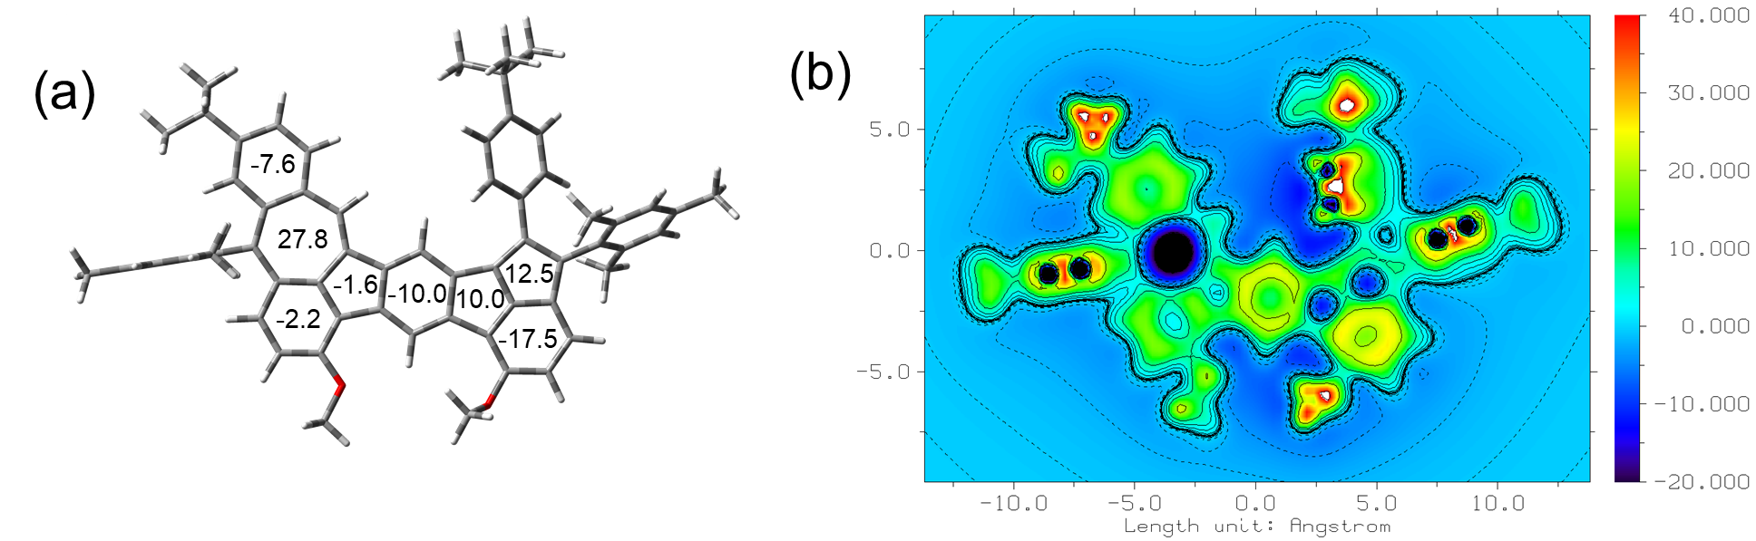
Figure S35 The aromaticity calculation of compound 25-1a. (a) Nucleus-independent chemical shift (NICS) values and (b) the isotropic chemical shielding surface (ICSS) maps based on DFT UB3LYP/6-31G(d,p) level.
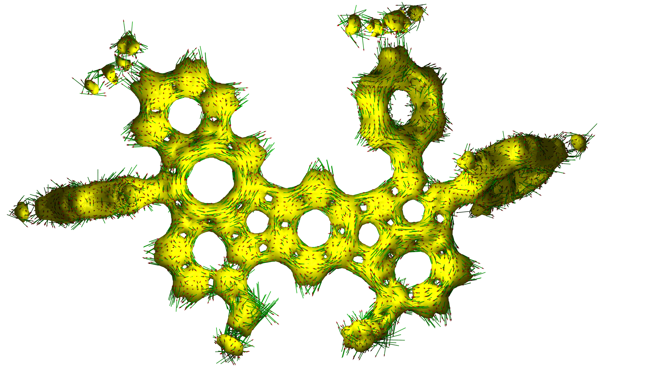
Figure S36 The aromaticity calculation of compound 25-1a. The calculated anisotropy of the induced current density (ACID) plots based on DFT UB3LYP/6-31G(d,p) level.
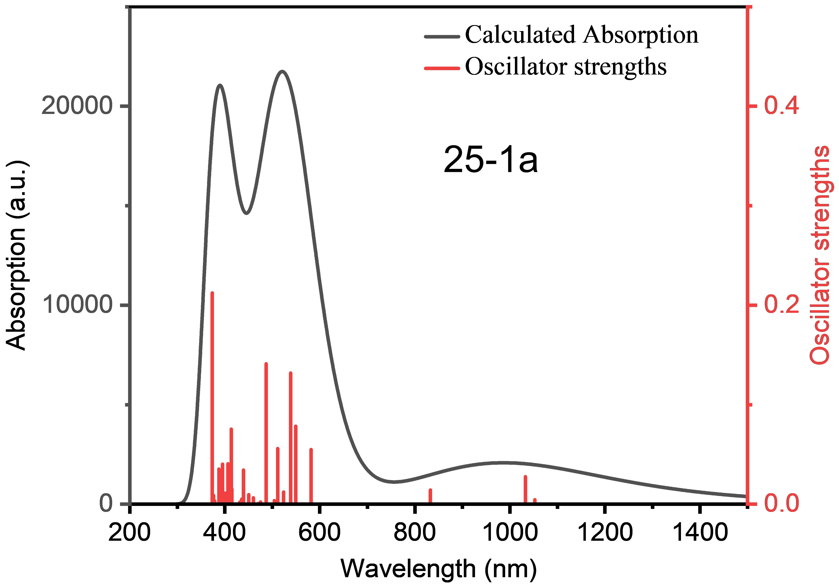
Figure S37 Calculated UV-vis absorption spectra of the 25-1a (triple state)
Table S16 Excitation energies, oscillator strengths and orbital contribution of the S₀ → S_{n} excitations of 25-1a calculated at the TD-UB3LYP-D3(BJ)/6-31G(d,p) level of theory.
transition | energy [eV] | energy [nm] | oscillator  strength | orbital contribution
S₀ → S₁ | 1.1781 | 1052.41 | 0.00440 | αH → αL | 89.5%
S₀ → S₂ | 1.2008 | 1032.51 | 0.02760 | βH → βL  αH → αL | 84.9%  5.0%
S₀ → S₃ | 1.4888 | 832.78 | 0.01410 | βH-1 → βL  βH → βL | 89.3%  5.3%
S₀ → S₄ | 2.1323 | 581.46 | 0.05490 | βH-2 → βL  αH-1 → αL | 57.5%  25.2%
S₀ → S₅ | 2.2580 | 549.09 | 0.07830 | αH-1 → αL  βH-2 → βL  βH-1 → βL+1 | 52.2%  15.4%  14.2%
S₀ → S₆ | 2.3017 | 538.66 | 0.13180 | βH-1 → βL+1  βH → βL+1  βH-2 → βL  αH-3 → αL  αH-1 → αL  βH-1 → βL+2  αH → αL+1 | 20.5%  15.1%  14.9%  12.5%  9.9%  7.2%  6.4%
S₀ → S₇ | 2.3675 | 523.69 | 0.01220 | βH → βL+1  βH-3 → βL  βH-1 → βL+2  αH-3 → αL  αH → αL+1  αH → αL+2  βH-2 → βL+1 | 21.3%  19.1%  11.8%  9.2%  8.9%  6.9%  5.8%
S₀ → S₈ | 2.4253 | 511.21 | 0.05590 | βH-3 → βL  βH-1 → βL+1  βH → βL+1 | 63.4%  9.1%  7.7%
S₀ → S₉ | 2.4597 | 504.06 | 0.00350 | αH → αL+1  βH → βL+1  βH-1 → βL+1  αH → αL+2  βH → βL+2 | 31.1%  21.1%  8.5%  7.6%  7.2%
S₀ → S₁₀ | 2.5457 | 487.03 | 0.14110 | βH-1 → βL+1  αH → αL+1  βH-1 → βL+2  αH-3 → αL | 29.5%  29.3%  16.1%  6.0%

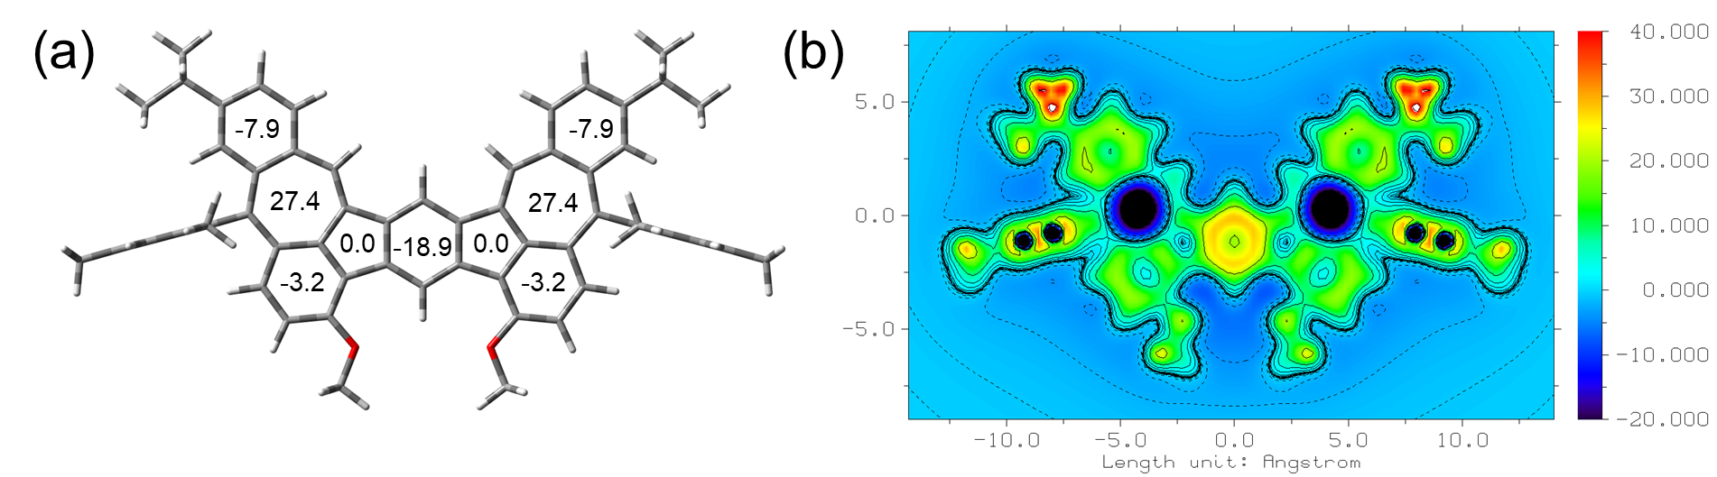
Figure S38 The aromaticity calculation of compound 25-2a. (a) Nucleus-independent chemical shift (NICS) values and (b) the isotropic chemical shielding surface (ICSS) maps based on DFT UB3LYP/6-31G(d,p) level.
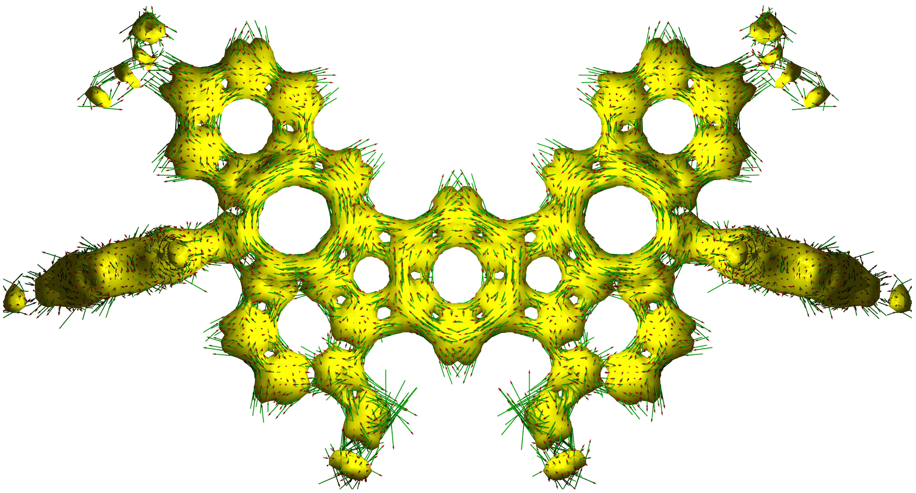
Figure S39 The aromaticity calculation of compound 25-2a. The calculated anisotropy of the induced current density (ACID) plots based on DFT UB3LYP/6-31G(d,p) level.
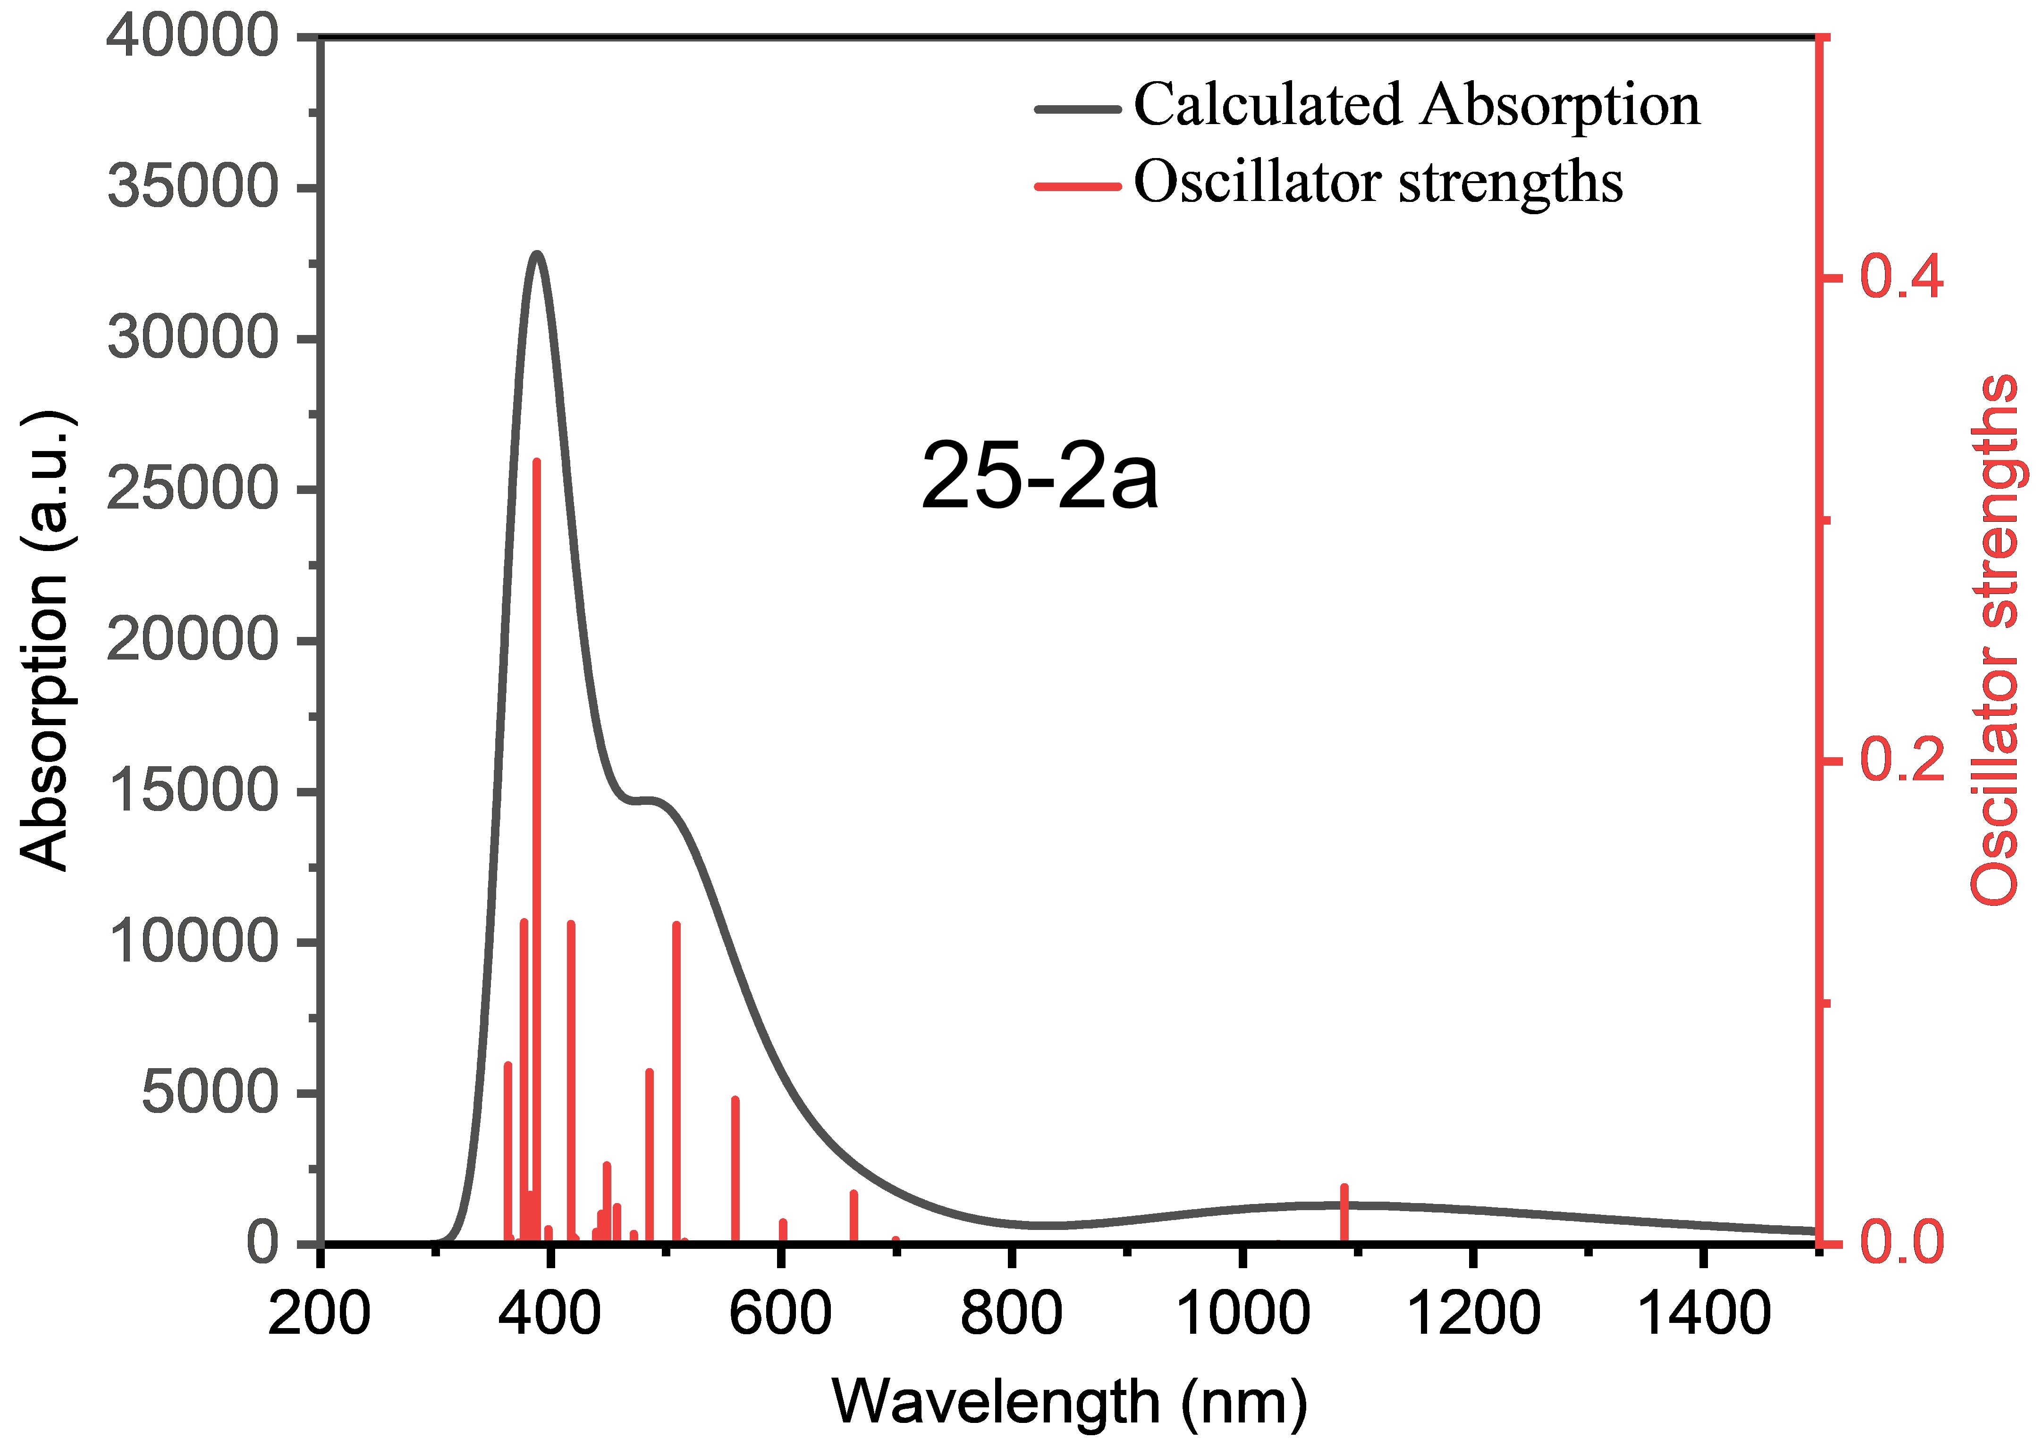
Figure S40 Calculated UV-vis absorption spectra of the 25-2a (triple state).
Table S17 Excitation energies, oscillator strengths and orbital contribution of the S₀ → S_{n} excitations of 25-2a calculated at the TD-UB3LYP-D3(BJ)/6-31G(d,p) level of theory.
transition | energy [eV] | energy [nm] | oscillator  strength | orbital contribution
S₀ → S₁ | 1.1394 | 1088.15 | 0.02370 | αH → αL  αH-1 → αL+1 | 78.0%  18.3%
S₀ → S₂ | 1.2028 | 1030.80 | 0.00030 | αH-1 → αL  αH → αL+1 | 65.2%  31.5%
S₀ → S₃ | 1.7735 | 699.09 | 0.00190 | αH → αL+1  αH-1 → αL | 62.3%  31.5%
S₀ → S₄ | 1.8713 | 662.56 | 0.02100 | αH-1 → αL+1  αH → αL | 77.0%  18.9%
S₀ → S₅ | 2.0621 | 601.25 | 0.00920 | βH → βL  αH-2 → αL  βH → βL+2 | 68.1%  10.2%  8.7%
S₀ → S₆ | 2.2140 | 560.00 | 0.06000 | βH-1 → βL  αH-3 → αL  βH → βL+1  βH-1 → βL+2 | 59.7%  11.7%  6.4%  5.8%
S₀ → S₇ | 2.4031 | 515.93 | 0.00110 | βH → βL+2  αH-2 → αL  αH → αL+2  βH → βL | 28.7%  18.3%  15.0%  14.4%
S₀ → S₈ | 2.4367 | 508.82 | 0.13230 | βH → βL+1  βH-1 → βL | 75.4%  6.0%
S₀ → S₉ | 2.5334 | 489.40 | 0.00000 | βH-1 → βL+1  αH-2 → αL  βH-2 → βL | 72.5%  7.7%  6.5%
S₀ → S₁₀ | 2.5534 | 485.57 | 0.07140 | βH-1 → βL+2  αH-3 → αL  βH-1 → βL | 37.0%  21.7%  20.4%

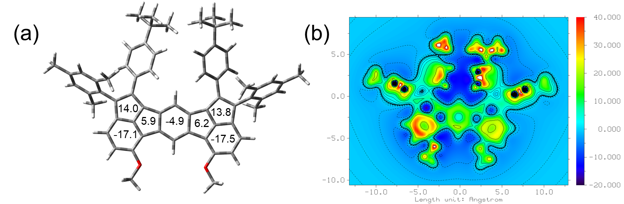
Figure S41 The aromaticity calculation of compound 25-3a. (a) Nucleus-independent chemical shift (NICS) values and (b) the isotropic chemical shielding surface (ICSS) maps based on DFT UB3LYP/6-31G(d,p) level.
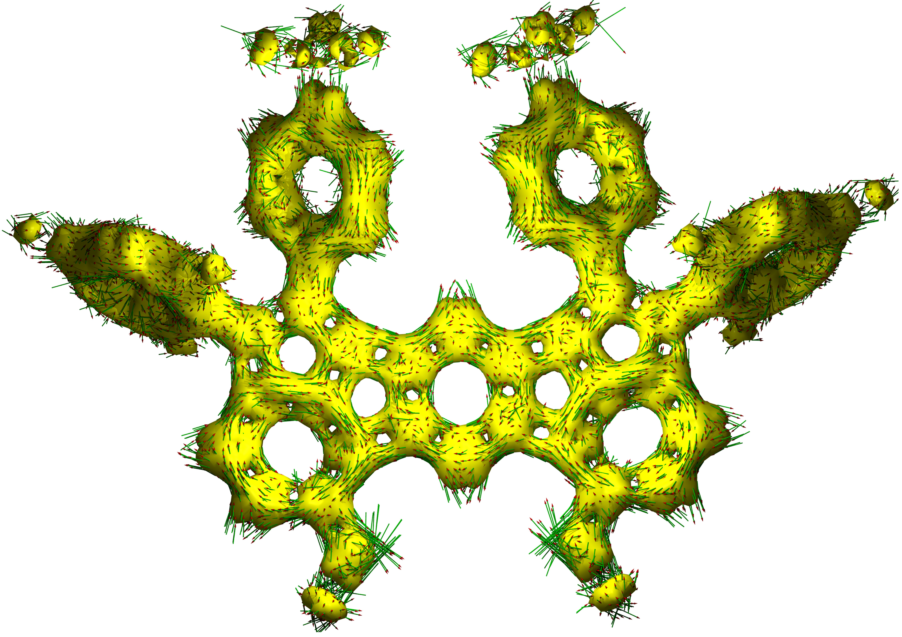
Figure S42 The aromaticity calculation of compound 25-3a. The calculated anisotropy of the induced current density (ACID) plots based on DFT UB3LYP/6-31G(d,p) level.
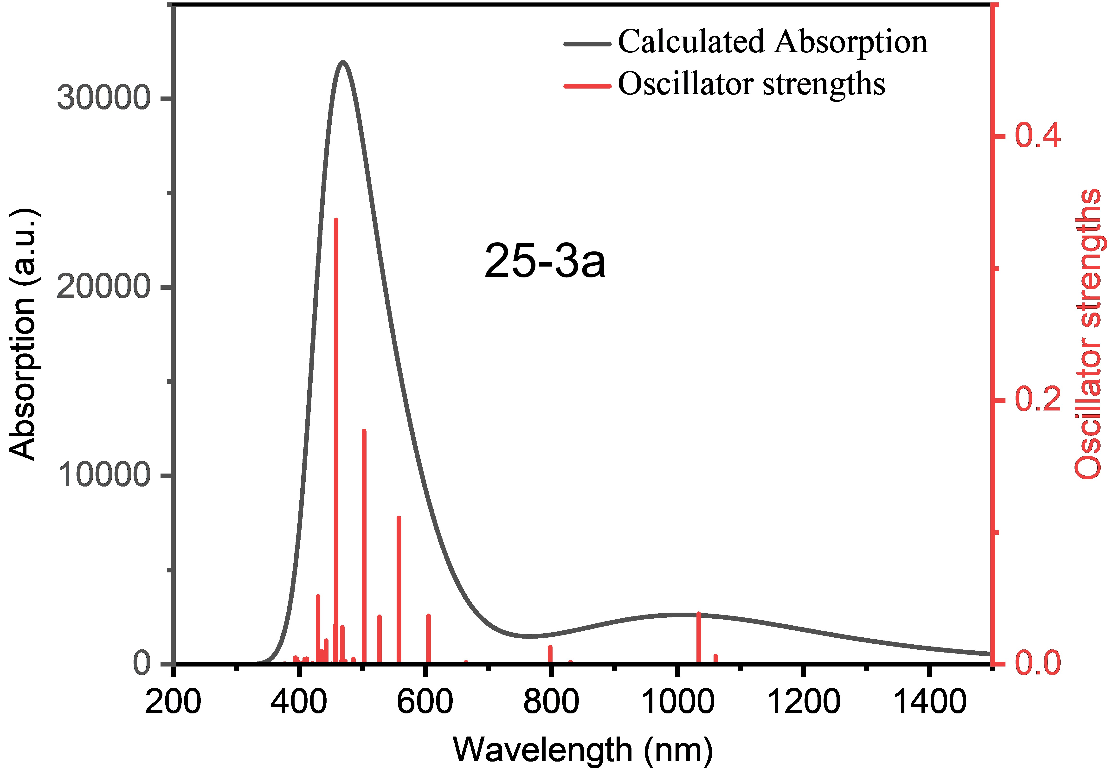
Figure S43 Calculated UV-vis absorption spectra of the 25-3a (triple state)
Table S18 Excitation energies, oscillator strengths and orbital contribution of the S₀ → S_{n} excitations of 25-3a calculated at the TD-UB3LYP-D3(BJ)/6-31G(d,p) level of theory.
transition | energy [eV] | energy [nm] | oscillator  strength | orbital contribution
S₀ → S₁ | 1.1689 | 1060.69 | 00.00620 | βH → βL  βH-1 → βL+1 | 71.8%  20.2%
S₀ → S₂ | 1.1993 | 1033.80 | 0.03830 | βH-1 → βL  βH → βL+1 | 57.5%  31.9%
S₀ → S₃ | 1.4935 | 830.16 | 0.00160 | βH-1 → βL+1  βH-2 → βL  βH → βL | 50.3%  24.4%  19.2%
S₀ → S₄ | 1.5534 | 798.15 | 0.01300 | βH → βL+1  βH-1 → βL | 56.6%  32.5%
S₀ → S₅ | 1.8660 | 664.44 | 0.00150 | βH-2 → βL  βH-1 → βL+1 | 72.1%  21.0%
S₀ → S₆ | 2.0496 | 604.92 | 0.03670 | βH-2 → βL+1  βH-3 → βL  βH-1 → βL | 78.4%  7.3%  6.6%
S₀ → S₇ | 2.2222 | 557.93 | 0.11090 | βH-3 → βL  αH → αL  βH-2 → βL+1  βH-4 → βL+1 | 62.6%  18.4%  6.2%  5.3%
S₀ → S₈ | 2.3527 | 526.99 | 0.03610 | βH-3 → βL+1  βH-4 → βL | 53.6%  34.1%
S₀ → S₉ | 2.4664 | 502.69 | 0.17690 | βH-4 → βL+1  αH → αL  βH-7 → βL  βH-3 → βL  βH-5 → βL | 28.3%  25.9%  22.3%  7.4%  6.4%
S₀ → S₁₀ | 2.5536 | 485.53 | 0.00410 | βH-4 → βL  βH-7 → βL+1  βH-3 → βL+1  βH-5 → βL+1  αH-2 → αL  αH-1 → αL | 38.2%  18.0%  10.3%  7.5%  6.7%  5.5%

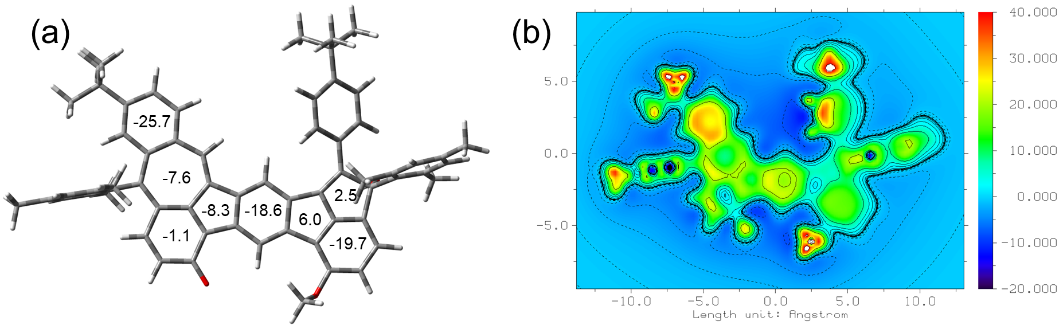
Figure S44 The aromaticity calculation of compound 26-1a. (a) Nucleus-independent chemical shift (NICS) values and (b) the isotropic chemical shielding surface (ICSS) maps based on DFT B3LYP/6-31G(d,p) level.
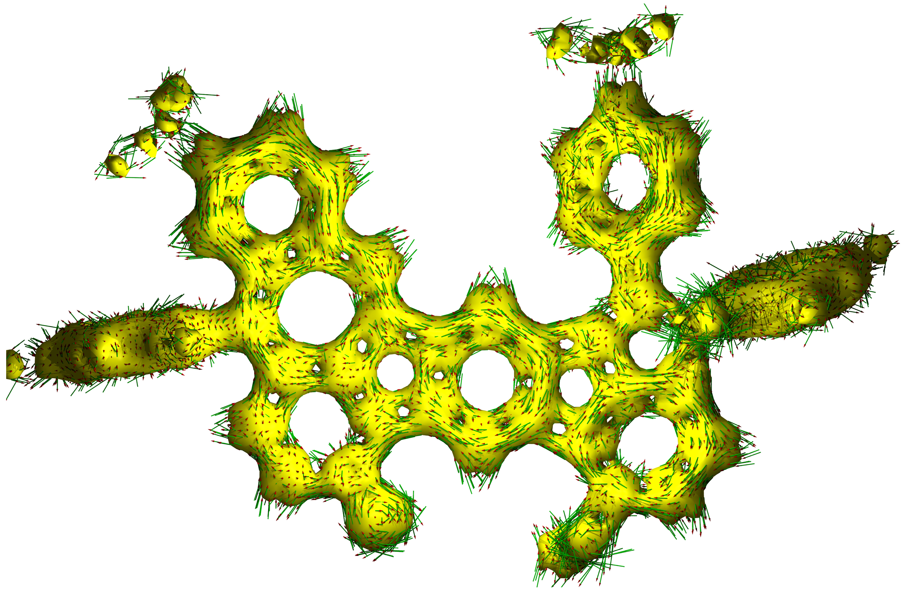
Figure S45 The aromaticity calculation of compound 26-1a. The calculated anisotropy of the induced current density (ACID) plots based on DFT B3LYP/6-31G(d,p) level.

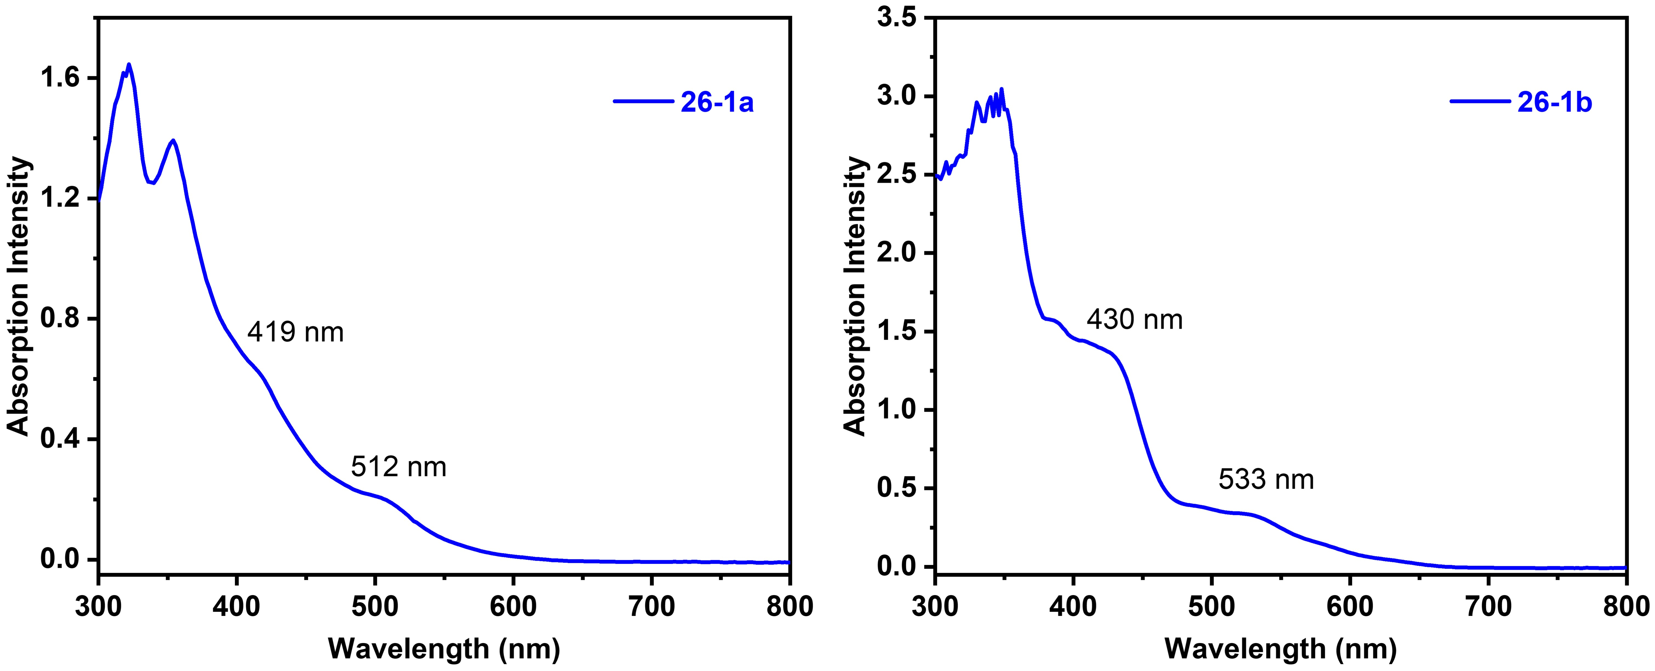
Figure S46 UV-vis absorption spectrum of compound 26-1a in dichloromethane solution (10⁻⁵ mol/L).
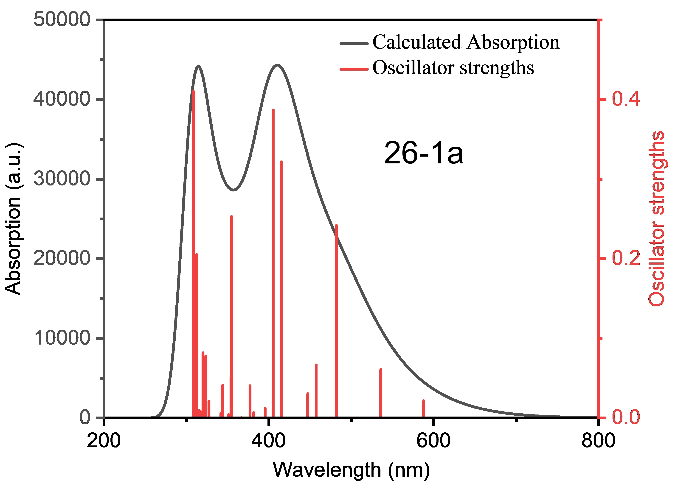
Figure S47 Calculated UV-vis absorption spectra of the 26-1a (closed-shell single state).

Table S19 Excitation energies, oscillator strengths and orbital contribution of the S₀ → S_{n} excitations of 26-1a calculated at the TD-B3LYP-D3(BJ)/6-31G(d,p) level of theory.
transition | energy [eV] | energy [nm] | oscillator  strength | orbital contribution
S₀ → S₁ | 2.1090 | 587.88 | 0.02160 | H → L  H→ L+1 | 79.0%  14.8%
S₀ → S₂ | 2.3145 | 535.68 | 0.06090 | H → L+1  H → L  H-1 → L | 66.4%  16.0%  9.6%
S₀ → S₃ | 2.5730 | 481.87 | 0.24180 | H-1 → L  H → L+1 | 81.8%  11.1%
S₀ → S₄ | 2.6474 | 468.32 | 0.00010 | H-5 → L | 92.3%
S₀ → S₅ | 2.7112 | 457.30 | 0.06670 | H-1 → L+1  H-2 → L | 52.4%  41.6%
S₀ → S₆ | 2.7725 | 447.19 | 0.03060 | H-2 → L  H-1 → L+1  H-2 → L+1  H → L+1 | 38.1%  27.1%  24.3%  5.2%
S₀ → S₇ | 2.9869 | 415.09 | 0.32170 | H-2 → L+1  H-1 →L+1  H-2 → L  H-1 → L+2 | 59.0%  9.6%  9.3%  6.2%
S₀ → S₈ | 3.0599 | 405.19 | 0.38690 | H → L+2  H-1 → L+2 | 87.2%  5.4%
S₀ → S₉ | 3.1357 | 395.40 | 0.01250 | H-3 → L | 96.2%
S₀ → S₁₀ | 3.2055 | 386.79 | 0.00010 | H-5 → L+1 | 94.1%
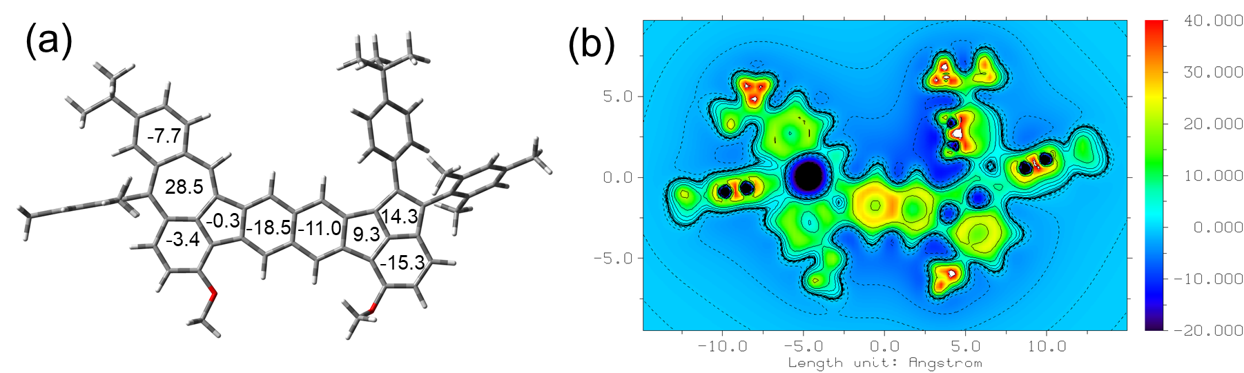
Figure S48 The aromaticity calculation of compound 25-1b. (a) Nucleus-independent chemical shift (NICS) values and (b) the isotropic chemical shielding surface (ICSS) maps based on DFT UB3LYP/6-31G(d,p) level.
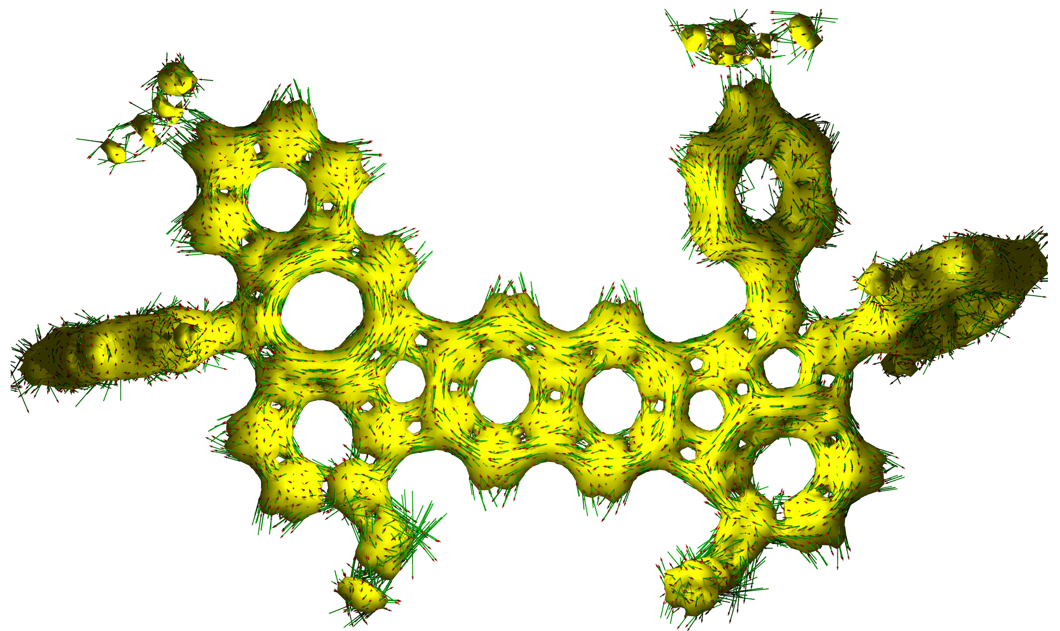
Figure S49 The aromaticity calculation of compound 25-1b. The calculated anisotropy of the induced current density (ACID) plots based on DFT UB3LYP/6-31G(d,p) level.
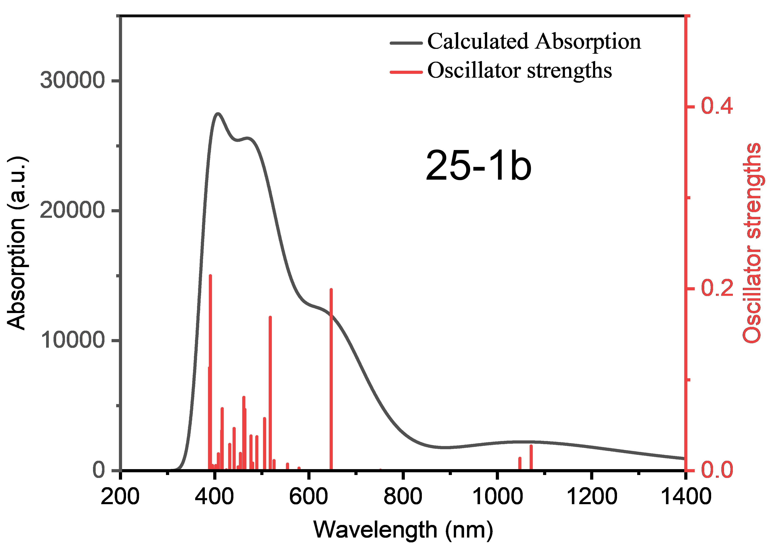
Figure S50 Calculated UV-vis absorption spectra of the 25-1b (triple state).
Table S20 Excitation energies, oscillator strengths and orbital contribution of the S₀ → S_{n} excitations of 25-1b calculated at the TD-UB3LYP-D3(BJ)/6-31G(d,p) level of theory.
transition | energy [eV] | energy [nm] | oscillator  strength | orbital contribution
S₀ → S₁ | 1.1569 | 1071.69 | 0.02710 | βH → βL | 88.9%
S₀ → S₂ | 1.1833 | 1047.78 | 0.01360 | αH → αL | 92.9%
S₀ → S₃ | 1.6492 | 751.78 | 0.00060 | βH-1 → βL  βH-2 → βL | 86.6%  7.0%
S₀ → S₄ | 1.9151 | 647.40 | 0.19910 | βH-2 → βL  βH-1 → βL | 77.6%  5.6%
S₀ → S₅ | 2.1414 | 578.99 | 0.00280 | αH → αL+1  αH-1 → αL  βH → βL+1 | 47.4%  19.1%  5.2%
S₀ → S₆ | 2.2352 | 554.69 | 0.00720 | αH-1 → αL  αH → αL+1 | 39.0%  36.2%
S₀ → S₇ | 2.3581 | 525.78 | 0.01100 | βH-3 → βL | 79.0%
S₀ → S₈ | 2.3942 | 517.85 | 0.16860 | βH → βL+1  αH-1 → αL  βH-1 → βL+1 | 46.3%  14.3%  11.2%
S₀ → S₉ | 2.4516 | 505.73 | 0.05730 | αH → αL+2  αH-1 → αL  βH-2 → βL+1  αH-3 → αL  αH-1 → αL+1  βH-1 → βL+1  βH → βL+1  βH-1 → βL+2 | 18.7%  9.6%  8.6%  8.4%  7.8%  7.0%  5.8%  5.3%
S₀ → S₁₀ | 2.5323 | 489.61 | 0.03730 | αH → αL+2  βH → βL+1  βH-1 → βL+2  βH-5 → βL | 38.1%  14.7%  7.5%  6.1%

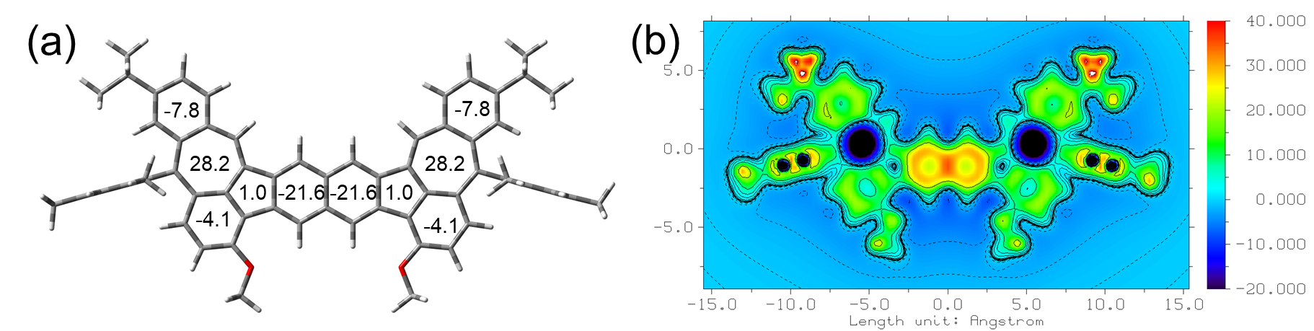
Figure S51 The aromaticity calculation of compound 25-2b. (a) Nucleus-independent chemical shift (NICS) values and (b) the isotropic chemical shielding surface (ICSS) maps based on DFT UB3LYP/6-31G(d,p) level.
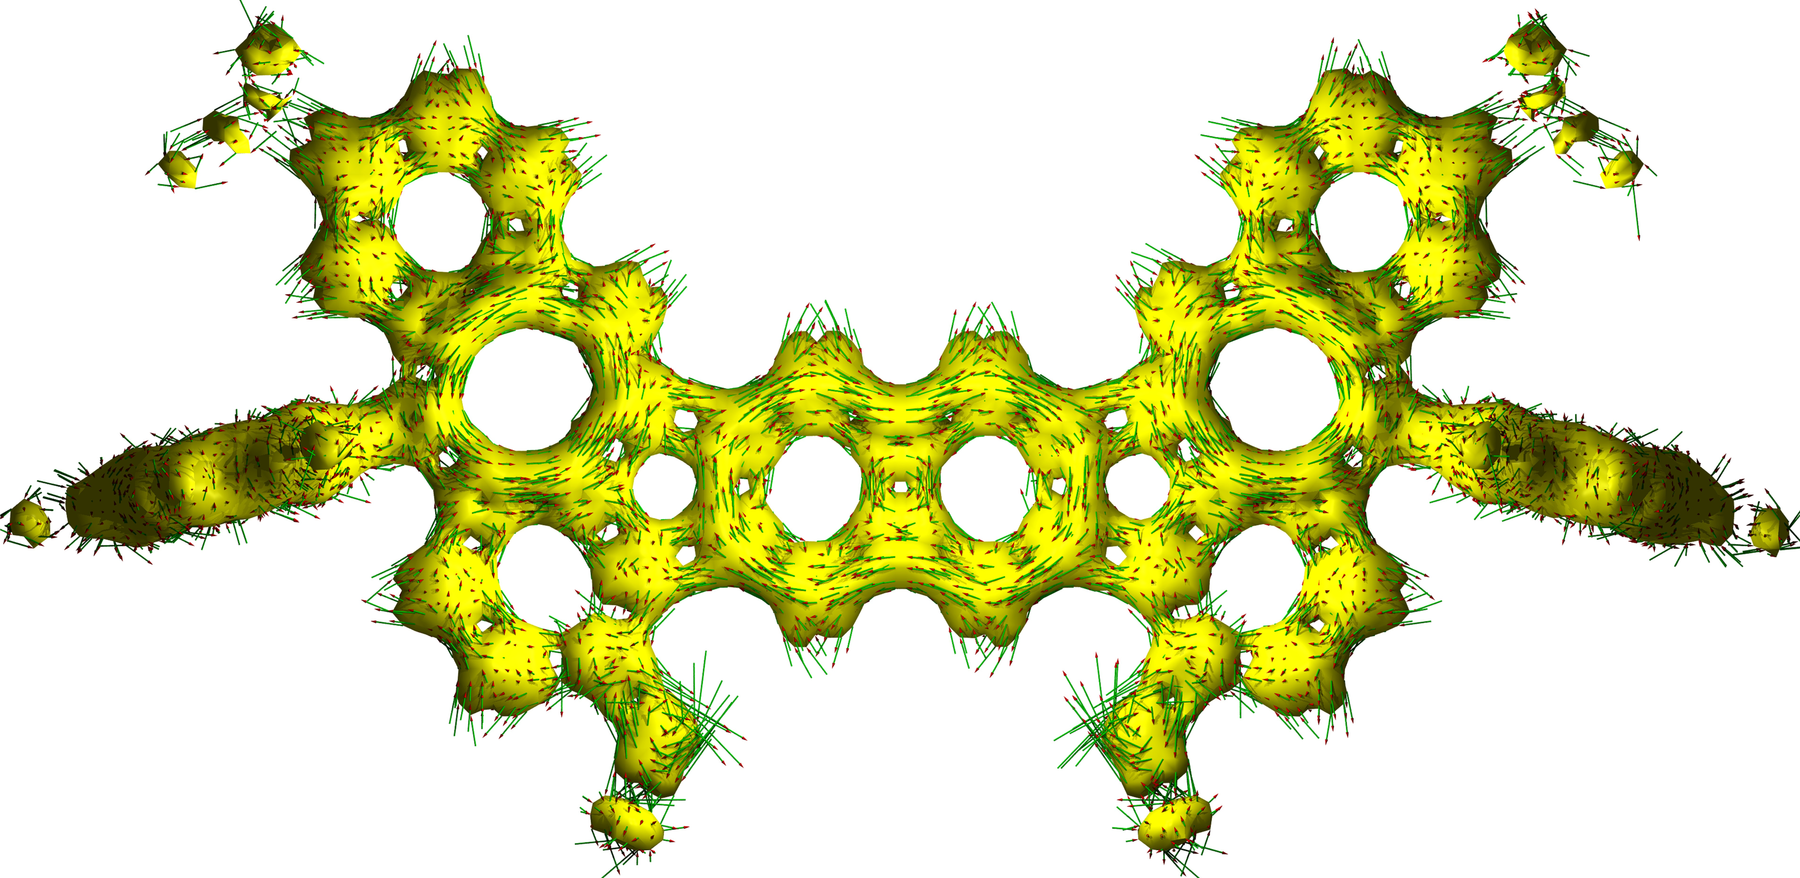
Figure S52 The aromaticity calculation of compound 25-2b. The calculated anisotropy of the induced current density (ACID) plots based on DFT UB3LYP/6-31G(d,p) level.
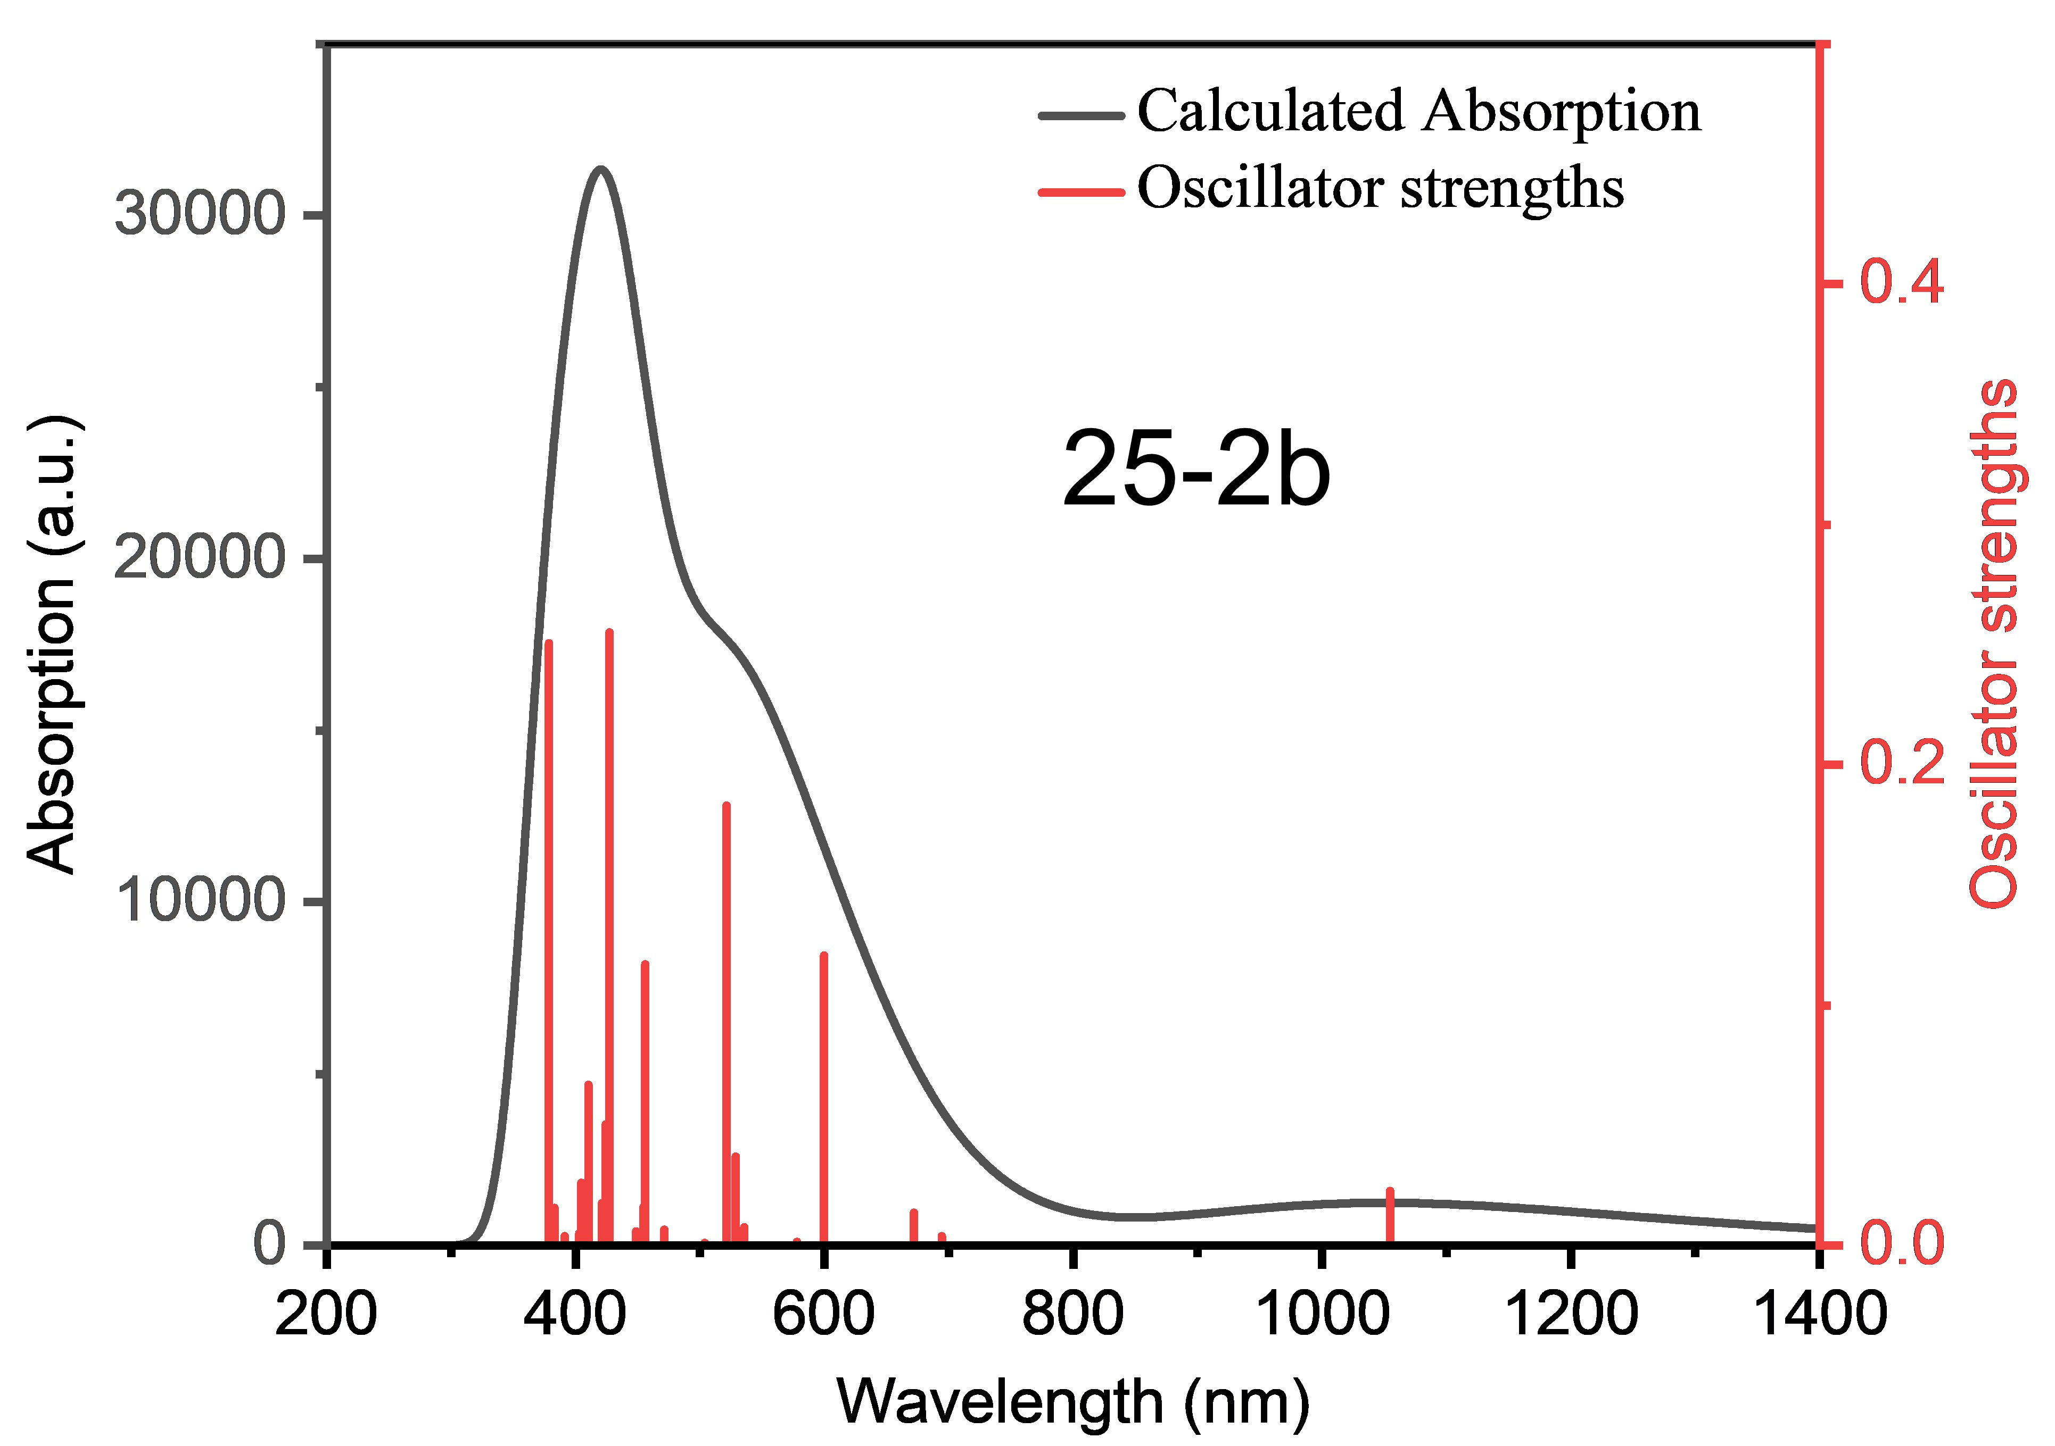
Figure S53 Calculated UV-vis absorption spectra of the 25-2b (triple state).
Table S21 Excitation energies, oscillator strengths and orbital contribution of the S₀ → S_{n} excitations of 25-2b calculated at the TD-UB3LYP-D3(BJ)/6-31G(d,p) level of theory.
transition | energy [eV] | energy [nm] | oscillator  strength | orbital contribution
S₀ → S₁ | 1.1755 | 1054.74 | 0.02280 | αH → αL  αH-1 → αL+1 | 67.2%  26.9%
S₀ → S₂ | 1.2040 | 1029.77 | 0.00010 | αH-1 → αL  αH → αL+1 | 52.9%  41.2%
S₀ → S₃ | 1.7859 | 694.24 | 0.00390 | αH → αL+1  αH-1 → αL | 49.0%  40.8%
S₀ → S₄ | 1.8455 | 671.82 | 0.01370 | αH-1 → αL+1  αH → αL | 67.8%  26.6%
S₀ → S₅ | 2.0676 | 599.65 | 0.12070 | βH → βL  αH-2 → αL  βH → βL+2  αH-1 → αL+2 | 67.9%  9.9%  5.5%  5.5%
S₀ → S₆ | 2.1458 | 577.80 | 0.00160 | αH → αL+2  βH → βL+3  αH-2 → αL+1  βH-1 → βL  βH → βL+4  αH-2 → αL+2 | 17.7%  16.0%  14.5%  9.7%  7.1%  5.5%
S₀ → S₇ | 2.2525 | 550.43 | 0.00010 | αH → αL+2  βH → βL+1  βH-1 → βL | 40.3%  21.4%  16.7%
S₀ → S₈ | 2.3159 | 535.36 | 0.00760 | βH → βL+1  αH → αL+2  βH-2 → βL | 55.7%  25.0%  5.4%
S₀ → S₉ | 2.3453 | 528.65 | 0.03710 | αH-1 → αL+2  βH → βL+2  αH-2 → αL  αH → αL | 54.5%  19.5%  8.1%  5.2%
S₀ → S₁₀ | 2.3788 | 521.20 | 0.18310 | αH-1 → αL+2  βH → βL  βH → βL+2  αH-2 → αL | 24.1%  23.3%  23.2%  18.0%

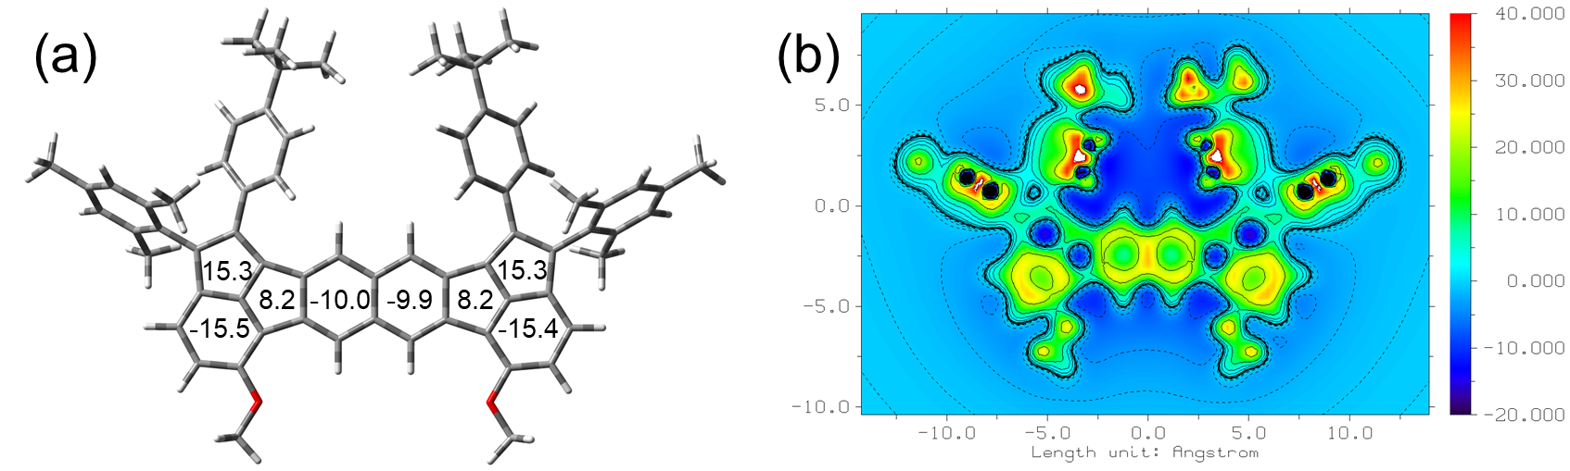
Figure S54 The aromaticity calculation of compound 25-3b. (a) Nucleus-independent chemical shift (NICS) values and (b) (b) the isotropic chemical shielding surface (ICSS) maps based on DFT UB3LYP/6-31G(d,p) level.
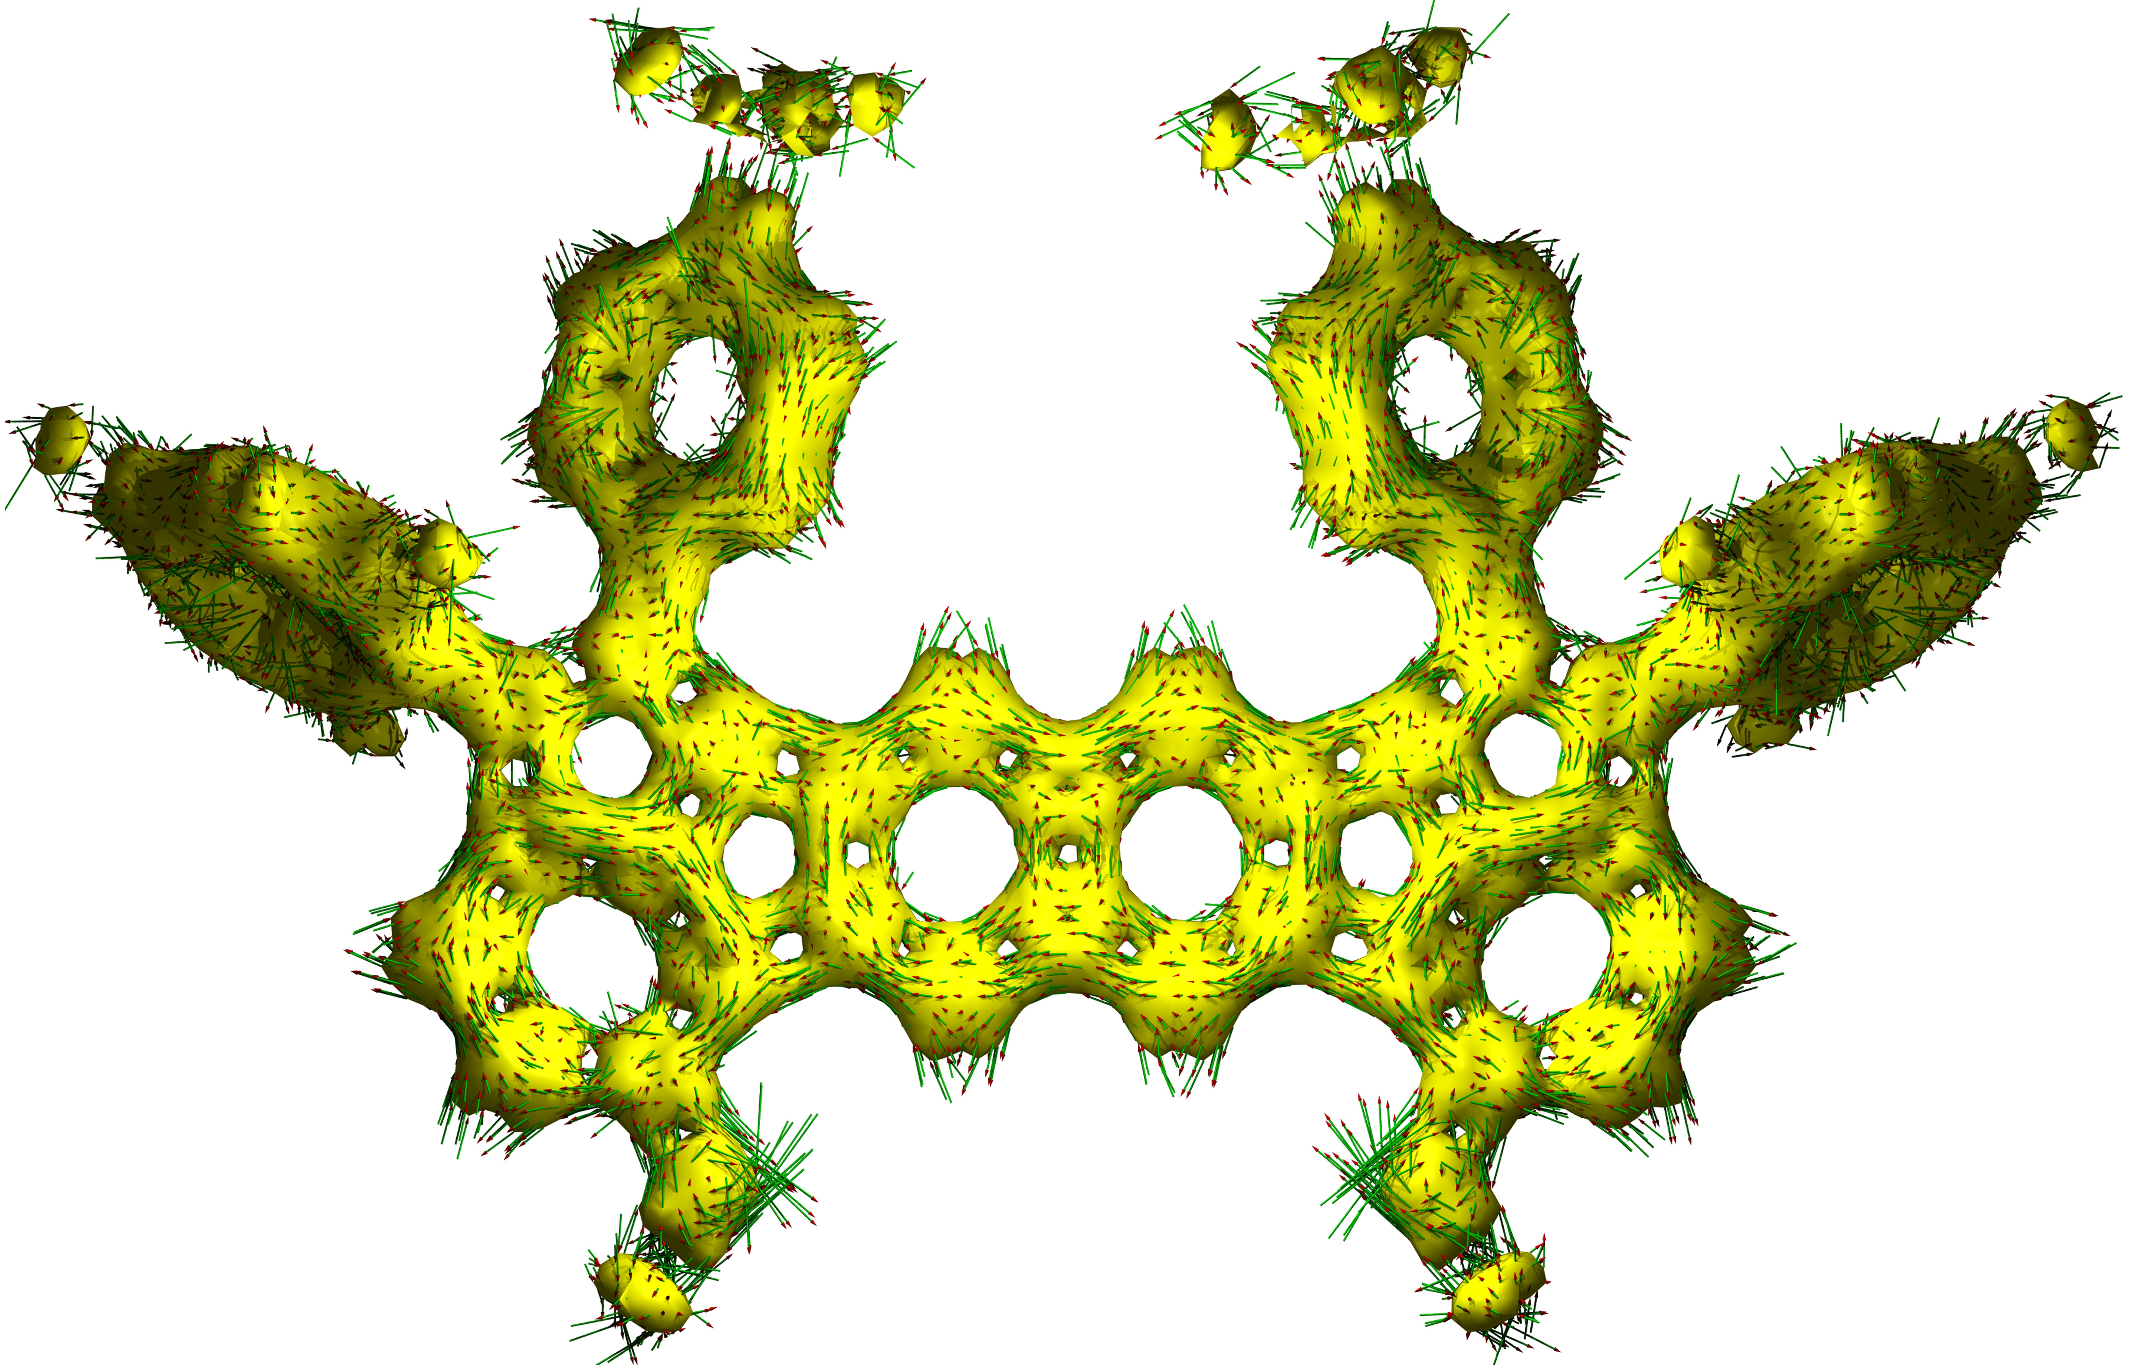
Figure S55 The aromaticity calculation of compound 25-3b. The calculated anisotropy of the induced current density (ACID) plots based on DFT UB3LYP/6-31G(d,p) level.
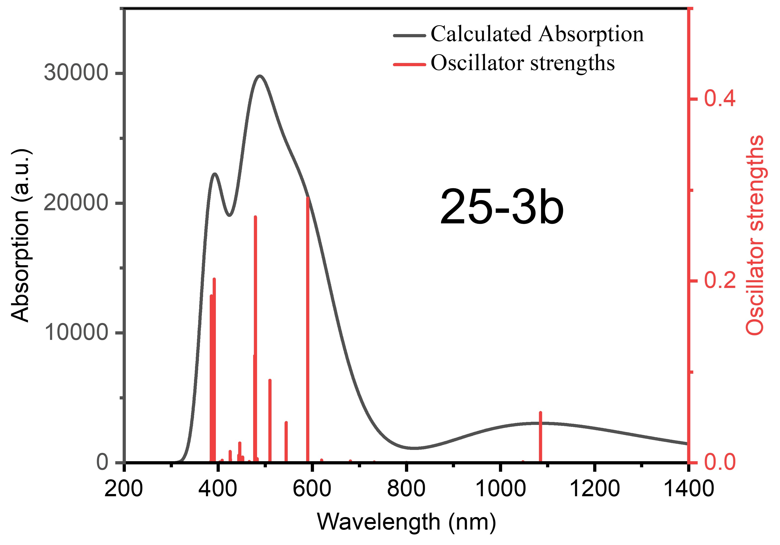
Figure S56 Calculated UV-vis absorption spectra of the 25-3b (triple state).
Table S22 Excitation energies, oscillator strengths and orbital contribution of the S₀ → S_{n} excitations of 25-3b calculated at the TD-UB3LYP-D3(BJ)/6-31G(d,p) level of theory.
transition | energy [eV] | energy [nm] | oscillator  strength | orbital contribution
S₀ → S₁ | 1.1426 | 1085.11 | 0.05530 | βH → βL  βH-1 → βL+1 | 74.1%  19.7%
S₀ → S₂ | 1.1834 | 1047.69 | 0.00110 | βH-1 → βL  βH → βL+1 | 65.6%  29.0%
S₀ → S₃ | 1.5497 | 800.05 | 0.00040 | βH-2 → βL  βH → βL+1  βH-1 → βL | 52.9%  23.7%  19.5%
S₀ → S₄ | 1.6952 | 731.38 | 0.00080 | βH-1 → βL+1  βH → βL  βH-3 → βL  βH-2 → βL+1 | 64.8%  15.2%  10.6%  6.7%
S₀ → S₅ | 1.8205 | 681.04 | 0.00200 | βH → βL+1  βH-2 → βL  βH-1 → βL | 43.7%  40.8%  11.7%
S₀ → S₆ | 2.0004 | 619.80 | 0.00300 | βH-3 → βL  βH-2 → βL+1  βH-1 → βL+1  βH → βL | 42.6%  33.3%  11.5%  7.1%
S₀ → S₇ | 2.1008 | 590.18 | 0.29120 | βH-2 → βL+1  βH-3 → βL  αH → αL | 46.3%  35.5%  5.9%
S₀ → S₈ | 2.2774 | 544.41 | 0.04430 | βH-3 → βL+1  βH-4 → βL | 60.5%  23.4%
S₀ → S₉ | 2.4319 | 509.82 | 0.09080 | βH-5 → βL  βH-4 → βL+1  βH-7 → βL  αH → αL | 48.8%  23.2%  14.1%  7.0%
S₀ → S₁₀ | 2.4456 | 506.97 | 0.00040 | βH-4 → βL  βH-5 → βL+1  βH-3 → βL+1 | 55.0%  15.0%  14.8%

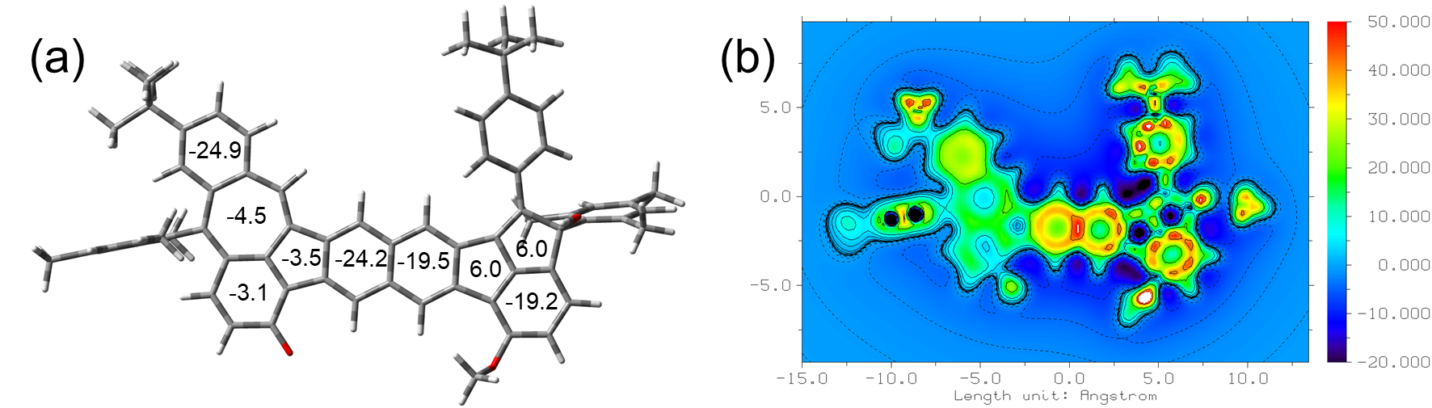
Figure S57 The aromaticity calculation of compound 26-1b. (a) Nucleus-independent chemical shift (NICS) values and (b) the isotropic chemical shielding surface (ICSS) maps based on DFT B3LYP/6-31G(d,p) level.
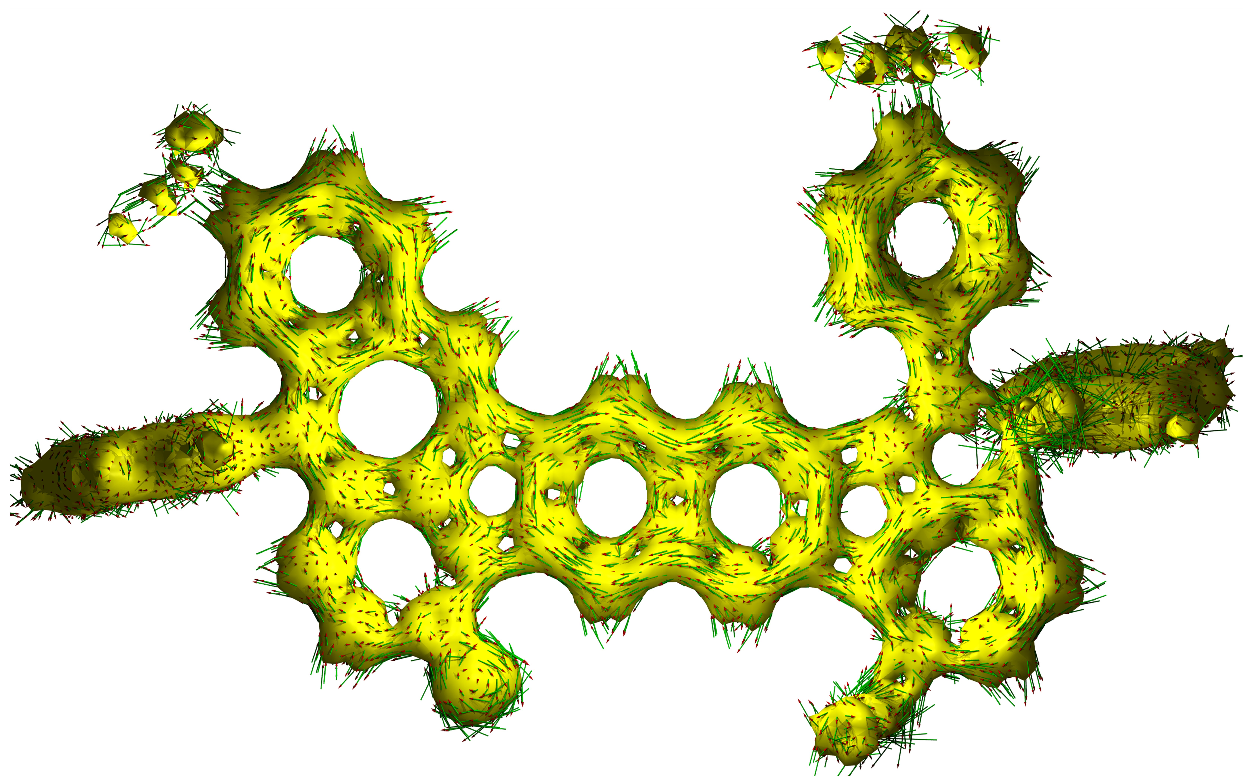
Figure S58 The aromaticity calculation of compound 26-1b. The calculated anisotropy of the induced current density (ACID) plots based on DFT B3LYP/6-31G(d,p) level.

Figure S59 UV-vis absorption spectrum of compound 26-1b in dichloromethane solution (10⁻⁵ mol/L).
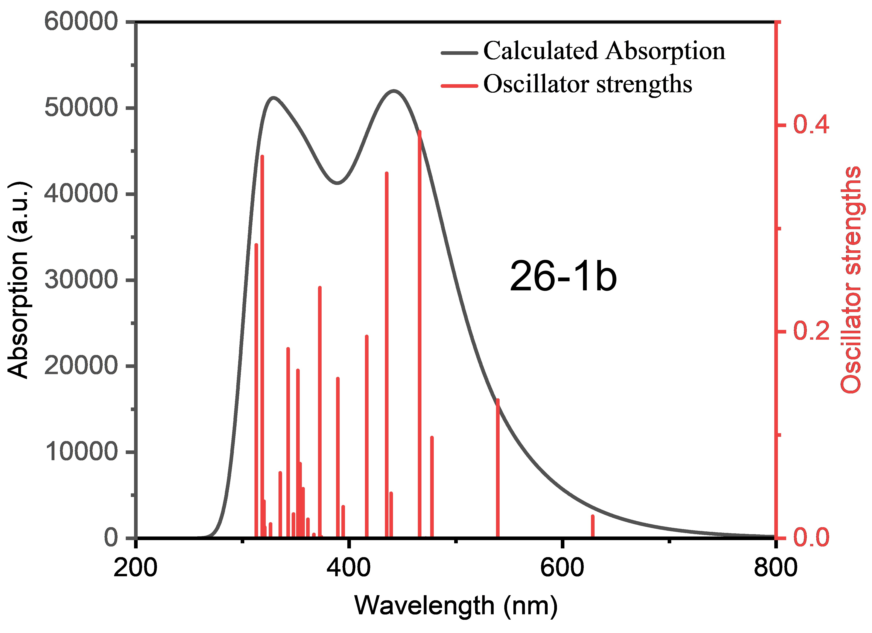
Figure S60 Calculated UV-vis absorption spectra of the 26-1b (closed-shell single state).

Table S23 Excitation energies, oscillator strengths and orbital contribution of the S₀ → S_{n} excitations of 26-1b calculated at the TD-B3LYP-D3(BJ)/6-31G(d,p) level of theory.
transition | energy [eV] | energy [nm] | oscillator  strength | orbital contribution
S₀ → S₁ | 1.9738 | 628.15 | 0.02130 | H → L | 92.5%
S₀ → S₂ | 2.2989 | 539.32 | 0.13390 | H → L+1  H-2 → L | 74.3%  15.1%
S₀ → S₃ | 2.5963 | 477.54 | 0.09750 | H-1 → L | 95.4%
S₀ → S₄ | 2.6284 | 471.71 | 0.00010 | H-5 → L | 91.5%
S₀ → S₅ | 2.6604 | 466.04 | 0.39390 | H-2 → L  H → L+1  H-1 → L+1 | 66.6%  17.3%  9.4%
S₀ → S₆ | 2.8226 | 439.26 | 0.04360 | H-2 → L+1  H → L+2 | 70.2%  23.0%
S₀ → S₇ | 2.8490 | 435.18 | 0.35360 | H →L+2  H-2 → L+1  H-1 → L+1 | 68.2%  18.7%  7.4%
S₀ → S₈ | 2.9771 | 416.46 | 0.19550 | H-1 → L+1  H-6 → L  H-2 → L | 69.8%  8.3%  7.3%
S₀ → S₉ | 3.1438 | 394.38 | 0.03050 | H-3 → L | 95.0%
S₀ → S₁₀ | 3.1843 | 389.36 | 0.15460 | H-1 → L+2  H-2 → L+2 | 62.6%  22.0%

12. Atomic Cartesian coordinates of the optimized geometry
Table S24 Cartesian coordinates of the optimized geometry of 1 at the B3LYP-D3(BJ)/6-31G(d,p) level of theory.
C -0.93951700 1.11391500 -0.06078100
C 0.40351100 1.33770100 -0.05963500
C 1.38557300 0.20680300 -0.07108600
C 0.90832700 -1.14394900 -0.06351900
C -0.43509700 -1.36819600 -0.06557600
C -1.41569900 -0.23627300 -0.07391100
C -1.21312500 -2.62607800 -0.02918100
C -2.51940400 -2.20320500 -0.02057400
C -2.69986600 -0.77886300 -0.06295700
C 1.17783000 2.59631900 -0.01879400
C 2.48474700 2.17655600 -0.01273400
C 2.66944900 0.75225600 -0.05853000
C -3.70309500 -2.90935700 0.06022800
C -4.74925300 -1.85424200 0.06078700
C -4.14422700 -0.58728800 -0.01752700
C 3.66537000 2.88739900 0.06820200
C 4.71516500 1.83707700 0.06341000
C 4.11575500 0.56686600 -0.01523400
C -1.05480500 -4.02179600 0.02366800
C -2.22311300 -4.82255500 0.08384800
C -3.53733800 -4.29716600 0.10457700
C 1.01386200 3.99101600 0.04038600
C 2.17902300 4.79591300 0.10178400
C 3.49496300 4.27449500 0.11776900
O 0.21968000 -4.50731900 0.01351900
O -0.26303500 4.47025300 0.03526200
C 4.80136200 -0.72957200 -0.05758900
C 6.16241500 2.12682900 0.10586400
C -4.81772100 0.71568000 -0.05595600
C -6.19830700 -2.13340500 0.10815500
C -6.75844200 -2.69676600 1.27568400
C -8.12774100 -2.96441800 1.31148700
C -8.95836700 -2.69944600 0.21944200
C -8.38229200 -2.15486400 -0.92989900
C -7.01869400 -1.86193100 -1.00699500
C -4.29648500 1.74630400 -0.85823000
C -4.90008700 2.99595700 -0.90253200
C -6.05258900 3.28263900 -0.15370600
C -6.57515300 2.24909000 0.63351700
C -5.97441700 0.99243700 0.68564300
C 4.28360000 -1.77155300 -0.84092300
C 4.90945400 -3.01535500 -0.89810000
C 6.08323500 -3.27347300 -0.18100500
C 6.60152000 -2.22381200 0.59577700
C 5.98099000 -0.98333800 0.66347800
C 6.98126900 1.86245800 -1.01174300
C 8.34458100 2.15768500 -0.93536700
C 8.92059700 2.70231900 0.21372700
C 8.09234200 2.95415400 1.31099800
C 6.72362100 2.68435700 1.27594600
C -6.44923000 -1.27233600 -2.27336600
C -5.90294000 -2.96721700 2.49000500
C -10.44072800 -2.96924900 0.29143700
C -6.67818400 4.68107200 -0.22365200
C -7.10790900 4.97541800 -1.67730500
C -7.91380600 4.81307300 0.68096400
C -5.63634000 5.72912500 0.22535200
C 6.41269000 1.26910800 -2.27672000
C 5.87112300 2.93675800 2.49622700
C 10.39081000 3.03631200 0.26250700
C 6.80292900 -4.62729700 -0.21451500
C 6.08063600 -5.64837900 -1.10792200
C 8.23316700 -4.43046300 -0.76228000
C 6.87629400 -5.20300300 1.21633400
C -0.45898600 5.87286300 0.11469500
C 0.40736400 -5.91186000 0.07626600
H -1.63853000 1.94200800 -0.03632900
H 1.60717600 -1.97221000 -0.04028400
H -2.11521500 -5.89967700 0.12138400
H -4.37750500 -4.98355000 0.15533800
H 2.06730800 5.87251500 0.14375100
H 4.33317200 4.96319900 0.16949700
H -8.55706300 -3.38712700 2.21687700
H -9.01035600 -1.95505100 -1.79490300
H -3.41994500 1.55036800 -1.46676900
H -4.46418900 3.76037500 -1.53827700
H -7.46250700 2.41755400 1.23182700
H -6.40181700 0.22173300 1.31631500
H 3.39101400 -1.59544400 -1.43189200
H 4.46799300 -3.78429400 -1.52068300
H 7.50850700 -2.37884600 1.17179200
H 6.40689600 -0.20384700 1.28384700
H 8.97281100 1.95654900 -1.79987700
H 8.52382500 3.36518500 2.22075400
H -7.14936300 -1.39150100 -3.10431700
H -6.24624400 -0.20271200 -2.15423800
H -5.50279200 -1.74719300 -2.54660400
H -5.31475900 -2.08505300 2.76363100
H -6.52092800 -3.24782100 3.34656200
H -5.18483800 -3.77337000 2.31004800
H -10.66047300 -3.82555300 0.93591700
H -10.98003200 -2.10661500 0.70218000
H -10.85816400 -3.17187500 -0.69905500
H -7.55291400 5.97392500 -1.74937000
H -6.25895500 4.93613800 -2.36545400
H -7.84846400 4.24500500 -2.01751200
H -8.32304500 5.82491700 0.60145100
H -7.66606900 4.63598000 1.73217700
H -8.70334000 4.11245100 0.39202400
H -4.74862600 5.71562400 -0.41355600
H -6.06516600 6.73626600 0.18202100
H -5.31247200 5.53799600 1.25316000
H 5.46205800 1.73731900 -2.54675300
H 7.10946200 1.39404900 -3.10963900
H 6.21782200 0.19796600 -2.15765800
H 6.49001500 3.21846200 3.35176500
H 5.14337400 3.73609500 2.32483000
H 5.29385100 2.04639500 2.76668800
H 10.96457200 2.41578700 -0.43169900
H 10.56800700 4.08355400 -0.01215200
H 10.79977300 2.89174600 1.26701000
H 6.62824300 -6.59583600 -1.10231800
H 5.06483400 -5.84930100 -0.75263400
H 6.01909300 -5.30648900 -2.14574200
H 8.76701600 -5.38670600 -0.78887300
H 8.81122700 -3.74059600 -0.14150000
H 8.20662600 -4.02436300 -1.77822200
H 5.87263100 -5.34640500 1.62848800
H 7.38762400 -6.17194600 1.21172400
H 7.42314700 -4.53951000 1.89179000
H -1.53896100 6.02615700 0.10903000
H -0.03844100 6.28562800 1.04002000
H -0.01320600 6.39041600 -0.74387300
H 1.48616900 -6.07194700 0.06134600
H -0.00956900 -6.33238100 0.99974900
H -0.04716300 -6.41711200 -0.78500400
Table S25 Cartesian coordinates of the optimized geometry of 2 at the UB3LYP-D3(BJ)/6-31G(d,p) level of theory.
C -1.71686500 -1.87235500 0.02868600
C -2.47221400 -0.59730700 0.01217600
C -1.76904900 0.60954100 0.01740100
C -0.36640000 0.62435400 0.02320700
C 0.36639800 -0.62434300 0.02320200
C -0.35302600 -1.86418400 0.03196200
C 0.35302400 1.86419500 0.03197400
C 1.71686300 1.87236600 0.02869800
C 2.47221200 0.59731900 0.01218000
C 1.76904700 -0.60952900 0.01739600
C 3.86600600 0.91467000 0.00987600
C -3.86600800 -0.91465900 0.00987200
C -2.69761600 -2.97671700 0.05523300
C 2.69761400 2.97672800 0.05525100
C 5.23833300 0.48600100 0.02424900
C -5.23833600 -0.48599000 0.02424400
C 2.77424800 4.38323500 0.09544800
C 4.05655900 4.98155200 0.12578200
C 5.26780500 4.24604000 0.12622800
C 5.20475200 2.85122800 0.09846100
C 3.91688400 2.34273700 0.05170900
C -2.77425100 -4.38322500 0.09541400
C -4.05656200 -4.98154200 0.12573900
C -5.26780800 -4.24602900 0.12618800
C -5.20475500 -2.85121700 0.09843300
C -3.91688600 -2.34272600 0.05169400
C -6.06245100 -1.64789100 0.07627400
C 6.06244800 1.64790000 0.07630300
C -5.70351900 0.90472900 -0.02201100
C 5.70351600 -0.90471700 -0.02202300
C -6.84077900 1.34101000 0.67926000
C -7.25985300 2.66272400 0.60126600
C -6.57313700 3.61621000 -0.16844800
C -5.43914200 3.17781800 -0.86207600
C -5.01416900 1.85225100 -0.79298900
C 5.01417800 -1.85222500 -0.79302800
C 5.43915300 -3.17779000 -0.86213500
C 6.57314100 -3.61619400 -0.16850000
C 7.25984500 -2.66272100 0.60124000
C 6.84076800 -1.34101000 0.67925400
C -7.07936400 5.06285100 -0.22273300
C -7.08843700 5.65567400 1.20300700
C -6.19730600 5.95606900 -1.10981300
C -8.51399300 5.07885900 -0.79383400
C 7.07937100 -5.06283300 -0.22280800
C 6.19732900 -5.95603400 -1.10992000
C 8.51400900 -5.07882500 -0.79388800
C 7.08842400 -5.65568500 1.20292000
O -1.59781700 -5.07133800 0.10156500
C -1.64761600 -6.48895800 0.14638500
O 1.59781400 5.07134800 0.10160300
C 1.64761200 6.48896600 0.14648400
C -7.53722100 -1.68039000 0.06470400
C -8.25604100 -1.25342700 -1.07255400
C -9.65151800 -1.30368500 -1.04857800
C -10.35694700 -1.75981200 0.06667600
C -9.62719900 -2.17572700 1.18342800
C -8.23180800 -2.15181400 1.20083100
C -7.48527500 -2.57313500 2.44398900
C -7.54711300 -0.75032100 -2.30531800
C -11.86369000 -1.82895300 0.05646200
C 7.53721800 1.68038900 0.06474000
C 8.25604000 1.25340700 -1.07251000
C 9.65151800 1.30363900 -1.04852200
C 10.35694700 1.75975500 0.06673500
C 9.62719600 2.17568900 1.18348100
C 8.23180600 2.15180300 1.20087300
C 7.48527300 2.57312400 2.44403100
C 7.54711900 0.75029500 -2.30527600
C 11.86369100 1.82886900 0.05653400
H -2.30765500 1.55187500 0.02493300
H 0.20244000 -2.79692500 0.04457000
H -0.20244200 2.79693700 0.04458800
H 2.30765300 -1.55186400 0.02492200
H 4.12823600 6.06181700 0.15260400
H 6.20973600 4.78646500 0.14862700
H -4.12823900 -6.06180700 0.15255300
H -6.20973900 -4.78645400 0.14857800
H -7.39437300 0.63851100 1.29077100
H -8.14202500 2.95838000 1.16064400
H -4.87516900 3.86805800 -1.47797700
H -4.14978400 1.53614400 -1.36802500
H 4.14980100 -1.53610900 -1.36807000
H 4.87519000 -3.86801900 -1.47805600
H 8.14201000 -2.95838700 1.16062400
H 7.39435300 -0.63852100 1.29078500
H -7.45291700 6.68860600 1.18414400
H -7.73553100 5.08459400 1.87426100
H -6.08058100 5.65554700 1.62962600
H -6.59480400 6.97562900 -1.11673300
H -6.17405800 5.60196400 -2.14514000
H -5.16823300 6.00317100 -0.73997900
H -8.53277700 4.66418000 -1.80649400
H -9.19990400 4.48987700 -0.17889200
H -8.89675700 6.10449400 -0.83591500
H 6.59482900 -6.97559300 -1.11685500
H 5.16825000 -6.00314600 -0.74010300
H 6.17409600 -5.60190900 -2.14524000
H 8.89677600 -6.10445800 -0.83598400
H 9.19990900 -4.48985500 -0.17892400
H 8.53280700 -4.66412600 -1.80653800
H 6.08056200 -5.65557000 1.62952400
H 7.45290700 -6.68861700 1.18404100
H 7.73550700 -5.08461900 1.87419600
H -0.61085700 -6.82707600 0.14743200
H -2.14713000 -6.84394300 1.05617200
H -2.16360100 -6.90003200 -0.73001300
H 0.61085200 6.82708300 0.14755800
H 2.14713700 6.84391200 1.05627900
H 2.16358500 6.90007900 -0.72990400
H -10.20180600 -0.97837900 -1.92833600
H -10.15782800 -2.52098000 2.06768700
H -8.17656300 -2.74460800 3.27291600
H -6.91311900 -3.49222400 2.28374900
H -6.76301700 -1.80918500 2.75011300
H -6.67659500 -1.36660100 -2.54647200
H -8.22122200 -0.75075000 -3.16583900
H -7.18364500 0.27273100 -2.16222200
H -12.29405400 -1.06587600 -0.59852400
H -12.21249300 -2.80391300 -0.30607900
H -12.27664600 -1.68950000 1.05988500
H 10.20180600 0.97831900 -1.92827500
H 10.15782500 2.52093400 2.06774300
H 8.17656800 2.74466600 3.27293700
H 6.91305600 3.49217000 2.28377200
H 6.76306900 1.80913800 2.75019700
H 7.18376600 -0.27280400 -2.16221700
H 6.67652800 1.36649400 -2.54636800
H 8.22119800 0.75083700 -3.16582000
H 12.21251500 2.80381700 -0.30601700
H 12.27663500 1.68942000 1.05996300
H 12.29404600 1.06577500 -0.59843800

Table S26 Cartesian coordinates of the optimized geometry of 3 at the B3LYP-D3(BJ)/6-31G(d,p) level of theory.
O -2.62381700 -4.76384800 -0.68004000
O 2.61480100 4.74845100 -0.70276000
C -3.98691200 -1.41450500 -0.25219600
C -3.24366400 -0.15465400 -0.10856500
C -3.06402900 -2.43866900 -0.40566000
C 3.23339600 0.14234000 -0.10923400
C -1.81953500 -0.47784100 -0.26928100
C 1.80854300 0.46591200 -0.27113300
C 1.71727600 1.86391000 -0.40883200
C 0.63406400 -0.34436000 -0.32749700
C 0.66216800 -1.76254100 -0.46679900
H 1.61346900 -2.25718900 -0.60518100
C 3.75470500 -1.05628000 0.27240700
H 3.03896200 -1.83613800 0.49947000
C 3.97684500 1.40129900 -0.25935100
C -0.64494600 0.33276600 -0.32895200
C -1.72777700 -1.87671800 -0.40080300
C 5.11461500 -1.48403700 0.42714800
C 5.39458600 1.64366300 -0.23466600
C 6.31298800 -0.71798900 0.22171700
C -5.40391300 -1.65598400 -0.22589700
C -4.88850300 -4.06530900 -0.55101000
H -5.21598800 -5.09359100 -0.66898200
C -3.76676100 1.04564000 0.26725700
H -3.05151100 1.82701800 0.49069300
C 3.05450500 2.42474200 -0.41716400
C -5.78166800 -3.06163800 -0.40569900
H -6.83800700 -3.29548400 -0.40780300
C -5.12637700 1.47222400 0.41918000
C -6.42333500 -0.72036800 -0.06265800
C 6.41305400 0.71032000 -0.06518400
C -3.43458100 -3.83680300 -0.55577900
C 0.47393800 2.50835300 -0.53784400
H 0.44713200 3.58056000 -0.68678100
C 7.82501600 1.22666100 -0.16190300
C -7.83376200 -1.24193500 -0.15827800
C -0.67287200 1.75007100 -0.47369600
H -1.62401900 2.24460200 -0.61357200
C -6.32329900 0.70784300 0.21626200
C 7.66076200 -2.76000900 0.68726100
C -0.48412100 -2.52141900 -0.52748100
H -0.45727000 -3.59423000 -0.67200600
C 7.53848700 -1.41908800 0.34951200
H 8.44610300 -0.86223700 0.17855800
C 3.42585800 3.82237100 -0.57475400
C -5.26526200 2.83960400 0.77462200
H -4.35745200 3.41187300 0.93946700
C 5.25421600 -2.84663800 0.78632300
H 4.34692400 -3.41981000 0.95108100
C 8.50980400 1.62716800 1.00055300
C -7.55534200 1.41006200 0.33734900
H -8.45692100 0.84864400 0.16297000
C 8.47152200 1.24792600 -1.41079100
C -7.67471700 2.74826600 0.66883300
C 5.77263300 3.04819000 -0.42304300
H 6.82929000 3.28108600 -0.42749900
C -8.47666800 -1.27885200 -1.40860200
C 9.80422500 1.66453000 -1.47525600
H 10.30515200 1.67411400 -2.44013300
C -6.48384200 3.46559400 0.90250300
H -6.51564600 4.51527100 1.17474700
C 9.06061400 -3.37546100 0.79645200
C 6.47539900 -3.47670200 0.91974900
H 6.50170600 -4.52379200 1.19502100
C 4.87972500 4.05116200 -0.57315400
H 5.20690200 5.07877000 -0.69748600
C -8.51701100 -1.64300700 1.00480700
C -9.84171700 -2.07257900 0.89614600
H -10.36967800 -2.37998300 1.79561300
C 9.84017400 2.03957200 0.89287400
H 10.36946900 2.34601100 1.79184400
C 10.50633800 2.06438600 -0.33577100
C -9.80385500 -1.71224200 -1.47398800
H -10.30198400 -1.73393400 -2.44013400
C -7.75019600 -0.84673000 -2.65804800
H -8.41268400 -0.87663300 -3.52619200
H -6.89202100 -1.49555400 -2.86246500
H -7.36064400 0.17206700 -2.55980200
C -10.50395400 -2.11396900 -0.33404200
C 7.74385800 0.81466100 -2.65915400
H 6.89081600 1.46867400 -2.86822800
H 7.34697900 -0.20080200 -2.55605600
H 8.40798600 0.83497600 -3.52630000
C -7.83282700 -1.60144600 2.34822100
H -7.50303200 -0.58631000 2.59399500
H -6.94067700 -2.23622800 2.35947000
H -8.50372600 -1.94270300 3.13997600
C 9.85905800 -2.62451200 1.88542900
H 9.95926300 -1.56068500 1.65277000
H 10.86600100 -3.04602300 1.97305500
H 9.36638700 -2.71153700 2.85892500
C 7.82259500 1.59972300 2.34278800
H 8.49390800 1.94297100 3.13329000
H 7.48739400 0.58807400 2.59542900
H 6.93388600 2.23927500 2.34732100
C -9.03464900 3.44227900 0.78831200
C 9.78517200 -3.23116500 -0.56010300
H 9.23368200 -3.74632400 -1.35273700
H 10.78762100 -3.66813100 -0.50105400
H 9.89355200 -2.18278800 -0.85166300
C 9.00848700 -4.86571900 1.16731500
H 8.52701700 -5.02554500 2.13720900
H 10.02511200 -5.26428900 1.23331000
H 8.47101000 -5.45194500 0.41523600
C 11.93542700 2.53741500 -0.43124400
H 12.44370800 2.09999600 -1.29509000
H 12.50319800 2.27717100 0.46688500
H 11.98315700 3.62764500 -0.54123800
C -11.92679100 -2.60534800 -0.43029000
H -11.96098700 -3.69684600 -0.53256300
H -12.43781500 -2.18022900 -1.29864200
H -12.50036800 -2.34550100 0.46426900
C -10.20491200 2.48683900 0.50080300
H -10.15956400 2.08094900 -0.51450100
H -11.15064800 3.02763900 0.60069200
H -10.22644500 1.64552900 1.20038600
C -9.19453900 3.99339900 2.22183000
H -9.15622100 3.18307600 2.95636200
H -10.15761200 4.50410300 2.32522500
H -8.40810000 4.71110300 2.47157300
C -9.09536400 4.60842400 -0.22213100
H -8.30765300 5.34514600 -0.04086500
H -10.05855200 5.12381400 -0.14721400
H -8.98253700 4.24070700 -1.24659300

Table S27 Cartesian coordinates of the optimized geometry of 25-1a at the UB3LYP-D3(BJ)/6-31G(d,p) level of theory.
C 0.47082800 -1.10441800 -0.04422100
C 0.62179100 -2.52039600 -0.03555700
C -0.49355300 -3.37478200 -0.04686400
C -1.75434900 -2.80291100 -0.08446600
C -1.91630600 -1.34300200 -0.08976300
C -0.78928400 -0.51366500 -0.06614400
C -3.33031700 -1.05670100 -0.08127900
C -3.10361000 -3.42006100 -0.07215300
C -4.38728900 -0.10637100 -0.01709200
C -3.76077700 -4.66340300 -0.03181500
C -5.17188300 -4.68167900 0.04388400
C -5.97904600 -3.52444300 0.09036300
C -5.34134900 -2.27777500 0.04379100
C -3.96201100 -2.34061000 -0.05272200
C -5.62885200 -0.82940700 0.05947100
C -4.23314300 1.35254000 -0.02944900
C -3.22811800 1.94372800 -0.81602100
C -3.05148300 3.32097200 -0.83876900
C -3.86838700 4.17992800 -0.08545100
C -4.87248800 3.58703200 0.68931400
C -5.05386600 2.20536800 0.72146000
C 1.80443000 -0.49630200 -0.01728900
C 2.77065000 -1.59427200 0.00555300
C 2.04809100 -2.80987200 -0.00585600
C 2.04588500 0.83784500 -0.01403300
C 4.18597800 -1.55404900 0.03447600
C 4.81664800 -2.83215900 0.05166900
C 4.11619700 -4.03506700 0.04042100
C 2.71845800 -4.04579500 0.01081200
C 5.00953600 -0.36489100 0.04757900
C 3.28255400 1.56904400 0.01068800
C 3.13225100 2.97433000 0.00722200
C 4.19594000 3.85358600 0.02649400
C 5.51355300 3.35224100 0.05068400
C 5.67972200 1.97845800 0.05520400
C 4.61767000 1.02110900 0.03701000
O -3.09209300 -5.86718300 -0.03740100
C -2.44239200 -6.16426600 -1.27262000
C -3.63722400 5.69513600 -0.13993600
C -3.81367500 6.18678600 -1.59306600
C -2.20238100 6.00936100 0.33686200
C -4.62153500 6.46751900 0.75290800
O 1.94723300 -5.16693100 -0.00486600
C 2.59925700 -6.42816300 0.03212200
C 6.70441900 4.31639100 0.07159800
C 6.61135100 5.20477200 1.33117100
C 6.65535500 5.20557800 -1.18987700
C 8.05486300 3.58125500 0.09486200
C 6.48935000 -0.62375700 0.07665500
C 7.20728600 -0.74033600 -1.13006100
C 8.58487400 -0.96053300 -1.08450900
C 9.27225500 -1.06971000 0.12895000
C 8.54167400 -0.95617500 1.31281600
C 7.16037600 -0.73520900 1.30696400
C 6.39936800 -0.60153000 2.60219600
C 6.49243800 -0.61193900 -2.45186400
C 10.76323300 -1.30054000 0.14892100
C -6.98046000 -0.24413800 0.10835800
C -7.49104700 0.47640200 -0.99302200
C -8.77735000 1.01387600 -0.91204200
C -9.57161900 0.86442400 0.22655100
C -9.04683800 0.15120700 1.30763300
C -7.77055400 -0.41201800 1.26772600
C -7.22887800 -1.13979300 2.47485300
C -6.67801000 0.66798200 -2.24921000
C -10.96814900 1.43189000 0.27834700
H -0.36045300 -4.44746600 -0.00595800
H -0.90969400 0.56440000 -0.05170500
H -5.63996600 -5.66022800 0.07368900
H -7.05845200 -3.62561100 0.15392000
H -2.60009100 1.30848600 -1.43230500
H -2.26722800 3.73446900 -1.46550100
H -5.52942000 4.20310100 1.29139900
H -5.83650700 1.78529500 1.34208800
H 1.16312000 1.47391900 -0.03281800
H 5.89684900 -2.87686100 0.07474400
H 4.67670600 -4.96155500 0.05481300
H 2.12101300 3.37104300 -0.01084400
H 4.00744300 4.92162000 0.02307900
H 6.68298700 1.58786000 0.07433500
H -1.71589600 -5.39115600 -1.54758800
H -1.92248200 -7.11384300 -1.13059300
H -3.17438600 -6.26651600 -2.08383500
H -4.82494800 5.97482300 -1.95374600
H -3.64777000 7.26800200 -1.65295400
H -3.10778000 5.70157300 -2.27277200
H -2.05252700 5.66933000 1.36626600
H -2.01586200 7.08829400 0.30138200
H -1.45209600 5.51943500 -0.29009700
H -4.41842500 7.54054700 0.68277000
H -5.65927300 6.30516800 0.44558300
H -4.52599500 6.17925200 1.80434000
H 1.80610900 -7.17610800 0.02394900
H 3.24445500 -6.57074600 -0.84314900
H 3.19749500 -6.54199200 0.94397200
H 6.64480400 4.59438300 2.23890500
H 7.44894200 5.90987900 1.36134500
H 5.68448300 5.78473200 1.35098800
H 6.72045900 4.59583000 -2.09635100
H 7.49351900 5.91064700 -1.19035200
H 5.72984000 5.78572500 -1.24160500
H 8.15872700 2.94920300 0.98204000
H 8.18877800 2.94865200 -0.78792000
H 8.86923400 4.31205000 0.10856200
H 9.13550100 -1.04716600 -2.01860200
H 9.05731400 -1.03919600 2.26652500
H 7.06057600 -0.73099500 3.46264500
H 5.92498200 0.38275500 2.67929300
H 5.59819800 -1.34486300 2.66915800
H 7.18369000 -0.74445000 -3.28790800
H 5.69429900 -1.35586900 -2.54384700
H 6.02073100 0.37183300 -2.54923300
H 11.13975000 -1.38546400 1.17162100
H 11.03174800 -2.21883900 -0.38523100
H 11.29947200 -0.47812300 -0.33810500
H -9.16965600 1.56280700 -1.76490500
H -9.64360300 0.03616400 2.20945000
H -7.89893800 -1.02459500 3.33048900
H -7.10436700 -2.21011000 2.28376600
H -6.24171300 -0.75931800 2.75702700
H -7.31834300 0.97222600 -3.08127300
H -5.91430700 1.44063900 -2.11171000
H -6.15551600 -0.25006200 -2.53213100
H -11.24596300 1.71647900 1.29752900
H -11.06465500 2.31443100 -0.36059200
H -11.70638600 0.69725700 -0.06652500

Table S28 Cartesian coordinates of the optimized geometry of 25-2a at the UB3LYP-D3(BJ)/6-31G(d,p) level of theory.
C 1.05156700 1.83624300 0.03119700
C 0.98510500 3.30633100 -0.02362500
C -0.23484400 3.96995800 -0.11573500
C -1.40144700 3.21094100 -0.14221900
C -1.35792600 1.74107200 -0.05452200
C -0.12617600 1.08157200 0.03085500
C -2.72036500 1.26516200 -0.07839300
C -2.81060100 3.63049800 -0.22277900
C -3.65121700 0.19153500 -0.00036000
C -3.61267900 4.78617300 -0.30559700
C -5.01939000 4.62325200 -0.33314100
C -5.66611000 3.36627400 -0.26745100
C -4.88213200 2.21194600 -0.16778200
C -3.51787900 2.45139000 -0.17457900
C -4.98048900 0.74677500 -0.06249500
C -3.31602600 -1.22701700 0.15764800
C -4.09461500 -2.09943100 0.93134500
C -3.72670600 -3.43310600 1.09688300
C -2.56763200 -3.95319700 0.51029400
C -1.79612600 -3.07808100 -0.27178100
C -2.16222700 -1.75144600 -0.45164700
C 2.44481000 1.46413400 0.08874900
C 3.14928100 2.71230500 0.11230300
C 2.35770600 3.83499100 0.03534500
C 3.45485700 0.46095900 0.12556100
C 4.52597200 2.57853200 0.17316500
C 5.22276000 3.79136500 0.15163600
C 4.48505800 4.99674800 0.08486100
C 3.07088100 5.05014600 0.02415500
C 4.73649500 1.12278800 0.17521100
C 3.27559500 -0.99366000 0.04010100
C 4.13867200 -1.88573300 0.70034800
C 4.04583500 -3.25444400 0.49044400
C 3.08834200 -3.80994000 -0.37379500
C 2.19075900 -2.92284700 -0.98226500
C 2.28052600 -1.54507200 -0.78111600
O -2.97213500 5.98783100 -0.35319900
C -3.75698800 7.16733000 -0.43244000
C -2.10998200 -5.40286700 0.70351800
C -3.09123600 -6.21953800 1.55918900
C -0.73760700 -5.39773600 1.41149100
C -1.98643500 -6.09069400 -0.67315900
O 2.34295200 6.19948400 -0.05033800
C 3.03716200 7.43685200 -0.07343500
C 3.10865200 -5.31687500 -0.66039300
C 4.43499300 -5.65893000 -1.37613200
C 1.94749200 -5.75558400 -1.56619400
C 3.02577600 -6.11215500 0.65987100
C 6.06416200 0.48127300 0.15720700
C 6.50728800 -0.22724300 -0.98031400
C 7.77412000 -0.81498500 -0.95923600
C 8.61376900 -0.72564800 0.15245200
C 8.15727400 -0.01873000 1.26832100
C 6.90327100 0.59300500 1.28849000
C 6.43542700 1.31598700 2.52891800
C 5.64452400 -0.35936900 -2.21051100
C 9.98757300 -1.34822500 0.13973500
C -6.24621800 -0.00796200 -0.06313800
C -6.56578500 -0.87044400 -1.13433100
C -7.77736700 -1.56399500 -1.10601000
C -8.67976900 -1.43489300 -0.04829400
C -8.34310100 -0.58040000 1.00484600
C -7.14817800 0.14070400 1.01432200
C -6.80714700 1.01834500 2.19499100
C -5.62876000 -1.04860500 -2.30298900
C -9.99369400 -2.17548300 -0.05466700
H -0.27578900 5.05204600 -0.16288400
H -0.08262200 0.00195000 0.11124000
H -5.64531700 5.50419600 -0.40349800
H -6.75133400 3.33195600 -0.29408800
H -4.98799700 -1.72987100 1.42005400
H -4.35672900 -4.06609300 1.71019100
H -0.88822700 -3.43464400 -0.74729300
H -1.56088600 -1.10742100 -1.08437300
H 6.30747600 3.83905200 0.17865400
H 5.04318900 5.92474700 0.07422800
H 4.90182600 -1.49908900 1.36454300
H 4.75044700 -3.90339000 1.00060100
H 1.42846600 -3.29598700 -1.65634900
H 1.60435800 -0.88121600 -1.31062200
H -3.05068500 7.99785700 -0.45550300
H -4.36676600 7.18295600 -1.34415000
H -4.41343200 7.27171300 0.44018600
H -4.08420300 -6.26702700 1.10116900
H -2.72317000 -7.24491500 1.66359200
H -3.19646400 -5.80138100 2.56495600
H 0.00150600 -4.81462100 0.85689500
H -0.35649300 -6.41941100 1.51758200
H -0.82093800 -4.95709100 2.40981500
H -2.95742500 -6.12163900 -1.17737800
H -1.28851400 -5.56614800 -1.33029600
H -1.62761500 -7.11902600 -0.55622600
H 2.27124200 8.21049400 -0.13668800
H 3.62719100 7.58288200 0.83971000
H 3.70009700 7.50872000 -0.94442600
H 5.30058300 -5.39868800 -0.76060200
H 4.48535000 -6.73108700 -1.59611900
H 4.51864300 -5.11055200 -2.31964200
H 0.97696200 -5.54089900 -1.11250400
H 2.00005100 -6.83518000 -1.73690800
H 1.98734300 -5.26468300 -2.54343700
H 3.03690900 -7.18788400 0.45366400
H 3.86960800 -5.89319400 1.31948700
H 2.10644300 -5.87794300 1.20226800
H 8.11391600 -1.35623400 -1.83914600
H 8.79107200 0.05279500 2.14915400
H 7.13856200 1.16953500 3.35263600
H 6.33229300 2.39212700 2.35787100
H 5.45115700 0.95834600 2.84897000
H 6.25181200 -0.61930700 -3.08155300
H 4.88984400 -1.14213500 -2.08059200
H 5.10830200 0.56855700 -2.42656200
H 10.74361900 -0.63127900 -0.20377600
H 10.28534800 -1.67888200 1.13923000
H 10.02880900 -2.21100500 -0.53128200
H -8.02269200 -2.22251200 -1.93590300
H -9.02476500 -0.47828300 1.84601400
H -7.52568200 0.87399700 3.00571600
H -5.80618600 0.79504000 2.57846900
H -6.80604600 2.07968200 1.92821600
H -6.14761300 -1.50916700 -3.14767800
H -5.21212600 -0.09248500 -2.63196100
H -4.78268800 -1.69051800 -2.03613900
H -10.78431500 -1.57408100 -0.52037600
H -9.92233300 -3.11060400 -0.61759400
H -10.32301200 -2.41310300 0.96118200

Table S29 Cartesian coordinates of the optimized geometry of 25-3a at the UB3LYP-D3(BJ)/6-31G(d,p) level of theory.
C -1.19443000 0.41802000 0.00003500
C -1.19271200 1.84119400 -0.00001800
C 0.00000300 2.56682700 -0.00004500
C 1.19271600 1.84119300 -0.00001500
C 1.19443300 0.41801800 0.00003900
C 0.00000100 -0.29982200 0.00006200
C 2.58685500 -0.04604600 0.00004200
C 2.58789100 2.28011700 -0.00002900
C 2.96896800 -1.34637800 0.00006300
C 3.12515800 3.57695700 -0.00003700
C 4.51703800 3.71402700 0.00001100
C 5.34044600 2.59212000 0.00005400
C 4.84589500 1.25708700 0.00003600
C 3.43229700 1.14888500 0.00000100
C 5.78984200 0.16012500 0.00007000
C -2.58685300 -0.04604200 0.00004400
C -3.43229400 1.14889000 -0.00000200
C -2.58788600 2.28012100 -0.00004000
C -2.96896900 -1.34637400 0.00008800
C -4.84589100 1.25709500 -0.00000800
C -5.34044000 2.59212900 -0.00005700
C -4.51703100 3.71403400 -0.00009500
C -3.12515000 3.57696200 -0.00008800
C -5.78984000 0.16013300 0.00001900
C -4.27688300 -1.94429800 0.00008900
C 4.27688200 -1.94430500 -0.00000900
C -4.27621400 -3.35706400 0.00012900
C -5.42686800 -4.12017100 0.00013400
C -6.68431900 -3.48314200 0.00010100
C -6.70455500 -2.09950800 0.00006500
C -5.54713300 -1.25925200 0.00005300
C 5.54713200 -1.25926000 -0.00002700
C 6.70455400 -2.09951900 -0.00014900
C 6.68431500 -3.48315300 -0.00022500
C 5.42686200 -4.12017900 -0.00017500
C 4.27621000 -3.35707000 -0.00007300
O 2.24107200 4.61356500 -0.00007400
C 2.76145500 5.93308100 -0.00016000
O -2.24106300 4.61356900 -0.00012200
C -2.76144500 5.93308600 -0.00022400
C -7.97072700 -4.31596100 0.00009900
C -7.99454800 -5.20743200 1.26065600
C -7.99451500 -5.20746000 -1.26044100
C -9.23617800 -3.44221000 0.00007400
C 7.97072100 -4.31597400 -0.00034900
C 9.23617200 -3.44222400 -0.00028900
C 7.99449000 -5.20732500 -1.26099400
C 7.99455800 -5.20759300 1.26010300
C -7.23469800 0.57291400 0.00000100
C -7.91478100 0.75528500 1.21856100
C -9.26574600 1.11192600 1.19881800
C -9.95947500 1.29617000 -0.00003900
C -9.26568900 1.11198200 -1.19888900
C -7.91473700 0.75534700 -1.21859200
C -7.19431400 0.54651800 -2.52697600
C -7.19443000 0.54638000 2.52697300
C -11.41071500 1.70890600 -0.00009100
C 7.23470000 0.57290800 0.00018700
C 7.91484600 0.75541200 -1.21836300
C 9.26577300 1.11204500 -1.19854200
C 9.95947200 1.29618100 0.00039400
C 9.26565700 1.11188300 1.19916500
C 7.91467000 0.75522600 1.21878900
C 7.19423400 0.54626300 2.52714500
C 7.19450300 0.54666100 -2.52680400
C 11.41071500 1.70891100 0.00034500
H 0.00000400 3.64658600 -0.00008600
H 0.00000000 -1.38637000 0.00010000
H 2.15885500 -2.07301900 0.00010800
H 4.97694000 4.69455900 0.00002700
H 6.41020300 2.75024100 0.00011100
H -2.15885700 -2.07301600 0.00012500
H -6.41019700 2.75025000 -0.00006500
H -4.97693100 4.69456700 -0.00012800
H -3.31238800 -3.85846400 0.00015800
H -5.35146500 -5.20216700 0.00016600
H -7.66132400 -1.60550800 0.00004500
H 7.66132300 -1.60552100 -0.00018400
H 5.35145700 -5.20217600 -0.00021900
H 3.31238300 -3.85846800 -0.00004300
H 1.89656400 6.59725700 -0.00025400
H 3.36757600 6.12608500 0.89352900
H 3.36765700 6.12593300 -0.89382500
H -1.89655300 6.59726000 -0.00028000
H -3.36761000 6.12594300 -0.89391400
H -3.36760200 6.12608600 0.89344000
H -7.97886900 -4.59551000 2.16785900
H -8.90249800 -5.81997800 1.27610700
H -7.13468300 -5.88214100 1.29643800
H -7.97881100 -4.59555700 -2.16765600
H -8.90246600 -5.82000700 -1.27590300
H -7.13464900 -5.88216900 -1.29618400
H -9.28748100 -2.80064100 0.88501200
H -9.28746200 -2.80066200 -0.88488100
H -10.12346400 -4.08277300 0.00007100
H 10.12345800 -4.08278700 -0.00043300
H 9.28741600 -2.80053400 -0.88514400
H 9.28751700 -2.80079500 0.88474900
H 7.13463200 -5.88204100 -1.29679600
H 8.90244800 -5.81985900 -1.27654900
H 7.97875800 -4.59531600 -2.16813700
H 8.90250000 -5.82015600 1.27546000
H 7.97891100 -4.59577700 2.16737800
H 7.13468300 -5.88229200 1.29582600
H -9.78907800 1.24532800 2.14286300
H -9.78898800 1.24543100 -2.14294700
H -6.82581700 -0.48141300 -2.61276600
H -7.85321800 0.74624900 -3.37577500
H -6.32163000 1.20299100 -2.60618000
H -7.85336700 0.74611000 3.37574800
H -6.82598500 -0.48157300 2.61274700
H -6.32172000 1.20280900 2.60624400
H -11.93244400 1.33363700 -0.88536200
H -11.93205200 1.33523700 0.88607900
H -11.51260800 2.80127000 -0.00107400
H 9.78914200 1.24553300 -2.14255900
H 9.78891300 1.24526600 2.14325100
H 7.85309000 0.74604300 3.37597100
H 6.32146700 1.20262400 2.60635000
H 6.82586400 -0.48171800 2.61289100
H 7.85353900 0.74617200 -3.37555300
H 6.82575400 -0.48118200 -2.61255600
H 6.32199000 1.20334900 -2.60614000
H 11.51263100 2.80125100 -0.00640100
H 11.93069700 1.33994800 0.88925900
H 11.93378500 1.32893300 -0.88214200

Table S30 Cartesian coordinates of the optimized geometry of 26-1a at the B3LYP-D3(BJ)/6-31G(d,p) level of theory.
C -0.59601000 -1.15544500 -0.19894500
C -0.70870400 -2.57046400 -0.12875600
C 0.41880100 -3.39778500 -0.17387200
C 1.66452000 -2.78663500 -0.26589600
C 1.78727700 -1.33371700 -0.32617300
C 0.64918500 -0.53267400 -0.30271800
C 3.21339700 -1.00891300 -0.46408400
C 3.01560300 -3.37934300 -0.36796500
C 4.18507100 -0.05226900 -0.56662800
C 3.66518100 -4.62709800 -0.40249400
C 5.06310100 -4.65565200 -0.58799800
C 5.85937100 -3.49901400 -0.74407300
C 5.22369100 -2.25998100 -0.69334700
C 3.86514000 -2.29579000 -0.50908600
C 4.07663600 1.39643400 -0.47723900
C 3.03590500 1.98613200 0.26708400
C 2.93336300 3.36386500 0.38872100
C 3.86084200 4.22746300 -0.21913900
C 4.90144900 3.63652000 -0.94598400
C 5.01691100 2.25415500 -1.07090200
C -1.94631500 -0.59473500 -0.14775300
C -2.86770700 -1.72419700 -0.03767500
C -2.12006400 -2.89602600 -0.02525300
C -2.24059700 0.73032200 -0.19706000
C -4.30343900 -1.71920800 0.05187600
C -4.90409100 -3.05163400 0.15901600
C -4.18561600 -4.19729500 0.17573500
C -2.71599200 -4.21770700 0.08775400
C -5.14506500 -0.60894400 0.04531100
C -3.50515100 1.40156700 -0.15956700
C -3.41875300 2.81517800 -0.24101800
C -4.51984200 3.64053200 -0.22078800
C -5.81271500 3.09030000 -0.11447900
C -5.91162600 1.71189400 -0.03417800
C -4.80978400 0.81142000 -0.05096200
O 2.99613400 -5.82166200 -0.29421000
C 2.45213900 -6.07770000 1.00247200
C 3.71047900 5.74449100 -0.05564000
C 3.79157200 6.10497600 1.44390600
C 2.34031000 6.18460500 -0.61578100
C 4.80765600 6.52315300 -0.79894200
C -7.04437600 4.00026200 -0.09045100
C -7.08827300 4.82320400 -1.39640200
C -6.94050400 4.95620700 1.11787900
C -8.35533500 3.20505600 0.02862000
C -6.62084900 -0.89614500 0.15142400
C -7.23474900 -0.94177100 1.41631800
C -8.61265500 -1.16075600 1.49112000
C -9.39307200 -1.33839200 0.34573200
C -8.75916800 -1.29192500 -0.89871400
C -7.38396000 -1.07529200 -1.01678600
C -6.72959400 -1.02520200 -2.37485200
C -6.42007900 -0.74816300 2.67086600
C -10.87451500 -1.60160500 0.45093800
C 6.74822600 -0.30574700 0.00901000
C 6.55434000 -0.14413600 1.40375000
C 7.60585300 0.31568700 2.20003000
C 8.86326100 0.60670600 1.67795200
C 9.05919800 0.36675200 0.32167600
C 8.04422800 -0.09741700 -0.52525700
C 8.46697200 -0.37421800 -1.95653100
C 5.26515700 -0.47864200 2.12159000
C 9.96767600 1.15039100 2.54828600
H 0.29794300 -4.47297000 -0.15679600
H 0.73548100 0.54579200 -0.38016900
H 5.52871300 -5.63545200 -0.61162700
H 6.93155200 -3.59754800 -0.88364600
H 2.33033400 1.34701200 0.78609100
H 2.12289800 3.77495900 0.98272900
H 5.64637400 4.25698100 -1.42916400
H 5.82669900 1.82891800 -1.64949300
H -1.38785500 1.40051600 -0.28019600
H -5.98233100 -3.10846100 0.22832300
H -4.67604600 -5.16232800 0.25799000
H -2.42931000 3.25449500 -0.32405400
H -4.38066200 4.71437200 -0.28754900
H -6.89385900 1.28007500 0.04733300
H 1.77644500 -5.27854700 1.32533000
H 1.89148800 -7.01027400 0.92459200
H 3.25404100 -6.18895200 1.74322700
H 4.75511300 5.80068500 1.86388200
H 3.68297200 7.18624000 1.58215400
H 3.00455700 5.61251600 2.02169000
H 2.25866100 5.93924000 -1.67923000
H 2.21255100 7.26666800 -0.50286100
H 1.51376300 5.69403200 -0.09406900
H 4.65641600 7.59767200 -0.65747600
H 5.80491000 6.27604900 -0.42233100
H 4.78769000 6.32323300 -1.87474300
H -7.16212500 4.16544100 -2.26784800
H -7.95786200 5.48859800 -1.39512200
H -6.19477200 5.44219700 -1.51729000
H -6.90868600 4.39415700 2.05631300
H -7.80800600 5.62364500 1.14789500
H -6.04240700 5.57835400 1.06802000
H -8.49617700 2.52234600 -0.81495400
H -8.39282000 2.61602700 0.95014100
H -9.20236800 3.89726700 0.04149100
H -9.08713600 -1.19118600 2.46888100
H -9.34907000 -1.42559800 -1.80215700
H -7.46894000 -1.14192100 -3.17051200
H -6.20773900 -0.07482900 -2.52964400
H -5.98279900 -1.81857600 -2.48472000
H -7.05553300 -0.77646400 3.55898200
H -5.65741300 -1.52741100 2.77251300
H -5.89298300 0.21181700 2.65794200
H -11.41004500 -1.22550200 -0.42541600
H -11.07954600 -2.67674000 0.52166900
H -11.30163200 -1.12994900 1.34052200
H 7.43145000 0.43911100 3.26604600
H 10.04582900 0.53203500 -0.10410100
H 9.55901000 -0.36766700 -2.01431500
H 8.10791400 -1.33996600 -2.31368700
H 8.08313400 0.37348200 -2.65406000
H 5.45247200 -0.53545400 3.19684100
H 4.49480900 0.28017500 1.96300000
H 4.85384000 -1.43895800 1.80528400
H 10.95353300 0.89422000 2.14953000
H 9.91614300 2.24428400 2.61412400
H 9.90071700 0.76120100 3.56875700
O -2.06761100 -5.27120200 0.11332200
C 5.57324800 -0.76611700 -0.85849100
O 5.86836200 -0.48038900 -2.23577200
H 5.11263200 -0.81013300 -2.74189300

Table S31 Cartesian coordinates of the optimized geometry of 25-1b at the UB3LYP-D3(BJ)/6-31G(d,p) level of theory.
C 1.73039400 -0.88995000 -0.02429500
C 1.85847300 -2.31713500 -0.01115100
C 0.73830100 -3.12654000 -0.02269000
C -0.54854400 -2.54319400 -0.04904100
C -0.68122000 -1.10756100 -0.06104900
C 0.48547100 -0.30166100 -0.04752200
C -1.72408700 -3.35719900 -0.05878900
C -2.96617800 -2.78764300 -0.09169700
C -3.10738300 -1.31460600 -0.09542100
C -1.97481200 -0.52227300 -0.07970400
C -4.52099600 -1.01018300 -0.07837200
C -4.32551300 -3.37805900 -0.07326400
C -5.56842000 -0.04503100 -0.00847600
C -5.00107500 -4.61323100 -0.03367800
C -6.40986300 -4.61114300 0.04713200
C -7.19942300 -3.43967200 0.09848300
C -6.54482500 -2.20385900 0.05272100
C -5.16507300 -2.28458600 -0.04772800
C -6.81532800 -0.75199800 0.07065400
C -5.40192500 1.41267100 -0.02243000
C -4.39815300 1.99914700 -0.80723800
C -4.22115100 3.38113900 -0.84323800
C -5.04076800 4.23998600 -0.10156200
C -6.04474100 3.64704900 0.68159600
C -6.22526700 2.27075300 0.72674000
C 3.07759600 -0.30471100 -0.00739200
C 4.02277400 -1.42136600 0.01703600
C 3.28467500 -2.62575400 0.01489900
C 3.34203000 1.02412000 -0.01398700
C 5.44063600 -1.40342600 0.04076300
C 6.05039200 -2.68965000 0.06260600
C 5.33214800 -3.88178500 0.06127300
C 3.93425000 -3.87050300 0.03726700
C 6.28448700 -0.22799500 0.04443200
C 4.59207700 1.73556200 -0.00005500
C 4.46646900 3.14232200 -0.01412500
C 5.54573000 4.00380700 -0.00438300
C 6.85387200 3.48035400 0.02089100
C 6.99563700 2.10338800 0.03512000
C 5.91711800 1.16533000 0.02611000
O -4.34568400 -5.82393100 -0.04747200
C -3.73053200 -6.13272900 -1.29786900
C -4.88513900 5.76566700 -0.11716000
C -6.19492800 6.40635400 -0.62547500
C -3.73763800 6.22514500 -1.03087300
C -4.59250300 6.26401200 1.31476300
O 3.14523600 -4.97962600 0.03387700
C 3.77980900 -6.24992400 0.06487700
C 8.06195500 4.42308000 0.03217200
C 7.98742200 5.32273000 1.28494400
C 8.02650600 5.30327400 -1.23603400
C 9.39899200 3.66387400 0.05871700
C 7.75970200 -0.51188300 0.07108700
C 8.43292000 -0.62361300 1.30200200
C 9.80976700 -0.86204000 1.30663000
C 10.53625700 -0.99615700 0.12053900
C 9.84883900 -0.88300000 -1.09074100
C 8.47265200 -0.64489500 -1.13506700
C 7.75880600 -0.50984200 -2.45674300
C 7.67636800 -0.46589500 2.59712700
C 12.01740000 -1.28208100 0.14722600
C -8.16207900 -0.15474100 0.12063500
C -8.66844000 0.56752000 -0.98155300
C -9.94996900 1.11619200 -0.89971700
C -10.74380900 0.97585500 0.24033100
C -10.22339100 0.26057500 1.32212300
C -8.95181100 -0.31327100 1.28145600
C -8.41436100 -1.04246700 2.48967600
C -7.85533900 0.75068400 -2.23889000
C -12.13532200 1.55546600 0.29294600
H 0.83872400 -4.20511800 -0.01113100
H 0.37036800 0.77905000 -0.05490700
H -1.60913300 -4.43590000 -0.01852800
H -2.06293500 0.55952000 -0.06779600
H -6.89349700 -5.58208200 0.07670700
H -8.28005500 -3.52496300 0.16515400
H -3.76684200 1.36146700 -1.41782500
H -3.43577900 3.78393900 -1.47164500
H -6.70084600 4.27344400 1.27793800
H -7.00704500 1.85330700 1.34996900
H 2.47039200 1.67528800 -0.03305400
H 7.12986400 -2.75106300 0.08155200
H 5.87858800 -4.81654300 0.07922000
H 3.46247700 3.55688800 -0.03341600
H 5.37535100 5.07483300 -0.01608200
H 7.99195700 1.69546300 0.05461700
H -4.48440900 -6.23597500 -2.08855500
H -3.00939500 -5.36303400 -1.59681300
H -3.21125200 -7.08364800 -1.16383600
H -7.04502700 6.14727300 0.01146300
H -6.10573600 7.49816100 -0.63895800
H -6.42302100 6.06852300 -1.64116700
H -2.77411300 5.82129100 -0.70449200
H -3.66426600 7.31678600 -1.00966100
H -3.90191300 5.92365100 -2.07009800
H -4.48306700 7.35401500 1.32455000
H -5.39790100 6.00207300 2.00627300
H -3.66670700 5.82317600 1.69733100
H 2.97666600 -6.98716600 0.06110100
H 4.41667000 -6.40053800 -0.81510600
H 4.38304000 -6.37343300 0.97226900
H 8.01169200 4.71890900 2.19736200
H 8.83760500 6.01288300 1.30811600
H 7.07115500 5.91940000 1.30190900
H 8.07872800 4.68549800 -2.13788700
H 8.87728200 5.99304000 -1.24355800
H 7.11150000 5.89962600 -1.29049800
H 9.49309300 3.03661800 0.95038200
H 9.52010600 3.02234800 -0.81944600
H 10.22642800 4.37993900 0.06562000
H 10.32721000 -0.94129900 2.25991200
H 10.39703400 -0.97879800 -2.02513300
H 6.94721200 -1.23960500 -2.54423400
H 7.30501300 0.48189100 -2.55857200
H 8.44654700 -0.65905800 -3.29287100
H 8.33662100 -0.59925900 3.45771600
H 7.21874200 0.52687000 2.66638200
H 6.86290200 -1.19505100 2.67128400
H 12.49056700 -0.85461200 1.03605500
H 12.21255000 -2.36154600 0.16204900
H 12.51878800 -0.87374400 -0.73509100
H -10.33868300 1.66709200 -1.75295300
H -10.81964200 0.15267700 2.22517100
H -9.07863300 -0.91384200 3.34791500
H -8.30581300 -2.11548500 2.30378100
H -7.42064500 -0.67434700 2.76505800
H -8.49386400 1.06056700 -3.07025800
H -7.08401400 1.51597700 -2.10273300
H -7.34186100 -0.17242500 -2.52185400
H -12.87988700 0.82825400 -0.05405400
H -12.41103900 1.84007500 1.31267900
H -12.22376800 2.44035200 -0.34393400

Table S32 Cartesian coordinates of the optimized geometry of 25-2b at the UB3LYP-D3(BJ)/6-31G(d,p) level of theory.
C -2.44729200 1.68893900 -0.11193600
C -2.44713900 3.16506100 -0.13611200
C -1.26226100 3.85609400 -0.15725900
C -0.02025900 3.15850100 -0.14851100
C -0.01633800 1.71664800 -0.11022800
C -1.24415200 1.00925400 -0.09273400
C 1.21818100 3.86203200 -0.16520000
C 2.40652100 3.17686600 -0.14861800
C 2.41498100 1.70082100 -0.11709500
C 1.21513500 1.01544200 -0.09325200
C 3.79459400 1.26990400 -0.09863400
C 3.81116100 3.64024500 -0.13199400
C 4.74808500 0.21861400 -0.03241500
C 4.58128600 4.82052400 -0.11973500
C 5.99158100 4.69908300 -0.07126100
C 6.67293900 3.45893300 -0.02277900
C 5.92166400 2.27963900 -0.02116800
C 4.55171200 2.48231500 -0.09353000
C 6.06040700 0.81254200 0.01525000
C 4.43646700 -1.21513800 -0.00956000
C 3.35727900 -1.70657100 -0.75929300
C 3.01046600 -3.05559100 -0.73320800
C 3.72931500 -3.97725700 0.03690900
C 4.81925700 -3.48281500 0.77238800
C 5.16953000 -2.13828200 0.75554600
C -3.82415200 1.25052200 -0.09024700
C -4.58827600 2.45809900 -0.07170400
C -3.85450300 3.62047000 -0.10790900
C -4.77045700 0.19295700 -0.02800300
C -5.95651000 2.24624200 0.00792100
C -6.71467800 3.42107700 0.01952300
C -6.04088800 4.66554600 -0.02562900
C -4.63167300 4.79594700 -0.08324900
C -6.08594200 0.77773000 0.03368400
C -4.44628000 -1.23810100 -0.02601400
C -5.15413000 -2.17759900 0.73581200
C -4.78770800 -3.52312100 0.73469600
C -3.70590200 -3.99127500 -0.02088200
C -3.01134800 -3.04776100 -0.79526900
C -3.37045900 -1.70686900 -0.80150400
O 3.90741900 6.00419700 -0.15532400
C 4.65887900 7.20812500 -0.14016200
C 3.37069600 -5.46698200 0.10509300
C 4.57311600 -6.30591200 -0.37860100
C 2.15560300 -5.81442300 -0.77013100
C 3.03520100 -5.84280600 1.56485800
O -3.96535400 5.98394600 -0.11649900
C -4.72404500 7.18311300 -0.08890500
C -3.26368600 -5.45988100 -0.03476900
C -4.11766700 -6.33489200 0.89648100
C -1.79240000 -5.55389100 0.42612000
C -3.38596000 -6.01502100 -1.47050700
C -7.36294700 0.04372500 0.07844600
C -8.18142600 0.13675600 1.22625900
C -9.38842400 -0.56335900 1.25911200
C -9.81517600 -1.34691900 0.18379000
C -8.99824500 -1.41526200 -0.94665900
C -7.77820000 -0.74007700 -1.02015400
C -6.93869100 -0.84544300 -2.26910800
C -7.74380200 0.94135300 2.42690700
C -11.10888100 -2.11928400 0.25347500
C 7.34308700 0.08824100 0.05587800
C 7.75473600 -0.70243100 -1.03918700
C 8.98012600 -1.36832000 -0.96998500
C 9.80596600 -1.28415900 0.15288700
C 9.38262500 -0.49408100 1.22479900
C 8.17048600 0.19726600 1.19591300
C 7.73693800 1.00857700 2.39354500
C 6.90542600 -0.82525000 -2.27989800
C 11.10558000 -2.04688200 0.21860400
H -1.26241900 4.94147900 -0.17385900
H -1.22457300 -0.07503800 -0.05533600
H 1.21313900 4.94734900 -0.18491500
H 1.20064900 -0.06874700 -0.05252500
H 6.59280700 5.59980100 -0.06648400
H 7.75851500 3.45800800 0.01298100
H 2.79629400 -1.02087700 -1.38581800
H 2.16827700 -3.38300500 -1.33102200
H 5.40553900 -4.16120500 1.38451600
H 6.00960600 -1.79531000 1.34802000
H -7.79995600 3.41360500 0.06295100
H -6.64741900 5.56259000 -0.01087900
H -5.98966900 -1.85265300 1.34488700
H -5.35871000 -4.20929400 1.34863100
H -2.17583300 -3.36526500 -1.41158000
H -2.82809700 -1.00575900 -1.42733900
H 3.92992800 8.01858000 -0.17075600
H 5.26042300 7.29370100 0.77308000
H 5.31925900 7.27955700 -1.01307900
H 5.46082900 -6.13144700 0.23547400
H 4.33670100 -7.37451400 -0.33070000
H 4.82814800 -6.05735700 -1.41349200
H 1.26131800 -5.26922600 -0.45338800
H 1.93625900 -6.88344700 -0.68886900
H 2.33889500 -5.59222600 -1.82606800
H 2.78295200 -6.90649900 1.63646800
H 3.87766500 -5.65185200 2.23519800
H 2.18050000 -5.26321400 1.92724500
H -4.00029600 7.99820600 -0.11984900
H -5.39103700 7.25560400 -0.95669400
H -5.31959200 7.25962700 0.82905800
H -5.17066000 -6.33533600 0.59817700
H -3.76195000 -7.36912200 0.85922700
H -4.05564600 -5.99872500 1.93615100
H -1.12871200 -4.98036400 -0.22660100
H -1.45325600 -6.59538900 0.41434700
H -1.67716600 -5.16669900 1.44318100
H -4.42121500 -5.95885400 -1.82096300
H -2.76387500 -5.45476100 -2.17402500
H -3.06898000 -7.06317500 -1.50319900
H -10.00877800 -0.49903700 2.14999200
H -9.32078500 -2.00730800 -1.79990500
H -7.53167600 -1.23279900 -3.10168900
H -6.52765800 0.12564300 -2.55893500
H -6.08901600 -1.51947200 -2.11832400
H -8.40544400 0.75992200 3.27762400
H -6.72198600 0.68434400 2.72454000
H -7.74437400 2.01610500 2.22045400
H -11.54754300 -2.25368300 -0.73950900
H -10.94983600 -3.11877500 0.67704000
H -11.84393800 -1.61223400 0.88536400
H 9.29961000 -1.96585300 -1.82054100
H 10.00983700 -0.41763900 2.10990300
H 8.40549600 0.83701500 3.24089800
H 7.73031400 2.08175100 2.17920600
H 6.71862500 0.74838200 2.70026400
H 7.49385600 -1.21716200 -3.11357200
H 6.06117600 -1.50288800 -2.11540300
H 6.48596700 0.14040500 -2.57573900
H 11.84255100 -1.52874200 0.83917000
H 10.95718400 -3.04333300 0.65305200
H 11.53650100 -2.18779200 -0.77685500

Table S33 Cartesian coordinates of the optimized geometry of 25-3b at the UB3LYP-D3(BJ)/6-31G(d,p) level of theory.
C 2.42137000 0.35130500 0.00002000
C 2.42001900 1.78683500 -0.00004000
C 1.23631800 2.48971500 -0.00008500
C -0.00001000 1.79046300 -0.00007100
C 0.00003400 0.34764700 -0.00000900
C 1.23727800 -0.34796700 0.00003500
C -1.23638100 2.48963300 -0.00011400
C -2.42004000 1.78667600 -0.00009600
C -2.42130300 0.35114400 -0.00003300
C -1.23716300 -0.34804900 0.00000900
C -3.81666900 -0.11050900 -0.00001700
C -3.81635800 2.22023100 -0.00012300
C -4.19913200 -1.41017200 0.00006200
C -4.35365000 3.51648000 -0.00017400
C -5.74522300 3.65239200 -0.00018000
C -6.56696600 2.52909800 -0.00014900
C -6.07305600 1.19484500 -0.00012200
C -4.65820700 1.08679000 -0.00009200
C -7.01812700 0.09846700 -0.00007500
C 3.81676600 -0.11026500 0.00005500
C 4.65824300 1.08709400 0.00001700
C 3.81631100 2.22047900 -0.00003300
C 4.19927000 -1.40991400 0.00009300
C 6.07307600 1.19523500 0.00005000
C 6.56692100 2.52953500 0.00003900
C 5.74508300 3.65275100 -0.00002300
C 4.35351500 3.51675800 -0.00006200
C 7.01819500 0.09886600 0.00012300
C 5.50816000 -2.00757700 0.00009600
C -5.50799000 -2.00790400 0.00010200
C 5.50883100 -3.41978800 0.00007000
C 6.66077000 -4.18192400 0.00003000
C 7.91714800 -3.54406200 0.00000300
C 7.93555500 -2.15990100 0.00003800
C 6.77734700 -1.32173300 0.00010600
C -6.77722700 -1.32215600 0.00004100
C -7.93536200 -2.16044000 0.00004500
C -7.91682900 -3.54460100 0.00015200
C -6.66039600 -4.18235600 0.00022500
C -5.50853200 -3.42012300 0.00019000
O -3.46936500 4.55273200 -0.00020200
C -3.99071800 5.87278100 -0.00025200
O 3.46918200 4.55295900 -0.00011400
C 3.99048400 5.87304100 -0.00012600
C 9.20460900 -4.37532000 -0.00008600
C 9.22984200 -5.26664400 1.26053500
C 10.46896700 -3.49993700 -0.00036200
C 9.22947900 -5.26691300 -1.26052300
C -9.20426700 -4.37589800 0.00016900
C -10.46868900 -3.50063000 -0.00002700
C -9.22928700 -5.26721300 1.26080600
C -9.22910900 -5.26752800 -1.26024700
C 8.46257800 0.51286200 0.00019000
C 9.14123400 0.70079300 -1.21846100
C 10.48941000 1.06741600 -1.19874500
C 11.18332000 1.25124900 0.00020500
C 10.48932600 1.06797500 1.19895000
C 9.14095400 0.70130400 1.21867400
C 8.41946200 0.49704800 2.52720100
C 8.41977300 0.49591500 -2.52690700
C 12.64913700 1.60880100 -0.00030700
C -8.46247500 0.51263600 -0.00012100
C -9.14237300 0.69585700 1.21853600
C -10.49292600 1.05371100 1.19882200
C -11.18662600 1.23829200 -0.00010700
C -10.49316700 1.05306800 -1.19890300
C -9.14248200 0.69515400 -1.21864800
C -8.42262400 0.48469200 -2.52709100
C -8.42218800 0.48617700 2.52692300
C -12.63749700 1.65228400 0.00027000
H 1.23625700 3.57297700 -0.00013000
H 1.22281400 -1.43493000 0.00008200
H -1.23638700 3.57289500 -0.00015900
H -1.22262800 -1.43501100 0.00005800
H -3.38898700 -2.13665200 0.00010600
H -6.20649100 4.63222700 -0.00020700
H -7.63684000 2.68659600 -0.00014900
H 3.38915800 -2.13643000 0.00010200
H 7.63676000 2.68730100 0.00009500
H 6.20632000 4.63259800 -0.00003100
H 4.54562300 -3.92232400 0.00007200
H 6.58623100 -5.26399900 -0.00000100
H 8.89164300 -1.66457000 0.00002600
H -8.89160700 -1.66542000 -0.00004300
H -6.58577700 -5.26442400 0.00029200
H -4.54527400 -3.92256800 0.00023000
H -3.12646000 6.53757900 -0.00026700
H -4.59692400 6.06444200 -0.89402100
H -4.59694100 6.06450300 0.89349300
H 3.12619300 6.53779600 -0.00016200
H 4.59666700 6.06477000 0.89363900
H 4.59671300 6.06473500 -0.89386800
H 8.37085400 -5.94245200 1.29641000
H 10.13858300 -5.87802700 1.27595600
H 9.21340500 -4.65470400 2.16771400
H 10.51924500 -2.85858300 -0.88554900
H 11.35706400 -4.13937900 -0.00032000
H 10.51940500 -2.85824400 0.88457000
H 8.37044000 -5.94267600 -1.29604000
H 9.21285200 -4.65516500 -2.16782900
H 10.13818000 -5.87835300 -1.27603800
H -10.51924400 -2.85919000 -0.88511100
H -11.35673300 -4.14013600 0.00007000
H -10.51928200 -2.85885800 0.88481500
H -8.37025100 -5.94297200 1.29664200
H -10.13799500 -5.87863700 1.27631100
H -9.21284300 -4.65524400 2.16796700
H -10.13779300 -5.87898900 -1.27570700
H -9.21257800 -4.65578500 -2.16755800
H -8.37004200 -5.94326400 -1.29580900
H 11.00975600 1.21178300 -2.14283000
H 11.00955400 1.21272100 2.14301100
H 8.05069200 -0.53054000 2.61558800
H 7.54684900 1.15392600 2.60428900
H 9.07789400 0.69892100 3.37584500
H 9.07826000 0.69726700 -3.37563100
H 8.05088900 -0.53167800 -2.61474500
H 7.54723100 1.15284300 -2.60436500
H 13.27588100 0.70864300 -0.02265500
H 12.91373400 2.20971100 -0.87537400
H 12.92317300 2.17315300 0.89578400
H -11.01608500 1.18770700 2.14288000
H -11.01646500 1.18657200 -2.14293200
H -9.08152100 0.68454500 -3.37585200
H -7.54920500 1.14010100 -2.60721600
H -8.05533400 -0.54372100 -2.61220900
H -9.08089200 0.68648000 3.37572800
H -8.05481800 -0.54216500 2.61253000
H -7.54878300 1.14167800 2.60645100
H -12.73845200 2.74461700 0.01592500
H -13.15589500 1.29107300 -0.89270200
H -13.16275400 1.26555300 0.87853600

Table S34 Cartesian coordinates of the optimized geometry of 26-1b at the B3LYP-D3(BJ)/6-31G(d,p) level of theory.
C 1.80877000 -0.94790200 -0.20262500
C 1.88676500 -2.37989200 -0.19625000
C 0.74988300 -3.15444000 -0.27755400
C -0.51458700 -2.52095300 -0.37305000
C -0.59701200 -1.08067000 -0.38401800
C 0.59148900 -0.31246400 -0.29412000
C -1.71398700 -3.28339100 -0.44775400
C -2.93220700 -2.66017400 -0.55131900
C -3.01926300 -1.19269800 -0.57585700
C -1.86699400 -0.44830100 -0.48060300
C -4.44615100 -0.83112200 -0.61661800
C -4.30166300 -3.21112300 -0.58476000
C -5.39787400 0.15178200 -0.55389000
C -4.98189100 -4.43985900 -0.54044700
C -6.39026500 -4.43206700 -0.48212400
C -7.16483600 -3.25146600 -0.46027100
C -6.49837900 -2.03001100 -0.54735700
C -5.12936000 -2.10106700 -0.60402400
C -5.24275800 1.59442000 -0.67147800
C -4.08416800 2.14264000 -1.24970800
C -3.90500200 3.51794000 -1.35542500
C -4.87830600 4.41701400 -0.90022100
C -6.04904600 3.86642400 -0.35367000
C -6.23855900 2.49579700 -0.24608500
C 3.17690600 -0.42438200 -0.10075900
C 4.06287700 -1.58288800 -0.03593200
C 3.29192700 -2.73669500 -0.09351800
C 3.50337300 0.89261900 -0.07513600
C 5.50236400 -1.61770100 0.07028800
C 6.06925900 -2.96670800 0.11094700
C 5.32461500 -4.09477400 0.05400500
C 3.85786600 -4.07595100 -0.05527500
C 6.36867700 -0.53123900 0.13520300
C 4.78424800 1.53050800 0.02026400
C 4.73461500 2.94696800 0.01823400
C 5.85638500 3.74189100 0.10152200
C 7.13251300 3.15474000 0.19442800
C 7.19474000 1.77085600 0.19748400
C 6.07126400 0.90346600 0.11428100
O -4.32846700 -5.65019600 -0.51418200
C -3.69835200 -5.99513500 -1.74865200
C -4.71849900 5.93888200 -0.99097600
C -5.85184300 6.52020900 -1.86414400
C -3.37288700 6.34833500 -1.61106300
C -4.80202800 6.54378400 0.42754400
C 8.38653400 4.02917700 0.28762500
C 8.28809600 4.91860600 1.54612100
C 8.47258600 4.92236500 -0.96911800
C 9.67464000 3.19409100 0.38074200
C 7.83568400 -0.86008100 0.24336300
C 8.43072400 -0.99165900 1.51125100
C 9.80205100 -1.24721100 1.59034900
C 10.59381000 -1.37834400 0.44645000
C 9.97829100 -1.24655000 -0.80107200
C 8.61018700 -0.99092900 -0.92363500
C 7.97572500 -0.84845200 -2.28458500
C 7.60362000 -0.85000300 2.76457700
C 12.06725300 -1.68197200 0.55499100
C -7.74402800 -0.20069900 0.67359900
C -9.15257800 -0.16233400 0.51535700
C -9.95203000 0.15229600 1.62147200
C -9.42790300 0.40048900 2.88619400
C -8.04965500 0.27475000 3.03907200
C -7.20102900 -0.03411700 1.97229200
C -5.73597600 -0.20193400 2.30920500
C -9.90266300 -0.47325900 -0.76649500
C -10.31432600 0.78155700 4.04453400
H 0.82860600 -4.23524200 -0.26800200
H 0.51289900 0.77186600 -0.29999700
H -1.64898100 -4.36490100 -0.39140500
H -1.90544400 0.63532300 -0.45815700
H -6.88126100 -5.39859800 -0.43615600
H -8.24480100 -3.31938400 -0.37439900
H -3.33308300 1.47673300 -1.65728500
H -2.99467700 3.88534400 -1.81380100
H -6.83855300 4.52387100 -0.00344300
H -7.16012300 2.11678400 0.17542300
H 2.66877600 1.58736000 -0.13592500
H 7.14469100 -3.05350000 0.19093500
H 5.79241100 -5.07387600 0.08738400
H 3.75811300 3.41624300 -0.05279900
H 5.74430800 4.82100800 0.09459200
H 8.16442000 1.30981400 0.26807500
H -4.44351900 -6.12079500 -2.54421100
H -2.97228500 -5.23512700 -2.05970400
H -3.18143700 -6.94142700 -1.58032300
H -6.83781800 6.29589000 -1.44849000
H -5.75708300 7.60924000 -1.93514300
H -5.81324200 6.10608700 -2.87638600
H -2.52724000 5.97957600 -1.02198600
H -3.30144800 7.43964100 -1.64770900
H -3.26775100 5.97489700 -2.63446200
H -4.69582400 7.63316700 0.38346900
H -5.75860200 6.31944000 0.90703200
H -4.00650700 6.14747700 1.06621300
H 8.22653000 4.30607000 2.45086100
H 9.17189300 5.56003100 1.62648600
H 7.40719800 5.56620900 1.51817900
H 8.54313300 4.31254400 -1.87504900
H 9.35888400 5.56334400 -0.91808100
H 7.59725800 5.57062600 -1.06768500
H 9.68236500 2.55358100 1.26802800
H 9.81144700 2.55616100 -0.49785400
H 10.53884900 3.86180100 0.44487600
H 10.26228900 -1.34395000 2.57058900
H 10.57725700 -1.34286300 -1.70330500
H 7.21197900 -1.61600600 -2.44814900
H 7.47876400 0.12165900 -2.39153000
H 8.72284700 -0.93809300 -3.07648700
H 8.22643700 -0.94110800 3.65738600
H 7.09703100 0.12042500 2.79862700
H 6.82358000 -1.61702000 2.81356200
H 12.49338000 -1.26881500 1.47367100
H 12.24644800 -2.76391600 0.57035600
H 12.62281300 -1.27236000 -0.29342100
H -11.02954600 0.18956000 1.48120600
H -7.61112400 0.40946100 4.02455900
H -5.60888600 -0.18791900 3.39439100
H -5.33701700 -1.14950300 1.94051200
H -5.11664400 0.59648700 1.89346300
H -10.95484600 -0.65579700 -0.53031800
H -9.84653100 0.35004600 -1.48157000
H -9.50680500 -1.35097200 -1.27842200
H -9.92124100 0.39878000 4.99115100
H -10.39076800 1.87165600 4.14170800
H -11.32912800 0.39439800 3.91499000
O 3.18464200 -5.11266600 -0.10938900
C -6.83396900 -0.52372200 -0.52320200
O -7.48768900 -0.08389500 -1.71745000
H -6.90624300 -0.33096400 -2.44953700

13. ¹H NMR and ¹³C NMR spectra
Figure S61 ¹H NMR spectrum of compound 5 (400 MHz, CDCl₃, 298 K)
Figure S62 ¹³C NMR spectrum of compound 5 (101 MHz, CDCl₃, 298 K)

Figure S63 ¹H NMR spectrum of compound 6 (400 MHz, CDCl₃, 298 K)

Figure S64 ¹³C NMR spectrum of compound 6 (101 MHz, CDCl₃, 298 K)

Figure S65 ¹H NMR spectrum of compound 7 (400 MHz, CDCl₃, 298 K)

Figure S66 ¹³C NMR spectrum of compound 7 (101 MHz, CDCl₃, 298 K)

Figure S67 ¹H NMR spectrum of compound 1 (700 MHz, C₂D₂Cl₄, 298 K)

Figure S68 ¹³C NMR spectrum of compound 1 (176 MHz, CDCl₃, 298 K)

Figure S69 ¹H NMR spectrum of compound Na-2Br-2OH (400 MHz, DMSO-d₆, 298 K)

Figure S70 ¹³C NMR spectrum of compound Na-2Br-2OH (101 MHz, DMSO-d₆, 298 K)
Figure S71 ¹H NMR spectrum of compound 10 (400 MHz, CDCl₃, 298 K)

Figure S72 ¹³C NMR spectrum of compound 10 (101 MHz, CDCl₃, 298 K)
Figure S73 ¹H NMR spectrum of compound 11 (400 MHz, CDCl₃, 298 K)

Figure S74 ¹³C NMR spectrum of compound 11 (101 MHz, CDCl₃, 298 K)

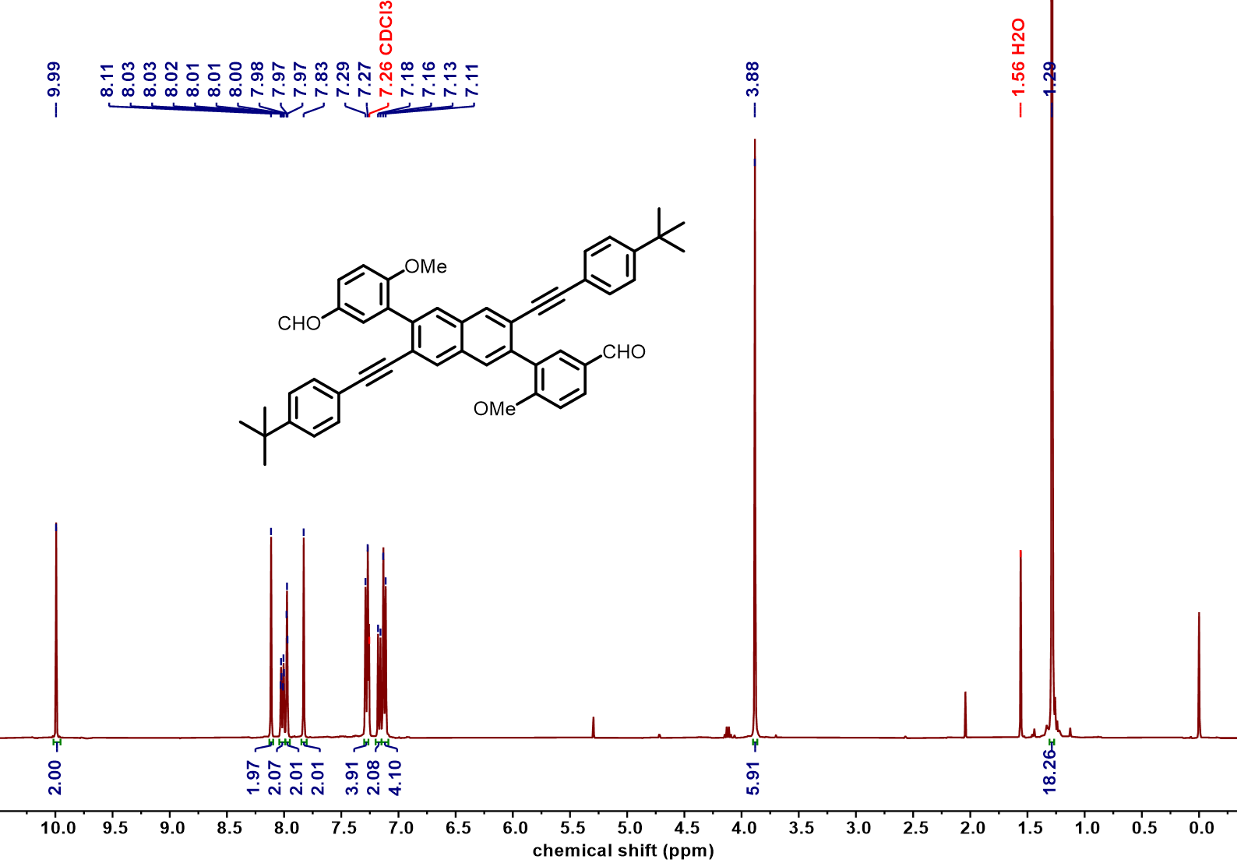
Figure S75 ¹H NMR spectrum of compound 12 (400 MHz, CDCl₃, 298 K)

Figure S76 ¹³C NMR spectrum of compound 12 (101 MHz, CDCl₃, 298 K)

Figure S77 ¹H NMR spectrum of compound 13 (400 MHz, CDCl₃, 298 K)

Figure S78 ¹³C NMR spectrum of compound 13 (101 MHz, CDCl₃, 298 K)

Figure S79 ¹H NMR spectrum of compound 2 (700 MHz, C₂D₂Cl₄, 298 K)

Figure S80 ¹³C NMR spectrum of compound 2 (176 MHz, C₂D₂Cl₄, 298 K)

Figure S81 ¹H NMR spectrum of compound 16 (400 MHz, CDCl₃, 298 K)

Figure S82 ¹³C NMR spectrum of compound 16 (101 MHz, CDCl₃, 298 K)

Figure S83 ¹H NMR spectrum of compound 17 (400 MHz, CDCl₃, 298 K)

Figure S84 ¹³C NMR spectrum of compound 17 (101 MHz, CDCl₃, 298 K)

Figure S85 ¹H NMR spectrum of compound 18 (400 MHz, CDCl₃, 298 K)

Figure S86 ¹³C NMR spectrum of compound 18 (101 MHz, CDCl₃, 298 K)

Figure S87 ¹H NMR spectrum of compound 19 (400 MHz, CDCl₃, 298 K)

Figure S88 ¹³C NMR spectrum of compound 19 (101 MHz, CDCl₃, 298 K)

Figure S89 ¹H NMR spectrum of compound 3 (400 MHz, CDCl₃, 298 K)

Figure S90 ¹³C NMR spectrum of compound 3 (101 MHz, CDCl₃, 298 K)

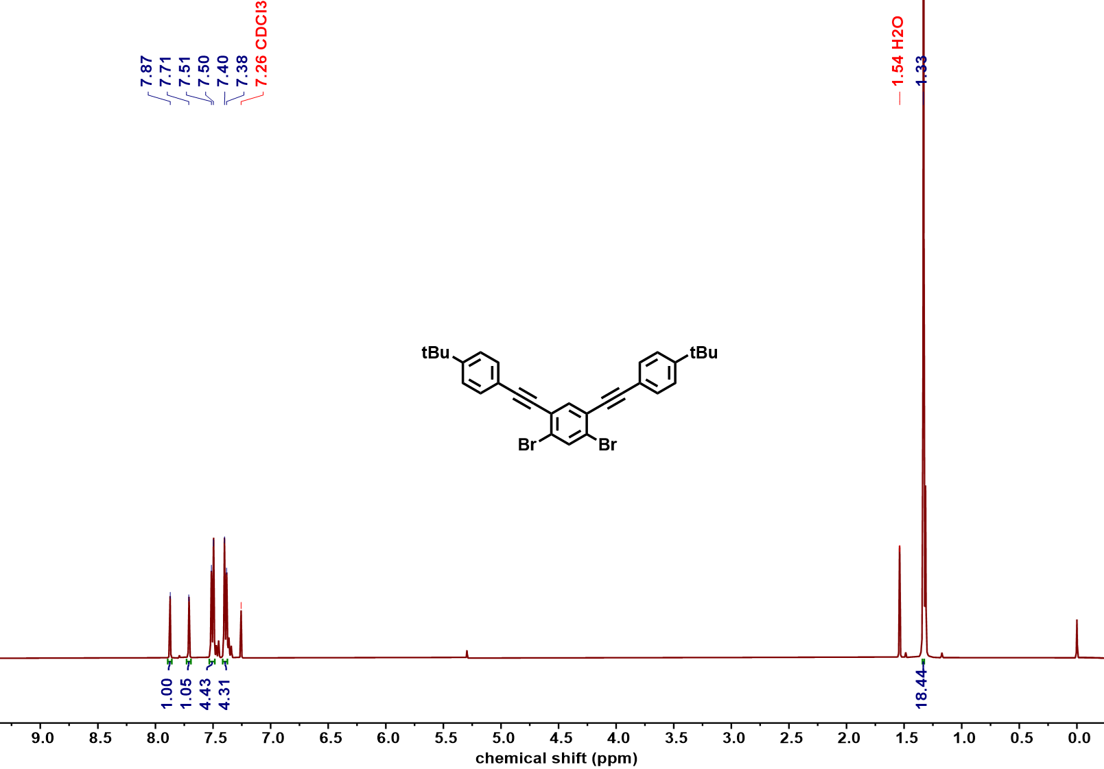
Figure S91 ¹H NMR spectrum of compound Ph-Yne (400 MHz, CDCl₃, 298 K)

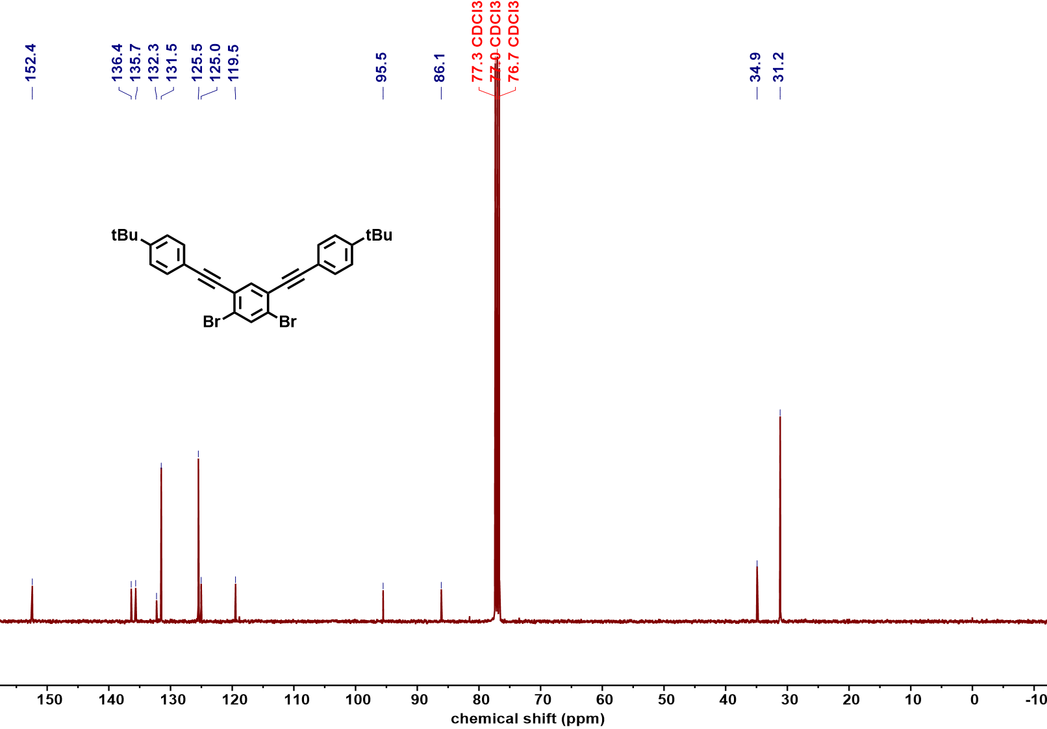
Figure S92 ¹³C NMR spectrum of compound Ph-Yne (101 MHz, CDCl₃, 298 K)

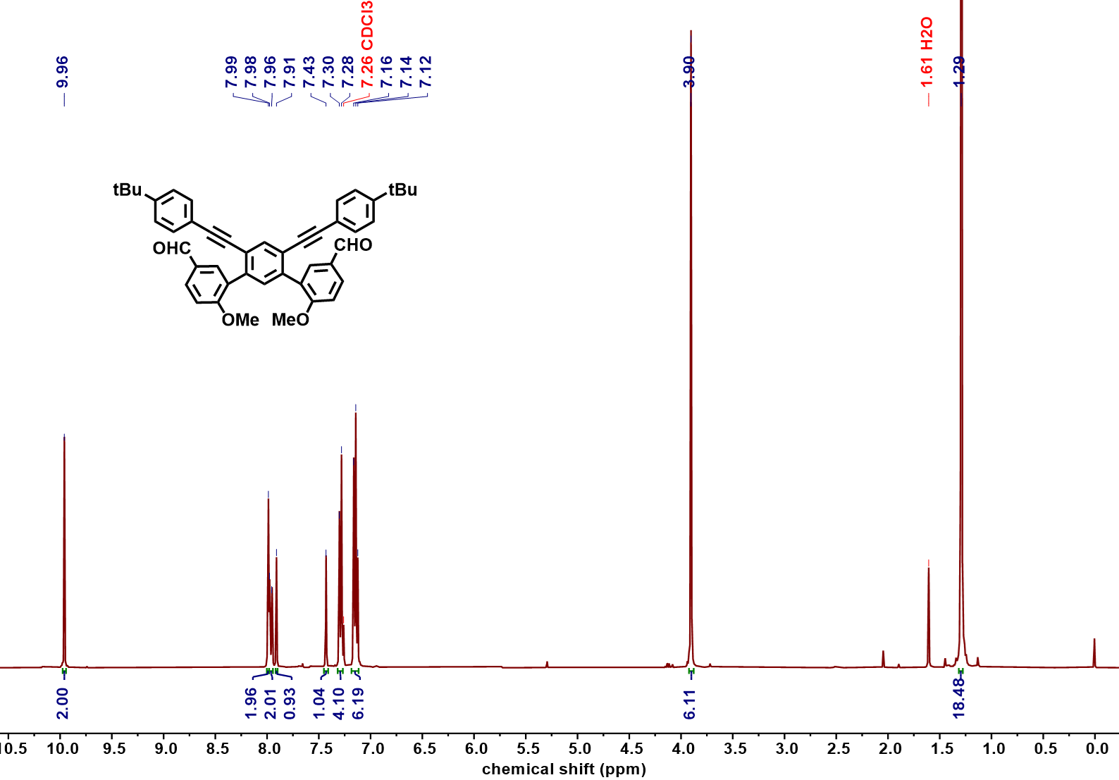
Figure S93 ¹H NMR spectrum of compound 22a (400 MHz, CDCl₃, 298 K)

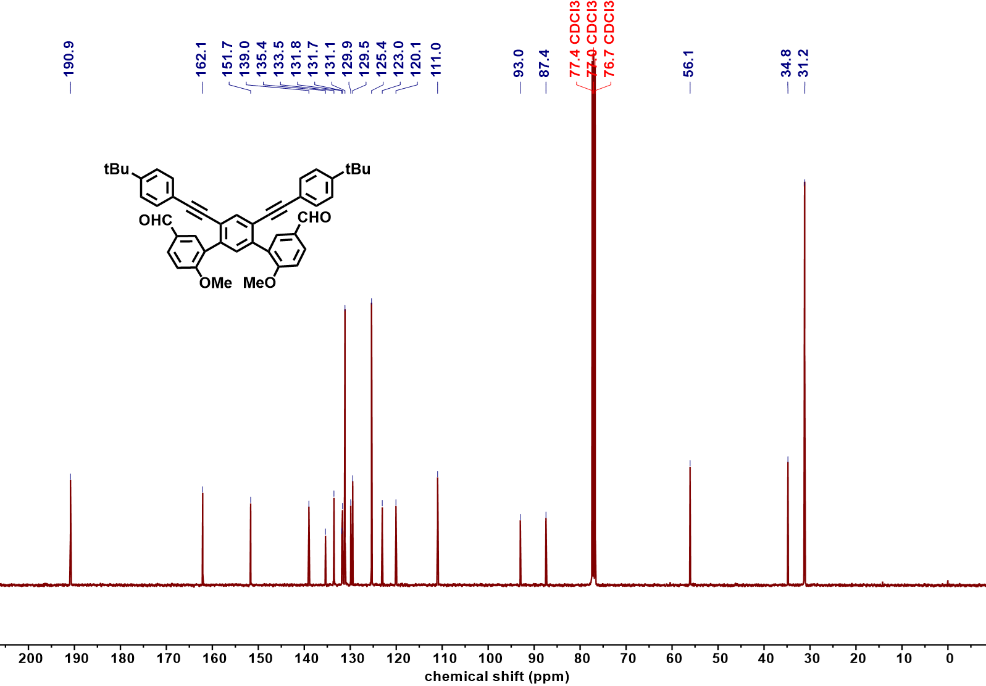
Figure S94 ¹³C NMR spectrum of compound 22a (101 MHz, CDCl₃, 298 K)

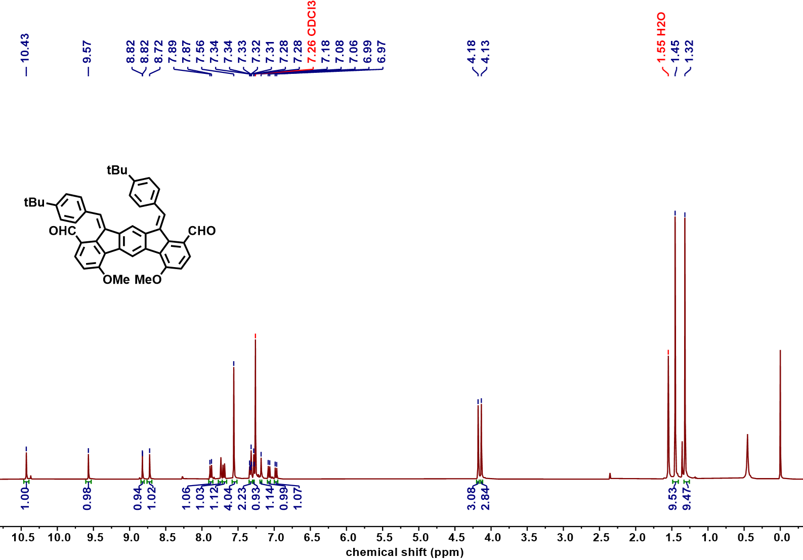
Figure S95 ¹H NMR spectrum of compound 23-1a (400 MHz, CDCl₃, 298 K)

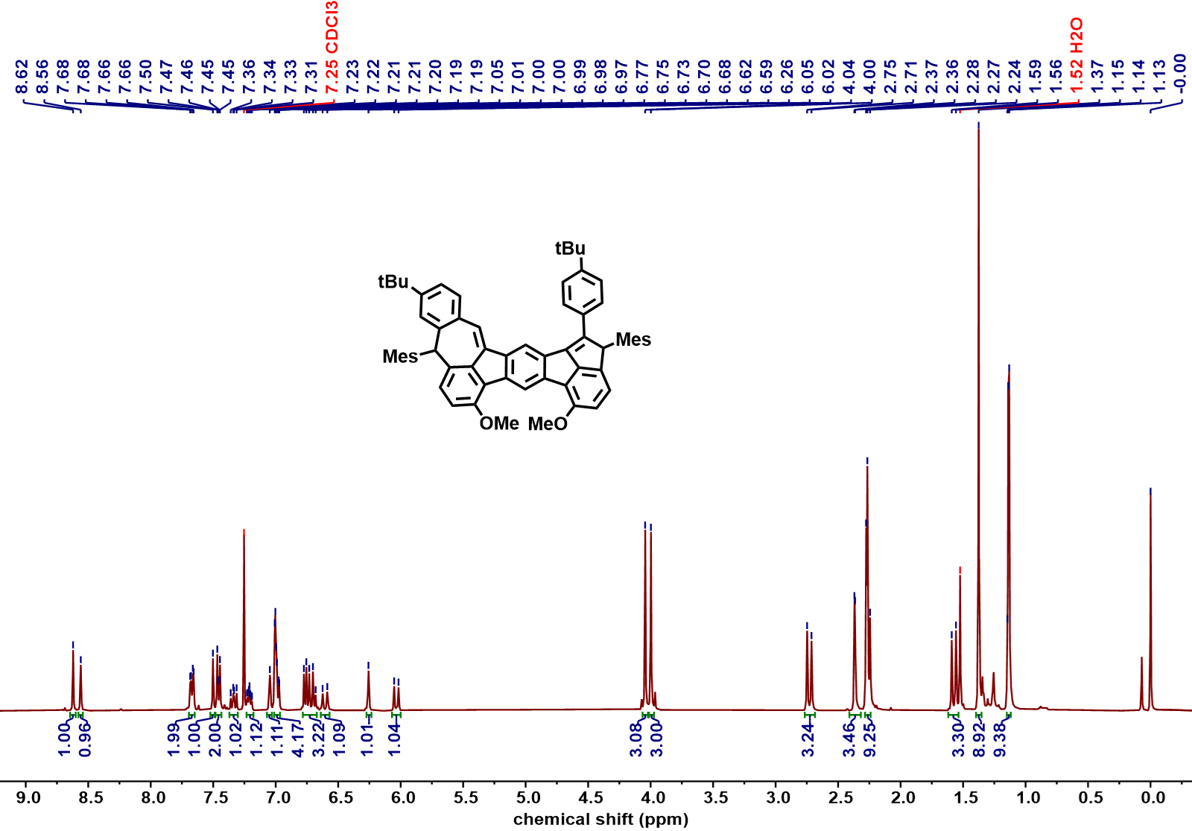
Figure S96 ¹H NMR spectrum of compound 24-1a (400 MHz, CDCl₃, 298 K)

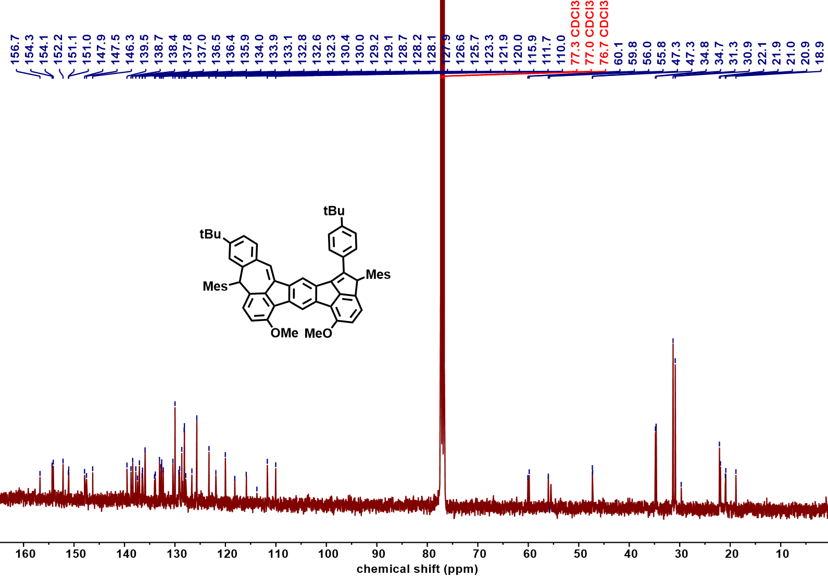
Figure S97 ¹³C NMR spectrum of compound 24-1a (101 MHz, CDCl₃, 298 K)

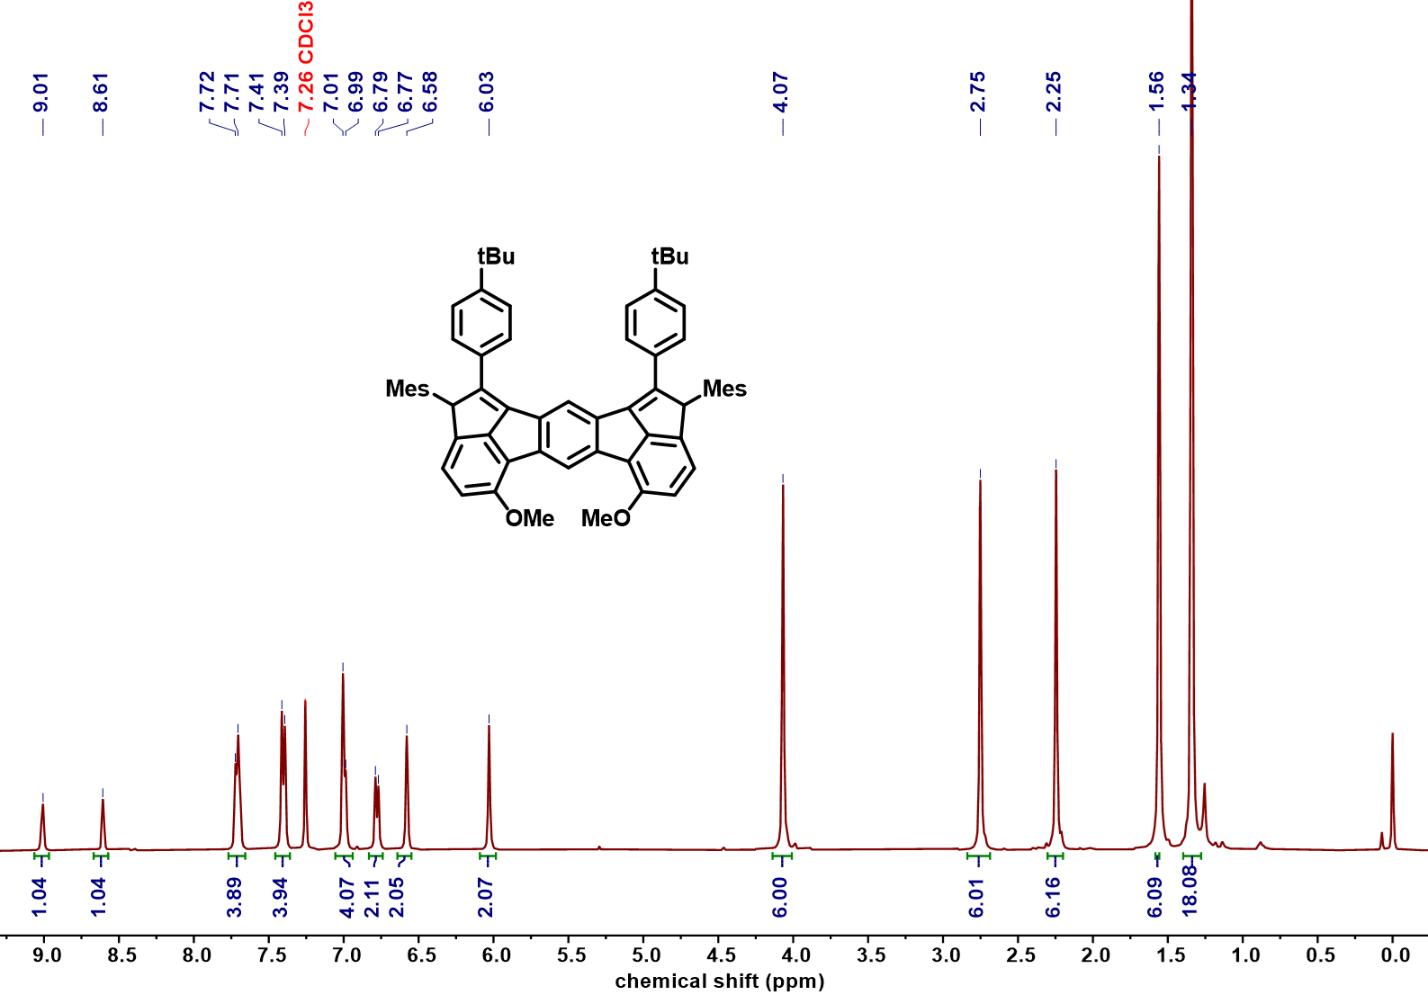
Figure S98 ¹H NMR spectrum of compound 24-3a (400 MHz, CDCl₃, 298 K)

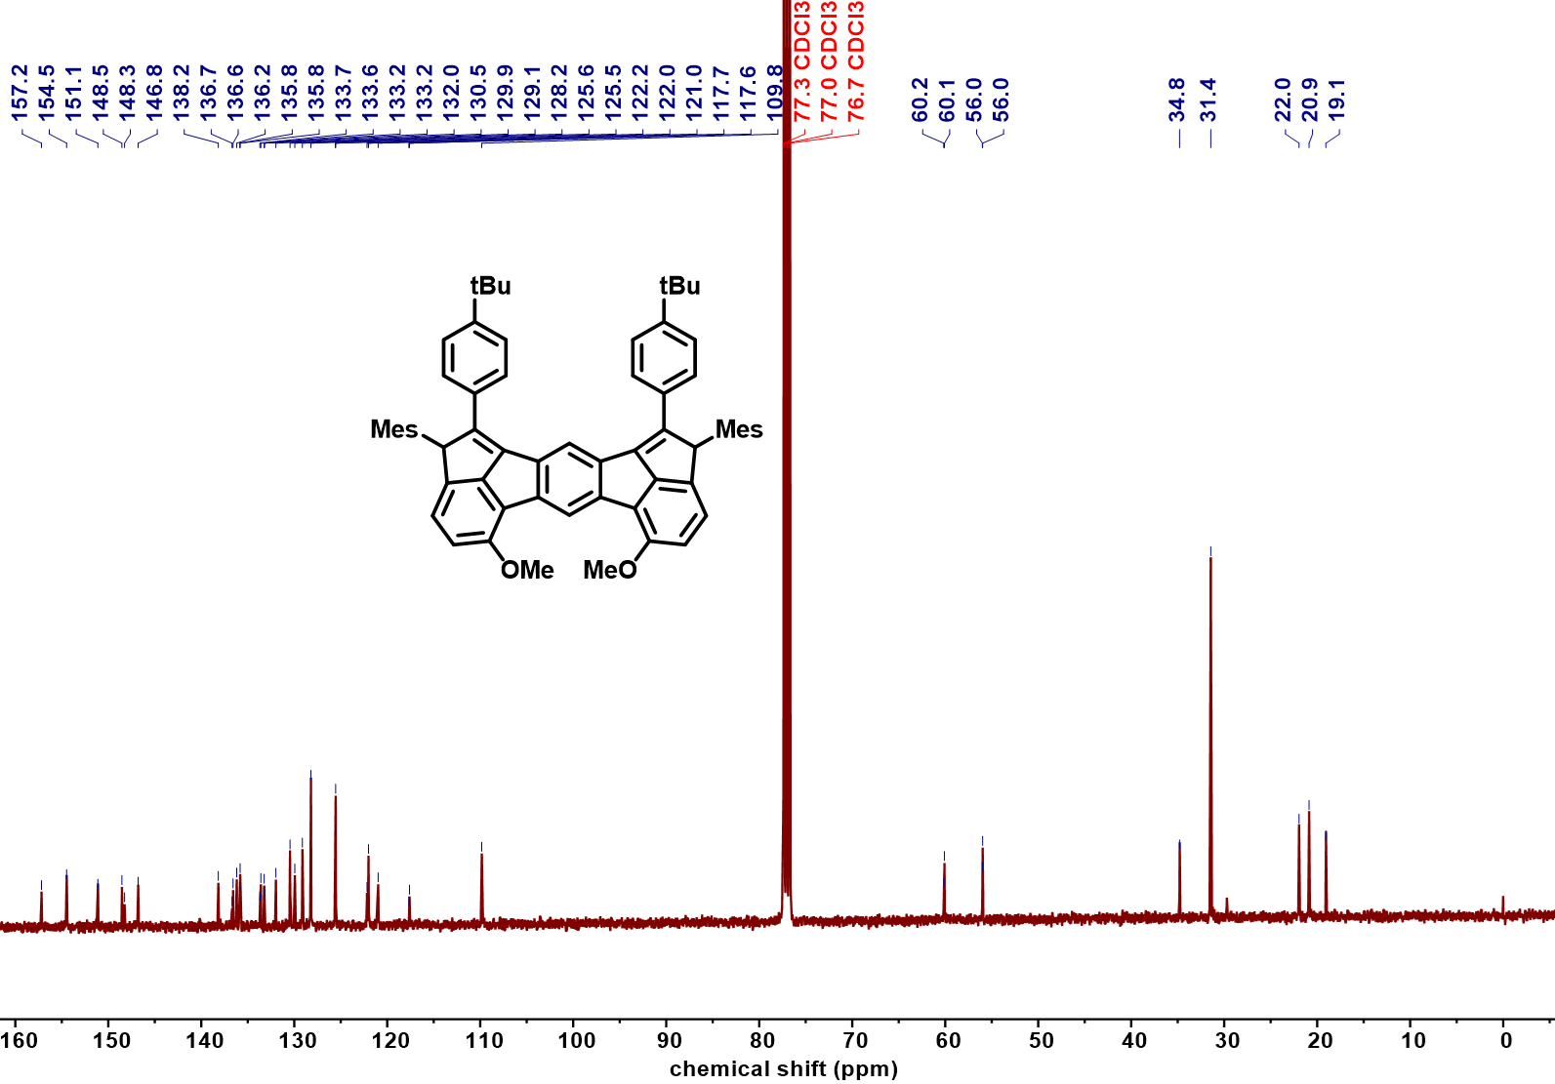
Figure S99 ¹³C NMR spectrum of compound 24-3a (101 MHz, CDCl₃, 298 K)

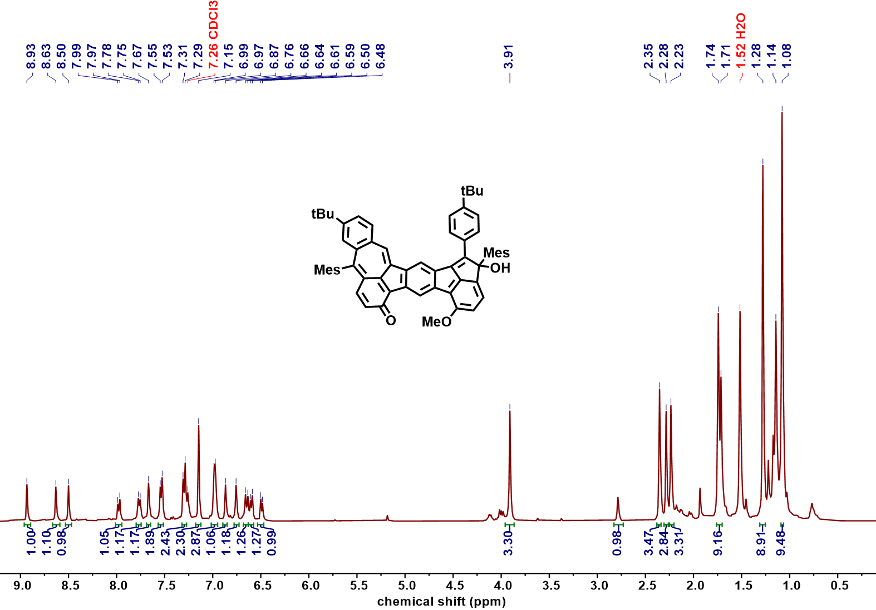
Figure S100 ¹H NMR spectrum of compound 26-1a (400 MHz, CDCl₃, 298 K)

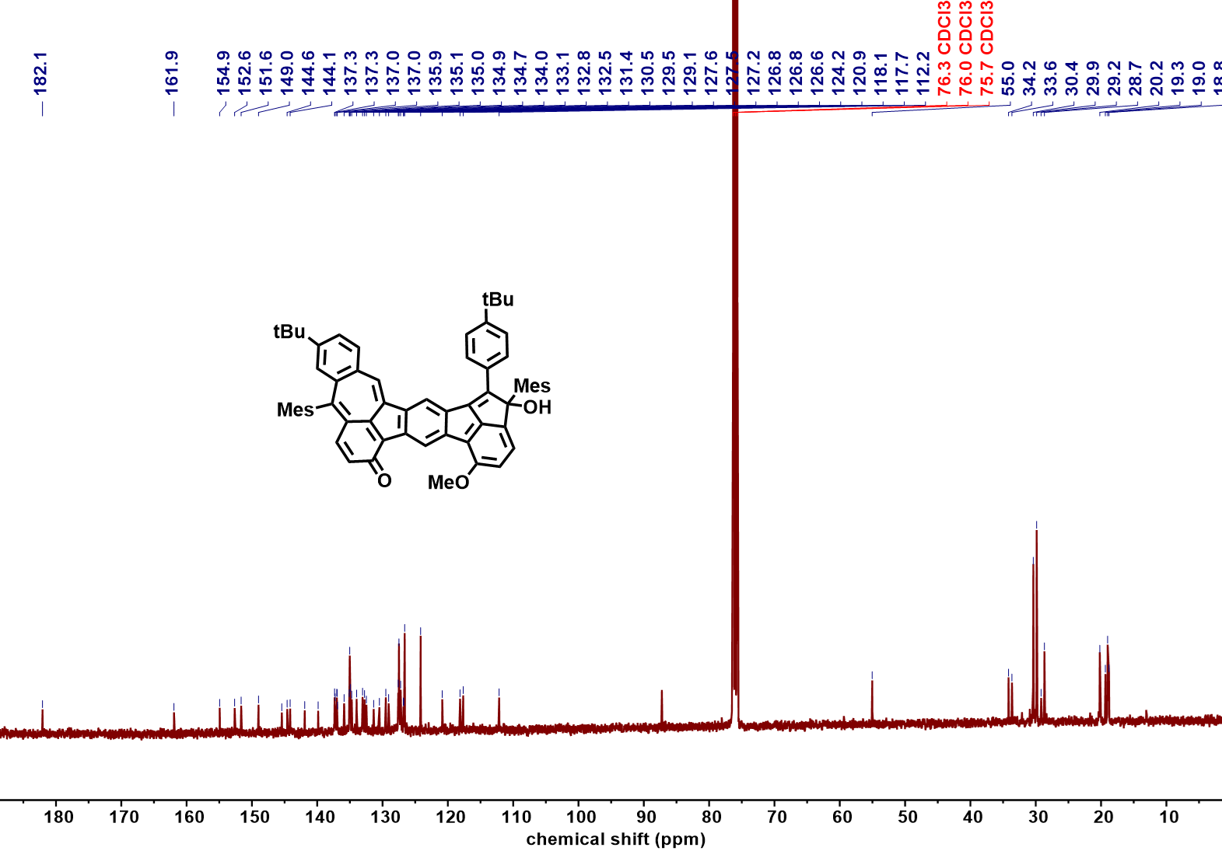
Figure S101 ¹³C NMR spectrum of compound 26-1a (101 MHz, CDCl₃, 298 K)

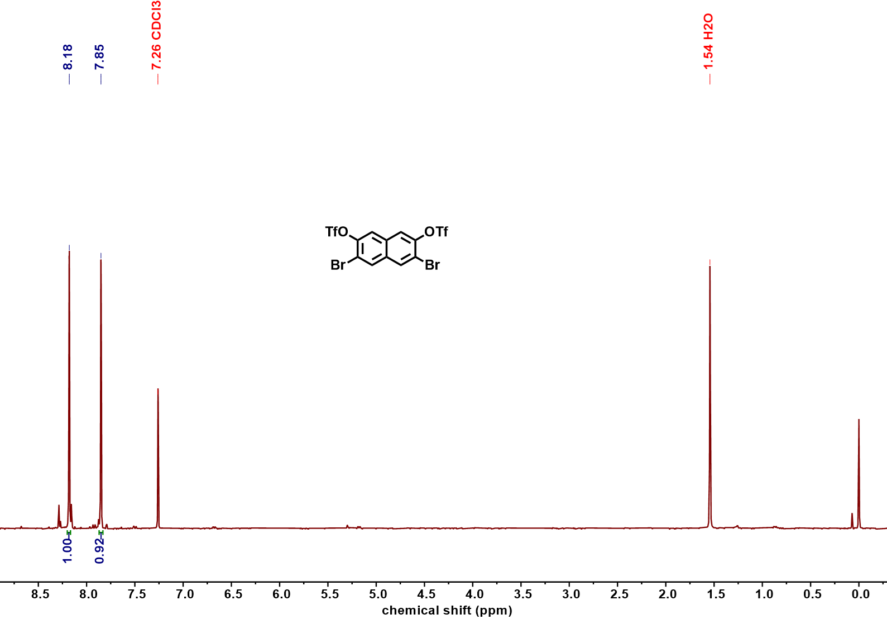
Figure S102 ¹H NMR spectrum of compound Na-OTf (400 MHz, CDCl₃, 298 K)

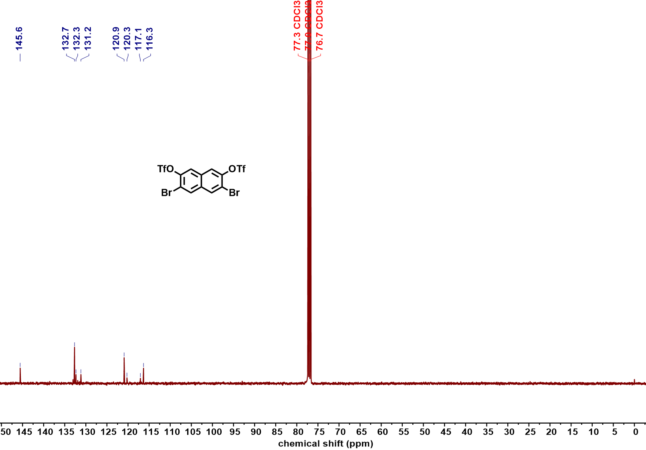
Figure S103 ¹³C NMR spectrum of compound Na-OTf (101 MHz, CDCl₃, 298 K)

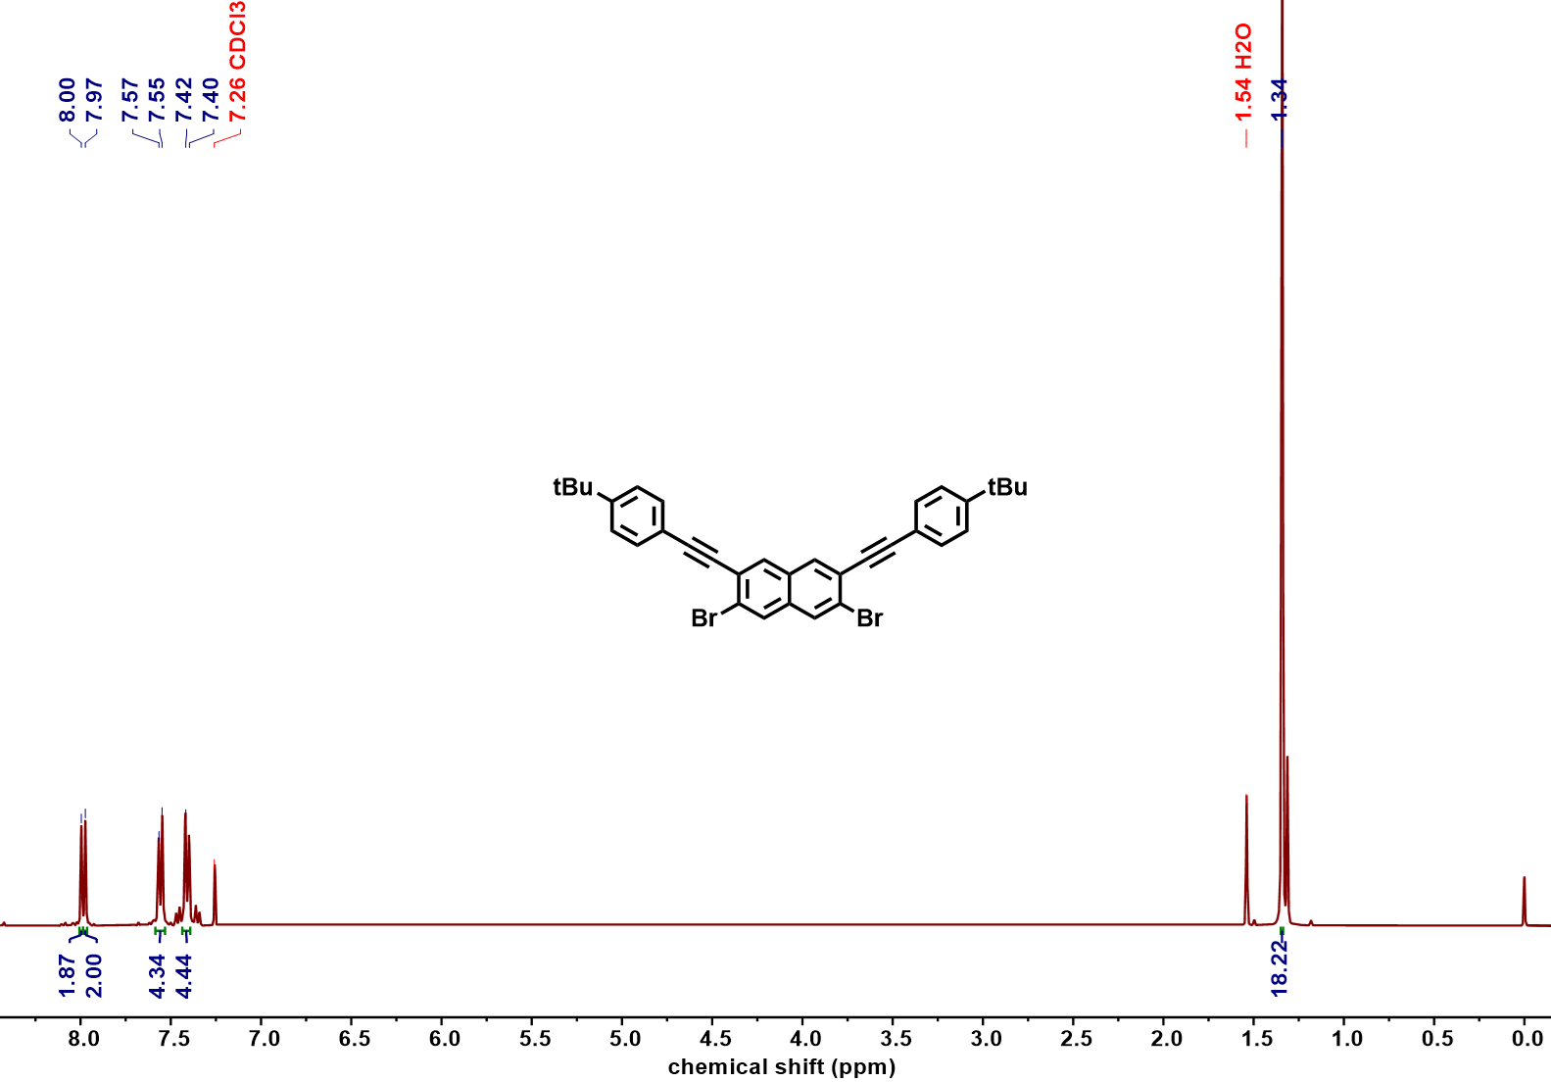
Figure S104 ¹H NMR spectrum of compound Na-Yne (400 MHz, CDCl₃, 298 K)

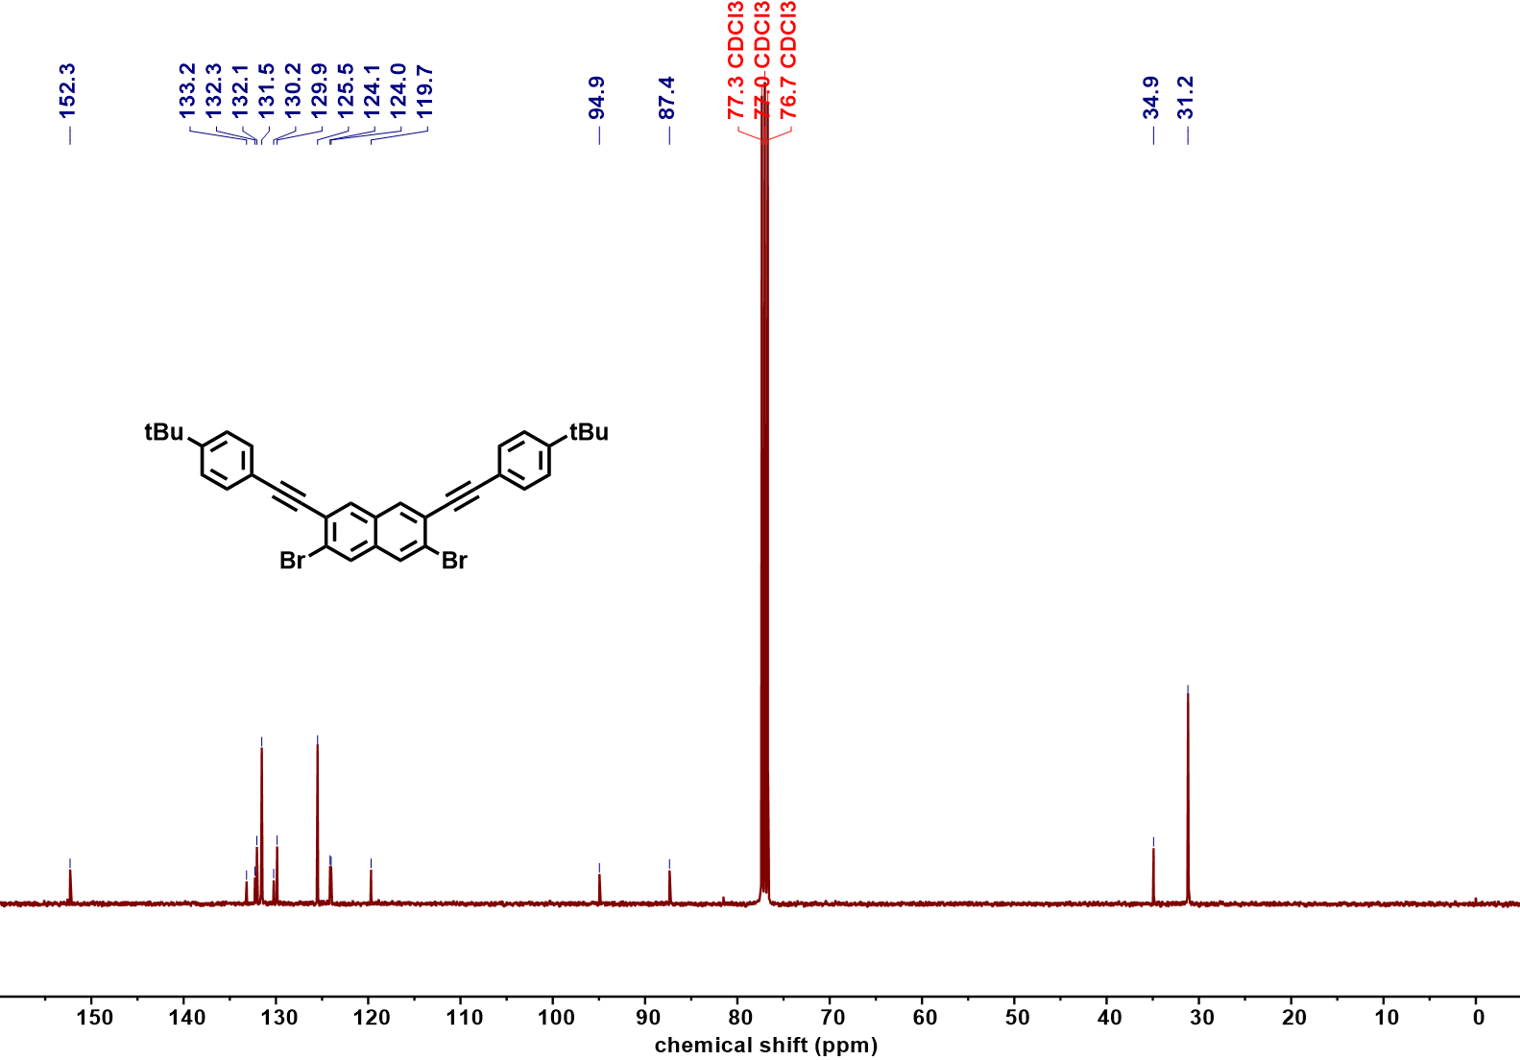
Figure S105 ¹³C NMR spectrum of compound Na-Yne (101 MHz, CDCl₃, 298 K)

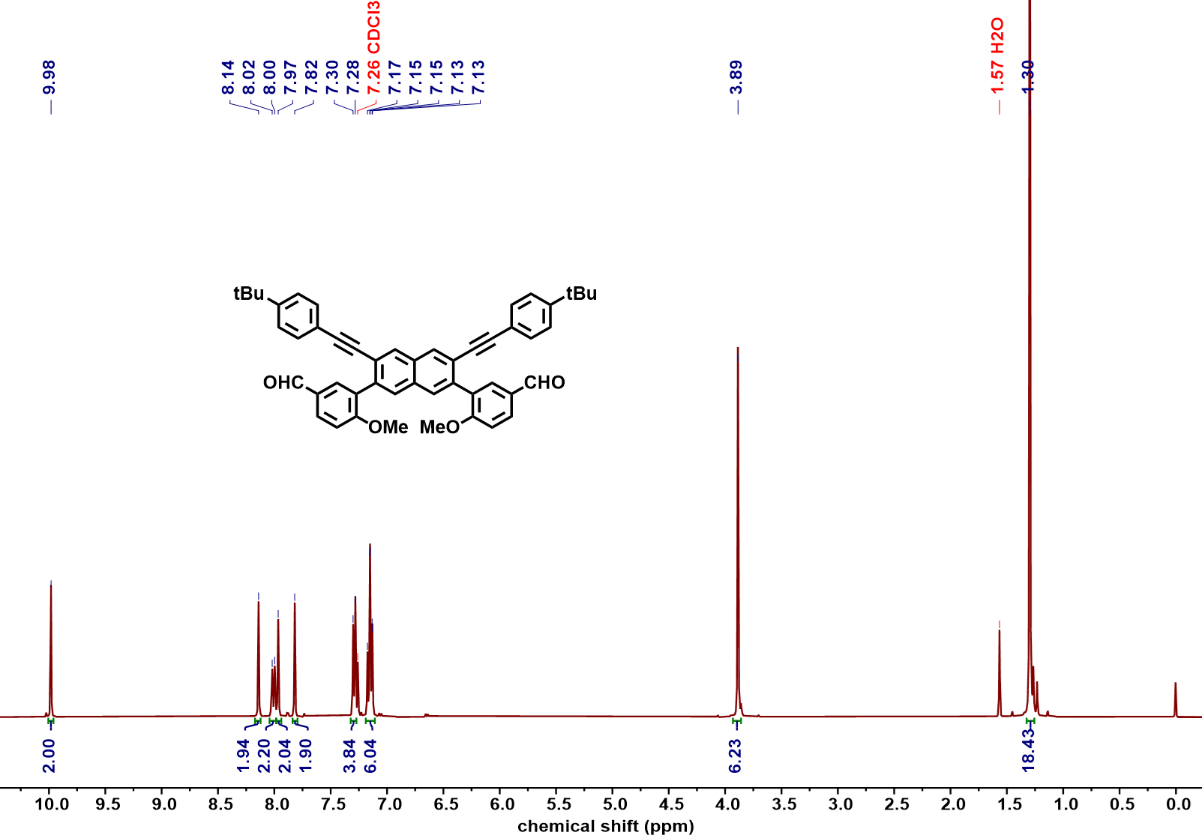
Figure S106 ¹H NMR spectrum of compound 22b (400 MHz, CDCl₃, 298 K)

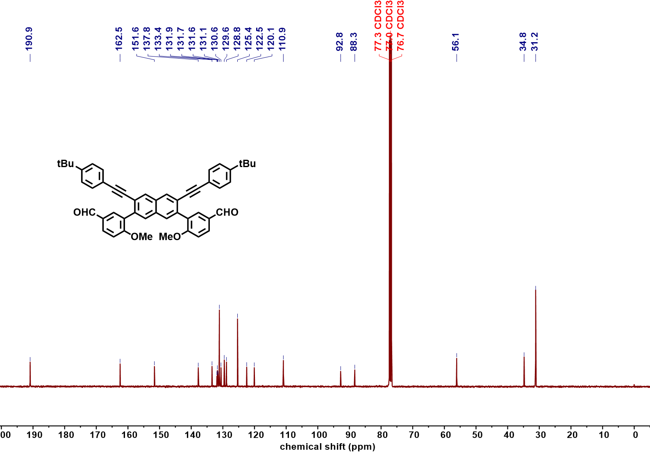
Figure S107 ¹³C NMR spectrum of compound 22b (101 MHz, CDCl₃, 298 K)

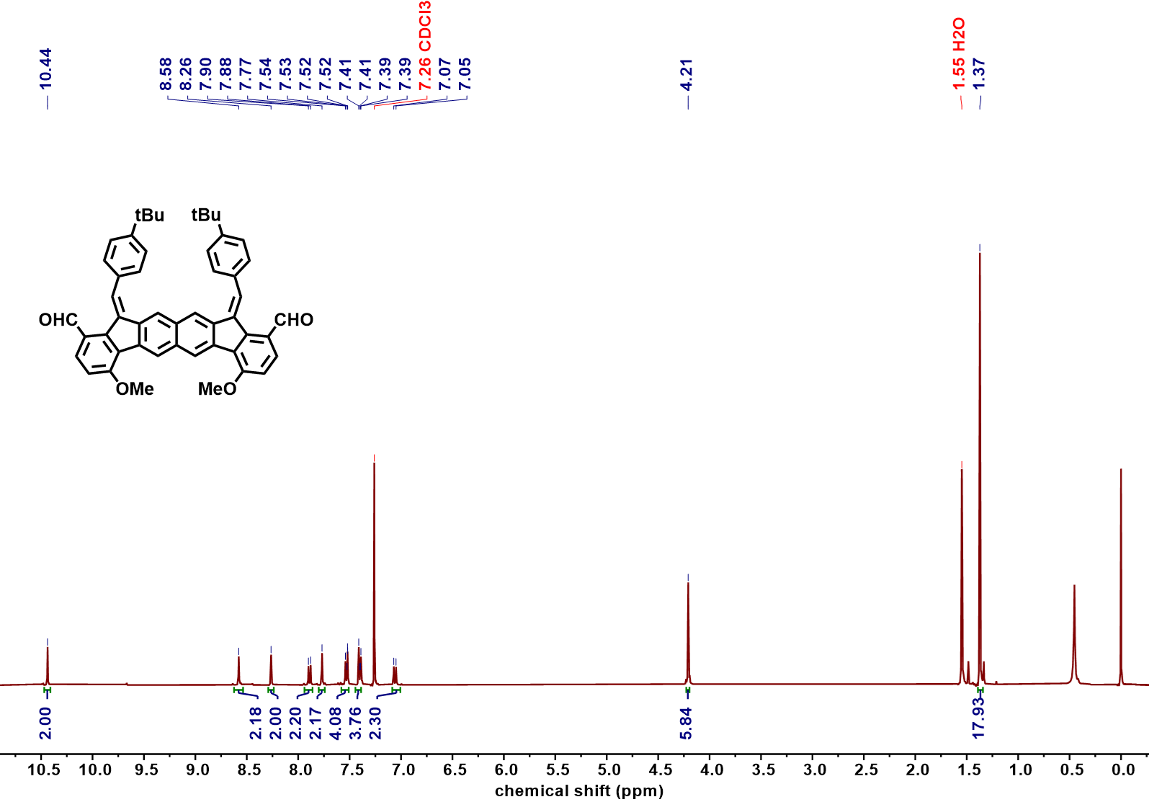
Figure S108 ¹H NMR spectrum of compound 23-3b (400 MHz, CDCl₃, 298 K)

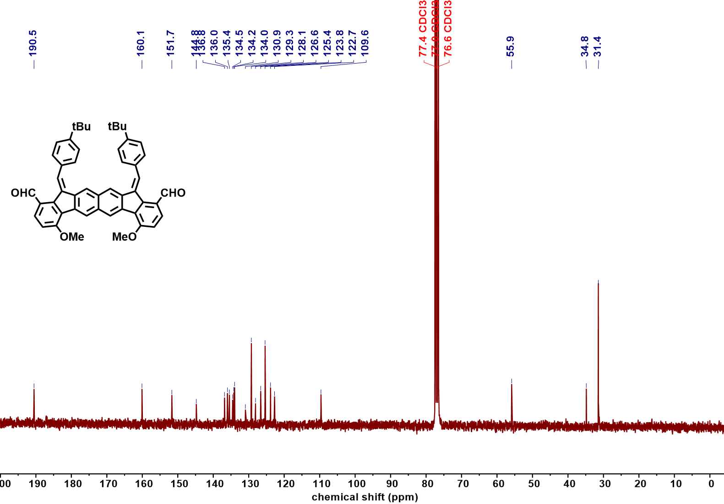
Figure S109 ¹³C NMR spectrum of compound 23-3b (101 MHz, CDCl₃, 298 K)

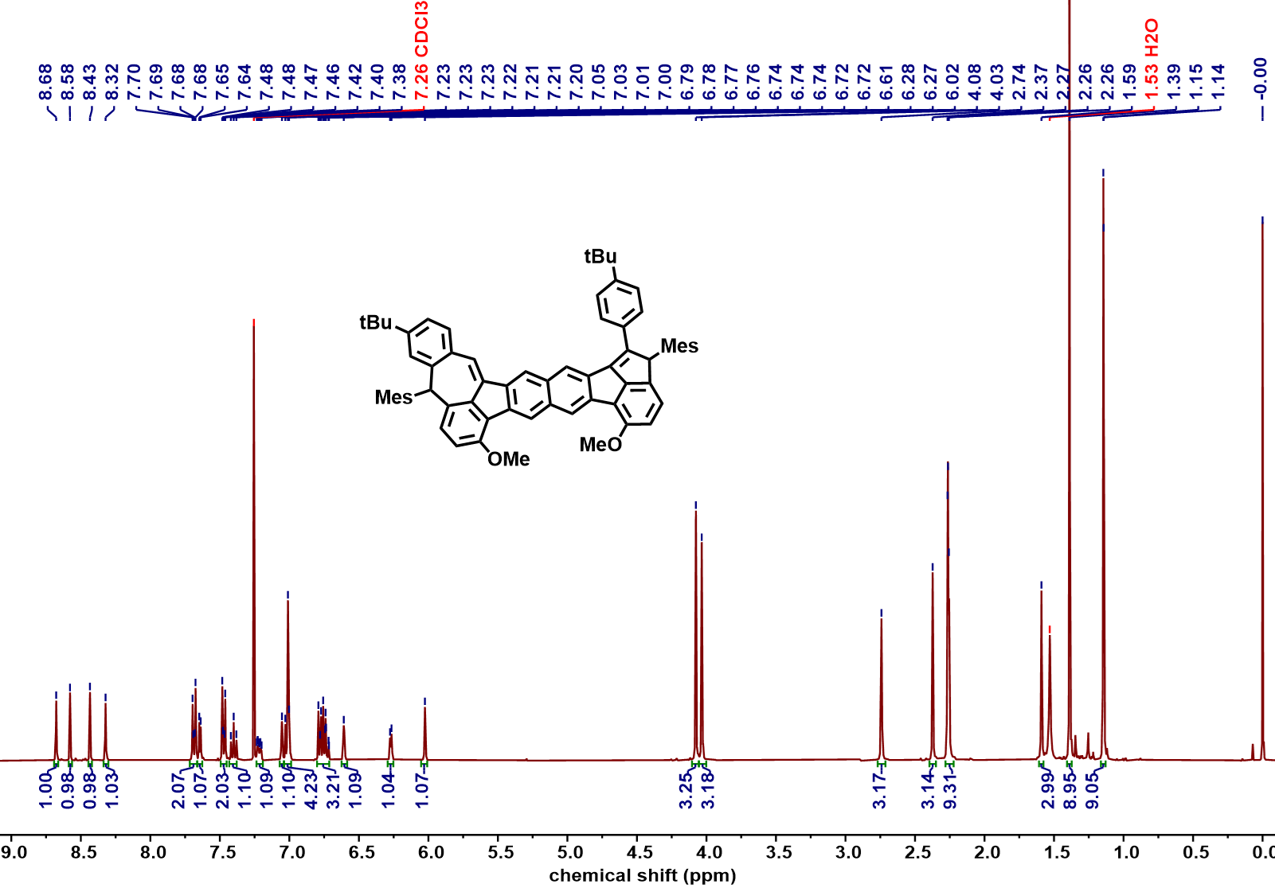
Figure S110 ¹H NMR spectrum of compound 24-1b (400 MHz, CDCl₃, 298 K)

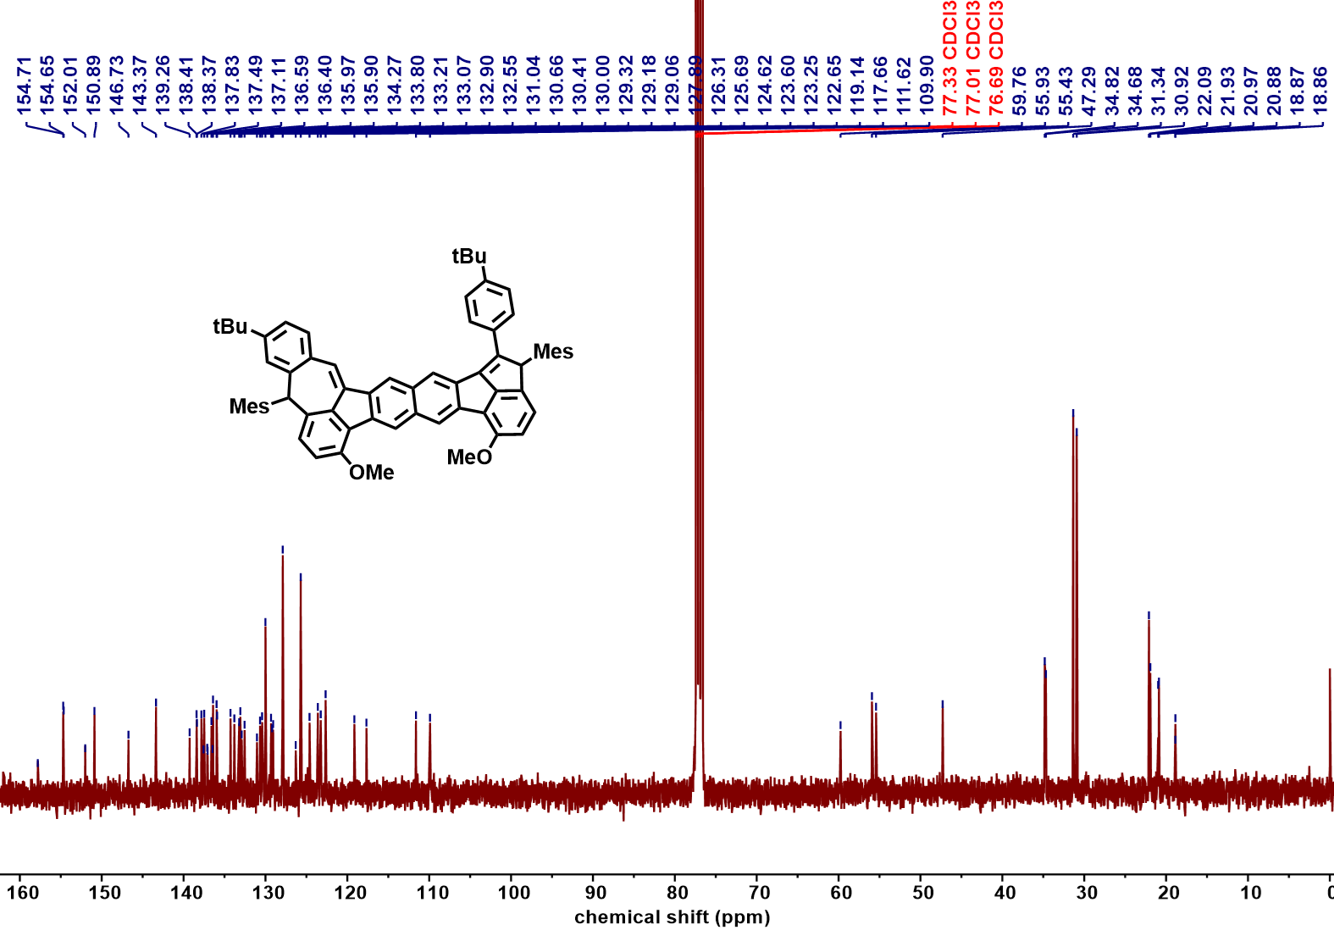
Figure S111 ¹³C NMR spectrum of compound 24-1b (101 MHz, CDCl₃, 298 K)

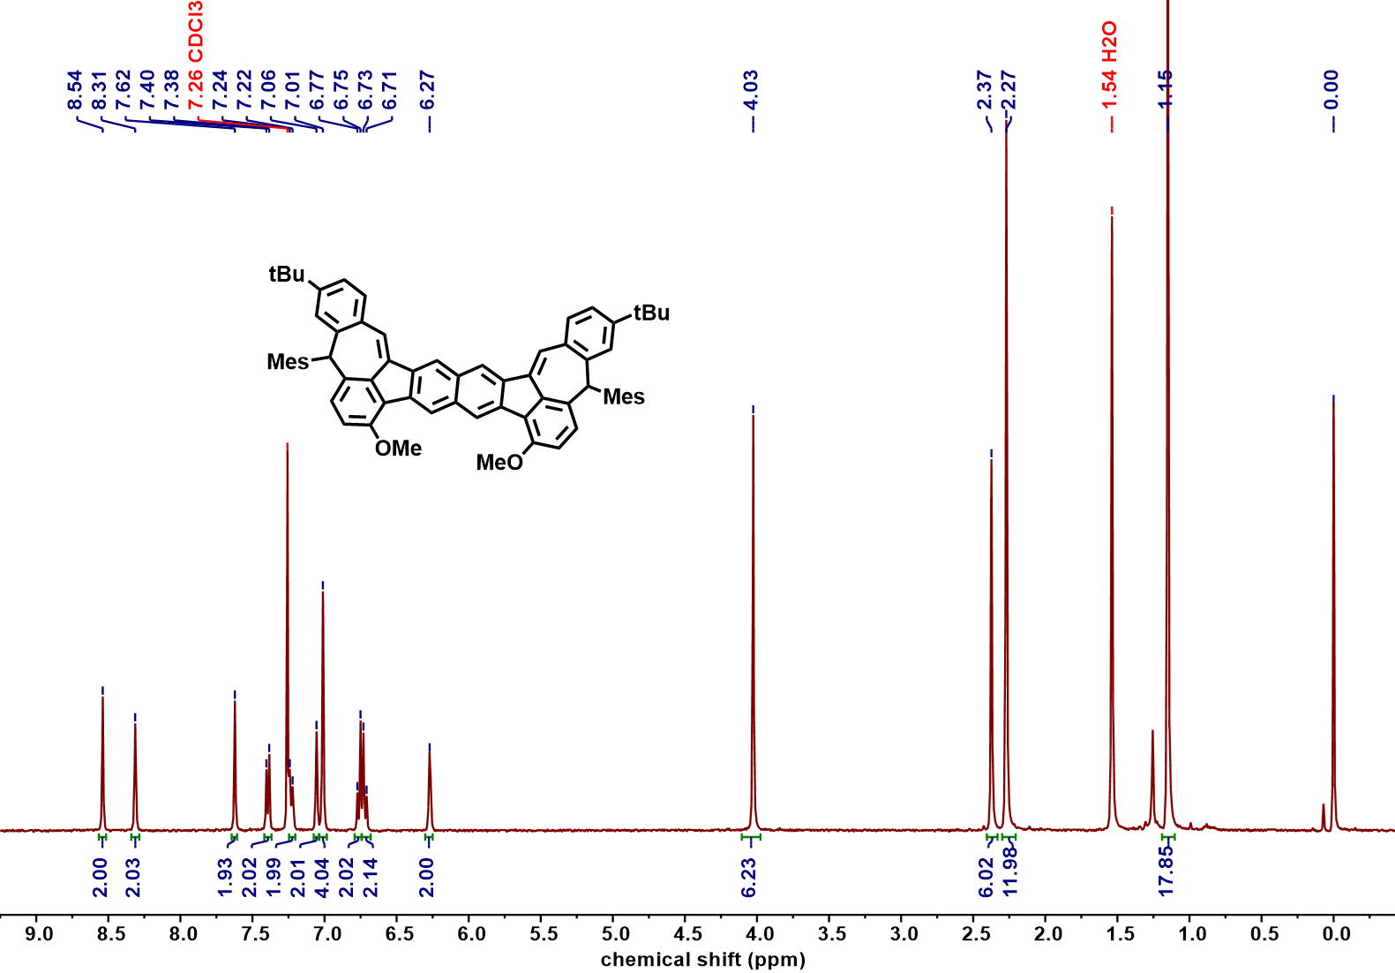
Figure S112 ¹H NMR spectrum of compound 24-2b (400 MHz, CDCl₃, 298 K)

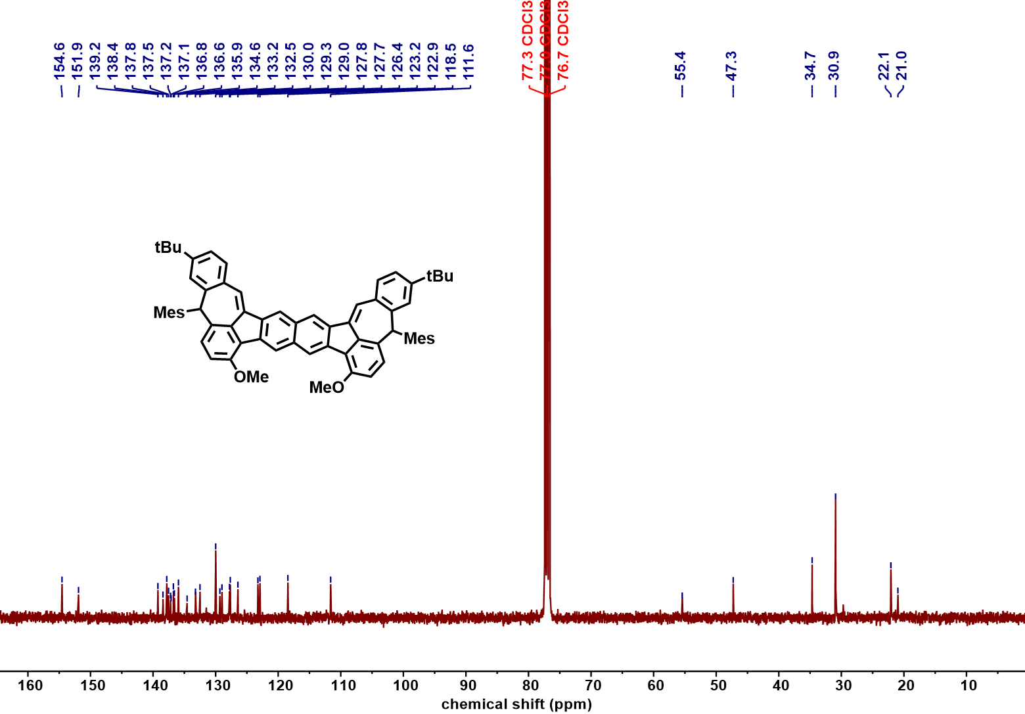
Figure S113 ¹³C NMR spectrum of compound 24-2b (101 MHz, CDCl₃, 298 K)

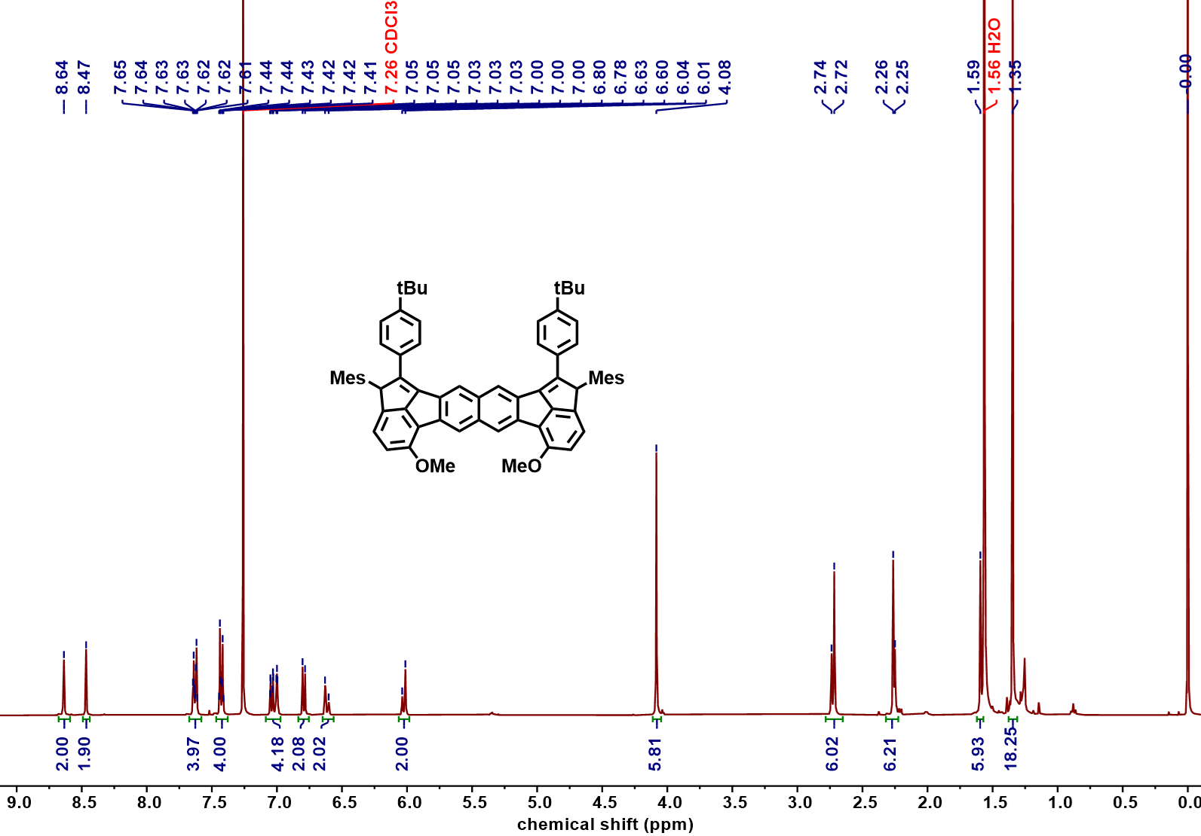
Figure S114 ¹H NMR spectrum of compound 24-3b (400 MHz, CDCl₃, 298 K)

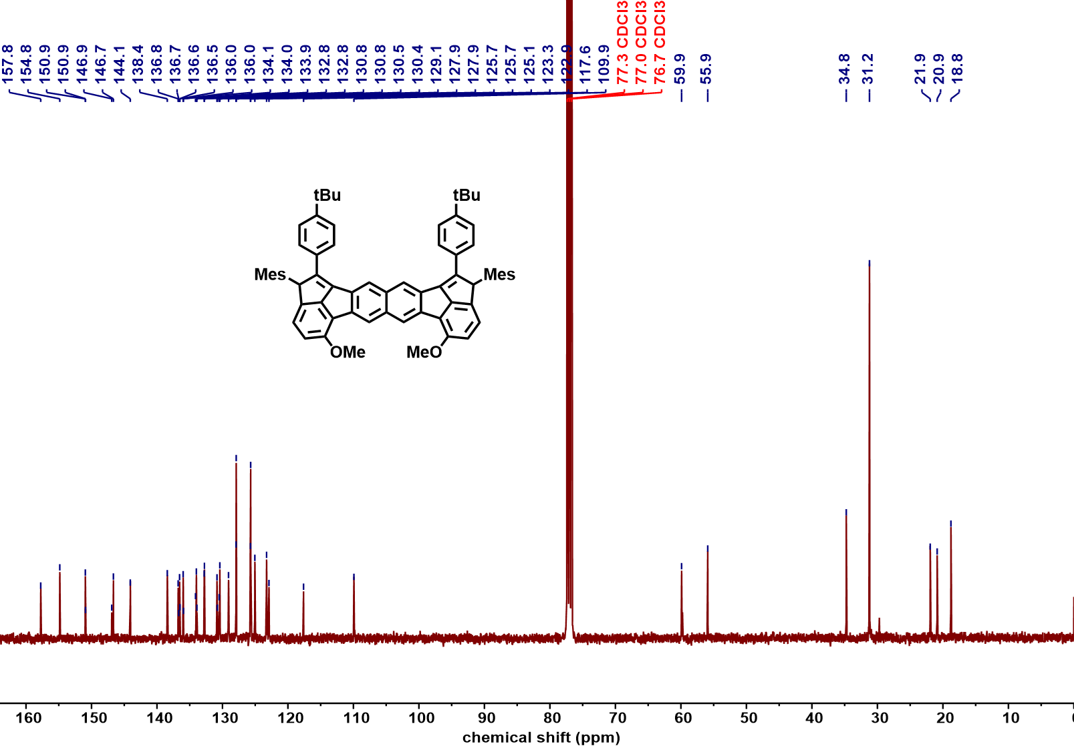
Figure S115 ¹³C NMR spectrum of compound 24-3b (101 MHz, CDCl₃, 298 K)

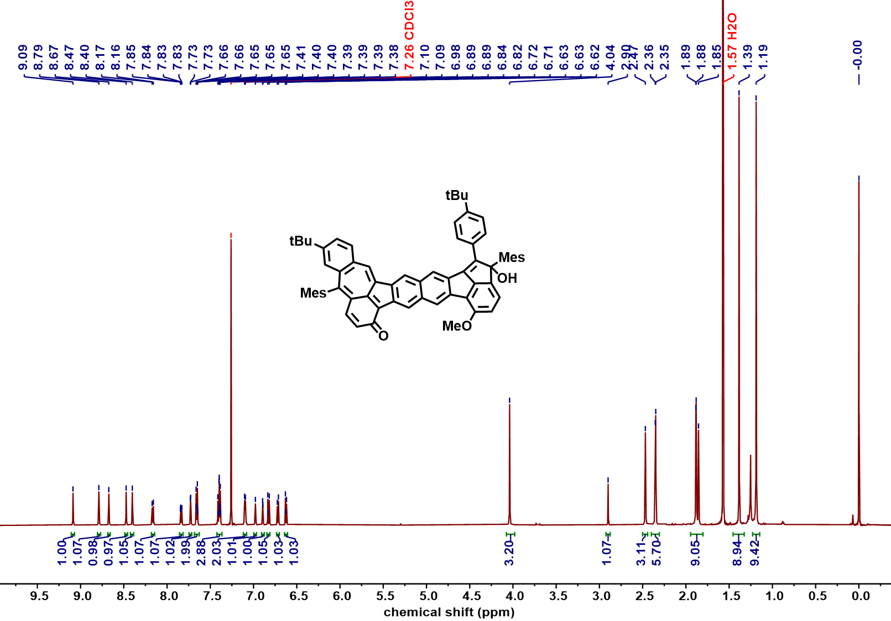
Figure S116 ¹H NMR spectrum of compound 26-1b (600 MHz, CDCl₃, 298 K)

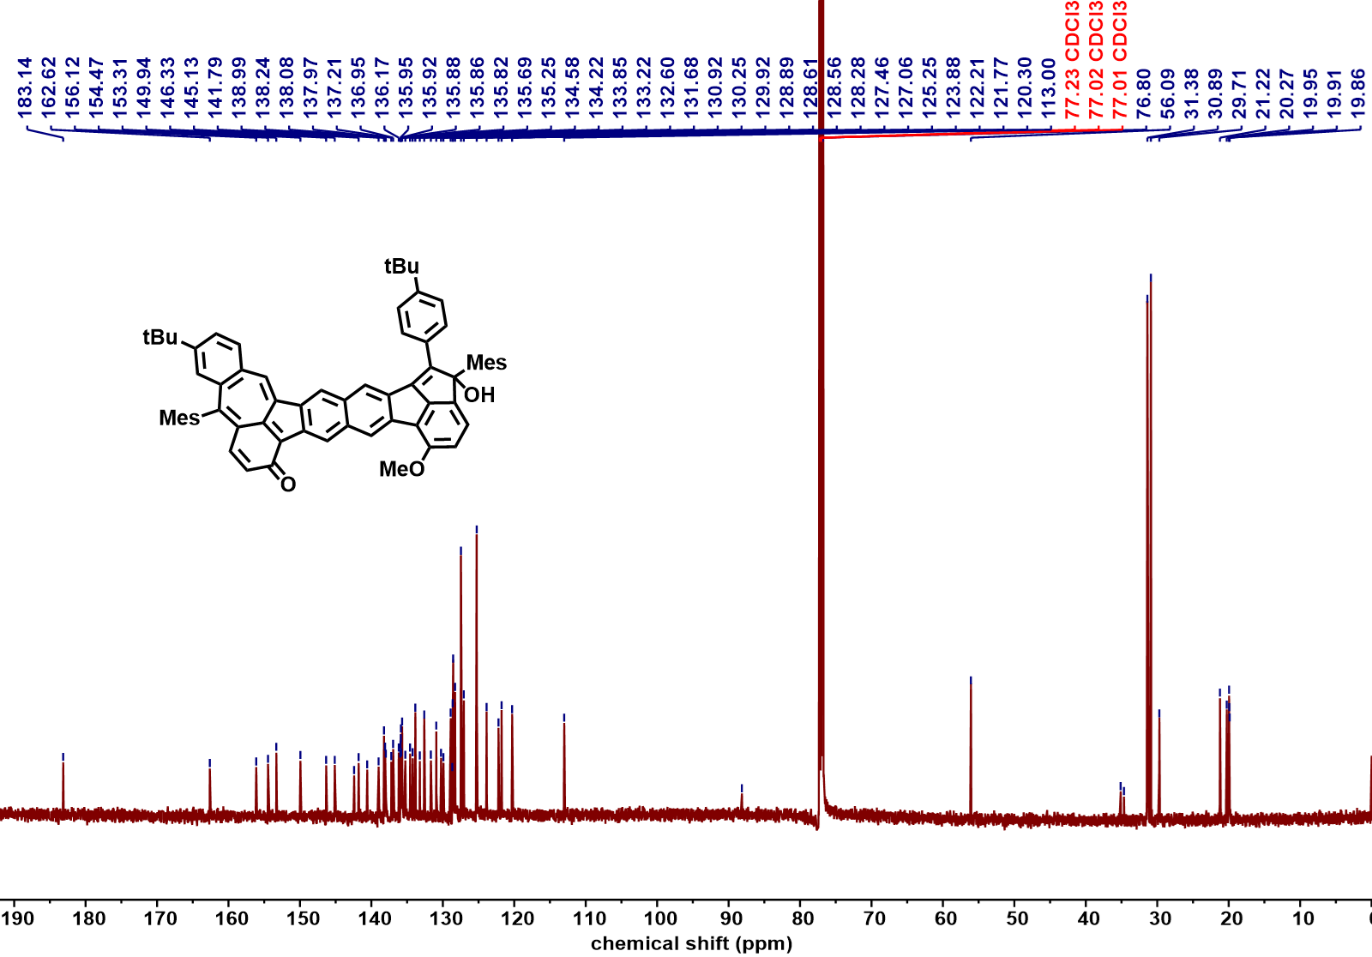
Figure S117 ¹³C NMR spectrum of compound 26-1b (151 MHz, CDCl₃, 298 K)

14. HRMS spectra
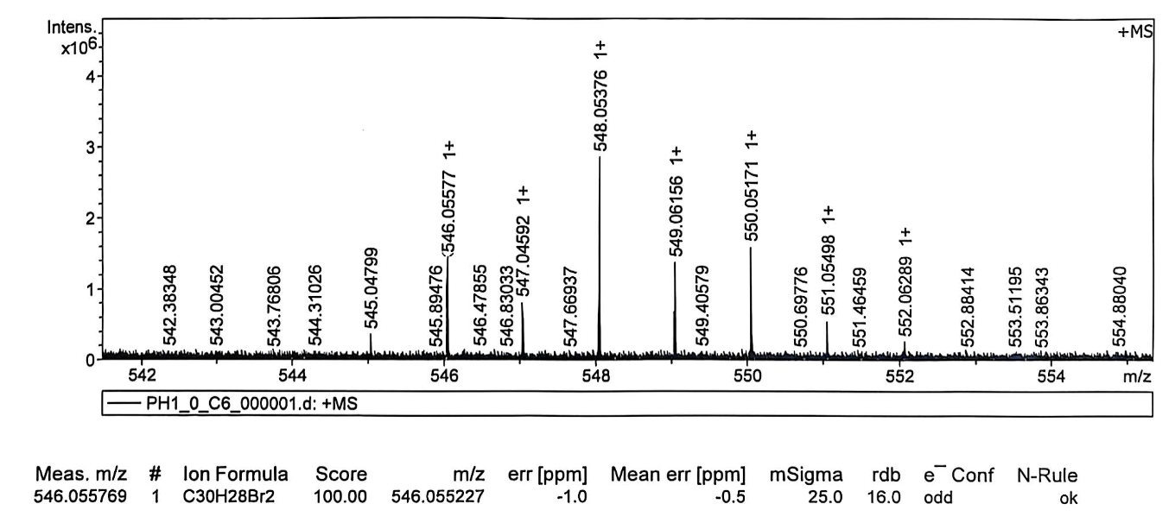
Figure S118 HRMS spectrum of compound 5
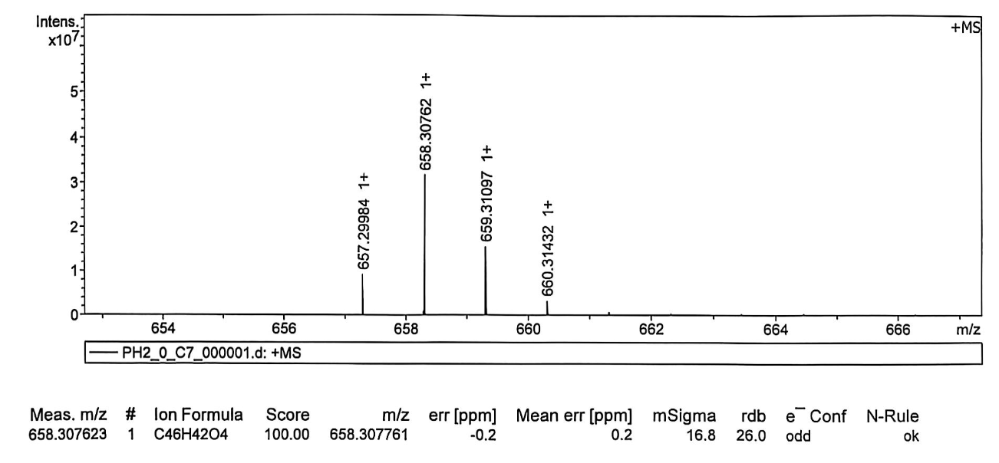
Figure S119 HRMS spectrum of compound 6
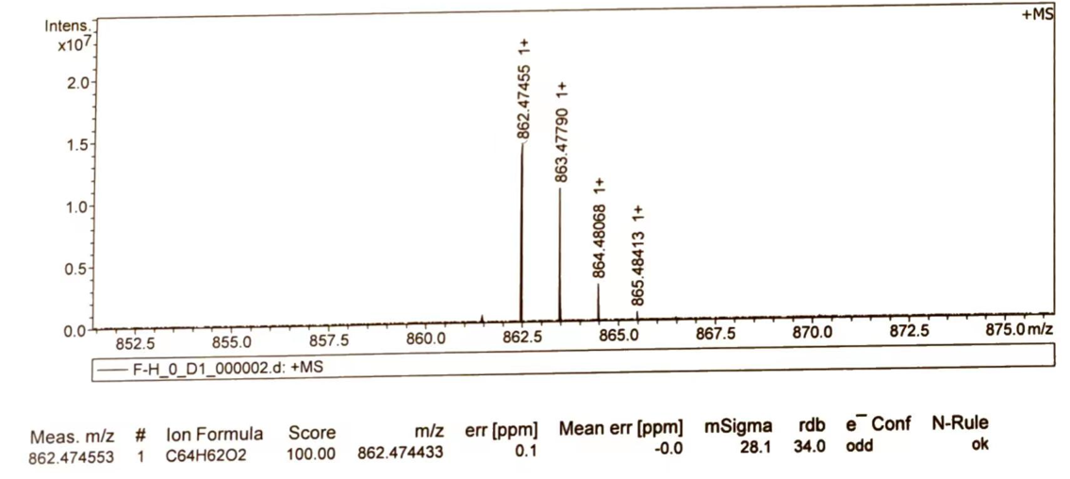
Figure S120 HRMS spectrum of compound 7

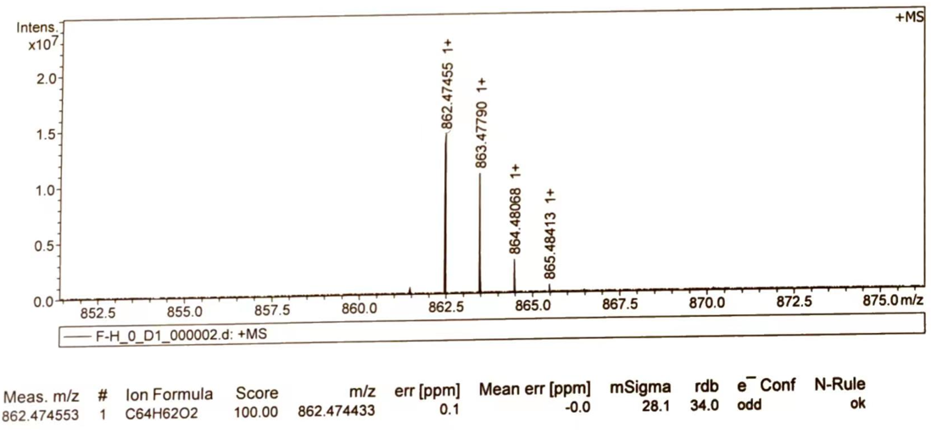
Figure S121 HRMS spectrum of compound 9
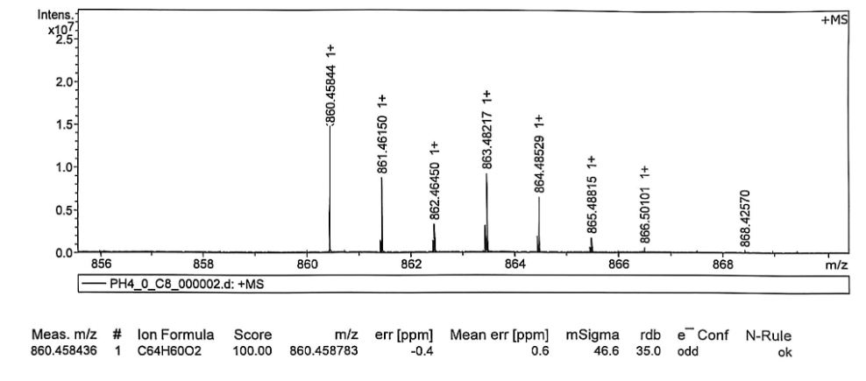
Figure S122 HRMS spectrum of compound 1
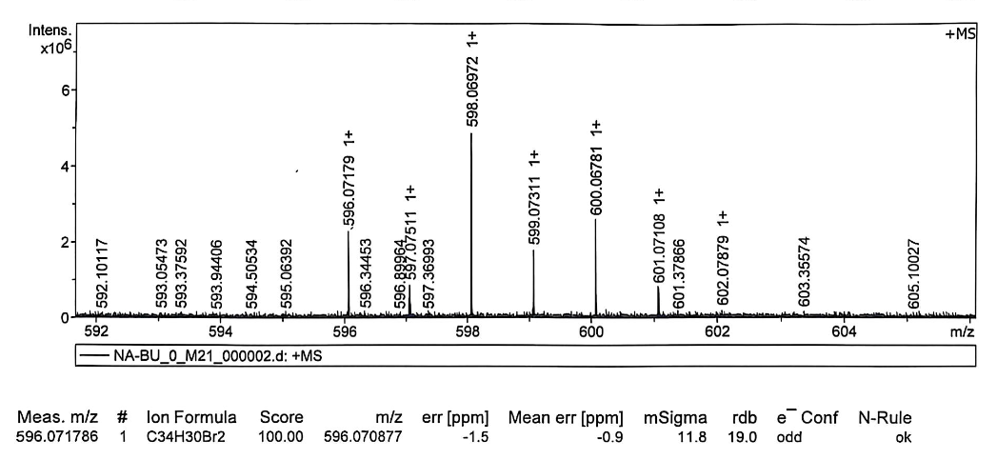
Figure S123 HRMS spectrum of compound 11
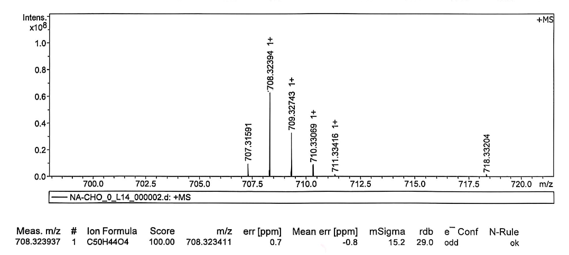
Figure S124 HRMS spectrum of compound 12
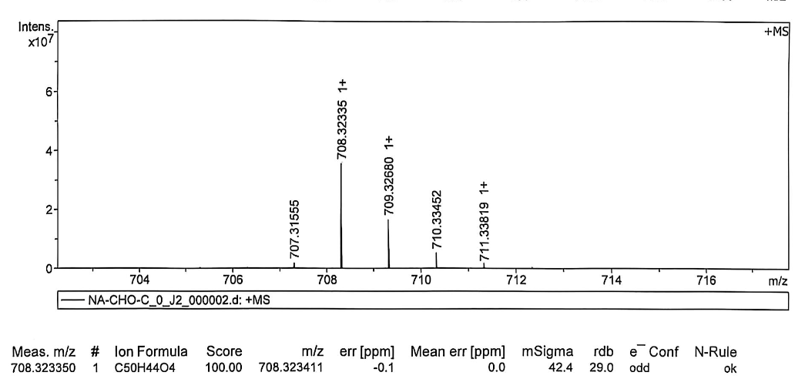
Figure S125 HRMS spectrum of compound 13
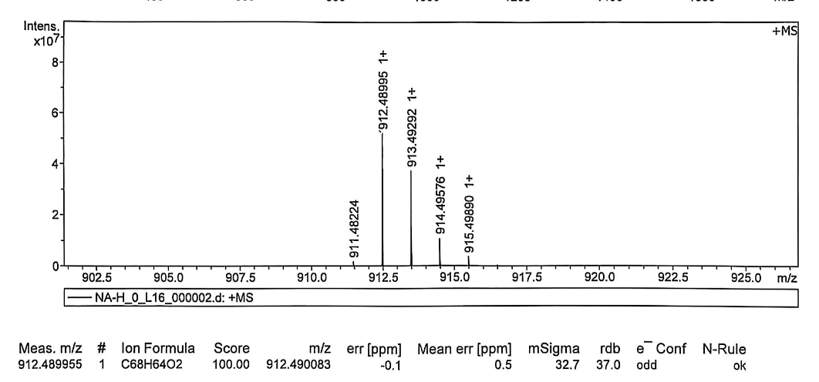
Figure S126 HRMS spectrum of compound 15

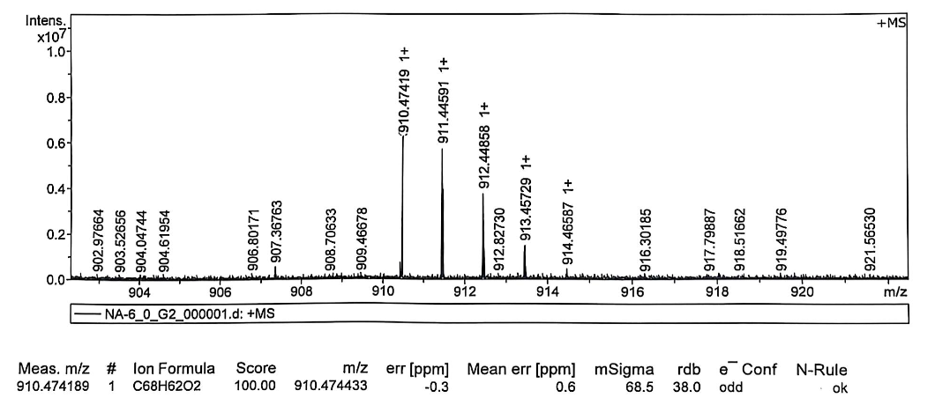
Figure S127 HRMS spectrum of compound 2
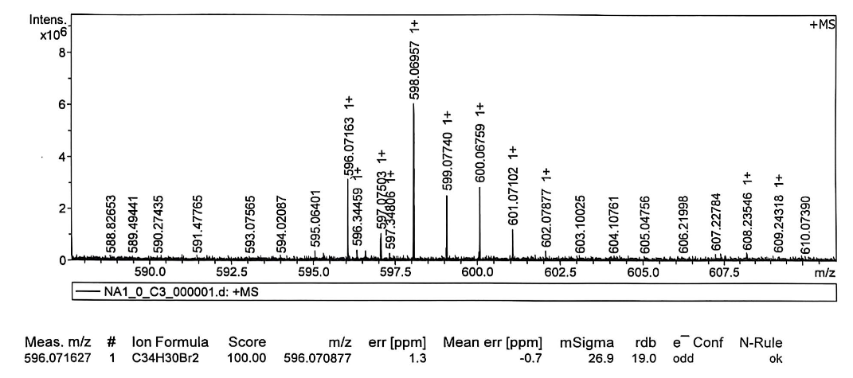
Figure S128 HRMS spectrum of compound 17
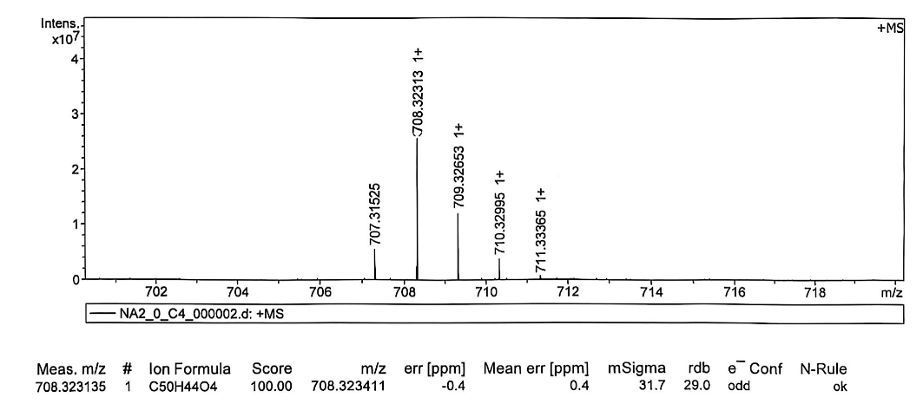
Figure S129 HRMS spectrum of compound 18
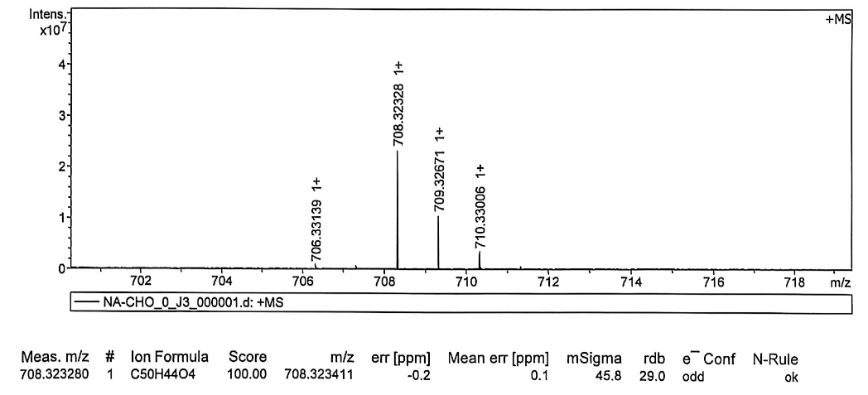
Figure S130 HRMS spectrum of compound 19
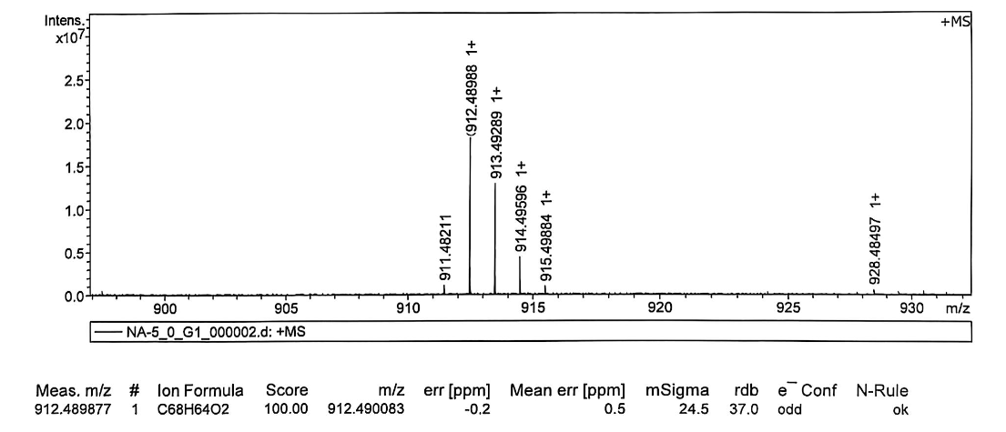
Figure S131 HRMS spectrum of compound 21

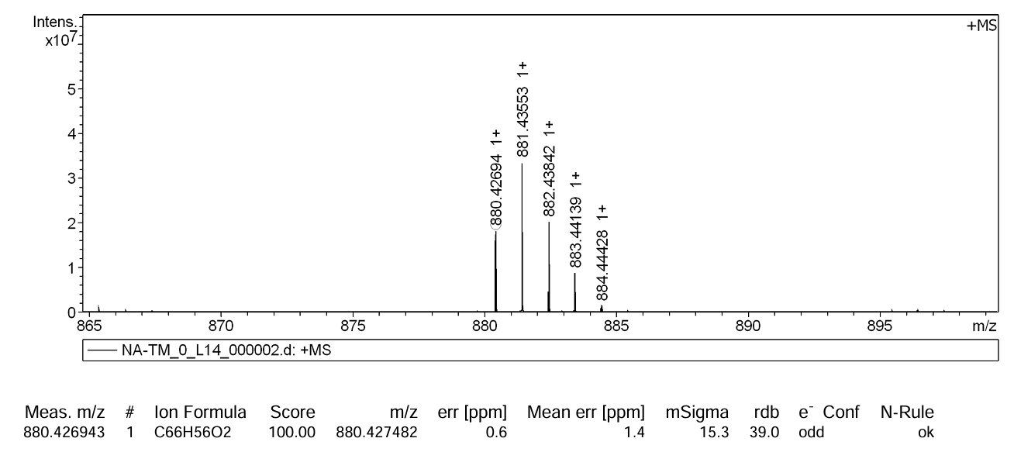
Figure S132 HRMS spectrum of compound 3
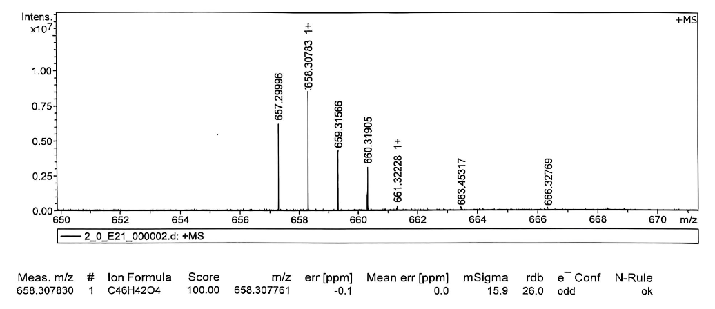
Figure S133 HRMS spectrum of compound 22a
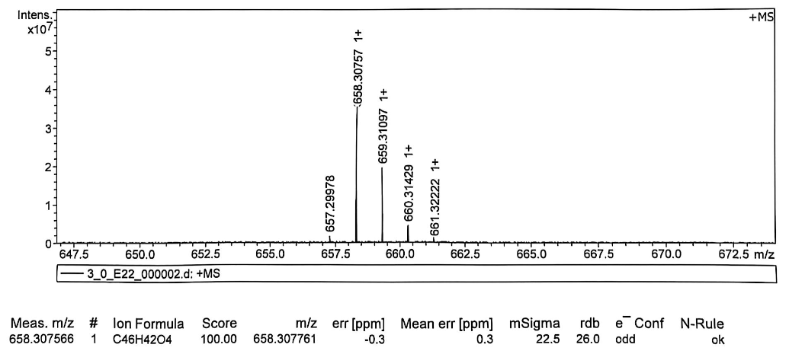
Figure S134 HRMS spectrum of the mixture of 23-1a, 23-2a and 23-3a
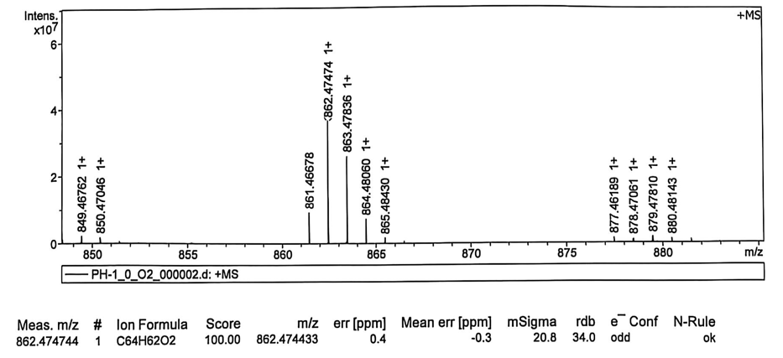
Figure S135 HRMS spectrum of compound 24-1a

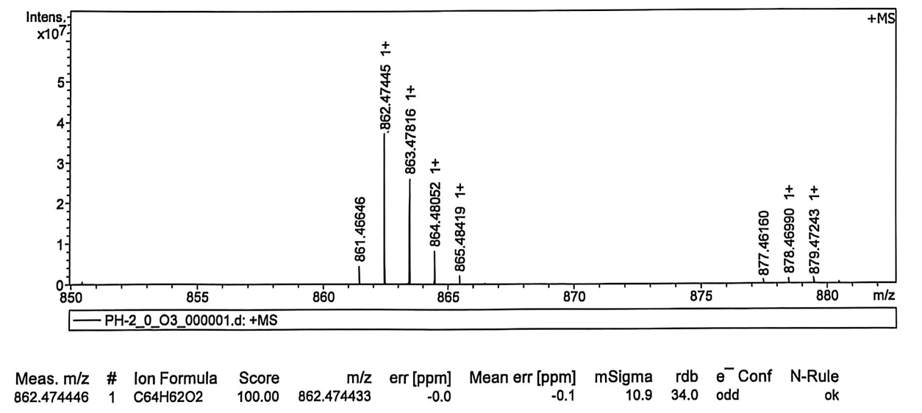
Figure S136 HRMS spectrum of compound 24-3a
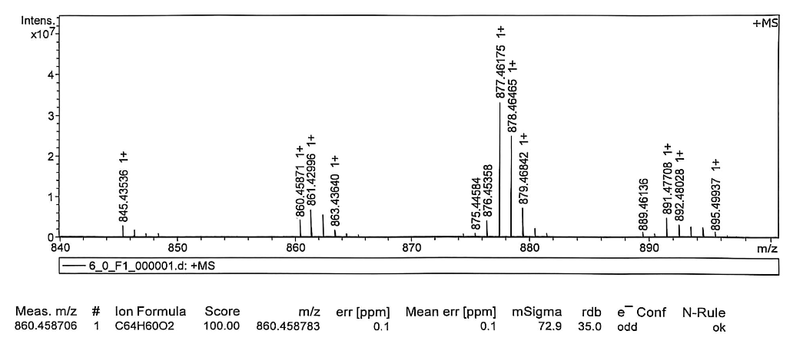
Figure S137 HRMS spectrum of compound 25-3a
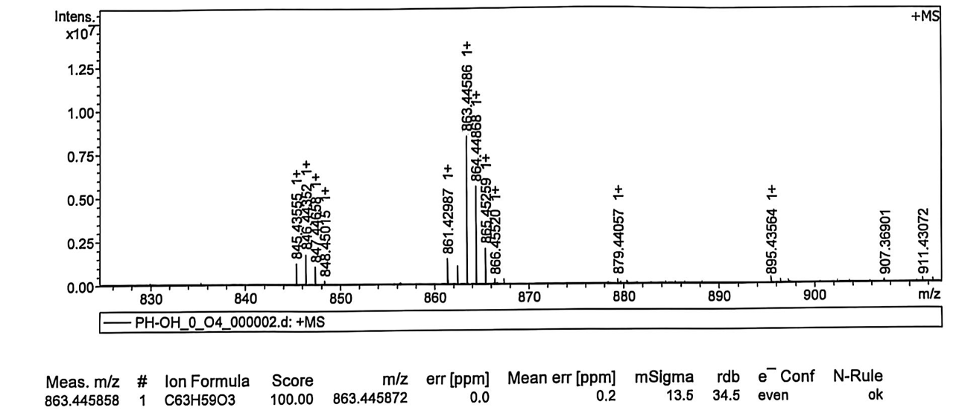
Figure S138 HRMS spectrum of compound 26-1a

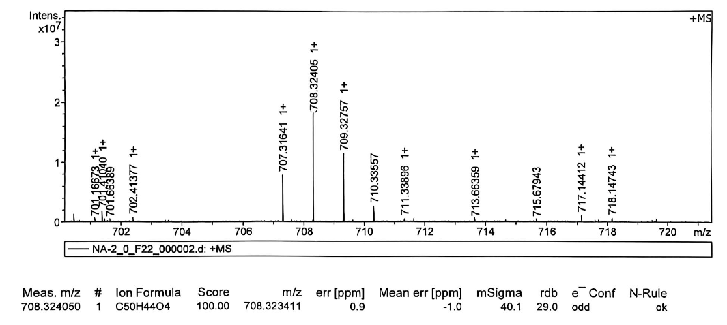Figure S139 HRMS spectrum of compound 22b
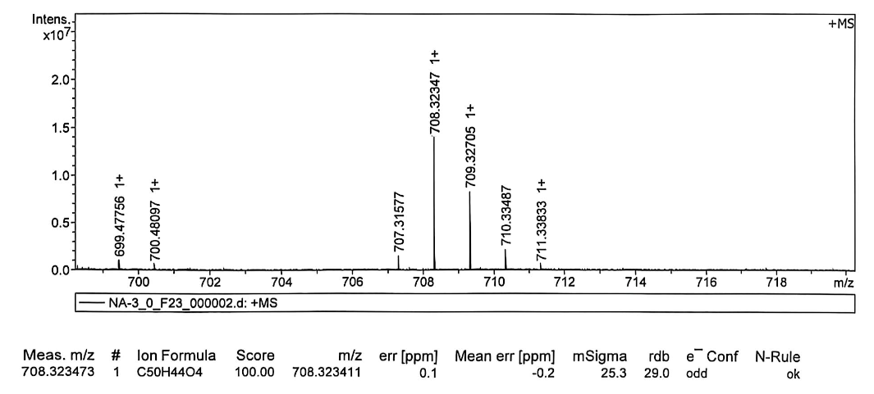
Figure S140 HRMS spectrum of the mixture of 23-1b, 23-2b and 23-3b
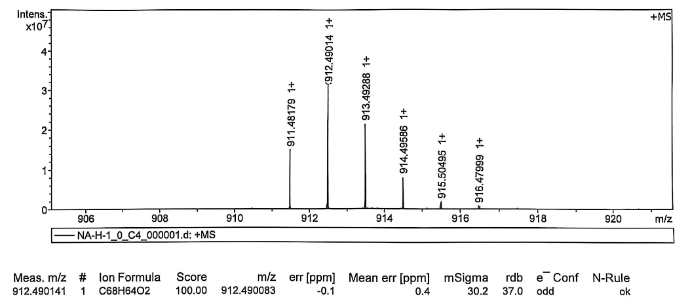
Figure S141 HRMS spectrum of compound 24-1b
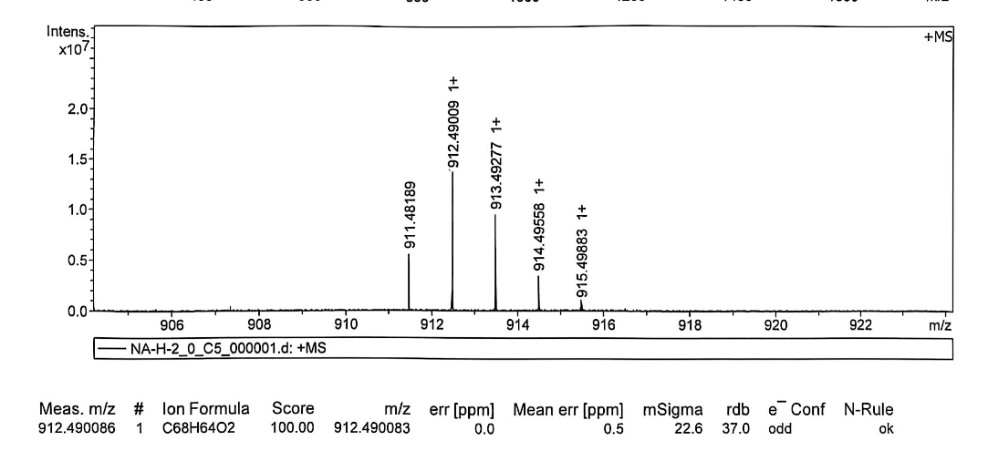
Figure S142 HRMS spectrum of compound 24-2b
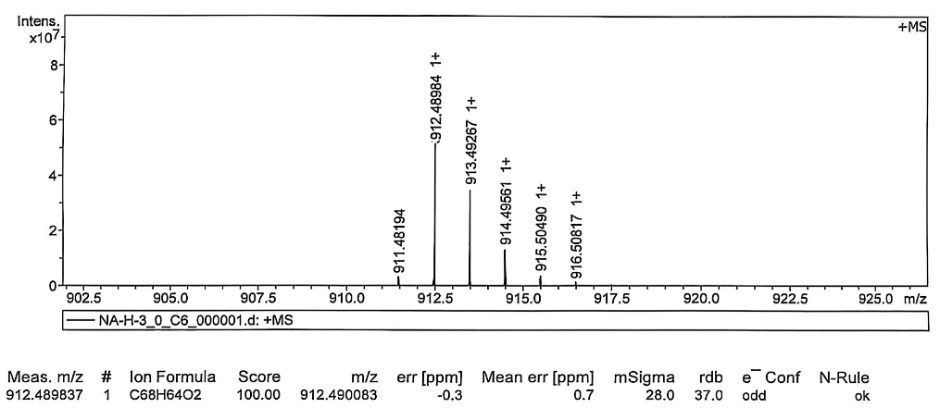
Figure S143 HRMS spectrum of compound 24-3b
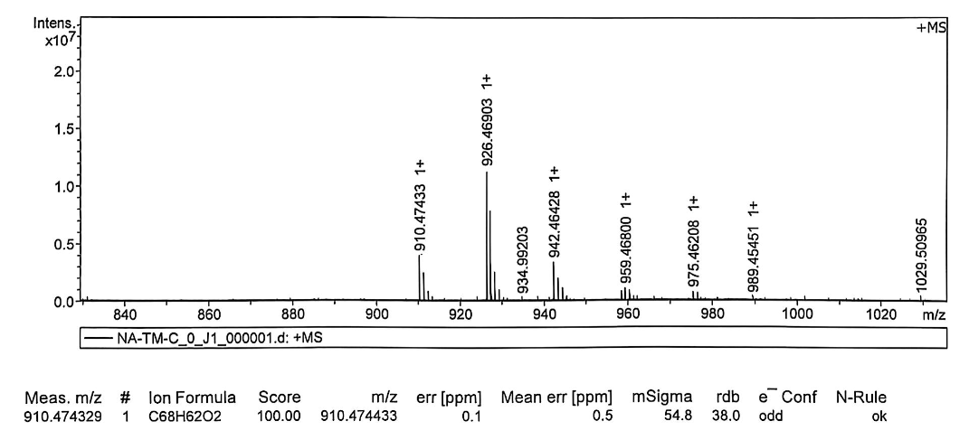
Figure S144 HRMS spectrum of compound 25-3b
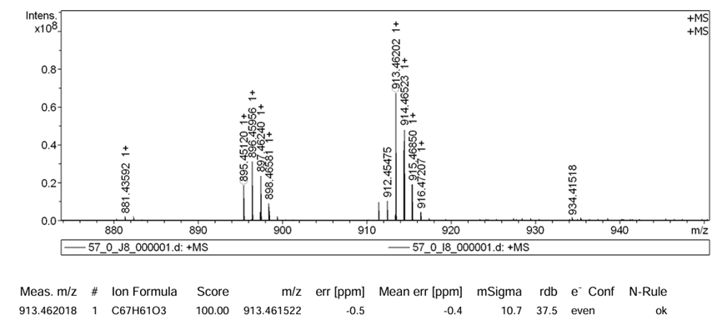
Figure S145 HRMS spectrum of compound 26-1b

15. Reference
[S1] M. J. Frisch, G. W. Trucks, H. B. Schlegel, G. E. Scuseria, M. A. Robb, J. R. Cheeseman, G. Scalmani, V. Barone, G. A. Petersson, H. Nakatsuji, X. Li, M. Caricato, A. V. Marenich, J. Bloino, B. G. Janesko, R. Gomperts, B. Mennucci, H. P. Hratchian, J. V. Ortiz, A. F. Izmaylov, J. L. Sonnenberg, D. Williams-Young, F. Ding, F. Lipparini, F. Egidi, J. Goings, B. Peng, A. Petrone, T. Henderson, D. Ranasinghe, V. G. Zakrzewski, J. Gao, N. Rega, G. Zheng, W. Liang, M. Hada, M. Ehara, K. Toyota, R. Fukuda, J. Hasegawa, M. Ishida, T. Nakajima, Y. Honda, O. Kitao, H. Nakai, T. Vreven, K. Throssell, J. A. Montgomery Jr, J. E. Peralta, F. Ogliaro, M. J. Bearpark, J. J. Heyd, E. N. Brothers, K. N. Kudin, V. N. Staroverov, T. A. Keith, R. Kobayashi, J. Normand, K. Raghavachari, A. P. Rendell, J. C. Burant, S. S. Iyengar, J. Tomasi, M. Cossi, J. M. Millam, M. Klene, C. Adamo, R. Cammi, J. W. Ochterski, R. L. Martin, K. Morokuma, O. Farkas, J. B. Foresman, D. J. Fox, Gaussian 09, Revision E.01, Gaussian, Inc., Wallingford CT, 2013.
[S2] P. J. Stephens, F. J. Devlin, C. F. Chabalowski, M. J. Frisch, J. Phys. Chem., 1994, 98, 11623-11627.
[S3] S. Grimme, J. Antony, S. Ehrlich, H. Krieg, J. Chem. Phys., 2010, 132, 154104.
[S4] P. C. Hariharan, J. A. Pople, Theor. Chim. Acta, 1973, 28, 213-222.
[S5] F. Furche, R. Ahlrichs, J. Chem. Phys., 2002, 117, 7433-7447.
[S6] Z. Chen, C. S. Wannere, C. Corminboeuf, R. Puchta, P. V. R. Schleyer, Chem. Rev., 2005, 105, 3842-3888.
[S7] D. Geuenich, K. Hess, F. Köhler, R. Herges, Chem. Rev., 2005, 105, 3758-3772.
[S8] Z. Liu, T. Lu, Q. Chen, Carbon, 2020, 165, 468-475.
[S9] T. Lu, F. Chen, J. Comput. Chem., 2012, 33, 580-592.
[S10] K. Kamada, K. Ohta, A. Shimizu, T. Kubo, R. Kishi, H. Takahashi, E. Botek, B. Champagne, M. Nakano, J. Phys. Chem. Lett. 2010, 1, 937-940.

